2026 年 AMC 8 真题与解答
American Mathematics Competitions 8 · 中英双语
共 25 题，限时 40 分钟；单项选择题，每题 1 分，答错不扣分，满分 25 分。
编排说明：第一部分为题目（先中文、后英文原题），第二部分为解答与答案，便于先做题后对答案。
第一部分 题目
第 1 题
下面这个表达式的值是多少？
1 + 2 - 3 + 4 + 5 - 6 +
7 + 8 - 9 + 10 + 11 - 12
（A）18 （B）21 （C）24 （D）27 （E）30
English
What is the value of the following expression?
1 + 2 - 3 + 4 + 5 - 6 +
7 + 8 - 9 + 10 + 11 - 12
(A) 18 (B) 21 (C) 24 (D) 27 (E) 30
第 2 题
在下图数组中，三个 3 被一圈 2 包围，而这一圈又被一圈 1 包围。数组中所有数的和是多少？
1 | 1 | 1 | 1 | 1 | 1 | 1
1 | 2 | 2 | 2 | 2 | 2 | 1
1 | 2 | 3 | 3 | 3 | 2 | 1
1 | 2 | 2 | 2 | 2 | 2 | 1
1 | 1 | 1 | 1 | 1 | 1 | 1

（A）49 （B）51 （C）53 （D）55 （E）57
English
In the array shown below, three 3s are surrounded by 2s, which are in turn surrounded by a border of 1s. What is the sum of the numbers in the array?
1 | 1 | 1 | 1 | 1 | 1 | 1
1 | 2 | 2 | 2 | 2 | 2 | 1
1 | 2 | 3 | 3 | 3 | 2 | 1
1 | 2 | 2 | 2 | 2 | 2 | 1
1 | 1 | 1 | 1 | 1 | 1 | 1

(A) 49 (B) 51 (C) 53 (D) 55 (E) 57
第 3 题
Haruki 有一根长 24 厘米的铁丝。他想把它分别弯成下面各图形。
边长为 5 厘米的正六边形。
面积为 36 平方厘米的正方形。
两条直角边分别为 6 和 8 厘米的直角三角形。
Haruki 能弯成哪些图形？
（A）只有三角形 （B）只有六边形和正方形 （C）只有六边形和三角形 （D）只有正方形和三角形 （E）三种都可以
English
Haruki has a piece of wire that is 24 centimeters long. He wants to bend it to form each of the following shapes, one at a time.
A regular hexagon with side length 5 cm.
A square of area 36 cm².
A right triangle whose legs are 6 and 8 cm long.
Which of the shapes can Haruki make?
(A) Triangle only (B) Hexagon and square only (C) Hexagon and triangle only (D) Square and triangle only (E) Hexagon, triangle, and square
第 4 题
Brynn 的存款在七月减少了 20%，然后在八月增加了 50%。现在她的存款是原来的百分之多少？
（A）80 （B）90 （C）100 （D）110 （E）120
English
Brynn’s savings decreased by 20% in July, then increased by 50% in August. Brynn’s savings are now what percent of the original amount?
(A) 80 (B) 90 (C) 100 (D) 110 (E) 120
第 5 题
Casey 开车旅行了 100 英里，途中只停下来吃了一次午饭。整趟旅行总共用了 3 小时，开车时的平均速度是每小时 40 英里。她的午饭休息用了多少分钟？
（A）15 （B）30 （C）40 （D）45 （E）60
English
Casey went on a road trip that covered 100 miles, stopping only for a lunch break along the way. The trip took 3 hours in total and her average speed while driving was 40 miles per hour. In minutes, how long was the lunch break?
(A) 15 (B) 30 (C) 40 (D) 45 (E) 60
第 6 题
Peter 住在一片长满黑莓灌木的长方形田地附近。田地长 10 米、宽 8 米，Peter 能摘到距离田地边界 1 米以内的所有黑莓，如图中阴影部分所示。他能摘到黑莓的区域占整片田地面积的几分之几？
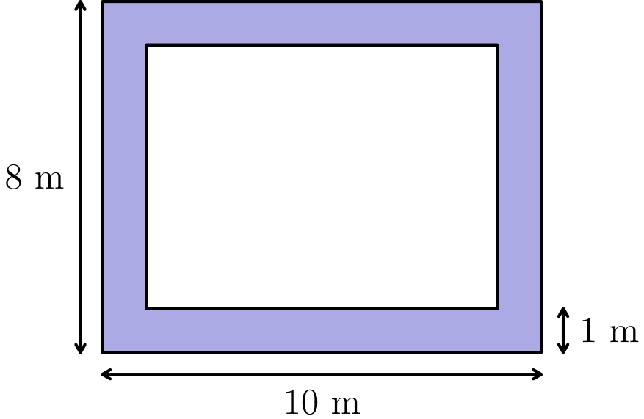
（A）1/6 （B）1/4 （C）1/3 （D）3/8 （E）2/5
English
Peter lives near a rectangular field that is filled with blackberry bushes. The field is 10 meters long and 8 meters wide, and Peter can reach any blackberries that are within 1 meter of an edge of the field. The portion of the field he can reach is shaded in the figure below. What fraction of the area of the field can Peter reach?
(A) 1/6 (B) 1/4 (C) 1/3 (D) 3/8 (E) 2/5
第 7 题
Mika 想估计她的电动自行车充满电能骑多远。两次骑行一共骑了 40 英里。第一次用了 1/2 的电量，第二次用了 3/10 的电量。充满电大约可以骑多少英里？
（A）45 （B）48 （C）50 （D）52 （E）55
English
Mika would like to estimate how far she can ride a new model of electric bike on a fully charged battery. She completed two trips totaling 40 miles. The first trip used 1/2 of the total battery power, while the second trip used 3/10 of the total battery power. How many miles can this electric bike go on a fully charged battery?
(A) 45 (B) 48 (C) 50 (D) 52 (E) 55
第 8 题
一项调查询问人们是否喜欢解数学题。正好有 74% 的人回答“是”。参加调查的人数最少可能是多少？
（A）10 （B）20 （C）25 （D）50 （E）100
English
A poll asked a number of people if they liked solving mathematics problems. Exactly 74% answered “yes.” What is the fewest possible number of people who could have been asked the question?
(A) 10 (B) 20 (C) 25 (D) 50 (E) 100
第 9 题
下面这个表达式的值是多少？
(√(16√(81)))/(√(81√(16)))
（A）4/9 （B）2/3 （C）1 （D）3/2 （E）9/4
English
What is the value of this expression?
(√(16√(81)))/(√(81√(16)))
(A) 4/9 (B) 2/3 (C) 1 (D) 3/2 (E) 9/4
第 10 题
五名跑步者 Luke、Melina、Nico、Olympia 和 Pedro 完成了艰苦的 Xmarathon 马拉松赛。
• Nico 比 Pedro 晚 11 分钟到达终点。
• Olympia 比 Melina 早 2 分钟到达，但比 Pedro 晚 3 分钟到达。
• Olympia 比 Luke 早 6 分钟到达。
哪名跑步者第四个到达终点？
（A）Luke （B）Melina （C）Nico （D）Olympia （E）Pedro
English
Five runners completed the grueling Xmarathon: Luke, Melina, Nico, Olympia, and Pedro.
• Nico finished 11 minutes behind Pedro.
• Olympia finished 2 minutes ahead of Melina, but 3 minutes behind Pedro.
• Olympia finished 6 minutes ahead of Luke.
Which runner finished fourth?
(A) Luke (B) Melina (C) Nico (D) Olympia (E) Pedro
第 11 题
边长为 1、1、2、3 和 5 的正方形拼成了图中的长方形。曲线由每个正方形中的四分之一圆弧组成，圆弧按正方形从小到大的顺序连接。曲线的长度是多少？
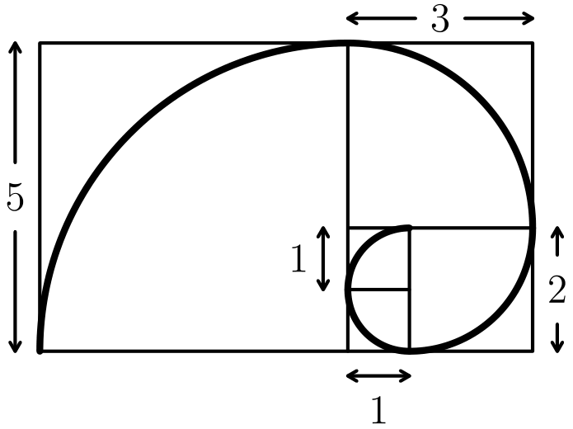
（A）4π （B）6π （C）13/2π （D）8π （E）13π
English
Squares of side length 1, 1, 2, 3, and 5 are arranged to form the rectangle shown below. A curve is drawn by inscribing a quarter circle in each square and joining the quarter circles in order, from shortest to longest. What is the length of the curve?
(A) 4π (B) 6π (C) 13/2π (D) 8π (E) 13π
第 12 题
图中六个圆圈要填入数字 1 到 6。每个数字恰好用一次。相邻圆圈之间方框里的数表示这两个圆圈中数字的和。最上面的圆圈中应该填什么数字？
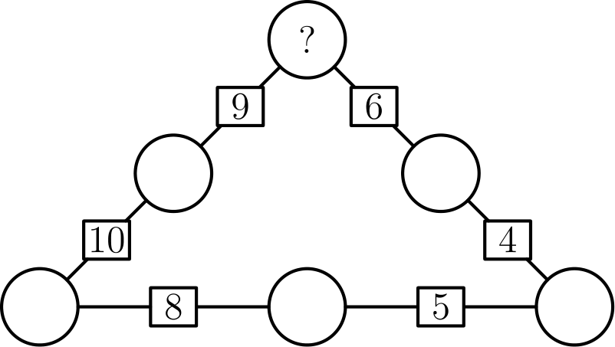
（A）2 （B）3 （C）4 （D）5 （E）不可能
English
In the figure below, each circle will be filled with a digit from 1 to 6. Each digit must appear exactly once. The sum of the digits in neighboring circles is shown in the box between them. What digit must be placed in the top circle?
(A) 2 (B) 3 (C) 4 (D) 5 (E) it is impossible to fill the circles
第 13 题
图中由 1 × 1 的单位正方形铺成，相邻两行之间水平错开半个单位。阴影正方形的每个顶点都是某个单位正方形的顶点。阴影正方形的面积是多少？
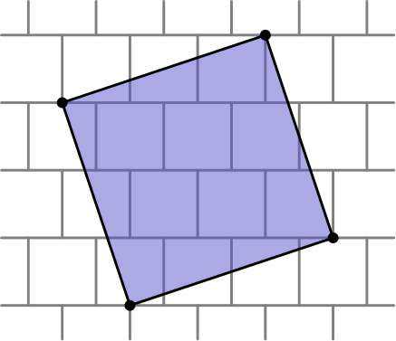
（A）10 （B）21/2 （C）32/3 （D）11 （E）34/3
English
The figure below shows a tiling of 1 × 1 unit squares. Each row of unit squares is shifted horizontally by half a unit relative to the row above it. A shaded square is drawn on top of the tiling. Each vertex of the shaded square is a vertex of one of the unit squares. In square units, what is the area of the shaded square?
(A) 10 (B) 21/2 (C) 32/3 (D) 11 (E) 34/3
第 14 题
Jami 选了三个等间隔的整数。第一个数和第二个数的和是 40，第二个数和第三个数的和是 60。这三个数的和是多少？
（A）70 （B）75 （C）80 （D）85 （E）90
English
Jami picked three equally spaced integer numbers on the number line. The sum of the first and the second numbers is 40, while the sum of the second and third numbers is 60. What is the sum of all three numbers?
(A) 70 (B) 75 (C) 80 (D) 85 (E) 90
第 15 题
Elijah 有一些立方体，每个立方体有 4 个面未涂色，另外 2 个相邻的面涂了阴影。他把这些立方体面贴面地粘在一起。图中显示 2 个这样的立方体粘在一起后，仍有 3 个阴影面可见。为了保证无论怎样旋转整个图形，都没有阴影面可见，至少需要多少个立方体？
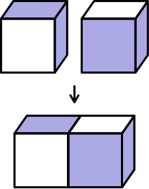
（A）4 （B）6 （C）8 （D）9 （E）27
English
Elijah has a large collection of identical wooden cubes which are plain on 4 faces and shaded on 2 faces that share an edge. He glues some cubes together face-to-face. The figure below shows 2 cubes being glued together, leaving 3 shaded faces visible. What is the fewest number of cubes that he could glue together to ensure that no shaded faces are visible, no matter how he rotates the figure?
(A) 4 (B) 6 (C) 8 (D) 9 (E) 27
第 16 题
考虑所有只由偶数数字组成的正四位整数。其中有多少比例能被 4 整除？
（A）1/4 （B）2/5 （C）1/2 （D）3/5 （E）3/4
English
Consider all positive four-digit integers consisting of only even digits. What fraction of these integers are divisible by 4?
(A) 1/4 (B) 2/5 (C) 1/2 (D) 3/5 (E) 3/4
第 17 题
四名学生坐成一排。他们可以和坐在自己旁边的人聊天。现在重新安排座位，使得没有任何一对原来相邻的学生仍然相邻。这样的重新安排有多少种？
（A）2 （B）4 （C）9 （D）12 （E）24
English
Four students are seated in a row. They chat with the people sitting next to them, then rearrange themselves so that they are no longer seated next to any of the same people. How many rearrangements are possible?
(A) 2 (B) 4 (C) 9 (D) 12 (E) 24
第 18 题
有多少种方法可以把 60 写成两个或更多个连续正奇数的和，并且这些奇数按递增顺序排列？
（A）1 （B）2 （C）3 （D）4 （E）5
English
In how many ways can 60 be written as the sum oftwo or moreconsecutive odd positive integers that are arranged in increasing order?
(A) 1 (B) 2 (C) 3 (D) 4 (E) 5
第 19 题
Miguel 带着狗 Luna 散步。在公园入口处，他把球直直地向前扔到一棵树旁，然后自己继续以稳定速度向前走。Luna 跑到停在树旁的球那里，再跑回 Miguel 身边。Luna 跑步的速度是 Miguel 走路速度的 5 倍。当 Luna 把球带回 Miguel 身边时，Miguel 已经走过了入口到树之间距离的几分之几？
（A）1/6 （B）1/5 （C）1/4 （D）1/3 （E）2/5
English
Miguel is walking with his dog, Luna. When they reach the entrance to a park, Miguel throws a ball straight ahead and continues to walk at a steady pace. Luna sprints toward the ball, which stops by a tree. As soon as the dog reaches the ball, she brings it back to Miguel. Luna runs 5 times faster than Miguel walks. What fraction of the distance between the entrance and the tree does Miguel cover by the time Luna brings him the ball?
(A) 1/6 (B) 1/5 (C) 1/4 (D) 1/3 (E) 2/5
第 20 题
Catania 有两种硬币：金币厚 1 毫米，银币厚 3 毫米。用这些硬币堆成高度为 8 毫米的一摞共有多少种方法？硬币的上下顺序不同算不同方法。
（A）3 （B）7 （C）10 （D）13 （E）16
English
The land of Catania uses gold coins and silver coins. Gold coins are 1 mm thick and silver coins are 3 mm thick. In how many ways can Taylor make a stack of coins that is 8 mm tall using any arrangement of gold and silver coins, assuming order matters?
(A) 3 (B) 7 (C) 10 (D) 13 (E) 16
第 21 题
蜘蛛 Charlotte 在图中形状像 5 角星的蛛网上随机行走。蛛网有 5 个外顶点和 5 个内顶点。每次到达一个顶点时，她都会随机选择一个相邻顶点并走过去。她从一个外顶点出发，走 3 步后在外顶点的概率是多少？
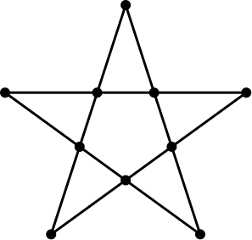
（A）1/5 （B）1/4 （C）2/5 （D）1/2 （E）3/5
English
Charlotte the spider is walking along a web shaped like a 5-pointed star, shown in the figure below. The web has 5 outer points and 5 inner points. Each time Charlotte reaches a point, she randomly chooses a neighboring point and moves to that point. Charlotte starts at one of the outer points and makes 3 moves (re-visiting points is allowed). What is the probability she is now at one of the outer points of the star?
(A) 1/5 (B) 1/4 (C) 2/5 (D) 1/2 (E) 3/5
第 22 题
将整数 1 到 25 任意分成五组，每组 5 个数。找出每组的中位数，再在这五个中位数中取中位数，记为 M。M 的最小可能值是多少？
（A）9 （B）10 （C）12 （D）13 （E）14
English
The integers from 1 through 25 are arbitrarily separated into five groups of 5 numbers each. The median of each group is identified. Let M equal the median of the five medians. What is the least possible value of M?
(A) 9 (B) 10 (C) 12 (D) 13 (E) 14
第 23 题
Lakshmi 有 5 枚圆形硬币，每枚直径为 4 厘米。她把硬币按图中 2 行摆在桌上，并用一根弹性带紧紧围住它们。弹性带的长度是多少厘米？
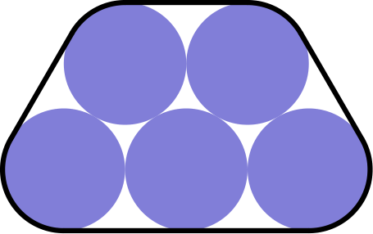
（A）2π + 20 （B）5/2π + 20 （C）4π + 20 （D）9/2π + 20 （E）5π + 20
English
Lakshmi has 5 round coins of diameter 4 centimeters. She arranges the coins in 2 rows on a table top, as shown below, and wraps an elastic band tightly around them. In centimeters, what will be the length of the band?
(A) 2π + 20 (B) 5/2π + 20 (C) 4π + 20 (D) 9/2π + 20 (E) 5π + 20
第 24 题
记号 n!（读作“n 的阶乘”）定义为前 n 个正整数的乘积。（例如，3! = 1 · 2 · 3 = 6。）定义正整数的超级阶乘n^(!) 为前 n 个整数的阶乘的乘积。（例如，3^(!) = 1! · 2! · 3! = 12。）51^(!)（也就是 51 的超级阶乘）的质因数分解中含有多少个因数 7？
（A）147 （B）150 （C）156 （D）168 （E）171
English
The notation n! (read “n factorial”) is defined as the product of the first n positive integers. (For example, 3! = 1 · 2 · 3 = 6.) Define thesuperfactorialof a positive integer, denoted by n^(!), to be the product of the factorials of the first n integers. (For example, 3^(!) = 1! · 2! · 3! = 12.) How many factors of 7 appear in the prime factorization of 51^(!), the superfactorial of 51?
(A) 147 (B) 150 (C) 156 (D) 168 (E) 171
第 25 题
一个等角六边形的所有内角都是 120°。图中例子边长依次为 2、3、1、3、2 和 2，并且这个六边形内接于等边三角形 △ ABC。考虑所有边长为正整数、内接于三角形 ABC 的等角六边形，六个顶点都在三角形边上。按旋转和反射视为相同，一共有多少种？
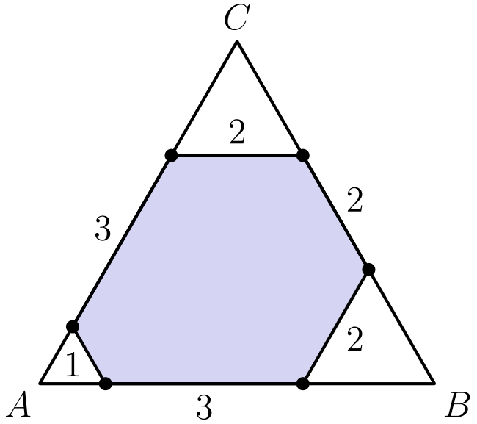
（A）4 （B）5 （C）6 （D）7 （E）8
English
In anequiangular hexagon, all interior angles measure 120°. An example of such a hexagon with side lengths of 2, 3, 1, 3, 2, and 2 is shown below, inscribed in equilateral triangle ABC. Consider all equiangular hexagons with positive integer side lengths that can be inscribed in △ ABC, with all six vertices on the sides of the triangle. What is the total number of such hexagons? Hexagons that differ only by a rotation or a reflection are considered the same.
(A) 4 (B) 5 (C) 6 (D) 7 (E) 8

第二部分 解答
答案速查：
题号 1 2 3 4 5 6 7 8 9
答案 A C D E B E C D B
题号 10 11 12 13 14 15 16 17 18
答案 A B D A B A D A B
题号 19 20 21 22 23 24 25
答案 D D B A C E E
答案串：ACDEBECDBABDABADABDDBACEE
第 1 题 答案 A
按三项一组计算：(1+2-3) +(4+5-6) +(7+8-9) +(10+11-12)。这四组的和分别是 0,3,6,9，所以总和是 0+3+6+9=18。
English
Group the expression as (1+2-3) +(4+5-6) +(7+8-9) +(10+11-12). These group sums are 0,3,6,9, respectively, so the total is 0+3+6+9=18.
第 2 题 答案 C
数组中有 20 个 1、12 个 2、3 个 3。所以总和为 20·1+12·2+3·3 =20+24+9 =53。
English
There are 20 border entries equal to 1, 12 entries equal to 2, and 3 entries equal to 3. The sum is 20·1+12·2+3·3 =20+24+9 =53.
第 3 题 答案 D
正六边形的周长是 6·5=30 厘米，对这根铁丝来说太长。正方形的边长为 6，所以周长为 24。直角三角形的斜边为 10，所以周长为 6+8+10=24。因此 Haruki 只能弯成正方形和三角形。
English
The regular hexagon would have perimeter 6·5=30, too long for the wire. The square has side length 6, so its perimeter is 24. The right triangle has hypotenuse 10, so its perimeter is 6+8+10=24. Haruki can make the square and the triangle only.
第 4 题 答案 E
若原来有 100 元，减少 20% 后剩 80 元。再增加 50% 得到 80·1.5=120 元，所以现在是原来的 120%。
English
If the original amount is 100, then after a 20% decrease Brynn has 80. Increasing by 50% gives 80·1.5=120, so the savings are 120% of the original amount.
第 5 题 答案 B
以每小时 40 英里行驶 100 英里，需要 100/40=2.5 小时。整趟旅行用了 3 小时，所以午饭休息用了 0.5 小时，也就是 30 分钟。
English
Driving 100 miles at 40 miles per hour takes 100/40=2.5 hours. The whole trip took 3 hours, so the lunch break lasted 0.5 hours, which is 30 minutes.
第 6 题 答案 E
整个场地面积为 10·8=80。中间不能到达的长方形长 8 米、宽 6 米，面积为 48。因此可到达的面积为 80-48=32，所求分数为 32/80=2/5。
English
The whole field has area 10·8=80. The unreachable inner rectangle is 8 meters by 6 meters, with area 48. Thus the reachable area is 80-48=32, and the fraction is 32/80=2/5.
第 7 题 答案 C
两次骑行一共用了 1/2+3/10=4/5 的满电电量。因为 4/5 的续航是 40 英里，所以充满电可以骑 40÷4/5=50 英里。
English
The two trips used 1/2+3/10=4/5 of a full battery. Since 4/5 of the range is 40 miles, a full charge gives 40÷4/5=50 miles.
第 8 题 答案 D
回答“是”的人数正好占 74%=74/100=37/50。总人数必须是 50 的倍数，因此最少可以是 50 人。
English
Exactly 74%=74/100=37/50 of the people answered yes. The total number of people must therefore be a multiple of 50, and 50 people is possible.
第 9 题 答案 B
分子为 √(16√(81)) =√(16·9) =√(144) =12。分母为 √(81√(16)) =√(81·4) =√(324) =18。所以这个值是 12/18=2/3。
English
The numerator is √(16√(81)) =√(16·9) =√(144) =12. The denominator is √(81√(16)) =√(81·4) =√(324) =18. The value is 12/18=2/3.
第 10 题 答案 A
以 Pedro 之后的分钟数记录到达时间。于是 Pedro 为 0，Olympia 为 3，Melina 为 5，Luke 为 9，Nico 为 11。第四个到达终点的是 Luke。
English
Measure finish times in minutes after Pedro. Then Pedro is at 0, Olympia is at 3, Melina is at 5, Luke is at 9, and Nico is at 11. The fourth finisher is Luke.
第 11 题 答案 B
曲线的每一段都是四分之一圆。半径分别为 1,1,2,3,5，所以总长度为 1/4·2π(1+1+2+3+5) =π/2·12 =6π。
English
Each piece of the curve is a quarter circle. The radii are 1,1,2,3,5, so the total length is 1/4·2π(1+1+2+3+5) =π/2·12 =6π.
第 12 题 答案 D
设最上面的数字为 x。沿顺时针方向，其余数字依次为 9-x、x-2、7-x、x+1、6-x。要使六个数正好是 1,2,3,4,5,6，取 x=5 可得到 5,4,3,2,6,1。所以最上面的数字是 5。
English
Let the top digit be x. Moving clockwise from the top, the other digits are 9-x, x-2, 7-x, x+1, and 6-x. For these six values to be exactly 1,2,3,4,5,6, the value x=5 works and gives the set 5,4,3,2,6,1. Thus the top digit is 5.
第 13 题 答案 A
阴影正方形的一条边可以看作直角三角形的斜边，其中水平距离为 3，竖直距离为 1。因此边长的平方为 3²+1²=10。正方形面积等于边长的平方，所以面积为 10。
English
One side of the shaded square goes 3 unit widths horizontally and 1 unit vertically in the grid. Its length squared is therefore 3²+1²=10. The area of a square equals its side length squared, so the shaded area is 10.
第 14 题 答案 B
设三个数为 a-d、a、a+d。题意给出 2a-d=40 和 2a+d=60。两式相加得 4a=100，所以 a=25。三个数的和为 3a=75。
English
Let the three equally spaced numbers be a-d, a, and a+d. The given sums are 2a-d=40 and 2a+d=60. Adding gives 4a=100, so a=25. The total of the three numbers is 3a=75.
第 15 题 答案 A
如果没有阴影面可见，那么每个立方体的两个阴影面都必须粘到相邻立方体上，所以每个立方体需要两个面相邻的邻居。若只有三个立方体，面相邻关系是一条链，因此端点立方体只有一个面相邻的邻居。四个立方体排成 2×2 的方阵时，每个立方体都可以把两个阴影面朝向内部，所以 4 个立方体足够。
English
For no shaded face to be visible, each cube must have both of its shaded faces glued to neighboring cubes, so each cube needs two face-neighbors. With only three cubes, the face-adjacency graph is a path, so an end cube has only one face-neighbor. Four cubes arranged as a 2×2 square can each be oriented with its two shaded faces pointing inward, so 4 cubes suffice.
第 16 题 答案 D
千位有 4 种选择，其他每一位各有 5 种选择，可选数字是 0,2,4,6,8。能否被 4 整除只取决于最后两位。在 25 个偶数数字结尾中，对每个十位数字，个位可以是 0,4,8，所以有 15 个结尾可行。所求比例为 15/25=3/5。
English
There are 4 choices for the thousands digit and 5 choices for each other digit. Divisibility by 4 depends only on the last two digits. Among the 25 even digit endings, for each tens digit 0,2,4,6,8, the ones digit can be 0,4,8, so 15 endings work. The desired fraction is 15/25=3/5.
第 17 题 答案 A
设原顺序为 A,B,C,D。禁止相邻的配对是 AB、BC、CD，所以只允许 AC、AD、BD 相邻。四人排成一排会有三对相邻位置，因此这三对必须全部出现，只能是 C,A,D,B 或其反向。共有 2 种。
English
Name the original order A,B,C,D. The forbidden neighboring pairs are AB, BC, and CD, so the only allowed pairs are AC, AD, and BD. To seat all four students in a row, the three row-adjacencies must be exactly these three edges, giving C,A,D,B or its reverse. There are 2 rearrangements.
第 18 题 答案 B
假设有 k≥2 项，首项为正奇整数 a。它们的和为 a+(a+2)+⋯+(a+2k-2) =k(a+k-1) =60。检查 k 为 60 的因数的情况，可行情况为 k=2 和 k=6，分别给出 29+31 和 5+7+9+11+13+15。所以共有 2 种方法。
English
Suppose there are k≥2 terms, starting with odd positive integer a. The sum is a+(a+2)+⋯+(a+2k-2) =k(a+k-1) =60. Testing divisors k of 60, the positive odd starts occur for k=2, giving 29+31, and for k=6, giving 5+7+9+11+13+15. Thus there are 2 ways.
第 19 题 答案 D
设 Miguel 的速度为 1，Luna 的速度为 5，入口到树的距离为 D。Luna 跑到树需要时间 D/5，这段时间 Miguel 走了 D/5。此时两者相距 4D/5，相向运动的合速度为 6，所以再过 2D/15 的时间相遇。Miguel 总共走了 D/5+2D/15=D/3，也就是入口到树距离的 1/3。
English
Let the entrance-to-tree distance be D, and let Miguel’s speed be 1. Luna’s speed is 5. Luna reaches the tree in time D/5, during which Miguel walks D/5. The remaining distance between Luna and Miguel is 4D/5, and they close it at combined speed 6, taking time 2D/15. Miguel walks a total distance D/5+2D/15=D/3, which is 1/3 of the entrance-to-tree distance.
第 20 题 答案 D
按银币数分类。没有银币时有 1 种；有一枚银币时，还有 5 枚金币和 1 枚银币，共 6 种排列；有两枚银币时，还有 2 枚金币和 2 枚银币，共 C(4, 2)=6 种排列。更多银币会太厚。总数为 1+6+6=13。
English
Count by the number of silver coins. With no silver coins, there is 1 stack. With one silver coin, there are 5 gold coins and 1 silver coin, so 6 arrangements. With two silver coins, there are 2 gold coins and 2 silver coins, so C(4, 2)=6 arrangements. More silver coins are too thick. The total is 1+6+6=13.
第 21 题 答案 B
从外顶点出发，Charlotte 第一步一定到内顶点。从内顶点出发，4 个相邻点中有 2 个是外顶点，所以走到外顶点的概率是 1/2。一步后她在内顶点。两步后她有 1/2 的概率在外顶点、1/2 的概率在内顶点。第三步后在外顶点，只能来自两步后在内顶点的情况，这一步概率为 1/2，所以最终概率为 1/2·1/2=1/4。
English
From an outer point, Charlotte must move to an inner point. From an inner point, 2 of the 4 neighboring points are outer, so the probability of moving to an outer point is 1/2. After one move she is inner. After two moves she is outer with probability 1/2 and inner with probability 1/2. After the third move, only the inner case can move to outer, with probability 1/2, so the final probability is 1/2·1/2=1/4.
第 22 题 答案 A
如果某组的中位数至多为 8，那么这一组至少有 3 个数不超过 8。若五个中位数的中位数至多为 8，则至少有 3 组满足这一点，需要至少 9 个不超过 8 的数，矛盾。因此 M≥9。这个下界可以达到，例如让五组的中位数为 5,8,9,12,17：{3,4,5,20,21}、{6,7,8,22,23}、{1,2,9,24,25}、{10,11,12,13,14} 和 {15,16,17,18,19}。所以最小值是 9。
English
If a group has median at most 8, then at least 3 numbers in that group are at most 8. For the median of the five medians to be at most 8, at least 3 groups would need such medians, requiring at least 9 numbers at most 8, impossible. Thus M≥9. This is attainable, for example with group medians 5,8,9,12,17: use groups {3,4,5,20,21}, {6,7,8,22,23}, {1,2,9,24,25}, {10,11,12,13,14}, and {15,16,17,18,19}. Hence the least possible value is 9.
第 23 题 答案 C
追踪这些硬币圆心的路径。圆心形成的凸包是一个梯形，底边为 8，上底为 4，两条斜边长度都是 4，所以周长为 20。硬币半径为 2，弹性带绕过圆角时额外增加一个完整圆周，长度为 2π·2=4π。因此弹性带长度为 20+4π。
English
Trace the path of the centers of the coins. Their convex hull is a trapezoid with bottom side 8, top side 4, and two slanted sides of length 4, so its perimeter is 20. Wrapping the band around coins of radius 2 adds one full circumference, 2π·2=4π. The band length is 20+4π.
第 24 题 答案 E
对每个 n!，因数 7 的个数是 ⌊ n/7⌋+⌊ n/49⌋。因此 51^(!) 中 7 的指数是 Σₙ₌₁⁵¹⌊ n/7⌋+Σₙ₌₁⁵¹⌊ n/49⌋。第一个和为 7(1+2+3+4+5+6)+3·7 =168，第二个和为 3。总数是 171。
English
For each n!, the number of factors of 7 is ⌊ n/7⌋+⌊ n/49⌋. Therefore the exponent of 7 in 51^(!) is Σₙ₌₁⁵¹⌊ n/7⌋+Σₙ₌₁⁵¹⌊ n/49⌋. The first sum is 7(1+2+3+4+5+6)+3·7 =168, and the second sum is 3. The total is 171.
第 25 题 答案 E
图中例子说明 △ ABC 的每条边长为 6。设靠近三个顶点 A,B,C 的小边长分别为 x,y,z。六边形另外三条边长分别为 6-x-y、6-y-z 和 6-z-x。所有六条边都是正整数，当且仅当 x,y,z 是正整数且每两者之和都小于 6。按旋转和反射视为相同，只需数无序三元组 x≤ y≤ z 且 y+z<6：(1,1,1)、(1,1,2)、(1,1,3)、(1,1,4)、(1,2,2)、(1,2,3)、(2,2,2) 和 (2,2,3)。共有 8 种。
English
The example shows that each side of △ ABC has length 6. Let x,y,z be the small corner lengths cut off at A,B,C, respectively. Then the other three side lengths of the hexagon are 6-x-y, 6-y-z, and 6-z-x. All six side lengths are positive integers exactly when x,y,z are positive integers and each pair sum is less than 6. Up to rotation and reflection, this means counting unordered triples x≤ y≤ z with y+z<6: (1,1,1), (1,1,2), (1,1,3), (1,1,4), (1,2,2), (1,2,3), (2,2,2), and (2,2,3). There are 8 such hexagons.

