2019 年 AMC 8 真题与解答
American Mathematics Competitions 8 · 中英双语
共 25 题，限时 40 分钟；单项选择题，每题 1 分，答错不扣分，满分 25 分。
编排说明：第一部分为题目（先中文、后英文原题），第二部分为解答与答案，便于先做题后对答案。
第一部分 题目
第 1 题
Ike 和 Mike 走进一家三明治店，总共有 $30.00 可以花。三明治每个 $4.50，汽水每杯 $1.00。Ike 和 Mike 计划尽可能多买三明治，并用剩下的钱买汽水。把汽水和三明治都算上，他们会买多少件商品？
（A）6 （B）7 （C）8 （D）9 （E）10
English
Ike and Mike go into a sandwich shop with a total of $30.00 to spend. Sandwiches cost $4.50 each and soft drinks cost $1.00 each. Ike and Mike plan to buy as many sandwiches as they can, and use any remaining money to buy soft drinks. Counting both soft drinks and sandwiches, how many items will they buy?
(A) 6 (B) 7 (C) 8 (D) 9 (E) 10
第 2 题
三个全等的矩形拼成了矩形 ABCD，如下图所示。已知每个小矩形较短边长为 5 英尺，矩形 ABCD 的面积是多少平方英尺？
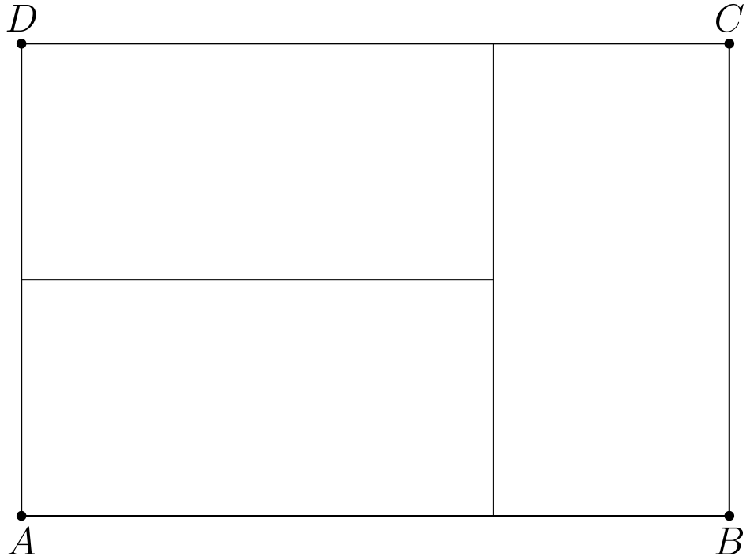
（A）45 （B）75 （C）100 （D）125 （E）150
English
Three identical rectangles are put together to form rectangle ABCD, as shown in the figure below. Given that the length of the shorter side of each of the smaller rectangles is 5 feet, what is the area in square feet of rectangle ABCD?
(A) 45 (B) 75 (C) 100 (D) 125 (E) 150
第 3 题
下列哪一项把分数 15/11、19/15 和 17/13 按从小到大排列正确？
（A）15/11 < 17/13 < 19/15 （B）15/11 < 19/15 < 17/13 （C）17/13 < 19/15 < 15/11 （D）19/15 < 15/11 < 17/13 （E）19/15 < 17/13 <
15/11
English
Which of the following is the correct order of the fractions 15/11, 19/15, and 17/13, from least to greatest?
(A) 15/11 < 17/13 < 19/15 (B) 15/11 < 19/15 < 17/13 (C) 17/13 < 19/15 < 15/11 (D) 19/15 < 15/11 < 17/13 (E) 19/15 < 17/13 <
15/11
第 4 题
四边形 ABCD 是一个周长为 52 米的菱形。对角线 AC 的长度为 24 米。菱形 ABCD 的面积是多少平方米？
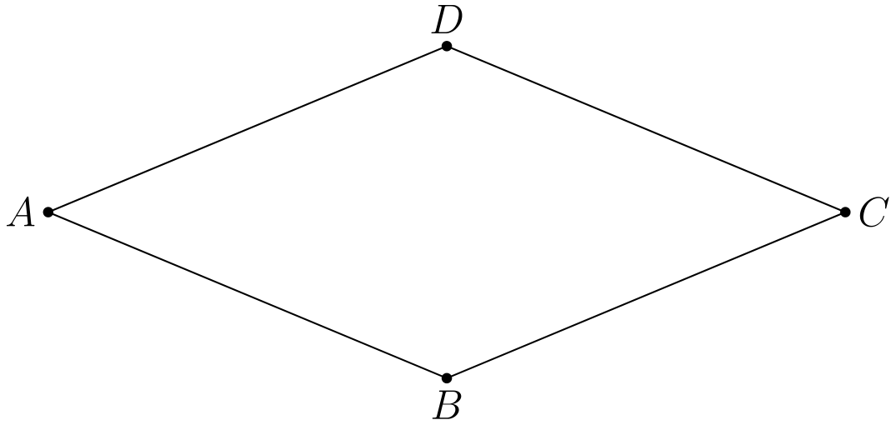
（A）60 （B）90 （C）105 （D）120 （E）144
English
Quadrilateral ABCD is a rhombus with perimeter 52 meters. The length of diagonal AC is 24 meters. What is the area in square meters of rhombus ABCD?
(A) 60 (B) 90 (C) 105 (D) 120 (E) 144
第 5 题
一只乌龟向一只兔子挑战赛跑。兔子欣然同意，很快跑到前面，把行动缓慢的乌龟甩在后面。兔子确信自己会赢，于是停下来打盹。与此同时，乌龟以缓慢而稳定的速度走完整场比赛。兔子醒来后跑向终点，却发现乌龟已经在那里。下列哪幅图符合这场比赛的描述，表示从开始到结束时两者的行进距离 d 随时间 t 的变化？
（A）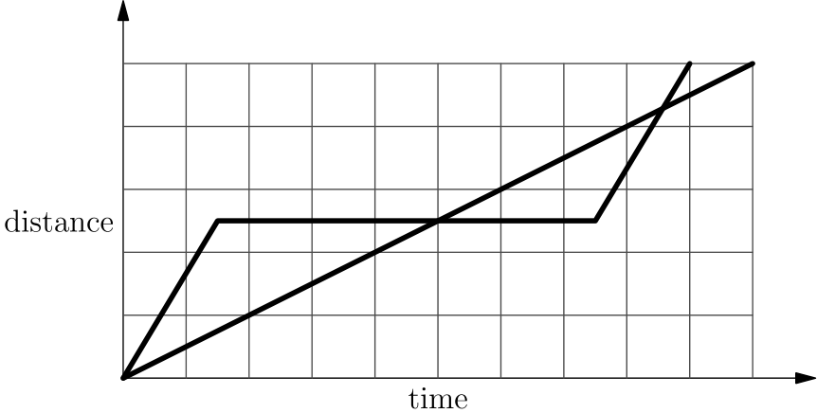
（B）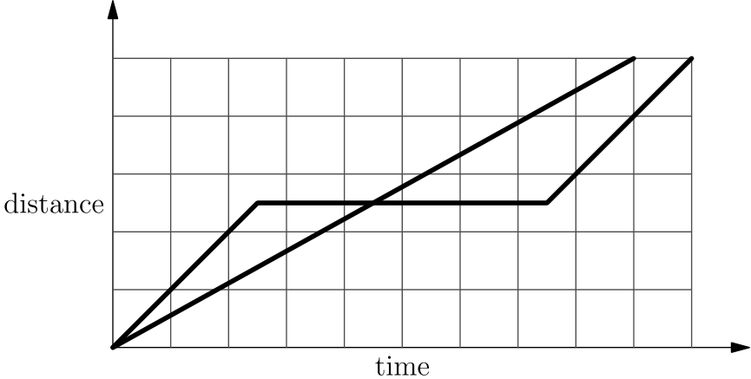
（C）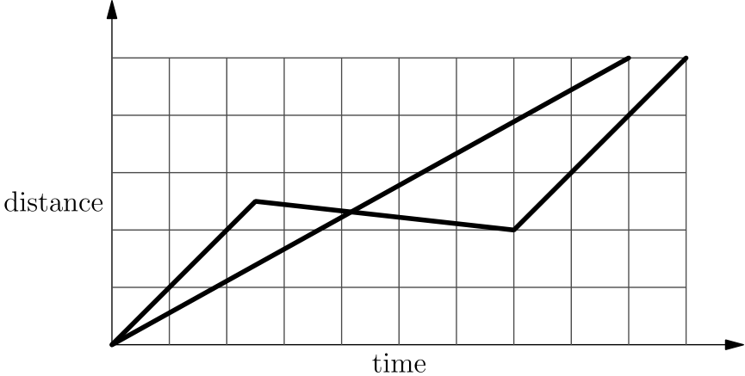
（D）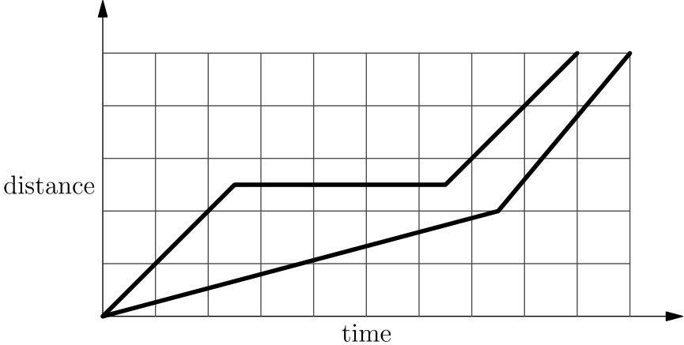
（E）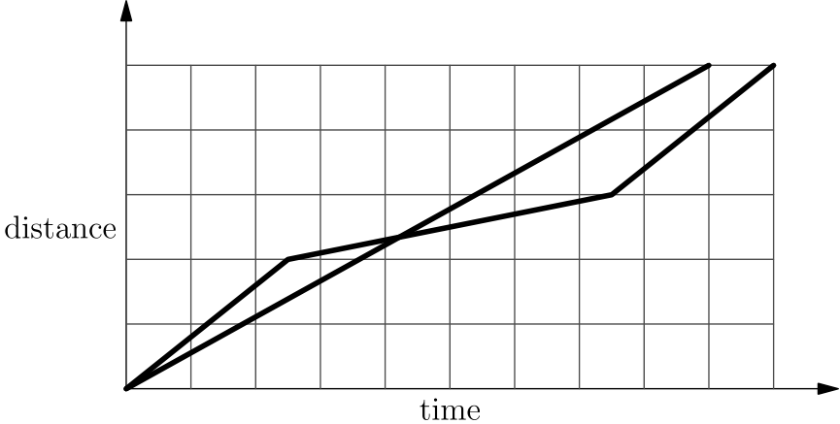
English
A tortoise challenges a hare to a race. The hare eagerly agrees and quickly runs ahead, leaving the slow-moving tortoise behind. Confident that he will win, the hare stops to take a nap. Meanwhile, the tortoise walks at a slow steady pace for the entire race. The hare awakes and runs to the finish line, only to find the tortoise already there. Which of the following graphs matches the description of the race, showing the distance d traveled by the two animals over time t from start to finish?
(A)
(B)
(C)
(D)
(E)
第 6 题
下图的正方形中有 81 个均匀分布的格点，包括边上的点。点 P 在正方形中心。若点 Q 从其余 80 个点中随机选取，那么直线 PQ 是正方形对称轴的概率是多少？
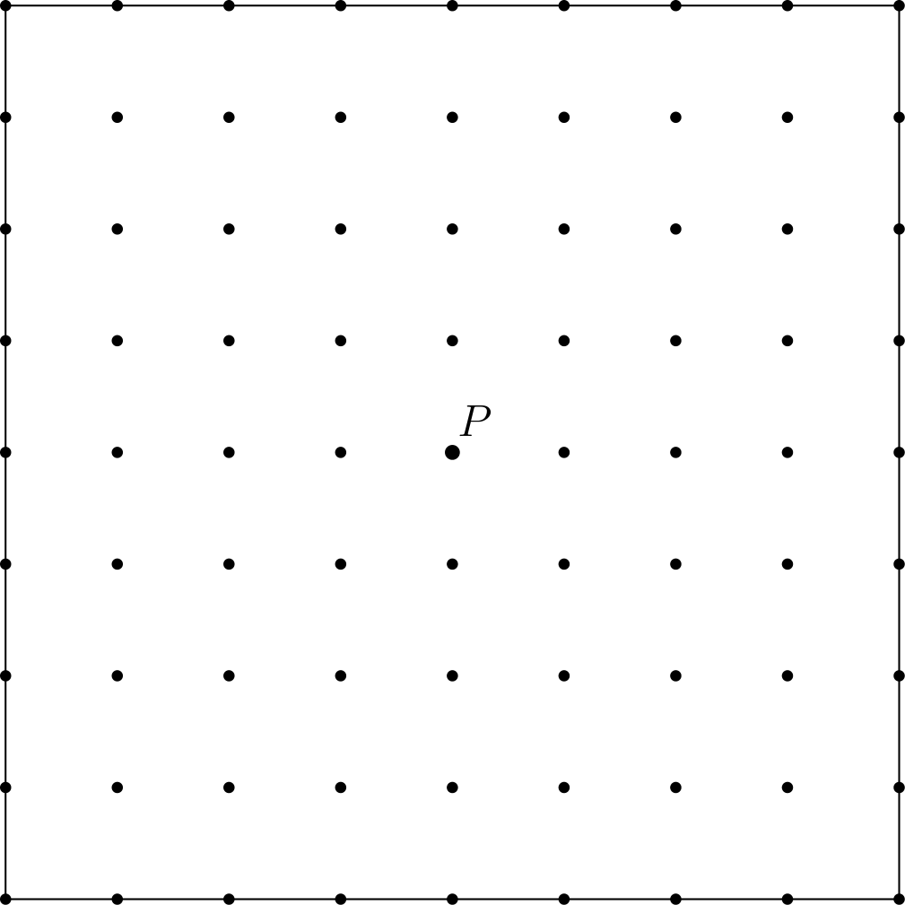
（A）/15 （B）/14 （C）/25 （D）/920 （E）/12
English
There are 81 grid points (uniformly spaced) in the square shown in the diagram below, including the points on the edges. Point P is in the center of the square. Given that point Q is randomly chosen among the other 80 points, what is the probability that the line PQ is a line of symmetry for the square?
(A) /15 (B) /14 (C) /25 (D) /920 (E) /12
第 7 题
Shauna 参加五次测试，每次满分 100 分。她前三次成绩是 76、94 和 87。为了五次测试平均分达到 81，另外两次测试中她可能得到的最低分是多少？
（A）48 （B）52 （C）66 （D）70 （E）74
English
Shauna takes five tests, each worth a maximum of 100 points. Her scores on the first three tests are 76, 94, and 87. In order to average 81 for all five tests, what is the lowest score she could earn on one of the other two tests?
(A) 48 (B) 52 (C) 66 (D) 70 (E) 74
第 8 题
Gilda 有一袋弹珠。她把其中 20% 给了朋友 Pedro。然后她把剩下弹珠的 10% 给了另一位朋友 Ebony。最后，她把袋中此时剩下弹珠的 25% 给了弟弟 Jimmy。Gilda 自己还剩原来那袋弹珠的百分之多少？
（A）20 （B）331/3 （C）38 （D）45 （E）54
English
Gilda has a bag of marbles. She gives 20% of them to her friend Pedro. Then Gilda gives 10% of what is left to another friend, Ebony. Finally, Gilda gives 25% of what is now left in the bag to her brother Jimmy. What percentage of her original bag of marbles does Gilda have left for herself?
(A) 20 (B) 331/3 (C) 38 (D) 45 (E) 54
第 9 题
Alex 和 Felicia 都养猫。Alex 买的猫粮罐是圆柱形，直径 6 厘米，高 12 厘米。Felicia 买的猫粮罐也是圆柱形，直径 12 厘米，高 6 厘米。Alex 的一个罐头体积与 Felicia 的一个罐头体积之比是多少？
（A）1:4 （B）1:2 （C）1:1 （D）2:1 （E）4:1
English
Alex and Felicia each have cats as pets. Alex buys cat food in cylindrical cans that are 6 cm in diameter and 12 cm high. Felicia buys cat food in cylindrical cans that are 12 cm in diameter and 6 cm high. What is the ratio of the volume of one of Alex’s cans to the volume of one of Felicia’s cans?
(A) 1:4 (B) 1:2 (C) 1:1 (D) 2:1 (E) 4:1
第 10 题
图中显示了上周每个工作日参加足球训练的学生人数。教练计算了平均数和中位数后，发现星期三实际有 21 人参加。修正后，平均数和中位数分别如何变化？
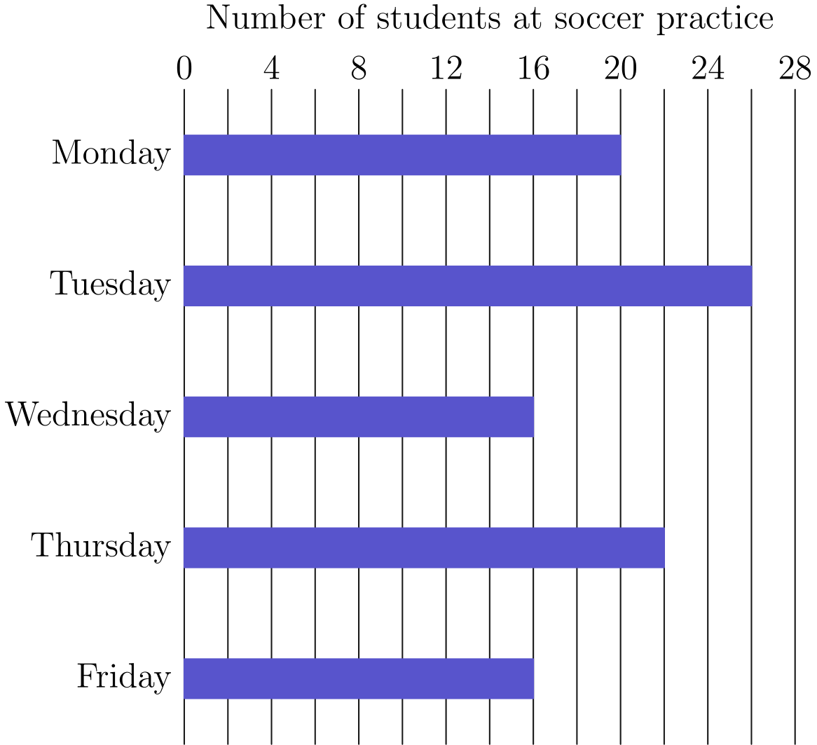
（A）平均数增加 1，中位数不变。 （B）平均数增加 1，中位数增加 1。 （C）平均数增加 1，中位数增加 5。 （D）平均数增加 5，中位数增加 1。 （E）平均数增加 5，中位数增加 5。
English
The diagram shows the number of students at soccer practice each weekday during last week. After computing the mean and median values, Coach discovers that there were actually 21 participants on Wednesday. Which of the following statements describes the change in the mean and median after the correction is made?
(A) The mean increases by 1 and the median does not
change. (B) The mean increases by 1 and the median
increases by 1. (C) The mean increases by 1 and the median increases by
5. (D) The mean increases by 5 and the median increases by
1. (E) The mean increases by 5 and the median increases by
5.
第 11 题
Lincoln 中学八年级有 93 名学生。每名学生上数学课、外语课，或两者都上。八年级有 70 人上数学课，有 54 人上外语课。有多少八年级学生只上数学课而不上外语课？
（A）16 （B）23 （C）31 （D）39 （E）70
English
The eighth grade class at Lincoln Middle School has 93 students. Each student takes a math class or a foreign language class or both. There are 70 eighth graders taking a math class, and there are 54 eighth graders taking a foreign language class. How many eighth graders takeonlya math class andnota foreign language class?
(A) 16 (B) 23 (C) 31 (D) 39 (E) 70
第 12 题
一个立方体的六个面涂成六种不同颜色：红色 R、白色 W、绿色 G、棕色 B、水蓝色 A 和紫色 P。下图给出了立方体的三个视图。与水蓝色面相对的面是什么颜色？
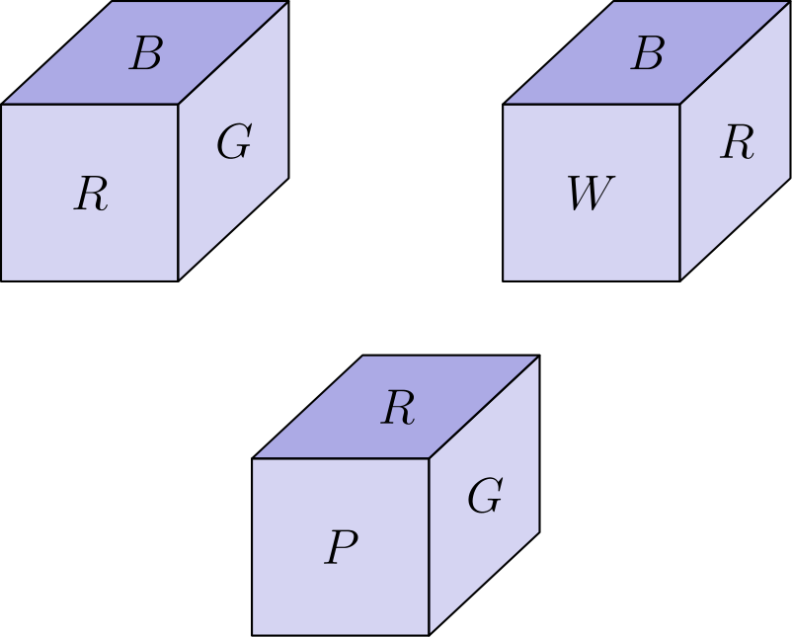
（A）红色 （B）白色 （C）绿色 （D）棕色 （E）紫色
English
The faces of a cube are painted in six different colors: red (R), white (W), green (G), brown (B), aqua (A), and purple (P). Three views of the cube are shown below. What is the color of the face opposite the aqua face?
(A) red (B) white (C) green (D) brown (E) purple
第 13 题
回文数是从左到右读和从右到左读数值相同的数。（例如 12321 是回文数。）设 N 是最小的三位整数，它不是回文数，但可以表示成三个不同的两位回文数之和。N 的数字和是多少？
（A）2 （B）3 （C）4 （D）5 （E）6
English
Apalindromeis a number that has the same value when read from left to right or from right to left. (For example, 12321 is a palindrome.) Let N be the least three-digit integer which is not a palindrome but which is the sum of three distinct two-digit palindromes. What is the sum of the digits of N?
(A) 2 (B) 3 (C) 4 (D) 5 (E) 6
第 14 题
Isabella 有 6 张优惠券，可以在 Pete’s Sweet Treats 兑换免费冰淇淋筒。为了让优惠券用得久一些，她决定每隔 10 天兑换一张，直到全部用完。她知道 Pete’s 星期日关门，但当她在日历上圈出这 6 个日期时，发现没有一个圈出的日期是星期日。Isabella 第一次兑换优惠券是在星期几？
（A）星期一 （B）星期二 （C）星期三 （D）星期四 （E）星期五
English
Isabella has 6 coupons that can be redeemed for free ice cream cones at Pete’s Sweet Treats. In order to make the coupons last, she decides that she will redeem one every 10 days until she has used them all. She knows that Pete’s is closed on Sundays, but as she circles the 6 dates on her calendar, she realizes that no circled date falls on a Sunday. On what day of the week does Isabella redeem her first coupon?
(A) Monday (B) Tuesday (C) Wednesday (D) Thursday (E) Friday
第 15 题
海滩上有 50 人戴太阳镜，35 人戴帽子。有些人两者都戴。如果从戴帽子的人中随机选一人，此人也戴太阳镜的概率是 2/5。如果改为从戴太阳镜的人中随机选一人，此人也戴帽子的概率是多少？
（A）/1485 （B）/725 （C）/25 （D）/47 （E）/710
English
On a beach 50 people are wearing sunglasses and 35 people are wearing caps. Some people are wearing both sunglasses and caps. If one of the people wearing a cap is selected at random, the probability that this person is also wearing sunglasses is 2/5. If instead, someone wearing sunglasses is selected at random, what is the probability that this person is also wearing a cap?
(A) /1485 (B) /725 (C) /25 (D) /47 (E) /710
第 16 题
Qiang 开了 15 英里，平均速度为每小时 30 英里。他还需要以每小时 55 英里的速度再开多少英里，才能使整趟旅行的平均速度为每小时 50 英里？
（A）45 （B）62 （C）90 （D）110 （E）135
English
Qiang drives 15 miles at an average speed of 30 miles per hour. How many additional miles will he have to drive at 55 miles per hour to average 50 miles per hour for the entire trip?
(A) 45 (B) 62 (C) 90 (D) 110 (E) 135
第 17 题
下列乘积的值是多少？
((1· 3)/(2· 2))((2· 4)/(3· 3))((3· 5)/(4· 4))
…((97· 99)/(98· 98))((98· 100)/(99· 99))
（A）/12 （B）/5099 （C）/98009801 （D）/10099 （E）50
English
What is the value of the product below?
((1· 3)/(2· 2))((2· 4)/(3· 3))((3· 5)/(4· 4))
…((97· 99)/(98· 98))((98· 100)/(99· 99))
(A) /12 (B) /5099 (C) /98009801 (D) /10099 (E) 50
第 18 题
两个公平骰子的各面都标有 1、2、3、5、7 和 8。掷这两个骰子时，它们点数之和为偶数的概率是多少？
（A）/49 （B）/12 （C）/59 （D）/35 （E）/23
English
The faces of each of two fair dice are numbered 1, 2, 3, 5, 7, and 8. When the two dice are tossed, what is the probability that their sum will be an even number?
(A) /49 (B) /12 (C) /59 (D) /35 (E) /23
第 19 题
一个锦标赛中有六支队伍，每两队互相比赛两次。胜一场得 3 分，平一场得 1 分，负一场得 0 分。所有比赛结束后，前三名队伍的总分相同。前三名每队可能得到的最大总分是多少？
（A）22 （B）23 （C）24 （D）26 （E）30
English
In a tournament there are six teams that play each other twice. A team earns 3 points for a win, 1 point for a draw, and 0 points for a loss. After all the games have been played it turns out that the top three teams earned the same number of total points. What is the greatest possible number of total points for each of the top three teams?
(A) 22 (B) 23 (C) 24 (D) 26 (E) 30
第 20 题
有多少个不同的实数 x 满足方程
(x² - 5)² = 16？
（A）0 （B）1 （C）2 （D）4 （E）8
English
How many different real numbers x satisfy the equation
(x² - 5)² = 16?
(A) 0 (B) 1 (C) 2 (D) 4 (E) 8
第 21 题
直线 y = 5、y = 1 + x、y = 1 - x 围成的三角形面积是多少？
（A）4 （B）8 （C）10 （D）12 （E）16
English
What is the area of the triangle formed by the lines y = 5, y = 1 + x, and y = 1 - x?
(A) 4 (B) 8 (C) 10 (D) 12 (E) 16
第 22 题
一家商店先把一件衬衫的原价提高某个百分比，再把新价格降低同样的百分比。已知最后价格是原价的 84%，价格提高和降低的百分比是多少？
（A）16 （B）20 （C）28 （D）36 （E）40
English
A store increased the original price of a shirt by a certain percent and then decreased the new price by the same percent. Given that the resulting price was 84% of the original price, by what percent was the price increased and decreased?
(A) 16 (B) 20 (C) 28 (D) 36 (E) 40
第 23 题
Euclid 高中最后一场篮球赛后，统计得知全队总分的 1/4 由 Alexa 得到，2/7 由 Brittany 得到。Chelsea 得了 15 分。其余 7 名队员中没有人得分超过 2 分。其余 7 名队员一共得了多少分？
（A）10 （B）11 （C）12 （D）13 （E）14
English
After Euclid High School’s last basketball game, it was determined that 1/4 of the team’s points were scored by Alexa and 2/7 were scored by Brittany. Chelsea scored 15 points. None of the other 7 team members scored more than 2 points. What was the total number of points scored by the other 7 team members?
(A) 10 (B) 11 (C) 12 (D) 13 (E) 14
第 24 题
在三角形 ABC 中，点 D 将边 AC 分成 AD: DC = 1: 2。设 E 是 BD 的中点，F 是直线 BC 与直线 AE 的交点。已知 △ ABC 的面积为 360，△ EBF 的面积是多少？
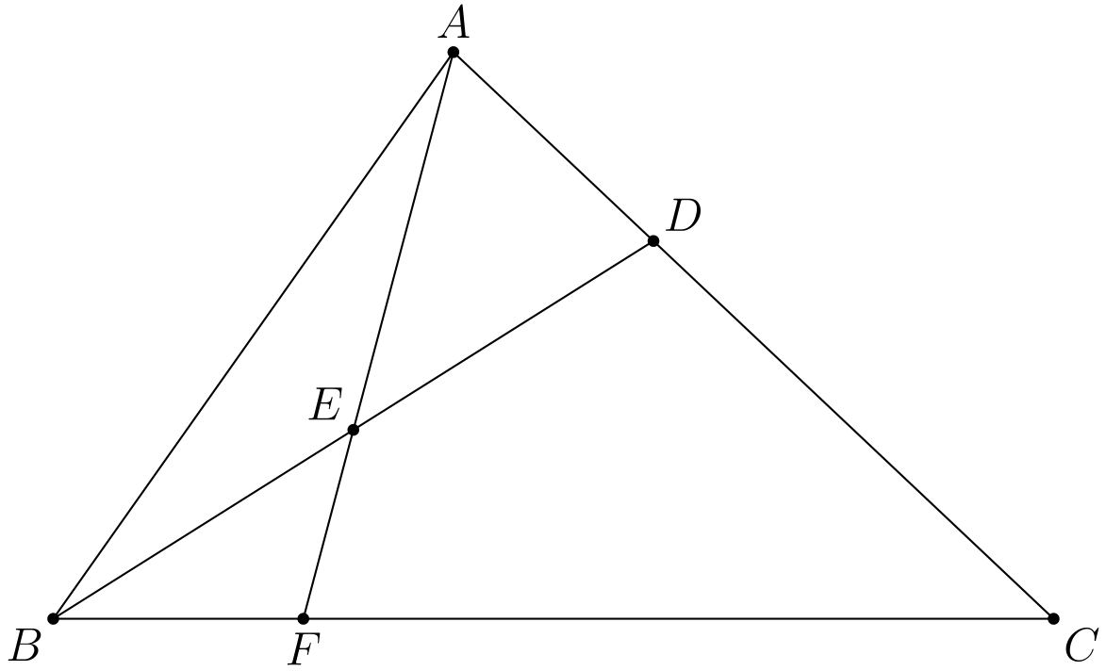
（A）24 （B）30 （C）32 （D）36 （E）40
English
In triangle ABC, point D divides side AC so that AD: DC = 1: 2. Let E be the midpoint of BD and let F be the point of intersection of line BC and line AE. Given that the area of △ ABC is 360, what is the area of △ EBF?
(A) 24 (B) 30 (C) 32 (D) 36 (E) 40
第 25 题
Alice 有 24 个苹果。她可以用多少种方式把这些苹果分给 Becky、Chris 和自己，使得三个人每人至少有两个苹果？
（A）105 （B）114 （C）190 （D）210 （E）380
English
Alice has 24 apples. In how many ways can she share them with Becky and Chris so that each of the three people has at least two apples?
(A) 105 (B) 114 (C) 190 (D) 210 (E) 380

第二部分 解答
答案速查：
题号 1 2 3 4 5 6 7 8 9
答案 D E E D B C A E B
题号 10 11 12 13 14 15 16 17 18
答案 B D A A C B D B C
题号 19 20 21 22 23 24 25
答案 C D E E B B C
答案串：DEEDBCAEBBDAACBDBCCDEEBBC
第 1 题 答案 D
买 6 个三明治需要 6 × 4.5 = 27 美元，已经不能再买一个三明治。
剩下 30 - 27 = 3 美元，可以买 3 杯汽水。商品总数为 6 + 3 = 9。
正确答案是D。
English
If they buy 6 sandwiches, they would spend 6 × 4.5 = 27 dollars. This means that they would not be able to buy any more sandwiches.
They would then have 30 - 27 = 3 dollars left. With this, they could buy 3 sodas. They would therefore buy a total of 6 + 3 = 9 items.
Thus, the correct answer isD.
第 2 题 答案 E
从图中可见，小矩形的长边等于两个短边，所以长边为 2 · 5 = 10 英尺。
大矩形的一边为 BC = 10 英尺，另一边为 DC = 10 + 5 = 15 英尺。面积为 10 · 15 = 150 平方英尺。
正确答案是E。
English
From the figure, we can see that the longer side has the same length as two of the shorter sides. This makes it 2 · 5 = 10 feet long.
This tells us that BC = 10 feet and DC = 10 + 5 = 15 feet. Therefore, the area is 10 · 15 = 150 square feet.
Thus, the correct answer isE.
第 3 题 答案 E
先把三个分数改写为同整数部分加一个分数：
15/11 = 1 + 4/11
17/13 = 1 + 4/13
19/15 = 1 + 4/15
。
分子相同的正分数，分母越大，分数越小。
因此正确顺序是
19/15 < 17/13 < 15/11。
正确答案是E。
English
We can rewrite the fraction as follows:
15/11 = 1 + 4/11
17/13 = 1 + 4/13
19/15 = 1 + 4/15.
Recall that if two fractions have the same numerator, then the fraction with the larger denominator is smaller.
Using this fact, we can see that the correct ordering is
19/15 < 17/13 < 15/11.
Thus, the correct answer isE.
第 4 题 答案 D
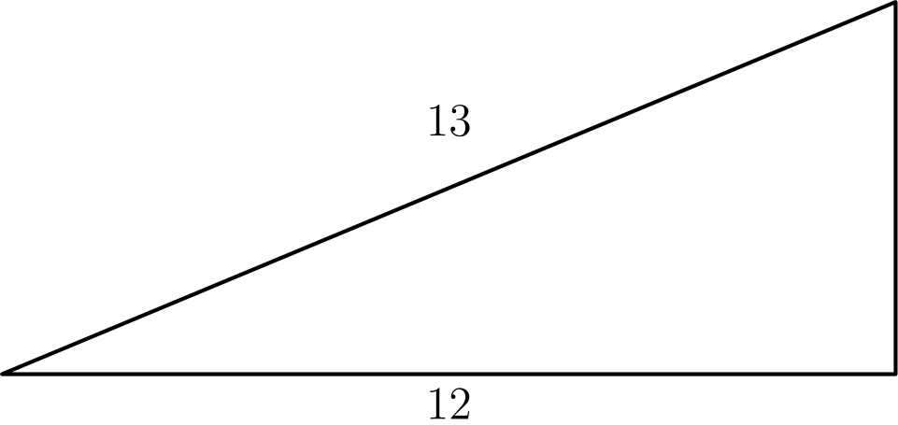
可以把菱形分成 4 个如图所示的直角三角形。
我们知道这是直角三角形，因为菱形的两条对角线互相垂直；斜边长为 52 ÷ 4 = 13。
用勾股定理，另一条直角边长为
√(13² - 12²) = √(25) = 5。
因此菱形面积为
4 · (5 · 12)/2 = 4 · 30 = 120。
正确答案是D。
English
We can split the rhombus up into 4 triangles, each of which looks like this.
We know that this is a right triangle, since the diagonals of a rhombus are perpendicular, and we know the hypotenuse is 52 ÷ 4 = 13.
Using the Pythagorean theorem, we get the other leg to be
√(13² - 12²) = √(25) = 5.
This means that the area of the rhombus is
4 · (5 · 12)/2 = 4 · 30 = 120.
Thus, the correct answer isD.
第 5 题 答案 B
兔子对应的那条路线，就是中间有一段水平线的那条，这段水平线代表兔子打盹的那段时间。
我们还知道，兔子跑到终点所用的时间比乌龟长。
这说明兔子那条路线的终点应该有更大的 x 值。符合这一点的正是图 B。
正确答案是B。
English
The hare’s path is the one with the horizontal line in the middle, which represents the period when the hare took a nap.
We also know that the time it takes the hare to reach the finish line is longer than the time it took the tortoise.
This means that the end of the hare’s path should have a larger x-value. This is exactly graph B.
Thus, the correct answer isB.
第 6 题 答案 C
正方形的对称轴只有两条对角线和两条连接对边中点的直线。
每条对称轴上有 8 个格点（不包括 P）。四条对称轴仅在 P 相交，而该点不能选取，所以共有 4 · 8 = 32 个不同的点可作为 Q。
所求概率为 32/80 = 2/5。
正确答案是C。
English
Note the only lines of symmetry for a square are the two diagonals and the two lines connecting opposite midpoints.
On each symmetry line there are 8 grid points other than P. The four lines intersect only at P, which is not eligible, so these give 4 · 8 = 32 distinct choices for Q.
The probability is therefore 32/80 = 2/5.
Thus, the correct answer isC.
第 7 题 答案 A
要让其中一次成绩尽可能低，就让另一次成绩尽可能高。假设 Shauna 第四次测试得 100 分。
这 4 次测试的总分为
76 + 94 + 87 + 100 = 357。
若五次平均分为 81，总分必须为 5 · 81 = 405，所以最后一次需要 405 - 357 = 48 分。
正确答案是A。
English
To minimize one of the scores, we have to maximize the other score. Assume that Shauna gets a 100 on her fourth test.
The sum of the 4 tests is then
76 + 94 + 87 + 100 = 357.
For an average of 81, Shauna’s test scores must add to 5 · 81 = 405. This means that she needs to get a 405 - 357 = 48 on her last test.
Thus, the correct answer isA.
第 8 题 答案 E
假设 Gilda 原来有 100 颗弹珠。给 Pedro 20 颗后，还剩 100 - 20 = 80 颗。
接着她给 Ebony 80 × 0.1 = 8 颗，还剩 80 - 8 = 72 颗。
最后她给 Jimmy 72 × 0.25 = 18 颗，还剩 72 - 18 = 54 颗，也就是原来的 54%。
正确答案是E。
English
Assume that Gilda starts off with 100 marbles. After giving 20 marbles to Pedro, she has 100 - 20 = 80 marbles left.
She then gives 80 × 0.1 = 8 marbles to Ebony, with her having 80 - 8 = 72 marbles left.
Finally, Gilda gives 72 × 0.25 = 18 marbles to Jimmy. She has a total of 72 - 18 = 54 marbles left, which is 54% of her original total.
Thus, the correct answer isE.
第 9 题 答案 B
Felicia 罐头的直径是 Alex 罐头的两倍，这说明她的罐头半径也是两倍。
圆的面积公式是 π r²。半径加倍时，底面积变为原来的四倍。
因此 Felicia 罐头的底面积是 Alex 罐头的 4 倍。
另一方面，Alex 罐头的高度是 Felicia 罐头的两倍。圆柱体积等于底面积乘高。
所以 Felicia 罐头的体积是 Alex 的 4 ÷ 2 = 2 倍。
正确答案是B。
English
Felicia’s diameter is twice as much as Alex’s which means that her radius is also twice as much.
Recall that the formula for the area of a circle is π r². If the radius is doubled, then the area is quadrupled.
This means that the base of Felicia’s can has 4 times the area as the base of Alex’s can.
We also see that Alex’s can is twice as tall as Felicia’s can. The formula for the volume of a can is base times height.
Using this formula, we see that Felicia’s can will have twice the volume of Alex’s can since 4 ÷ 2 = 2.
Thus, the correct answer isB.
第 10 题 答案 B
修正后多出 5 名参与者，所以平均数增加 5 ÷ 5 = 1。
原来的中位数是 20。把 16 换成 21 后，中位数变为 21。
所以中位数也增加 1。
正确答案是B。
English
There are 5 more participants, which means the mean is increased by 5 ÷ 5 = 1.
Right now, we can see that the median is 20. If 16 gets replaced with 21, then the median becomes 21.
This shows that the median is also increased by 1.
Thus, the correct answer isB.
第 11 题 答案 D
两门课都上的人数为
70 + 54 - 93 = 31。
用上数学课的人数减去这个数，就得到只上数学课的人数。
所求人数为 70 - 31 = 39。
正确答案是D。
English
The number of kids that are taking both classes is
70 + 54 - 93 = 31.
Subtracting this from the number of kids taking a math class will give us the number of kids taking only a math class.
The desired number is 70 - 31 = 39.
Thus, the correct answer isD.
第 12 题 答案 A
比较第一和第三个视图，可知棕色与紫色相对。
比较第一和第二个视图，可知绿色与白色相对。
剩下的颜色是水蓝色和红色，所以水蓝色与红色相对。
正确答案是A。
English
Using the first and third cubes, we can see that brown is opposite purple.
Similarly, with the first and second cubes, we see that green and white are opposites.
The only color left to pair with aqua is red, so aqua and red are opposite faces.
Thus, the correct answer isA.
第 13 题 答案 A
2 位回文数的十位和个位相同，所以都是 11 的倍数。
如果一个 3 位数是 3 个不同的 2 位回文数之和，那么它也必须是 11 的倍数。
最小的 3 位 11 的倍数且不是回文数的是 110。它可以写成 11 + 22 + 77。
因此 N = 110，数字和为 1 + 1 + 0 = 2。
正确答案是A。
English
Note that 2-digit palindromes have the tens and units digits the same. This means that they are all multiples of 11.
If a 3-digit number is the sum of 3 2-digit palindromes, then it itself must also be a multiple of 11.
The smallest 3-digit multiple of 11 that is not a palindrome is 110. This can be achieved by adding 11 + 22 + 77.
Therefore, N = 110. The sum of its digits is 1 + 1 + 0 = 2.
Thus, the correct answer isA.
第 14 题 答案 C
逐个检查选项即可。
每隔 10 天兑换一次，星期几会前进 3 天。
若第一次是星期 x，六次兑换的星期依次为 x, x+3, x+6, x+2, x+5 和 x+1（模 7）。
唯一没出现的是 x+4，所以星期日必须在第一次兑换日后四天。星期日前四天是星期三。
正确答案是C。
English
Let us go through the answer choices.
Each redemption is 10 days later, which advances the weekday by 3 days.
Starting on day x, the six redemption days are x, x+3, x+6, x+2, x+5, and x+1 modulo 7.
The only missed weekday is x+4, so Sunday must be four days after the first redemption day. Four days before Sunday is Wednesday.
Thus, the correct answer isC.
第 15 题 答案 B
概率为 2/5，表示戴帽子的人中有 2/5 也戴太阳镜。
所以两者都戴的人数为 35 · 2/5 = 14。
从戴太阳镜的五十人中随机选，选到也戴帽子的概率为 14/50 = 7/25。
正确答案是B。
English
If the probability is 2/5, that means 2/5 of the people wearing caps are also wearing sunglasses.
This means that 35 · 2/5 = 14 people are wearing both caps and sunglasses.
The probability of a person wearing sunglasses also wearing a cap is 14/50 = 7/25.
Thus, the correct answer isB.
第 16 题 答案 D
前 15 英里用时 15/30 = 1/2 小时。
设还需开 x 英里，则这段用时为 x/55 小时。
整趟路程为 15 + x 英里。平均速度为 50 英里每小时，所以总用时也等于 (x + 15)/50 小时。
令两种总用时相等，得到
1/2 + x/55 = (x + 15)/50。
交叉相乘并化简得
15 + x = 25 + 10x/11 ⇒ x = 110。
正确答案是D。
English
For the first 15 miles, Qiang drove for 15/30 = 1/2 an hour.
Let x be the distance that Qiang must drive to satisfy the condition. It will take him x/55 hours to drive this distance.
The total trip is now 15 + x miles. We know the average speed is 50 miles per hour, so this will take him (x + 15)/50 hours.
Setting the two times equal to each other, we get
1/2 + x/55 = (x + 15)/50.
Cross-multiplying and simplifying yields
15 + x = 25 + 10x/11 ⇒ x = 110.
Thus, the correct answer isD.
第 17 题 答案 B
可以把所有因子重新组合为
1/2 · ((3 · 2)/(2· 3))((4· 3)/(3· 4))
…((99· 98)/(98· 99)) · 100/99
。
由这个形式可见，中间各项全部相消，只剩
1/2 · 100/99 = 50/99。
正确答案是B。
English
We can regroup all the factors as follows.
1/2 · ((3 · 2)/(2· 3))((4· 3)/(3· 4))
…((99· 98)/(98· 99)) · 100/99
From this representation, we can see that all the middle terms cancel leaving only
1/2 · 100/99 = 50/99.
Thus, the correct answer isB.
第 18 题 答案 C
和为偶数有两种情况：两个都是偶数，或两个都是奇数。
单个骰子掷出偶数的概率为 2/6 = 1/3，掷出奇数的概率为 4/6 = 2/3。
因此所求概率为
1/3 · 1/3 + 2/3 · 2/3 = 5/9。
正确答案是C。
English
The only two ways that the sum can be even is if both rolls are even or both are odd.
The probability that a roll is even is 2/6 = 1/3, and the probability that it is odd is 4/6 = 2/3.
Therefore, the desired probability is
1/3 · 1/3 + 2/3 · 2/3 = 5/9.
Thus, the correct answer isC.
第 19 题 答案 C
每支前三名队伍与后三名队伍比赛 6 场，所以从这些比赛中最多得到 6 · 3 = 18 分。
前三名队伍之间有 3 对，因此共有 6 场比赛。每场比赛总共最多产生 3 分，所以这六场比赛给三支队伍的总分至多为 18 分。若三队最终同分，每队从中至多得到 18/3=6 分。
因此每支前三名队伍最多得到 18+6=24 分。这个上界可以达到：让每支前三名队伍赢下所有对后三名队伍的比赛，并让每对前三名队伍在两场交锋中各赢一场。这样每支前三名队伍都得到 18+6=24 分。
所以正确答案是C。
English
Each top team plays 6 games against the bottom three teams, so it can earn at most 6 · 3 = 18 points from those games.
Among the top three teams, there are 3 pairs and hence 6 games. Each game awards at most 3 points total, so these games award at most 18 points among the three teams. If their final scores are equal, each can therefore receive at most 18/3=6 of those points.
Thus each top team has at most 18+6=24 points. This bound is attainable: let every top team win all its games against the bottom teams, and for each pair of top teams let each team win one of their two games. Then each top team earns 18+6=24 points.
Thus, the correct answer isC.
第 20 题 答案 D
回顾平方差公式：
a² - b² = (a + b)(a - b)。
于是可以作如下变形：
(x² - 5)² - 4² = 0
(x² - 1)(x² - 9) = 0
因此可以看出，共有 4 个 x 的可能取值。
正确答案是D。
English
Recall that
a² - b² = (a + b)(a - b).
We can do the following rearrangement.
(x² - 5)² - 4² = 0
(x² - 1)(x² - 9) = 0
From this we can see that there are 4 possible values for x.
Thus, the correct answer isD.
第 21 题 答案 E
先求三角形的顶点。直线 y = 5 与另外两条直线的交点为 (4, 5) 和 (-4, 5)。
求第三个交点时，令两条斜线相等，得到
1 + x = 1 - x ⇒ x = 0。
所以第三个顶点是 (0, 1)。
前两个交点关于 y 轴对称，因此这个三角形是等腰三角形。
底边长为 2 · 4 = 8，高为 5 - 1 = 4。三角形面积为
1/2 · 8 · 4 = 16。
正确答案是E。
English
First, let us find the vertices of the triangle. The intersections between y = 5 and the other two lines are (4, 5) and (-4, 5).
To find the third intersection, we can equate the two equations to get
1 + x = 1 - x ⇒ x = 0.
This gives us the point (0, 1).
Note that the first two intersection points are mirrored across the y-axis. This tells us that the triangle is isosceles.
The base is therefore 2 · 4 = 8, and the height is 5 - 1 = 4. The area of the triangle is therefore
1/2 · 8 · 4 = 16.
Thus, the correct answer isE.
第 22 题 答案 E
设这个百分比写成小数为 x。涨价会把原价乘以 1 + x。
之后降价会把新价格乘以 1 - x。因此最终价格是原价乘以
(1 + x)(1 - x) = 1 - x² = 0.84。
于是
x² = 0.16 ⇒ x = 0.4。
所以这个百分比是 40%。
正确答案是E。
English
Let x be the percent converted to a real number. Then the percent increase would multiply the original by 1 + x.
The percent decrease would multiply the new price by 1 - x. The final price will then be the original price multiplied by
(1 + x)(1 - x) = 1 - x² = 0.84.
This tells us that
x² = 0.16 ⇒ x = 0.4.
This tells us that the percent would be 40%.
Thus, the correct answer isE.
第 23 题 答案 B
设总得分为 x，所求答案为 y。
由题意可得
x/4 + 2x/7 + 15 + y = x。
化简得
y + 15 = 13x/28。
我们知道 y ≤ 14，因为其余 7 名队员每人的得分不超过 2 分。
此外，x 必须是 28 的倍数。若 x = 28，则
y + 15 = 13 ⇒ y = -2，
不合要求。
若 x = 2 · 28 = 56，则
y + 15 = 26 ⇒ y = 11，
符合要求。
下一个可能的总分是 x = 84，这会得到 y = 24 > 14。更大的 28 的倍数会使 y 更大，所以 y = 11 是唯一可能值。
所以正确答案是B。
English
Let x be the total number of points and y be the desired answer.
Then from the problem statement we get that
x/4 + 2x/7 + 15 + y = x.
Simplifying yields
y + 15 = 13x/28.
We know that y ≤ 14 since none of the 7 team members scored more than 2 points.
We also know that x must be a multiple of 28. If x = 28, then we get that
y + 15 = 13 ⇒ y = -2,
which is not allowed.
If x = 2 · 28 = 56, then we have that
y + 15 = 26 ⇒ y = 11,
which works.
The next possible total is x = 84, which would give y = 24 > 14. Every larger multiple of 28 makes y still larger, so y = 11 is the only possible value.
Thus, the correct answer isB.
第 24 题 答案 B
因为 AD: DC = 1: 2，三角形 ABD 与 DBC 的面积比也是 1: 2。所以 [ABD] = 120，[DBC] = 240。
因为 E 是 BD 的中点，三角形 ABE 和 AED 的面积各为 60。设 x = [EBF]。同样有 [DEF] = x，因为 BE = ED，且两个三角形的第三个顶点都在直线 AF 上。
线段 DF 分割 △ DBC，所以 [DFC] = 240 - 2x。另外，△ ADF 和 △ DFC 的底边 AD 与 DC 在同一直线上，面积比为 1: 2。
因此
(60 + x)/(240 - 2x) = 1/2。
解得 120 + 2x = 240 - 2x，所以 x = 30。
正确答案是B。
English
Since AD: DC = 1: 2, triangles ABD and DBC have areas in the ratio 1: 2. Thus [ABD] = 120 and [DBC] = 240.
Because E is the midpoint of BD, triangles ABE and AED each have area 60. Let x = [EBF]. Then [DEF] = x as well, since BE = ED and both triangles have their third vertex on line AF.
Segment DF splits △ DBC, so [DFC] = 240 - 2x. Also, △ ADF and △ DFC have bases AD and DC on the same line, so their areas are in the ratio 1: 2.
Therefore
(60 + x)/(240 - 2x) = 1/2.
Solving gives 120 + 2x = 240 - 2x, so x = 30.
Thus, the correct answer isB.
第 25 题 答案 C
先给三个人每人 2 个苹果，剩下 24 - 3 · 2 = 18 个。
接下来我们要解方程
a + b + c = 18，
其中 a、b 和 c 分别是 Alice、Becky 和 Chris 额外得到的苹果数。
因为每人至少两个苹果的条件已经满足，所以这些变量都是非负整数。
由隔板法，方案数为
C(18 + 3 - 1, 3 - 1) = C(20, 2) = 190。
正确答案是C。
English
Let us assign everybody 2 apples. This leaves us with 24 - 3 · 2 = 18 apples.
Then, we want to solve
a + b + c = 18,
where a, b, and c are the additional apples given to Alice, Becky, and Chris.
Note that these are all nonnegative, since we already satisfied the only condition we needed to.
We can use stars and bars to get the number of solutions as
C(18 + 3 - 1, 3 - 1) = C(20, 2) = 190.
Thus, the correct answer isC.

