2018 年 AMC 8 真题与解答
American Mathematics Competitions 8 · 中英双语
共 25 题，限时 40 分钟；单项选择题，每题 1 分，答错不扣分，满分 25 分。
编排说明：第一部分为题目（先中文、后英文原题），第二部分为解答与答案，便于先做题后对答案。
第一部分 题目
第 1 题
一个游乐园收藏了全国各地建筑和景观的比例模型，比例为 1: 20。美国国会大厦高 289 英尺。这个公园中它的复制模型高多少英尺？答案四舍五入到最接近的整数。
（A）14 （B）15 （C）16 （D）18 （E）20
English
An amusement park has a collection of scale models, with a ratio of 1: 20, of buildings and other sights from around the country. The height of the United States Capitol is 289 feet. What is the height in feet of its replica at this park, rounded to the nearest whole number?
(A) 14 (B) 15 (C) 16 (D) 18 (E) 20
第 2 题
下列乘积的值是多少？
(1+1/1)·(1+1/2)
·(1+1/3)·(1+1/4)
·(1+1/5)·(1+1/6)
？
（A）7/6 （B）4/3 （C）7/2 （D）7 （E）8
English
What is the value of the product
(1+1/1)·(1+1/2)
·(1+1/3)·(1+1/4)
·(1+1/5)·(1+1/6)?
(A) 7/6 (B) 4/3 (C) 7/2 (D) 7 (E) 8
第 3 题
学生 Arn、Bob、Cyd、Dan、Eve 和 Fon 按这个顺序围成一圈。他们开始报数：Arn 先报，然后 Bob，以此类推。当一个数含有数字 7（例如 47）或者是 7 的倍数时，报到这个数的人离开圆圈，报数继续。最后留在圆圈里的是谁？
（A）Arn （B）Bob （C）Cyd （D）Dan （E）Eve
English
Students Arn, Bob, Cyd, Dan, Eve, and Fon are arranged in that order in a circle. They start counting: Arn first, then Bob, and so forth. When the number contains a 7 as a digit (such as 47) or is a multiple of 7 that person leaves the circle and the counting continues. Who is the last one present in the circle?
(A) Arn (B) Bob (C) Cyd (D) Dan (E) Eve
第 4 题
图中的十二边形画在 1 cm× 1 cm 的方格纸上。该图形的面积是多少 cm²？
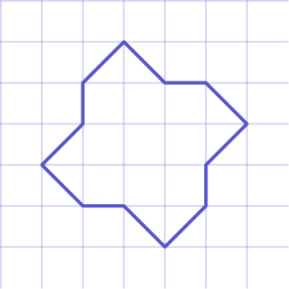
（A）12 （B）12.5 （C）13 （D）13.5 （E）14
English
The twelve-sided figure shown has been drawn on 1 cm× 1 cm graph paper. What is the area of the figure in cm²?
(A) 12 (B) 12.5 (C) 13 (D) 13.5 (E) 14
第 5 题
下列表达式的值是多少？
1+3+5+⋯+2017+2019
-2-4-6-⋯-2016-2018
？
（A）-1010 （B）-1009 （C）1008 （D）1009 （E）1010
English
What is the value of
1+3+5+⋯+2017+2019
-2-4-6-⋯-2016-2018?
(A) -1010 (B) -1009 (C) 1008 (D) 1009 (E) 1010
第 6 题
Anh 去海滩旅行时，在高速公路上行驶了 50 英里，在海边通道上行驶了 10 英里。他在高速公路上的速度是海边通道上的三倍。如果 Anh 在海边通道上开了 30 分钟，那么他的整趟行程用了多少分钟？
（A）50 （B）70 （C）80 （D）90 （E）100
English
On a trip to the beach, Anh traveled 50 miles on the highway and 10 miles on a coastal access road. He drove three times as fast on the highway as on the coastal road. If Anh spent 30 minutes driving on the coastal road, how many minutes did his entire trip take?
(A) 50 (B) 70 (C) 80 (D) 90 (E) 100
第 7 题
5 位数 2 0 1 8 U 能被 9 整除。这个数除以 8 的余数是多少？
（A）1 （B）3 （C）5 （D）6 （E）7
English
The 5-digit number 2 0 1 8 U is divisible by 9. What is the remainder when this number is divided by 8?
(A) 1 (B) 3 (C) 5 (D) 6 (E) 7
第 8 题
Garcia 老师询问健康课的学生上周有多少天至少锻炼了 30 分钟。结果汇总在下面的条形图中，柱子的高度表示学生人数。
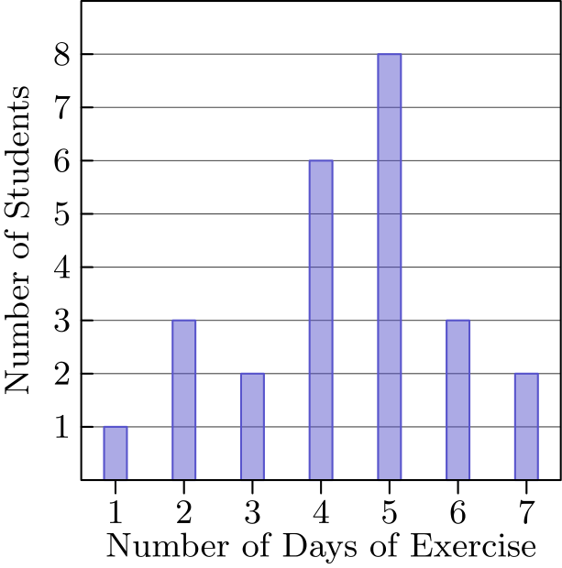
Garcia 老师班上学生报告的上周锻炼天数的平均数是多少？答案四舍五入到最接近的百分之一。
（A）3.50 （B）3.57 （C）4.36 （D）4.50 （E）5.00
English
Mr. Garcia asked the members of his health class how many days last week they exercised for at least 30 minutes. The results are summarized in the following bar graph, where the heights of the bars represent the number of students.
What was the mean number of days of exercise last week, rounded to the nearest hundredth, reported by the students in Mr. Garcia’s class?
(A) 3.50 (B) 3.57 (C) 4.36 (D) 4.50 (E) 5.00
第 9 题
Tyler 正在给他 12 英尺乘 16 英尺的客厅铺地砖。他计划沿房间边缘用一英尺乘一英尺的正方形地砖铺一圈边框，其余部分用二英尺乘二英尺的正方形地砖铺满。他一共会用多少块地砖？
（A）48 （B）87 （C）91 （D）96 （E）120
English
Tyler is tiling the floor of his 12 foot by 16 foot living room. He plans to place one-foot by one-foot square tiles to form a border along the edges of the room and to fill in the rest of the floor with two-foot by two-foot square tiles. How many tiles will he use?
(A) 48 (B) 87 (C) 91 (D) 96 (E) 120
第 10 题
一组非零数的调和平均数定义为这些数的倒数的平均数再取倒数。1、2 和 4 的调和平均数是多少？
（A）3/7 （B）7/12 （C）12/7 （D）7/4 （E）7/3
English
Theharmonic meanof a set of non-zero numbers is the reciprocal of the average of the reciprocals of the numbers. What is the harmonic mean of 1, 2, and 4?
(A) 3/7 (B) 7/12 (C) 12/7 (D) 7/4 (E) 7/3
第 11 题
Abby、Bridget 和另外四位同学将坐成两排、每排三人来拍集体照，如下图所示。
X | X | X
X | X | X

如果座位随机分配，那么 Abby 和 Bridget 在同一行或同一列相邻的概率是多少？
（A）1/3 （B）2/5 （C）7/15 （D）1/2 （E）2/3
English
Abby, Bridget, and four of their classmates will be seated in two rows of three for a group picture, as shown.
X | X | X
X | X | X

If the seating positions are assigned randomly, what is the probability that Abby and Bridget are adjacent to each other in the same row or the same column?
(A) 1/3 (B) 2/5 (C) 7/15 (D) 1/2 (E) 2/3
第 12 题
Sri 车里的钟不准，并且以恒定速度走快。某天他开始购物时，车钟和他准确的手表都显示中午 12:00 整。购物结束时，他的手表显示 12:30，车钟显示 12:35。当天晚些时候，Sri 弄丢了手表。他看车钟，显示 7:00 整。实际时间是多少？
（A）5:50 （B）6:00 （C）6:30 （D）6:55 （E）8:10
English
The clock in Sri’s car, which is not accurate, gains time at a constant rate. One day as he begins shopping he notes that his car clock and his watch (which is accurate) both say 12:00 noon. When he is done shopping, his watch says 12:30 and his car clock says 12:35. Later that day, Sri loses his watch. He looks at his car clock and it says 7:00. What is the actual time?
(A) 5:50 (B) 6:00 (C) 6:30 (D) 6:55 (E) 8:10
第 13 题
Laila 参加了五次数学测试，每次满分 100 分。每次成绩都是 0 到 100 之间的整数。她前四次测试得了相同分数，最后一次分数更高。五次测试的平均分是 82。Laila 最后一次测试的分数可能有多少个不同的值？
（A）4 （B）5 （C）9 （D）10 （E）18
English
Laila took five math tests, each worth a maximum of 100 points. Laila’s score on each test was an integer between 0 and 100, inclusive. Laila received the same score on the first four tests, and she received a higher score on the last test. Her average score on the five tests was 82. How many values are possible for Laila’s score on the last test?
(A) 4 (B) 5 (C) 9 (D) 10 (E) 18
第 14 题
设 N 是数字乘积为 120 的最大五位数。N 的各位数字之和是多少？
（A）15 （B）16 （C）17 （D）18 （E）20
English
Let N be the greatest five-digit number whose digits have a product of 120. What is the sum of the digits of N?
(A) 15 (B) 16 (C) 17 (D) 18 (E) 20
第 15 题
如下图，在两个较小圆中，每个较小圆的一条直径都是大圆的一条半径。如果两个较小圆的总面积为 1 平方单位，那么阴影区域的面积是多少平方单位？

（A）1/4 （B）1/3 （C）1/2 （D）1 （E）π/2
English
In the diagram below, a diameter of each of the two smaller circles is a radius of the larger circle. If the two smaller circles have a combined area of 1 square unit, then what is the area of the shaded region, in square units?
(A) 1/4 (B) 1/3 (C) 1/2 (D) 1 (E) π/2
第 16 题
Chang 教授有九本不同的语言书排在书架上：两本阿拉伯语书、三本德语书和四本西班牙语书。若要求阿拉伯语书放在一起，西班牙语书也放在一起，那么这九本书有多少种排列方式？
（A）1440 （B）2880 （C）5760 （D）182,440 （E）362,880
English
Professor Chang has nine different language books lined up on a bookshelf: two Arabic, three German, and four Spanish. How many ways are there to arrange the nine books on the shelf keeping the Arabic books together and keeping the Spanish books together?
(A) 1440 (B) 2880 (C) 5760 (D) 182,440 (E) 362,880
第 17 题
Bella 从自己家出发，朝朋友 Ella 家走去。与此同时，Ella 从自己家骑自行车朝 Bella 家出发。她们都保持恒定速度，Ella 骑车速度是 Bella 步行速度的 5 倍。两家相距 2 英里，即 10,560 英尺，Bella 每一步走 2 1/2 英尺。到两人相遇时，Bella 会走多少步？
（A）704 （B）845 （C）1056 （D）1760 （E）3520
English
Bella begins to walk from her house toward her friend Ella’s house. At the same time, Ella begins to ride her bicycle toward Bella’s house. They each maintain a constant speed, and Ella rides 5 times as fast as Bella walks. The distance between their houses is 2 miles, which is 10,560 feet, and Bella covers 2 1/2 feet with each step. How many steps will Bella take by the time she meets Ella?
(A) 704 (B) 845 (C) 1056 (D) 1760 (E) 3520
第 18 题
23,232 有多少个正因数？
（A）9 （B）12 （C）28 （D）36 （E）42
English
How many positive factors does 23,232 have?
(A) 9 (B) 12 (C) 28 (D) 36 (E) 42
第 19 题
在一个符号金字塔中，如果某格下面两个格子的符号相同，则该格填 “+”；如果下面两个格子的符号不同，则该格填 “-”。下图展示了一个四层符号金字塔。有多少种方法可以填最底行的四个格子，使得金字塔顶端为 “+”？
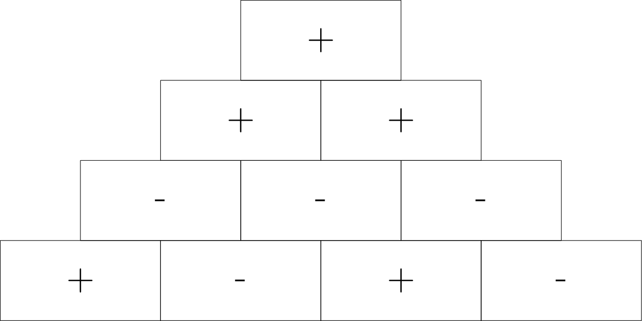
（A）2 （B）4 （C）8 （D）12 （E）16
English
In a sign pyramid a cell gets a “+” if the two cells below it have the same sign, and it gets a “-” if the two cells below it have different signs. The diagram below illustrates a sign pyramid with four levels. How many possible ways are there to fill the four cells in the bottom row to produce a “+” at the top of the pyramid?
(A) 2 (B) 4 (C) 8 (D) 12 (E) 16
第 20 题
在 △ ABC 中，点 E 在 AB 上，且 AE=1、EB=2。点 D 在 AC 上，使得 DE ∥ BC；点 F 在 BC 上，使得 EF ∥ AC。CDEF 的面积与 △ ABC 的面积之比是多少？
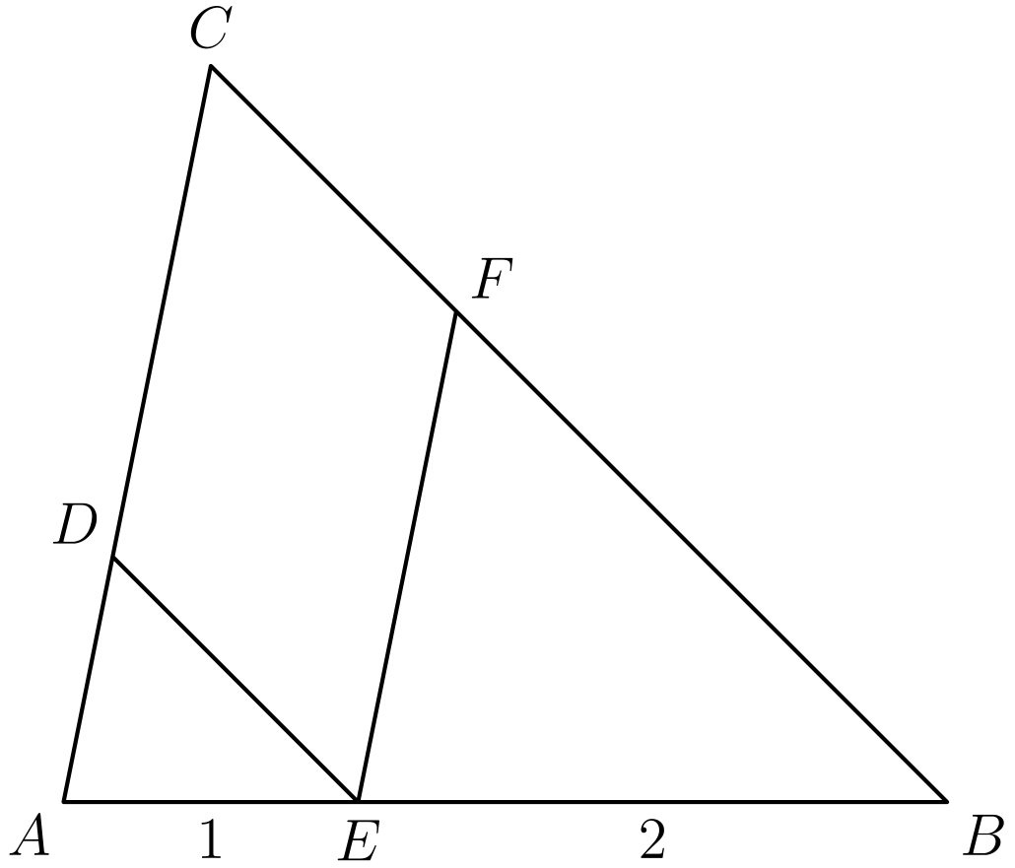
（A）4/9 （B）1/2 （C）5/9 （D）3/5 （E）2/3
English
In △ ABC, a point E is on AB with AE=1 and EB=2. Point D is on AC so that DE ∥ BC and point F is on BC so that EF ∥ AC. What is the ratio of the area of CDEF to the area of △ ABC?
(A) 4/9 (B) 1/2 (C) 5/9 (D) 3/5 (E) 2/3
第 21 题
有多少个正的三位整数，除以 6 余 2，除以 9 余 5，且除以 11 余 7？
（A）1 （B）2 （C）3 （D）4 （E）5
English
How many positive three-digit integers have a remainder of 2 when divided by 6, a remainder of 5 when divided by 9, and a remainder of 7 when divided by 11?
(A) 1 (B) 2 (C) 3 (D) 4 (E) 5
第 22 题
在正方形 ABCD 中，点 E 是边 CD 的中点。BE 与对角线 AC 相交于 F。四边形 AFED 的面积为 45。正方形 ABCD 的面积是多少？
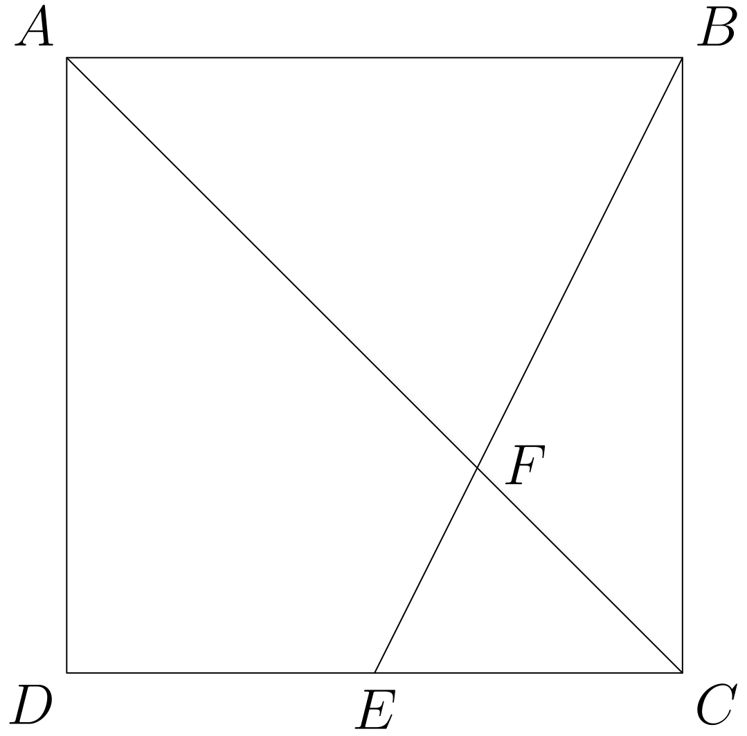
（A）100 （B）108 （C）120 （D）135 （E）144
English
Point E is the midpoint of side CD in square ABCD, and BE meets diagonal AC at F. The area of quadrilateral AFED is 45. What is the area of ABCD?
(A) 100 (B) 108 (C) 120 (D) 135 (E) 144
第 23 题
从一个正八边形中随机选择三个顶点并连接成一个三角形。这个三角形至少有一条边也是八边形的一条边的概率是多少？
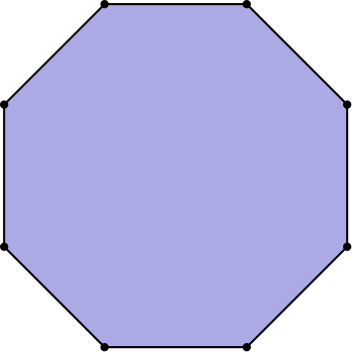
（A）2/7 （B）5/42 （C）11/14 （D）5/7 （E）6/7
English
From a regular octagon, a triangle is formed by connecting three randomly chosen vertices of the octagon. What is the probability that at least one of the sides of the triangle is also a side of the octagon?
(A) 2/7 (B) 5/42 (C) 11/14 (D) 5/7 (E) 6/7
第 24 题
在立方体 ABCDEFGH 中，C 与 E 是相对顶点，J 和 I 分别是棱 FB 和 HD 的中点。设 R 为截面 EJCI 的面积与立方体一个面的面积之比。R² 是多少？
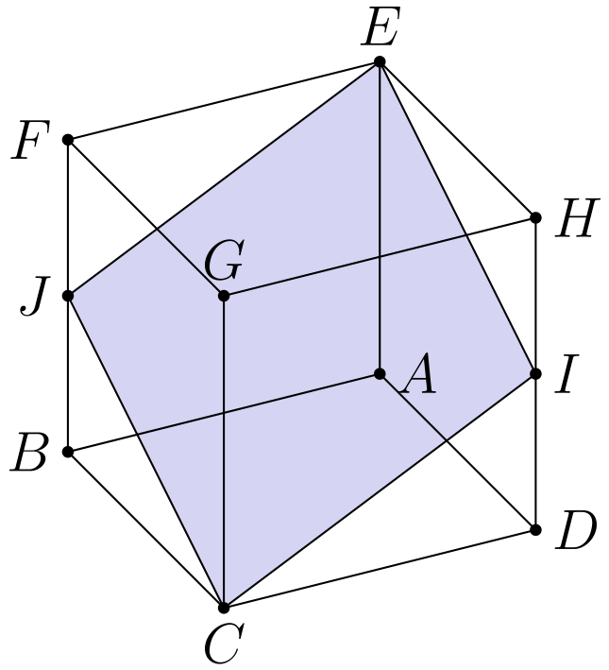
（A）5/4 （B）4/3 （C）3/2 （D）25/16 （E）9/4
English
In the cube ABCDEFGH with opposite vertices C and E, J and I are the midpoints of edges FB and HD, respectively. Let R be the ratio of the area of the cross-section EJCI to the area of one of the faces of the cube. What is R²?
(A) 5/4 (B) 4/3 (C) 3/2 (D) 25/16 (E) 9/4
第 25 题
在 2⁸+1 和 2¹⁸+1 之间（含端点）有多少个完全立方数？
（A）4 （B）9 （C）10 （D）57 （E）58
English
How many perfect cubes lie between 2⁸+1 and 2¹⁸+1, inclusive?
(A) 4 (B) 9 (C) 10 (D) 57 (E) 58

第二部分 解答
答案速查：
题号 1 2 3 4 5 6 7 8 9
答案 A D D C E C B C B
题号 10 11 12 13 14 15 16 17 18
答案 C C B A D D C A E
题号 19 20 21 22 23 24 25
答案 C A E B D C E
答案串：ADDCECBCBCCBADDCAECAEBDCE
第 1 题 答案 A
复制模型的高度是 289/20=14.45 英尺，四舍五入得到 14 英尺。
所以正确答案是A。
English
The replica is 289/20=14.45 feet tall, which rounds to 14 feet.
Thus, the correct answer isA.
第 2 题 答案 D
先注意，形如 1 + 1/n 的因子可以改写为
n/n + 1/n = n+1/n。
因此题中的乘积可以写成
(1+1/1)·(1+1/2)
·(1+1/3)·(1+1/4)
·(1+1/5)·(1+1/6)
=2/1 · 3/2 · 4/3 ·5/4 ·6/5 ·7/6
=7
所以正确答案是D。
English
Let’s first note that if we are given an expression of the form 1 + 1/n, we can rewrite this as
n/n + 1/n = n+1/n.
With that in mind, we can rewrite the expression given to us in the problem, as shown below:
(1+1/1)·(1+1/2)
·(1+1/3)·(1+1/4)
·(1+1/5)·(1+1/6)
=2/1 · 3/2 · 4/3 ·5/4 ·6/5 ·7/6
=7
Thus, the correct answer isD.
第 3 题 答案 D
最先会让人离开的五个数是 7,14,17,21,27。只跟踪这些轮次即可。
Arn 报到 7，Cyd 报到 14，Fon 报到 17，Bob 报到 21，Eve 报到 27。
Dan 是唯一留在圆圈里的学生，所以正确答案是D。
English
The first five removal numbers are 7,14,17,21,27. Tracking only those turns gives:
Arn says 7, Cyd says 14, Fon says 17, Bob says 21, and Eve says 27.
Dan is the only student remaining, soDis the correct answer.
第 4 题 答案 C
如图所示，可以把图形分解：
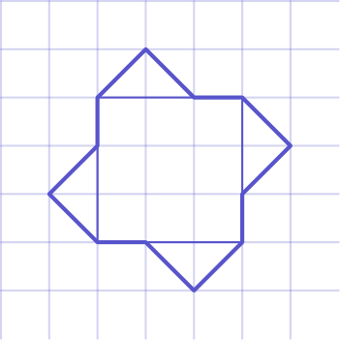
现在可以看出，中间是一个 3 × 3 正方形，周围有 4 个较小的阴影三角形。
正方形面积为 3 · 3 = 9。每个小三角形的底为 2，高为 1，所以面积为
bh/2 = (2· 1)/2 =1。
这样的三角形有 4 个，所以它们的总面积为 1· 4 = 4。
因此总面积是 9+4 = 13。
所以正确答案是C。
English
To solve for the area of the figure, we separate the compound shape into parts that are easier to work with, as such:
As is now clear, there is the center 3 × 3 square, with 4 smaller shaded triangles surrounding it.
The area of the square is 3 · 3 = 9. The other triangles each have a base of 2 and a height of 1, so their area is equal to
bh/2 = (2· 1)/2 =1.
There are 4 of these triangles, so their total area is 1· 4 = 4.
Therefore, the total area is 9+4 = 13.
Thus, the correct answer isC.
第 5 题 答案 E
重新分组可得
1 + (3-2) + (5-4) + ⋯ +
(2017-2016) + (2019-2018)
。
每一项都等于 1，而这样的项共有 2019-1/2+1 = 1010 项，所以总和为 1010·1 = 1010。
所以正确答案是E。
English
Rearranging the terms, notice that the expression in the question is equal to:
1 + (3-2) + (5-4) + ⋯ +
(2017-2016) + (2019-2018).
Each term is equal to 1, and there are 2019-1/2+1 = 1010 terms, so the total sum is 1010·1 = 1010.
Thus,Eis the correct answer.
第 6 题 答案 C
Anh 在海边通道上开了 10 英里，用了 30 分钟。因此海边通道速度（记为 v_(c)）是
v_(c)=10/30
=1/3
，
也就是每分钟 1/3 英里。因为他在高速公路上的速度是 3 倍，也就是 vₕ=3v_(c)，所以高速公路速度为
3· 1/3 = 1
英里每分钟。他在海边通道上开了 30 分钟，在高速公路上开了 50 英里，速度为每分钟 1 英里，所以这 50 英里需要 50 分钟。
因此总行程时间为 50+30=80 分钟。
所以正确答案是C。
English
Anh drove 10 miles on the coastal road in 30 minutes. Therefore, his speed on the coastal road (notated as v_(c)) is
v_(c)=10/30
=1/3.
This is 1/3 mile per minute. Since he drives 3 times as fast on the highway (i.e. vₕ=3v_(c)), his highway speed is
3· 1/3 = 1
mile per minute. Armed with these two facts, we know that Anh drove for 30 minutes on the coastal road, and he drove 50 miles at 1 mile per minute. This means it takes 50 minutes to drive the 50 miles on the highway.
As such, the total travel time is 50+30=80 minutes.
Thus, the correct answer isC.
第 7 题 答案 B
注意，一个数能被 9 整除，当且仅当它的各位数字之和也能被 9 整除。
题中这个 5 位数的数字和为
2+0+1+8+U= 11+U。
因为 2 0 1 8 U 能被 9 整除，11+U 也必须被 9 整除。又因为 U 是一位数字，0≤ U≤ 9，所以 U 只能是 7。
现在可知这个 5 位数是 20187，而我们要求 20187 除以 8 的余数。长除法给出 20187=2523· 8 + 3，所以余数是 3。
所以正确答案是B。
English
Notice that a number is divisible by 9 if and only if the sum of its digits is also divisible by 9.
The sum of the digits of the 5-digit number in the problem is:
2+0+1+8+U= 11+U.
As 2 0 1 8 U is divisible by 9, 11+U must also be divisible by 9. Also, as U is a digit, we know that 0≤ U≤ 9. This means that U can only be 7.
Now we know that the 5-digit number in question is 20187, and we want to find the remainder when we divide 20187 by 8. To solve this, simply use long division to see that 20187=2523· 8 + 3. Therefore, the remainder is 3.
Thus, the correct answer isB.
第 8 题 答案 C
从条形图可知，锻炼 1,2,3,4,5,6,7 天的学生人数依次为 1,3,2,6,8,3,2，学生总数为 25。
学生报告的锻炼天数总和为
1·1+2·3+3·2+4·6
+5·8+6·3+7·2=109
。
平均数为 109/25=4.36 天。
所以正确答案是C。
English
The bar heights for 1,2,3,4,5,6,7 days are 1,3,2,6,8,3,2, for a total of 25 students.
The total number of reported exercise days is
1·1+2·3+3·2+4·6
+5·8+6·3+7·2=109.
The mean is 109/25=4.36 days.
Thus,Cis the correct answer.
第 9 题 答案 B
注意边框每平方英尺需要一块地砖，所以四边相加会得到 16+12+16+12=56 块。不过这样四个角各重复计算了一次，所以要减去 4。因此边框共需要 56-4=52 块 1× 1 正方形地砖。
由于每边都去掉了一英尺宽的边框，剩下的内部矩形为 10 英尺乘 14 英尺。它要完全铺上 2 × 2 的地砖，所以这部分需要
(10·14)/(2·2) = 35
块地砖。
边框需要 52 块 1× 1 地砖，内部需要 35 块 2× 2 地砖，因此一共需要 52+35=87 块地砖。
所以正确答案是B。
English
Note that each square foot of the border would require one tile, meaning that the border will take 16+12+16+12=56 tiles. However, notice that this will cause overlapping tiles in each of the four corners, so to fix this, we subtract 4. Therefore, the border will take 56-4=52 1× 1 square tiles to completely tile.
Since we have removed one foot from each side due to the border, the remaining rectangle is 10 feet by 14 feet. This must be tiled completely by 2 × 2 tiles, so it will take
(10·14)/(2·2) = 35
tiles in total to tile this area.
As it takes 52 1× 1 square tiles to tile the border, and 35 2× 2 square tiles to tile the remaining area, it will take 52+35=87 tiles in total to fill in Tyler’s entire living room floor.
Thus, the correct answer isB.
第 10 题 答案 C
1、2 和 4 的倒数分别是 1/1、1/2 和 1/4。它们的平均数为
((1 + 1/2 + 1/4))/3 = ((7/4))/3
= 7/12
。
调和平均数是这些倒数的平均数的倒数；刚才算出的平均数是 7/12，所以调和平均数为 12/7。
正确答案是C。
English
The reciprocals of 1, 2, and 4 are 1/1, 1/2, and 1/4, respectively. The average of these reciprocals is
((1 + 1/2 + 1/4))/3 = ((7/4))/3
= 7/12.
As the harmonic mean is the reciprocal of the average of the reciprocals of the numbers (which we just calculated to be 7/12), we conclude that the harmonic mean is 12/7.
Thus, the correct answer isC.
第 11 题 答案 C
把情况分成两类：第 1 类是 Abby 坐在中间列的两个座位之一，第 2 类是她坐在外侧的 4 个座位之一。
Abby 坐在中间列的概率是 2/6 = 1/3，这就是第 1 类。此时 Bridget 要与 Abby 相邻，可以坐在 Abby 左右两个座位中的一个，或者坐在同一列的座位，共有 3 个可选位置；剩下共有 5 个空位，所以条件概率是 3/5。因此这一类的概率为
1/3 · 3/5 = 3/15。
Abby 坐在外侧的概率是 4/6 = 2/3，这就是第 2 类。此时 Bridget 要与 Abby 相邻，只能坐在同一行相邻的那个座位，或同一列的座位，共有 2 个可选位置；剩下仍有 5 个空位，所以条件概率是 2/5。因此这一类的概率为
2/3 · 2/5 = 4/15。
因此任一类发生的总概率为 3/15 + 4/15 = 7/15 。
所以正确答案是C。
English
We can split the problem into two cases. In case 1, Abby is in one of the middle two seats, and in case 2, she is in one of the outer 4 seats.
Firstly notice that there is a 2/6 = 1/3 probability of case 1 being true (i.e. Abby is in the middle two seats). For Bridget to be adjacent to Abby in this case, she must be in either of the two seats beside Abby in the same row, or she is in the same column as her. There are 3 ways to make this happen out of a possible 5 open seats, so there is a 3/5 chance of this happening. Therefore, the total probability of this case is
1/3 · 3/5 = 3/15.
Next, notice that there is a 4/6 = 2/3 probability of case 2 being true (i.e. Abby is in the outer four seats). For Bridget to be adjacent to Abby in this case, she must either be in the single seat next to Abby in the same row, or she is in the same column as Abby. There are 2 ways to make this happen out of a possible 5 open seats, so there is a 2/5 chance of this happening. Therefore, the total probability of this case is
2/3 · 2/5 = 4/15.
Therefore, the final probability ofeitherof these cases happening is 3/15 + 4/15 = 7/15.
Thus,Cis the correct answer.
第 12 题 答案 B
从 12:00 中午开始，真实经过 30 分钟时，车钟走快到经过了 35 分钟。
因此车钟每走一分钟，真实时间经过 30/35 = 6/7 分钟。从 12:00 到 7:00，车钟走了 7· 60 = 420 分钟，所以真实时间经过了 420 · 6/7 = 360 分钟，也就是 6 小时。从 12:00 开始经过 6 小时，实际时间是 6:00 。
所以正确答案是B。
English
Starting from 12:00 noon, after 30 minutes of time elapsed, the car clock went 35 minutes ahead.
Therefore, for every minute the car clock goes ahead, 30/35 = 6/7 minutes of actual time pass by. From the time 12:00 to 7:00, the car clock goes ahead 7· 60 = 420 minutes, and therefore, 420 · 6/7 = 360 minutes, or 6 hours, of actual time have passed by. If we start at 12:00 and 6 hours pass by, the time is 6:00.
Thus,Bis the correct answer.
第 13 题 答案 A
因为五次测试平均分是 82，所以五次总分为 5·82 = 410 。
设 f 为前 4 次测试的分数，l 为最后一次测试的分数。
我们知道
f < l ≤ 100
且
4f + l = 410。
又因为 410 = 4f + l < 5l ，所以 410/5 = 82 < l 。
另外，由于 4f + l = 410 ，而 410 除以 4 的余数是 2，所以 l 除以 4 也必须余 2，因为 4f 除以 4 没有余数。等价地，
l ≡ 2 mod 4。
因为 82 < l ≤ 100 且 l ≡ 2 mod 4，所以 l 只能是 86,90,94,98。这给出四组不同的解：
(f,l) = (81,86);
(80,90);
(79,94);
(78,98)
因此共有 4 种可能，正确答案是A。
English
Since the average score on the five tests is 82, the total score of those five tests must be 5·82 = 410.
Now, let f be the score on the first 4 tests and let l be the score for the last test.
We know that
f < l ≤ 100
and
4f + l = 410.
And as 410 = 4f + l < 5l, we know 410/5 = 82 < l.
Also, since 4f + l = 410, and dividing 410 by 4 gives us a remainder of 2, we know that dividing l by 4 must leave a remainder of 2 as 4f will leave no remainder when divided by 4. Equivalently:
l ≡ 2 mod 4.
Since 82 < l ≤ 100 and l ≡ 2 mod 4, the only options for l are 86,90,94,98. This yields four distinct solutions as follows:
(f,l) = (81,86);
(80,90);
(79,94);
(78,98)
Therefore, there are 4 solutions, andAis the correct answer.
第 14 题 答案 D
为了使 5 位数最大，必须先让第一位，也就是万位，尽可能大。
小于 10 且能整除 120 的最大数字是 8，所以第一位必须是 8。剩下各位数字的乘积为 15。
同样地，现在要让第二位尽可能大。
小于 10 且能整除 15 的最大数字是 5，所以第二位是 5。剩下各位数字的乘积为 3。
接着让第三位尽可能大。
小于 10 且能整除 3 的最大数字是 3，所以第三位是 3。剩下的乘积是 1，这说明第 4 位和第 5 位都是 1。
于是 N = 85311，各位数字之和为
8+5+3+1+1=18
所以正确答案是D。
English
To make the largest possible 5 digit number, we must maximize the first digit (the digit in the ten-thousands place).
The largest number that is strictly less than 10 and divides 120 is 8, so the first digit must be 8. Therefore, the product of the remaining number is 15.
Similarly, we must now maximize the second digit.
The largest number that is less than 10 and divides 15 is 5, so the second digit is 5. Therefore, the product of the remaining number is 3.
We must then maximize the third digit.
The largest number that is less than 10 and divides 3 is 3, so the third digit is 3. Therefore, the product of the remaining number is 1. This means the 4th and 5th digits are 1.
This makes N = 85311, so the sum of the digits is
8+5+3+1+1=18
Thus,Dis the correct answer.
第 15 题 答案 D
设大圆面积为 A。
每个小圆的直径等于大圆半径，所以每个小圆的半径是大圆半径的一半。
用符号表示，若大圆半径为 rₗ，每个小圆半径为 rₛ，则
rₛ = 1/2 rₗ
因为大圆面积为 A=π rₗ²，所以每个小圆面积为
π rₛ² = π (1/2 rₗ)²
= 1/4 (π rₗ²)
=1/4 A
。
两个小圆总面积为 1 平方单位，于是 2· 1/4 A=1 平方单位，所以 A=2 平方单位。
阴影面积等于大圆面积 (A) 减去两个小圆的总面积 (1)，所以阴影面积为 A - 1=2-1=1 平方单位。
所以正确答案是D。
English
Let A be the area of the large circle.
Since the diameter of each of the two smaller circles is itself the radius of the larger circle, the radius of each smaller circle is half that of the larger circle.
Symbolically, if we allow rₗ to be the radius of the large circle and rₛ to be the radius of each of the smaller circles:
rₛ = 1/2 rₗ
As the area of the larger circle is equal to A=π rₗ², the area of the smaller circles are equal to
π rₛ² = π (1/2 rₗ)²
= 1/4 (π rₗ²)
=1/4 A.
As the area of two of these smaller circles combined is equal to 1 square unit, then it follows that 2· 1/4 A=1 square unit, implying that A=2 square units.
As the area of the shaded region is equal to the area of the larger circle (A) minus the combined area of the two smaller circles (1), the area of the shaded region is A - 1=2-1=1 square unit.
Thus, the correct answer isD
第 16 题 答案 C
把两本阿拉伯语书作为一个块，四本西班牙语书作为一个块。
此时共有 5 个对象：三本德语书、一个阿拉伯语书块、一个西班牙语书块。可用 5! 种方式排列这 5 个对象。阿拉伯语书块内部有 2! 种排列，西班牙语书块内部有 4! 种排列，所以总排列数为
5! · 4! · 2! = 120 · 24 · 2
= 5760
所以正确答案是C。
English
Since we are keeping the Arabic books together and the Spanish books together, we can look at each group as a single block.
As such, there are 5 objects on the bookshelf: three German books, one collection of Arabic books, and one collection of Spanish books. There are 5! ways to order the 5 objects. As we already have the books together, there are 2! ways of ordering the Arabic books and 4! ways of ordering the Spanish books. Therefore, the total ways to order the books is
5! · 4! · 2! = 120 · 24 · 2
= 5760
Thus, the correct answer isC.
第 17 题 答案 A
Ella 每骑 5 英尺，Bella 走一英尺，所以相遇时 Bella 走了两家距离的 1/6。因此 Bella 走了
1/6 · 10560=1760
英尺。因为她每步走 2.5 英尺，到相遇时她走了
1760/2.5 = 704
步。
所以正确答案是A。
English
Since for every foot Bella walks, Ella rides 5 feet, we know that Bella will walk 1/6 of the distance between the two houses, and so she walks
1/6 · 10560=1760
feet. Since she walks 2.5 feet per step, she takes
1760/2.5 = 704
steps by the time she meets Ella.
Thus,Ais the correct answer.
第 18 题 答案 E
质因数分解为 23,232=2⁶·3·11²。构造正因数时，指数可以从 0 到 6（对应质因数 2）、从 0 到 1（对应 3）、从 0 到 2（对应 11）中选择。因此正因数的个数为 (6+1)(1+1)(2+1)=42。
所以正确答案是E。
English
The prime factorization is 23,232=2⁶·3·11². A divisor may use any exponent from 0 through 6 on 2, from 0 through 1 on 3, and from 0 through 2 on 11. Therefore, the number of positive divisors is (6+1)(1+1)(2+1)=42.
Thus,Eis the correct answer.
第 19 题 答案 C
设有两个相邻的下方格子和它们上方的格子。如果已知左下格和上方格，就总能确定右下格：
如果上方格是 +，则右下格必须与左下格相同；如果上方格是 -，则右下格必须与左下格相反。
现在假设已知某一行。只要选择这一行最左格左下方的那个格子的符号，就能依次确定下一整行。
因此，顶行已知为 + 时，下一行有 2 种选择；同理，第三行有 2 种选择，第四行也有 2 种选择。底行共有 2·2·2=8 种可能。
所以正确答案是C。
English
Suppose we have two cells and the cell above them. If we are given the bottom left cell and the top cell, we can always find the bottom right cell as follows:
If the top cell is +, then the bottom right cell must be the same as the bottom left cell, and if the top cell is -, the bottom right cell must be the opposite of the bottom left cell.
Now, suppose we are given a row. Then, suppose we choose a value for the cell below and to the left of the leftmost cell in our given row. We then can inductively determine the entire row below our given by first finding the bottom-right cell of the leftmost cell in our row, and using that newly found cell as the bottom-left reference for the second to the left cell in the given row to find its bottom-right counterpart. The process continues on until the row below the given row is fully solved.
Therefore, since we know that the top row has a cell labelled +, we have 2 choices for the row below, depending on our choice of the bottom-left cell. Similarly, we have 2 choices for the third row, and thus 2 choices for the fourth row. This makes 2·2·2=8 total choices for the bottom row of the sign pyramid.
Thus, the correct answer isC.
第 20 题 答案 A
设 △ ABC 的面积为 t。由于 DE ∥ BC 且 FE ∥ CA ，可得
ADE ∼ ABC
以及
EFB ∼ ABC。
因为 AE = AB/3，所以 ADE 的面积为 (1/3)² t = t/9 。因为 EB = 2AB/3，所以 EFB 的面积为 (2/3)² t = 4/9t 。最后，要找 CDEF 的面积，就从 ABC =t 中减去 ADE 和 EFB 的面积，即
t- t/9 - 4t/9 = 4t/9。
因此 CDEF 与 ABC 的面积比为 ((4t/9))/t = 4/9 。
所以正确答案是A。
English
Let the area of △ ABC be equal to t. Since DE ∥ BC and FE ∥ CA, we can deduce that
ADE ∼ ABC
and
EFB ∼ ABC.
Since AE = AB/3, the area of ADE is equal to (1/3)² t = t/9. Since EB = 2AB/3, the area of EFB is equal to (2/3)² t = 4/9t. Finally, to find the area of CDEF, we take the area of ABC =t and subtract the areas of ADE and EFB. This is equivalent to the expression
t- t/9 - 4t/9 = 4t/9.
Therefore, the ratio of the area of CDEF and ABC is ((4t/9))/t = 4/9.
Thus,Ais the correct answer.
第 21 题 答案 E
每个所给余数都比相应除数小 4，所以 x+4 必须同时被 6,9 和 11 整除。因此 x+4 是 lcm(6,9,11)=198 的倍数。
因为 x 是三位数，所以 104≤ x+4≤1003。这个区间内 198 的倍数是 198,396,594,792,990，因此共有 5 个符合条件的整数。
正确答案是E。
English
Each required remainder is 4 less than its divisor, so x+4 must be divisible by 6,9, and 11. Hence x+4 is a multiple of lcm(6,9,11)=198.
For a three-digit x, we have 104≤ x+4≤1003. The multiples of 198 in this interval are 198,396,594,792,990, giving 5 possible integers.
Thus,Eis the correct answer.
第 22 题 答案 B
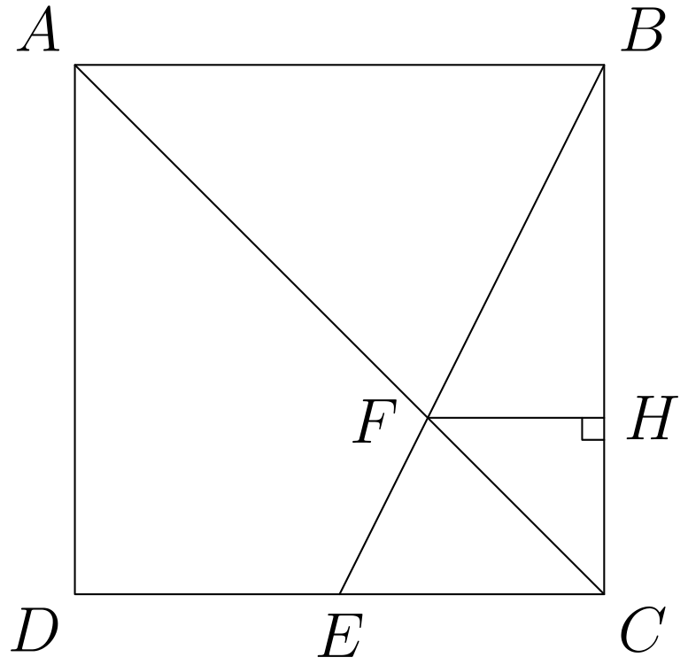
设正方形边长为 s，并设 H 是从 F 向 BC 作垂线的垂足。直角三角形 CAB 与 CFH 相似，所以 CH=FH。另外，三角形 BFH 与 BEC 相似，因此
FH/EC=BH/BC。
因为 EC=s/2、BC=s，且 BH=s-CH=s-FH，所以 2FH/s=1-FH/s，从而 FH=CH=s/3。
因此，三角形 EFC 的底为 EC=s/2，高为 CH=s/3，所以面积为 s²/12。于是
[AFED]=[△ ACD]-[△ EFC]
=s²/2-s²/12
=5s²/12
。
因为这个面积是 45，所以 s²=108，这就是正方形的面积。
English
Let the square have side length s, and let H be the foot of the perpendicular from F to BC. The right triangles CAB and CFH are similar, so CH=FH. Also, triangles BFH and BEC are similar, giving
FH/EC=BH/BC.
Since EC=s/2, BC=s, and BH=s-CH=s-FH, this becomes 2FH/s=1-FH/s, so FH=CH=s/3.
Thus triangle EFC has base EC=s/2 and height CH=s/3, so its area is s²/12. Therefore
[AFED]=[△ ACD]-[△ EFC]
=s²/2-s²/12
=5s²/12.
Since this area is 45, we get s²=108, the area of the square.
第 23 题 答案 D
用补集计数：计算任意两个所选顶点都不相邻的三角形。从一个所选顶点出发，设三个间隔中未选顶点的正整数个数为 x,y,z。那么 x+y+z=5，共有 C(4, 2)=6 个正整数解。
起点有 8 种选择，而每个三角形会从它的 3 个顶点各被计算一次，所以补集中有 (8·6)/3=16 个三角形。全部三角形共有 C(8, 3)=56 个，因此所求概率是 1-16/56=5/7。
所以正确答案是D。
English
Count the complement: triangles with no two chosen vertices adjacent. Starting at a chosen vertex, let x,y,z be the positive numbers of unchosen vertices in the three gaps. Then x+y+z=5, which has C(4, 2)=6 positive solutions.
There are 8 choices for the starting vertex, and each triangle is counted from each of its 3 vertices, so the complement contains (8·6)/3=16 triangles. Out of C(8, 3)=56 total triangles, the desired probability is 1-16/56=5/7.
Thus,Dis the correct answer.
第 24 题 答案 C
设立方体边长为 s。注意截面四边形每条边长度相同，所以 EJCI 是菱形。菱形面积等于两条对角线乘积的一半，因此它的面积为 1/2 IJ· CE。由勾股定理，
IJ=FH=s√(2)。
再次使用勾股定理可得
CE=√(AC²+AE²)
=√((s√(2))²+s²)
=√(2s²+s²)
=s√(3)
因此
R=(1/2 IJ· CE)/s²
=(1/2 s²√(2)√(3))/s²
=√(3/2)
所以 R²=3/2，正确答案是C。
English
Allow s to represent the length of an edge of the cube. Noting that each side of the cross section is equal in length, we conclude that EJCI is a rhombus. The area of this rhombus can be calculated as 1/2 IJ· CE, as the area of a rhombus is equal to half the product of its diagonals. Using the Pythagorean Theorem:
IJ=FH=s√(2).
Similarly, using the Pythagorean Theorem again lets us see that:
CE=√(AC²+AE²)
=√((s√(2))²+s²)
=√(2s²+s²)
=s√(3)
Therefore,
R=(1/2 IJ· CE)/s²
=(1/2 s²√(2)√(3))/s²
=√(3/2)
Thus, R²=3/2, and the correct answer isC.
第 25 题 答案 E
因为 6³=216<257，且 257<343=7³，区间内最小的完全立方数是 7³。又因为 64³=2¹⁸<2¹⁸+1<65³，最大的完全立方数是 64³。
所以整数立方根为 7,8,…,64，共有 64-7+1=58 个。
所以正确答案是E。
English
Because 6³=216<257 and 257<343=7³, the smallest cube in the interval is 7³. Also, 64³=2¹⁸<2¹⁸+1<65³, so the largest cube is 64³.
The integer cube roots are therefore 7,8,…,64, a total of 64-7+1=58.
Thus,Eis the correct answer.

