2017 年 AMC 8 真题与解答
American Mathematics Competitions 8 · 中英双语
共 25 题，限时 40 分钟；单项选择题，每题 1 分，答错不扣分，满分 25 分。
编排说明：第一部分为题目（先中文、后英文原题），第二部分为解答与答案，便于先做题后对答案。
第一部分 题目
第 1 题
下列哪个值最大？
（A）2+0+1+7 （B）2 × 0 +1+7 （C）2+0 × 1 + 7 （D）2+0+1 × 7 （E）2 × 0 × 1 × 7
English
Which of the following values is largest?
(A) 2+0+1+7 (B) 2 × 0 +1+7 (C) 2+0 × 1 + 7 (D) 2+0+1 × 7 (E) 2 × 0 × 1 × 7
第 2 题
艾丽西亚、布伦达和科尔比是最近一次学生会主席选举的候选人。下方饼图显示了三位候选人的得票分布。如果布伦达得到 36 票，那么总共投出了多少票？
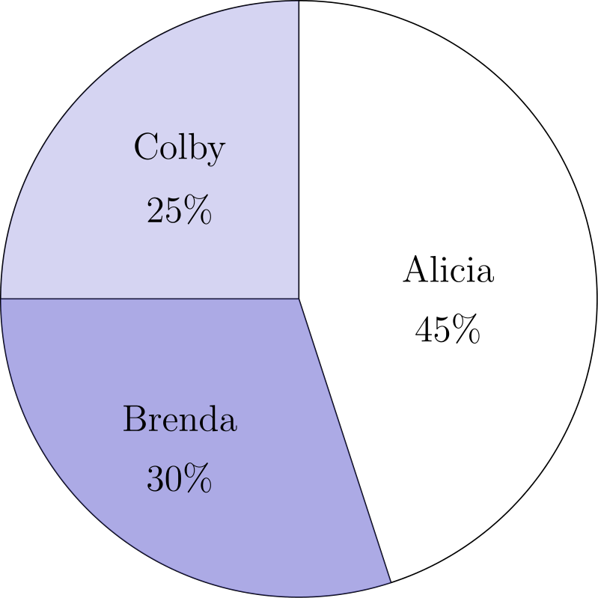
（A）70 （B）84 （C）100 （D）106 （E）120
English
Alicia, Brenda, and Colby were the candidates in a recent election for student president. The pie chart below shows how the votes were distributed among the three candidates. If Brenda received 36 votes, then how many votes were cast all together?
(A) 70 (B) 84 (C) 100 (D) 106 (E) 120
第 3 题
表达式 √(16√(8√(4))) 的值是多少？
（A）4 （B）4√(2) （C）8 （D）8√(2) （E）16
English
What is the value of the expression √(16√(8√(4)))?
(A) 4 (B) 4√(2) (C) 8 (D) 8√(2) (E) 16
第 4 题
0.000315 乘以 7,928,564 的乘积最接近下列哪一个数？
（A）210 （B）240 （C）2,100 （D）2,400 （E）24,000
English
When 0.000315 is multiplied by 7,928,564 the product is closest to which of the following?
(A) 210 (B) 240 (C) 2,100 (D) 2,400 (E) 24,000
第 5 题
下面这个表达式的值是多少
(1 · 2 · 3 · 4 · 5 · 6 · 7 · 8)/1+2+3+4+5+6+7+8？
（A）1020 （B）1120 （C）1220 （D）2240 （E）3360
English
What is the value of the expression
(1 · 2 · 3 · 4 · 5 · 6 · 7 · 8)/1+2+3+4+5+6+7+8?
(A) 1020 (B) 1120 (C) 1220 (D) 2240 (E) 3360
第 6 题
如果一个三角形的角度之比为 3:3:4，那么这个三角形最大角的度数是多少？
（A）18 （B）36 （C）60 （D）72 （E）90
English
If the degree measures of the angles of a triangle are in the ratio 3:3:4, what is the degree measure of the largest angle of the triangle?
(A) 18 (B) 36 (C) 60 (D) 72 (E) 90
第 7 题
设 Z 是一个 6 位正整数，例如 247247，其前三位数字与后三位数字按相同顺序完全相同。下列哪个数一定是 Z 的因数？
（A）11 （B）19 （C）101 （D）111 （E）1111
English
Let Z be a 6-digit positive integer, such as 247247, whose first three digits are the same as its last three digits taken in the same order. Which of the following numbers must be a factor of Z?
(A) 11 (B) 19 (C) 101 (D) 111 (E) 1111
第 8 题
马尔科姆今天放学后想去伊莎贝拉家。他知道她住在哪条街，但不知道门牌号。她告诉他：“我的门牌号是两位数，并且下列四个陈述中恰好有三个是真的。”
(1) 它是质数。
(2) 它是偶数。
(3) 它能被 7 整除。
(4) 它的一个数字是 9。
这些信息足以让马尔科姆确定伊莎贝拉的门牌号。它的个位数字是多少？
（A）4 （B）6 （C）7 （D）8 （E）9
English
Malcolm wants to visit Isabella after school today and knows the street where she lives but doesn’t know her house number. She tells him, “My house number has two digits, and exactly three of the following four statements about it are true.”
(1) It is prime.
(2) It is even.
(3) It is divisible by 7.
(4) One of its digits is 9.
This information allows Malcolm to determine Isabella’s house number. What is its units digit?
(A) 4 (B) 6 (C) 7 (D) 8 (E) 9
第 9 题
玛茜的所有弹珠都是蓝色、红色、绿色或黄色。她的弹珠中三分之一是蓝色，四分之一是红色，且有六颗绿色弹珠。玛茜最少可能有多少颗黄色弹珠？
（A）1 （B）2 （C）3 （D）4 （E）5
English
All of Marcy’s marbles are blue, red, green, or yellow. One third of her marbles are blue, one fourth of them are red, and six of them are green. What is the smallest number of yellow marbles that Marcy could have?
(A) 1 (B) 2 (C) 3 (D) 4 (E) 5
第 10 题
一个盒子中有五张卡片，编号为 1、2、3、4 和 5。从盒中随机不放回地选出三张卡片。所选卡片中的最大值为 4 的概率是多少？
（A）1/10 （B）1/5 （C）3/10 （D）2/5 （E）1/2
English
A box contains five cards, numbered 1, 2, 3, 4, and 5. Three cards are selected randomly without replacement from the box. What is the probability that 4 is the largest value selected?
(A) 1/10 (B) 1/5 (C) 3/10 (D) 2/5 (E) 1/2
第 11 题
一个正方形地板由全等的正方形瓷砖铺成。如果位于两条对角线上的瓷砖总数是 37，那么铺满地板共有多少块瓷砖？
（A）148 （B）324 （C）361 （D）1296 （E）1369
English
A square-shaped floor is covered with congruent square tiles. If the total number of tiles that lie on the two diagonals is 37, how many tiles cover the floor?
(A) 148 (B) 324 (C) 361 (D) 1296 (E) 1369
第 12 题
在大于 1 的正整数中，除以 4、5 和 6 时余数都是 1 的最小的那个数位于下列哪一对数之间？
（A）2 和 19 （B）20 和 39 （C）40 和 59 （D）60 和 79 （E）80 和 124
English
The smallest positive integer greater than 1 that leaves a remainder of 1 when divided by 4, 5, and 6 lies between which of the following pairs of numbers?
(A) 2 and 19 (B) 20 and 39 (C) 40 and 59 (D) 60 and 79 (E) 80 and 124
第 13 题
彼得、艾玛和凯勒互相下棋。彼得赢了 4 局，输了 2 局。艾玛赢了 3 局，输了 3 局。如果凯勒输了 3 局，他赢了多少局？
（A）0 （B）1 （C）2 （D）3 （E）4
English
Peter, Emma, and Kyler played chess with each other. Peter won 4 games and lost 2 games. Emma won 3 games and lost 3 games. If Kyler lost 3 games, how many games did he win?
(A) 0 (B) 1 (C) 2 (D) 3 (E) 4
第 14 题
克洛伊和佐伊都是迪米纳老师数学课上的学生。昨晚她们各自独立完成了家庭作业的一半题目，然后一起完成了另一半。克洛伊独立完成的题中只有 80% 正确，但总体有 88% 的答案正确。佐伊独立完成的题中 90% 正确。佐伊的总体正确率是多少？
（A）89 （B）92 （C）93 （D）96 （E）98
English
Chloe and Zoe are both students in Ms. Demeanor’s math class. Last night they each solved half of the problems in their homework assignment alone and then solved the other half together. Chloe had correct answers to only 80% of the problems she solved alone, but overall 88% of her answers were correct. Zoe had correct answers to 90% of the problems she solved alone. What was Zoe’s overall percentage of correct answers?
(A) 89 (B) 92 (C) 93 (D) 96 (E) 98
第 15 题
在下方字母和数字的排列中，有多少条不同路径可以拼出 AMC8？从中间的 A 开始，路径每一步只能移动到上下左右相邻的字母或数字，不能斜着走。图中描出了一条这样的路径。
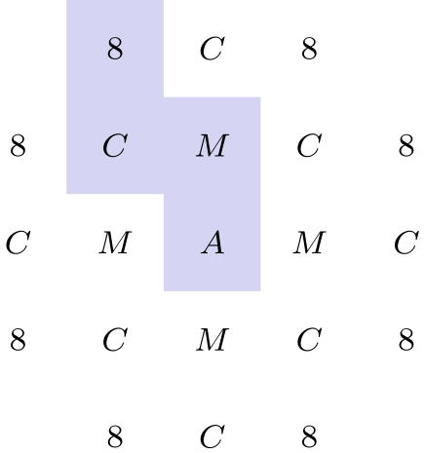
（A）8 （B）9 （C）12 （D）24 （E）36
English
In the arrangement of letters and numerals below, by how many different paths can one spell AMC8? Beginning at the A in the middle, a path allows only moves from one letter to an adjacent (above, below, left, or right, but not diagonal) letter. One example of such a path is traced in the picture.
(A) 8 (B) 9 (C) 12 (D) 24 (E) 36
第 16 题
在下图中，在边 BC 上选择点 D，使得 △ ACD 和 △ ABD 的周长相等。△ ABD 的面积是多少？
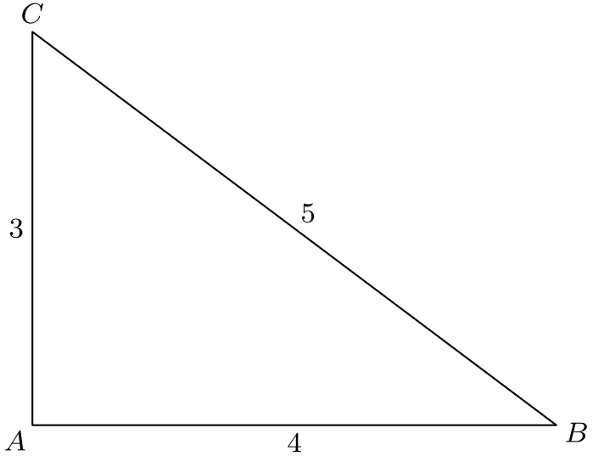
（A）3/4 （B）3/2 （C）2 （D）12/5 （E）5/2
English
In the figure shown below, choose point D on side BC so that △ ACD and △ ABD have equal perimeters. What is the area of △ ABD?
(A) 3/4 (B) 3/2 (C) 2 (D) 12/5 (E) 5/2
第 17 题
我有一些金币和一些空宝箱。我试着每个宝箱放 9 枚金币，但这样会剩下 2 个宝箱空着。于是我改为每个宝箱放 6 枚金币，但这样会剩下 3 枚金币。我有多少枚金币？
（A）9 （B）27 （C）45 （D）63 （E）81
English
Starting with some gold coins and some empty treasure chests, I tried to put 9 gold coins in each treasure chest, but that left 2 treasure chests empty. So instead I put 6 gold coins in each treasure chest, but then I had 3 gold coins left over. How many gold coins did I have?
(A) 9 (B) 27 (C) 45 (D) 63 (E) 81
第 18 题
如下图所示，非凸四边形 ABCD 中，∠ BCD 是直角，AB=12、BC=4、CD=3、AD=13。四边形 ABCD 的面积是多少？
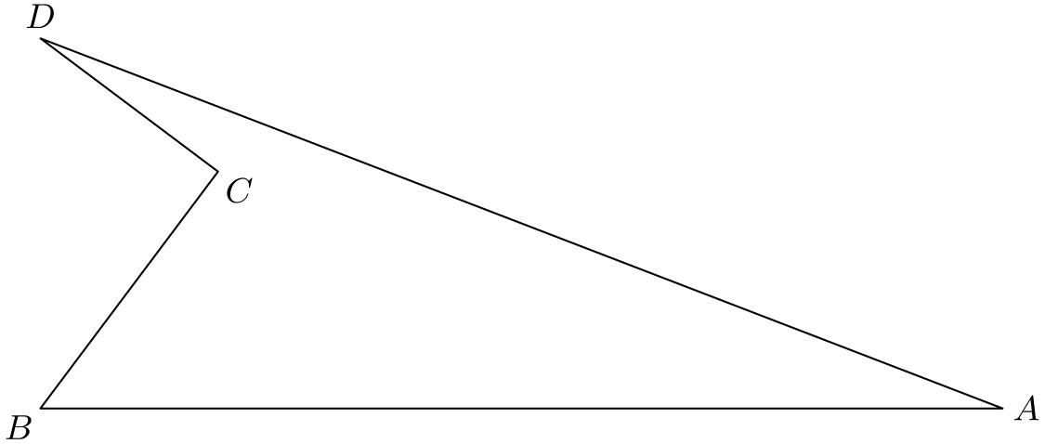
（A）12 （B）24 （C）26 （D）30 （E）36
English
In the non-convex quadrilateral ABCD shown below, ∠ BCD is a right angle, AB=12, BC=4, CD=3, and AD=13. What is the area of quadrilateral ABCD?
(A) 12 (B) 24 (C) 26 (D) 30 (E) 36
第 19 题
对任意正整数 M，记号 M! 表示从 1 到 M 的所有整数的乘积。使 5ⁿ 成为下列和式的因数的最大整数 n 是多少？
98!+99!+100!
（A）23 （B）24 （C）25 （D）26 （E）27
English
For any positive integer M, the notation M! denotes the product of the integers 1 through M. What is the largest integer n for which 5ⁿ is a factor of the sum:
98!+99!+100!
(A) 23 (B) 24 (C) 25 (D) 26 (E) 27
第 20 题
从 1000 到 9999（含端点）之间随机选一个整数。它是奇数且各位数字互不相同的概率是多少？
（A）14/75 （B）56/225 （C）107/400 （D）7/25 （E）9/25
English
An integer between 1000 and 9999, inclusive, is chosen at random. What is the probability that it is an odd integer whose digits are all distinct?
(A) 14/75 (B) 56/225 (C) 107/400 (D) 7/25 (E) 9/25
第 21 题
假设 a、b 和 c 是非零实数，且 a+b+c=0。下列表达式可能的值是什么
a/(|a|)+b/(|b|)+c/(|c|)+abc/(|abc|)？
（A）0 （B）1 和 -1 （C）2 和 -2 （D）0、2 和 -2 （E）0、1 和 -1
English
Suppose a, b, and c are nonzero real numbers, and a+b+c=0. What are the possible value(s) for
a/(|a|)+b/(|b|)+c/(|c|)+abc/(|abc|)?
(A) 0 (B) 1 and -1 (C) 2 and -2 (D) 0, 2, and -2 (E) 0, 1, and -1
第 22 题
在直角三角形 ABC 中，AC=12、BC=5，且角 C 是直角。如图，一个半圆内切于该三角形。这个半圆的半径是多少？
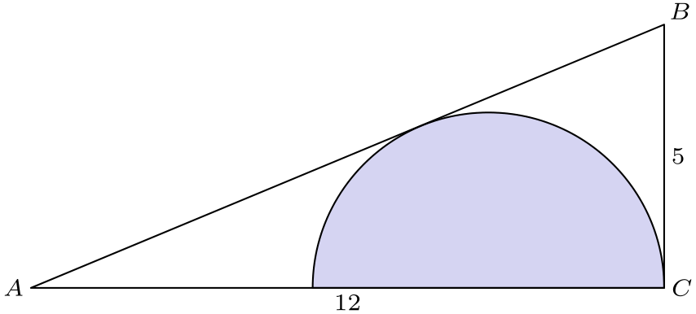
（A）7/6 （B）13/5 （C）59/18 （D）10/3 （E）60/13
English
In the right triangle ABC, AC=12, BC=5, and angle C is a right angle. A semicircle is inscribed in the triangle as shown. What is the radius of the semicircle?
(A) 7/6 (B) 13/5 (C) 59/18 (D) 10/3 (E) 60/13
第 23 题
连续四天，琳达每天旅行一小时，并且她的速度使她每行进一英里所需分钟数都是整数。第一天之后，每天她的速度都降低，使得每行进一英里所需分钟数比前一天多 5 分钟。四天中每天她行进的距离也都是整数英里。这四次旅行一共多少英里？
（A）10 （B）15 （C）25 （D）50 （E）82
English
Each day for four days, Linda traveled for one hour at a speed that resulted in her traveling one mile in an integer number of minutes. Each day after the first, her speed decreased so that the number of minutes to travel one mile increased by 5 minutes over the preceding day. Each of the four days, her distance traveled was also an integer number of miles. What was the total number of miles for the four trips?
(A) 10 (B) 15 (C) 25 (D) 50 (E) 82
第 24 题
桑德斯夫人有三个孙辈，他们定期给她打电话。一个每三天打一次，一个每四天打一次，一个每五天打一次。三人都在 2016 年十二月 31 日给她打了电话。接下来的一年中，有多少天她没有接到任何孙辈的电话？
（A）78 （B）80 （C）144 （D）146 （E）152
English
Mrs. Sanders has three grandchildren, who call her regularly. One calls her every three days, one calls her every four days, and one calls her every five days. All three called her on December 31, 2016. On how many days during the next year did she not receive a phone call from any of her grandchildren?
(A) 78 (B) 80 (C) 144 (D) 146 (E) 152
第 25 题
如图，US 和 UT 都是长度为 2 的线段，且 m∠ TUS = 60°。
弧 oversetlargefrownTR 和 oversetlargefrownSR 都是半径为 2 的圆的六分之一。图中区域面积是多少？
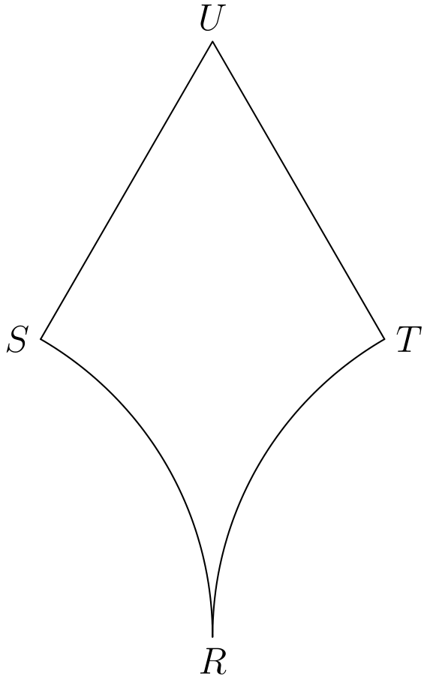
（A）3√(3)-π （B）4√(3)-4π/3 （C）2√(3) （D）4√(3)-2π/3 （E）4+4π/3
English
In the figure shown, US and UT are line segments each of length 2, and m∠ TUS = 60°.
Arcs oversetlargefrownTR and oversetlargefrownSR are each one-sixth of a circle with radius 2. What is the area of the region shown?
(A) 3√(3)-π (B) 4√(3)-4π/3 (C) 2√(3) (D) 4√(3)-2π/3 (E) 4+4π/3

第二部分 解答
答案速查：
题号 1 2 3 4 5 6 7 8 9
答案 A E C D B D A D D
题号 10 11 12 13 14 15 16 17 18
答案 C C D B C D D C B
题号 19 20 21 22 23 24 25
答案 D B A D C D B
答案串：AECDBDADDCCDBCDDCBDBADCDB
第 1 题 答案 A
选项 (A) 的值为 10。
选项 (B) 的值为 0 + 1 + 7 = 8。
选项 (C) 的值为 2 + 0 + 7 = 9。
选项 (D) 的值为 2 + 0 + 7 = 9。
选项 (E) 的值为 0。
所以正确答案是A。
English
Option (A) evaluates to 10.
Option (B) evaluates to 0 + 1 + 7 = 8.
Option (C) evaluates to 2 + 0 + 7 = 9.
Option (D) evaluates to 2 + 0 + 7 = 9.
Option (E) evaluates to 0.
Thus,Ais the correct answer.
第 2 题 答案 E
如果 36 票是总票数的 30%，那么总票数的 10% 是 12 票。总票数就是 10 · 12 = 120。
所以正确答案是E。
English
If 36 votes is 30% of the total votes, then 10% of the total votes is 12 votes. The number of total votes would then be 10 · 12 = 120.
Thus,Eis the correct answer.
第 3 题 答案 C
这个表达式可化简为
√(16√(8√(4))) = √(16√(16))
= √(64)
= 8
所以正确答案是C。
English
This expression can be reduced as follows:
√(16√(8√(4))) = √(16√(16))
= √(64)
= 8
Thus,Cis the correct answer.
第 4 题 答案 D
可以将乘积近似为
(3 · 10⁻⁴)(8 · 10⁶) = 24 · 10²
= 2,400
。
所以正确答案是D。
English
We can approximate the product as
(3 · 10⁻⁴)(8 · 10⁶) = 24 · 10²
= 2,400.
Thus,Dis the correct answer.
第 5 题 答案 B
分母为 1+2+⋯+8=36=2·3·6。从分子中约去这三个因数，剩下 4·5·7·8=1120。
所以正确答案是B。
English
The denominator is 1+2+⋯+8=36=2·3·6. Canceling those three factors from the numerator leaves 4·5·7·8=1120.
Thus,Bis the correct answer.
第 6 题 答案 D
设三个角为 3x、3x 和 4x。它们的和为 180，所以 3x + 3x + 4x = 180，即 10x = 180，从而 x = 18。
最大角为 4x = 72。
所以正确答案是D。
English
We can let the three angles be equal to 3x, 3x, and 4x. Then we know that their sum equals 180. From this we can set 3x + 3x + 4x = 180, and solving this, we get 10x = 180 and x = 18.
The largest angle is 4x = 72.
Thus,Dis the correct answer.
第 7 题 答案 A
设 n 为任意一个重复数块所组成的三位数。那么
Z=1000n+n
=1001n
=7·11·13· n
。
因此，11 一定是 Z 的因数。
所以正确答案是A。
English
Let n be the three-digit number formed by either repeated block. Then
Z=1000n+n
=1001n
=7·11·13· n.
Therefore, 11 must be a factor of Z.
Thus,Ais the correct answer.
第 8 题 答案 D
陈述 (1) 和 (2) 不能同时为真，因为唯一的偶质数不是两位数。陈述 (1) 和 (3) 也不能同时为真，因为能被 7 整除的两位数不是质数。由于只有一个陈述为假，陈述 (1) 必须为假，而陈述 (2)、(3) 和 (4) 为真。
门牌号能被 2 和 7 整除，所以能被 14 整除。在两位的 14 的倍数中，唯一含有数字 9 的是 98。因此个位数字是 8。
所以正确答案是D。
English
Statements (1) and (2) cannot both be true, because the only even prime is not two-digit. Statements (1) and (3) also cannot both be true, because a two-digit number divisible by 7 would not be prime. Since only one statement is false, statement (1) must be false, while statements (2), (3), and (4) are true.
The house number is divisible by 2 and 7, so it is divisible by 14. Among the two-digit multiples of 14, the only one with a digit of 9 is 98. Therefore, the units digit is 8.
Thus,Dis the correct answer.
第 9 题 答案 D
如果弹珠总数同时能被 3 和 4 整除，那么它必须能被 12 整除。测试 12 时，蓝色有 4 颗，红色有 3 颗，最多只剩 5 颗绿色，不可能。
若总数为 24，则蓝色有 8 颗，红色有 6 颗。黄色弹珠数为 24 - 8 - 6 - 6 = 4。
所以正确答案是D。
English
If the number of marbles is divisible by both 3 and 4, then the number must be divisible by 12. If we test 12, we get that there are 4 blue marbles and 3 red marbles. This leaves a maximum of 5 green marbles, which is not possible.
If there are 24 marbles, then there are 8 blue marbles and 6 red marbles. To find the number of yellow marbles, we get 24 - 8 - 6 - 6 = 4.
Thus,Dis the correct answer.
第 10 题 答案 C
从 5 张卡中选 3 张共有 5 choose 3 = 10 种方式。如果 4 是所选卡片中的最大值，那么另外两张必须从 {1, 2, 3} 中选，有 3 choose 2 = 3 种方式。因此概率为 3/10。
所以正确答案是C。
English
The number of ways to choose 3 cards from 5 is 5 choose 3 = 10. If 4 is the largest value selected, then the other two cards have to be chosen from {1, 2, 3}. There are 3 choose 2 = 3 ways to do this. The probability is then 3/10.
Thus,Cis the correct answer.
第 11 题 答案 C
两条对角线共有 37 块瓷砖，表示每条对角线上有 19 块瓷砖，因为中间有一块重叠。每行瓷砖数等于一条对角线上的瓷砖数，所以总瓷砖数为 19² = 361。
所以正确答案是C。
English
37 tiles on both diagonals imply that there are 19 tiles on each diagonal, since one tile overlaps in the middle. The total number of tiles would then be 19² = 361 since the number of tiles in each row is equal to the number of tiles in one diagonal.
Thus,Cis the correct answer.
第 12 题 答案 D
如果一个数除以 4、5 和 6 时余数都是 1，那么它比这些数的最小公倍数多一。最小公倍数是 60，所以最小的这类正整数是 60 + 1 = 61。
所以正确答案是D。
English
If a number leaves a remainder of 1 when divided by 4, 5, and 6, then it is one more than the least common multiple of these numbers. The least common multiple is 60, so the smallest such positive integer is 60 + 1 = 61.
Thus,Dis the correct answer.
第 13 题 答案 B
把三个人的记录合在一起，每一场胜利都对应一场失败；和棋若有，则对胜负总数都没有贡献。总负场数为 2+3+3=8，所以凯勒赢了 8-4-3=1 局。
所以正确答案是B。
English
Across all players, every win is matched by one loss; drawn games, if any, contribute neither. The number of losses is 2+3+3=8, so the number of games Kyler won is 8-4-3=1.
Thus,Bis the correct answer.
第 14 题 答案 C
因为题目数量不影响答案，可以假设作业有 100 道题。80% 的 50 是 40，所以克洛伊独立答对 40 道。88% 的 100 是 88，所以克洛伊总共答对 88 道。因此共同完成部分她答对 88 - 40 = 48 道。
90% 的 50 是 45，所以佐伊独立答对 45 道。共同完成部分她也答对 48 道，所以总共答对 45 + 48 = 93 道，整体正确率为 93%。
所以正确答案是C。
English
Since the answer is the same regardless of the number of problems, we can assume that there were 100 problems on the assignment. 80% of 50 is 40, so Chloe answered 40 questions correctly alone. 88% of 100 is 88, so Chloe answered 88 questions correctly in total. This means that Chloe answered 88 - 40 = 48 together with Zoe.
90% of 50 is 45, so Zoe answered 45 questions correctly by herself. We know that she answered 48 questions correctly with Chloe, so she answered 45 + 48 = 93 correctly in total. This means that her overall percentage is 93%.
Thus,Cis the correct answer.
第 15 题 答案 D
从 A 出发，有 4 种方式到达一个 M。从每个 M 出发，有 3 种方式到达一个 C。从每个 C 出发，有 2 种方式到达一个 8。因此路径总数为 4 · 3 · 2 = 24。
所以正确答案是D。
English
Starting from A, there are 4 ways to reach an M. From each M, there are 3 ways to reach a C. From each C, there are 2 ways to reach an 8. Multiplying all these possibilities, we get 4 · 3 · 2 = 24.
Thus,Dis the correct answer.
第 16 题 答案 D
要使两个三角形周长相等，BC 必须分成 CD = 3 和 BD = 2。
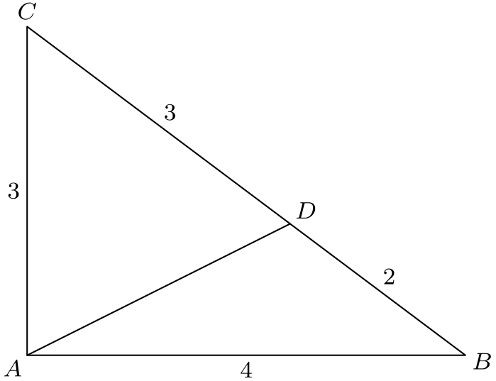
△ ACD 和 △ ABD 有相同的高，所以面积与底边长度成比例。这说明 △ ABD 的面积是 2/5 倍的 △ ABC 的面积，即
2/5 · 3 · 4/2 = 12/5。
所以正确答案是D。
English
The only way to split BC into two parts such that the two triangles have the same perimeter is if CD = 3 and BD = 2.
△ ACD and △ ABD have the same altitudes, so their areas are proportional to their bases. This means that the area of △ ABD is 2/5 the area of △ ABC, which is
2/5 · 3 · 4/2 = 12/5.
Thus,Dis the correct answer.
第 17 题 答案 C
设宝箱数为 n，金币数为 g。那么
9(n - 2) = g
且
6n + 3 = g。
解这个方程组得 n = 7，所以金币数为 6 · 7 + 3 = 45。
所以正确答案是C。
English
Let n be the number of treasure chests and g be the number of gold coins. Then
9(n - 2) = g
and
6n + 3 = g.
Solving this system yields n = 7, so the number of gold coins is 6 · 7 + 3 = 45.
Thus,Cis the correct answer.
第 18 题 答案 B
因为 ∠ BCD 是直角，对 △ BCD 用勾股定理得 BD = 5。又可得 ∠ DBA 是直角，因为 △ BDA 的三边构成勾股三元组。
四边形 ABCD 的面积等于
面积(△ BDA) - 面积(△ BCD)
= 1/2 · 12 · 5 - 1/2 · 4 · 3
= 30 - 6
= 24
。
所以正确答案是B。
English
Since ∠ BCD is a right angle, we can apply the Pythagorean theorem to △ BCD to get that BD = 5. We also get that ∠ DBA is right since the sides of △ BDA form a Pythagorean triple.
Then the area of ABCD is equal to
area(△ BDA) - area(△ BCD)
= 1/2 · 12 · 5 - 1/2 · 4 · 3
= 30 - 6
= 24.
Thus,Bis the correct answer.
第 19 题 答案 D
提出公因式 98!：
98!+99!+100! =98!(1+99
+100·99)
=98!·100²
。
98! 中因子 5 的指数是 ⌊98/5⌋+⌊98/25⌋，等于 19+3=22。因子 100² 还贡献四个因子 5，所以总指数是 22+4=26。
所以正确答案是D。
English
Factor out 98!:
98!+99!+100! =98!(1+99
+100·99)
=98!·100².
The exponent of 5 in 98! is ⌊98/5⌋+⌊98/25⌋, which equals 19+3=22. The factor 100² contributes four more factors of 5, so the total exponent is 22+4=26.
Thus,Dis the correct answer.
第 20 题 答案 B
这个数是奇数，所以个位数字有 5 种选择。千位数字不能为零，也不能等于个位数字，因此有 8 种选择。百位有 8 种选择，十位有 7 种选择。符合条件的数共有 5 · 8 · 8 · 7 = 2,240，所以概率为 (2,240)/(9,000) = 56/225。
所以正确答案是B。
English
Since the number is odd, the last digit is odd, giving 5 possibilities. The thousands digit cannot be zero or the number we already got, so that gives 8 possibilities. Similarly, the hundreds digit has 8 possibilities, and the tens digit has 7 possibilities. This gives a total of 5 · 8 · 8 · 7 = 2,240, making the probability (2,240)/(9,000) = 56/225.
Thus,Bis the correct answer.
第 21 题 答案 A
因为 a+b+c=0 且三个数都不为零，所以它们的符号只能是两个正数、一个负数，或两个负数、一个正数。第一种情况下，前三个符号分式的和为 1，而 abc/(|abc|)=-1；第二种情况下，前三个分式的和为 -1，而 abc/(|abc|)=1。无论哪种情况，整个表达式都等于 0。
所以正确答案是A。
English
Because a+b+c=0 and none of the numbers is zero, their signs are either two positive and one negative or two negative and one positive. In the first case, the first three sign fractions sum to 1, while abc/(|abc|)=-1. In the second case, the first three sum to -1, while abc/(|abc|)=1. Either way, the entire expression equals 0.
Thus,Ais the correct answer.
第 22 题 答案 D
设 O 为内切半圆圆心，D 为半圆与 AB 的切点。于是 BD = 5，因为 BD 和 BC 都与半圆相切。由此得 AD = 8，并记 OD = r。因为 OD 垂直于 AB，所以 △ ADO ∼ △ BCA，有 r/8 = 5/12，解得 r = 10/3。
所以正确答案是D。
English
Let O be the center of the inscribed semicircle and D be the tangent point of the semicircle on AB. Then BD = 5 since BD and BC are tangents to the semicircle. Then AD = 8 and OD = r. OD is perpendicular to AB so △ ADO ∼ △ BCA, so r/8 = 5/12. Solving this, we get r = 10/3.
Thus,Dis the correct answer.
第 23 题 答案 C
琳达每天旅行 60 分钟。因为每天每英里所需分钟数是整数，且每天行进英里数也是整数，所以每天的每英里分钟数必须是 60 的因数。60 的因数为 1、2、3、4、5、6、10、12、15、20、30 和 60。其中唯一一组四个相邻相差 5 的数是 5、10、15 和 20。四天总路程为
60/5 + 60/10 + 60/15 + 60/20 = 25
英里。
所以正确答案是C。
English
Linda traveled for 60 minutes every day. Since one mile was traveled in an integer amount of minutes each day, her minutes per mile every day must be a factor of 60. The factors of 60 are 1, 2, 3, 4, 5, 6, 10, 12, 15, 20, 30, and 60. The only sequence of four of these numbers that differ by 5 are 5, 10, 15, and 20. For the four days, she traveled
60/5 + 60/10 + 60/15 + 60/20 = 25
miles in total.
Thus,Cis the correct answer.
第 24 题 答案 D
在一个 60 天周期中，第一个孙辈打 20 次，第二个打 15 次，第三个打 12 次。但 20 + 15 + 12 = 47 有重复计数：第一个和第二个孙辈在同一天打电话 60/12 = 5 次，第一个和第三个在同一天打电话 60/15 = 4 次，第二个和第三个在同一天打电话 60/20 = 3 次。从 47 中减去这些，得 47 - 5 - 4 - 3 = 35。
第 60 天三人都打电话，被加了三次又减了三次，所以要加回一次，得到每 60 天有 36 天收到电话，也就是 24 天没有电话。这一年有 6 个完整的 60 天周期，剩下第 361 天和第 362 天没有电话，因此没有电话的天数为 24 · 6 + 2 = 146。
所以正确答案是D。
English
In a 60-day period, the first child calls 20 times, the second child calls 15 times, and the third child calls 12 times. 20 + 15 + 12 = 47 overcounts, however. The first and second children call on the same day 60/12 = 5 times. The first and third children call on the same day 60/15 = 4 times. The second and third children call on the same day 60/20 = 3 times. Subtracting these from 47 yields 47 - 5 - 4 - 3 = 35.
The 60th day is added in thrice and subtracted out thrice, so we need to add it back in. This means that for every 60 days, Mrs. Sanders receives a call 36 days, which means that she does not receive a call on 24 days. There are 6 60-day periods, and there are no calls on the 361st or 362nd day, which results in 24 · 6 + 2 = 146 total days with no phone calls.
Thus,Dis the correct answer.
第 25 题 答案 B
可以延长 SU 和 TU，形成如下图形。
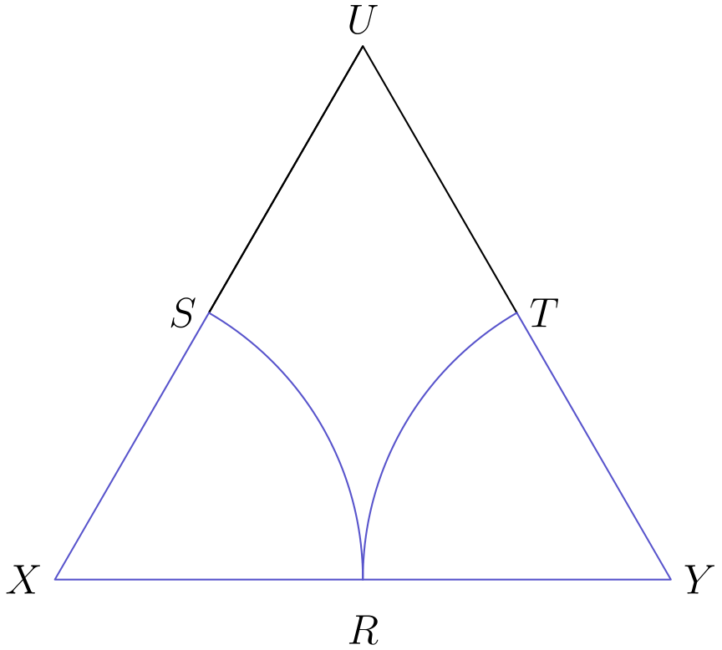
所求面积等于边长为 4 的等边三角形面积，减去两个半径为 2 的六分之一圆面积。边长为 s 的等边三角形面积为 (s²√(3))/4。因此总面积为 (4² √(3))/4 - 1/3 π · 2² = 4 √(3) - 4/3 π。
所以正确答案是B。
English
We can extend SU and TU to form the following picture.
The area of this region is the area of an equilateral triangle with side length of 4 minus the area of two-sixths of a circle with radius 2. The area for an equilateral triangle with side length s is (s²√(3))/4. This means that the total area is (4² √(3))/4 - 1/3 π · 2² = 4 √(3) - 4/3 π.
Thus,Bis the correct answer.

