2016 年 AMC 8 真题与解答
American Mathematics Competitions 8 · 中英双语
共 25 题，限时 40 分钟；单项选择题，每题 1 分，答错不扣分，满分 25 分。
编排说明：第一部分为题目（先中文、后英文原题），第二部分为解答与答案，便于先做题后对答案。
第一部分 题目
第 1 题
有史以来最长的职业网球比赛总共持续了 11 小时 5 分钟。这是多少分钟？
（A）605 （B）655 （C）665 （D）1005 （E）1105
English
The longest professional tennis match ever played lasted a total of 11 hours and 5 minutes. How many minutes was this?
(A) 605 (B) 655 (C) 665 (D) 1005 (E) 1105
第 2 题
在长方形 ABCD 中，AB=6，AD=8。点 M 是 AD 的中点。△ AMC 的面积是多少？
（A）12 （B）15 （C）18 （D）20 （E）24
English
In rectangle ABCD, AB=6 and AD=8. Point M is the midpoint of AD. What is the area of △ AMC?
(A) 12 (B) 15 (C) 18 (D) 20 (E) 24
第 3 题
四名学生参加考试。其中三人的分数是 70，80 和 90。如果四人平均分为 70，那么剩下那人的分数是多少？
（A）40 （B）50 （C）55 （D）60 （E）70
English
Four students take an exam. Three of their scores are 70, 80, and 90. If the average of their four scores is 70, then what is the remaining score?
(A) 40 (B) 50 (C) 55 (D) 60 (E) 70
第 4 题
奇努小时候能在 3 小时 30 分钟内跑 15 英里。现在他年老了，能在 4 小时内走 10 英里。现在他走一英里比小时候跑一英里多花多少分钟？
（A）6 （B）10 （C）15 （D）18 （E）30
English
When Cheenu was a boy he could run 15 miles in 3 hours and 30 minutes. As an old man he can now walk 10 miles in 4 hours. How many minutes longer does it take for him to walk a mile now compared to when he was a boy?
(A) 6 (B) 10 (C) 15 (D) 18 (E) 30
第 5 题
数 N 是一个两位数，满足以下性质：
第一个条件是 N 除以 9 的余数为 1；第二个条件是 N 除以 10 的余数为 3。
N 除以 11 的余数是多少？
（A）0 （B）2 （C）4 （D）5 （E）7
English
The number N is a two-digit number with the following properties:
• When N is divided by 9, the remainder is 1.
• When N is divided by 10, the remainder is 3.
What is the remainder when N is divided by 11?
(A) 0 (B) 2 (C) 4 (D) 5 (E) 7
第 6 题
下方条形图表示 19 个人的名字长度（字母数）。这些名字长度的中位数是多少？
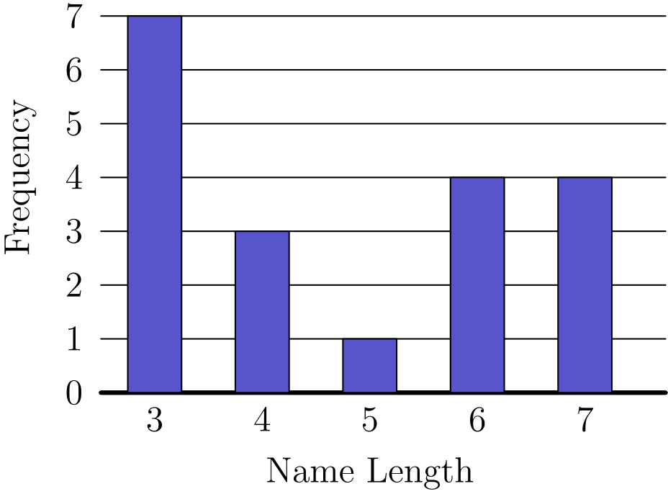
（A）3 （B）4 （C）5 （D）6 （E）7
English
The following bar graph represents the length (in letters) of the names of 19 people. What is the median length of these names?
(A) 3 (B) 4 (C) 5 (D) 6 (E) 7
第 7 题
下列哪个数不是完全平方数？
（A）1²⁰¹⁶ （B）2²⁰¹⁷ （C）3²⁰¹⁸ （D）4²⁰¹⁹ （E）5²⁰²⁰
English
Which of the following numbers is not a perfect square?
(A) 1²⁰¹⁶ (B) 2²⁰¹⁷ (C) 3²⁰¹⁸ (D) 4²⁰¹⁹ (E) 5²⁰²⁰
第 8 题
求下列表达式的值：
100 - 98 + 96 - 94 + 92 - 90
+ ⋯ + 8 - 6 + 4 - 2
（A）20 （B）40 （C）50 （D）80 （E）100
English
Find the value of the expression
100 - 98 + 96 - 94 + 92 - 90
+ ⋯ + 8 - 6 + 4 - 2.
(A) 20 (B) 40 (C) 50 (D) 80 (E) 100
第 9 题
2016 的不同质数因子之和是多少？
（A）9 （B）12 （C）16 （D）49 （E）63
English
What is the sum of the distinct prime integer divisors of 2016?
(A) 9 (B) 12 (C) 16 (D) 49 (E) 63
第 10 题
假设 a ∗ b 表示 3a - b。若下式成立，那么 x 的值是多少？
2 ∗ (5 ∗ x) = 1？
（A）1/10 （B）2 （C）10/3 （D）10 （E）14
English
Suppose that a ∗ b means 3a - b. What is the value of x if
2 ∗ (5 ∗ x) = 1?
(A) 1/10 (B) 2 (C) 10/3 (D) 10 (E) 14
第 11 题
有多少个两位数满足以下性质？
将这个数与它的数字反序得到的数相加，和为 132。
（A）5 （B）7 （C）9 （D）11 （E）12
English
Determine how many two-digit numbers satisfy the following property:
When the number is added to the number obtained by reversing its digits, the sum is 132.
(A) 5 (B) 7 (C) 9 (D) 11 (E) 12
第 12 题
杰斐逊中学的男生和女生人数相同。女生中的四分之三和男生中的三分之二参加了实地考察。参加实地考察的学生中，女生占几分之几？
（A）1/2 （B）9/17 （C）7/13 （D）2/3 （E）14/15
English
Jefferson Middle School has the same number of boys and girls. Three-fourths of the girls and two-thirds of the boys went on a field trip. What fraction of the students on the field trip were girls?
(A) 1/2 (B) 9/17 (C) 7/13 (D) 2/3 (E) 14/15
第 13 题
从集合
{ - 2, -1, 0, 3, 4, 5}
中随机选出两个不同的数并相乘。乘积为 0 的概率是多少？
（A）1/6 （B）1/5 （C）1/4 （D）1/3 （E）1/2
English
Two different numbers are randomly selected from the set
{ - 2, -1, 0, 3, 4, 5}
and multiplied together. What is the probability that the product is 0?
(A) 1/6 (B) 1/5 (C) 1/4 (D) 1/3 (E) 1/2
第 14 题
卡尔的汽车每 35 英里用一加仑汽油，油箱加满时可装 14 加仑。
某天，卡尔出发时油箱是满的，开了 350 英里后买了 8 加仑汽油，然后继续开到目的地。到达时，他的油箱还有一半满。卡尔那天一共开了多少英里？
（A）525 （B）560 （C）595 （D）665 （E）735
English
Karl’s car uses a gallon of gas every 35 miles, and his gas tank holds 14 gallons when it is full.
One day, Karl started with a full tank of gas, drove 350 miles, bought 8 gallons of gas, and continued driving to his destination. When he arrived, his gas tank was half full. How many miles did Karl drive that day?
(A) 525 (B) 560 (C) 595 (D) 665 (E) 735
第 15 题
能整除 13⁴ - 11⁴ 的最大的 2 的幂是多少？
（A）8 （B）16 （C）32 （D）64 （E）128
English
What is the largest power of 2 that is a divisor of 13⁴ - 11⁴?
(A) 8 (B) 16 (C) 32 (D) 64 (E) 128
第 16 题
安妮和邦妮正在绕一个 400 米椭圆形跑道跑圈。她们同时出发，但安妮已经领先，因为她比邦妮快 25%。安妮第一次追上并超过邦妮时，她已经跑了多少圈？
（A）11/4 （B）31/3 （C）4 （D）5 （E）25
English
Annie and Bonnie are running laps around a 400-meter oval track. They started together, but Annie has pulled ahead, because she runs 25% faster than Bonnie. How many laps will Annie have run when she first passes Bonnie?
(A) 11/4 (B) 31/3 (C) 4 (D) 5 (E) 25
第 17 题
弗雷德银行的 ATM 密码由 0 到 9 中的四个数字组成，允许数字重复。如果密码不能以序列 9、1、1 开头，那么有多少个可能密码？
（A）30 （B）7290 （C）9000 （D）9990 （E）9999
English
An ATM password at Fred’s Bank is composed of four digits from 0 to 9, with repeated digits allowable. If no password may begin with the sequence 9, 1, 1, then how many passwords are possible?
(A) 30 (B) 7290 (C) 9000 (D) 9990 (E) 9999
第 18 题
在一次全地区田径赛中，216 名短跑运动员参加 100 米短跑比赛。跑道有 6 条道，所以一次只能有 6 名运动员比赛。每场比赛结束后，五名非获胜者被淘汰，获胜者将在后面的比赛中继续参赛。
需要多少场比赛才能决出短跑冠军？
（A）36 （B）42 （C）43 （D）60 （E）72
English
In an All-Area track meet, 216 sprinters enter a 100-meter dash competition. The track has 6 lanes, so only 6 sprinters can compete at a time. At the end of each race, the five non-winners are eliminated, and the winner will compete again in a later race.
How many races are needed to determine the champion sprinter?
(A) 36 (B) 42 (C) 43 (D) 60 (E) 72
第 19 题
25 个连续偶整数的和是 10,000。这 25 个连续偶整数中最大的是多少？
（A）360 （B）388 （C）412 （D）416 （E）424
English
The sum of 25 consecutive even integers is 10,000. What is the largest of these 25 consecutive even integers?
(A) 360 (B) 388 (C) 412 (D) 416 (E) 424
第 20 题
a 和 b 的最小公倍数是 12，b 和 c 的最小公倍数是 15。a 和 c 的最小公倍数的最小可能值是多少？
（A）20 （B）30 （C）60 （D）120 （E）180
English
The least common multiple of a and b is 12, and the least common multiple of b and c is 15. What is the least possible value of the least common multiple of a and c?
(A) 20 (B) 30 (C) 60 (D) 120 (E) 180
第 21 题
一个盒子里有 3 枚红色筹码和 2 枚绿色筹码。每次随机抽出一枚筹码且不放回，直到 3 枚红色筹码都被抽出，或直到两枚绿色筹码都被抽出。3 枚红色筹码都被抽出的概率是多少？
（A）3/10 （B）2/5 （C）1/2 （D）3/5 （E）2/3
English
A box contains 3 red chips and 2 green chips. Chips are drawn randomly, one at a time without replacement, until all 3 of the reds are drawn or until both green chips are drawn. What is the probability that the 3 reds are drawn?
(A) 3/10 (B) 2/5 (C) 1/2 (D) 3/5 (E) 2/3
第 22 题
下图中长方形 DEFA 是一个 3 × 4 长方形，且 DC=CB=BA=1。“蝙蝠翅膀”（阴影部分）的面积是
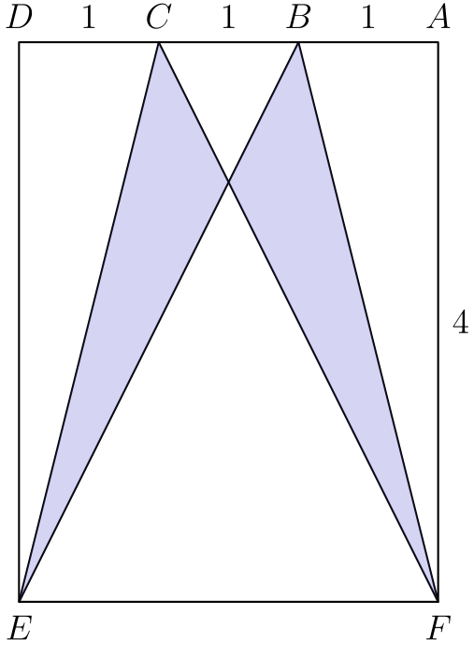
（A）2 （B）2 1/2 （C）3 （D）3 1/2 （E）4
English
Rectangle DEFA below is a 3 × 4 rectangle with DC=CB=BA=1. The area of the “bat wings” (shaded area) is
(A) 2 (B) 2 1/2 (C) 3 (D) 3 1/2 (E) 4
第 23 题
两个全等圆分别以点 A 和 B 为圆心，并且每个圆都经过另一个圆的圆心。经过 A 和 B 的直线延长后与两个圆分别交于点 C 和 D。
两圆相交于两点，其中一点为 E。∠ CED 的度数是多少？
（A）90 （B）105 （C）120 （D）135 （E）150
English
Two congruent circles centered at points A and B each pass through the other circle’s center. The line containing both A and B is extended to intersect the circles at points C and D.
The circles intersect at two points, one of which is E. What is the degree measure of ∠ CED?
(A) 90 (B) 105 (C) 120 (D) 135 (E) 150
第 24 题
数字 1、2、3、4、5 各使用一次，写成五位数 PQRST。三位数 PQR 能被 4 整除，三位数 QRS 能被 5 整除，三位数 RST 能被 3 整除。P 是多少？
（A）1 （B）2 （C）3 （D）4 （E）5
English
The digits 1, 2, 3, 4, and 5 are each used once to write a five-digit number PQRST. The three-digit number PQR is divisible by 4, the three-digit number QRS is divisible by 5, and the three-digit number RST is divisible by 3. What is P?
(A) 1 (B) 2 (C) 3 (D) 4 (E) 5
第 25 题
一个半圆内切于一个底为 16、高为 15 的等腰三角形中，半圆的直径位于三角形的底边上，如图所示。半圆的半径是多少？
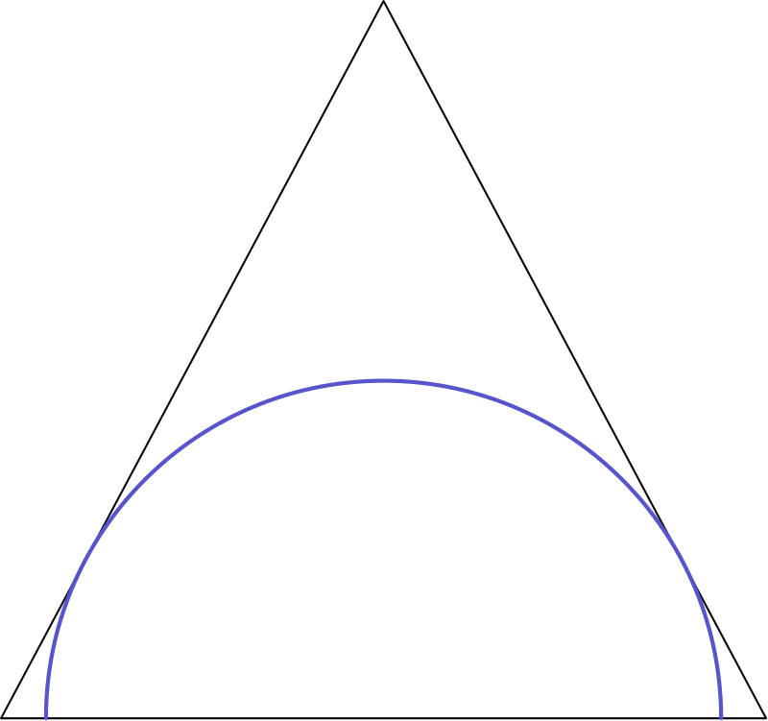
（A）4 √(3) （B）120/17 （C）10 （D）(17√(2))/2 （E）(17√(3))/2
English
A semicircle is inscribed in an isosceles triangle with base 16 and height 15 so that the diameter of the semicircle is contained in the base of the triangle as shown. What is the radius of the semicircle?
(A) 4 √(3) (B) 120/17 (C) 10 (D) (17√(2))/2 (E) (17√(3))/2

第二部分 解答
答案速查：
题号 1 2 3 4 5 6 7 8 9
答案 C A A B E B B C B
题号 10 11 12 13 14 15 16 17 18
答案 D B B D A C D D C
题号 19 20 21 22 23 24 25
答案 E A B C C A B
答案串：CAABEBBCBDBBDACDDCEABCCAB
第 1 题 答案 C
一小时有 60 分钟，所以总时间为 60 · 11 + 5 = 665 分钟。
所以正确答案是C。
English
There are 60 minutes in an hour, so the total time is 60 · 11 + 5 = 665 minutes.
Thus,Cis the correct answer.
第 2 题 答案 A
因为 M 是 AD 的中点，所以底边 AM 长 4。从 C 到 AM 的高为 AB=6。因此面积为 1/2 · 4 · 6 = 12。
所以正确答案是A。
English
Since M is the midpoint of AD, the base AM has length 4. The altitude from C to AM has length AB=6. The area is therefore 1/2 · 4 · 6 = 12.
Thus,Ais the correct answer.
第 3 题 答案 A
由平均分可知四人总分为 4 · 70 = 280。因此剩下的分数为
280 - 70 - 80 - 90 = 40。
所以正确答案是A。
English
From the average, we can calculate the sum of the scores to be 4 · 70 = 280. This means that the remaining score is
280 - 70 - 80 - 90 = 40.
Thus,Ais the correct answer.
第 4 题 答案 B
为了更容易比较速度，将它们都换成每英里所需分钟数。
小时候他跑 15 英里用了 3 · 60 + 30 = 210 分钟，所以速度为 210/15 = 14 分钟每英里。
现在他走 10 英里用了 4 · 60 = 240 分钟，所以速度为 240/10 = 24 分钟每英里。
相减得，现在他走一英里多花 10 分钟。
所以正确答案是B。
English
To better compare the rates, we can change his speed into minutes per mile.
As a boy he ran 15 miles in 3 · 60 + 30 = 210 minutes, which means that he ran at a pace of 210/15 = 14 minutes per mile.
As an adult, he can walk 10 miles in 4 · 60 = 240 minutes, which means he walks at a pace of 240/10 = 24 minutes per mile.
Subtracting the two, we get that he takes 10 more minutes to walk a mile as an adult.
Thus,Bis the correct answer.
第 5 题 答案 E
第二个条件说明 N 的个位数字是 3，所以可能的数为 13、23、33、43、53、63、73、83、93。其中只有 73 除以 9 余 1，因为它的各位数字之和是 10。最后，73=6·11+7，所以所求余数是 7。
所以正确答案是E。
English
The second condition says that N ends in 3, so the possibilities are 13, 23, 33, 43, 53, 63, 73, 83, 93. Of these, only 73 leaves remainder 1 when divided by 9, because its digit sum is 10. Finally, 73=6·11+7, so the requested remainder is 7.
Thus,Eis the correct answer.
第 6 题 答案 B
因为有 19 个人，每人对应一个名字长度，所以中间的长度是第十个值。从左侧开始数，数到第十个时得到 4。
所以正确答案是B。
English
Since there are 19 people, each with one corresponding name length, the middle length will be the tenth one. Counting from the left side, the tenth value that we arrive upon is 4.
Thus,Bis the correct answer.
第 7 题 答案 B
任何指数为偶数的数都是完全平方数，所以可排除A、C和E。另外，平方数的任意次幂仍然是平方数，所以也排除D。
所以正确答案是B。
English
Since any number with an even exponent is a perfect square, we can eliminateA,C, andE. Also, a square number to any power remains a square number, so that rules outD.
Thus,Bis the correct answer.
第 8 题 答案 C
可以把这个和分组为
(100 - 98) + (96 - 94)
+ ⋯ + (4 - 2)
每一对的值都是 2，共有 25 对。因此总和为 2 · 25 = 50。
所以正确答案是C。
English
We can group the sum as follows:
(100 - 98) + (96 - 94)
+ ⋯ + (4 - 2).
Note that each pair evaluates to 2 and there are 25 pairs. Therefore, the total sum is 2 · 25 = 50.
Thus,Cis the correct answer.
第 9 题 答案 B
将 2016 质因数分解为 2⁵ · 3² · 7。因此 2016 的质因子是 2、3 和 7。它们的和为 12，所以正确答案是B。
English
We can prime factorize 2016 as 2⁵ · 3² · 7. This shows that the prime divisors of 2016 are 2, 3, and 7. The sum of these is 12, soBis the correct answer.
第 10 题 答案 D
先算内层运算，得 5∗ x=15-x。再应用一次定义：
2∗(15-x)=6-(15-x)
=x-9。
因此 x-9=1，所以 x=10。
所以正确答案是D。
English
First, 5∗ x=15-x. Applying the operation again gives
2∗(15-x)=6-(15-x)
=x-9.
Thus x-9=1, so x=10.
Thus,Dis the correct answer.
第 11 题 答案 B
设十位数字为 a，个位数字为 b。原数与反序数相加得
(10a+b)+(10b+a)=132
11(a+b)=132，
所以 a+b=12。可行的数字对为 (3,9)、(4,8)、(5,7)、(6,6)、(7,5)、(8,4)、(9,3)，共得到 7 个两位数。
所以正确答案是B。
English
Let a be the tens digit and b the units digit. Adding the number and its reversal gives
(10a+b)+(10b+a)=132
11(a+b)=132,
so a+b=12. The valid digit pairs are (3,9), (4,8), (5,7), (6,6), (7,5), (8,4), (9,3), giving 7 numbers.
Thus,Bis the correct answer.
第 12 题 答案 B
假设有 12 名女生和 12 名男生，那么参加实地考察的有 9 名女生和 8 名男生，所以参加者中女生所占的比例是 9/9+8=9/17。
所以正确答案是B。
English
Suppose there are 12 girls and 12 boys. Then 9 girls and 8 boys go on the field trip, so the fraction of field-trip students who are girls is 9/9+8=9/17.
Thus,Bis the correct answer.
第 13 题 答案 D
从六个数中选两个不同的数共有 C(6, 2)=15 种方法。乘积为 0 当且仅当选出的一个数是 0，另一个数有 5 种选择。因此所求概率为 5/15=1/3。
所以正确答案是D。
English
There are C(6, 2)=15 ways to select two different numbers. A product is 0 exactly when one selected number is 0, and there are 5 choices for the other number. Thus the probability is 5/15=1/3.
Thus,Dis the correct answer.
第 14 题 答案 A
卡尔开 350 英里用了 350/35 加仑汽油。
他又加了 8 加仑到原来剩下的 14 - 10 = 4 加仑中，一共有 12 加仑。
到达时油箱半满，所以后来又用了 12 - 7 = 5 加仑，对应 5 · 35 = 175 英里。
因此他行驶的总路程为 350+175=525 英里。
所以正确答案是A。
English
If Karl drove 350 miles, then he used 350/35 gallons of gas.
When he bought more gas, he added 8 gallons to 14 - 10 = 4 gallons, attaining a total of 12 gallons.
If his tank was half full when he arrived, he used 12 - 7 = 5 gallons, which equates to 5 · 35 = 175 miles.
Therefore, he traveled a total distance of 350+175=525 miles.
Thus,Ais the correct answer.
第 15 题 答案 C
使用平方差分解：
13⁴-11⁴ =(13²+11²)
·(13²-11²)
=290·48
=32·435
。
因为 435 是奇数，所以 32 是能整除该表达式的最大的 2 的幂。
所以正确答案是C。
English
We can factor this expression using difference of squares.
13⁴-11⁴ =(13²+11²)
·(13²-11²)
=290·48
=32·435.
Because 435 is odd, 32 is the largest power of 2 that divides the expression.
Thus,Cis the correct answer.
第 16 题 答案 D
因为安妮比邦妮快 25%，所以邦妮每完成一圈时，安妮完成 1 1/4 圈。也就是说，邦妮每跑一圈，安妮领先四分之一圈。
安妮要整整领先一圈，需要邦妮完成 4 圈，此时安妮完成 5 圈。
所以正确答案是D。
English
Since Annie is 25% faster than Bonnie, for every lap Bonnie finishes, Annie completes 1 1/4 laps. Therefore, Annie gains a quarter lap every time Bonnie finishes a lap.
With this in mind, for Annie to completely lap Bonnie, Bonnie must finish 4 laps, which means that Annie finished 5 laps.
Thus,Dis the correct answer.
第 17 题 答案 D
没有限制时，密码总数为 10⁴。这个条件排除了 10 个密码，因为前 3 位已经固定，最后一位可以任意。因此可接受密码数为
10,000 - 10 = 9990。
所以正确答案是D。
English
The total number of passwords with no conditions is 10⁴. The condition removes 10 possible passwords since the first 3 are determined, and the last one can be anything. Therefore, the number of acceptable passwords is
10,000 - 10 = 9990.
Thus,Dis the correct answer.
第 18 题 答案 C
每场比赛淘汰 5 人。要决出冠军，需要淘汰 215 人。因此需要 215/5 = 43 场比赛。
所以正确答案是C。
English
Note that each race eliminates 5 people. For there to be a winner, 215 must be eliminated. Therefore, 215/5 = 43 races are required to eliminate this number of people.
Thus,Cis the correct answer.
第 19 题 答案 E
这些数的平均数为 (10,000)/25 = 400。因为共有二十五个连续偶整数，平均数就是中间项。最大数比中间项大 12 个偶数间隔，所以等于 400 + 12 · 2 = 424。
所以正确答案是E。
English
The average of these numbers is (10,000)/25 = 400. The largest number is 12 even numbers away, which means that it equals 400 + 12 · 2 = 424.
Thus,Eis the correct answer.
第 20 题 答案 A
b 必须同时整除 12 和 15，所以它只能是 1 或 3。
如果 b = 1，则可取 a = 12、c = 15，它们的最小公倍数为 60。如果 b = 3，则可取 a = 4、c = 5，此时最小公倍数为 20。
所以正确答案是A。
English
We know that b has to divide both 12 and 15, so it must equal either 1 or 3.
If b = 1, then a = 12 and c = 15, making their least common multiple 60. If b = 3, then we may take a = 4 and c = 5. The least common multiple in this scenario is 20.
Thus,Ais the correct answer.
第 21 题 答案 B
3 枚红色筹码先于两枚绿色筹码都被抽出，当且仅当完整抽取顺序中的最后一枚筹码是绿色。选择两枚绿色筹码位置的等可能方式共有 10 种，其中最后一个位置为绿色的有 4 种。
因此所求概率为
4/10 = 2/5。
所以正确答案是B。
English
The 3 reds are drawn before both green chips exactly when a green chip is the last chip in the full ordering. There are 10 equally likely ways to choose the two positions of the green chips, and 4 of them have a green chip in the last position.
Therefore, the desired probability is
4/10 = 2/5.
Thus,Bis the correct answer.
第 22 题 答案 C
设 I 为 AD 的中点，G 为 EF 的中点。再设 H 为 CF 与 BE 的交点。
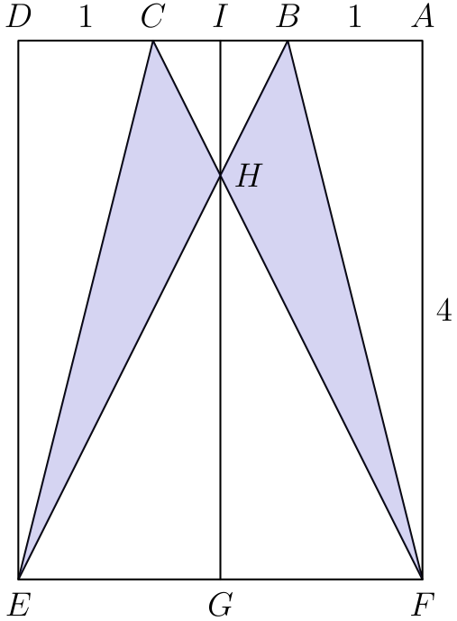
△ BCE 的面积是 1/2·1·4=2。由对称性可知，△ BCH 与 △ EFH 相似。它们的底边之比为 1: 3，所以高之比也相同。因此 3IH = HG，从而 IH = 1。
所以 [△ BCH]=1/2·1·1=1/2。于是 [△ ECH]=2-1/2=3/2。图形关于中线对称，因此蝙蝠双翼的总面积为 2·3/2=3。
所以正确答案是C。
English
Define I to be the midpoint of AD and G to be the midpoint of EF. Also define H to be the intersection of CF and BE.
The area of △ BCE is 1/2·1·4=2. By symmetry, we can see that △ BCH and △ EFH are similar. Since their bases are in a 1: 3 ratio, so are their altitudes. This means that 3IH = HG, which implies that IH = 1.
Therefore, [△ BCH]=1/2·1·1=1/2. It follows that [△ ECH]=2-1/2=3/2. Since the figure is symmetric, the total area of the bat wings is 2·3/2=3.
Thus,Cis the correct answer.
第 23 题 答案 C
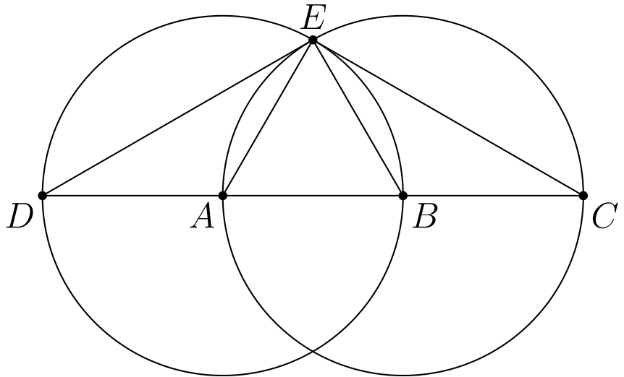
因为 AE = EB = AB，它们都是全等圆的半径，所以三点构成等边三角形，∠ AEB = 60°。
又因为 DB 和 AC 是直径，所以 ∠ DEB=∠ AEC=90°。因此
∠ CED = ∠ DEB+∠ AEC
-∠ AEB
=90°+90°-60°
=120°。
所以正确答案是C。
English
We know that AE = EB = AB since they are all radii of congruent circles, so they form an equilateral triangle, which means that ∠ AEB = 60°.
The segments DB and AC are diameters, so ∠ DEB=∠ AEC=90°. Therefore,
∠ CED = ∠ DEB+∠ AEC
-∠ AEB
=90°+90°-60°
=120°.
Thus,Cis the correct answer.
第 24 题 答案 A
因为 QRS 能被 5 整除，所以 S = 5。
因为 PQR 能被 4 整除，所以 QR 可以是 12、24 或 32。
如果 QR=12，则 R=2，那么 RST=25T，用剩余数字无法使其被 3 整除。如果 QR=32，则 R=2，也遇到同样问题。因此 QR=24，于是 RST=45T。在剩余数字中，只有 T=3 使 453 能被 3 整除。
因此 PQRST = 12453。
所以正确答案是A。
English
Since QRS is divisible by 5, we know that S = 5.
Since PQR is divisible by 4, QR equals either 12, 24, or 32.
If QR=12, then R=2, so RST=25T cannot be divisible by 3 using the remaining digits. If QR=32, then R=2 again, giving the same obstacle. Thus QR=24, and then RST=45T. Among the remaining digits, only T=3 makes 453 divisible by 3.
Therefore, PQRST = 12453.
Thus,Ais the correct answer.
第 25 题 答案 B
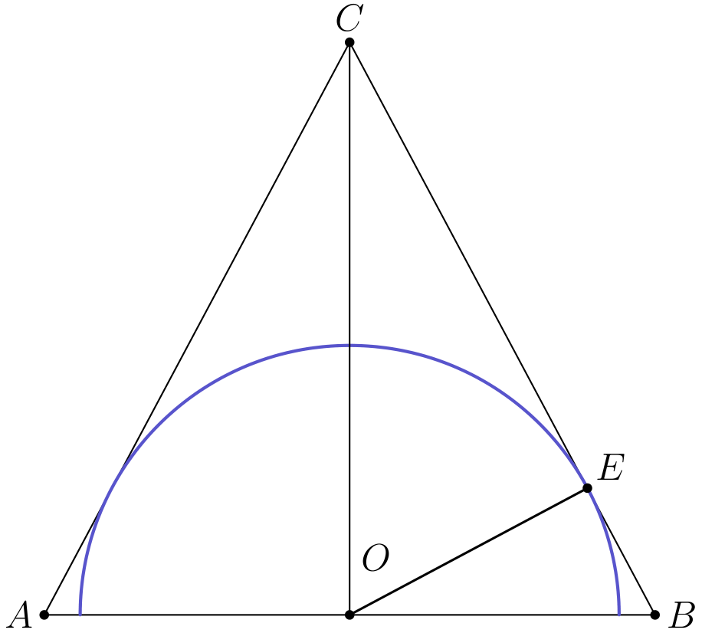
设 O 是圆心，也就是 AB 的中点。
由勾股定理可得 BC = 17。
三角形右半部分的面积为
[△ BOC]=1/2·8·15=60。
半径 OE 垂直于相切的边 BC，所以同一面积也等于 1/2· OE·17。因此
OE=120/17。
所以正确答案是B。
English
Let O be the center of the circle, which is the midpoint of AB.
We then get that BC = 17 via the Pythagorean theorem.
The right half of the isosceles triangle has area
[△ BOC]=1/2·8·15=60.
The radius OE is perpendicular to the tangent side BC, so the same area is 1/2· OE·17. Hence
OE=120/17.
Thus,Bis the correct answer.

