2015 年 AMC 8 真题与解答
American Mathematics Competitions 8 · 中英双语
共 25 题，限时 40 分钟；单项选择题，每题 1 分，答错不扣分，满分 25 分。
编排说明：第一部分为题目（先中文、后英文原题），第二部分为解答与答案，便于先做题后对答案。
第一部分 题目
第 1 题
要铺满一个长 12 英尺、宽 9 英尺的长方形地板，需要多少平方码地毯？（一码等于 3 英尺。）
（A）12 （B）36 （C）108 （D）324 （E）972
English
How many square yards of carpet are required to cover a rectangular floor that is 12 feet long and 9 feet wide? (There are 3 feet in a yard.)
(A) 12 (B) 36 (C) 108 (D) 324 (E) 972
第 2 题
点 O 是正八边形 ABCDEFGH 的中心，X 是边 AB 的中点。阴影部分占八边形面积的几分之几？
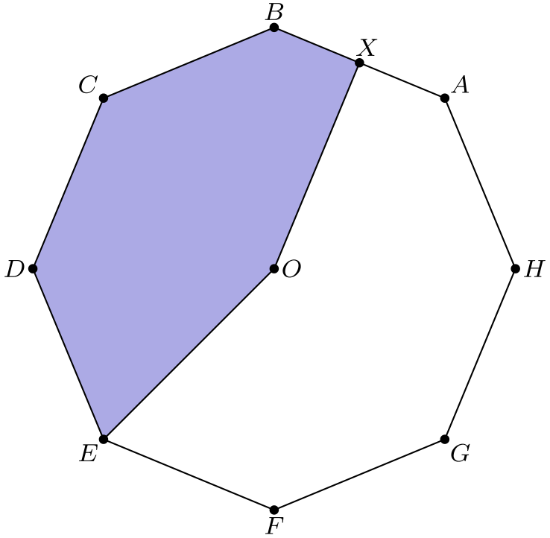
（A）11/32 （B）3/8 （C）13/32 （D）7/16 （E）15/32
English
Point O is the center of the regular octagon ABCDEFGH, and X is the midpoint of the side AB. What fraction of the area of the octagon is shaded?
(A) 11/32 (B) 3/8 (C) 13/32 (D) 7/16 (E) 15/32
第 3 题
杰克和吉尔要去离家一英里的游泳池游泳。他们同时离家。吉尔以每小时 10 英里的恒定速度骑自行车去游泳池。杰克以每小时 4 英里的恒定速度步行去游泳池。吉尔比杰克早到多少分钟？
（A）5 （B）6 （C）8 （D）9 （E）10
English
Jack and Jill are going swimming at a pool that is one mile from their house. They leave home simultaneously. Jill rides her bicycle to the pool at a constant speed of 10 miles per hour. Jack walks to the pool at a constant speed of 4 miles per hour. How many minutes before Jack does Jill arrive?
(A) 5 (B) 6 (C) 8 (D) 9 (E) 10
第 4 题
森特维尔中学国际象棋队由两名男生和三名女生组成。一位摄影师想为当地报纸拍一张队伍照片。她决定让他们坐成一排，两端各坐一名男生，中间坐三名女生。这样的排列有多少种？
（A）2 （B）4 （C）5 （D）6 （E）12
English
The Centerville Middle School chess team consists of two boys and three girls. A photographer wants to take a picture of the team to appear in the local newspaper. She decides to have them sit in a row with a boy at each end and the three girls in the middle. How many such arrangements are possible?
(A) 2 (B) 4 (C) 5 (D) 6 (E) 12
第 5 题
比利的篮球队在赛季前 11 场比赛中的得分如下：
42、47、53、53、58、58、58、61、64、65、73。
如果他的球队在第 12 场比赛中得到 40 分，下列哪一个统计量会增加？
（A）极差 （B）中位数 （C）平均数 （D）众数 （E）中程数
English
Billy’s basketball team scored the following points over the course of the first 11 games of the season:
42, 47, 53, 53, 58, 58, 58, 61, 64, 65, 73.
If his team scores 40 in the 12th game, which of the following statistics will show an increase?
(A) range (B) median (C) mean (D) mode (E) mid-range
第 6 题
在 △ ABC 中，AB=BC=29，且 AC=42。△ ABC 的面积是多少？
（A）100 （B）420 （C）500 （D）609 （E）701
English
In △ ABC, AB=BC=29, and AC=42. What is the area of △ ABC?
(A) 100 (B) 420 (C) 500 (D) 609 (E) 701
第 7 题
两个盒子中各有三枚编号为 1、2、3 的筹码。从每个盒子中随机取出一枚筹码，并将两枚筹码上的数字相乘。乘积为偶数的概率是多少？
（A）1/9 （B）2/9 （C）4/9 （D）1/2 （E）5/9
English
Each of two boxes contains three chips numbered 1, 2, 3. A chip is drawn randomly from each box and the numbers on the two chips are multiplied. What is the probability that their product is even?
(A) 1/9 (B) 2/9 (C) 4/9 (D) 1/2 (E) 5/9
第 8 题
大于任意一个有一条边长为 5、另一条边长为 19 的三角形周长的最小整数是多少？
（A）24 （B）29 （C）43 （D）48 （E）57
English
What is the smallest whole number larger than the perimeter of any triangle with a side of length 5 and a side of length 19?
(A) 24 (B) 29 (C) 43 (D) 48 (E) 57
第 9 题
珍娜贝尔第一天上班卖出一个小部件。第二天卖出三个。第三天卖出五个，此后每天都比前一天多卖两个。工作 20 天后，珍娜贝尔总共卖出多少个小部件？
（A）39 （B）40 （C）210 （D）400 （E）401
English
On her first day of work, Janabel sold one widget. On day two, she sold three widgets. On day three, she sold five widgets, and on each succeeding day, she sold two more widgets than she had sold on the previous day. How many widgets in total had Janabel sold after working 20 days?
(A) 39 (B) 40 (C) 210 (D) 400 (E) 401
第 10 题
从 1000 到 9999 之间，有多少个四位整数的四个数字互不相同？
（A）3024 （B）4536 （C）5040 （D）6480 （E）6561
English
How many integers between 1000 and 9999 have four distinct digits?
(A) 3024 (B) 4536 (C) 5040 (D) 6480 (E) 6561
第 11 题
在小国“数学国”，所有汽车牌照都有四个符号。第一个必须是元音字母（A、E、I、O 或 U），第二个和第三个必须是 21 个非元音字母中的两个不同字母，第四个必须是一个数字（零到 9）。如果符号在满足这些条件下随机选择，牌照读作“AMC8”的概率是多少？
（A）1/(22,050) （B）1/(21,000) （C）1/(10,500) （D）1/(2,100) （E）1/(1,050)
English
In the small country of Mathland, all automobile license plates have four symbols. The first must be a vowel (A, E, I, O, or U), the second and third must be two different letters among the 21 non-vowels, and the fourth must be a digit (0 through 9). If the symbols are chosen at random subject to these conditions, what is the probability that the plate will read “AMC8”?
(A) 1/(22,050) (B) 1/(21,000) (C) 1/(10,500) (D) 1/(2,100) (E) 1/(1,050)
第 12 题
一个立方体有多少对平行棱，例如 AB 和 GH，或 EH 和 FG？
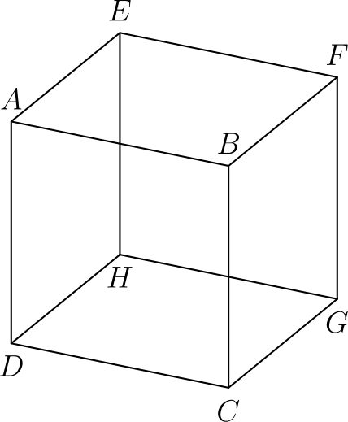
（A）6 （B）12 （C）18 （D）24 （E）36
English
How many pairs of parallel edges, such as AB and GH or EH and FG, does a cube have?
(A) 6 (B) 12 (C) 18 (D) 24 (E) 36
第 13 题
从集合
{1, 2, 3, 4, 5, 6, 7, 8, 9, 10, 11}
中可以移除多少个不同的二元素子集，使剩余九个数的平均数为 6？
（A）1 （B）2 （C）3 （D）5 （E）6
English
How many subsets of two elements can be removed from the set
{1, 2, 3, 4, 5, 6, 7, 8, 9, 10, 11}
so that the mean (average) of the nine remaining numbers is 6?
(A) 1 (B) 2 (C) 3 (D) 5 (E) 6
第 14 题
下列哪个整数不能写成四个连续奇整数之和？
（A）16 （B）40 （C）72 （D）100 （E）200
English
Which of the following integers cannot be written as the sum of four consecutive odd integers?
(A) 16 (B) 40 (C) 72 (D) 100 (E) 200
第 15 题
在欧拉中学，198 名学生对学校公投中的两个议题进行了投票，结果如下：149 人支持第一个议题，119 人支持第二个议题。如果正好有 29 名学生两个议题都反对，那么有多少名学生两个议题都支持？
（A）49 （B）70 （C）79 （D）99 （E）149
English
At Euler Middle School, 198 students voted on two issues in a school referendum with the following results. 149 voted in favor of the first issue and 119 voted in favor of the second issue. If there were exactly 29 students who voted against both issues, how many students voted in favor of both issues?
(A) 49 (B) 70 (C) 79 (D) 99 (E) 149
第 16 题
在一个中学导师项目中，一些六年级学生与一名九年级学生配成伙伴。没有九年级学生被分配超过一名六年级伙伴。如果所有九年级学生的 1/3 与所有六年级学生的 2/5 配成伙伴，那么六年级和九年级学生总数中有伙伴的比例是多少？
（A）2/15 （B）4/11 （C）11/30 （D）3/8 （E）11/15
English
In a middle-school mentoring program, a number of the sixth graders are paired with a ninth-grade student as a buddy. No ninth grader is assigned more than one sixth-grade buddy. If 1/3 of all the ninth graders are paired with 2/5 of all the sixth graders, what fraction of the total number of sixth and ninth graders have a buddy?
(A) 2/15 (B) 4/11 (C) 11/30 (D) 3/8 (E) 11/15
第 17 题
杰里米的父亲在交通高峰期开车送他上学要 20 分钟。某天没有交通拥堵，所以父亲能把车速提高每小时 18 英里，并在 12 分钟内把他送到学校。到学校有多少英里？
（A）4 （B）6 （C）8 （D）9 （E）12
English
Jeremy’s father drives him to school in rush hour traffic in 20 minutes. One day there is no traffic, so his father can drive him 18 miles per hour faster and gets him to school in 12 minutes. How far in miles is it to school?
(A) 4 (B) 6 (C) 8 (D) 9 (E) 12
第 18 题
等差数列是指从第二项开始，每一项都由前一项加上一个常数得到的数列。例如，2、5、8、11、14 是一个五项等差数列，第一项是 2，每次加上的常数是 3。这个 5×5 阵列中，每一行和每一列都是五项等差数列。X 的值是多少？
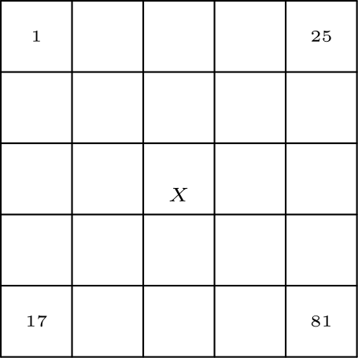
（A）21 （B）31 （C）36 （D）40 （E）42
English
An arithmetic sequence is a sequence in which each term after the first is obtained by adding a constant to the previous term. For example, 2, 5, 8, 11, 14 is an arithmetic sequence with five terms, in which the first term is 2 and the constant 3 is added. Each row and each column in this 5×5 array is an arithmetic sequence with five terms. What is the value of X?
(A) 21 (B) 31 (C) 36 (D) 40 (E) 42
第 19 题
顶点为 A=(1,3)、B=(5,1)、C=(4,4) 的三角形画在一个 6×5 网格上。这个三角形覆盖了网格的几分之几？
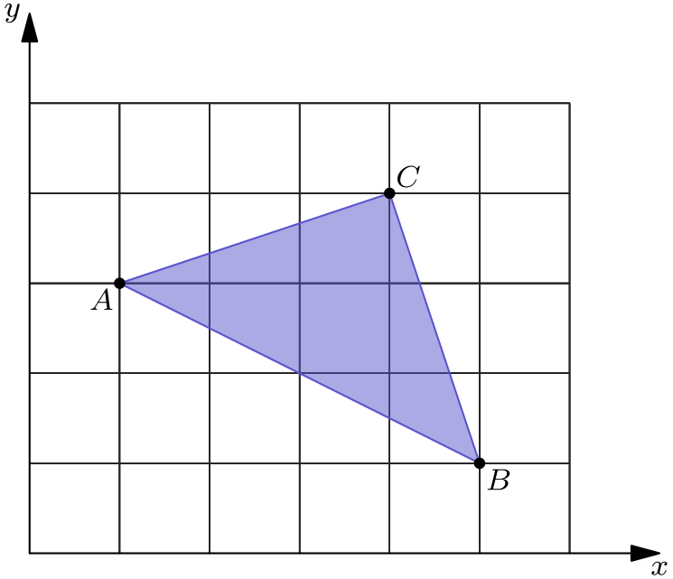
（A）1/6 （B）1/5 （C）1/4 （D）1/3 （E）1/2
English
A triangle with vertices at A=(1,3), B=(5,1), and C=(4,4) is plotted on a 6×5 grid. What fraction of the grid is covered by the triangle?
(A) 1/6 (B) 1/5 (C) 1/4 (D) 1/3 (E) 1/2
第 20 题
拉尔夫去商店买了 12 双袜子，总价 $24。他买的袜子中有些每双 $1，有些每双 $3，有些每双 $4。如果每种袜子他至少买一双，那么拉尔夫买了多少双 $1 的袜子？
（A）4 （B）5 （C）6 （D）7 （E）8
English
Ralph went to the store and bought 12 pairs of socks for a total of $24. Some of the socks he bought cost $1 a pair, some of the socks he bought cost $3 a pair, and some of the socks he bought cost $4 a pair. If he bought at least one pair of each type, how many pairs of $1 socks did Ralph buy?
(A) 4 (B) 5 (C) 6 (D) 7 (E) 8
第 21 题
如图，六边形 ABCDEF 是等角六边形，ABJI 和 FEHG 是面积分别为 18 和 32 的正方形，△ JBK 是等边三角形，且 FE=BC。△ KBC 的面积是多少？
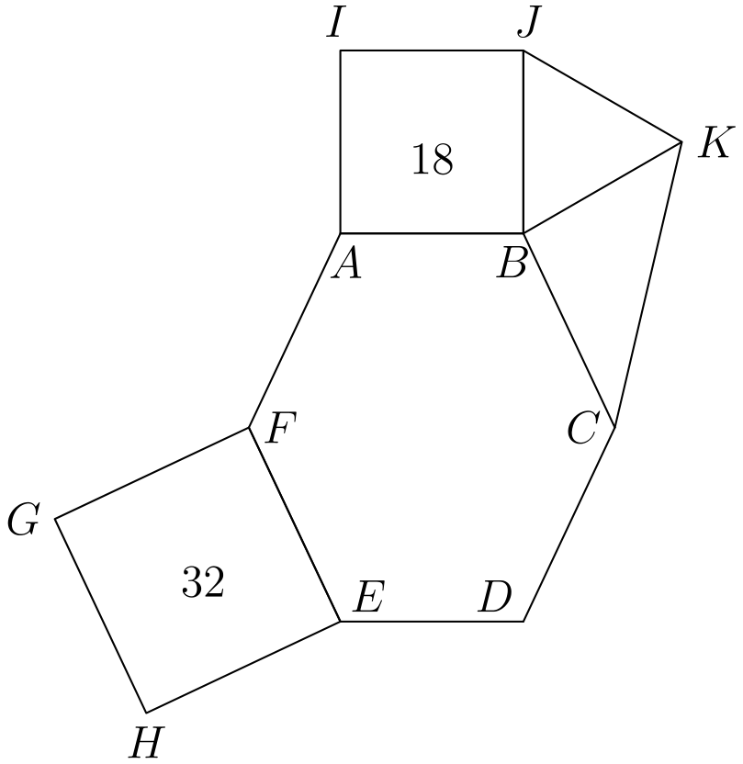
（A）6√(2) （B）9 （C）12 （D）9√(2) （E）32
English
In the given figure hexagon ABCDEF is equiangular, ABJI and FEHG are squares with areas 18 and 32 respectively, △ JBK is equilateral and FE=BC. What is the area of △ KBC?
(A) 6√(2) (B) 9 (C) 12 (D) 9√(2) (E) 32
第 22 题
六月 1 日，一组学生排成若干行，每行 15 人。六月 2 日，同一组学生排成一长行。六月 3 日，同一组学生每行只站一人。六月 4 日，同一组学生每行 6 人。这个过程一直持续到六月 12 日，每天每行人数都不同。然而到六月 13 日，他们找不到新的排列方式。这组学生最少可能有多少人？
（A）21 （B）30 （C）60 （D）90 （E）1080
English
On June 1, a group of students is standing in rows, with 15 students in each row. On June 2, the same group is standing with all of the students in one long row. On June 3, the same group is standing with just one student in each row. On June 4, the same group is standing with 6 students in each row. This process continues through June 12 with a different number of students per row each day. However, on June 13, they cannot find a new way of organizing the students. What is the smallest possible number of students in the group?
(A) 21 (B) 30 (C) 60 (D) 90 (E) 1080
第 23 题
汤姆有十二张纸条，他想把它们放入标有 A、B、C、D、E 的五个杯子中。
他希望每个杯子中纸条上的数之和都是整数，而且这五个整数从 A 到 E 连续递增。纸条上的数是 2、2、2、2.5、2.5、3、3、3、3、3.5、4、4.5。如果一张写有 2 的纸条放入杯子 E，一张写有 3 的纸条放入杯子 B，那么写有 3.5 的纸条必须放入哪个杯子？
（A）A （B）B （C）C （D）D （E）E
English
Tom has twelve slips of paper which he wants to put into five cups labeled A, B, C, D, E.
He wants the sum of the numbers on the slips in each cup to be an integer. Furthermore, he wants the five integers to be consecutive and increasing from A to E. The numbers on the papers are 2, 2, 2, 2.5, 2.5, 3, 3, 3, 3, 3.5, 4, 4.5. If a slip with 2 goes into cup E and a slip with 3 goes into cup B, then the slip with 3.5 must go into what cup?
(A) A (B) B (C) C (D) D (E) E
第 24 题
一个棒球联盟由两个四队分区组成。每支球队与同分区其他每支球队比赛 N 场。每支球队与另一个分区的每支球队比赛 M 场，其中 N > 2M，且 M > 4。每支球队赛程共 76 场。
每支球队在本分区内打多少场比赛？
（A）36 （B）48 （C）54 （D）60 （E）72
English
A baseball league consists of two four-team divisions. Each team plays every other team in its division N games. Each team plays every team in the other division M games with N > 2M and M > 4. Each team plays a 76 game schedule.
How many games does a team play within its own division?
(A) 36 (B) 48 (C) 54 (D) 60 (E) 72
第 25 题
从这个 5 英寸正方形的四个角各切去一个一英寸正方形。能放入剩余空间中的最大正方形面积是多少平方英寸？
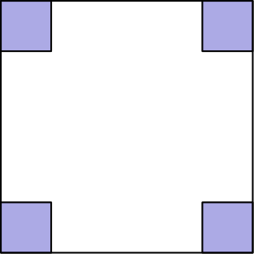
（A）9 （B）121/2 （C）15 （D）151/2 （E）17
English
One-inch squares are cut from the corners of this 5 inch square. What is the area in square inches of the largest square that can be fitted into the remaining space?
(A) 9 (B) 121/2 (C) 15 (D) 151/2 (E) 17

第二部分 解答
答案速查：
题号 1 2 3 4 5 6 7 8 9
答案 A D D E A B E D D
题号 10 11 12 13 14 15 16 17 18
答案 B B C D D D B D B
题号 19 20 21 22 23 24 25
答案 A D C C D B C
答案串：ADDEABEDDBBCDDDBDBADCCDBC
第 1 题 答案 A
一边长 12 英尺，即 12/3 = 4 码。
另一边长 9 英尺，即 9/3 = 3 码。
因为尺寸是 4 码乘 3 码，所以面积为
4·3=12
平方码。
所以正确答案是A。
English
Since one side is 12 feet, it would be 12/3 = 4 yards.
Since another side is 9 feet, it would be 9/3 = 3 yards.
Since the dimensions are 4 yards by 3 yards, the area is
4·3=12
square yards.
Thus, the correct answer isA.
第 2 题 答案 D
先注意，八边形可分成 8 个面积相等的三角形，每个三角形都以 O 为一个顶点。因此每个三角形占八边形总面积的 1/8。
阴影部分包含三个完整三角形和三角形 ABO 的一半。因此阴影面积是八边形总面积的
3.5/8 = 7/16
倍。
所以正确答案是D。
English
First notice that there are 8 equally sized triangles that can be created with O and any two consecutive points. Therefore, they each take up 1/8 of the total area of the octagon.
The shaded area has three complete triangles and half of the triangle ABO. Therefore, the shaded area is
3.5/8 = 7/16
of the total area of the octagon.
Thus, the correct answer isD.
第 3 题 答案 D
杰克走 4 英里需要 60 分钟，所以他到游泳池需要 60/4 = 15 分钟。
吉尔骑行 10 英里需要 60 分钟，所以她到游泳池需要 60/10 = 6 分钟。
两人的时间差为 15-6 = 9 分钟。
所以正确答案是D。
English
Jack travels at a rate of 4 miles per 60 minutes. Therefore, it takes him 60/4 = 15 minutes to get to the pool.
Jill travels at a rate of 10 miles per 60 minutes. Therefore it takes her 60/10 = 6 minutes to get to the pool.
Therefore, the difference in their times is 15-6 = 9 minutes.
Thus, the correct answer isD.
第 4 题 答案 E
两名男生坐在两端有 2! = 2 种方式。三名女生坐在中间三个座位有 3! = 6 种方式。
因此总排列数为 2·6=12。
所以正确答案是E。
English
There are 2! = 2 ways to place the two boys at the two ends. There are 3! = 6 ways to arrange the three girls in the middle seats.
Thus the total number of arrangements is 2·6=12.
Thus,Eis the correct answer.
第 5 题 答案 A
考虑全部 12 场比赛时，得分 40 来自第 12 场，并会成为最低分。因此，与前 11 场的极差相比，全部 12 场的极差从 73-42 = 31 增加到 73-40=33。
所以正确答案是A。
English
When considering all 12 games, 40, from the 12th game, will be the lowest score. Therefore, compared to the range of just the first 11 games, the range of all 12 games would increase from 73-42 = 31 to 73-40=33.
Thus, the correct answer isA.
第 6 题 答案 B
从 B 向 AC 作高，交 AC 于 X。因为 AB=BC，点 X 是 AC 的中点，所以 AX=21。
在直角三角形 ABX 中，高为
BX = √(29²-21²)
= √(400) = 20
。
因此 △ ABC 的面积为 1/2·42·20=420。
所以正确答案是B。
English
Drop the altitude from B to AC, meeting AC at X. Since AB=BC, point X is the midpoint of AC, so AX=21.
In right triangle ABX, the altitude is
BX = √(29²-21²)
= √(400) = 20.
The area of △ ABC is 1/2·42·20=420.
Thus,Bis the correct answer.
第 7 题 答案 E
只有当两枚筹码都是奇数时，乘积才是奇数。每个盒子中有两个奇数筹码 1 和 3，共三个筹码，所以乘积为奇数的概率是 (2/3)²=4/9。
乘积为偶数的概率是补集，等于 1-4/9=5/9。
所以正确答案是E。
English
The product is odd only when both chips are odd. Each box has two odd chips, 1 and 3, out of three chips, so the probability of an odd product is (2/3)²=4/9.
The probability of an even product is the complement, 1-4/9=5/9.
Thus,Eis the correct answer.
第 8 题 答案 D
设第三边长为 s。三角不等式给出 s<5+19=24，所以周长满足
5+19+s<48。
周长可以从下方任意接近 48，因此大于所有这类三角形周长的最小整数是 48。
所以正确答案是D。
English
Let the third side length be s. The triangle inequality gives s<5+19=24, so the perimeter satisfies
5+19+s<48.
Perimeters can be made arbitrarily close to 48 from below, so the smallest whole number larger than the perimeter of any such triangle is 48.
Thus,Dis the correct answer.
第 9 题 答案 D
我们要计算
1+3 + ⋯ + 39。
把两端的项依次配对，可得
(1+39)+(3+37)+⋯
+(19+21)
。
共有 10 对，每对和为 40，所以
10·40=400。
所以正确答案是D。
English
We want to find
1+3 + ⋯ + 39.
Pairing terms from the ends gives
(1+39)+(3+37)+⋯
+(19+21).
There are 10 pairs, and each pair sums to 40. Therefore, the sum is
10·40=400.
Thus, the correct answer isD.
第 10 题 答案 B
首先，千位有 9 种选择，因为 0 不能选。
接着，百位有 9 种选择，十位有 8 种选择，个位有 7 种选择。因此这样的整数共有 9·9·8·7 = 4536 个。
所以正确答案是B。
English
First, there are 9 digits to choose for the thousands digit since 0 can’t be chosen.
Then, after that, there are 9 ways to choose the hundreds digit, 8 ways to choose the tens digit, and 7 ways to choose the ones digit. Therefore, we get 9·9·8·7 = 4536 ways to choose such an integer.
Thus, the correct answer isB.
第 11 题 答案 B
第一个符号有 5 种选择，第二个有 21 种选择，第三个必须是不同的非元音字母，所以有 20 种选择，最后一个数字有 10 种选择。
因此可能牌照数为 5·21·20·10=21,000。其中正好一个是 AMC8，所以概率为 1/(21,000)。
所以正确答案是B。
English
There are 5 choices for the first symbol, 21 choices for the second, 20 choices for the third because it must be a different non-vowel, and 10 choices for the final digit.
Thus there are 5·21·20·10=21,000 possible plates. Exactly one of these is AMC8, so the probability is 1/(21,000).
Thus,Bis the correct answer.
第 12 题 答案 C
立方体有 12 条棱。对任意一条棱，都有另外 3 条棱与它平行。
这样每一对平行棱都被数了两次，所以平行棱对数为 (12·3)/2=18。
所以正确答案是C。
English
A cube has 12 edges. For any edge, there are 3 other edges parallel to it.
This counts each pair twice, once from each edge in the pair, so the number of pairs of parallel edges is (12·3)/2=18.
Thus,Cis the correct answer.
第 13 题 答案 D
原集合的和为 1+2+⋯+11=66。移除两个数后剩下 9 个数，平均数要为 6，所以剩余数总和必须是 9·6=54。
因此被移除的两个数之和必须是 66-54=12。可能的二元素子集为 {1,11}、{2,10}、{3,9}、{4,8}、{5,7}，共有 5 种。
所以正确答案是D。
English
The original set has sum 1+2+⋯+11=66. After removing two numbers, 9 numbers remain and must have mean 6, so their sum must be 9·6=54.
Therefore the two removed numbers must have sum 66-54=12. The possible two-element subsets are {1,11}, {2,10}, {3,9}, {4,8}, {5,7}, so there are 5 choices.
Thus,Dis the correct answer.
第 14 题 答案 D
设四个连续奇整数为 2k+1、2k+3、2k+5 和 2k+7。它们的和为
8k+16=8(k+2)。
所以这样的和必须是 8 的倍数。选项中唯一不能被 8 整除的是 100。
所以正确答案是D。
English
Let the four consecutive odd integers be 2k+1, 2k+3, 2k+5, and 2k+7. Their sum is
8k+16=8(k+2).
So any such sum must be a multiple of 8. The only answer choice that is not divisible by 8 is 100.
Thus,Dis the correct answer.
第 15 题 答案 D
因为 29 名学生两个议题都反对，所以 198-29 = 169 名学生至少支持一个议题。
已知 149 人支持第一个议题，119 人支持第二个议题，且 169 人至少支持一个议题。由容斥原理，两个都支持的人数为
149+119-169 = 99。
所以正确答案是D。
English
Since 29 students voted against both, we know that 198-29 = 169 people voted for at least one.
As we know that 149 students voted for the first issue, and 119 students voted for the second issue, and 169 students that voted for at least one issue, we conclude that the number of students that voted for both is
149+119-169 = 99.
Thus, the correct answer isD.
第 16 题 答案 B
设六年级学生有 s 人，九年级学生有 n 人。配对的九年级学生数等于配对的六年级学生数，所以
1/3 n=2/5 s。
得 5n=6s，所以 n:s=6:5。学生总数对应 11 份。
配对的九年级学生占全体学生的 1/3·6/11=2/11，配对的六年级学生占全体学生的 2/5·5/11=2/11。合计有 4/11 的学生有伙伴。
所以正确答案是B。
English
Let there be s sixth graders and n ninth graders. The number of paired ninth graders equals the number of paired sixth graders, so
1/3 n=2/5 s.
This gives 5n=6s, so n:s=6:5. The total number of students is therefore proportional to 11 parts.
The paired ninth graders make up 1/3·6/11=2/11 of all students, and the paired sixth graders make up 2/5·5/11=2/11 of all students. Altogether, 4/11 of the students have a buddy.
Thus,Bis the correct answer.
第 17 题 答案 D
设高峰期速度为每小时 s 英里。20 分钟是 1/3 小时，所以距离为 s/3。
没有交通拥堵时，速度为每小时 s+18 英里，路程用时 12 分钟，即 1/5 小时。同一距离为 s+18/5。
令两种距离相等：
s/3=s+18/5
得 5s=3s+54，所以 s=27。距离为 27/3=9 英里。
所以正确答案是D。
English
Let the rush-hour speed be s miles per hour. The 20-minute rush-hour trip takes 1/3 hour, so the distance is s/3.
Without traffic, the speed is s+18 miles per hour and the trip takes 12 minutes, or 1/5 hour. The same distance is s+18/5.
Set the distances equal:
s/3=s+18/5.
Then 5s=3s+54, so s=27. The distance is 27/3=9 miles.
Thus,Dis the correct answer.
第 18 题 答案 B
在任意五项等差数列中，中间项是首项和末项的平均数。
顶行的中间项为 1+25/2=13，底行的中间项为 17+81/2=49。
再对中间列使用同样事实，得 X=13+49/2=31。
所以正确答案是B。
English
In any five-term arithmetic sequence, the middle term is the average of the first and last terms.
The middle entry of the top row is 1+25/2=13, and the middle entry of the bottom row is 17+81/2=49.
Now apply the same fact to the middle column: X=13+49/2=31.
Thus,Bis the correct answer.
第 19 题 答案 A
整个网格的面积是 6·5=30。要求三角形面积，可把它放在下图所示的宽为 4、高为 3 的长方形中。
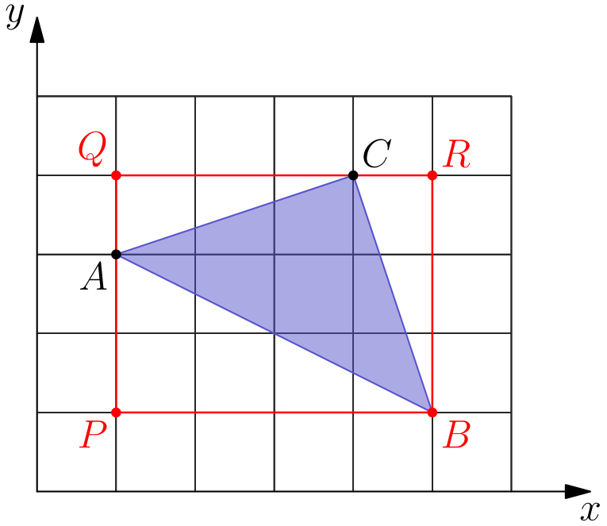
长方形的面积为 4·3=12。三个角上三角形的面积分别为 1/2(4)(2)=4、1/2(1)(3)=3/2 和 1/2(3)(1)=3/2。因此
[△ ABC] = 12-4-3/2-3/2
=5
。
因此覆盖比例为 5/30 = 1/6 。
所以正确答案是A。
English
The total area of the grid is 6·5=30. To find the area of the triangle, place it inside the 4-by-3 rectangle shown below.
The rectangle has area 4·3=12. The three corner triangles have areas 1/2(4)(2)=4, 1/2(1)(3)=3/2, and 1/2(3)(1)=3/2. Therefore,
[△ ABC] = 12-4-3/2-3/2
=5.
Therefore, the fraction of the area is 5/30 = 1/6.
Thus, the correct answer isA.
第 20 题 答案 D
设 a、b、c 分别为 $1、$3、$4 的袜子双数。则
a+b+c=12，
a+3b+4c=24。
两式相减得 2b+3c=12。因为每种至少买一双，所以 b>0、c>0。又 3c<12，所以 c<4。从方程模 2 看，c 必须是偶数，所以 c=2。
于是 2b+6=12，得 b=3，所以 a=12-3-2=7。
所以正确答案是D。
English
Let a, b, and c be the numbers of $1, $3, and $4 pairs, respectively. Then
a+b+c=12,
a+3b+4c=24.
Subtracting gives 2b+3c=12. Since at least one pair of each type was bought, b>0 and c>0. Also 3c<12, so c<4. Modulo 2, the equation gives c even, so c=2.
Then 2b+6=12, so b=3, and a=12-3-2=7.
Thus,Dis the correct answer.
第 21 题 答案 C
面积为 18 的正方形边长为 JB=√(18)=3√(2)。因为 △ JBK 是等边三角形，所以 BK=3√(2)。
面积为 32 的正方形边长为 FE=√(32)=4√(2)。因为 FE=BC，所以 BC=4√(2)。
在 B 点处，等边三角形、正方形和等角六边形的内角分别为 60°、90° 和 120°。因此
∠ KBC = 360°-60°-90°
-120°
=90°
。
所以
[△ KBC]=1/2(3√(2))(4√(2))=12。
所以正确答案是C。
English
The square with area 18 has side length JB=√(18)=3√(2). Since △ JBK is equilateral, BK=3√(2).
The square with area 32 has side length FE=√(32)=4√(2). Since FE=BC, we have BC=4√(2).
At B, the equilateral triangle, square, and equiangular hexagon contribute angles of 60°, 90°, and 120°, respectively. Hence
∠ KBC = 360°-60°-90°
-120°
=90°.
Therefore
[△ KBC]=1/2(3√(2))(4√(2))=12.
Thus,Cis the correct answer.
第 22 题 答案 C
每行可站的人数正好是学生总数的正因数。因为六月 1 日至六月 12 日有不同排列，而六月 13 日没有新的排列方式，所以总人数必须恰好有 12 个正因数。
总人数必须同时能被 15 和 6 整除，因此能被 lcm(15,6)=30=2·3·5 整除。而这个数只有 8 个因数。
最小的 30 的倍数且有 12 个因数的是 60=2²·3·5，其因数个数为 (2+1)(1+1)(1+1)=12。
所以正确答案是C。
English
The possible numbers of students per row are exactly the positive divisors of the total number of students. Since June 1 through June 12 give different arrangements and June 13 gives no new one, the total number of students must have exactly 12 positive divisors.
The number must be divisible by both 15 and 6, hence by lcm(15,6)=30=2·3·5. This number has only 8 divisors.
The smallest multiple of 30 with 12 divisors is 60=2²·3·5, which has (2+1)(1+1)(1+1)=12 divisors.
Thus,Cis the correct answer.
第 23 题 答案 D
所有纸条的和为 35，所以五个连续整数杯子和的平均数必须是 7。因此杯子 A、B、C、D、E 的和分别为 5、6、7、8、9。
杯子 B 已经有一张 3，且总和必须为 6，所以它还必须有另一张 3。杯子 E 已经有一张 2，所以 E 中其他纸条之和必须为 7。
3.5 不能放在 A，因为杯子 A 还需要 1.5。它不能放在 B，因为这个杯子已经满了。它不能放在 C 或 E，因为那样还需要另一个 3.5，而剩余纸条不能凑出这个和。杯子 D 可行，例如 3.5+4.5=8。
所以正确答案是D。
English
The sum of all the slips is 35, so the five consecutive integer cup sums must average 7. Therefore cups A, B, C, D, and E must have sums 5, 6, 7, 8, and 9, respectively.
Cup B already contains a 3 and must sum to 6, so it must contain another 3. Cup E already contains a 2, so the other slips in E must sum to 7.
The 3.5 slip cannot go in A, because cup A would need another 1.5. It cannot go in B, which is already full. It cannot go in C or E, because either would then need another 3.5, and no remaining slips can make that total. Cup D works, for example with 3.5+4.5=8.
Thus,Dis the correct answer.
第 24 题 答案 B
每支球队在本分区内打 3N 场，对另一个分区打 4M 场，所以
3N+4M=76。
因为 N>2M，所以 3N>6M，从而 76=3N+4M>10M。因此 M<7.6。又 M>4，所以 M∈{5,6,7}。
将 3N+4M=76 模 3，得 M≡1pmod3，所以 M=7。因此每支球队打 4M=28 场非分区比赛，本分区比赛为 76-28=48 场。
所以正确答案是B。
English
Each team plays 3N games within its own division and 4M games against the other division, so
3N+4M=76.
Since N>2M, we have 3N>6M, and hence 76=3N+4M>10M. Thus M<7.6. Together with M>4, this gives M∈{5,6,7}.
Reducing 3N+4M=76 modulo 3 gives M≡1pmod3, so M=7. Therefore the team plays 4M=28 non-division games and 76-28=48 division games.
Thus,Bis the correct answer.
第 25 题 答案 C
对于能放入的最大正方形，它的每条边都必须接触一个被挖去的边长为 1 英寸的小正方形的内角，否则还可以继续放大。因此它围住中央的 3×3 正方形，并在四边各增加一个全等直角三角形。
中央正方形面积为 3·3=9。每个增加的三角形两条直角边为 3 和 1，四个三角形总面积为
4((3·1)/2)=6。
放入的正方形面积为 9+6=15。
所以正确答案是C。
English
For a largest fitted square, each side must touch an inner corner of one of the removed 1-inch squares; otherwise the fitted square could be enlarged. Thus it surrounds the central 3×3 square and adds four congruent right triangles, one along each side.
The central square has area 3·3=9. Each added triangle has base 3 and height 1, so the four triangles have total area
4((3·1)/2)=6.
The fitted square has area 9+6=15.
Thus,Cis the correct answer.

