2012 年 AMC 8 真题与解答
American Mathematics Competitions 8 · 中英双语
共 25 题，限时 40 分钟；单项选择题，每题 1 分，答错不扣分，满分 25 分。
编排说明：第一部分为题目（先中文、后英文原题），第二部分为解答与答案，便于先做题后对答案。
第一部分 题目
第 1 题
Rachelle 用 3 磅肉为家人做 8 个汉堡。她要为社区野餐做 24 个汉堡，需要多少磅肉？
（A）6 （B）62/3 （C）71/2 （D）8 （E）9
English
Rachelle uses 3 pounds of meat to make 8 hamburgers for her family. How many pounds of meat does she need to make 24 hamburgers for a neighborhood picnic?
(A) 6 (B) 62/3 (C) 71/2 (D) 8 (E) 9
第 2 题
在 East Westmore 县，统计学家估计每 8 小时出生一个婴儿，每天死亡一人。四舍五入到最接近的百位，East Westmore 每年人口增加多少人？
（A）600 （B）700 （C）800 （D）900 （E）1000
English
In the county of East Westmore, statisticians estimate there is a baby born every 8 hours and a death every day. To the nearest hundred, how many people are added to the population of East Westmore each year?
(A) 600 (B) 700 (C) 800 (D) 900 (E) 1000
第 3 题
二月 13 日，The Oshkosh Northwester刊登的白昼时长为 10 小时 24 分钟，日出时间为 6:57AM 并把日落时间标为 8:15PM，而白昼时长和日出时间是正确的，但日落时间是错误的。太阳实际什么时候落下？
（A）5:10PM （B）5:21PM （C）5:41PM （D）5:57PM （E）6:03PM
English
On February 13The Oshkosh Northwesterlisted the length of daylight as 10 hours and 24 minutes, the sunrise as 6:57AM, and the sunset as 8:15PM. The length of daylight and sunrise were correct, but the sunset was wrong. When did the sun really set?
(A) 5:10PM (B) 5:21PM (C) 5:41PM (D) 5:57PM (E) 6:03PM
第 4 题
Peter 一家晚餐订了一个切成 12 片的披萨。Peter 吃了一片，又和弟弟 Paul 平分了另一片。Peter 吃了这个披萨的几分之几？
（A）1/24 （B）1/12 （C）1/8 （D）1/6 （E）1/4
English
Peter’s family ordered a 12-slice pizza for dinner. Peter ate one slice and shared another slice equally with his brother Paul. What fraction of the pizza did Peter eat?
(A) 1/24 (B) 1/12 (C) 1/8 (D) 1/6 (E) 1/4
第 5 题
图中所有角都是直角，边长以厘米为单位给出。注意图形不是按比例绘制的。X 是多少厘米？
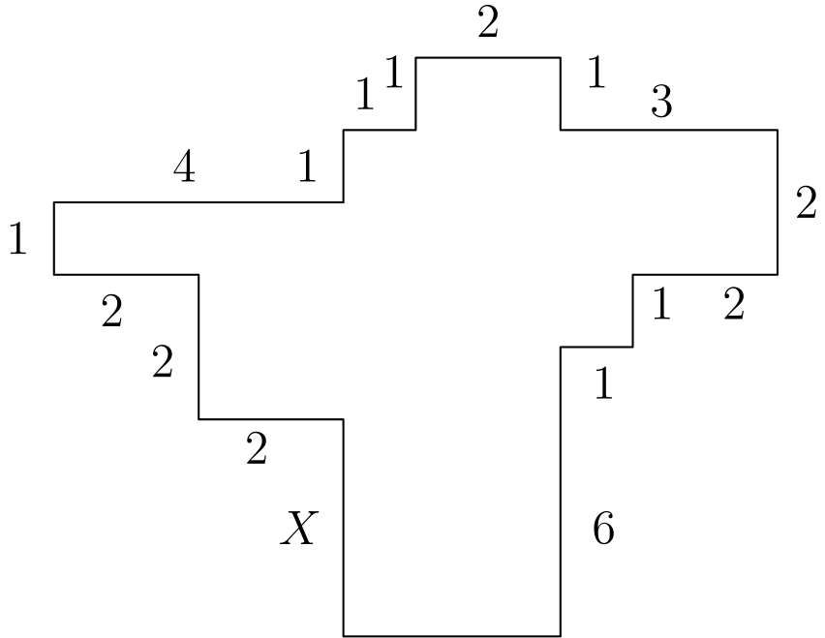
（A）1 （B）2 （C）3 （D）4 （E）5
English
In the diagram, all angles are right angles and the lengths of the sides are given in centimeters. Note the diagram is not drawn to scale. What is X, in centimeters?
(A) 1 (B) 2 (C) 3 (D) 4 (E) 5
第 6 题
一张长方形照片放入相框后，照片四周形成宽二英寸的边框。照片高 8 英寸、宽 10 英寸。边框的面积是多少平方英寸？
（A）36 （B）40 （C）64 （D）72 （E）88
English
A rectangular photograph is placed in a frame that forms a border two inches wide on all sides of the photograph. The photograph measures 8 inches high and 10 inches wide. What is the area of the border, in square inches?
(A) 36 (B) 40 (C) 64 (D) 72 (E) 88
第 7 题
Isabella 的数学课要进行四次满分为 100 分的测试。她的目标是四次测试的平均分至少达到 95。她前两次测试成绩是 97 和 91。看到第三次测试成绩后，她意识到自己仍然可以达到目标。她第三次测试最低可能得多少分？
（A）90 （B）92 （C）95 （D）96 （E）97
English
Isabella must take four 100-point tests in her math class. Her goal is to achieve an average grade of at least 95 on the tests. Her first two test scores were 97 and 91. After seeing her score on the third test, she realized that she could still reach her goal. What is the lowest possible score she could have made on the third test?
(A) 90 (B) 92 (C) 95 (D) 96 (E) 97
第 8 题
一家商店广告称“今天促销所有商品半价”。此外，一张优惠券可在促销价基础上再享受 20% 的折扣。使用优惠券后，今天的价格相对于原价的折扣率是多少？
（A）10 （B）33 （C）40 （D）60 （E）70
English
A shop advertises that everything is “half price in today’s sale.” In addition, a coupon gives a 20% discount on sale prices. Using the coupon, the price today represents what percentage discount off the original price?
(A) 10 (B) 33 (C) 40 (D) 60 (E) 70
第 9 题
Fort Worth Zoo 有一些两条腿的鸟和一些四条腿的哺乳动物。Margie 某次参观动物园时数到 200 个头和 522 条腿。Margie 数到的动物中有多少是两条腿的鸟？
（A）61 （B）122 （C）139 （D）150 （E）161
English
The Fort Worth Zoo has a number of two-legged birds and a number of four-legged mammals. On one visit to the zoo, Margie counted 200 heads and 522 legs. How many of the animals that Margie counted were two-legged birds?
(A) 61 (B) 122 (C) 139 (D) 150 (E) 161
第 10 题
使用 2012 的四个数字，可以组成多少个大于 1000 的 4 位数？
（A）6 （B）7 （C）8 （D）9 （E）12
English
How many 4-digit numbers greater than 1000 are there that use the four digits of 2012?
(A) 6 (B) 7 (C) 8 (D) 9 (E) 12
第 11 题
正整数 3、4、5、6、6、7 和 x 的平均数、中位数和唯一众数都相等。x 的值是多少？
（A）5 （B）6 （C）7 （D）11 （E）12
English
The mean, median, and unique mode of the positive integers 3, 4, 5, 6, 6, 7, and x are all equal. What is the value of x?
(A) 5 (B) 6 (C) 7 (D) 11 (E) 12
第 12 题
13²⁰¹² 的个位数字是什么？
（A）1 （B）3 （C）5 （D）7 （E）9
English
What is the units digit of 13²⁰¹²?
(A) 1 (B) 3 (C) 5 (D) 7 (E) 9
第 13 题
Jamar 在学校书店买了一些铅笔，每支铅笔价格超过一美分，共支付 $1.43。Sharona 买了同样的铅笔，共支付 $1.87。Sharona 比 Jamar 多买了多少支铅笔？
（A）2 （B）3 （C）4 （D）5 （E）6
English
Jamar bought some pencils costing more than a penny each at the school bookstore and paid $1.43. Sharona bought some of the same pencils and paid $1.87. How many more pencils did Sharona buy than Jamar?
(A) 2 (B) 3 (C) 4 (D) 5 (E) 6
第 14 题
在中学橄榄球联盟 BIG N 中，每支球队与其他每支球队恰好比赛一次。如果 2012 赛季共进行了 21 场联盟比赛，那么 BIG N 联盟有多少支球队？
（A）6 （B）7 （C）8 （D）9 （E）10
English
In the BIG N, a middle school football conference, each team plays every other team exactly once. If a total of 21 conference games were played during the 2012 season, how many teams were members of the BIG N conference?
(A) 6 (B) 7 (C) 8 (D) 9 (E) 10
第 15 题
大于 2 且除以 3、4、5 或 6 时余数都为 2 的最小数，位于哪两个数之间？
（A）40 和 50 （B）51 和 55 （C）56 和 60 （D）61 和 65 （E）66 和 99
English
The smallest number greater than 2 that leaves a remainder of 2 when divided by 3, 4, 5, or 6 lies between what numbers?
(A) 40 and 50 (B) 51 and 55 (C) 56 and 60 (D) 61 and 65 (E) 66 and 99
第 16 题
数字 0、1、2、3、4、5、6、7、8 和 9 各使用一次，组成两个五位数，使它们的和尽可能大。下列哪一个可能是其中一个数？
（A）76531 （B）86724 （C）87431 （D）96240 （E）97403
English
Each of the digits 0, 1, 2, 3, 4, 5, 6, 7, 8, and 9 is used only once to make two five-digit numbers so that they have the largest possible sum. Which of the following could be one of the numbers?
(A) 76531 (B) 86724 (C) 87431 (D) 96240 (E) 97403
第 17 题
一个边长为整数的正方形被切成 10 个正方形，所有小正方形边长都是整数，并且至少 8 个小正方形的面积为 1。原正方形边长的最小可能值是多少？
（A）3 （B）4 （C）5 （D）6 （E）7
English
A square with an integer side length is cut into 10 squares, all of which have integer side length and at least 8 of which have area 1. What is the smallest possible value of the length of the side of the original square?
(A) 3 (B) 4 (C) 5 (D) 6 (E) 7
第 18 题
最小的正整数是多少，要求它既不是质数也不是平方数，并且没有小于 50 的质因数？
（A）3127 （B）3133 （C）3137 （D）3139 （E）3149
English
What is the smallest positive integer that is neither prime nor square and that has no prime factor less than 50?
(A) 3127 (B) 3133 (C) 3137 (D) 3139 (E) 3149
第 19 题
一个罐子里有红色、绿色和蓝色弹珠。除了 6 个以外全是红弹珠，除了 8 个以外全是绿弹珠，除了 4 个以外全是蓝弹珠。罐子里有多少个弹珠？
（A）6 （B）8 （C）9 （D）10 （E）18
English
In a jar of red, green, and blue marbles, all but 6 are red marbles, all but 8 are green, and all but 4 are blue. How many marbles are in the jar?
(A) 6 (B) 8 (C) 9 (D) 10 (E) 18
第 20 题
三个数 5/19 、7/21 和 9/23 按从小到大排列的正确顺序是什么？
（A）9/23 < 7/21 < 5/19 （B）5/19 < 7/21 <
9/23 （C）9/23 < 5/19 < 7/21 （D）5/19 < 9/23 < 7/21 （E）7/21 < 5/19 < 9/23
English
What is the correct ordering of the three numbers 5/19, 7/21, and 9/23, in increasing order?
(A) 9/23 < 7/21 < 5/19 (B) 5/19 < 7/21 <
9/23 (C) 9/23 < 5/19 < 7/21 (D) 5/19 < 9/23 < 7/21 (E) 7/21 < 5/19 < 9/23
第 21 题
Marla 有一个边长 10 英尺的大白色立方体。她还有足够覆盖 300 平方英尺的绿色油漆。Marla 用完所有油漆，在每个面上画出一个居中的白色正方形，周围是绿色边框。每个白色正方形的面积是多少平方英尺？
（A）5√(2) （B）10 （C）10√(2) （D）50 （E）50√(2)
English
Marla has a large white cube that has an edge of 10 feet. She also has enough green paint to cover 300 square feet. Marla uses all the paint to create a white square centered on each face, surrounded by a green border. What is the area of one of the white squares, in square feet?
(A) 5√(2) (B) 10 (C) 10√(2) (D) 50 (E) 50√(2)
第 22 题
设 R 是一个由九个互不相同整数构成的集合。其中六个元素是 2、3、4、6、9 和 14。R 的中位数可能有多少个不同的值？
（A）4 （B）5 （C）6 （D）7 （E）8
English
Let R be a set of nine distinct integers. Six of the elements of the set are 2, 3, 4, 6, 9, and 14. What is the number of possible values of the median of R?
(A) 4 (B) 5 (C) 6 (D) 7 (E) 8
第 23 题
一个等边三角形和一个正六边形周长相等。如果三角形面积为 4，那么六边形面积是多少？
（A）4 （B）5 （C）6 （D）4√(3) （E）6√(3)
English
An equilateral triangle and a regular hexagon have equal perimeters. If the triangle’s area is 4, what is the area of the hexagon?
(A) 4 (B) 5 (C) 6 (D) 4√(3) (E) 6√(3)
第 24 题
一个半径为 2 的圆被分成四段全等圆弧。将这四段圆弧连接成图中的星形。星形面积与原圆面积之比是多少？
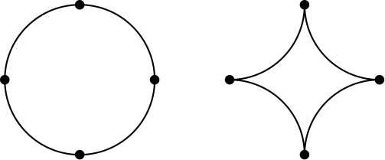
（A）4-π/π （B）1/π （C）(√(2))/π （D）π-1/π （E）3/π
English
A circle of radius 2 is cut into four congruent arcs. The four arcs are joined to form the star figure shown. What is the ratio of the area of the star figure to the area of the original circle?
(A) 4-π/π (B) 1/π (C) (√(2))/π (D) π-1/π (E) 3/π
第 25 题
一个面积为 4 的正方形内接于一个面积为 5 的正方形，较小正方形的每个顶点分别在较大正方形的一条边上。较小正方形的一个顶点将较大正方形的一条边分成两段，长度分别为 a 和 b。ab 的值是多少？
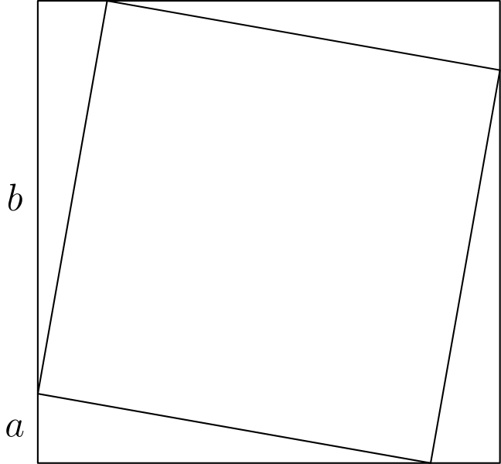
（A）1/5 （B）2/5 （C）1/2 （D）1 （E）4
English
A square with area 4 is inscribed in a square with area 5, with one vertex of the smaller square on each side of the larger square. A vertex of the smaller square divides a side of the larger square into two segments, one of length a and the other of length b. What is the value of ab ?
(A) 1/5 (B) 2/5 (C) 1/2 (D) 1 (E) 4

第二部分 解答
答案速查：
题号 1 2 3 4 5 6 7 8 9
答案 E B B C E E B D C
题号 10 11 12 13 14 15 16 17 18
答案 D D A C B D C B A
题号 19 20 21 22 23 24 25
答案 C B D D C A C
答案串：EBBCEEBDCDDACBDCBACBDDCAC
第 1 题 答案 E
8 个汉堡是 24 个汉堡的 1/3，所以 3 磅也是所需肉量的 1/3。因此总肉量为 1/(1/3) · 3 = 3·3 = 9。
所以正确答案是E。
English
If we have 8 hamburgers, we have 1/3 of the 24 hamburgers. This means we have 1/3 of the meat when we have 3 pounds. The total amount of meat is therefore 1/(1/3) · 3 = 3·3 = 9.
Thus, the answer isE.
第 2 题 答案 B
每 8 小时出生 1 个婴儿，所以每 24 小时出生 3 个婴儿。因此每天有 3 人出生、1 人死亡，平均每天人口净增加 2 人。一年有 365 天，每天净增加 2 人，所以一年净增加约 2· 365 = 730 人，约为 700。
所以正确答案是B。
English
Since we have 1 birth every 8 hours, we have 3 births every 24 hours. Therefore, we have 3 births a day and 1 death a day. The net change in population every day should be on average 2. Since we have 365 days in a year and 2 added to the population every day, the net change in population should be around 2· 365 = 730. This is approximately 700.
Thus, the answer isB.
第 3 题 答案 B
从 6:57 AM 起 10 小时后是 4:57 PM 。也就是说，日出后 10 小时 3 分钟是 5:00 PM 。距日落还有 21 分钟，所以实际日落时间是 5:21 PM 。
所以正确答案是B。
English
Since 10 hours after 6:57 AM is 4:57 PM, we can then say 10 hours and 3 minutes after sunrise is 5:00 PM. We then have 21 more minutes until sunset, so sunset is 5:21 PM.
Thus, the answer isB.
第 4 题 答案 C
Peter 吃了 1 整片，又吃了他分得的那片的 1/2。
因此他吃了整个披萨的 (3/2)/12，也就是 1/8。
所以正确答案是C。
English
Peter ate 1 full slice, and he ate 1/2 of the slice that he split.
Therefore, he ate (3/2)/12 of the pizza, which is equivalent to 1/8.
Thus, the answer isC.
第 5 题 答案 E
先从右侧高度相加求图形总高度，得 1+2+1+6 = 10。
再从左侧高度相加，得 1+1+1+2+X = 5+X。
两个高度相同，所以 10=5+X ，因此 X = 5。
所以正确答案是E。
English
First, we can find the height of the object by getting the sum of the heights on the right. Therefore, the height is 1+2+1+6 = 10.
Next, we can find the height of the object by getting the sum of the heights on the left. Therefore, the height is 1+1+1+2+X = 5+X.
Since the heights are the same, we know 10=5+X, so X = 5.
Thus, the answer isE.
第 6 题 答案 E
每一边都增加 2 英寸，所以高度和宽度各总共增加 4 英寸。外部长方形尺寸为 12 × 14，面积为 12· 14 = 168。
照片本身面积为 8 · 10 =80。
因此边框面积为 168-80=88。
所以正确答案是E。
English
If we add 2 inches on each side, we add 4 inches total on both sides. This means that the dimensions of the outer part of the frame are 12 × 14. The area of this is 12· 14 = 168.
However, we must take out the area of the inner part of the frame which has area 8 · 10 =80.
Therefore, the total area is 168-80=88.
Thus, the answer isE.
第 7 题 答案 B
若平均分为 95，四次测试总分为 95· 4 = 380 。由于已知前两次成绩，后两次测试总分是 380 减去前两次成绩。
后两次测试总分必须为 380-91-97 = 192。因此后两次成绩之和为 192。
要使第三次成绩最低，就让第四次成绩最高，为 100。于是第三次成绩为 192 -100 = 92。
所以正确答案是B。
English
If the average is 95, then the sum of the tests is 95· 4 = 380. Since we have the first two tests, the sum of the last two tests is 380 minus the first two scores.
This makes the sum of the last two scores equal to 380-91-97 = 192. Her last two scores therefore have a sum of 192.
Given the sum of the tests we try to minimize one score, then we must maximize the other test. Therefore, we maximize the fourth test by making it 100. This would make the third test equal to 192 -100 = 92.
Thus, the answer isB.
第 8 题 答案 D
设原价为 p。半价后价格为 0.5p。
再打 20% 折扣表示支付价格的 80%，所以最终价格为 0.5p· 0.8 =0.4p。
因此减少了 0.6p，折扣率为 0.6p/p = 0.6，即 60%。
所以正确答案是D。
English
Let p be the original price. If everything is half off, we have the new price as 0.5p.
Having a 20% discount makes it such that we keep 80% of the price, so the price is 0.5p· 0.8 =0.4p.
This would have 0.6p off, so we get a discount of 0.6p/p = 0.6, which is 60%.
Thus, the answer isD.
第 9 题 答案 C
设 f 为 4 条腿动物的数量，t 为 2 条腿动物的数量。
数腿得到 2t+4f = 522，数头得到 t + f = 200。将第二式乘以四，得 4t+4f = 800。减去第一式，得到 2t = 278 implies t = 139。因此有 139 只两条腿的鸟。
所以正确答案是C。
English
Let f be the number of animals with 4 legs and let t be the number of animals with 2 legs.
Counting the number of legs yields 2t+4f = 522 and counting the number of heads yields t + f = 200. This means 4t+4f = 800, and subtracting the first equation from the second yields 2t = 278 implies t = 139. This means there are 139 two-legged birds.
Thus, the answer isC.
第 10 题 答案 D
0 不能放在千位。因此有 3 个位置可放。放好零后，数字 1 有 3 个可用位置，两个 2 自动占据剩余位置。因此共有 3· 3 = 9 个数。
所以正确答案是D。
English
First, we can’t have the 0 in the thousands position. Therefore, we have 3 spots we can put it. Then, we have 3 available positions for the 1, and then the two 2s are placed. This makes it such that we have 3· 3 = 9 combinations.
Thus, the answer isD.
第 11 题 答案 D
已列出的数中，除 6 外每个数只出现一次，而 6 出现两次。若 x 等于其他已列出的数，就会有两个众数，不再有唯一众数。因此唯一众数必须是 6，平均数也必须是 6。共有 7 个数，所以总和为 6· 7 = 42。另一方面，总和还等于
3+4+5+6+6+7+x
= 31+x
= 42，
所以 x = 11。
所以正确答案是D。
English
Every listed value except 6 appears once while 6 appears twice. If x equals any of the other listed values, then we have two modes, which means we do not have a unique mode. Otherwise, the only value that shows up more than once is 6 making that the unique mode. This also means 6 is the mean. Since there are 7 elements, the sum of the elements is 6· 7 = 42. The sum is also
3+4+5+6+6+7+x
= 31+x
= 42,
so x = 11.
Thus, the answer isD.
第 12 题 答案 A
要求个位数字，只需计算 13²⁰¹² mod 10。
13²⁰¹² ≡ 3²⁰¹² mod 10
≡ 81⁵⁰³ mod 10
≡ 1⁵⁰³ mod 10
≡ 1 mod 10
这说明 13²⁰¹² 的个位数字与 1 相同，所以 13²⁰¹² 的个位数字是 1。
所以正确答案是A。
English
We have to find 13²⁰¹² mod 10. The following is true:
13²⁰¹² ≡ 3²⁰¹² mod 10
≡ 81⁵⁰³ mod 10
≡ 1⁵⁰³ mod 10
≡ 1 mod 10
This means 13²⁰¹² has the same units digit as 1, so the units digit of 13²⁰¹² is 1.
Thus, the answer isA.
第 13 题 答案 C
设每支铅笔价格为 c 美分。则 c 同时整除 143 和 187，且 c>1。
因为 143=11·13，且 187=11·17，最大公因数是 11。所以每支铅笔 11 美分。
Sharona 多付了 187-143=44 美分，所以她多买了 44/11=4 支铅笔。所以正确答案是C。
English
Let c be the price of one pencil in cents. Then c divides both 143 and 187, and c>1.
Since 143=11·13 and 187=11·17, the greatest common divisor is 11. Thus each pencil costs 11 cents.
Sharona paid 187-143=44 cents more, so she bought 44/11=4 more pencils. Thus, the answer isC.
第 14 题 答案 B
若有 N 支球队，每支球队要与 N-1 支球队比赛。不过，每场比赛涉及 2 支球队，所以把 N 与 N-1 相乘会把每场比赛数两次。因此 N(N-1) = 42。这给出
N² -N +0.25 = 42.25
从而
(N-0.5)² = 6.5²，
于是
N-0.5 = 6.5
N = 7
所以正确答案是B。
English
Each of the N teams plays N-1 games. However, 2 teams play each game, so multiplying N and N-1 would be twice the number of games. Therefore, we know N(N-1) = 42. This leads to
N² -N +0.25 = 42.25
which implies
(N-0.5)² = 6.5².
In turn, this suggests:
N-0.5 = 6.5
N = 7
Thus, the answer isB.
第 15 题 答案 D
设这个数为 x。因为它除以 3、4、5 和 6 时余数都是 2，所以 x-2 是 3、4、5 和 6 的公倍数。这表示 x-2 是 lcm(3,4,5,6) 的倍数，而这个最小公倍数是 60。因此 x-2 必须是 60 的倍数。下一个满足条件的数出现在 x-2 = 60 implies x = 62 时。
所以正确答案是D。
English
Let the number be x. Since it leaves a remainder of 2 when divided by 3, 4, 5, and 6, we know x-2 is a multiple of 3, 4, 5, and 6. This means x-2 is a multiple of lcm(3,4,5,6), which is 60. Therefore, x-2 must be a multiple of 60. The next number such that this occurs is when x-2 = 60 implies x = 62.
Thus, the answer isD.
第 16 题 答案 C
要让两个五位数的和最大，从左到右的各位数字应尽可能大。因此两个数的第一位必须是 9 或 8，第二位是 7 或 6，第三位是 5 或 4，第四位是 3 或 2，最后一位是 1 或 0。
给出的数中，唯一满足这种位置要求的是 87431。
所以正确答案是C。
English
To construct two five-digit numbers, the digits in the largest place values must be as great as possible. Therefore, the leftmost digits must be the greatest two digits. This means the first digit must be either 9 or 8, the second digit must be either 7 or 6, the third digit must be either 5 or 4, the fourth digit must be either 3 or 2, and the last digit must be either 1 or 0.
The only one of the given numbers that satisfy this is 87431.
Thus, the answer isC.
第 17 题 答案 B
因为这 10 个小正方形的边长都是正整数，所以每个小正方形的面积至少为 1，总面积至少为 10。边长不超过 3 的整数边长正方形面积至多为 3²=9，所以大正方形的边长不能小于 4。
下图把一个 4×4 正方形切成十个整数边长的正方形，其中八个是单位正方形。因此边长 4 可以达到，而且是最小值。
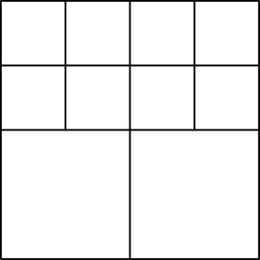
所以正确答案是B。
English
Since all 10 squares have positive integer side lengths, each has area at least 1. Their total area is therefore at least 10. A square with integer side length at most 3 has area at most 3²=9, so its side length cannot be less than 4.
The following configuration cuts a 4×4 square into ten integer-sided squares, eight of which are unit squares. Therefore side length 4 is attainable and is the minimum.
Thus, the answer isB.
第 18 题 答案 A
这个数是合数，不是质数，并且没有小于 50 的质因数。因此最小可能的质因数是 53、59、61，依此类推。
像 53² 这样的平方数不允许，而 53³ 远大于 53·59。最小的非平方合数是 53·59=3127。
所以正确答案是A。
English
The number is composite, not prime, and has no prime factor below 50. The smallest possible prime factors are therefore 53, 59, 61, and so on.
A square such as 53² is not allowed, and 53³ is much larger than 53·59. The smallest allowed nonsquare composite is 53·59=3127.
Thus, the answer isA.
第 19 题 答案 C
设红、绿、蓝弹珠数分别为 r,g,b。由题意可知
r+g+b -r=6，
r+g+b-g = 8，
r+g+b-b = 4。
把这些方程相加，得到 3(r+g+b) -(r+g+b) = 18。因此 2(r+g+b) = 18，所以 r+g+b = 9。也就是说，弹珠总数为 9。
所以正确答案是C。
English
Let r,g,b be the number of red marbles, green marbles, and blue marbles respectively. We then know
r+g+b -r=6,
r+g+b-g = 8,
r+g+b-b = 4
by the statements given. Adding these equations yields 3(r+g+b) -(r+g+b) = 18. This would mean 2(r+g+b) = 18, so r+g+b = 9. Therefore, the sum of all of the marbles is 9.
Thus, the answer isC.
第 20 题 答案 B
中间的分数为 7/21=1/3。又因为 3·5=15<19，所以 5/19<1/3；因为 3·9=27>23，所以 9/23>1/3。因此
5/19<7/21<9/23。
所以正确答案是B。
English
The middle fraction is 7/21=1/3. Also, 5/19<1/3 because 3·5=15<19, while 9/23>1/3 because 3·9=27>23. Therefore
5/19<7/21<9/23.
Thus, the answer isB.
第 21 题 答案 D
立方体总表面积为 6· 10· 10 = 600。因此未被绿色覆盖的面积为 600-300 = 300 平方英尺，平均到每个面是 300/6 = 50 平方英尺。
所以正确答案是D。
English
The total surface area is 6· 10· 10 = 600. Therefore, 600-300 = 300 square feet aren’t covered. This would be 300/6 = 50 square feet per face.
Thus, the answer isD.
第 22 题 答案 D
九个互不相同整数排序后，中位数是第五个数。
中位数不能小于 3，否则 3、4、6、9 和 14 已经给出至少五个更大的元素。中位数也不能大于 9，否则 2、3、4、6 和 9 已经给出至少五个更小的元素。
从 3 到 9 的每个整数都可以通过适当选择另外三个整数成为中位数。因此可能的中位数有 7 个。所以正确答案是D。
English
In a sorted set of nine distinct integers, the median is the fifth number.
The median cannot be below 3, since then 3, 4, 6, 9, and 14 would already give at least five larger elements. It cannot be above 9, since 2, 3, 4, 6, and 9 would already give at least five smaller elements.
Each integer from 3 through 9 can be made the median by choosing the three missing integers appropriately. Therefore there are 7 possible medians. Thus, the answer isD.
第 23 题 答案 C
设三角形边长为 s。其周长为 3s，所以六边形边长为 3s/6 = s/2。
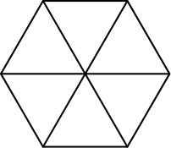
如图，正六边形可分成 6 个边长为 s/2 的等边三角形。每个小三角形是原三角形按比例 1/2 缩小得到的，所以面积缩小为 (1/2)² = 1/4 。因此每个小三角形面积为 4 · 1/4 = 1。共有 6 个，所以六边形面积为 6· 1 = 6。
所以正确答案是C。
English
Let the side length of the triangle be s. This means the perimeter is 3s. Therefore, the side length for the hexagon is 3s/6 = s/2.
A hexagon can be made of 6 equilateral triangles with side length s/2 as shown above. Each triangle is the original triangle scaled down by 1/2, so the area is scaled down by (1/2)² = 1/4. Therefore, the area of each of these triangles is 4 · 1/4 = 1. Since there are 6 of them, the area is 6· 1 = 6.
Thus, the answer isC.
第 24 题 答案 A
原圆面积为 π·2²=4π。
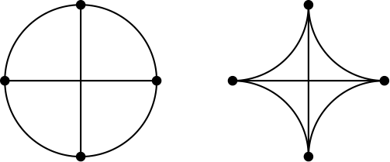
连接四个四分之一圆弧端点形成一个正方形。这个正方形的两条对角线分别是 4 和 4，所以面积为 1/2·4·4=8。
圆内但正方形外的部分面积为 4π-8。这四块与正方形内但星形外的四块全等。
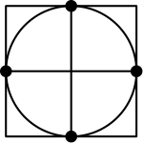
因此星形面积为 8-(4π-8)=16-4π。所求比值为 16-4π/4π=4-π/π。所以正确答案是A。
English
The area of the original circle is π·2²=4π.
Join the four quarter-circle endpoints to form a square. The square has diagonals 4 and 4, so its area is 1/2·4·4=8.
The part inside the circle but outside this square has area 4π-8. Those four pieces are congruent to the pieces inside the square but outside the star.
Thus the star area is 8-(4π-8)=16-4π. The desired ratio is 16-4π/4π=4-π/π. Thus, the answer isA.
第 25 题 答案 C
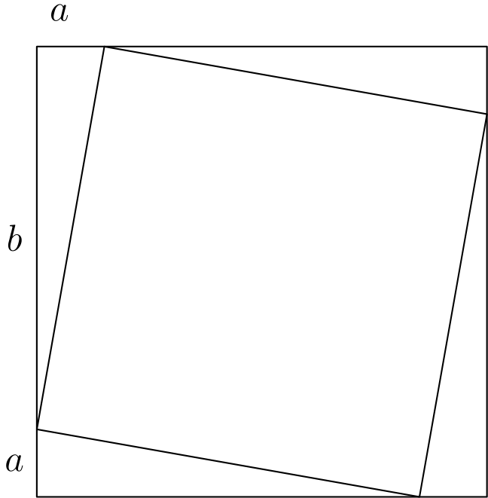
四个三角形都可以通过旋转互相得到，所以它们全等。因此可以如图标出 a。两个正方形之间的总面积为 5-4 = 1，所以有 4 个全等三角形的总面积为 1。每个三角形面积为 1/4。每个三角形的面积也等于 ab/2，所以 ab/2 = 1/4。因此 ab = 1/2 。
所以正确答案是C。
English
Since all the triangles can be made from each other by rotating them around, they are all congruent. Therefore, we can place the a as we have. The total area of the triangles is 5-4 = 1, so we have 4 congruent triangles with a combined area of 1. This means the area of each triangle is 1/4. The area of each triangle is also ab/2, so ab/2 = 1/4. This means ab = 1/2.
Thus, the correct answer isC.

