2010 年 AMC 8 真题与解答
American Mathematics Competitions 8 · 中英双语
共 25 题，限时 40 分钟；单项选择题，每题 1 分，答错不扣分，满分 25 分。
编排说明：第一部分为题目（先中文、后英文原题），第二部分为解答与答案，便于先做题后对答案。
第一部分 题目
第 1 题
欧几里得中学的数学老师有热尔曼小姐、牛顿先生和杨夫人。今年参加 AMC 8 竞赛的学生中，热尔曼小姐班有 11 人，牛顿先生班有 8 人，杨夫人班有 9 人。欧几里得中学共有多少名学生参加竞赛？
（A）26 （B）27 （C）28 （D）29 （E）30
English
At Euclid Middle School the mathematics teachers are Miss Germain, Mr. Newton, and Mrs. Young. There are 11 students in Miss Germain’s class, 8 students in Mr. Newton’s class, and 9 students in Mrs. Young’s class taking the AMC 8 Contest this year. How many mathematics students at Euclid Middle School are taking the contest?
(A) 26 (B) 27 (C) 28 (D) 29 (E) 30
第 2 题
对于正整数 a、b，定义 a ∗ b = (a× b)/a+b。那么 5 ∗ 10 是多少？
（A）3/10 （B）1 （C）2 （D）10/3 （E）50
English
If a ∗ b = (a× b)/a+b for a, b positive integers, then what is 5 ∗ 10?
(A) 3/10 (B) 1 (C) 2 (D) 10/3 (E) 50
第 3 题
图中显示一年中前十个月五加仑汽油的价格。最高价格比最低价格高百分之多少？
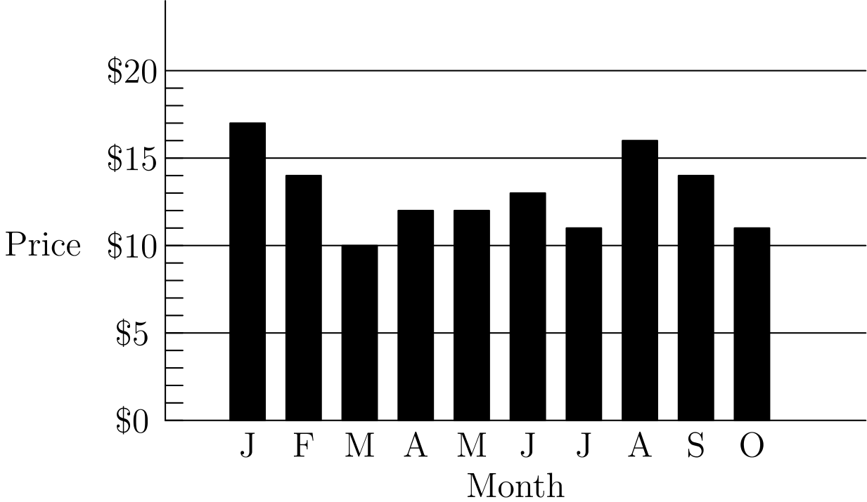
（A）50 （B）62 （C）70 （D）89 （E）100
English
The graph shows the price of five gallons of gasoline during the first ten months of the year. By what percent is the highest price more than the lowest price?
(A) 50 (B) 62 (C) 70 (D) 89 (E) 100
第 4 题
数 2，3，0，3，1，4，0，3 的平均数、中位数和众数之和是多少？
（A）6.5 （B）7 （C）7.5 （D）8.5 （E）9
English
What is the sum of the mean, median, and mode of the numbers 2, 3, 0, 3, 1, 4, 0, 3?
(A) 6.5 (B) 7 (C) 7.5 (D) 8.5 (E) 9
第 5 题
爱丽丝需要更换厨房里一个位于天花板下方 10 厘米处的灯泡。天花板离地面 2.4 米。爱丽丝身高 1.5 米，并且手能伸到头顶上方 46 厘米。站在凳子上时，她刚好能够到灯泡。凳子的高度是多少厘米？
（A）32 （B）34 （C）36 （D）38 （E）40
English
Alice needs to replace a light bulb located 10 centimeters below the ceiling in her kitchen. The ceiling is 2.4 meters above the floor. Alice is 1.5 meters tall and can reach 46 centimeters above the top of her head. Standing on a stool, she can just reach the light bulb. What is the height of the stool, in centimeters?
(A) 32 (B) 34 (C) 36 (D) 38 (E) 40
第 6 题
下列哪个图形有最多条对称轴？
（A）等边三角形 （B）非正方形的菱形 （C）非正方形的长方形 （D）等腰梯形 （E）正方形
English
Which of the following figures has the greatest number of lines of symmetry?
(A) equilateral triangle (B) non-square rhombus (C) non-square rectangle (D) isosceles trapezoid (E) square
第 7 题
只使用一美分、五美分、十美分和二十五美分硬币，弗雷迪最少需要多少枚硬币，才能支付小于一美元的任意金额？
（A）6 （B）10 （C）15 （D）25 （E）99
English
Using only pennies, nickels, dimes, and quarters, what is the smallest number of coins Freddie would need so he could pay any amount of money less than a dollar?
(A) 6 (B) 10 (C) 15 (D) 25 (E) 99
第 8 题
艾米丽沿一条笔直长路骑自行车时，看到埃默森在她前方 1/2 英里处同方向滑行。她超过他后，可以从后视镜里看到他，直到他落在她后方 1/2 英里处。艾米丽以每小时 12 英里的恒定速度骑行，埃默森以每小时 8 英里的恒定速度滑行。艾米丽能看到埃默森多少分钟？
（A）6 （B）8 （C）12 （D）15 （E）16
English
As Emily is riding her bicycle on a long straight road, she spots Emerson skating in the same direction 1/2 mile in front of her. After she passes him, she can see him in her rear view mirror until he is 1/2 mile behind her. Emily rides at a constant rate of 12 miles per hour, and Emerson skates at a constant rate of 8 miles per hour. For how many minutes can Emily see Emerson?
(A) 6 (B) 8 (C) 12 (D) 15 (E) 16
第 9 题
瑞安在一份有 25 道题的测试中答对了 80%，在一份有 40 道题的测试中答对了 90%，在一份有 10 道题的测试中答对了 70%。所有题目中瑞安答对了百分之多少？
（A）63 （B）75 （C）80 （D）84 （E）86
English
Ryan got 80% of the problems correct on a 25-problem test, 90% on a 40-problem test, and 70% on a 10-problem test. What percent of all the problems did Ryan answer correctly?
(A) 63 (B) 75 (C) 80 (D) 84 (E) 86
第 10 题
如图摆放时，六片圆形意大利辣香肠正好横跨一个 12 英寸披萨的直径。如果总共 24 片辣香肠无重叠地放在这个披萨上，披萨面积的几分之几被辣香肠覆盖？
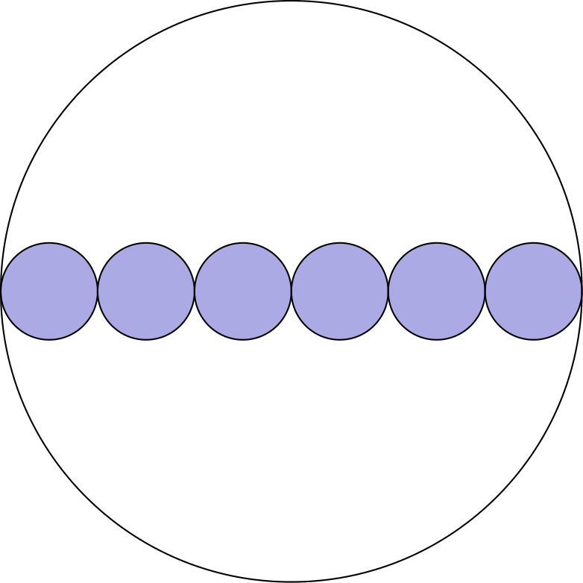
（A）1/2 （B）2/3 （C）3/4 （D）5/6 （E）7/8
English
Six pepperoni circles will exactly fit across the diameter of a 12-inch pizza when placed as shown. If a total of 24 circles of pepperoni are placed on this pizza without overlap, what fraction of the pizza is covered by pepperoni?
(A) 1/2 (B) 2/3 (C) 3/4 (D) 5/6 (E) 7/8
第 11 题
一棵树的树顶比另一棵树的树顶高 16 英尺。两棵树的高度之比为 3:4。较高的树高多少英尺？
（A）48 （B）64 （C）80 （D）96 （E）112
English
The top of one tree is 16 feet higher than the top of another tree. The heights of the two trees are in the ratio 3:4. In feet, how tall is the taller tree?
(A) 48 (B) 64 (C) 80 (D) 96 (E) 112
第 12 题
一个大袋子里有 500 个球，其中 80% 是红球，其余是蓝球。必须拿走多少个红球，才能使剩余球中 75% 是红球？
（A）25 （B）50 （C）75 （D）100 （E）150
English
Of the 500 balls in a large bag, 80% are red and the rest are blue. How many of the red balls must be removed so that 75% of the remaining balls are red?
(A) 25 (B) 50 (C) 75 (D) 100 (E) 150
第 13 题
一个三角形的三边长度（单位为英寸）是三个连续整数。最短边长度是周长的 30%。最长边长度是多少？
（A）7 （B）8 （C）9 （D）10 （E）11
English
The lengths of the sides of a triangle in inches are three consecutive integers. The length of the shortest side is 30% of the perimeter. What is the length of the longest side?
(A) 7 (B) 8 (C) 9 (D) 10 (E) 11
第 14 题
2010 的质因数之和是多少？
（A）67 （B）75 （C）77 （D）201 （E）210
English
What is the sum of the prime factors of 2010?
(A) 67 (B) 75 (C) 77 (D) 201 (E) 210
第 15 题
一个罐子里有 5 种不同颜色的软糖。30% 是蓝色，20% 是棕色，15% 是红色，10% 是黄色，另外 30 颗是绿色。如果把一半蓝色软糖换成棕色软糖，那么会有多少颗棕色软糖？
（A）35 （B）36 （C）42 （D）48 （E）64
English
A jar contains 5 different colors of gum drops. 30% are blue, 20% are brown, 15% are red, 10% are yellow, and the other 30 gum drops are green. If half of the blue gum drops are replaced by brown gum drops, how many gum drops will be brown?
(A) 35 (B) 36 (C) 42 (D) 48 (E) 64
第 16 题
一个正方形和一个圆的面积相同。正方形边长与圆半径之比是多少？
（A）(√(π))/2 （B）√(π) （C）π （D）2π （E）π²
English
A square and a circle have the same area. What is the ratio of the side length of the square to the radius of the circle?
(A) (√(π))/2 (B) √(π) (C) π (D) 2π (E) π²
第 17 题
图中八边形由 10 个单位正方形组成。PQ 下方部分是一个单位正方形和一个底为 5 的三角形。如果 PQ 平分这个八边形的面积，那么 XQ/QY 是多少？
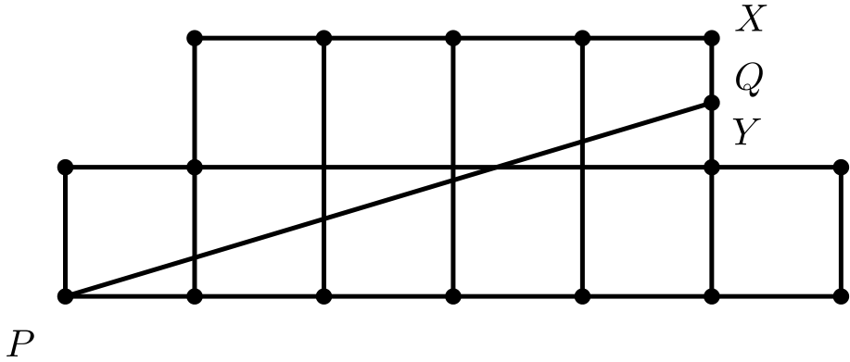
（A）2/5 （B）1/2 （C）3/5 （D）2/3 （E）3/4
English
The diagram shows an octagon consisting of 10 unit squares. The portion below PQ is a unit square and a triangle with base 5. If PQ bisects the area of the octagon, what is the ratio XQ/QY?
(A) 2/5 (B) 1/2 (C) 3/5 (D) 2/3 (E) 3/4
第 18 题
一扇装饰窗由一个长方形和两端的半圆组成。AD 与 AB 的比为 3:2，且 AB=30 英寸。长方形面积与两个半圆面积之和的比是多少？
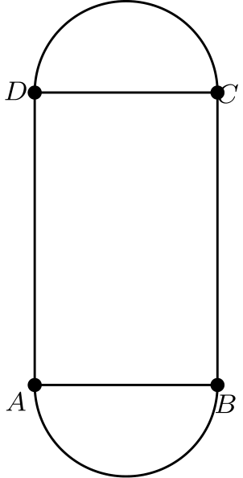
（A）2:3 （B）3:2 （C）6:π （D）9:π （E）30:π
English
A decorative window is made up of a rectangle with semicircles on either end. The ratio of AD to AB is 3:2, and AB=30 inches. What is the ratio of the area of the rectangle to the combined areas of the semicircles?
(A) 2:3 (B) 3:2 (C) 6:π (D) 9:π (E) 30:π
第 19 题
图中的两个圆有相同的圆心 C。弦 AD 在 B 点与内圆相切，AC 长 10，且弦 AD 长 16。两个圆之间区域的面积是多少？
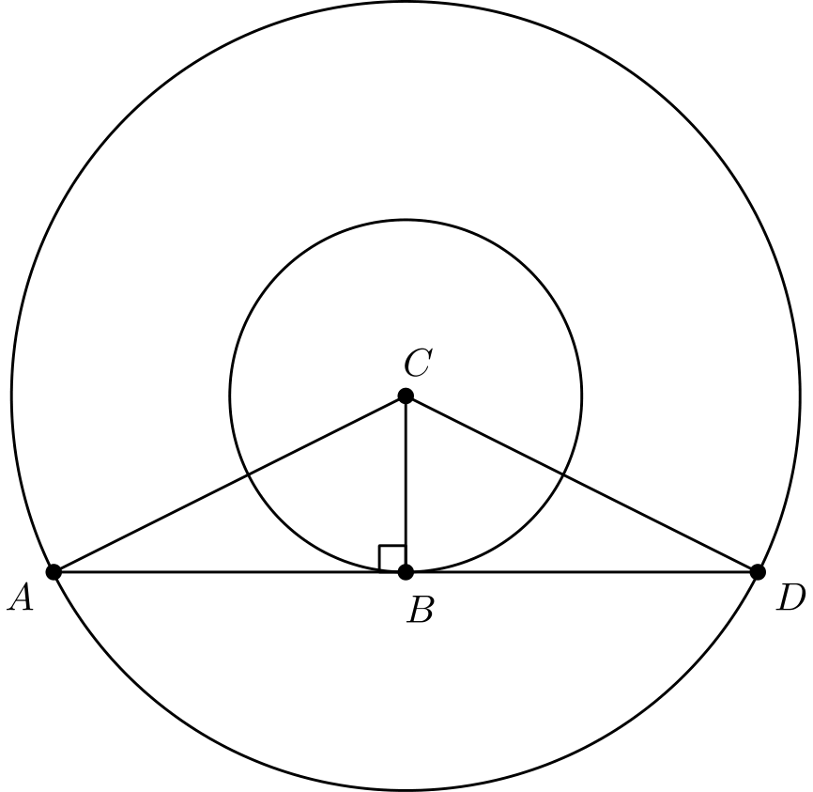
（A）36 π （B）49 π （C）64 π （D）81 π （E）100 π
English
The two circles pictured have the same center C. Chord AD is tangent to the inner circle at B, AC is 10, and chord AD has length 16. What is the area between the two circles?
(A) 36 π (B) 49 π (C) 64 π (D) 81 π (E) 100 π
第 20 题
一个房间里，2/5 的人戴手套，3/4 的人戴帽子。房间里至少有多少人同时戴帽子和手套？
（A）3 （B）5 （C）8 （D）15 （E）20
English
In a room, 2/5 of the people are wearing gloves, and 3/4 of the people are wearing hats. What is the minimum number of people in the room wearing both a hat and gloves?
(A) 3 (B) 5 (C) 8 (D) 15 (E) 20
第 21 题
惠很爱读书。她买了一本畅销书《数学真美》。第一天，惠读了全书页数的 1/5 又多读 12 页；第二天，她读了剩余页数的 1/4 又多读 15 页；第三天，她读了剩余页数的 1/3 又多读 18 页。随后她发现只剩 62 页要读，并在次日读完。这本书共有多少页？
（A）120 （B）180 （C）240 （D）300 （E）360
English
Hui is an avid reader. She bought a copy of the bestseller Math is Beautiful. On the first day, Hui read 1/5 of the pages plus 12 more, and on the second day she read 1/4 of the remaining pages plus 15 pages. On the third day she read 1/3 of the remaining pages plus 18 pages. She then realized that there were only 62 pages left to read, which she read the next day. How many pages are in this book?
(A) 120 (B) 180 (C) 240 (D) 300 (E) 360
第 22 题
一个三位数的百位数字比个位数字大 2。将这个三位数的数字倒序排列，再用原三位数减去倒序后的数。结果的个位数字是多少？
（A）0 （B）2 （C）4 （D）6 （E）8
English
The hundreds digit of a three-digit number is 2 more than the units digit. The digits of the three-digit number are reversed, and the result is subtracted from the original three-digit number. What is the units digit of the result?
(A) 0 (B) 2 (C) 4 (D) 6 (E) 8
第 23 题
半圆 POQ 和 ROS 都经过圆心 O。两个半圆面积之和与圆 O 面积之比是多少？
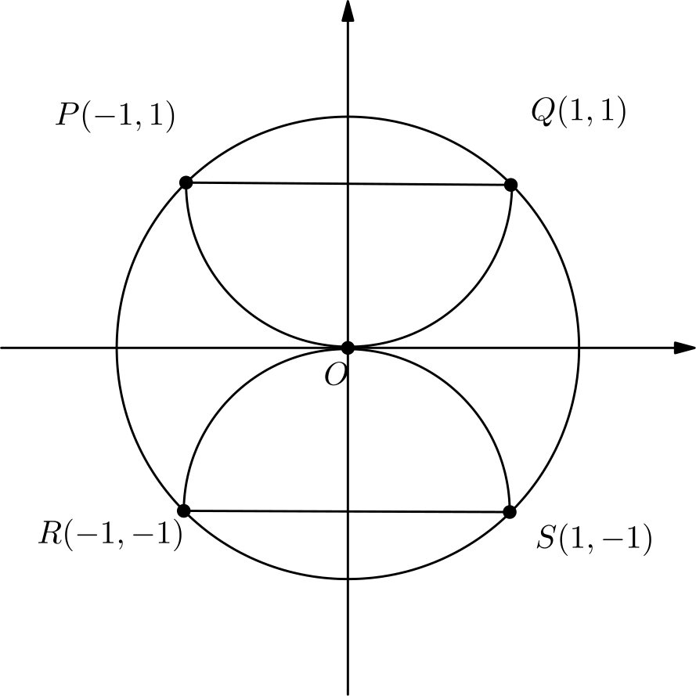
（A）(√(2))/4 （B）1/2 （C）2/π （D）2/3 （E）(√(2))/2
English
Semicircles POQ and ROS pass through the center of circle O. What is the ratio of the combined areas of the two semicircles to the area of circle O?
(A) (√(2))/4 (B) 1/2 (C) 2/π (D) 2/3 (E) (√(2))/2
第 24 题
三个数 10⁸、5¹² 和 2²⁴ 的正确大小顺序是什么？
（A）2²⁴ < 10⁸ < 5¹² （B）2²⁴ < 5¹² < 10⁸ （C）5¹² < 2²⁴ < 10⁸ （D）10⁸ < 5¹² < 2²⁴ （E）10⁸ < 2²⁴ < 5¹²
English
What is the correct ordering of the three numbers, 10⁸, 5¹², and 2²⁴?
(A) 2²⁴ < 10⁸ < 5¹² (B) 2²⁴ < 5¹² < 10⁸ (C) 5¹² < 2²⁴ < 10⁸ (D) 10⁸ < 5¹² < 2²⁴ (E) 10⁸ < 2²⁴ < 5¹²
第 25 题
乔每天在学校爬一段 6 级的楼梯。乔每次可以爬 1、2 或 3 级。例如，乔可以先爬 3 级，再爬 1 级，再爬 2 级。乔有多少种爬完楼梯的方法？
（A）13 （B）18 （C）20 （D）22 （E）24
English
Every day at school, Jo climbs a flight of 6 stairs. Jo can take the stairs 1, 2, or 3 at a time. For example, Jo could climb 3, then 1, then 2. In how many ways can Jo climb the stairs?
(A) 13 (B) 18 (C) 20 (D) 22 (E) 24

第二部分 解答
答案速查：
题号 1 2 3 4 5 6 7 8 9
答案 C D C C B E B D D
题号 10 11 12 13 14 15 16 17 18
答案 B B D E C C B D C
题号 19 20 21 22 23 24 25
答案 C A C E B A E
答案串：CDCCBEBDDBBDECCBDCCACEBAE
第 1 题 答案 C
学生总数为 11+8+9 = 28。
所以正确答案是C。
English
There are 11+8+9 = 28 students.
Therefore, the answer isC.
第 2 题 答案 D
由 a∗ b 的定义，
5 ∗ 10 = (5 × 10)/(5 + 10) = 50/15 = 10/3。
所以正确答案是D。
English
Given our definition of a∗ b, we have
5 ∗ 10 = (5 × 10)/(5 + 10) = 50/15 = 10/3.
Thus, the answer isD.
第 3 题 答案 C
最高价格为 17，最低价格为 10。因此百分数为
(17/10-1)· 100 = 70。
所以正确答案是C。
English
The highest price is 17 and the lowest price is 10. This means the percent is
(17/10-1)· 100 = 70.
Thus, the answer isC.
第 4 题 答案 C
重新排序后的列表是 0,0,1,2,3,3,3,4。
中位数是中间两个数的平均数，即 2+3/2 = 2.5。众数是 3，因为 3 出现次数最多。平均数为
0+0+1+2+3+3+3+4/8
= 16/8 = 2。
它们的和为 2.5+3+2 = 7.5。
所以正确答案是C。
English
The list reordered is 0,0,1,2,3,3,3,4.
The median is the mean of the middle two numbers, which would be 2+3/2 = 2.5. The mode is 3 since 3 appears the most. The mean is
0+0+1+2+3+3+3+4/8
= 16/8 = 2.
Their sum is 2.5+3+2 = 7.5.
Thus, the answer isC.
第 5 题 答案 B
天花板高度为 2.4 · 100 = 240 厘米。减去已知的各段高度，得到
240 - 150 - 46 - 10 = 34。
因此凳子的高度是 34 厘米。所以正确答案是B。
English
We know the height of the ceiling is 2.4 · 100 = 240 cm. Subtracting out all the given values, we get
240 - 150 - 46 - 10 = 34.
Therefore, the height of the stool is 34 cm. Thus,Bis the correct answer.
第 6 题 答案 E
每条对称轴都必须经过图形的中心，否则中心会只在一侧，反射后无法重合。
如果对称轴经过某条边，它必须经过这条边的中点，并且与这条边垂直，这样反射后该边两侧长度相同且仍落在自身上。
如果对称轴经过某个顶点，它必须经过该角的角平分线，并且两侧边长相同，反射后角才会重合。
现在逐个考察这些图形。等边三角形只有 3 条经过顶点或边中点的直线，所以至多有 3 条对称轴。非正方形的菱形只有两条对称轴，因为只有经过相对顶点的直线可行，而经过边中点的直线与该边不垂直。非正方形的长方形也只有两条对称轴，它们经过对边的中点；经过顶点的直线不平分该角，所以不可行。等腰梯形只有 1 条对称轴，它经过一组对边的中点。正方形有 4 条对称轴，分别经过相对顶点和相对边的中点。
因此正方形有最多条对称轴。
所以正确答案是E。
English
First, each line of symmetry must go through the center of the shape. This would ensure that the center of the shape isn’t on only one side, as that would make it asymmetric.
Next, if a line goes through any side, it must go through its midpoint, to ensure that after a reflection over this line, the same amount of the line is on both sides. Moreover, it must be perpendicular, to ensure that the line when reflected stays on itself.
Similarly, if a line goes through any corner, it must go through its angle bisector, to ensure that after a reflection over this line, the angle of the line is the same after reflection. Moreover, it must have the same side length on both sides.
Now, let’s look at each of the shapes. An equilateral triangle has 3 lines that intersect a corner or a midpoint, so it has at most 3 symmetry lines. A non-square rhombus only has two symmetry lines, as only the lines that go through the corners work, but not the ones through the midpoints as they would not intersect perpendicularly. A non-square rectangle only has two symmetry lines as it has symmetry lines through the midpoints of opposite sides, but not through the corners since it doesn’t bisect the angle. An isosceles trapezoid only has 1 symmetry line, that goes through the midpoints of opposite sides. A square has 4 symmetry lines, which go through opposite corners and opposite midpoints.
A square therefore has the most symmetry lines.
Thus, the answer isE.
第 7 题 答案 B
要支付 4 美分，至少需要四枚一美分硬币。有了这四枚后，为了能支付 5 美分，下一枚硬币的面值至多为 5 美分，最好选一枚五美分硬币。这五枚硬币总值只有 9 美分。下一枚硬币的面值至多为 10 美分；即使选一枚十美分硬币，总值也只有 19 美分。因此还需要一枚面值至多为 20 美分的硬币，所以在不产生金额缺口的情况下使用二十五美分硬币之前，至少需要七枚硬币。
若总共只有九枚硬币，在必需的七枚之后最多只剩两枚。前七枚的总值至多为 4+5+10+10=29 美分，再加两枚二十五美分硬币也只有 79 美分，所以九枚硬币不能支付从一美分到 99 美分的每个金额。
十枚硬币确实可以做到：四枚一美分硬币、一枚五美分硬币、两枚十美分硬币和三枚二十五美分硬币，可以支付从 1 到 99 美分的每个金额。因此最少需要 10 枚。
所以正确答案是B。
English
At least four pennies are necessary to pay 4 cents. After those four pennies, the next coin must be worth at most 5 cents so that 5 cents can be paid; a nickel is the best choice. Those five coins total only 9 cents. The next coin must be worth at most 10 cents, and even a dime brings the total to only 19 cents. One more coin worth at most 20 cents is therefore necessary, so at least seven coins are needed before quarters can be used without leaving a gap.
With only nine coins total, at most two coins could remain after those required seven. The first seven can total at most 4+5+10+10=29 cents, and two more quarters would bring the total to only 79 cents, so nine coins cannot pay every amount through 99 cents.
Ten coins do work: four pennies, one nickel, two dimes, and three quarters can make every amount from 1 through 99 cents. Therefore the minimum is 10.
Therefore, the answer isB.
第 8 题 答案 D
设 d 为艾米丽领先埃默森的距离。艾米丽能看到埃默森当且仅当 -1/2 ≤ d ≤ 1/2。其中 t 以小时为单位；令 t= 0 时 d = -1/2。根据两人的相对速度，d = (12-8)t - 1/2 。当 d = 1/2 时，
1/2 = 4t - 1/2 implies 1 = 4t
implies t = 0.25。
因此经过 0.25 小时，也就是 60·0.25 = 15 分钟。
所以正确答案是D。
English
Let d be how far Emily is ahead of Emerson. Emily sees Emerson if -1/2 ≤ d ≤ 1/2. Suppose at t= 0, where t is in hours, that d = -1/2. Then, d = (12-8)t - 1/2. Since we must find where d = 1/2, we find the time where
1/2 = 4t - 1/2 implies 1 = 4t
implies t = 0.25.
Since 0.25 hours passed, we know that 60·0.25 = 15 minutes passed.
Therefore, the answer isD.
第 9 题 答案 D
三份测试共有 25+40+10 = 75 题。
第一份测试答对 0.8·25 = 20 题。
第二份测试答对 0.9·40 = 36 题。
第三份测试答对 0.7·10 = 7 题。
因此他总共答对 20+36+7=63 题，答对比例为 63/75 = 84%。
所以正确答案是D。
English
There were a total of 25+40+10 = 75 problems.
On the first test, he solved 0.8·25 = 20 problems.
On the second test, he solved 0.9·40 = 36 problems.
On the third test, he solved 0.7·10 = 7 problems.
Therefore, he solved a total of 20+36+7=63. This means the fraction he solved is 63/75 = 84%.
Therefore, the answer isD.
第 10 题 答案 B
每片圆形辣香肠的直径是大圆直径的 1/6，所以它的面积是总面积的 (1/6)² = 1/36。
因为有 24 片辣香肠，所以覆盖面积为 24 · 1/36 = 2/3。
所以正确答案是B。
English
Each circle has 1/6 the diameter of the large circle, so it has (1/6)² = 1/36 of the total area.
Since there are 24 pepperoni, they take up 24 · 1/36 = 2/3 of the area.
Therefore, the answer isB.
第 11 题 答案 B
设较高和较矮的树高分别为 b、s。则 b= s+16，且 s = 0.75b。代入得
b = 0.75b + 16 implies 0.25b = 16
implies b = 64。
所以正确答案是B。
English
Let b, s be the heights of bigger and smaller trees respectively. Then, b= s+16 and s = 0.75b. If we substitute, we get
b = 0.75b + 16 implies 0.25b = 16
implies b = 64.
Thus, the answer isB.
第 12 题 答案 D
若 r 是红球数，则
r = 0.8·500 = 400。
因此若 b 是蓝球数，则
b = 500-400 = 100。
拿走一些球后，如果红球占 75%，那么蓝球占 25%。蓝球数量不变，所以剩余球总数为 100/0.25 = 400。这表示总球数减少了 500-400 = 100，也就是拿走了一百个红球。
所以正确答案是D。
English
If r is the number of red balls, then
r = 0.8·500 = 400.
Therefore, if b is the number of blue balls, then
b = 500-400 = 100.
If there are 75% red balls after removing balls, then there are 25% blue balls. This means the total number of balls is 100/0.25 = 400. This means the total number of balls decreased by 500-400 = 100.
Thus, the answer isD.
第 13 题 答案 E
设最短边长为 s。三边长度为 s、s+1、s+2，周长为 3s+3。因为 s = 0.3(3s+3)，所以 s = 0.9s + 0.9 。因此 0.1s = 0.9，得到 s = 9，最长边为 s + 2 = 11。
所以正确答案是E。
English
Let s be the smallest length. Then, all the side lengths are s, s+1, s+2. This would make the perimeter equal to 3s+3. Since s = 0.3(3s+3), then s = 0.9s + 0.9. This makes 0.1s = 0.9, so s = 9 which makes the longest side length s + 2 = 11.
Thus, the answer isE.
第 14 题 答案 C
首先，质数 2、5 是 2010 的因数，因为它是 10 的倍数。2010 除以 10 得 201。接着，3 是 201 的因数，因为 201 的数位和是 3 的倍数。再除以 3 得到质数 67。因此质因数为 2、3、5、67，它们的和为 77。
所以正确答案是C。
English
First, the primes 2, 5 are factors of 2010 since it is a multiple of 10. Dividing 2010 by 10 is 201. Then, 3 is a factor of 201 since the digit sum of 201 is a multiple of 3. Dividing this by 3 yields the prime number 67. This means the prime factors are 2, 3, 5, 67, which makes their sum 77.
Thus, the correct answer isC.
第 15 题 答案 C
绿色所占百分比是 100% 减去其他颜色百分比之和：
100%-30%-20%-
15%-10% = 25%
因为 30 颗绿色软糖是总数的 25%，所以软糖总数为 30/0.25 = 120。
一开始棕色软糖有 0.2·120 = 24 颗，蓝色软糖有 0.3·120 = 36 颗。把一半蓝色换成棕色会增加 36/2 = 18 颗棕色软糖。因此棕色软糖共有 24+18= 42 颗。
所以正确答案是C。
English
Since we have percentages for every color except green, the percent of green is 100% minus the sum of the other colors. This would make the percent of green equal to
100%-30%-20%-
15%-10% = 25%
Since we know 30 gum drops is 25%, we know that the total number of gum drops is 30/0.25 = 120.
This means there are 0.2·120 = 24 brown gum drops to start and 0.3·120 = 36 blue gum drops. If half of the blue gum drops are turned to brown, then 36/2 = 18 more brown gum drops are added. Therefore, we have 24+18= 42 brown gum drops.
Thus, the answer isC.
第 16 题 答案 B
设正方形边长为 s，圆半径为 r。由于面积相同，s² = π r² 。因此 (s/r)² = π，所以 s/r = √(π) 。
所以正确答案是B。
English
Let s be the side length of the square and let r be the radius of the circle. Then, since they have the same areas, s² = π r². This means (s/r)² = π, so s/r = √(π).
Thus, the answer isB.
第 17 题 答案 D
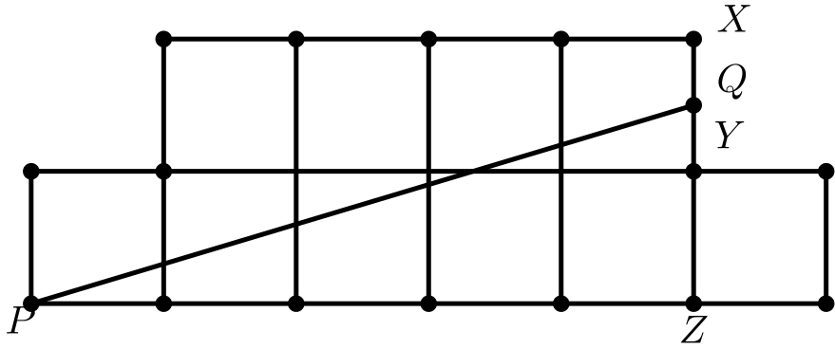
因为 PQ 平分面积，直线下方的面积为 5。去掉右侧的单位正方形后，底部是一个底为 5、面积为 4 的三角形。设这个三角形的底为 PZ。
面积为 4，所以
((PZ)(ZQ))/2=(5(ZQ))/2 = 4
implies ZQ = 1.6。
因此 QY = QZ-1 = 0.6，且 XQ = 2-QZ = 0.4。于是 XQ/QY = 0.4/0.6 = 2/3。
所以正确答案是D。
English
Since PQ bisects the area, the area under the line is 5. Removing the square on the right makes the bottom a triangle of base 5 with area 4. Let the base of this triangle be PZ.
The area being 4 means
((PZ)(ZQ))/2=(5(ZQ))/2 = 4
implies ZQ = 1.6.
Therefore, QY = QZ-1 = 0.6 and XQ = 2-QZ = 0.4. This would make XQ/QY = 0.4/0.6 = 2/3.
Thus, the answer isD.
第 18 题 答案 C
两个半圆合起来是一个直径为 d=30 的圆，其半径为 d/2。因此两个半圆的总面积为
(d/2)² · π = (π d²)/4。
因为 AD:AB=3:2 且 AB=d，所以 AD = 3/2 d。长方形面积为 3/2 d²。所求比值为 (3/2 d²)/((π d²)/4) = 6/π。
所以正确答案是C。
English
Combining the semicircles would make a circle of diameter d=30. This would make the radius equal to d/2. Therefore, the combined area of the semicircles is
(d/2)² · π = (π d²)/4.
Side AD = 3/2 d because AD:AB=3:2 and AB=d. The area of the rectangle is therefore 3/2 d². The ratio of the area of the rectangle to the area of the semicircles is (3/2 d²)/((π d²)/4) = 6/π.
Thus, the answer isC.
第 19 题 答案 C
两圆之间的面积等于大圆面积减去小圆面积，即
(AC)²π - (CB)² π
= π(AC² - CB²)。
由勾股定理，
AC² - CB² = AB²。
因此只需求 AB² π。
因为 AB 是 AD 的一半，所以 AB = 8。于是 AB² π = 64 π。
所以正确答案是C。
English
The area between the two circles is the area of the larger circle minus the area of the smaller circle. This would be
(AC)²π - (CB)² π
= π(AC² - CB²).
By the Pythagorean Theorem, we can get
AC² - CB² = AB².
Therefore, we need to find AB² π.
Since AB is half of AD, we get AB = 8. This makes AB² π = 64 π.
Thus, the answer isC.
第 20 题 答案 A
因为房间中 2/5 的人戴手套，所以总人数必须是 5 的倍数。因为 3/4 的人戴帽子，所以总人数必须是 4 的倍数。因此总人数必须是 20 的倍数。
另外，由容斥原理可以写出下面的关系：同时戴两者的比例 = 戴手套的比例 + 戴帽子的比例 − 至少戴其中一种的比例。
所求比例等于 2/5 + 3/4 - 至少戴一种物品的比例。要使同时戴两者的人数最少，就让至少戴一种物品的比例尽可能大，最多为 1。所以同时戴两者的比例至少为 2/5 + 3/4- 1 = 3/20。
取最小的正总人数 20，在这 20 人中，同时戴两者的人数为 3。
所以正确答案是A。
English
Since our room has 2/5 of the people wearing gloves, the number of people must be a multiple of 5. Since our room has 3/4 of the people wearing hats, the number of people must be a multiple of 4. Therefore, the people in the room must be a multiple of 20.
Now, we can also use the following formula by the principle of inclusion exclusion: Fraction of people wearing both = Fraction of people wearing gloves + Fraction of people wearing hats - Fraction of people wearing either.
This makes our desired fraction equal to 2/5 + 3/4 - Fraction of people who wear either. If we wish to minimize the number who wear both, we maximize the fraction of people who wear either, up to 1. Therefore, the fraction of people that wear both is 2/5 + 3/4- 1 = 3/20.
Since our number is a (positive) multiple of 20, we have the number of people wearing both as 3 if we choose to have just 20 people.
Therefore,Ais the correct answer.
第 21 题 答案 C
第三天后剩下 62 页。在读最后额外的 18 页之前，她还剩 80 页。这是当时剩余页数的 2/3，所以第三天开始前她剩下 120 页。
在读第二天额外的 15 页之前，她还剩 120+15=135 页。这是当时剩余页数的 3/4，所以第二天开始前她剩下 180 页。
在读第一天额外的 12 页之前，她还剩 180+12=192 页。这是当时剩余页数的 4/5，所以第一天开始前她有 240 页，也就是全书 240 页。
所以正确答案是C。
English
The pages left after the third day is 62. Before reading the last 18 pages, she had 80 pages left. This is 2/3 of the pages remaining, so she had 120 pages left before the third day.
Before reading the 15 pages, she had 120+15=135 pages left. This is 3/4 of the pages remaining, so she had 180 pages left before the second day.
Before reading the 12 pages, she had 180+12=192 pages left. This is 4/5 of the pages remaining, so she had 240 pages left before the first day, making the book 240 pages.
Thus, the answer isC.
第 22 题 答案 E
设个位数字为 u，十位数字为 t。则百位数字为 u+2。原数为
100(u+2) +10t+u
=101u+200+10t，
倒序数为
100u +10t+(u+2)
=101u+2+10t。
两数之差为
(101u+10t+200)-
(101u+10t+2)=198。
因此结果的个位数字是 8。
所以正确答案是E。
English
Let the units digit be u, and let the tens digit be t. This makes the hundreds digit be u+2. This makes the number equal to
100(u+2) +10t+u
=101u+200+10t
and the reversed number is
100u +10t+(u+2)
=101u+2+10t.
This makes the difference equal to
(101u+10t+200)-
(101u+10t+2)=198.
This makes the units digit 8.
Therefore, the answer isE.
第 23 题 答案 B
每个半圆的面积是 π r²/2 。它们的半径都是 1，所以两个半圆的总面积为 π 1/2 + π 1/2 = π。
大圆半径等于 OQ 的长度，即 √(1²+1²) = √(2)。它的面积为 π r² = π(√(2))² = 2π。
因此比值为 π/2π = 1/2。
所以正确答案是B。
English
The area of each of the semicircles is π r²/2. Each of them has a radius of 1, so their combined area is π 1/2 + π 1/2 = π.
Next, the radius of the larger circle is equal to the length of OQ, which is equal to √(1²+1²) = √(2). Its area is π r² = π(√(2))² = 2π.
This means the ratio is π/2π = 1/2.
Thus, the answer isB.
第 24 题 答案 A
首先，
2²⁴ = (2⁸)(4⁸) < (2⁸)(5⁸) = 10⁸。
接着，
10⁸ = (2⁸)(5⁸) =
(4⁴)(5⁸) < (5⁴)(5⁸) = 5¹²。
因此 2²⁴ < 10⁸ < 5¹² 。
所以正确答案是A。
English
First, we get
2²⁴ = (2⁸)(4⁸) < (2⁸)(5⁸) = 10⁸.
Next, we get
10⁸ = (2⁸)(5⁸) =
(4⁴)(5⁸) < (5⁴)(5⁸) = 5¹².
This means 2²⁴ < 10⁸ < 5¹².
Thus, the answer isA.
第 25 题 答案 E
设 wₙ 为爬 n 级楼梯的方法数。对于 n≥4，第一步可以爬 1、2 或 3 级，所以 wₙ=wₙ₋₁+wₙ₋₂+wₙ₋₃。
有 w₁=1、w₂=2、w₃=4。因此 w₄=4+2+1=7、w₅=7+4+2=13、w₆=13+7+4=24。
所以正确答案是E。
English
Let wₙ be the number of ways to climb n stairs. For n≥4, the first step can be 1, 2, or 3 stairs, so wₙ=wₙ₋₁+wₙ₋₂+wₙ₋₃.
We have w₁=1, w₂=2, and w₃=4. Therefore w₄=4+2+1=7, w₅=7+4+2=13, and w₆=13+7+4=24.
Thus, the answer isE.

