2008 年 AMC 8 真题与解答
American Mathematics Competitions 8 · 中英双语
共 25 题，限时 40 分钟；单项选择题，每题 1 分，答错不扣分，满分 25 分。
编排说明：第一部分为题目（先中文、后英文原题），第二部分为解答与答案，便于先做题后对答案。
第一部分 题目
第 1 题
苏珊有 $50 可以在嘉年华会上花。她花了 $12 买食物，又花了这个数的两倍去玩游乐项目。她还剩多少美元可以花？
（A）12 （B）14 （C）26 （D）38 （E）50
English
Susan had $50 to spend at the carnival. She spent $12 on food and twice as much on rides. How many dollars did she have left to spend?
(A) 12 (B) 14 (C) 26 (D) 38 (E) 50
第 2 题
十个字母的代码 BEST OF LUCK 依次表示数字 0-9。代码单词 CLUE 表示哪个 4 位数？
（A）8671 （B）8672 （C）9781 （D）9782 （E）9872
English
The ten-letter code BEST OF LUCK represents the ten digits 0-9, in order. What 4-digit number is represented by the code word CLUE?
(A) 8671 (B) 8672 (C) 9781 (D) 9782 (E) 9872
第 3 题
如果某年二月的 13 号是星期五，那么二月 1 号是星期几？
（A）星期日 （B）星期一 （C）星期三 （D）星期四 （E）星期六
English
If February is a month that contains Friday the 13th, what day of the week is February 1?
(A) Sunday (B) Monday (C) Wednesday (D) Thursday (E) Saturday
第 4 题
如图，外面的等边三角形面积为 16，里面的等边三角形面积为 1，三个梯形全等。一个梯形的面积是多少？
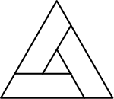
（A）3 （B）4 （C）5 （D）6 （E）7
English
In the figure, the outer equilateral triangle has area 16, the inner equilateral triangle has area 1, and the three trapezoids are congruent. What is the area of one of the trapezoids?
(A) 3 (B) 4 (C) 5 (D) 6 (E) 7
第 5 题
巴尼·施温注意到他的自行车里程表显示 1441，这是一个回文数，因为正读反读相同。当天又骑了 4 小时、第二天骑了 6 小时后，他注意到里程表显示另一个回文数 1661。他的平均速度是多少英里每小时？
（A）15 （B）16 （C）18 （D）20 （E）22
English
Barney Schwinn notices that the odometer on his bicycle reads 1441, a palindrome, because it reads the same forward and backward. After riding 4 more hours that day and 6 the next, he notices that the odometer shows another palindrome, 1661. What was his average speed in miles per hour?
(A) 15 (B) 16 (C) 18 (D) 20 (E) 22
第 6 题
图中阴影正方形的面积与非阴影正方形的面积之比是多少？
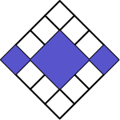
（A）3:10 （B）3:8 （C）3:7 （D）3:5 （E）1:1
English
In the figure, what is the ratio of the area of the shaded squares to the area of the unshaded squares?
(A) 3:10 (B) 3:8 (C) 3:7 (D) 3:5 (E) 1:1
第 7 题
如果 3/5=M/45=60/N，那么 M+N 是多少？
（A）27 （B）29 （C）45 （D）105 （E）127
English
If 3/5=M/45=60/N, what is M+N?
(A) 27 (B) 29 (C) 45 (D) 105 (E) 127
第 8 题
助威俱乐部从一月到四月的糖果销售额如图所示。平均每月销售额是多少美元？
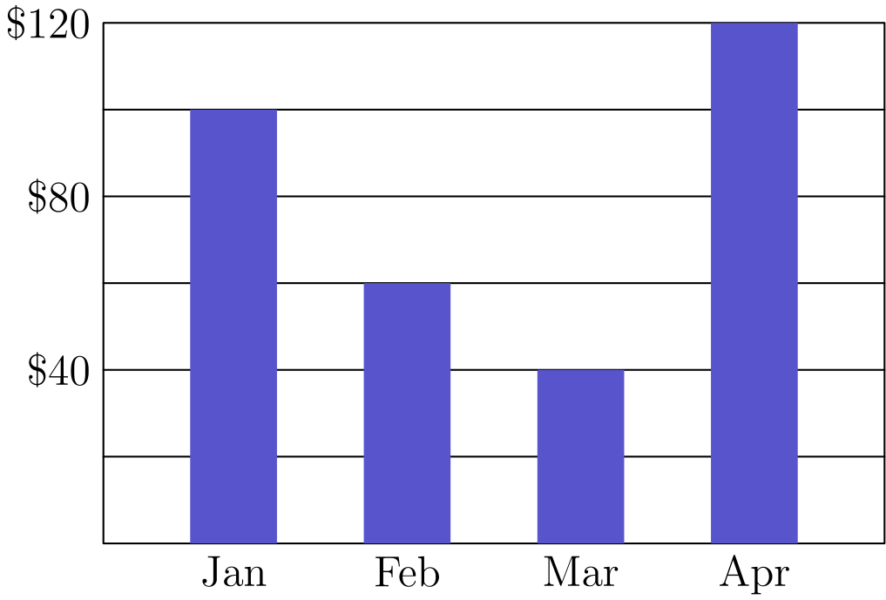
（A）60 （B）70 （C）75 （D）80 （E）85
English
Candy sales of the Boosters Club for January through April are shown. What were the average sales per month in dollars?
(A) 60 (B) 70 (C) 75 (D) 80 (E) 85
第 9 题
2005 年，投资大亨塔米投入了 $100，为期两年。第一年她的投资亏损 15%，但第二年剩余投资增长了 20%。这两年内塔米的投资变化是多少？
（A）亏损 5% （B）亏损 2% （C）增长 1% （D）增长 2% （E）增长 5%
English
In 2005 Tycoon Tammy invested $100 for two years. During the first year her investment suffered a 15% loss, but during the second year the remaining investment showed a 20% gain. Over the two-year period, what was the change in Tammy’s investment?
(A) 5% loss (B) 2% loss (C) 1% gain (D) 2% gain (E) 5% gain
第 10 题
A 房间里 6 个人的平均年龄是 40。B 房间里 4 个人的平均年龄是 25。如果把两组人合在一起，所有人的平均年龄是多少？
（A）32.5 （B）33 （C）33.5 （D）34 （E）35
English
The average age of the 6 people in Room A is 40. The average age of the 4 people in Room B is 25. If the two groups are combined, what is the average age of all the people?
(A) 32.5 (B) 33 (C) 33.5 (D) 34 (E) 35
第 11 题
林肯中学八年级的 39 名学生中，每人养一只狗、一只猫，或狗和猫都养。有二十名学生养狗，26 名学生养猫。有多少名学生狗和猫都养？
（A）7 （B）13 （C）19 （D）39 （E）46
English
Each of the 39 students in the eighth grade at Lincoln Middle School has one dog or one cat or both a dog and a cat. Twenty students have a dog and 26 students have a cat. How many students have both a dog and a cat?
(A) 7 (B) 13 (C) 19 (D) 39 (E) 46
第 12 题
一个球从 3 米高处落下。第一次反弹时它升到 2 米高。之后每次下落并反弹到前一次反弹高度的 2/3。第几次反弹时它不会升到 0.5 米高？
（A）3 （B）4 （C）5 （D）6 （E）7
English
A ball is dropped from a height of 3 meters. On its first bounce it rises to a height of 2 meters. It keeps falling and bouncing to 2/3 of the height it reached in the previous bounce. On which bounce will it not rise to a height of 0.5 meters?
(A) 3 (B) 4 (C) 5 (D) 6 (E) 7
第 13 题
哈曼先生想知道他要邮寄的三个箱子的总重量，单位为磅。不过唯一可用的秤在重量小于 100 磅或大于 150 磅时不准确。于是他把箱子按所有可能的两两组合称重，结果是 122、125 和 127 磅。这三个箱子的总重量是多少磅？
（A）160 （B）170 （C）187 （D）195 （E）354
English
Mr. Harman needs to know the combined weight in pounds of three boxes he wants to mail. However, the only available scale is not accurate for weights less than 100 pounds or more than 150 pounds. So the boxes are weighed in pairs in every possible way. The results are 122, 125 and 127 pounds. What is the combined weight in pounds of the three boxes?
(A) 160 (B) 170 (C) 187 (D) 195 (E) 354
第 14 题
三个 A、三个 B 和三个 C 被放入九个格子中，使每一行和每一列都各含一个字母。若 A 放在左上角，共有多少种排列？
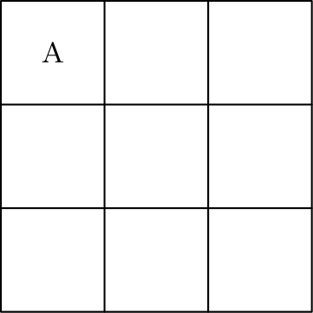
（A）2 （B）3 （C）4 （D）5 （E）6
English
Three A’s, three B’s, and three C’s are placed in the nine spaces so that each row and column contain one of each letter. If A is placed in the upper left corner, how many arrangements are possible?
(A) 2 (B) 3 (C) 4 (D) 5 (E) 6
第 15 题
特蕾莎前 8 场篮球比赛分别得了 7、4、3、6、8、3、1 和 5 分。第九场她得分少于 10 分，并且九场比赛的场均得分是整数。类似地，第十场她得分少于 10 分，并且 10 场比赛的场均得分也是整数。她第九场和第十场得分的乘积是多少？
（A）35 （B）40 （C）48 （D）56 （E）72
English
In Theresa’s first 8 basketball games, she scored 7, 4, 3, 6, 8, 3, 1 and 5 points. In her ninth game, she scored fewer than 10 points and her points-per-game average for the nine games was an integer. Similarly in her tenth game, she scored fewer than 10 points and her points-per-game average for the 10 games was also an integer. What is the product of the number of points she scored in the ninth and tenth games?
(A) 35 (B) 40 (C) 48 (D) 56 (E) 72
第 16 题
如图，七个单位立方体拼成一个立体图形。体积的立方单位数与表面积的平方单位数之比是多少？
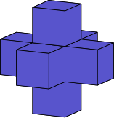
（A）1: 6 （B）7: 36 （C）1: 5 （D）7: 30 （E）6: 25
English
A shape is created by joining seven unit cubes, as shown. What is the ratio of the volume in cubic units to the surface area in square units?
(A) 1: 6 (B) 7: 36 (C) 1: 5 (D) 7: 30 (E) 6: 25
第 17 题
奥斯本女士要求班上每个学生画一个边长为整数、周长为 50 单位的长方形。所有学生都计算了自己所画长方形的面积。这些长方形可能面积的最大值与最小值之差是多少？
（A）76 （B）120 （C）128 （D）132 （E）136
English
Ms. Osborne asks each student in her class to draw a rectangle with integer side lengths and a perimeter of 50 units. All of her students calculate the area of the rectangle they draw. What is the difference between the largest and smallest possible areas of the rectangles?
(A) 76 (B) 120 (C) 128 (D) 132 (E) 136
第 18 题
两个圆同心，半径分别为 10 米和 20 米。一只土豚沿图示路线奔跑，从 A 出发，到 K 结束。它跑了多少米？
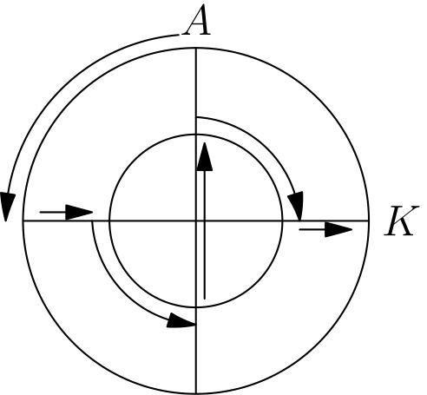
（A）10π+20 （B）10π+30 （C）10π+40 （D）20π+20 （E）20π+40
English
Two circles that share the same center have radii 10 meters and 20 meters. An aardvark runs along the path shown, starting at A and ending at K. How many meters does the aardvark run?
(A) 10π+20 (B) 10π+30 (C) 10π+40 (D) 20π+20 (E) 20π+40
第 19 题
如图，八个点以一个单位的间隔分布在一个 2×2 正方形的周围。从这 8 个点中随机选两个点。它们相距一个单位的概率是多少？

（A）1/4 （B）2/7 （C）4/11 （D）1/2 （E）4/7
English
Eight points are spaced at intervals of one unit around a 2×2 square, as shown. Two of the 8 points are chosen at random. What is the probability that the points are one unit apart?
(A) 1/4 (B) 2/7 (C) 4/11 (D) 1/2 (E) 4/7
第 20 题
尼特金先生班上的学生参加了一次书法测试。男生中的三分之二和女生中的 3/4 通过了测试，并且通过测试的男生人数和女生人数相等。这个班最少可能有多少名学生？
（A）12 （B）17 （C）24 （D）27 （E）36
English
The students in Mr. Neatkin’s class took a penmanship test. Two-thirds of the boys and 3/4 of the girls passed the test, and an equal number of boys and girls passed the test. What is the minimum possible number of students in the class?
(A) 12 (B) 17 (C) 24 (D) 27 (E) 36
第 21 题
杰里从一个 6 厘米长的圆柱形博洛尼亚香肠中切下一块楔形部分，如虚线曲线所示。哪一个选项最接近这块楔形部分的体积，单位为立方厘米？
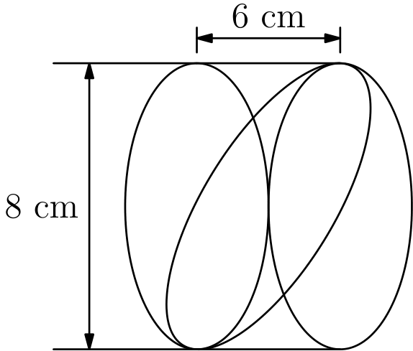
（A）48 （B）75 （C）151 （D）192 （E）603
English
Jerry cuts a wedge from a 6-cm cylinder of bologna as shown by the dashed curve. Which answer choice is closest to the volume of his wedge in cubic centimeters?
(A) 48 (B) 75 (C) 151 (D) 192 (E) 603
第 22 题
有多少个正整数 n，使得 n/3 和 3n 都是三位整数？
（A）12 （B）21 （C）27 （D）33 （E）34
English
For how many positive integer values of n are both n/3 and 3n three-digit whole numbers?
(A) 12 (B) 21 (C) 27 (D) 33 (E) 34
第 23 题
在正方形 ABCE 中，AF=2FE，且 CD=2DE。△ BFD 的面积与正方形 ABCE 的面积之比是多少？
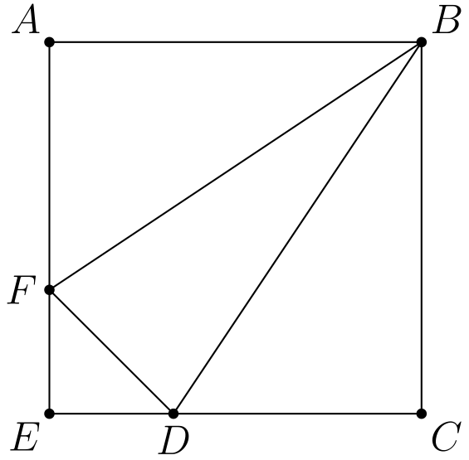
（A）1/6 （B）2/9 （C）5/18 （D）1/3 （E）7/20
English
In square ABCE, AF=2FE and CD=2DE. What is the ratio of the area of △ BFD to the area of square ABCE?
(A) 1/6 (B) 2/9 (C) 5/18 (D) 1/3 (E) 7/20
第 24 题
编号为 1 到 10 的十块牌面朝下放着。随机翻开一块牌，并掷一个骰子。牌上的数与骰子点数的乘积是平方数的概率是多少？
（A）1/10 （B）1/6 （C）11/60 （D）1/5 （E）7/30
English
Ten tiles numbered 1 through 10 are turned face down. One tile is turned up at random, and a die is rolled. What is the probability that the product of the numbers on the tile and the die will be a square?
(A) 1/10 (B) 1/6 (C) 11/60 (D) 1/5 (E) 7/30
第 25 题
玛吉获奖的艺术设计如图所示。最小的圆半径为 2 英寸，每个后续圆的半径都增加 2 英寸。这个设计中大约百分之多少被涂上阴影？

（A）42 （B）44 （C）45 （D）46 （E）48
English
Margie’s winning art design is shown. The smallest circle has radius 2 inches, with each successive circle’s radius increasing by 2 inches. Approximately what percent of the design is shaded?
(A) 42 (B) 44 (C) 45 (D) 46 (E) 48

第二部分 解答
答案速查：
题号 1 2 3 4 5 6 7 8 9
答案 B A A C E D E D D
题号 10 11 12 13 14 15 16 17 18
答案 D A C C C B D D E
题号 19 20 21 22 23 24 25
答案 B B C A C C A
答案串：BAACEDEDDDACCCBDDEBBCACCA
第 1 题 答案 B
苏珊在游乐项目上花了 2· 12=24 美元，所以她一共花了 12+24=36 美元。
她还剩 50-36=14 美元。
所以正确答案是B。
English
Susan spent 2· 12=24 dollars on rides, so she spent 12+24=36 dollars total.
She had 50-36=14 dollars left.
Thus,Bis the correct answer.
第 2 题 答案 A
代码 BEST OF LUCK 依次表示数字 0 到 9，所以 C=8、L=6、U=7、E=1。
因此 CLUE=8671。
所以正确答案是A。
English
The code BEST OF LUCK represents the digits 0 through 9 in order, so C=8, L=6, U=7, and E=1.
Therefore, CLUE=8671.
Thus,Ais the correct answer.
第 3 题 答案 A
因为 13 号是星期五，所以 6 号也是星期五。1 号比这个星期五早 5 天，因此是星期日。
所以正确答案是A。
English
Since the 13th is a Friday, we know that the 6th is also a Friday. The 1st is 5 days before the Friday, making it a Sunday.
Thus, the answer isA.
第 4 题 答案 C
外三角形面积为 16，内三角形面积为 1。
因此三个全等梯形的总面积为 16-1=15，每个梯形的面积为 15÷3=5。
所以正确答案是C。
English
The outer triangle has area 16, and the inner triangle has area 1.
So the three congruent trapezoids have total area 16-1=15, and each trapezoid has area 15÷3=5.
Thus,Cis the correct answer.
第 5 题 答案 E
里程表增加了 1661-1441=220 英里。
巴尼一共骑了 4+6=10 小时，所以平均速度为 220÷10=22 英里每小时。
所以正确答案是E。
English
The odometer increased by 1661-1441=220 miles.
Barney rode for 4+6=10 hours, so his average speed was 220÷10=22 miles per hour.
Thus,Eis the correct answer.
第 6 题 答案 D
把中央阴影正方形细分后，图中共有 16 个相等的小正方形。
其中 6 个是阴影，10 个不是阴影，所以所求比值为 6:10=3:5。
所以正确答案是D。
English
After subdividing the central shaded square, the figure has 16 equal small squares.
Of these, 6 are shaded and 10 are unshaded, so the desired ratio is 6:10=3:5.
Thus,Dis the correct answer.
第 7 题 答案 E
由 3/5=M/45，得 M=(3·45)/5=27。
由 3/5=60/N，得 3N=300，所以 N=100。
因此 M+N=27+100=127。
所以正确答案是E。
English
From 3/5=M/45, we get M=(3·45)/5=27.
From 3/5=60/N, we get 3N=300, so N=100.
Therefore, M+N=27+100=127.
Thus,Eis the correct answer.
第 8 题 答案 D
四个月的销售额分别为 100、60、40 和 120 美元。
它们的平均值为 100+60+40+120/4 =320/4 =80 美元。
所以正确答案是D。
English
The four monthly sales are 100, 60, 40, and 120 dollars.
Their average is 100+60+40+120/4 =320/4 =80 dollars.
Thus,Dis the correct answer.
第 9 题 答案 D
15% 的亏损使投资从 $100 变为 0.85·$100=$85。
20% 的增长再使其变为 1.2·$85=$102。
投资从 $100 变为 $102，也就是增长 2%。
所以正确答案是D。
English
The 15% loss changes the investment from $100 to 0.85·$100=$85.
The 20% gain then changes it to 1.2·$85=$102.
The investment went from $100 to $102, which is a 2% gain.
Thus,Dis the correct answer.
第 10 题 答案 D
A 房间的年龄总和为
6· 40 = 240。
B 房间的年龄总和为
4· 25 = 100。
总和为
240+100 = 340。
因此平均年龄为
340/10 =34。
所以正确答案是D。
English
The sum of the ages in Room A is
6· 40 = 240.
The sum of the ages in Room B is
4· 25 = 100.
The total sum is
240+100 = 340.
The average is therefore
340/10 =34.
Thus, the answer isD.
第 11 题 答案 A
同时养两种动物的人数等于养猫人数加养狗人数，再减去至少养一种动物的人数。
因此同时养两种动物的人数为
20+26-39 = 7。
所以正确答案是A。
English
The number of people that have both animals is equal to the number of people that own a cat plus the number of people that own a dog minus the number of people that own either.
Therefore, the number of people who own both is
20+26-39 = 7.
Thus, the answer isA.
第 12 题 答案 C
第一次反弹升到 2 米。之后每次反弹都是前一次反弹高度的 2/3。
第四次反弹升到 2(2/3)³=16/27，大于 1/2。
第五次反弹升到 2(2/3)⁴=32/81，小于 1/2。
所以正确答案是C。
English
The first bounce rises to 2 meters. Each later bounce is 2/3 of the previous bounce.
The fourth bounce rises to 2(2/3)³=16/27, which is greater than 1/2.
The fifth bounce rises to 2(2/3)⁴=32/81, which is less than 1/2.
Thus,Cis the correct answer.
第 13 题 答案 C
设三个箱子的重量为 a、b、c。已知
a+b = 122
a+c = 125
b+c = 127

。
把这些式子相加得到
2(a+b+c) =
122+125+127=374。
所以
a+b+c = 187。
所以正确答案是C。
English
Let the weights be a, b, c. We know
a+b = 122
a+c = 125
b+c = 127.

Adding all of this yields
2(a+b+c) =
122+125+127=374.
This makes
a+b+c = 187.
Thus, the answer isC.
第 14 题 答案 C
另外两个 A 必须各占剩余两行和剩余两列中的一个格子。三个 A 的位置有两种可能的对角模式。
对于任意一种 A 的位置模式，第一行剩余两个位置可以填成 B,C 或 C,B，之后其余格子都被确定。
因此共有 2·2=4 种排列。
所以正确答案是C。
English
The other two A’s must occupy one square in each of the remaining two rows and columns. There are two possible diagonal patterns for the three A’s.
For either A-pattern, the two remaining positions in the top row can be filled as B,C or C,B, and then the rest of the grid is forced.
So there are 2·2=4 arrangements.
Thus,Cis the correct answer.
第 15 题 答案 B
她前 8 场的得分和为 37。因为前 9 场的平均分是整数，所以前 9 场的总分是 9 的倍数。
由于第九场得分少于 10，前 9 场的总分在 37 到 47 之间，并且是 9 的倍数，因此总分为 45。所以第 9 场得分为 45-37=8。
特蕾莎前 9 场的总分是 45。因为前 10 场的平均分是整数，所以前 10 场的总分是 10 的倍数。
由于第十场得分少于 10，前 10 场的总分在 45 到 55 之间，并且是 10 的倍数，因此总分为 50。所以第 10 场得分为 50-45=5。
因此乘积为 8· 5=40。
所以正确答案是B。
English
The sum of her first 8 scores is 37. Since the average of the first 9 scores is an integer, the sum of the first 9 scores is a multiple of 9.
Since the score is less than 10, the sum of the scores after 9 games is between 37 and 47, and is a multiple of 9, making the sum 45. Thus, the score of the 9th game is 45-37=8.
The sum of Theresa’s first 9 scores is 45. Since the average of the first 10 scores is an integer, the sum of the first 10 scores is a multiple of 10.
Since the score is less than 10, the sum of the scores after 10 games is between 45 and 55, and is a multiple of 10, making the sum 50. Thus, the score of the 10th game is 50-45=5.
Therefore, their product is 8· 5=40.
Thus, the answer isB.
第 16 题 答案 D
这个立体由 7 个单位立方体组成，所以体积是 7 立方单位。
中央立方体没有外露面。六个外侧立方体各有 5 个外露面，所以表面积为 6·5=30 平方单位。
体积与表面积之比为 7:30。
所以正确答案是D。
English
The shape uses 7 unit cubes, so its volume is 7 cubic units.
The center cube has no exposed faces. Each of the six outer cubes has 5 exposed faces, for a total surface area of 6·5=30 square units.
The ratio of volume to surface area is 7:30.
Thus,Dis the correct answer.
第 17 题 答案 D
若边长为 l 和 w，则 2l+2w=50，所以 l+w=25。
最小可能面积来自边长 1 和 24，面积为 24。
最大可能面积来自和为 25 且最接近的整数对，即 12 和 13，面积为 156。
差为 156-24=132。
所以正确答案是D。
English
If the side lengths are l and w, then 2l+2w=50, so l+w=25.
The smallest possible area comes from side lengths 1 and 24, giving area 24.
The largest possible area comes from the closest integer pair with sum 25, namely 12 and 13, giving area 156.
The difference is 156-24=132.
Thus,Dis the correct answer.
第 18 题 答案 E
圆的周长是 π d = 2rπ ，所以走四分之一圆周的长度是 (π r)/2。
它先沿大圆走四分之一圈，这部分是 10 π 米。然后从大圆到小圆，长度为 20-10=10 米。
接着沿小圆走四分之一圈，这部分是 5 π 米。然后穿过小圆的直径，长度为 10· 2=20 米。
再沿小圆走四分之一圈，这部分是 5 π 米。最后从小圆到大圆，长度为 20-10=10 米。
总长度为
10π + 10+5π + 20 + 5π + 10
=20π + 40。
所以正确答案是E。
English
The circumference of a circle is π d = 2rπ, so going a quarter of the way around is (π r)/2.
He goes a quarter of the way around the large circle, so this part is 10 π meters. He then goes from the larger circle to the smaller circle, which is 20-10=10 meters.
He goes a quarter of the way around the smaller circle, so this part is 5 π meters. He then goes through the diameter of the smaller circle, which is 10· 2=20 meters.
He then goes a quarter of the way around the smaller circle, so this part is 5 π meters. He finally goes from the smaller circle to the larger circle, which is 20-10=10 meters.
The total length is
10π + 10+5π + 20 + 5π + 10
=20π + 40.
Thus, the answer isE.
第 19 题 答案 B
每个点都有 2 个点与它相距一个单位。
因此无论第一个点怎么选，其余 7 个点中有 2 个与它相距一个单位，所以概率为 2/7。
所以正确答案是B。
English
Each dot has 2 dots that are one unit away from it.
Therefore, regardless of the choice of the first dot, 2 of the other 7 dots would be within one unit, so the probability is 2/7.
Thus, the answer isB.
第 20 题 答案 B
设通过测试的男生数和女生数都为 p。
因为男生中的 2/3 通过了测试，男生人数为 3p/2。因为女生中的 3/4 通过了测试，女生人数为 4p/3。
使两个人数都为整数的最小正数 p 是 6。此时有 9 名男生和 8 名女生，最小总人数为 17。
所以正确答案是B。
English
Let p be the common number of boys and girls who passed.
Since 2/3 of the boys passed, the number of boys is 3p/2. Since 3/4 of the girls passed, the number of girls is 4p/3.
The smallest positive p that makes both counts whole is 6. Then there are 9 boys and 8 girls, for a minimum total of 17 students.
Thus,Bis the correct answer.
第 21 题 答案 C
圆柱直径是 8 厘米，所以半径是 4 厘米。它的长度是 6 厘米。
整个圆柱的体积是 π r²h=π·4²·6=96π。
虚线切割得到圆柱的一半，所以楔形部分体积为 48π，约为 151 立方厘米。
所以正确答案是C。
English
The cylinder has diameter 8 cm, so its radius is 4 cm. Its length is 6 cm.
The whole cylinder has volume π r²h=π·4²·6=96π.
The dashed cut takes half of the cylinder, so the wedge has volume 48π, which is about 151 cubic centimeters.
Thus,Cis the correct answer.
第 22 题 答案 A
令 x=n/3。则 n=3x，所以 3n=9x。
x 和 9x 都必须是三位整数。因此 100≤ x，并且 9x≤999，所以 100≤ x≤111。
共有 111-100+1=12 个整数 x，每个都对应一个正整数 n。
所以正确答案是A。
English
Let x=n/3. Then n=3x, so 3n=9x.
Both x and 9x must be three-digit whole numbers. Thus 100≤ x and 9x≤999, so 100≤ x≤111.
There are 111-100+1=12 integer values of x, and each gives one positive integer value of n.
Thus,Ais the correct answer.
第 23 题 答案 C
因为答案是比值，取正方形边长为 3。则 AF=2、FE=1、CD=2、DE=1。
正方形面积为 9。三角形 ABF 和 BCD 的面积都为 1/2·3·2=3。
三角形 DEF 的面积为 1/2·1·1=1/2。
所以 [BFD]=9-3-3-1/2=5/2，所求比值为 (5/2)/9=5/18。
所以正确答案是C。
English
Because the answer is a ratio, choose the side length of the square to be 3. Then AF=2, FE=1, CD=2, and DE=1.
The square has area 9. The areas of triangles ABF and BCD are each 1/2·3·2=3.
Triangle DEF has area 1/2·1·1=1/2.
So [BFD]=9-3-3-1/2=5/2, and the desired ratio is (5/2)/9=5/18.
Thus,Cis the correct answer.
第 24 题 答案 C
如果骰子点数为 1，牌可以是 1、4、9，有 3 种组合。
如果骰子点数为 2，牌可以是 2、8，有 2 种组合。
如果骰子点数为 3，牌可以是 3，有 1 种组合。
如果骰子点数为 4，牌可以是 1、4、9，有 3 种组合。
如果骰子点数为 5，牌可以是 5，有 1 种组合。
如果骰子点数为 6，牌可以是 6，有 1 种组合。
组合总数为
3+2+1+3+1+1=11。
共有 60 个等可能组合，所以概率是 11/60 。
所以正确答案是C。
English
If the rolled number was 1, then the tile can be 1, 4, 9, yielding 3 combinations.
If the rolled number was 2, then the tile can be 2, 8, yielding 2 combinations.
If the rolled number was 3, then the tile can be 3, yielding 1 combination.
If the rolled number was 4, then the tile can be 1, 4, 9, yielding 3 combinations.
If the rolled number was 5, then the tile can be 5, yielding 1 combination.
If the rolled number was 6, then the tile can be 6, yielding 1 combination.
The total number of combinations is
3+2+1+3+1+1=11.
There are 60 combinations each with equal likelihood, so the probability is 11/60.
Thus, the answer isC.
第 25 题 答案 A
最大圆的半径为 12，所以整个设计的面积为 12²π=144π。
阴影部分的面积为 2²π=4π、(6²-4²)π=20π 和 (10²-8²)π=36π。
阴影总面积为 4π+20π+36π=60π，所以阴影比例为 60π/144π=5/12，约为 42%。
所以正确答案是A。
English
The largest circle has radius 12, so the entire design has area 12²π=144π.
The shaded parts have areas 2²π=4π, (6²-4²)π=20π, and (10²-8²)π=36π.
The total shaded area is 4π+20π+36π=60π, so the shaded fraction is 60π/144π=5/12, which is about 42%.
Thus,Ais the correct answer.

