2007 年 AMC 8 真题与解答
American Mathematics Competitions 8 · 中英双语
共 25 题，限时 40 分钟；单项选择题，每题 1 分，答错不扣分，满分 25 分。
编排说明：第一部分为题目（先中文、后英文原题），第二部分为解答与答案，便于先做题后对答案。
第一部分 题目
第 1 题
Theresa 的父母同意，如果她平均每周花 10 小时帮忙做家务，连续 6 周，就给她买票去看她最喜欢的乐队。前 5 周她分别帮忙 8、11、7、12 和 10 小时。为了得到门票，最后一周她必须工作多少小时？
（A）9 （B）10 （C）11 （D）12 （E）13
English
Theresa’s parents have agreed to buy her tickets to see her favorite band if she spends an average of 10 hours per week helping around the house for 6 weeks. For the first 5 weeks she helps around the house for 8, 11, 7, 12 and 10 hours. How many hours must she work for the final week to earn the tickets?
(A) 9 (B) 10 (C) 11 (D) 12 (E) 13
第 2 题
对 650 名学生进行了意大利面偏好调查。选项包括千层面、意式夹馅卷、意式馄饨和意大利面条。调查结果显示在条形图中。喜欢意大利面条的学生人数与喜欢意式夹馅卷的学生人数之比是多少？
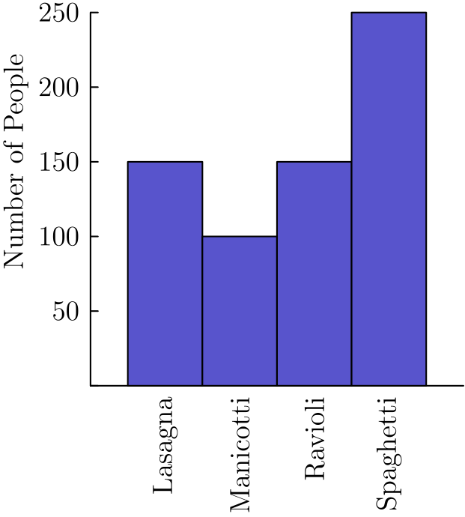
（A）2/5 （B）1/2 （C）5/4 （D）5/3 （E）5/2
English
650 students were surveyed about their pasta preferences. The choices were lasagna, manicotti, ravioli and spaghetti. The results of the survey are displayed in the bar graph. What is the ratio of the number of students who preferred spaghetti to the number of students who preferred manicotti?
(A) 2/5 (B) 1/2 (C) 5/4 (D) 5/3 (E) 5/2
第 3 题
250 的两个最小质因数之和是多少？
（A）2 （B）5 （C）7 （D）10 （E）12
English
What is the sum of the two smallest prime factors of 250?
(A) 2 (B) 5 (C) 7 (D) 10 (E) 12
第 4 题
一座鬼屋有六扇窗。幽灵 Georgie 从一扇窗进入，并从另一扇不同的窗离开，共有多少种方式？
（A）12 （B）15 （C）18 （D）30 （E）36
English
A haunted house has six windows. In how many ways can Georgie the Ghost enter the house by one window and leave by a different window?
(A) 12 (B) 15 (C) 18 (D) 30 (E) 36
第 5 题
Chandler 想买一辆 $500 的山地车。生日时，他的祖父母给他 $50，姑姑给他 $35，表亲给他 $15。他送报每周赚 $16。他会使用所有生日钱和所有送报赚的钱。多少周后他可以买这辆山地车？
（A）24 （B）25 （C）26 （D）27 （E）28
English
Chandler wants to buy a $500 mountain bike. For his birthday, his grandparents send him $50, his aunt sends him $35 and his cousin gives him $15. He earns $16 per week for his paper route. He will use all of his birthday money and all of the money he earns from his paper route. In how many weeks will he be able to buy the mountain bike?
(A) 24 (B) 25 (C) 26 (D) 27 (E) 28
第 6 题
1985 年，美国长途电话平均费用为每分钟 41 美分；2005 年为每分钟 7 美分。求长途电话每分钟费用大约下降了百分之多少。
（A）7 （B）17 （C）34 （D）41 （E）80
English
The average cost of a long-distance call in the USA in 1985 was 41 cents per minute, and the average cost of a long-distance call in the USA in 2005 was 7 cents per minute. Find the approximate percent decrease in the cost per minute of a long-distance call.
(A) 7 (B) 17 (C) 34 (D) 41 (E) 80
第 7 题
一个房间里 5 个人的平均年龄是 30 岁。一名 18 岁的人离开房间。剩下四个人的平均年龄是多少？
（A）25 （B）26 （C）29 （D）33 （E）36
English
The average age of 5 people in a room is 30 years. An 18-year-old person leaves the room. What is the average age of the four remaining people?
(A) 25 (B) 26 (C) 29 (D) 33 (E) 36
第 8 题
在梯形 ABCD 中，AD 垂直于 DC，AD = AB = 3，且 DC = 6。此外，E 在 DC 上，且 BE 平行于 AD。求 △ BEC 的面积。
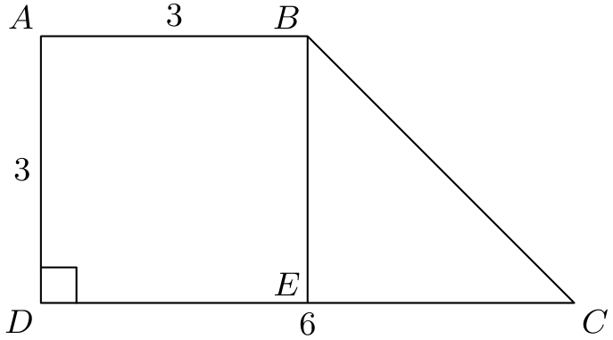
（A）3 （B）4.5 （C）6 （D）9 （E）18
English
In trapezoid ABCD, AD is perpendicular to DC, AD = AB = 3, and DC = 6. In addition, E is on DC, and BE is parallel to AD. Find the area of △ BEC.
(A) 3 (B) 4.5 (C) 6 (D) 9 (E) 18
第 9 题
要完成下面的方格，每一行和每一列都必须各出现一次数字 1 到 4。右下角方格中会是什么数？
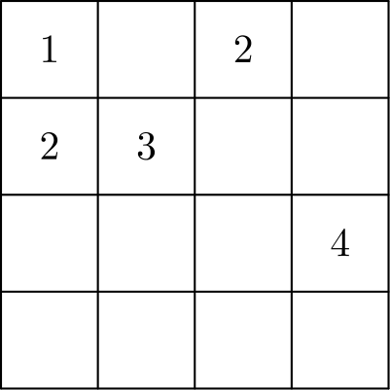
（A）1 （B）2 （C）3 （D）4 （E）无法确定
English
To complete the grid below, each of the digits 1 through 4 must occur once in each row and once in each column. What number will occupy the lower right-hand square?
(A) 1 (B) 2 (C) 3 (D) 4 (E) cannot be determined
第 10 题
对任意正整数 n，定义 boxedn 为 n 的所有正因数之和。例如，
boxed6 = 1 + 2 + 3 + 6 = 12。
求 boxedboxed11。
（A）13 （B）20 （C）24 （D）28 （E）30
English
For any positive integer n, define boxedn to be the sum of the positive factors of n. For example,
boxed6 = 1 + 2 + 3 + 6 = 12.
Find boxedboxed11.
(A) 13 (B) 20 (C) 24 (D) 28 (E) 30
第 11 题
瓷片 I、II、III 和 IV 被平移，使每个瓷片分别与长方形 A、B、C 和 D 中的一个重合。在最终排列中，任意两个相邻瓷片公共边上的两个数字必须相同。哪个瓷片被平移到长方形 C？
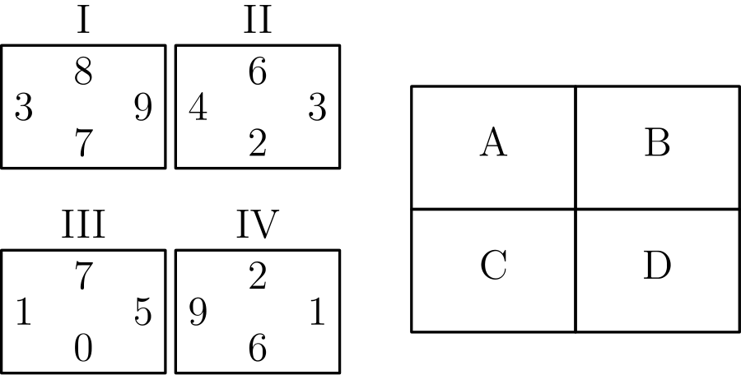
（A）I （B）II （C）III （D）IV （E）无法确定
English
Tiles I, II, III and IV are translated so one tile coincides with each of the rectangles A, B, C and D. In the final arrangement, the two numbers on any side common to two adjacent tiles must be the same. Which of the tiles is translated to Rectangle C?
(A) I (B) II (C) III (D) IV (E) cannot be determined
第 12 题
一个单位六角星由一个边长为 1 的正六边形和它的 6 个等边三角形延伸部分组成，如图所示。延伸部分的面积与原正六边形面积之比是多少？
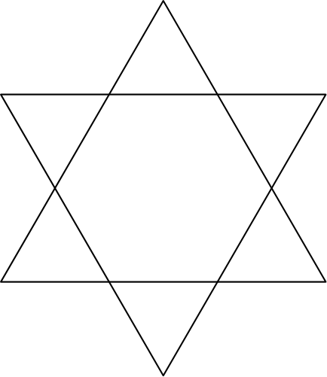
（A）1:1 （B）6:5 （C）3:2 （D）2:1 （E）3:1
English
A unit hexagram is composed of a regular hexagon of side length 1 and its 6 equilateral triangular extensions, as shown in the diagram. What is the ratio of the area of the extensions to the area of the original hexagon?
(A) 1:1 (B) 6:5 (C) 3:2 (D) 2:1 (E) 3:1
第 13 题
如维恩图所示，集合 A 和 B 的元素个数相同。它们的并集有 2007 个元素，交集有 1001 个元素。求集合 A 的元素个数。
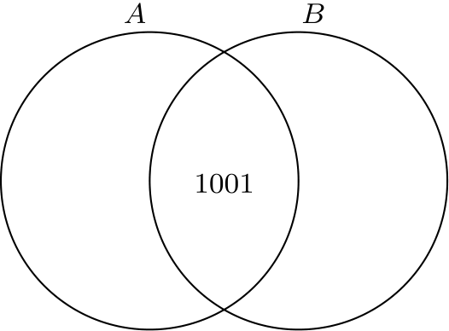
（A）503 （B）1006 （C）1504 （D）1507 （E）1510
English
Sets A and B, shown in the Venn diagram, have the same number of elements. Their union has 2007 elements and their intersection has 1001 elements. Find the number of elements in A.
(A) 503 (B) 1006 (C) 1504 (D) 1507 (E) 1510
第 14 题
等腰三角形 △ ABC 的底边长为 24，面积为 60。其中一条全等边的长度是多少？
（A）5 （B）8 （C）13 （D）14 （E）18
English
The base of isosceles △ ABC is 24 and its area is 60. What is the length of one of the congruent sides?
(A) 5 (B) 8 (C) 13 (D) 14 (E) 18
第 15 题
设 a，b 和 c 是满足 0 < a < b < c 的数。下列哪一项不可能？
（A）a + c < b （B）a · b < c （C）a + b < c （D）a · c < b （E）b/c = a
English
Let a, b and c be numbers with 0 < a < b < c. Which of the following is impossible?
(A) a + c < b (B) a · b < c (C) a + b < c (D) a · c < b (E) b/c = a
第 16 题
Amanda Reckonwith 画了五个半径为 1、2、3、4 和 5 的圆。然后对每个圆，她描点 (C, A)，其中 C 是圆的周长，A 是圆的面积。下列哪一个可能是她的图？
（A）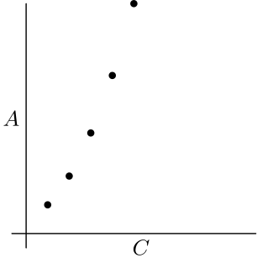
（B）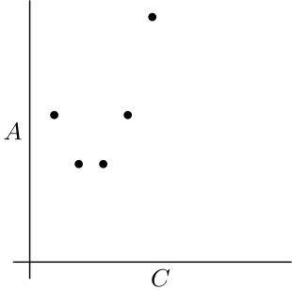
（C）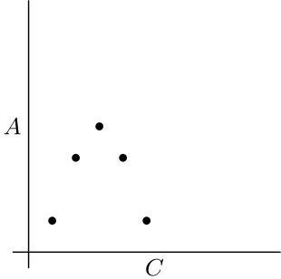
（D）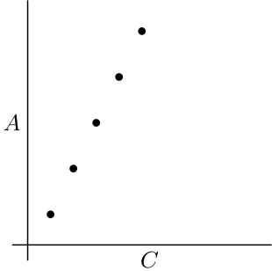
（E）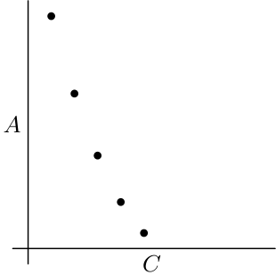
English
Amanda Reckonwith draws five circles with radii 1, 2, 3, 4 and 5. Then for each circle she plots the point (C, A), where C is its circumference and A is its area. Which of the following could be her graph?
(A)
(B)
(C)
(D)
(E)
第 17 题
30 升油漆混合物中有 25% 红色颜料、30% 黄色颜料和 45% 水。向原混合物中加入五升黄色颜料。新混合物中黄色颜料占百分之多少？
（A）25 （B）35 （C）40 （D）45 （E）50
English
A mixture of 30 liters of paint is 25% red tint, 30% yellow tint and 45% water. Five liters of yellow tint are added to the original mixture. What is the percent of yellow tint in the new mixture?
(A) 25 (B) 35 (C) 40 (D) 45 (E) 50
第 18 题
两个 99 位数
303,030,303,…,030,303
和
505,050,505,…,050,505
的乘积，其千位数字为 A，个位数字为 B。A+B 是多少？
（A）3 （B）5 （C）6 （D）8 （E）10
English
The product of the two 99-digit numbers
303,030,303,…,030,303
and
505,050,505,…,050,505
has thousands digit A and units digit B. What is A+B?
(A) 3 (B) 5 (C) 6 (D) 8 (E) 10
第 19 题
选择两个连续正整数，它们的和小于 100。把这两个整数分别平方，然后求平方差。下列哪一个可能是这个差？
（A）2 （B）64 （C）79 （D）96 （E）131
English
Pick two consecutive positive integers whose sum is less than 100. Square both of those integers and then find the difference of the squares. Which of the following could be the difference?
(A) 2 (B) 64 (C) 79 (D) 96 (E) 131
第 20 题
在分区赛前，Unicorns 赢了他们篮球比赛的 45 %。分区赛中，他们又赢六场、输两场，最终以胜率一半结束赛季。Unicorns 总共打了多少场比赛？
（A）48 （B）50 （C）52 （D）54 （E）60
English
Before district play, the Unicorns had won 45 % of their basketball games. During district play, they won six more games and lost two, to finish the season having won half their games. How many games did the Unicorns play in all?
(A) 48 (B) 50 (C) 52 (D) 54 (E) 60
第 21 题
从一副牌中发出两张牌。这副牌有四张红牌，分别标为 A、B、C、D，还有四张绿牌，也分别标为 A、B、C、D。一对获胜牌是两张同色牌或两张同字母牌。抽到一对获胜牌的概率是多少？
（A）2/7 （B）3/8 （C）1/2 （D）4/7 （E）5/8
English
Two cards are dealt from a deck of four red cards labeled A, B, C, D and four green cards labeled A, B, C, D. A winning pair is two of the same color or two of the same letter. What is the probability of drawing a winning pair?
(A) 2/7 (B) 3/8 (C) 1/2 (D) 4/7 (E) 5/8
第 22 题
一只旅鼠坐在边长为 10 米的正方形的一个角上。它沿对角线朝对面的顶点跑了 6.2 米。它停下，向右转 90°，又跑了 2 米。一位科学家测量旅鼠到正方形每条边的最短距离。这四个距离的平均数是多少米？
（A）2 （B）4.5 （C）5 （D）6.2 （E）7
English
A lemming sits at a corner of a square with side length 10 meters. The lemming runs 6.2 meters along a diagonal toward the opposite corner. It stops, makes a 90° right turn and runs 2 more meters. A scientist measures the shortest distance between the lemming and each side of the square. What is the average of these four distances in meters?
(A) 2 (B) 4.5 (C) 5 (D) 6.2 (E) 7
第 23 题
图中 5 × 5 方格里的阴影风车形面积是多少？
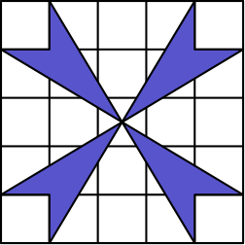
（A）4 （B）6 （C）8 （D）10 （E）12
English
What is the area of the shaded pinwheel shown in the 5 × 5 grid?
(A) 4 (B) 6 (C) 8 (D) 10 (E) 12
第 24 题
一个袋子里有四张纸片，分别标有数字 1、2、3、4，没有重复。从中不放回地一次抽出三张，用来组成一个三位数。这个三位数是 3 的倍数的概率是多少？
（A）1/4 （B）1/3 （C）1/2 （D）2/3 （E）3/4
English
A bag contains four pieces of paper, each labeled with one of the digits 1, 2, 3 or 4, with no repeats. Three of these pieces are drawn, one at a time without replacement, to construct a three-digit number. What is the probability that the three-digit number is a multiple of 3?
(A) 1/4 (B) 1/3 (C) 1/2 (D) 2/3 (E) 3/4
第 25 题
下图的飞镖盘中，外圆半径为 6，内圆半径为 3。三条半径把每个圆分成三个全等区域，并标出分值。飞镖击中某区域的概率与该区域面积成正比。当两支飞镖击中这个靶时，得分为击中区域分值之和。得分为奇数的概率是多少？
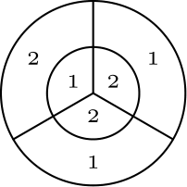
（A）17/36 （B）35/72 （C）1/2 （D）37/72 （E）19/36
English
On the dart board shown in the figure below, the outer circle has radius 6 and the inner circle has radius 3. Three radii divide each circle into three congruent regions, with point values shown. The probability that a dart will hit a given region is proportional to the area of the region. When two darts hit this board, the score is the sum of the point values of the regions hit. What is the probability that the score is odd?
(A) 17/36 (B) 35/72 (C) 1/2 (D) 37/72 (E) 19/36

第二部分 解答
答案速查：
题号 1 2 3 4 5 6 7 8 9
答案 D E C D B E D B B
题号 10 11 12 13 14 15 16 17 18
答案 D D A C C A A C D
题号 19 20 21 22 23 24 25
答案 C A D C B C B
答案串：DECDBEDBBDDACCAACDCADCBCB
第 1 题 答案 D
前 5 周 Theresa 总共工作
8+11+7+12+10=48
小时。
她承诺总共工作 10· 6=60 小时。
因此她最后一周必须工作 60-48=12 小时才能得到门票。
所以正确答案是D。
English
During the first 5 weeks, Theresa works for a total of
8+11+7+12+10=48
hours.
She promised to work 10· 6=60 hours in all.
This means that she has to work 60-48=12 hours during the final week to earn the tickets.
Thus,Dis the correct answer.
第 2 题 答案 E
喜欢意大利面条的学生有 250 人，喜欢意式夹馅卷的学生有 100 人。
比值为
250/100 = 5/2。
所以正确答案是E。
English
There are 250 students who preferred spaghetti and 100 that preferred manicotti.
The ratio is therefore
250/100 = 5/2.
Thus,Eis the correct answer.
第 3 题 答案 C
对 250 分解质因数：
250 = 2 · 5³。
因此 250 只有两个质因数：2 和 5。它们的和为 7。
所以正确答案是C。
English
We can prime factorize 250 to get
250 = 2 · 5³.
From this, we can see that 250 only has two prime factors: 2 and 5. The sum of these is 7.
Thus,Cis the correct answer.
第 4 题 答案 D
Georgie 有 6 种选择进入的窗户。但离开时只能选择不同的窗户，所以有 5 种选择。
路径总数为 6 · 5 = 30。
所以正确答案是D。
English
Georgie has 6 options for which window he enters through. He, however, only has 5 options for the exit since it must be different from the entrance.
The total number of paths is therefore 6 · 5 = 30.
Thus,Dis the correct answer.
第 5 题 答案 B
Chandler 的生日钱总额为 50+35+15=100 美元。因此他还需要 500-100=400 美元。
送报需要 400÷ 16=25 周赚到这笔钱。
所以正确答案是B。
English
The total amount of birthday money Chandler gets is 50+35+15=100 dollars. Therefore, he still needs 500-100=400 dollars.
This can be earned in 400÷ 16=25 weeks through his paper route.
Thus,Bis the correct answer.
第 6 题 答案 E
费用下降了 41-7=34 美分每分钟。
百分比下降为 100·34/41%，略大于 80%，所以最接近的答案是 80。
所以正确答案是E。
English
The decrease in cost is 41-7=34 cents per minute.
The percent decrease is 100·34/41%, which is a little more than 80%, so the closest answer is 80.
Thus,Eis the correct answer.
第 7 题 答案 D
起初，房间里所有人的总年龄为 5 · 30 = 150 岁。
这个人离开后，总年龄为 150 - 18 = 132。剩下 4 人，平均年龄为 132/4 = 33。
所以正确答案是D。
English
Initially, the total age of everyone in the room is 5 · 30 = 150 years.
After the person leaves, the total age is 150 - 18 = 132. With 4 people remaining, the average age becomes 132/4 = 33.
Thus,Dis the correct answer.
第 8 题 答案 B
我们有
EC = DC - DE
= 6 - 3
= 3。
还知道
BE = AD = 3。
因此 △ BEC 的面积为
1/2 · 3 · 3 = 9/2。
所以正确答案是B。
English
We know that
EC = DC - DE
= 6 - 3
= 3.
We also know that
BE = AD = 3.
Therefore, the area of △ BEC is
1/2 · 3 · 3 = 9/2.
Thus,Bis the correct answer.
第 9 题 答案 B
第二行最后一个格子必须是 1，因为该行已有 2 和 3，最后一列已有 4。
接着右上角格子必须是 3，因为第一行已有 1 和 2，最后一列已有 1 和 4。
这迫使 2 位于右下角方格。
所以正确答案是B。
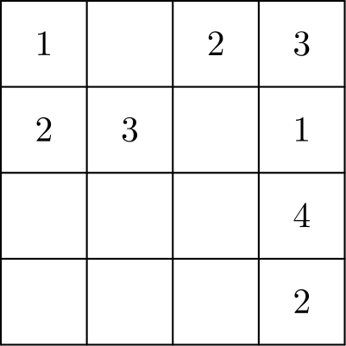
English
The last square in the second row must be 1, since that row already contains 2 and 3, and the last column already contains 4.
Then the top-right square must be 3, since the top row already contains 1 and 2, and the last column already contains 1 and 4.
This forces the 2 to be in the bottom-right square.
Thus,Bis the correct answer.
第 10 题 答案 D
首先，由于 11 是质数，
boxed11 = 1 + 11 = 12。
接着求 boxed12。12 的因数为
1, 2, 3, 4, 6, 12。
相加得到 boxed12 = 28。
所以正确答案是D。
English
First, we find that
boxed11 = 1 + 11 = 12
since 11 is prime. Then we need to find boxed12. The factors of 12 are
1, 2, 3, 4, 6, 12.
Adding these yields boxed12 = 28.
Thus,Dis the correct answer.
第 11 题 答案 D
只有瓷片 III 的边上有 0，所以瓷片 III 必须放在 C 或 D，使这个边可以在外侧。
瓷片 III 的右边还有 5，且没有其他瓷片有 5。因此瓷片 III 必须放在 D，让 5 在外侧。
1 标在瓷片 III 的左边，唯一能与之匹配的是瓷片 IV，所以瓷片 IV 放在 C。
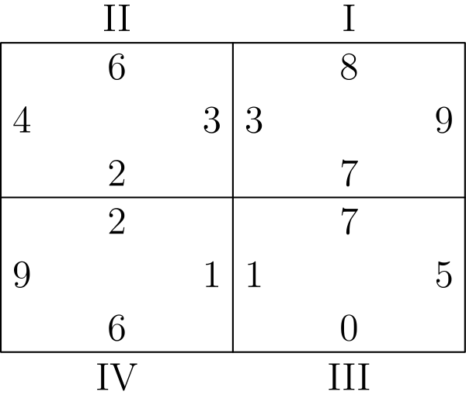
所以正确答案是D。
English
Only Tile III has a 0 on an edge, so Tile III must be placed in C or D, where that edge can be on the outside.
Tile III also has a 5 on its right edge, and no other tile has a 5. Therefore Tile III must be placed in D, with its 5 on the outside.
The only tile that can match the 1 on the left edge of Tile III is Tile IV, so Tile IV is placed in C.
Thus,Dis the correct answer.
第 12 题 答案 A
可以把六边形分成 6 个全等等边三角形，如下图。
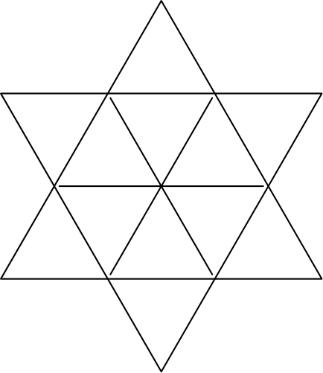
因为每个内部三角形都与一个外侧三角形共边，所以所有这些三角形全等。因此面积比为 1:1。
所以正确答案是A。
English
Note that we can split the hexagon into 6 congruent equilateral triangles as follows.
Since each of them share an edge with an exterior triangle, all the triangles are congruent. Therefore, the ratio of areas is 1:1.
Thus,Ais the correct answer.
第 13 题 答案 C
设 x 为集合 A 和 B 各自的元素个数，并设 y 为它们交集的元素个数。
条件给出
2x - y = 2007
且
y = 1001。
将 y 代入第一式得到
2x - 1001 = 2007
2x = 3008
x = 1504
。
所以正确答案是C。
English
Let x be the number of elements in each A and B. Also let y be the number of elements in their intersection.
The conditions give us that
2x - y = 2007
and
y = 1001.
Plugging y into the first equation yields
2x - 1001 = 2007
2x = 3008
x = 1504.
Thus,Cis the correct answer.
第 14 题 答案 C
作 BD 为从 B 到 AC 的高。
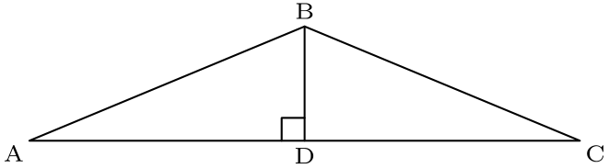
则
60 = 1/2 · BD · 24，
得到 BD = 5。
在 △ ABD 中使用勾股定理：
AB² = 5² + 12² = 169 = 13²。
因此 AB = 13。
所以正确答案是C。
English
Construct BD as the altitude from B to AC.
Then
60 = 1/2 · BD · 24,
which gives us that BD = 5.
From this, we apply the Pythagorean Theorem on △ ABD:
AB² = 5² + 12² = 169 = 13².
This gives us that AB = 13.
Thus,Cis the correct answer.
第 15 题 答案 A
已知 b < c 且 0 < a。把这两个不等式相加得到
b < c + a。
这说明A不可能，因此就是正确答案。
为确认这一点，可以给出其他选项可行的例子。
B和C：取 a = 1、b = 2、c = 4。
D：取 a = 1/3、b = 1/2、c = 1。
E：取 a = 1/2、b = 1、c = 2。
所以正确答案是A。
English
We know that b < c and 0 < a. Adding these two inequalities together yields
b < c + a.
This shows thatAis impossible, and therefore the right answer.
To ensure that this is correct, we can show that the other options are possible.
BandC: a = 1, b = 2, and c = 4
D: a = 1/3, b = 1/2, and c = 1
E: a = 1/2, b = 1, and c = 2
Thus,Ais the correct answer.
第 16 题 答案 A
半径 1 到 5 的圆的周长分别为 2π、4π、6π、8π 和 10π，对应面积分别为 π、4π、9π、16π 和 25π。
当 C 等量增加时，A 增加得越来越快，所以这些点形成递增的二次形状。只有图 A 有这种形状。
所以正确答案是A。
English
The circumferences of circles with radii 1 through 5 are 2π, 4π, 6π, 8π, and 10π. Their respective areas are π, 4π, 9π, 16π, and 25π.
As C increases by equal amounts, A increases more and more quickly, so the points form an increasing quadratic pattern. Only graph A has that shape.
Thus,Ais the correct answer.
第 17 题 答案 C
原混合物中黄色颜料为 0.3 × 30 = 9 升。加入 5 升后，黄色颜料共有 14 升。
新混合物总量为 35 升，所以黄色颜料百分比为
100 · 14/35 = 100 · 2/5 = 40 %。
所以正确答案是C。
English
The amount of yellow tint in the original mixture is 0.3 × 30 = 9 liters. Adding 5 liters results in a total of 14 liters of yellow tint.
The new mixture has a total of 35 liters, so the percent of yellow tint is
100 · 14/35 = 100 · 2/5 = 40 %.
Thus,Cis the correct answer.
第 18 题 答案 D
只有最后四位会影响乘积的千位和个位。这两个数分别以 0303 和 0505 结尾，所以只需计算 303· 505。
因为 303· 505=153015，完整乘积的最后四位是 3015。
因此 A=3，B=5，所以 A+B=8。
所以正确答案是D。
English
Only the last four digits can affect the thousands digit and units digit of the product. The two numbers end in 0303 and 0505, so it is enough to compute 303· 505.
Since 303· 505=153015, the last four digits of the full product are 3015.
This gives A=3 and B=5, so A+B=8.
Thus,Dis the correct answer.
第 19 题 答案 C
设连续正整数为 x 和 x+1。它们的和为 2x+1，小于 100。
它们的平方差为
(x+1)²-x²
= (x+1+x)(x+1-x)
= 2x+1
。
所以这个差必须是小于 100 的奇数。选项中只有 79 可能，它由 39 和 40 得到。
所以正确答案是C。
English
Let the consecutive positive integers be x and x+1. Their sum is 2x+1, which is less than 100.
The difference of their squares is
(x+1)²-x²
= (x+1+x)(x+1-x)
= 2x+1.
So the difference must be an odd number less than 100. Among the choices, 79 is the only possibility, and it occurs for 39 and 40.
Thus,Cis the correct answer.
第 20 题 答案 A
设 Unicorns 分区赛前打了 x 场比赛。那么分区赛前赢了 0.45x 场，分区赛后共赢了 0.45x+6 场。
他们总共打了 x+8 场。题意给出
0.45x+6=x+8/2。
解得 0.45x+6=0.5x+4，所以 2=0.05x，x=40。因此 Unicorns 总共打了 40+8=48 场。
所以正确答案是A。
English
Let x be the number of games the Unicorns had played before district play. Then they had won 0.45x games before district play and 0.45x+6 games after district play.
In total, they played x+8 games. The problem statement tells us that
0.45x+6=x+8/2.
Solving gives 0.45x+6=0.5x+4, so 2=0.05x, and x=40. Therefore, the Unicorns played 40+8=48 games in all.
Thus,Ais the correct answer.
第 21 题 答案 D
抽出第一张牌后，还剩 7 张。其中 3 张同色，1 张同字母。因此会与第一张牌形成获胜牌对的有 4 张，它们都在剩余的 7 张牌中。
概率为 4/7。
所以正确答案是D。
English
After drawing the first card, there are 7 left. 3 of them have the same color, and 1 of them has the same letter. Therefore, there are 4 out of 7 possibilities that result in a winning pair.
The probability of drawing a pair is then 4/7.
Thus,Dis the correct answer.
第 22 题 答案 C
根据题目给出的长度，旅鼠停下后仍在正方形内。
因为旅鼠仍在正方形内，它到两条水平边的距离和为 10 米，到两条竖直边的距离和也一样。因此 4 个距离之和为 20 米，平均数为 20 ÷ 4 = 5 米。
所以正确答案是C。
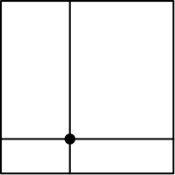
English
Based on the lengths given in the problem, the lemming is still in the square after it stops.
Since the lemming is still in the square, the sum of the distances to the horizontal sides is 10 meters and the same for the vertical sides. Therefore, the 4 distances sum to 20 meters, making the average 20 ÷ 4 = 5 meters.
Thus,Cis the correct answer.
第 23 题 答案 B
可以用总面积减去未阴影面积来求阴影面积。
有 4 个边长为 1 的正方形，每个面积为 1，对未阴影面积贡献共 4。
还有 4 个底为 3、高为 5/2 的三角形，总面积为
4 · 1/2 · 3 · 5/2 = 15。
未阴影总面积为 4 + 15 = 19。
整个方格面积为 5² = 25，所以阴影面积为 25 - 19 = 6。
所以正确答案是B。
English
We can find the area of the shaded part by subtracting the area of the unshaded part from the whole area.
There are 4 squares with side length 1, contributing 1 each to the unshaded area, for a total of 4.
There are also 4 triangles with base 3 and height 5/2. This contributes a total area of
4 · 1/2 · 3 · 5/2 = 15.
The total unshaded area is therefore 4 + 15 = 19.
The total area is 5² = 25, and subtracting the unshaded area yields 25 - 19 = 6 as the area of the shaded region.
Thus,Bis the correct answer.
第 24 题 答案 C
一个数能被 3 整除，当且仅当它的数字和能被 3 整除。
从 1,2,3,4 中取三个不同数字，数字和能被 3 整除的只有 (1,2,3) 和 (2,3,4)。
因此所组成的数是 3 的倍数，当且仅当袋中剩下的是 1 或 4。
每种事件概率都是 1/4，总概率为 2·1/4=1/2。
所以正确答案是C。
English
Recall that a number is divisible by 3 if the sum of its digits is divisible by 3.
The only triples of distinct digits from 1,2,3,4 whose sum is divisible by 3 are (1,2,3) and (2,3,4).
This means the constructed number is a multiple of 3 exactly when either 1 or 4 is left in the bag.
Each of these events has probability 1/4, for a total probability of 2·1/4=1/2.
Thus,Cis the correct answer.
第 25 题 答案 B
外圆面积为 6²π = 36π，内圆面积为 3²π = 9π。因此外环面积为 36π - 9π = 27π。
所以击中一个外环扇区的概率为 9π/36π = 1/4。类似地，击中一个内圆扇区的概率为 3π/36π = 1/12。
汇总所有可能，击中 1 分区域的概率为
1/12 + 2 · 1/4 = 7/12。
击中 2 分区域的概率为
2 · 1/12 + 1/4 = 5/12。
得到奇数得分的唯一方式是一支击中 1 分，另一支击中 2 分。
两种顺序的总概率为
2 · 5/12 · 7/12 = 35/72。
所以正确答案是B。
English
The area of the outer circle is 6²π = 36π, and the area of the inner circle is 3²π = 9π. Therefore, the area of the outer ring is 36π - 9π = 27π.
This means that the probability of hitting an outer segment is 9π/36π = 1/4. Similarly, the probability of hitting an inner segment is 3π/36π = 1/12.
Summing over all possibilities, the probability of hitting a 1 is
1/12 + 2 · 1/4 = 7/12.
Similarly, the probability of hitting a 2 is
2 · 1/12 + 1/4 = 5/12.
The only way to get an odd score is to hit one 1 and one 2.
The probability of hitting these numbers in either order is
2 · 5/12 · 7/12 = 35/72.
Thus,Bis the correct answer.

