2006 年 AMC 8 真题与解答
American Mathematics Competitions 8 · 中英双语
共 25 题，限时 40 分钟；单项选择题，每题 1 分，答错不扣分，满分 25 分。
编排说明：第一部分为题目（先中文、后英文原题），第二部分为解答与答案，便于先做题后对答案。
第一部分 题目
第 1 题
Mindy 买了三样东西，价格分别是 $1.98、$5.04 和 $9.89。她的总花费四舍五入到最接近的美元是多少？
（A）$10 （B）$15 （C）$16 （D）$17 （E）$18
English
Mindy made three purchases for $1.98, $5.04, and $9.89. What was her total, to the nearest dollar?
(A) $10 (B) $15 (C) $16 (D) $17 (E) $18
第 2 题
在 AMC 8 竞赛中，Billy 答对 13 题，答错 7 题，最后 5 题未作答。他的分数是多少？
（A）1 （B）6 （C）13 （D）19 （E）26
English
On the AMC 8 contest Billy answers 13 questions correctly, answers 7 questions incorrectly and doesn’t answer the last 5. What is his score?
(A) 1 (B) 6 (C) 13 (D) 19 (E) 26
第 3 题
Elisa 在泳池里游圈。刚开始时，她用 25 分钟游完 10 圈。现在她能用 24 分钟游完 12 圈。她每圈用时减少了多少分钟？
（A）1/2 （B）3/4 （C）1 （D）2 （E）3
English
Elisa swims laps in the pool. When she first started, she completed 10 laps in 25 minutes. Now, she can finish 12 laps in 24 minutes. By how many minutes has she improved her lap time?
(A) 1/2 (B) 3/4 (C) 1 (D) 2 (E) 3
第 4 题
起初，一个转盘指向西。Chenille 将它顺时针转 2 1/4 圈，然后逆时针转 3 3/4 圈。两次移动后转盘指向什么方向？
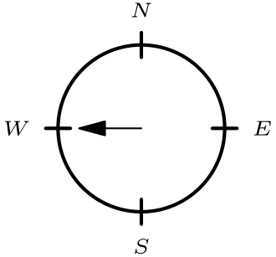
（A）北 （B）东 （C）南 （D）西 （E）西北
English
Initially, a spinner points west. Chenille moves it clockwise 2 1/4 revolutions and then counterclockwise 3 3/4 revolutions. In what direction does the spinner point after the two moves?
(A) North (B) East (C) South (D) West (E) Northwest
第 5 题
点 A、B、C 和 D 是大正方形各边的中点。如果大正方形面积为 60，小正方形的面积是多少？
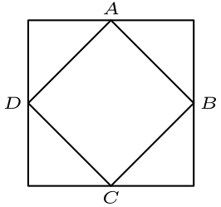
（A）15 （B）20 （C）24 （D）30 （E）40
English
Points A, B, C and D are midpoints of the sides of the larger square. If the larger square has area 60, what is the area of the smaller square?
(A) 15 (B) 20 (C) 24 (D) 30 (E) 40
第 6 题
字母 T 由两个 2 × 4 英寸的长方形相邻放置而成，如图所示。这个 T 的周长是多少英寸？
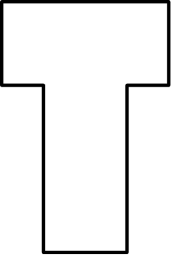
（A）12 （B）16 （C）20 （D）22 （E）24
English
The letter T is formed by placing two 2 × 4 inch rectangles next to each other, as shown. What is the perimeter of the T, in inches?
(A) 12 (B) 16 (C) 20 (D) 22 (E) 24
第 7 题
圆 X 的半径为 π。圆 Y 的周长为 8 π。圆 Z 的面积为 9 π。按半径从小到大排列这些圆。
（A）X、Y、Z （B）Z、X、Y （C）Y、X、Z （D）Z、Y、X （E）X、Z、Y
English
Circle X has a radius of π. Circle Y has a circumference of 8 π. Circle Z has an area of 9 π. List the circles in order from smallest to largest radius.
(A) X, Y, Z (B) Z, X, Y (C) Y, X, Z (D) Z, Y, X (E) X, Z, Y
第 8 题
表格显示了广播电台 KAMC 一项调查的部分结果。接受调查的男性中有百分之多少收听这个电台？
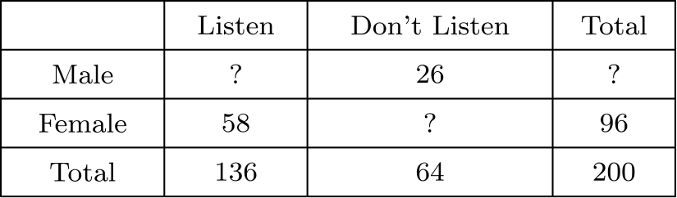
（A）39 （B）48 （C）52 （D）55 （E）75
English
The table shows some of the results of a survey by radio station KAMC. What percentage of the males surveyed listen to the station?
(A) 39 (B) 48 (C) 52 (D) 55 (E) 75
第 9 题
下列乘积是多少？
3/2×4/3×5/4×⋯×2006/2005？
（A）1 （B）1002 （C）1003 （D）2005 （E）2006
English
What is the product of
3/2×4/3×5/4×⋯×2006/2005?
(A) 1 (B) 1002 (C) 1003 (D) 2005 (E) 2006
第 10 题
Jorge 的老师让他画出所有有序数对 (w, l)，其中 w 是面积为 12 的长方形的宽，l 是长，并且宽和长都是正整数。他的图应该是什么样？
（A）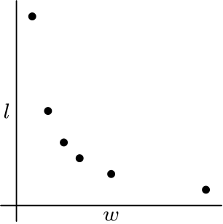
（B）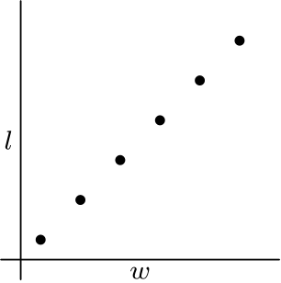
（C）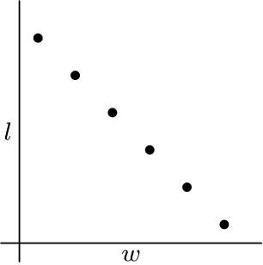
（D）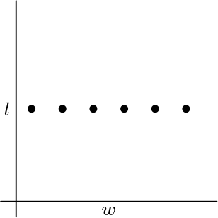
（E）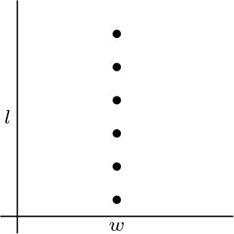
English
Jorge’s teacher asks him to plot all the ordered pairs (w, l) of positive integers for which w is the width and l is the length of a rectangle with area 12. What should his graph look like?
(A)
(B)
(C)
(D)
(E)
第 11 题
有多少个两位数的各位数字和是完全平方数？
（A）13 （B）16 （C）17 （D）18 （E）19
English
How many two-digit numbers have digits whose sum is a perfect square?
(A) 13 (B) 16 (C) 17 (D) 18 (E) 19
第 12 题
Antonette 在一场有 10 道题的测试中得分率为 70 %，在一场有 20 道题的测试中得分率为 80 %，在一场有 30 道题的测试中得分率为 90 %。如果三次测试合并成一场有 60 道题的测试，哪个百分数最接近她的总成绩？
（A）40 （B）77 （C）80 （D）83 （E）87
English
Antonette gets 70 % on a 10-problem test, 80 % on a 20-problem test and 90 % on a 30-problem test. If the three tests are combined into one 60-problem test, which percent is closest to her overall score?
(A) 40 (B) 77 (C) 80 (D) 83 (E) 87
第 13 题
Cassie 上午 8:30 从 Escanaba 骑车前往 Marquette，速度恒定为每小时 12 英里。Brian 上午 9:00 从 Marquette 骑车前往 Escanaba，速度恒定为每小时 16 英里。他们骑在 Escanaba 和 Marquette 之间同一条 62 英里的路线上。上午几点他们相遇？
（A）10:00 （B）10:15 （C）10:30 （D）11:00 （E）11:30
English
Cassie leaves Escanaba at 8:30 AM heading for Marquette on her bike. She bikes at a uniform rate of 12 miles per hour. Brian leaves Marquette at 9:00 AM heading for Escanaba on his bike. He bikes at a uniform rate of 16 miles per hour. They both bike on the same 62-mile route between Escanaba and Marquette. At what time in the morning do they meet?
(A) 10:00 (B) 10:15 (C) 10:30 (D) 11:00 (E) 11:30
第 14 题
第 14、15 和 16 题涉及 Reed 老师的英语作业。
小说阅读作业
Reed 老师英语课上的学生都在读同一本 760 页的小说。Alice、Bob 和 Chandra 是班上的三个朋友。Alice 读一页需要 20 秒，Bob 读一页需要 45 秒，Chandra 读一页需要 30 秒。
如果 Bob 和 Chandra 都读完整本书，Bob 会比 Chandra 多花多少秒阅读？
（A）7,600 （B）11,400 （C）12,500 （D）15,200 （E）22,800
English
Problems 14, 15, and 16 involve Mrs. Reed’s English assignment.
A Novel Assignment
The students in Mrs. Reed’s English class are reading the same 760-page novel. Three friends, Alice, Bob and Chandra, are in the class. Alice reads a page in 20 seconds, Bob reads a page in 45 seconds and Chandra reads a page in 30 seconds.
If Bob and Chandra both read the whole book, Bob will spend how many more seconds reading than Chandra?
(A) 7,600 (B) 11,400 (C) 12,500 (D) 15,200 (E) 22,800
第 15 题
Chandra 和 Bob 各有一本书，他们决定用“团队阅读”来节省时间。按照这种方法，Chandra 从第 1 页读到某一页，Bob 从下一页读到第 760 页，读完整本书。读完后他们会互相讲述自己读的部分。为了让 Chandra 和 Bob 阅读时间相同，Chandra 应该读到最后哪一页？
（A）425 （B）444 （C）456 （D）484 （E）506
English
Chandra and Bob, who each have a copy of the book, decide that they can save time by “team reading” the novel. In this scheme, Chandra will read from page 1 to a certain page and Bob will read from the next page through page 760, finishing the book. When they are through they will tell each other about the part they read. What is the last page that Chandra should read so that she and Bob spend the same amount of time reading the novel?
(A) 425 (B) 444 (C) 456 (D) 484 (E) 506
第 16 题
在 Chandra 和 Bob 开始阅读前，Alice 说她也想和他们一起团队阅读。如果他们把书分成三部分，使每个人阅读时间相同，那么每个人需要阅读多少秒？
（A）6400 （B）6600 （C）6800 （D）7000 （E）7200
English
Before Chandra and Bob start reading, Alice says she would like to team read with them. If they divide the book into three sections so that each reads for the same length of time, how many seconds will each have to read?
(A) 6400 (B) 6600 (C) 6800 (D) 7000 (E) 7200
第 17 题
Jeff 旋转转盘 P、Q 和 R，并把得到的数字相加。他的和为奇数的概率是多少？
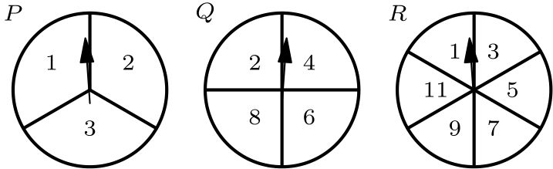
（A）1/4 （B）1/3 （C）1/2 （D）2/3 （E）3/4
English
Jeff rotates spinners P, Q and R and adds the resulting numbers. What is the probability that his sum is an odd number?
(A) 1/4 (B) 1/3 (C) 1/2 (D) 2/3 (E) 3/4
第 18 题
一个棱长为 3 英寸的立方体由 27 个棱长为 1 英寸的小立方体组成。其中十九个小立方体是白色，八个是黑色。如果八个黑色小立方体放在大立方体的八个角上，那么大立方体表面积中白色部分占几分之几？
（A）1/9 （B）1/4 （C）4/9 （D）5/9 （E）19/27
English
A cube with 3-inch edges is made using 27 cubes with 1-inch edges. Nineteen of the smaller cubes are white and eight are black. If the eight black cubes are placed at the corners of the larger cube, what fraction of the surface area of the larger cube is white?
(A) 1/9 (B) 1/4 (C) 4/9 (D) 5/9 (E) 19/27
第 19 题
三角形 ABC 是等腰三角形，且 AB=BC。点 D 同时是 BC 和 AE 的中点，且 CE 长 11 个单位。三角形 ABD 与三角形 ECD 全等。BD 的长度是多少？
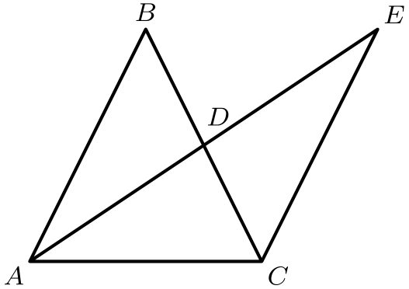
（A）4 （B）4.5 （C）5 （D）5.5 （E）6
English
Triangle ABC is an isosceles triangle with AB=BC. Point D is the midpoint of both BC and AE, and CE is 11 units long. Triangle ABD is congruent to triangle ECD. What is the length of BD?
(A) 4 (B) 4.5 (C) 5 (D) 5.5 (E) 6
第 20 题
一场单打锦标赛有六名选手。每名选手与其他每名选手只比赛一次，没有平局。如果 Helen 赢了 4 场，Ines 赢了 3 场，Janet 赢了 2 场，Kendra 赢了 2 场，Lara 赢了 2 场，那么 Monica 赢了几场？
（A）0 （B）1 （C）2 （D）3 （E）4
English
A singles tournament had six players. Each player played every other player only once, with no ties. If Helen won 4 games, Ines won 3 games, Janet won 2 games, Kendra won 2 games and Lara won 2 games, how many games did Monica win?
(A) 0 (B) 1 (C) 2 (D) 3 (E) 4
第 21 题
一个水族箱的长方形底面为 100 cm 乘 40 cm，高 50 cm。水族箱中水深 37 cm。随后放入一个体积为 1000cm³ 的石头并完全浸没。水位上升多少厘米？
（A）0.25 （B）0.5 （C）1 （D）1.25 （E）2.5
English
An aquarium has a rectangular base that measures 100 cm by 40 cm and has a height of 50 cm. The aquarium is filled with water to a depth of 37 cm. A rock with volume 1000cm³ is then placed in the aquarium and completely submerged. By how many centimeters does the water level rise?
(A) 0.25 (B) 0.5 (C) 1 (D) 1.25 (E) 2.5
第 22 题
三个不同的一位正整数放在底行格子中。相邻格子的数相加，和放在它们上方的格子中。在第二行继续同样过程，得到顶格中的数。顶格中可能的最大数与最小数之差是多少？
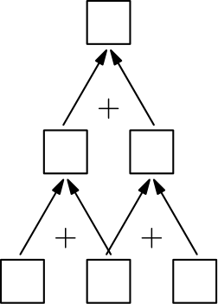
（A）16 （B）24 （C）25 （D）26 （E）35
English
Three different one-digit positive integers are placed in the bottom row of cells. Numbers in adjacent cells are added and the sum is placed in the cell above them. In the second row, continue the same process to obtain a number in the top cell. What is the difference between the largest and smallest numbers possible in the top cell?
(A) 16 (B) 24 (C) 25 (D) 26 (E) 35
第 23 题
一个盒子里有金币。如果把金币平均分给六个人，会剩下四枚。如果平均分给五个人，会剩下三枚。如果盒子中装的是满足这两个条件的最少金币数，那么平均分给七个人时会剩下几枚？
（A）0 （B）1 （C）2 （D）3 （E）5
English
A box contains gold coins. If the coins are equally divided among six people, four coins are left over. If the coins are equally divided among five people, three coins are left over. If the box holds the smallest number of coins that meets these two conditions, how many coins are left when equally divided among seven people?
(A) 0 (B) 1 (C) 2 (D) 3 (E) 5
第 24 题
在下面的乘法题中，A、B、C、D 是不同的数字。A+B 是多少？
 | A | B | A
× |  | C | D
C | D | C | D

（A）1 （B）2 （C）3 （D）4 （E）9
English
In the multiplication problem below A, B, C, D are different digits. What is A+B?
 | A | B | A
× |  | C | D
C | D | C | D

(A) 1 (B) 2 (C) 3 (D) 4 (E) 9
第 25 题
Barry 写了 6 个不同的数，分别写在 3 张卡片的两面，并把卡片如图摆在桌上。每张卡片两面数字之和都相等。三个隐藏面上的数都是质数。隐藏的质数的平均数是多少？
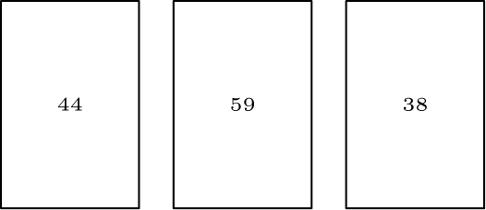
（A）13 （B）14 （C）15 （D）16 （E）17
English
Barry wrote 6 different numbers, one on each side of 3 cards, and laid the cards on a table, as shown. The sums of the two numbers on each of the three cards are equal. The three numbers on the hidden sides are prime numbers. What is the average of the hidden prime numbers?
(A) 13 (B) 14 (C) 15 (D) 16 (E) 17

第二部分 解答
答案速查：
题号 1 2 3 4 5 6 7 8 9
答案 D C A B D C B E C
题号 10 11 12 13 14 15 16 17 18
答案 A C D D B C E B D
题号 19 20 21 22 23 24 25
答案 D C A D A A B
答案串：DCABDCBECACDDBCEBDDCADAAB
第 1 题 答案 D
这些数都接近整数美元，可以把价格四舍五入后相加。
这些价格分别约为 $ 2、$ 5 和 $ 10，总和为 $ 17。
所以正确答案是D。
English
Since all the values are already close to a whole number, we can just add the sums of the rounded numbers.
These prices round to $ 2, $ 5, and $ 10, which add to $ 17.
Thus,Dis the correct answer.
第 2 题 答案 C
AMC 8 每答对一题得 1 分，所以 Billy 得 13 分。
所以正确答案是C。
English
Since the AMC 8 only awards 1 point for each correct question, Billy will get 13 points.
Thus,Cis the correct answer.
第 3 题 答案 A
起初 Elisa 每圈用 25/10=2.5 分钟。现在她每圈用 24/12=2 分钟。
因此每圈用时减少 2.5-2=0.5=1/2 分钟。
所以正确答案是A。
English
Initially, Elisa swam one lap in 25/10=2.5 minutes. Now she swims one lap in 24/12=2 minutes.
Therefore, she improved her lap time by 2.5-2=0.5=1/2 minute.
Thus,Ais the correct answer.
第 4 题 答案 B
转盘顺时针转 2 1/4 圈，再逆时针转 3 3/4 圈，等价于总共逆时针转 1 1/2 圈。
因此转盘最终指向东。
所以正确答案是B。
English
If the spinner goes 2 1/4 revolutions clockwise and 3 3/4 revolutions counterclockwise, it goes 1 1/2 revolutions counterclockwise.
This means that the spinner will be pointing east.
Thus,Bis the correct answer.
第 5 题 答案 D
可以把所有三角形向内折叠，正好覆盖小正方形。这说明小正方形的面积是大正方形面积的一半。
所以小正方形面积为 60 ÷ 2 = 30。
所以正确答案是D。
English
Note that we can fold all the triangles in to perfectly cover the smaller square. This means that area of the smaller square is half the area of the larger square.
This makes the area of the smaller square 60 ÷ 2 = 30.
Thus,Dis the correct answer.
第 6 题 答案 C
如果分别计算两个长方形的总周长，会得到
2(2(2 + 4)) = 2 · 2 · 6 = 24。
在字母 T 中，它们的相交部分从每个长方形中去掉了一段长度 2 的边。因此 T 的周长为
24 - 2 · 2 = 20。
所以正确答案是C。
English
If we found the total perimeter of the two rectangles separately, we would have gotten
2(2(2 + 4)) = 2 · 2 · 6 = 24.
In the letter T, we can see that their intersection removes a piece of length 2 from each of the rectangles. Therefore, the perimeter of the T is
24 - 2 · 2 = 20.
Thus,Cis the correct answer.
第 7 题 答案 B
公式为 C = 2 π r 和 A = π r²。由此圆 Y 的半径是
8 π ÷ (2 π) = 4。
圆 Z 的半径是
√(9 π ÷ π) = 3。
因为 π 大于 3 且小于 4，所以正确顺序为 Z、X、Y。
所以正确答案是B。
English
Recall that C = 2 π r and A = π r². Using these formulas we get that the radius of Y is
8 π ÷ (2 π) = 4.
We also get that the radius of Z is
√(9 π ÷ π) = 3.
As π is greater than 3 and less than 4, the correct order is Z, X, Y.
Thus, the answer isB.
第 8 题 答案 E
接受调查的男性总数是调查总人数减去女性人数：200-96=104。
这些男性中 26 人不收听，所以 104-26=78 名男性收听。所求百分比为 78/104· 100%=75%。
所以正确答案是E。
English
The total number of males surveyed is the total number surveyed minus the number of females surveyed: 200-96=104.
Of those males, 26 do not listen, so 104-26=78 males listen. The desired percentage is 78/104· 100%=75%.
Thus,Eis the correct answer.
第 9 题 答案 C
每个分数的分子都会与下一个分数的分母约掉。最后只剩
2006/2 = 1003。
所以正确答案是C。
English
Note that the numerator of every fraction cancels with the denominator of the following fraction. This leaves two numbers:
2006/2 = 1003.
Thus,Cis the correct answer.
第 10 题 答案 A
满足 wl=12 的正整数因数对 (w,l) 为 (1,12)、(2,6)、(3,4)、(4,3)、(6,2) 和 (12,1)。
这些点形成六个递减排列的点，只有图 A 与它们匹配。
所以正确答案是A。
English
The positive integer factor pairs (w,l) with wl=12 are (1,12), (2,6), (3,4), (4,3), (6,2), and (12,1).
These points form a decreasing set of six points, and only graph A matches them.
Thus,Ais the correct answer.
第 11 题 答案 C
数位和为 1 的数有 1 个：10。
数位和为 4 的数有 4 个：13、22、31 和 40。
数位和为 9 的数有 9 个：18、27、36、45、54、63、72、81 和 90。
数位和为 16 的数有 3 个：79、88 和 97。
因此共有 17 个数满足题意。
所以正确答案是C。
English
There is 1 number whose digit sum is 1: 10.
There are 4 numbers whose digit sum is 4: 13, 22, 31, and 40.
There are 9 numbers whose digit sum is 9: 18, 27, 36, 45, 54, 63, 72, 81, and 90.
There are 3 numbers whose digit sum is 16: 79, 88, and 97.
Therefore, there are 17 numbers that satisfy the problem statement.
Thus,Cis the correct answer.
第 12 题 答案 D
Antonette 第一次测试答对 0.7· 10=7 题。类似地，她第二、三次测试分别答对 0.8· 20=16 题和 0.9· 30=27 题。
总共答对 50 题。合并测试成绩为 100· 50/60=831/3%，最接近 83%。
所以正确答案是D。
English
Antonette got 0.7· 10=7 questions right on the first test. Similarly, she got 0.8· 20=16 and 0.9· 30=27 problems right on her second and third tests.
Adding these up yields 50 correct questions. Her score on the combined test would have been 100· 50/60=831/3%, closest to 83%.
Thus,Dis the correct answer.
第 13 题 答案 D
Brian 开始骑车时，Cassie 已经骑了 1/2· 12=6 英里。因此两人相距 62-6=56 英里。
他们合起来以每小时 12+16=28 英里的速度缩短距离。因此他们在上午 9:00 后 56÷ 28=2 小时相遇。
所以他们在上午 11:00 相遇。
所以正确答案是D。
English
By the time Brian starts biking, Cassie has already traveled 1/2· 12=6 miles. This means that Cassie and Brian are then 62-6=56 miles apart.
Together, they close the distance at 12+16=28 miles per hour. This means that they meet 56÷ 28=2 hours after 9:00 AM.
This means that they meet at 11:00 AM.
Thus,Dis the correct answer.
第 14 题 答案 B
Bob 读完整本书需要 760 · 45 秒，Chandra 需要 760 · 30 秒。
两人阅读时间相差
760 · 45 - 760 · 30
= 760(45 - 30)
= 760 · 15
= 11,400
秒。
所以正确答案是B。
English
Bob will take 760 · 45 seconds to read the book, and Chandra will take 760 · 30 seconds.
The difference between the time they spent reading is
760 · 45 - 760 · 30
= 760(45 - 30)
= 760 · 15
= 11,400
seconds.
Thus,Bis the correct answer.
第 15 题 答案 C
设 Chandra 阅读 x 页，那么 Bob 阅读 760 - x 页。
为了让阅读时间相同，
30x = 45(760 - x)
30x = 45 · 760 - 45x
75x = 45 · 760
5x = 3 · 760
x = 3 · 152
x = 456
。
所以正确答案是C。
English
Let x be the number of pages that Chandra will read. Then Bob will read 760 - x pages.
For them to read for the same amount of time,
30x = 45(760 - x)
30x = 45 · 760 - 45x
75x = 45 · 760
5x = 3 · 760
x = 3 · 152
x = 456.
Thus,Cis the correct answer.
第 16 题 答案 E
如果 3 人阅读相同时间，那么 Bob、Chandra 和 Alice 阅读页数之比为 4:6:9。
因此他们分别读 160、240 和 360 页。因为三人阅读时间相同，只需计算 Bob 读他那部分所需时间。
Bob 读完这部分需要 45 · 160 = 7200 秒。
所以正确答案是E。
English
If all 3 individuals read the same amount of time, then the number of pages Bob, Chandra, and Alice will read will be in the ratio 4:6:9 respectively.
This means that they will read 160, 240, and 360 pages respectively. Since they all read for the same amount of time, we can just calculate how long it takes for Bob to read his portion.
Bob will take 45 · 160 = 7200 seconds to read his portion.
Thus,Eis the correct answer.
第 17 题 答案 B
转盘 Q 总是落在偶数上，所以不改变总和的奇偶性。转盘 R 总是落在奇数上。
为了让总和为奇数，转盘 P 的数必须是偶数。转盘 P 的三个等可能区域中只有一个是偶数。
因此概率为 1/3。
所以正确答案是B。
English
Spinner Q always lands on an even number, so it does not change the parity of the total. Spinner R always lands on an odd number.
For the full sum to be odd, the number from spinner P must be even. Only one of the three equal sectors of spinner P contains an even number.
Therefore the probability is 1/3.
Thus,Bis the correct answer.
第 18 题 答案 D
因为每个面的黑白表面积比例相同，只需分析一个面的白色比例。
一个面上有 9 个单位正方形，其中 4 个是黑色。因此每个面有 5/9 是白色。
所以正确答案是D。
English
Since each face has the same black and white surface area, we can analyze what fraction of one side is white.
On one side, there are 9 unit squares. 4 of them are black. This means that 5/9 of each face is white.
Thus,Dis the correct answer.
第 19 题 答案 D
由全等条件可知
AB = EC = 11。
由等腰条件，
BC = AB = 11。
因为 D 是 BC 的中点，
BD = BC ÷ 2 = 5.5。
所以正确答案是D。
English
By the congruency condition, we know that
AB = EC = 11.
Also from the isosceles condition, we know that
BC = AB = 11.
Since D is the midpoint of BC, we know that
BD = BC ÷ 2 = 5.5.
Thus,Dis the correct answer.
第 20 题 答案 C
每场比赛恰好有一个胜者。六名选手共有 6 · 5 ÷ 2 = 15 场比赛，因此共有 15 个胜场。
已经计入的胜场数为
4 + 3 + 2 + 2 + 2 = 13
场，所以 Monica 赢了 15 - 13 = 2 场。
所以正确答案是C。
English
In every match, there was exactly one winner. There are 6 · 5 ÷ 2 = 15 games and therefore 15 wins.
There are already
4 + 3 + 2 + 2 + 2 = 13
wins accounted for, so Monica won 15 - 13 = 2 games.
Thus,Cis the correct answer.
第 21 题 答案 A
水族箱底面积为 100· 40=4000cm²。
完全浸没的石头排开 1000cm³ 的水，所以水位上升 1000÷ 4000=0.25 cm。
所以正确答案是A。
English
The base area of the aquarium is 100· 40=4000cm².
The submerged rock displaces 1000cm³ of water, so the water level rises by 1000÷ 4000=0.25 cm.
Thus,Ais the correct answer.
第 22 题 答案 D
如果底行格子中的数依次为 a、b 和 c，那么中间一行就是 a+b 和 b+c。
因此顶格为 a+2b+c。要使它最小，把 b=1 放在中间，外侧放 2 和 3，得到顶格数 7。
要使它最大，把 b=9 放在中间，外侧放 7 和 8，得到顶格数 33。所求差为 33-7=26。
所以正确答案是D。
English
If the lower cells contain a, b, and c, the middle row will have a+b and b+c.
This means that the top row will have a+2b+c. To minimize this, put b=1 in the middle and 2 and 3 in the outer cells. This yields a top number of 7.
To maximize it, put b=9 in the middle and 7 and 8 in the outer cells. This yields a top number of 33. The desired difference is 33-7=26.
Thus,Dis the correct answer.
第 23 题 答案 A
除以 6 余 4 的正整数为
4, 10, 16, 22, 28, 34, 40, ⋯。
除以 5 余 3 的正整数为
3, 8, 13, 18, 23, 28, 33, ⋯。
可见满足条件的最少金币数是 28。它除以 7 余 0。
所以正确答案是A。
English
The positive integers that leave a remainder of 4 when divided by 6 are
4, 10, 16, 22, 28, 34, 40, ⋯.
The positive integers that leave a remainder of 3 when divided by 5 are
3, 8, 13, 18, 23, 28, 33, ⋯.
From this, we can see that the smallest number of coins that work is 28. This leaves a remainder of 0 when divided by 7.
Thus,Ais the correct answer.
第 24 题 答案 A
注意
CDCD = 101 · CD。
这迫使 ABA = 101。所以 A = 1，B = 0，且 A + B = 1。
所以正确答案是A。
English
Note that
CDCD = 101 · CD.
This forces ABA = 101. Then A = 1, B = 0, and A + B = 1.
Thus,Ais the correct answer.
第 25 题 答案 B
公共和必须是奇数。如果公共和是偶数，那么 44 和 38 背后的隐藏数都必须是偶质数，但偶质数只有一个。
所以奇数 59 背后的隐藏质数必须是 2，公共和为 59+2=61。
另外两个隐藏质数是 61-44=17 和 61-38=23。
隐藏质数的平均数为 2+17+23/3=14。
所以正确答案是B。
English
The common sum must be odd. If the common sum were even, then the hidden numbers behind 44 and 38 would both have to be even primes, but there is only one even prime.
So the prime hidden behind the odd visible number 59 must be 2, making the common sum 59+2=61.
The other two hidden primes are 61-44=17 and 61-38=23.
The average of the hidden primes is 2+17+23/3=14.
Thus,Bis the correct answer.

