2005 年 AMC 8 真题与解答
American Mathematics Competitions 8 · 中英双语
共 25 题，限时 40 分钟；单项选择题，每题 1 分，答错不扣分，满分 25 分。
编排说明：第一部分为题目（先中文、后英文原题），第二部分为解答与答案，便于先做题后对答案。
第一部分 题目
第 1 题
康妮把一个数乘以 2，得到答案 60。可是她本应把这个数除以 2 才能得到正确答案。正确答案是多少？
（A）7.5 （B）15 （C）30 （D）120 （E）240
English
Connie multiplies a number by 2 and gets 60 as her answer. However, she should have divided the number by 2 to get the correct answer. What is the correct answer?
(A) 7.5 (B) 15 (C) 30 (D) 120 (E) 240
第 2 题
卡尔在佩阿洛特商店买了五个文件夹，每个 $2.50。第二天佩阿洛特商店有 20% 折扣促销。如果卡尔等一天再买，他可以省多少钱？
（A）$ 1.00 （B）$ 2.00 （C）$ 2.50 （D）$ 2.75 （E）$ 5.00
English
Karl bought five folders from Pay-A-Lot at a cost of $2.50 each. Pay-A-Lot had a 20%-off sale the following day. How much could Karl have saved on the purchase by waiting a day?
(A) $ 1.00 (B) $ 2.00 (C) $ 2.50 (D) $ 2.75 (E) $ 5.00
第 3 题
最少还必须涂黑多少个小正方形，才能使对角线 BD 成为正方形 ABCD 的一条对称轴？
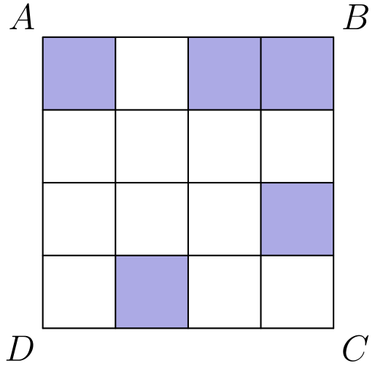
（A）1 （B）2 （C）3 （D）4 （E）5
English
What is the minimum number of small squares that must be shaded so that a line of symmetry lies on the diagonal BD of square ABCD?
(A) 1 (B) 2 (C) 3 (D) 4 (E) 5
第 4 题
一个正方形和一个三角形周长相等。三角形的三边长分别是 6.1 cm、8.2 cm 和 9.7 cm。正方形的面积是多少平方厘米？
（A）24 （B）25 （C）36 （D）48 （E）64
English
A square and a triangle have equal perimeters. The lengths of the three sides of the triangle are 6.1 cm, 8.2 cm and 9.7 cm. What is the area of the square in square centimeters?
(A) 24 (B) 25 (C) 36 (D) 48 (E) 64
第 5 题
汽水以 6、12 和 24 罐装出售。要正好买 90 罐汽水，最少需要多少包？
（A）4 （B）5 （C）6 （D）8 （E）15
English
Soda is sold in packs of 6, 12 and 24 cans. What is the minimum number of packs needed to buy exactly 90 cans of soda?
(A) 4 (B) 5 (C) 6 (D) 8 (E) 15
第 6 题
设 d 是一个数字。有多少个 d 的取值满足
2.00d5 > 2.005？
（A）0 （B）4 （C）5 （D）6 （E）10
English
Suppose d is a digit. For how many values of d is
2.00d5 > 2.005?
(A) 0 (B) 4 (C) 5 (D) 6 (E) 10
第 7 题
比尔先向南走 1/2 英里，再向东走 3/4 英里，最后又向南走 1/2 英里。沿直线计算，他离起点有多少英里？
（A）1 （B）1 1/4 （C）1 1/2 （D）1 3/4 （E）2
English
Bill walks 1/2 mile south, then 3/4 mile east, and finally 1/2 mile south. How many miles is he, in a direct line, from his starting point?
(A) 1 (B) 1 1/4 (C) 1 1/2 (D) 1 3/4 (E) 2
第 8 题
设 m 和 n 是正奇数。下列哪一个一定也是奇数？
（A）m + 3n （B）3m - n （C）3m² + 3n² （D）(nm + 3)² （E）3mn
English
Suppose m and n are positive odd integers. Which of the following must also be an odd integer?
(A) m + 3n (B) 3m - n (C) 3m² + 3n² (D) (nm + 3)² (E) 3mn
第 9 题
在四边形 ABCD 中，边 AB 和 BC 长度都为 10，边 CD 和 DA 长度都为 17，且角 ADC 的度数是 60°。对角线 AC 的长度是多少？
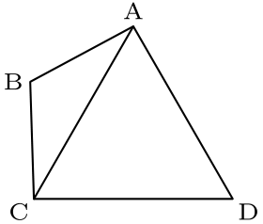
（A）13.5 （B）14 （C）15.5 （D）17 （E）18.5
English
In quadrilateral ABCD, sides AB and BC both have length 10, sides CD and DA both have length 17, and the measure of angle ADC is 60°. What is the length of diagonal AC?
(A) 13.5 (B) 14 (C) 15.5 (D) 17 (E) 18.5
第 10 题
乔从家到学校走到一半时发现自己迟到了，于是剩下的路跑到学校。他跑步速度是步行速度的 3 倍。乔走到学校一半用了 6 分钟。他从家到学校总共用了多少分钟？
（A）7 （B）7.3 （C）7.7 （D）8 （E）8.3
English
Joe had walked half way from home to school when he realized he was late. He ran the rest of the way to school. He ran 3 times as fast as he walked. Joe took 6 minutes to walk half way to school. How many minutes did it take Joe to get from home to school?
(A) 7 (B) 7.3 (C) 7.7 (D) 8 (E) 8.3
第 11 题
伯格维尔的销售税率为 6%。伯格维尔大衣店促销期间，一件原价为 $90.00 的外套打 20% 折扣。两名店员杰克和吉尔各自计算账单。杰克先按 $90.00 加收 6% 的销售税，再从总额中减去 20%。吉尔先从 $90.00 中减去原价的 20%，再对折后价加收 6% 的销售税。杰克的总额减去吉尔的总额是多少？
（A）-$ 1.06 （B）-$ 0.53 （C）$ 0 （D）$ 0.53 （E）$ 1.06
English
The sales tax rate in Bergville is 6%. During a sale at the Bergville Coat Closet, the price of a coat is discounted 20% from its $90.00 price. Two clerks, Jack and Jill, calculate the bill independently. Jack rings up $90.00 and adds 6% sales tax, then subtracts 20% from this total. Jill rings up $90.00, subtracts 20% of the price, then adds 6% of the discounted price for sales tax. What is Jack’s total minus Jill’s total?
(A) -$ 1.06 (B) -$ 0.53 (C) $ 0 (D) $ 0.53 (E) $ 1.06
第 12 题
大艾尔这只猩猩从五月 1 日到五月 5 日一共吃了 100 根香蕉。他每天都比前一天多吃六根。大艾尔在五月 5 日吃了多少根香蕉？
（A）20 （B）22 （C）30 （D）32 （E）34
English
Big Al, the ape, ate 100 bananas from May 1 through May 5. Each day he ate six more bananas than on the previous day. How many bananas did Big Al eat on May 5?
(A) 20 (B) 22 (C) 30 (D) 32 (E) 34
第 13 题
多边形 ABCDEF 的面积为 52，且 AB=8，BC=9，FA=5。DE+EF 是多少？
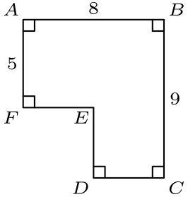
（A）7 （B）8 （C）9 （D）10 （E）11
English
The area of polygon ABCDEF is 52 with AB=8, BC=9 and FA=5. What is DE+EF?
(A) 7 (B) 8 (C) 9 (D) 10 (E) 11
第 14 题
小十二篮球联盟有两个分区，每个分区有六支球队。每支球队与本分区其他每支球队比赛两次，并与另一分区每支球队比赛一次。联盟共安排了多少场比赛？
（A）80 （B）96 （C）100 （D）108 （E）192
English
The Little Twelve Basketball Conference has two divisions, with six teams in each division. Each team plays each of the other teams in its own division twice and every team in the other division once. How many conference games are scheduled?
(A) 80 (B) 96 (C) 100 (D) 108 (E) 192
第 15 题
有多少个不同的等腰三角形，其边长均为整数且周长为 23？
（A）2 （B）4 （C）6 （D）9 （E）11
English
How many different isosceles triangles have integer side lengths and perimeter 23?
(A) 2 (B) 4 (C) 6 (D) 9 (E) 11
第 16 题
一个五条腿的火星人有一抽屉袜子，每只袜子是红色、白色或蓝色，并且每种颜色至少有五只。火星人不看地一次取出一只袜子。为了保证有 5 只同色袜子，火星人必须从抽屉里取出多少只袜子？
（A）6 （B）9 （C）12 （D）13 （E）15
English
A five-legged Martian has a drawer full of socks, each of which is red, white or blue, and there are at least five socks of each color. The Martian pulls out one sock at a time without looking. How many socks must the Martian remove from the drawer to be certain there will be 5 socks of the same color?
(A) 6 (B) 9 (C) 12 (D) 13 (E) 15
第 17 题
图中显示了一支越野队训练跑的结果。哪位学生的平均速度最大？
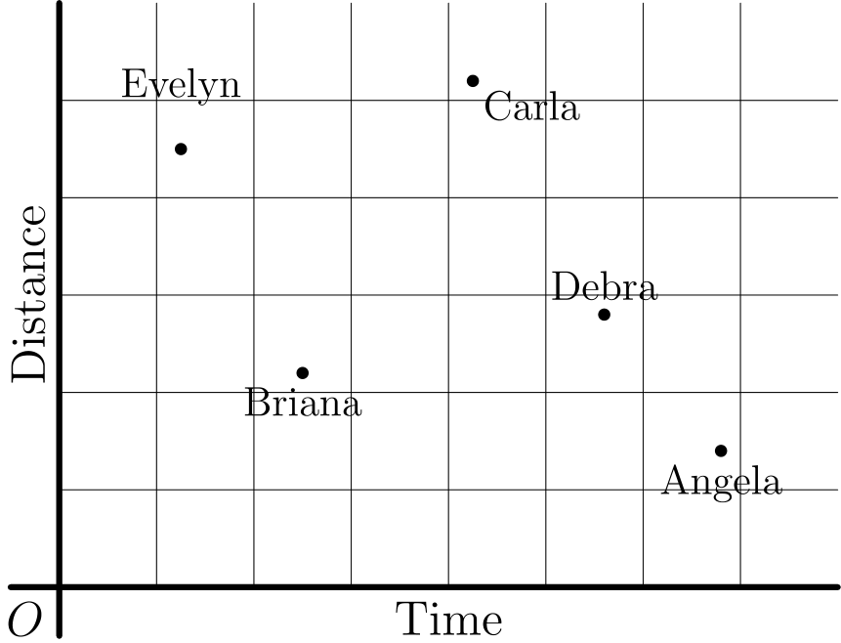
（A）Angela （B）Briana （C）Carla （D）Debra （E）Evelyn
English
The results of a cross-country team’s training run are graphed below. Which student has the greatest average speed?
(A) Angela (B) Briana (C) Carla (D) Debra (E) Evelyn
第 18 题
有多少个三位数能被 13 整除？
（A）7 （B）67 （C）69 （D）76 （E）77
English
How many three-digit numbers are divisible by 13?
(A) 7 (B) 67 (C) 69 (D) 76 (E) 77
第 19 题
梯形 ABCD 的周长是多少？
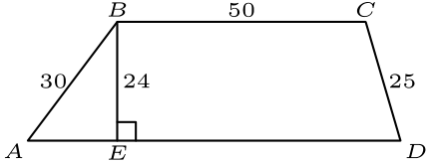
（A）180 （B）188 （C）196 （D）200 （E）204
English
What is the perimeter of trapezoid ABCD?
(A) 180 (B) 188 (C) 196 (D) 200 (E) 204
第 20 题
爱丽丝和鲍勃在一个圆上玩游戏，圆周上有 12 个等距点。这些点按顺时针方向编号为 1 到 12。两人都从点 12 开始。爱丽丝顺时针移动，鲍勃逆时针移动。每轮游戏中，爱丽丝顺时针移动 5 个点，鲍勃逆时针移动 9 个点。当他们停在同一点时游戏结束。需要多少轮？
（A）6 （B）8 （C）12 （D）14 （E）24
English
Alice and Bob play a game involving a circle whose circumference is divided by 12 equally-spaced points. The points are numbered clockwise, from 1 to 12. Both start on point 12. Alice moves clockwise and Bob, counterclockwise. In a turn of the game, Alice moves 5 points clockwise and Bob moves 9 points counterclockwise. The game ends when they stop on the same point. How many turns will this take?
(A) 6 (B) 8 (C) 12 (D) 14 (E) 24
第 21 题
用下图中的三个点作为顶点，可以画出多少个不同的三角形？
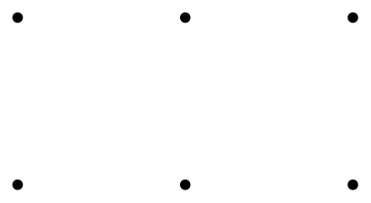
（A）9 （B）12 （C）18 （D）20 （E）24
English
How many distinct triangles can be drawn using three of the dots below as vertices?
(A) 9 (B) 12 (C) 18 (D) 20 (E) 24
第 22 题
一家公司销售三种不同大小的洗涤剂盒：小号（S）、中号（M）和大号（L）。中号价格比小号高 50 %，含量比大号少 20 %。大号含量是小号的两倍，价格比中号高 30 %。按性价比从好到差排列这三种大小。
（A）SML （B）LMS （C）MSL （D）LSM （E）MLS
English
A company sells detergent in three different sized boxes: small (S), medium (M) and large (L). The medium size costs 50 % more than the small size and contains 20 % less detergent than the large size. The large size contains twice as much detergent as the small size and costs 30 % more than the medium size. Rank the three sizes from best to worst buy.
(A) SML (B) LMS (C) MSL (D) LSM (E) MLS
第 23 题
等腰直角三角形 ABC 包含一个面积为 2π 的半圆。圆心 O 在斜边 AB 上，并且圆与边 AC 和 BC 相切。三角形 ABC 的面积是多少？
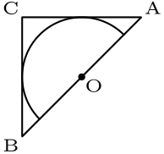
（A）6 （B）8 （C）3 π （D）10 （E）4 π
English
Isosceles right triangle ABC encloses a semicircle of area 2π. The circle has its center O on hypotenuse AB and is tangent to sides AC and BC. What is the area of triangle ABC?
(A) 6 (B) 8 (C) 3 π (D) 10 (E) 4 π
第 24 题
某计算器只有两个键 [+1] 和 [× 2]。按下其中一个键时，计算器会自动显示结果。例如，如果计算器原来显示“9”，按 [+1] 后会显示“10”。如果接着按 [× 2]，会显示“20”。从显示“1”开始，要达到“200”最少需要按多少次键？
（A）8 （B）9 （C）10 （D）11 （E）12
English
A certain calculator has only two keys [+1] and [× 2]. When you press one of the keys, the calculator automatically displays the result. For instance, if the calculator originally displayed “9” and you pressed [+1], it would display “10.” If you then pressed [× 2], it would display “20.” Starting with the display “1,” what is the fewest number of keystrokes you would need to reach “200”?
(A) 8 (B) 9 (C) 10 (D) 11 (E) 12
第 25 题
一个边长为 2 的正方形和一个圆有相同的中心。圆内正方形外的区域总面积等于圆外正方形内的区域总面积。圆的半径是多少？
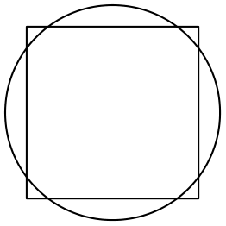
（A）2/(√(π)) （B）(1+√(2))/2 （C）3/2 （D）√(3) （E）√(π)
English
A square with side length 2 and a circle share the same center. The total area of the regions that are inside the circle and outside the square is equal to the total area of the regions that are outside the circle and inside the square. What is the radius of the circle?
(A) 2/(√(π)) (B) (1+√(2))/2 (C) 3/2 (D) √(3) (E) √(π)

第二部分 解答
答案速查：
题号 1 2 3 4 5 6 7 8 9
答案 B C D C B C B E D
题号 10 11 12 13 14 15 16 17 18
答案 D C D C B C D E C
题号 19 20 21 22 23 24 25
答案 A A C E B B A
答案串：BCDCBCBEDDCDCBCDECAACEBBA
第 1 题 答案 B
因为康妮乘以 2，所以原来的数是 60 ÷ 2 = 30。正确做法是除以 2，得到 30 ÷ 2 = 15。
所以正确答案是B。
English
Since Connie multiplied by 2, her original number was 60 ÷ 2 = 30. To get the correct answer, she must divide by 2 to get 30 ÷ 2 = 15.
Thus,Bis the correct answer.
第 2 题 答案 C
卡尔为文件夹支付了 5·$2.50=$12.50。
20% 的 $12.50 折扣会省下 0.20·12.50=2.50 美元。
所以正确答案是C。
English
Karl paid 5·$2.50=$12.50 for the folders.
A 20% discount on $12.50 would save 0.20·12.50=2.50 dollars.
Thus,Cis the correct answer.
第 3 题 答案 D
要使对角线 BD 成为对称轴，对角线外每个已涂黑小正方形都必须在对角线另一侧有一个对应的反射涂黑小正方形。
有 4 个已涂黑小正方形的反射位置尚未涂黑，所以还必须涂黑 4 个小正方形。
所以正确答案是D。
English
For diagonal BD to be a line of symmetry, every shaded square off the diagonal must have a matching reflected shaded square on the other side of the diagonal.
There are 4 shaded squares whose reflected partners are not shaded, so 4 additional small squares must be shaded.
Thus,Dis the correct answer.
第 4 题 答案 C
三角形的周长为
6.1 + 8.2 + 9.7 = 24 cm。
这意味着正方形的边长为
24 ÷ 4 = 6 cm。
因此正方形面积为
6² = 36 cm²。
所以正确答案是C。
English
The perimeter of the triangle is
6.1 + 8.2 + 9.7 = 24 cm.
This means that the side length of the square is
24 ÷ 4 = 6 cm.
Therefore, the area of the square is
6² = 36 cm².
Thus,Cis the correct answer.
第 5 题 答案 B
四包不可能够用。四个 24 罐装共有 96 罐，把其中任意一个 24 罐装换成较小的包装，罐数会减少 12 或 18。因此不可能恰好从 96 减少 6 罐而得到 90 罐。
五包可以做到：三个 24 罐装、一个 12 罐装和一个 6 罐装共有
3·24+12+6=90
罐。因此最少需要 5 包。
所以正确答案是B。
English
Four packs cannot be enough. Four 24-packs would contain 96 cans, and replacing any 24-pack by a smaller pack decreases the total by either 12 or 18 cans. There is no way to decrease 96 by exactly 6 cans to reach 90.
Five packs do work: three 24-packs, one 12-pack, and one 6-pack contain
3·24+12+6=90
cans. Therefore, the minimum number is 5.
Thus,Bis the correct answer.
第 6 题 答案 C
2.00d5 和 2.005 第一次不同出现在千分位：比较 d 和 5。
因此 2.00d5>2.005 当且仅当 d≥ 5。可能数字为 5、6、7、8、9，共有 5 个值。
所以正确答案是C。
English
The numbers 2.00d5 and 2.005 first differ in the thousandths place: d is compared with 5.
Thus 2.00d5>2.005 exactly when d≥ 5. The possible digits are 5, 6, 7, 8, 9, for 5 values.
Thus,Cis the correct answer.
第 7 题 答案 B
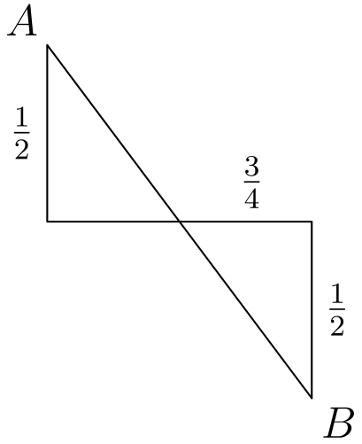
所求是对角线长度。使用勾股定理：
√((1/2 + 1/2)² + 3/4²)
= √(1 + 9/16) = √(25/16) = 5/4
所以正确答案是B。
English
Note that what we want is the length of the diagonal. We can use the Pythagorean theorem to find this.
√((1/2 + 1/2)² + 3/4²)
= √(1 + 9/16) = √(25/16) = 5/4
Thus,Bis the correct answer.
第 8 题 答案 E
先回顾以下四条规则：
• 奇数加奇数、偶数加偶数，结果都是偶数
• 偶数加奇数，结果是奇数
• 偶数乘任何整数，结果都是偶数
• 奇数乘奇数，结果是奇数
任意奇数可写成 2m+1，任意偶数可写成 2n，其中 m、n 为整数，因此很容易验证这些规则。
下面逐一检查各选项：
A:
注意 3 是奇数，因此对模 2 而言，该式为
1 + 1 · 1 ≡ 0 pmod 2。
根据上述规则，结果是偶数。
B:
1 · 1 - 1 ≡ 0 pmod 2。
结果仍是偶数。
C:
1 · 1² + 1 · 1² ≡ 0 pmod 2。
结果也是偶数。
D:
(1 · 1 + 1)² ≡ 0 pmod 2。
结果同样是偶数。
E:
1 · 1 · 1 ≡ 1 pmod 2。
结果是奇数。
因此只有E一定是奇数。
所以正确答案是E。
English
Recall the four following rules:
• odd plus odd and even plus even is even
• even plus odd is odd
• even times anything is even
• odd times odd is odd
These rules can be easily verified by representing arbitrary odd numbers as 2m+1 and arbitrary even numbers as 2n respectively, for integers m, n.
With this in mind, let’s examine each answer choice individually:
A:
Note that 3 is odd. Modulo 2, this gives us
1 + 1 · 1 ≡ 0 pmod 2.
From our above rules, we know that this is even.
B:
1 · 1 - 1 ≡ 0 pmod 2.
Once again, this is even.
C:
1 · 1² + 1 · 1² ≡ 0 pmod 2.
This is also even.
D:
(1 · 1 + 1)² ≡ 0 pmod 2.
Unfortunately, this is also even.
E:
1 · 1 · 1 ≡ 1 pmod 2.
This is odd.
Therefore,Eis the only answer choice that is an odd integer.
Thus,Eis the correct answer.
第 9 题 答案 D
△ ADC 是等腰三角形，所以 ∠ DAC = ∠ DCA。
我们得到
∠ DAC + ∠ DCA
+ ∠ ADC = 180°
∠ DAC + ∠ DCA = 120°
∠ DAC = ∠ DCA = 60°
。
所以 △ ADC 是等边三角形，因此
AC = CD = 17。
所以正确答案是D。
English
Note that △ ADC is isosceles. This means that ∠ DAC = ∠ DCA.
We get that
∠ DAC + ∠ DCA
+ ∠ ADC = 180°
∠ DAC + ∠ DCA = 120°
∠ DAC = ∠ DCA = 60°.
This shows that △ ADC is equilateral. This gives us that
AC = CD = 17.
Thus,Dis the correct answer.
第 10 题 答案 D
乔走前半段用了 6 分钟。
后半段距离相同，他以步行速度的 3 倍跑，所以这一半用 6÷3=2 分钟。
总时间为 6+2=8 分钟。
所以正确答案是D。
English
Joe took 6 minutes to walk the first half of the distance.
He ran the second half, the same distance, at 3 times his walking speed, so that half took 6÷3=2 minutes.
His total time was 6+2=8 minutes.
Thus,Dis the correct answer.
第 11 题 答案 C
杰克的总额是 90.00·1.06·0.80 美元。
吉尔的总额是 90.00·0.80·1.06 美元。
因为乘法满足交换律，这两个乘积相等，所以杰克的总额减去吉尔的总额为 $0。
所以正确答案是C。
English
Jack’s total is 90.00·1.06·0.80 dollars.
Jill’s total is 90.00·0.80·1.06 dollars.
These products are equal because multiplication is commutative, so Jack’s total minus Jill’s total is $0.
Thus,Cis the correct answer.
第 12 题 答案 D
设大艾尔在五月 3 日吃了 x 根香蕉。那么从五月 1 日开始，五天的数量为
x - 12, x - 6, x, x + 6, x + 12。
它们的和为 5x，等于 100。所以 x = 20。于是五月 5 日大艾尔吃了 20 + 12 = 32 根香蕉。
所以正确答案是D。
English
Let x be the number of bananas Big Al ate on May 3. Then Big Al ate the following amounts starting from May 1:
x - 12, x - 6, x, x + 6, x + 12.
The sum of this is 5x, which equals 100. This gives us that x = 20. Then on May 5, Big Al ate 20 + 12 = 32 bananas.
Thus,Dis the correct answer.
第 13 题 答案 C
将图形补成长方形 ABCG，其面积为 8·9=72。
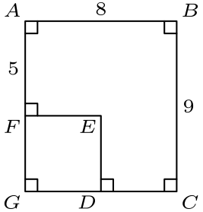
缺失长方形 FEDG 的面积为 72-52=20。它的高是 DE=BC-FA=9-5=4。
因此 EF=20÷4=5，所以 DE+EF=4+5=9。
所以正确答案是C。
English
Complete the shape to rectangle ABCG, which has area 8·9=72.
The missing rectangle FEDG has area 72-52=20. Its height is DE=BC-FA=9-5=4.
Therefore EF=20÷4=5, so DE+EF=4+5=9.
Thus,Cis the correct answer.
第 14 题 答案 B
关注一支球队。它与本分区另外 5 支球队各比赛两次，共 2 · 5 = 10 场。
它还与另一分区的 6 支球队各比赛一场，所以总共打 10 + 6 = 16 场。
共有 12 支球队，于是按球队计数为 12 · 16 = 192 场。但每场比赛涉及 2 支球队，所以要除以 2。
实际总场数为 192 ÷ 2 = 96。
所以正确答案是B。
English
Let us focus on one team. This team plays against 5 other teams twice in its own division, for a total of 2 · 5 = 10 games.
This team also plays 6 games with teams from the other division. Therefore, they play a total of 10 + 6 = 16 games.
There are 12 teams total, so there are 12 · 16 = 192 games conducted. Each game, however, involves 2 teams, so we have to divide by 2.
This gives us the actual total number of games to be 192 ÷ 2 = 96.
Thus,Bis the correct answer.
第 15 题 答案 C
设相等边长为 a，底边为 b。则 2a+b=23，所以 b 必须是奇数。
三角形不等式要求 b<2a。由于 b=23-2a，得到 23-2a<2a，即 a>23/4。所以 a≥6。
还要 b≥1，所以 2a≤22，即 a≤11。可能的值 a=6、7、8、9、10 和 11 都可行，共 6 个三角形。
所以正确答案是C。
English
Let the equal side length be a and the base be b. Then 2a+b=23, so b must be odd.
The triangle inequality requires b<2a. Since b=23-2a, this gives 23-2a<2a, so a>23/4. Thus a≥6.
Also b≥1, so 2a≤22 and a≤11. The possible values a=6, 7, 8, 9, 10, and 11 all work, giving 6 triangles.
Thus,Cis the correct answer.
第 16 题 答案 D
火星人可能先取出每种颜色各 4 只袜子，而还没有 5 只同色。第 13 只袜子必然是某种颜色的第 5 只。
所以正确答案是D。
English
Note that the Martian can pull out 4 socks of each color without drawing 5 of the same color. The 13th sock, however, must be the 5th sock of some color.
Thus,Dis the correct answer.
第 17 题 答案 E
平均速度是距离除以时间，也就是从原点到该点连线的斜率。
Evelyn 的斜率最大，因此她的平均速度最大。
所以正确答案是E。
English
Average speed is distance over time, which is given by the slope of the line through the point and the origin.
Evelyn has the steepest slope, telling us that she had the greatest average speed.
Thus,Eis the correct answer.
第 18 题 答案 C
要求有多少个 k 的取值使得 13k 是三位数。
最小的 k 满足 13k > 99，因此 k = 8。
最大的 k 满足 13k < 1000，因此 k = 76。
所以 k 可以取从 8 到 76 的整数，也就是说共有 69 个可能的 k 值。
所以正确答案是C。
English
We want to find how many k exist such that 13k is a three-digit number.
The smallest possible k such that 13k > 99 is k = 8.
The largest possible k such that 13k < 1000 is k = 76.
This tells us that k can range from 8 to 76, which gives us 69 values for k.
Thus,Cis the correct answer.
第 19 题 答案 A
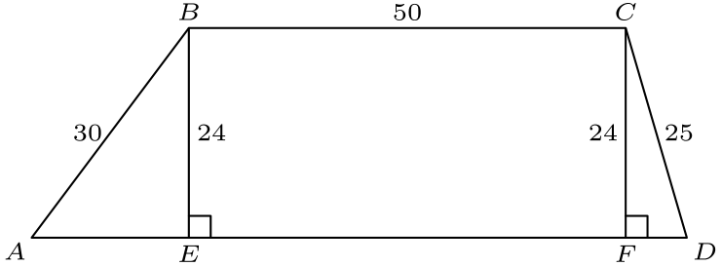
从 C 作高，交 AD 于 F。已有的从 B 作的高交 AD 于 E。
由勾股定理，AE=√(30²-24²)=18，FD=√(25²-24²)=7。同时 EF=BC=50。
因此 AD=18+50+7=75，梯形周长为 30+50+25+75=180。
所以正确答案是A。
English
Drop the altitude from C to meet AD at F. The existing altitude from B meets AD at E.
By the Pythagorean theorem, AE=√(30²-24²)=18 and FD=√(25²-24²)=7. Also EF=BC=50.
Thus AD=18+50+7=75, and the trapezoid perimeter is 30+50+25+75=180.
Thus,Ais the correct answer.
第 20 题 答案 A
一轮后，爱丽丝顺时针移动 5 个点，鲍勃逆时针移动 9 个点。他们每轮的相对位移为 5+9=14 个点。
当 14k 是 12 的倍数时他们相遇，其中 k 是轮数。
因为 14k≡2kpmod12，使 2k 成为 12 的倍数的最小正整数 k 是 6。
所以正确答案是A。
English
After one turn, Alice has moved 5 points clockwise and Bob has moved 9 points counterclockwise. Their relative movement is 5+9=14 points per turn.
They meet when 14k is a multiple of 12, where k is the number of turns.
Since 14k≡2kpmod12, the smallest positive k making 2k a multiple of 12 is 6.
Thus,Ais the correct answer.
第 21 题 答案 C
任取 3 个点通常会形成三角形，只有 2 组三点共线的情况除外。
选择三个点有 C(6, 3) = 20 种方式，减去 2 得到 20 - 2 = 18。
所以正确答案是C。
English
Notice that choosing any of these 3 dots forms a triangle, except for the 2 triples that form a straight line.
There are C(6, 3) = 20 ways to choose the points, and then we subtract 2 to get 20 - 2 = 18.
Thus,Cis the correct answer.
第 22 题 答案 E
选择方便数值：设小号价格为 $1.00，含量为 10 盎司。那么大号含量为 20 盎司。
中号价格为 $1.50，含量比大号少 20%，即 16 盎司。大号价格比中号高 30%，即 $1.95。
每盎司价格分别为 S: 1.00/10=0.100，M: 1.50/16=0.09375，L: 1.95/20=0.0975。
从好到差的顺序是 M、L、S。
所以正确答案是E。
English
Choose convenient values: let the small box cost $1.00 and contain 10 ounces. Then the large box contains 20 ounces.
The medium box costs $1.50 and contains 20% less than the large box, or 16 ounces. The large box costs 30% more than the medium, or $1.95.
The costs per ounce are S: 1.00/10=0.100, M: 1.50/16=0.09375, and L: 1.95/20=0.0975.
From best to worst buy, the order is M, L, S.
Thus,Eis the correct answer.
第 23 题 答案 B
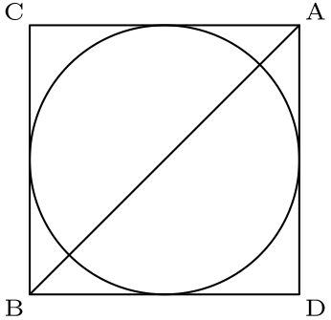
将三角形和半圆关于斜边 AB 反射，会形成一个内切于正方形的整圆。
半圆面积为 2π，所以整圆面积为 4π，半径为 2。因此正方形边长为 4。
正方形面积为 16，原三角形面积是其一半，即 8。
所以正确答案是B。
English
Reflect the triangle and semicircle across hypotenuse AB. This forms a full circle inscribed in a square.
The semicircle has area 2π, so the full circle has area 4π and radius 2. The square side length is therefore 4.
The square area is 16, so the original triangle has half that area, 8.
Thus,Bis the correct answer.
第 24 题 答案 B
从 200 反向操作。数为偶数时，用除以 2 撤销 ×2；数为奇数时，用减去 1 撤销 +1。
200,100,50,25,24,12,6,3,2,1
使用 9 个反向步骤，所以 9 次按键足够。
对于目标 200，8 次按键不够：小于目标的最大可达值由先 ×2,+1，再六次加倍得到，即 3·2⁶=192。更大的可能会至少达到 256，所以 200 不能在 8 次按键内到达。
所以正确答案是B。
English
Work backward from 200. When the number is even, undo ×2 by dividing by 2; when it is odd, undo +1 by subtracting 1.
200,100,50,25,24,12,6,3,2,1
uses 9 reverse steps, so 9 keystrokes are enough.
Eight keystrokes are not enough: the largest value below 200 reachable in 8 keystrokes is obtained by ×2,+1 followed by six doublings, giving 3·2⁶=192. The next larger possibilities overshoot to at least 256, so 200 cannot be reached in 8 keystrokes.
Thus,Bis the correct answer.
第 25 题 答案 A
设 S 为同时在正方形和圆内的公共面积。题目说明圆独有区域面积等于正方形独有区域面积。
在两个相等面积上都加上 S，可知圆的总面积等于正方形的总面积。
正方形面积为 2²=4，所以 π r²=4。因此 r=2/(√(π))。
所以正确答案是A。
English
Let S be the common area inside both the square and circle. The problem says the circle-only area equals the square-only area.
Adding S to both equal areas shows that the total area of the circle equals the total area of the square.
The square area is 2²=4, so π r²=4. Hence r=2/(√(π)).
Thus,Ais the correct answer.

