2004 年 AMC 8 真题与解答
American Mathematics Competitions 8 · 中英双语
共 25 题，限时 40 分钟；单项选择题，每题 1 分，答错不扣分，满分 25 分。
编排说明：第一部分为题目（先中文、后英文原题），第二部分为解答与答案，便于先做题后对答案。
第一部分 题目
第 1 题
在地图上，12 厘米的长度表示 72 千米。那么 17 厘米的长度表示多少千米？
（A）6 （B）102 （C）204 （D）864 （E）1224
English
On a map, a 12-centimeter length represents 72 kilometers. How many kilometers does a 17-centimeter length represent?
(A) 6 (B) 102 (C) 204 (D) 864 (E) 1224
第 2 题
重新排列 2004 中的四个数字，可以组成多少个不同的四位数？
（A）4 （B）6 （C）16 （D）24 （E）81
English
How many different four-digit numbers can be formed by rearranging the four digits in 2004?
(A) 4 (B) 6 (C) 16 (D) 24 (E) 81
第 3 题
十二个朋友在奥斯卡超大份牡蛎餐厅共进晚餐，每人点了一份餐。餐量非常大，足够 18 个人吃。如果他们共享食物，为了刚好够这 12 个人吃，他们本应点多少份餐？
（A）8 （B）9 （C）10 （D）15 （E）18
English
Twelve friends met for dinner at Oscar’s Overstuffed Oyster House, and each ordered one meal. The portions were so large, there was enough food for 18 people. If they shared, how many meals should they have ordered to have just enough food for the 12 of them?
(A) 8 (B) 9 (C) 10 (D) 15 (E) 18
第 4 题
汉密尔顿老师的八年级班想参加一年一度的三人篮球队锦标赛。兰斯、萨莉、乔伊和弗雷德被选为队员。三名首发队员有多少种选择方式？
（A）2 （B）4 （C）6 （D）8 （E）10
English
Ms. Hamilton’s eighth-grade class wants to participate in the annual three-person-team basketball tournament. Lance, Sally, Joy, and Fred are chosen for the team. In how many ways can the three starters be chosen?
(A) 2 (B) 4 (C) 6 (D) 8 (E) 10
第 5 题
汉密尔顿老师的八年级班想参加一年一度的三人篮球队锦标赛。每场比赛的失败队伍会被淘汰。如果有十六支队伍参赛，需要打多少场比赛才能决出冠军？
（A）4 （B）7 （C）8 （D）15 （E）16
English
Ms. Hamilton’s eighth-grade class wants to participate in the annual three-person-team basketball tournament. The losing team of each game is eliminated from the tournament. If sixteen teams compete, how many games will be played to determine the winner?
(A) 4 (B) 7 (C) 8 (D) 15 (E) 16
第 6 题
萨莉投篮 20 次后，命中率为 55%。她又投 5 次后，命中率提高到 56%。最后 5 次投篮中她命中了几次？
（A）1 （B）2 （C）3 （D）4 （E）5
English
After Sally takes 20 shots, she has made 55% of her shots. After she takes 5 more shots, she raises her percentage to 56%. How many of the last 5 shots did she make?
(A) 1 (B) 2 (C) 3 (D) 4 (E) 5
第 7 题
运动员的目标心率（每分钟心跳次数）是理论最大心率的 80%。最大心率由 220 减去运动员年龄（岁）得到。一个 26 岁运动员的目标心率最接近多少？
（A）134 （B）155 （C）176 （D）194 （E）243
English
An athlete’s target heart rate, in beats per minute, is 80% of the theoretical maximum heart rate. The maximum heart rate is found by subtracting the athlete’s age, in years, from 220. To the nearest whole number, what is the target heart rate of an athlete who is 26 years old?
(A) 134 (B) 155 (C) 176 (D) 194 (E) 243
第 8 题
数字和为 7 的两位正整数有多少个？
（A）6 （B）7 （C）8 （D）9 （E）10
English
Find the number of two-digit positive integers whose digits total 7.
(A) 6 (B) 7 (C) 8 (D) 9 (E) 10
第 9 题
一个列表中五个数的平均数是 54。前两个数的平均数是 48。后三个数的平均数是多少？
（A）55 （B）56 （C）57 （D）58 （E）59
English
The average of the five numbers in a list is 54. The average of the first two numbers is 48. What is the average of the last three numbers?
(A) 55 (B) 56 (C) 57 (D) 58 (E) 59
第 10 题
“能手”亚伦星期一帮邻居 1 1/4 小时，星期二帮 50 分钟，星期三上午从 8:20 到 10:45，星期五帮半小时。他每小时得到 $3。他这一周赚了多少钱？
（A）$8 （B）$9 （C）$10 （D）$12 （E）$15
English
Handy Aaron helped a neighbor 1 1/4 hours on Monday, 50 minutes on Tuesday, from 8:20 to 10:45 on Wednesday morning, and a half-hour on Friday. He is paid $3 per hour. How much did he earn for the week?
(A) $8 (B) $9 (C) $10 (D) $12 (E) $15
第 11 题
数字 -2、4、6、9 和 12 按以下规则重新排列：
1。最大数不在第一位，但在前三位之一。
2。最小数不在最后一位，但在后三位之一。
3。中位数既不在第一位，也不在最后一位。
第一位和最后一位数字的平均数是多少？
（A）3.5 （B）5 （C）6.5 （D）7.5 （E）8
English
The numbers -2, 4, 6, 9 and 12 are rearranged according to these rules:
1. The largest isn’t first, but it is in one of the first three places.
2. The smallest isn’t last, but it is in one of the last three places.
3. The median isn’t first or last.
What is the average of the first and last numbers?
(A) 3.5 (B) 5 (C) 6.5 (D) 7.5 (E) 8
第 12 题
妮基通常让手机保持开机。如果手机开着但她实际上没有使用，电池能持续 24 小时。如果她一直使用，电池只能持续 3 小时。自上次充电以来，她的手机已经开机 9 小时，其中她使用了 60 分钟。如果她不再通话但保持手机开机，电池还能持续多少小时？
（A）7 （B）8 （C）11 （D）14 （E）15
English
Niki usually leaves her cell phone on. If her cell phone is on but she is not actually using it, the battery will last for 24 hours. If she is using it constantly, the battery will last for only 3 hours. Since the last recharge, her phone has been on 9 hours, and during that time she has used it for 60 minutes. If she doesn’t talk any more but leaves the phone on, how many more hours will the battery last?
(A) 7 (B) 8 (C) 11 (D) 14 (E) 15
第 13 题
艾米、比尔和赛琳是年龄不同的朋友。以下陈述中恰好只有一个是真的。
I。比尔年龄最大。
II。艾米不是年龄最大的。
III。赛琳不是年龄最小的。
请按从年龄最大到最小排列这些朋友。
（A）比尔、艾米、赛琳 （B）艾米、比尔、赛琳 （C）赛琳、艾米、比尔 （D）赛琳、比尔、艾米 （E）艾米、赛琳、比尔
English
Amy, Bill and Celine are friends with different ages. Exactly one of the following statements is true.
I. Bill is the oldest.
II. Amy is not the oldest.
III. Celine is not the youngest.
Rank the friends from the oldest to youngest.
(A) Bill, Amy, Celine (B) Amy, Bill, Celine (C) Celine, Amy, Bill (D) Celine, Bill, Amy (E) Amy, Celine, Bill
第 14 题
下面钉板四边形围成的面积是多少？
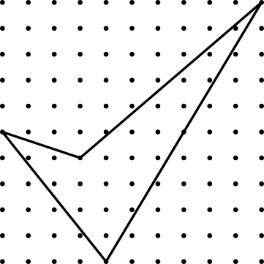
（A）15 （B）181/2 （C）221/2 （D）27 （E）41
English
What is the area enclosed by the geoboard quadrilateral below?
(A) 15 (B) 181/2 (C) 221/2 (D) 27 (E) 41
第 15 题
十三块阴影六边形瓷砖和六块未阴影六边形瓷砖组成下图。如果用与其他瓷砖大小和形状相同的未阴影瓷砖加上一圈边框形成新图形，新图形中未阴影瓷砖总数与阴影瓷砖总数之差是多少？
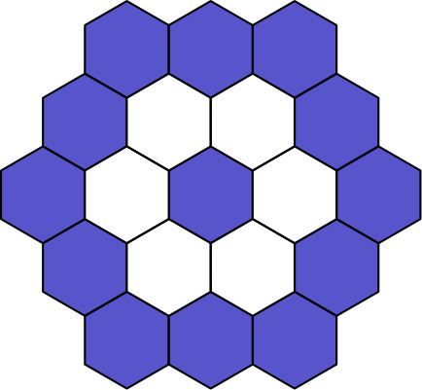
（A）5 （B）7 （C）11 （D）12 （E）18
English
Thirteen shaded and six unshaded hexagonal tiles were used to create the figure below. If a new figure is created by attaching a border of unshaded tiles with the same size and shape as the others, what will be the difference between the total number of unshaded tiles and the total number of shaded tiles in the new figure?
(A) 5 (B) 7 (C) 11 (D) 12 (E) 18
第 16 题
两个 600 毫升的水壶中装有橙汁。一个水壶装了 1/3 满，另一个装了 2/5 满。向每个水壶中加水直到装满，然后把两个水壶都倒入一个大容器。大容器中混合液的橙汁占几分之几？
（A）1/8 （B）3/16 （C）11/30 （D）11/19 （E）11/15
English
Two 600 mL pitchers contain orange juice. One pitcher is 1/3 full and the other pitcher is 2/5 full. Water is added to fill each pitcher completely, then both pitchers are poured into one large container. What fraction of the mixture in the large container is orange juice?
(A) 1/8 (B) 3/16 (C) 11/30 (D) 11/19 (E) 11/15
第 17 题
三个朋友共有 6 支相同的铅笔，每个人至少有一支。共有多少种可能？
（A）1 （B）3 （C）6 （D）10 （E）12
English
Three friends have a total of 6 identical pencils, and each one has at least one pencil. In how many ways can this happen?
(A) 1 (B) 3 (C) 6 (D) 10 (E) 12
第 18 题
五个朋友参加飞镖比赛。每人向同一个圆形靶子投两支飞镖，每个人的得分是击中区域分数之和。靶子区域的分数是整数 1 到 10，十次投掷击中的区域分值互不相同。得分为：爱丽丝 16 分，本 4 分，辛迪 7 分，戴夫 11 分，埃伦 17 分。谁击中了分值为 6 的区域？
（A）爱丽丝 （B）本 （C）辛迪 （D）戴夫 （E）埃伦
English
Five friends compete in a dart-throwing contest. Each one has two darts to throw at the same circular target, and each individual’s score is the sum of the scores in the target regions that are hit. The scores for the target regions are the whole numbers 1 through 10. Each throw hits the target in a region with a different value. The scores are: Alice 16 points, Ben 4 points, Cindy 7 points, Dave 11 points, and Ellen 17 points. Who hits the region worth 6 points?
(A) Alice (B) Ben (C) Cindy (D) Dave (E) Ellen
第 19 题
一个大于 2 的整数，分别除以下各数时余数都是 2：3、4、5 和 6。最小的这样一个数位于下列哪两个数之间？
（A）40 和 49 （B）60 和 79 （C）100 和 129 （D）210 和 249 （E）320 和 369
English
A whole number larger than 2 leaves a remainder of 2 when divided by each of the numbers 3, 4, 5, and 6. The smallest such number lies between which two numbers?
(A) 40 and 49 (B) 60 and 79 (C) 100 and 129 (D) 210 and 249 (E) 320 and 369
第 20 题
一个房间里三分之二的人坐在四分之三的椅子上。剩下的人站着。如果有 6 把空椅子，房间里有多少人？
（A）12 （B）18 （C）24 （D）27 （E）36
English
Two-thirds of the people in a room are seated in three-fourths of the chairs. The rest of the people are standing. If there are 6 empty chairs, how many people are in the room?
(A) 12 (B) 18 (C) 24 (D) 27 (E) 36
第 21 题
转盘 A 和 B 被旋转。在每个转盘上，指针落在每个数字上的可能性相同。两个转盘数字的乘积为偶数的概率是多少？
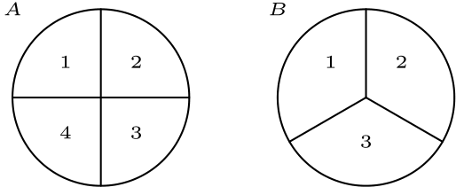
（A）1/4 （B）1/3 （C）1/2 （D）2/3 （E）3/4
English
Spinners A and B are spun. On each spinner, the arrow is equally likely to land on each number. What is the probability that the product of the two spinners’ numbers is even?
(A) 1/4 (B) 1/3 (C) 1/2 (D) 2/3 (E) 3/4
第 22 题
一个聚会上只有单身女性和已婚男性及其妻子。随机选择一名女性，她是单身的概率为 2/5。房间里的人中，已婚男性占几分之几？
（A）1/3 （B）3/8 （C）2/5 （D）5/12 （E）3/5
English
At a party there are only single women and married men with their wives. The probability that a randomly selected woman is single is 2/5. What fraction of the people in the room are married men?
(A) 1/3 (B) 3/8 (C) 2/5 (D) 5/12 (E) 3/5
第 23 题
特丝沿长方形街区 JKLM 逆时针跑步。她住在角 J。哪张图可能表示她到家的直线距离？
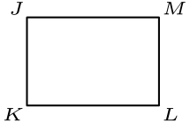
（A）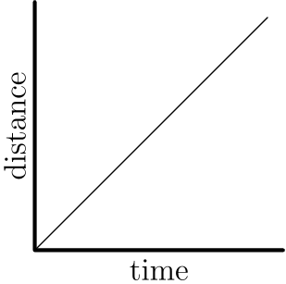
（B）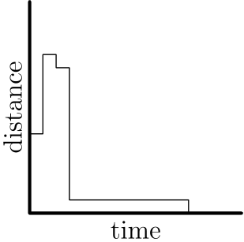
（C）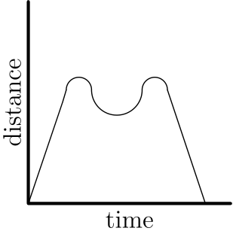
（D）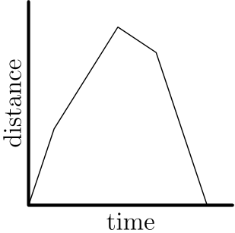
（E）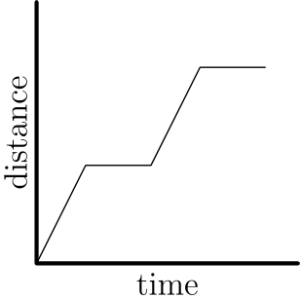
English
Tess runs counterclockwise around rectangular block JKLM. She lives at corner J. Which graph could represent her straight-line distance from home?
(A)
(B)
(C)
(D)
(E)
第 24 题
图中，ABCD 是长方形，EFGH 是平行四边形。利用图中给出的测量值，求线段 d 的长度；该线段垂直于 HE 和 FG。
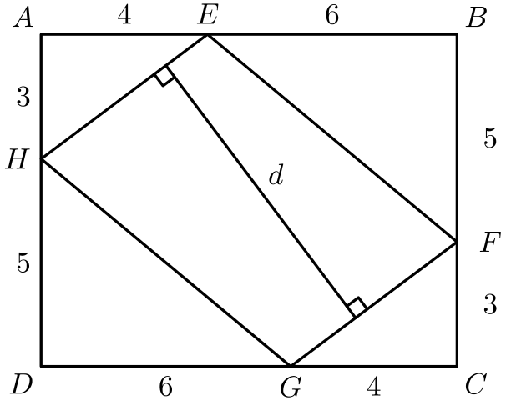
（A）6.8 （B）7.1 （C）7.6 （D）7.8 （E）8.1
English
In the figure, ABCD is a rectangle and EFGH is a parallelogram. Using the measurements given in the figure, what is the length d of the segment that is perpendicular to HE and FG?
(A) 6.8 (B) 7.1 (C) 7.6 (D) 7.8 (E) 8.1
第 25 题
两个 4 × 4 正方形成直角相交，并且每个正方形都平分另一个正方形被其穿过的两条边，如图所示。圆的直径是两个交点之间的线段。从两个正方形中去掉圆后形成的阴影区域面积是多少？

（A）16-4π （B）16-2π （C）28-4π （D）28-2π （E）32-2π
English
Two 4 × 4 squares intersect at right angles, bisecting their intersecting sides, as shown. The circle’s diameter is the segment between the two points of intersection. What is the area of the shaded region created by removing the circle from the squares?
(A) 16-4π (B) 16-2π (C) 28-4π (D) 28-2π (E) 32-2π

第二部分 解答
答案速查：
题号 1 2 3 4 5 6 7 8 9
答案 B B A B D C B B D
题号 10 11 12 13 14 15 16 17 18
答案 E C B E C C C D A
题号 19 20 21 22 23 24 25
答案 B D D B D C D
答案串：BBABDCBBDECBECCCDABDDBDCD
第 1 题 答案 B
1 厘米表示 72 ÷ 12 = 6 千米。因此 17 厘米表示 6 · 17 = 102 千米。
所以正确答案是B。
English
Note that 1 cm represents 72 ÷ 12 = 6 kilometers. This means that 17 cm represents 6 · 17 = 102 kilometers.
Thus,Bis the correct answer.
第 2 题 答案 B
有 2 个非零数字可以作为千位数字。
选定后，需要安排另外 3 个数字。另一个非零数字有 3 个位置可放。
因此共有 2 · 3 = 6 个可能的数。
所以正确答案是B。
English
Note that there are 2 non-zero digits that could be the thousands digit.
After choosing that, we need to arrange the other 3 digits. There are 3 spots for the other non-zero digit.
This gives us 2 · 3 = 6 possible numbers.
Thus,Bis the correct answer.
第 3 题 答案 A
12 份餐能喂饱 18 个人，所以一份餐能喂饱 18/12 = 3/2 个人。
因此所需餐数为 12 ÷ 3/2 = 8，正好够 12 个人吃。
所以正确答案是A。
English
Note that 12 meals feed 18 people. This means that one meal feeds 18/12 = 3/2 people.
This means that they need 12 ÷ 3/2 = 8 meals for 12 people.
Thus,Ais the correct answer.
第 4 题 答案 B
若有 3 名首发，则有一人不首发。选择不首发的人就确定了首发。
不首发的人有 4 种选择。
所以正确答案是B。
English
If there are 3 starters, then one person must not be starting. Choosing the person who doesn’t start determines the starters.
There are 4 choices for the person who doesn’t start.
Thus,Bis the correct answer.
第 5 题 答案 D
每场比赛后都会淘汰一支队伍。要只剩下一支队伍，必须淘汰 15 支队伍。
因此必须打 15 场比赛。
所以正确答案是D。
English
Note that after every game, one team gets eliminated. For there to be one team remaining, 15 teams must have been eliminated.
This means that 15 games had to have been played.
Thus,Dis the correct answer.
第 6 题 答案 C
萨莉在最初的 20 次投篮中命中了 20 × 0.55 = 11 次。于是
(11 + x)/25 = 0.56，
所以
11 + x = 14
且 x = 3。
所以正确答案是C。
English
Sally made 20 × 0.55 = 11 of her first 20 shots. Then we get that
(11 + x)/25 = 0.56,
which tells us that
11 + x = 14
and x = 3.
Thus,Cis the correct answer.
第 7 题 答案 B
这名运动员的最大心率为 220 - 26 = 194。目标心率为 194 × 0.8 ≈ 155。
所以正确答案是B。
English
The maximum heart rate for this athlete would be 220 - 26 = 194. Then the target heart rate would be 194 × 0.8 ≈ 155.
Thus,Bis the correct answer.
第 8 题 答案 B
十位数字可以从 1 到 7，而这个数字会确定个位数字。
因此共有 7 个数。
所以正确答案是B。
English
Note that the tens digit can range from 1 to 7, and this digit determines the units digit.
Therefore, there are 7 numbers.
Thus,Bis the correct answer.
第 9 题 答案 D
5 个数的总和是 54 · 5 = 270。前 2 个数的总和是 48 · 2 = 96。
后 3 个数的总和是 270 - 96 = 174，所以平均数是 174 ÷ 3 = 58。
所以正确答案是D。
English
The sum of all 5 numbers is 54 · 5 = 270. The sum of the first 2 numbers is 48 · 2 = 96.
The sum of the last 3 numbers is 270 - 96 = 174. The average is therefore 174 ÷ 3 = 58.
Thus,Dis the correct answer.
第 10 题 答案 E
亚伦星期一工作 75 分钟，星期二工作 50 分钟，星期三工作 145 分钟，星期五工作 30 分钟。
总时间为 75+50+145+30=300 分钟，即 5 小时。
按每小时 $3 计算，他赚了 5·3=15 美元。
所以正确答案是E。
English
Aaron worked 75 minutes on Monday, 50 minutes on Tuesday, 145 minutes on Wednesday, and 30 minutes on Friday.
The total is 75+50+145+30=300 minutes, or 5 hours.
At $3 per hour, he earned 5·3=15 dollars.
Thus,Eis the correct answer.
第 11 题 答案 C
最大数、最小数和中位数都不能在第一位或最后一位。
因此第一位和最后一位是 4 和 9，顺序不限。它们的平均数为
(4 + 9) ÷ 2 = 13 ÷ 2 = 6.5。
所以正确答案是C。
English
Note that the largest, smallest, and median numbers cannot be the first or last number.
This means that the first and last numbers are 4 and 9 in some order. Their average is
(4 + 9) ÷ 2 = 13 ÷ 2 = 6.5.
Thus,Cis the correct answer.
第 12 题 答案 B
不使用时，手机每小时消耗 1/24 的电量。使用时，每小时消耗 1/3 的电量。
妮基的手机开机 9 小时，其中 8 小时待机，1 小时通话。
因此手机已消耗 2/3 的电量。剩余 1/3 电量在不使用时还能持续 8 小时。
所以正确答案是B。
English
When not in use, her cell phone uses up 1/24 of its battery per hour. When it is in use, it uses up 1/3 of its battery per hour.
Niki’s phone has been on for 9 hours, with 8 of those hours being idle and 1 hour being used to talk on the phone.
This means that the phone has used up 2/3 of its battery. In order to drain the remaining 1/3 of the battery, the phone can last for 8 more hours without being used.
Thus,Bis the correct answer.
第 13 题 答案 E
如果比尔最大，那么陈述 I 和 II 都为真，所以比尔不是最大的。
如果赛琳最大，那么陈述 II 和 III 都为真，所以赛琳也不是最大的。
因此艾米最大。陈述 I 和 II 为假，所以陈述 III 必须是唯一为真的陈述。因此赛琳不是最小，比尔最小。
顺序是艾米、赛琳、比尔。
所以正确答案是E。
English
If Bill were oldest, then statements I and II would both be true, so Bill is not oldest.
If Celine were oldest, then statements II and III would both be true, so Celine is not oldest.
Therefore Amy is oldest. Statements I and II are false, so statement III must be the single true statement. Thus Celine is not youngest, leaving Bill youngest.
The order is Amy, Celine, Bill.
Thus,Eis the correct answer.
第 14 题 答案 C
将四边形放入外接的 10×10 正方形中，其面积为 100。
五个外侧部分的面积分别为 15、1/2·6·7=21、1/2·1·3=3/2、1/2·4·5=10、1/2·6·10=30。
外侧面积为 15+21+3/2+10+30=771/2，所以四边形面积为 100-771/2=221/2。
所以正确答案是C。
English
Place the quadrilateral inside the surrounding 10×10 square, whose area is 100.
The five outside pieces have areas 15, 1/2·6·7=21, 1/2·1·3=3/2, 1/2·4·5=10, and 1/2·6·10=30.
The outside area is 15+21+3/2+10+30=771/2, so the quadrilateral area is 100-771/2=221/2.
Thus,Cis the correct answer.
第 15 题 答案 C
原图有 13 块阴影瓷砖和 6 块未阴影瓷砖。
新边框是围绕图形的下一圈六边形环，有 18 块未阴影瓷砖。
新图形有 6+18=24 块未阴影瓷砖和 13 块阴影瓷砖，所以差为 24-13=11。
所以正确答案是C。
English
The original figure has 13 shaded tiles and 6 unshaded tiles.
The new border is the next hexagonal ring around the figure, which has 18 unshaded tiles.
The new figure has 6+18=24 unshaded tiles and 13 shaded tiles, so the difference is 24-13=11.
Thus,Cis the correct answer.
第 16 题 答案 C
第一个水壶含有 600 · 1/3 = 200 毫升橙汁。第二个含有 600 · 2/5 = 240 毫升。
大容器中共有 200 + 240 = 440 毫升橙汁。混合液总量为 2 · 600 = 1200 毫升。
因此橙汁所占比例为 440/1200 = 11/30。
所以正确答案是C。
English
The first pitcher contains 600 · 1/3 = 200 mL of orange juice. The second one has 600 · 2/5 = 240 mL.
The large container then has 200 + 240 = 440 mL of orange juice. The total amount of mixture is 2 · 600 = 1200 mL.
Then the fraction of orange juice is 440/1200 = 11/30.
Thus,Cis the correct answer.
第 17 题 答案 D
先给每个朋友一支铅笔。还剩 3 支铅笔要分给 3 个朋友。
如果一个朋友得到全部剩下的 3 支，有 3 种方式。如果剩下的铅笔按 2 和 1 分，有 3·2=6 种方式。如果每个朋友再各得一支，有 1 种方式。
总方式数为 3+6+1=10。
所以正确答案是D。
English
First give each friend one pencil. Then 3 pencils remain to distribute among the 3 friends.
If one friend gets all 3 remaining pencils, there are 3 ways. If the remaining pencils split as 2 and 1, there are 3·2=6 ways. If each friend gets one more, there is 1 way.
The total number of ways is 3+6+1=10.
Thus,Dis the correct answer.
第 18 题 答案 A
本得到 4 分的唯一方式是 1 和 3，因为他不能两次击中 2。
辛迪的得分可能来自
1 + 6, 2 + 5, 3 + 4。
本已经击中了 1 和 3，所以辛迪必须击中 2 和 5。
同理，戴夫必须击中 4 和 7。最后，因为 7 已经被使用，爱丽丝只能击中 6 和 10，埃伦击中 8 和 9。
所以正确答案是A。
English
The only way to get Ben’s score of 4 is with a 1 and 3 since he can’t hit 2 twice.
Cindy can achieve her score with
1 + 6, 2 + 5, 3 + 4.
Ben already hit 1 and 3, so Cindy must have hit 2 and 5.
Similarly, Dave must have hit 4 and 7. Finally, since 7 is already used, Alice is forced to have hit 6 and 10 with Ellen hitting 8 and 9.
Thus,Ais the correct answer.
第 19 题 答案 B
设这个数为 x。那么 x - 2 能被 3、4、5 和 6 整除。
这些数的最小公倍数是 60，所以 x 为 62。
所以正确答案是B。
English
Let x be the number. Then x - 2 is divisible by 3, 4, 5, and 6.
The least common multiple of these numbers is 60, which makes x 62.
Thus,Bis the correct answer.
第 20 题 答案 D
因为 3/4 的椅子被坐了，所以 6 把空椅子是所有椅子的 1/4。因此共有 24 把椅子。
坐着的人数是 3/4 乘 24，即 18。
这 18 个坐着的人是所有人的 2/3，所以总人数为 18÷2/3=27。
所以正确答案是D。
English
Since 3/4 of the chairs are occupied, the 6 empty chairs are 1/4 of all the chairs. Thus there are 24 chairs.
The number of seated people is 3/4 of 24, which is 18.
Those 18 seated people are 2/3 of all the people, so the total number of people is 18÷2/3=27.
Thus,Dis the correct answer.
第 21 题 答案 D
要使乘积为偶数，至少一个转盘必须落在偶数上。
使用补集计数，计算两个转盘都落在奇数上的概率。
这个概率为
1/2 · 2/3 = 1/3。
因此至少一个为偶数的概率为
1 - 1/3 = 2/3。
所以正确答案是D。
English
For the product to be even, at least one of the spinners must land on an even number.
We can use complementary counting and calculate the probability of both spinners landing on odds.
This happens with a probability of
1/2 · 2/3 = 1/3.
Then the probability of landing on at least one even is
1 - 1/3 = 2/3.
Thus,Dis the correct answer.
第 22 题 答案 B
为了便于按比例计算，设房间里有 5 名女性。那么单身女性有 5 · 2/5 = 2 名。
因此已婚女性有 5 - 2 = 3 名，也就是已婚男性的人数。
房间里共有 5 + 3 = 8 人。已婚男性所占比例为 3/8。
所以正确答案是B。
English
For a convenient ratio model, let there be 5 women in the room. Then there are 5 · 2/5 = 2 single women.
This means that there are 5 - 2 = 3 married women, which is also the number of married men.
There are a total of 5 + 3 = 8 people in the room. The fraction of married men is 3/8.
Thus,Bis the correct answer.
第 23 题 答案 D
特丝从 J 出发跑向 K 时，她到家的距离不断增加。
从 K 到 L，距离继续增加，但变化方式不同，并在对角 L 达到最大。
从 L 到 M，再从 M 回到 J，距离逐渐减小到 0，并在 M 处再次改变变化方式。
只有图 D 先以一种方式增加，再改变增加方式；随后改变减少方式，最后减小到 0。
所以正确答案是D。
English
As Tess runs from J to K, her distance from home increases.
From K to L, her distance continues to increase, but with a different shape, reaching its maximum at the opposite corner L.
From L to M and then from M back to J, her distance decreases back to 0, again changing behavior at M.
Graph D is the only graph with this increase, changed-rate increase, changed-rate decrease, and final decrease to 0.
Thus,Dis the correct answer.
第 24 题 答案 C
长方形边长为 10 和 8，所以面积为 80。
四个角上三角形的总面积为
2·1/2·3·4
+2·1/2·6·5
=12+30=42
。
因此平行四边形 EFGH 的面积为 80-42=38。
线段 HE 长为 5，这可由 3-4-5 直角三角形得到。因为平行四边形面积为 HE· d，所以 5d=38，从而 d=7.6。
所以正确答案是C。
English
The rectangle has side lengths 10 and 8, so its area is 80.
The four corner triangles have total area
2·1/2·3·4
+2·1/2·6·5
=12+30=42.
Thus parallelogram EFGH has area 80-42=38.
Segment HE has length 5 by the 3-4-5 right triangle. Since the parallelogram area is HE· d, we have 5d=38, so d=7.6.
Thus,Cis the correct answer.
第 25 题 答案 D
两个 4×4 正方形总面积为 32，但它们的重叠部分是一个 2×2、面积为 4 的正方形。因此两个正方形并集的面积为 32-4=28。
圆的直径是这个 2×2 重叠正方形的对角线，所以直径为 2√(2)，半径为 √(2)。
圆面积为 π(√(2))²=2π，所以阴影面积为 28-2π。
所以正确答案是D。
English
The two 4×4 squares have total area 32, but their overlap is a 2×2 square with area 4. Thus the area covered by the union of the two squares is 32-4=28.
The circle’s diameter is the diagonal of that 2×2 overlap square, so the diameter is 2√(2) and the radius is √(2).
The circle area is π(√(2))²=2π, so the shaded area is 28-2π.
Thus,Dis the correct answer.

