2003 年 AMC 8 真题与解答
American Mathematics Competitions 8 · 中英双语
共 25 题，限时 40 分钟；单项选择题，每题 1 分，答错不扣分，满分 25 分。
编排说明：第一部分为题目（先中文、后英文原题），第二部分为解答与答案，便于先做题后对答案。
第一部分 题目
第 1 题
Jamie 数了一个立方体的棱数，Jimmy 数了顶点数，Judy 数了面数。然后他们把这三个数相加。得到的和是多少？
（A）12 （B）16 （C）20 （D）22 （E）26
English
Jamie counted the number of edges of a cube, Jimmy counted the number of corners, and Judy counted the number of faces. They then added the three numbers. What was the resulting sum?
(A) 12 (B) 16 (C) 20 (D) 22 (E) 26
第 2 题
下列哪个数的最小质因数最小？
（A）55 （B）57 （C）58 （D）59 （E）61
English
Which of the following numbers has the smallest prime factor?
(A) 55 (B) 57 (C) 58 (D) 59 (E) 61
第 3 题
Ricky C’s 的一个汉堡重 120 克，其中 30 克是填充物。汉堡中不是填充物的部分占百分之多少？
（A）60 % （B）65 % （C）70 % （D）75 % （E）90 %
English
A burger at Ricky C’s weighs 120 grams, of which 30 grams are filler. What percent of the burger is not filler?
(A) 60 % (B) 65 % (C) 70 % (D) 75 % (E) 90 %
第 4 题
一群骑自行车和三轮车的孩子经过 Billy Bob 家。Billy Bob 数到 7 个孩子和 19 个轮子。有多少辆三轮车？
（A）2 （B）4 （C）5 （D）6 （E）7
English
A group of children riding on bicycles and tricycles rode past Billy Bob’s house. Billy Bob counted 7 children and 19 wheels. How many tricycles were there?
(A) 2 (B) 4 (C) 5 (D) 6 (E) 7
第 5 题
如果一个数的 20 % 是 12，那么同一个数的 30% 是多少？
（A）15 （B）18 （C）20 （D）24 （E）30
English
If 20 % of a number is 12, what is 30% of the same number?
(A) 15 (B) 18 (C) 20 (D) 24 (E) 30
第 6 题
根据图中三个正方形的面积，内部三角形的面积是多少？
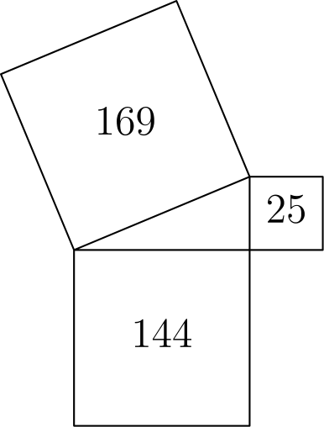
（A）13 （B）30 （C）60 （D）300 （E）1800
English
Given the areas of the three squares in the figure, what is the area of the interior triangle?
(A) 13 (B) 30 (C) 60 (D) 300 (E) 1800
第 7 题
Blake 和 Jenny 各参加了四次 100 分测试。Blake 四次测试平均分为 78。Jenny 第一次测试比 Blake 高 10 分，第二次比他低 10 分，第三次和第四次都比他高 20 分。Jenny 的平均分和 Blake 的平均分相差多少？
（A）10 （B）15 （C）20 （D）25 （E）40
English
Blake and Jenny each took four 100-point tests. Blake averaged 78 on the four tests. Jenny scored 10 points higher than Blake on the first test, 10 points lower than him on the second test, and 20 points higher on both the third and fourth tests. What is the difference between Jenny’s average and Blake’s average on these four tests?
(A) 10 (B) 15 (C) 20 (D) 25 (E) 40
第 8 题
第 8，9 和 10 题使用随附段落和图形中的数据。
烘焙义卖
四个朋友 Art、Roger、Paul 和 Trisha 烤饼干，所有饼干厚度相同。饼干的形状如下所示。
• Art 的饼干是梯形：
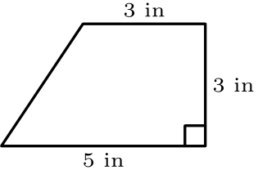
• Roger 的饼干是长方形：
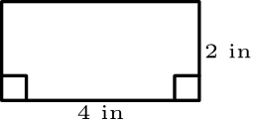
• Paul 的饼干是平行四边形：
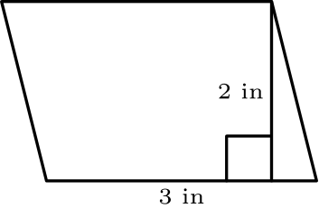
• Trisha 的饼干是三角形：
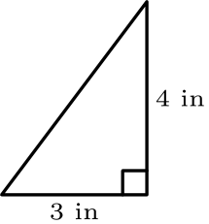
每个朋友使用相同数量的面团，且 Art 正好做了 12 块饼干。
谁用一批饼干面团做出的饼干数量最少？
（A）Art （B）Paul （C）Roger （D）Trisha （E）最少数量出现并列
English
Problems 8, 9, and 10 use the data found in the accompanying paragraph and figures.
Bake Sale
Four friends, Art, Roger, Paul and Trisha, bake cookies, and all cookies have the same thickness. The shapes of the cookies differ, as shown.
• Art’s cookies are trapezoids:
• Roger’s cookies are rectangles:
• Paul’s cookies are parallelograms:
• Trisha’s cookies are triangles:
Each friend uses the same amount of dough, and Art makes exactly 12 cookies.
Who gets the fewest cookies from one batch of cookie dough?
(A) Art (B) Paul (C) Roger (D) Trisha (E) There is a tie for fewest.
第 9 题
Art 的饼干每块卖 60¢。为了从一批面团中赚到同样金额，Roger 的一块饼干应卖多少钱？
（A）18¢ （B）25¢ （C）40¢ （D）75¢ （E）90¢
English
Art’s cookies sell for 60¢ each. To earn the same amount from a single batch, how much should one of Roger’s cookies cost?
(A) 18¢ (B) 25¢ (C) 40¢ (D) 75¢ (E) 90¢
第 10 题
一批 Trisha 的饼干会有多少块？
（A）10 （B）12 （C）16 （D）18 （E）24
English
How many cookies will be in one batch of Trisha’s cookies?
(A) 10 (B) 12 (C) 16 (D) 18 (E) 24
第 11 题
Lou’s Fine Shoes 生意有点慢，于是 Lou 决定促销。星期五，Lou 将星期四所有价格提高 10 %。周末，Lou 做广告：“标价九折，促销星期一开始。”星期四售价 $40 的一双鞋，星期一卖多少钱？
（A）$36 （B）$39.60 （C）$40 （D）$40.40 （E）$44
English
Business is a little slow at Lou’s Fine Shoes, so Lou decides to have a sale. On Friday, Lou increases all of Thursday’s prices by 10 %. Over the weekend, Lou advertises the sale: “Ten percent off the listed price. Sale starts Monday.” How much does a pair of shoes cost on Monday that cost $40 on Thursday?
(A) $36 (B) $39.60 (C) $40 (D) $40.40 (E) $44
第 12 题
当一个公平的六面骰子被掷到桌面上时，底面看不见。可见的五个面上的数字乘积能被 6 整除的概率是多少？
（A）1/3 （B）1/2 （C）2/3 （D）5/6 （E）1
English
When a fair six-sided die is tossed on a table top, the bottom face cannot be seen. What is the probability that the product of the numbers on the five faces that can be seen is divisible by 6?
(A) 1/3 (B) 1/2 (C) 2/3 (D) 5/6 (E) 1
第 13 题
十四个白色立方体拼成右图。这个立体的整个表面，包括底面，都被涂成红色。然后将这个立体拆成单个立方体。有多少个单个立方体恰好有四个面是红色的？

（A）4 （B）6 （C）8 （D）10 （E）12
English
Fourteen white cubes are put together to form the figure on the right. The complete surface of the figure, including the bottom, is painted red. The figure is then separated into individual cubes. How many of the individual cubes have exactly four red faces?
(A) 4 (B) 6 (C) 8 (D) 10 (E) 12
第 14 题
在这个加法题中，每个字母代表一个不同数字。
 | T | W | O
+ | T | W | O
F | O | U | R

如果 T = 7，且字母 O 表示一个偶数，那么 W 唯一可能的值是多少？
（A）0 （B）1 （C）2 （D）3 （E）4
English
In this addition problem, each letter stands for a different digit.
 | T | W | O
+ | T | W | O
F | O | U | R

If T = 7 and the letter O represents an even number, what is the only possible value for W?
(A) 0 (B) 1 (C) 2 (D) 3 (E) 4
第 15 题
一个图形由单位立方体构成。每个立方体至少与另一个立方体共享一个面。若要得到图中所示的正视图和侧视图，最少需要多少个立方体？
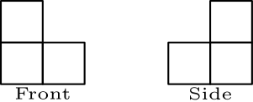
（A）3 （B）4 （C）5 （D）6 （E）7
English
A figure is constructed from unit cubes. Each cube shares at least one face with another cube. What is the minimum number of cubes needed to build a figure with the front and side views shown?
(A) 3 (B) 4 (C) 5 (D) 6 (E) 7
第 16 题
Ali、Bonnie、Carlo 和 Dianna 将一起开车去附近的主题公园。他们使用的车有四个座位：一个驾驶座、一个前排乘客座和两个后排座位。只有 Bonnie 和 Carlo 会开这辆车。有多少种可能的座位安排？
（A）2 （B）4 （C）6 （D）12 （E）24
English
Ali, Bonnie, Carlo and Dianna are going to drive together to a nearby theme park. The car they are using has four seats: one driver’s seat, one front passenger seat and two back seats. Bonnie and Carlo are the only two who can drive the car. How many possible seating arrangements are there?
(A) 2 (B) 4 (C) 6 (D) 12 (E) 24
第 17 题
下面列出的六个孩子来自两个家庭，每个家庭有三个兄弟姐妹。每个孩子有蓝色或棕色眼睛，以及黑色或金色头发。同一个家庭的孩子至少有其中一个特征相同。哪两个孩子是 Jim 的兄弟姐妹？
姓名 | 眼睛颜色 | 头发颜色
Benjamin | 蓝色 | 黑色
Jim | 棕色 | 金色
Nadeen | 棕色 | 黑色
Austin | 蓝色 | 金色
Tevyn | 蓝色 | 黑色
Sue | 蓝色 | 金色

（A）Nadeen 和 Austin （B）Benjamin 和 Sue （C）Benjamin 和 Austin （D）Nadeen 和 Tevyn （E）Austin 和 Sue
English
The six children listed below are from two families of three siblings each. Each child has blue or brown eyes and black or blond hair. Children from the same family have at least one of these characteristics in common. Which two children are Jim’s siblings?
Child | Eye Color | Hair Color
Benjamin | Blue | Black
Jim | Brown | Blond
Nadeen | Brown | Black
Austin | Blue | Blond
Tevyn | Blue | Black
Sue | Blue | Blond

(A) Nadeen and Austin (B) Benjamin and Sue (C) Benjamin and Austin (D) Nadeen and Tevyn (E) Austin and Sue
第 18 题
下图中的二十个点各代表 Sarah 的一位同学。互为朋友的同学之间用线段连接。Sarah 生日聚会只邀请以下同学：她所有的朋友，以及至少和她某个朋友是朋友的同学。有多少位同学不会被邀请参加 Sarah 的聚会？
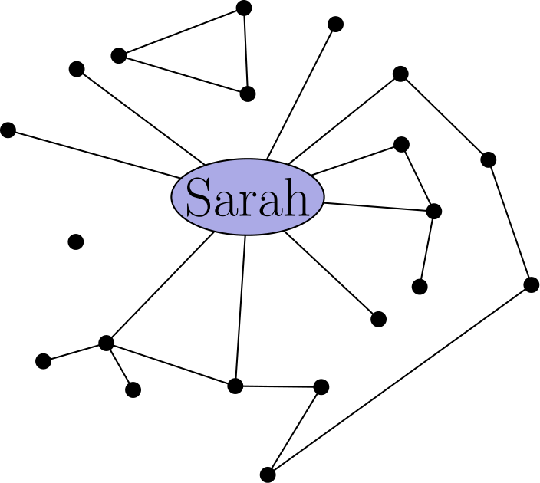
（A）1 （B）4 （C）5 （D）6 （E）7
English
Each of the twenty dots on the graph below represents one of Sarah’s classmates. Classmates who are friends are connected with a line segment. For her birthday party, Sarah is inviting only the following: all of her friends and all of those classmates who are friends with at least one of her friends. How many classmates will not be invited to Sarah’s party?
(A) 1 (B) 4 (C) 5 (D) 6 (E) 7
第 19 题
1000 和 2000 之间有多少个整数同时以 15，20 和 25 为因数？
（A）1 （B）2 （C）3 （D）4 （E）5
English
How many integers between 1000 and 2000 have all three of the numbers 15, 20, and 25 as factors?
(A) 1 (B) 2 (C) 3 (D) 4 (E) 5
第 20 题
凌晨 4:20 时，钟表两根指针形成的锐角是多少度？
（A）0° （B）5° （C）8° （D）10° （E）12°
English
What is the measure of the acute angle formed by the hands of a clock at 4:20 a.m.?
(A) 0° (B) 5° (C) 8° (D) 10° (E) 12°
第 21 题
梯形 ABCD 的面积是 164cm²。高为 8 cm，AB 为 10 cm，CD 为 17 cm。BC 等于多少厘米？
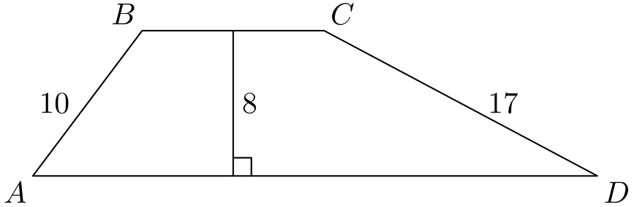
（A）9 （B）10 （C）12 （D）15 （E）20
English
The area of trapezoid ABCD is 164cm². The altitude is 8 cm, AB is 10 cm, and CD is 17 cm. What is BC, in centimeters?
(A) 9 (B) 10 (C) 12 (D) 15 (E) 20
第 22 题
下列图形由正方形和圆组成。哪个图形的阴影区域面积最大？
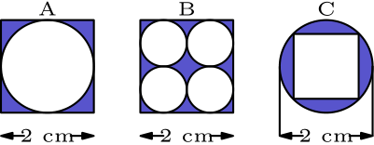
（A）只有 A （B）只有 B （C）只有 C （D）A 和 B （E）全部相等
English
The following figures are composed of squares and circles. Which figure has a shaded region with largest area?
(A) A only (B) B only (C) C only (D) both A and B (E) all are equal
第 23 题
在下面的图案中，猫在四个正方形中顺时针移动，老鼠沿四个正方形外侧的八条线段逆时针移动。
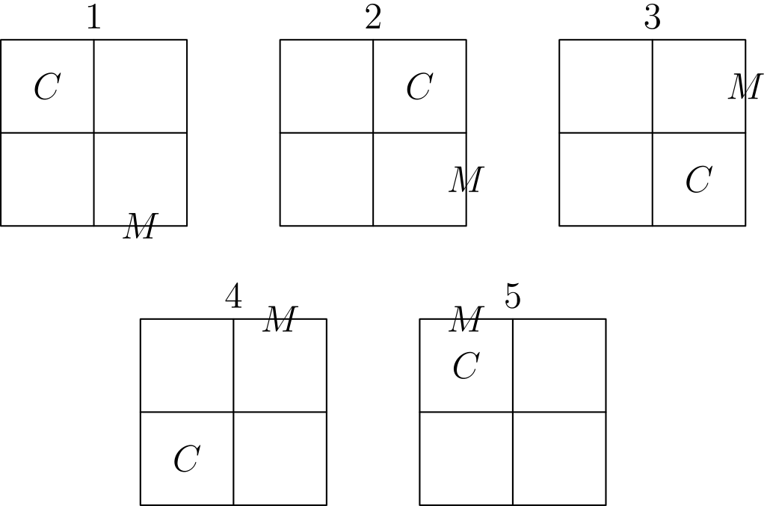
如果图案继续下去，第 247 次移动后猫和老鼠会在哪里？
（A）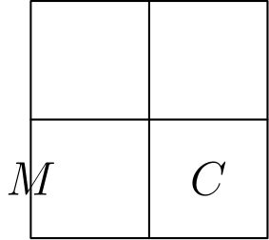
（B）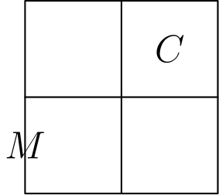
（C）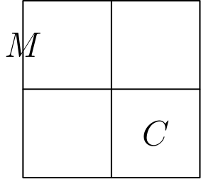
（D）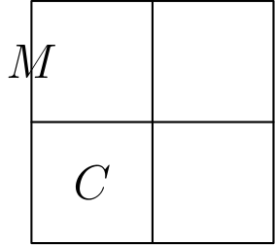
（E）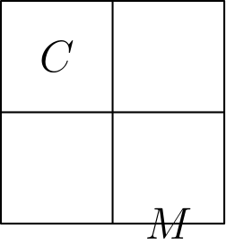
English
In the pattern below, the cat moves clockwise through the four squares and the mouse moves counterclockwise through the eight exterior segments of the four squares.
If the pattern is continued, where would the cat and mouse be after the 247th move?
(A)
(B)
(C)
(D)
(E)
第 24 题
一艘船沿半圆路径从点 A 到点 B，该半圆以岛 X 为圆心。然后它沿直线路径从 B 到 C。下列哪张图最能表示船沿路线移动时到岛 X 的距离？
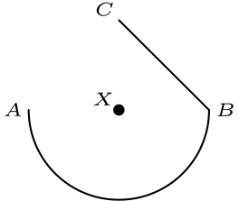
（A）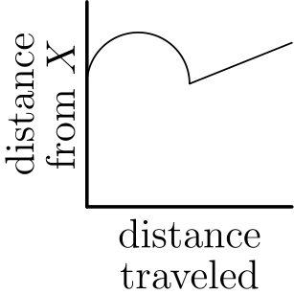
（B）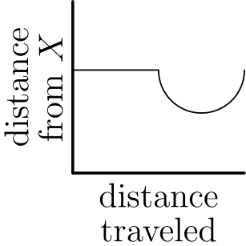
（C）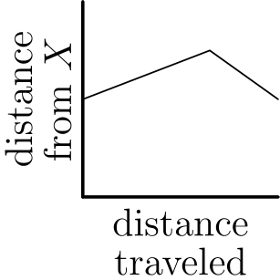
（D）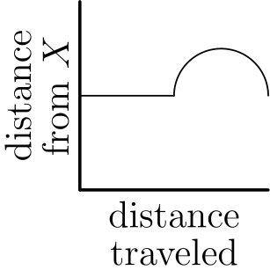
（E）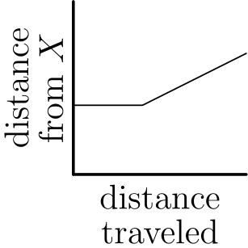
English
A ship travels from point A to point B along a semicircular path, centered at Island X. Then it travels along a straight path from B to C. Which of these graphs best shows the ship’s distance from Island X as it moves along its course?
(A)
(B)
(C)
(D)
(E)
第 25 题
图中，正方形 WXYZ 的面积为 25 cm²。四个较小正方形边长为 1 cm，边要么与大正方形的边平行，要么重合。在 △ ABC 中，AB = AC，且当 △ ABC 沿边 BC 折叠时，点 A 与 O（正方形 WXYZ 的中心）重合。△ ABC 的面积是多少平方厘米？
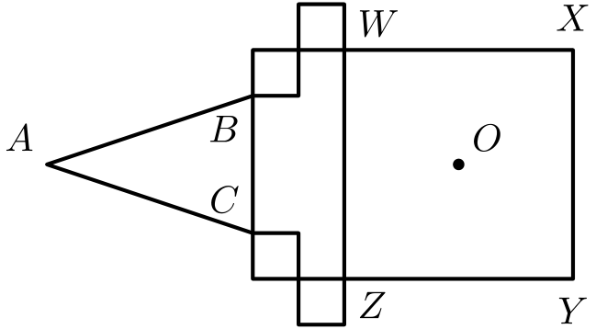
（A）15/4 （B）21/4 （C）27/4 （D）21/2 （E）27/2
English
In the figure, the area of square WXYZ is 25 cm². The four smaller squares have sides 1 cm long, either parallel to or coinciding with the sides of the large square. In △ ABC, AB = AC, and when △ ABC is folded over side BC, point A coincides with O, the center of square WXYZ. What is the area of △ ABC, in square centimeters?
(A) 15/4 (B) 21/4 (C) 27/4 (D) 21/2 (E) 27/2

第二部分 解答
答案速查：
题号 1 2 3 4 5 6 7 8 9
答案 E C D C B B A A C
题号 10 11 12 13 14 15 16 17 18
答案 E B E B D B D E D
题号 19 20 21 22 23 24 25
答案 C D B C A B C
答案串：ECDCBBAACEBEBDBDEDCDBCABC
第 1 题 答案 E
一个立方体有 12 条棱、8 个顶点和 6 个面。相加得到
12 + 8 + 6 = 26。
所以正确答案是E。
English
A cube has 12 edges, 8 corners, and 6 faces. Adding these together yields
12 + 8 + 6 = 26.
Thus,Eis the correct answer.
第 2 题 答案 C
最小的质数是 2。因此任何偶数都会是答案。
所以正确答案是C。
English
Note that the smallest prime number is 2. This means that any even number would be our answer.
Thus,Cis the correct answer.
第 3 题 答案 D
不是填充物的部分为 120 - 30 = 90 克。因此百分比为
100 · 90/120 = 100 · 3/4 = 75 %。
所以正确答案是D。
English
We get that 120 - 30 = 90 grams are not filler. The percentage is therefore
100 · 90/120 = 100 · 3/4 = 75 %.
Thus,Dis the correct answer.
第 4 题 答案 C
设 b 为自行车数量，t 为三轮车数量。可列方程组：
b + t = 7,
2b + 3t = 19。
将第一个方程乘以 2，再从第二个方程中减去所得等式，得到 t = 5。
所以正确答案是C。
English
Let b be the number of bicycles and t be the number of tricycles. Then we can set up the following system of equations:
b + t = 7,
2b + 3t = 19.
Multiplying the first equation by 2 and subtracting from the second equation, we get t = 5.
Thus,Cis the correct answer.
第 5 题 答案 B
因为这个数的 20% 是 12，所以这个数的 10% 是 6。
因此同一个数的 30% 是 3·6=18。
所以正确答案是B。
English
Since 20% of the number is 12, 10% of the number is 6.
Therefore 30% of the same number is 3·6=18.
Thus,Bis the correct answer.
第 6 题 答案 B
三个正方形的边长分别为
√(169) = 13、
√(144) = 12
和
√(25) = 5。
这些长度构成一个勾股数组。
因此内部三角形是直角三角形，面积为
1/2 · 5 · 12 = 30。
所以正确答案是B。
English
The side lengths of the squares are
√(169) = 13,
√(144) = 12,
and
√(25) = 5.
These lengths form a Pythagorean triple.
Therefore, the interior triangle is right. Its area is
1/2 · 5 · 12 = 30.
Thus,Bis the correct answer.
第 7 题 答案 A
两人四次测试的总分差为
10 - 10 + 20 · 2 = 40，
所以平均分之差为 40 ÷ 4 = 10。
所以正确答案是A。
English
The total point difference between the two is
10 - 10 + 20 · 2 = 40.
The average of this difference is 40 ÷ 4 = 10.
Thus,Ais the correct answer.
第 8 题 答案 A
因为所有饼干厚度相同且使用相同数量的面团，所以面积最大的饼干形状会产生最少的饼干。
Art 的梯形面积为 1/2(3+5)·3=12。Roger 的长方形面积为 4·2=8。Paul 的平行四边形面积为 3·2=6，Trisha 的三角形面积为 1/2·3·4=6。
Art 的饼干面积最大，所以 Art 用一批面团得到的饼干最少。
所以正确答案是A。
English
Since the cookies all have the same thickness and use the same amount of dough, the largest cookie shape produces the fewest cookies.
Art’s trapezoid has area 1/2(3+5)·3=12. Roger’s rectangle has area 4·2=8. Paul’s parallelogram has area 3·2=6, and Trisha’s triangle has area 1/2·3·4=6.
Art has the largest cookie area, so Art gets the fewest cookies from one batch.
Thus,Ais the correct answer.
第 9 题 答案 C
Art 做 12 块饼干，每块卖 60 分，所以一批收入 12·60=720 分。
这批面团面积为 12·12=144 平方英寸，每块 Roger 饼干面积为 4·2=8。因此 Roger 能做 144÷8=18 块饼干。
一批需要赚到 720 分，而 Roger 有 18 块饼干，因此每块应卖 720÷18=40 分。
所以正确答案是C。
English
Art makes 12 cookies that sell for 60 cents each, so one batch earns 12·60=720 cents.
The batch has 12·12=144 square inches of dough area, and each Roger cookie has area 4·2=8. Thus Roger makes 144÷8=18 cookies.
To earn 720 cents from 18 cookies, each Roger cookie should cost 720÷18=40 cents.
Thus,Cis the correct answer.
第 10 题 答案 E
Art 的一块饼干面积为 12 平方英寸，所以整批面团面积为 12·12=144 平方英寸。
Trisha 的三角形饼干面积为 1/2·3·4=6 平方英寸。
因此 Trisha 每批可以做 144÷6=24 块饼干。
所以正确答案是E。
English
Art’s cookie area is 12 square inches, so the whole batch has area 12·12=144 square inches.
Trisha’s triangular cookie has area 1/2·3·4=6 square inches.
Therefore Trisha can make 144÷6=24 cookies per batch.
Thus,Eis the correct answer.
第 11 题 答案 B
星期五鞋价提高 10%，所以标价变为 40·1.10=44 美元。
星期一再打 10% 的折扣，从 $44 降到 44·0.90=39.60 美元。
所以正确答案是B。
English
On Friday, the shoes are marked up by 10%, so the listed price becomes 40·1.10=44 dollars.
On Monday, the 10% discount is taken from $44, giving 44·0.90=39.60 dollars.
Thus,Bis the correct answer.
第 12 题 答案 E
如果数字 6 的面可见，那么可见数字的乘积能被 6 整除。
如果数字 6 在底面，那么可见面仍包含 2 和 3，所以它们的乘积仍能被 6 整除。
每种可能的掷骰结果都满足条件，所以概率为 1。
所以正确答案是E。
English
If the face numbered 6 is visible, then the visible product is divisible by 6.
If the face numbered 6 is on the bottom, then the visible faces include both 2 and 3, so their product is still divisible by 6.
Every possible toss works, so the probability is 1.
Thus,Eis the correct answer.
第 13 题 答案 B
一个小立方体恰好有四个面被涂色，当且仅当它恰好与两个其他立方体相连。
4 个顶部立方体只接触一个其他立方体，所以它们有 5 个涂色面。4 个底部角落立方体接触三个其他立方体，所以它们有 3 个涂色面。
剩下的 14-4-4=6 个立方体各恰好接触两个其他立方体，所以它们恰好有四个涂色面。
所以正确答案是B。
English
A cube has exactly four painted faces exactly when it is attached to exactly two other cubes.
The 4 top cubes touch only one other cube, so they have 5 painted faces. The 4 bottom corner cubes touch three other cubes, so they have 3 painted faces.
The remaining 14-4-4=6 cubes each touch exactly two other cubes, so they have exactly four painted faces.
Thus,Bis the correct answer.
第 14 题 答案 D
因为两个 T 都是 7，所以 O 是 4 或 5。由于 O 是偶数，得到 O = 4。
于是 R = 4 + 4 = 8。还知道 W + W 不会进位，否则 O 会是 5。
因此 W 小于 5，且不能是 4 或 1。如果 W = 0，则 U = 0，两个字母会代表同一个数字。如果 W = 2，则 U = 4，这也不允许。
所以 W = 3。
所以正确答案是D。
English
Since both T’s are 7, we get that O is either 4 or 5. Since O is even, we get that O = 4.
Then, we get that R = 4 + 4 = 8. We also know that W + W doesn’t carry over, since otherwise O would be 5.
Therefore, W is less than 5 and cannot be 4 or 1. If W = 0, then U = 0, which gives two letters the same digit. If W = 2, then U = 4, which is also not allowed.
This makes W = 3.
Thus,Dis the correct answer.
第 15 题 答案 B
正视图需要一个有三个可见位置的 L 形，所以至少需要三个立方体。
假设恰好有三个立方体。正视图中上下相叠的两个立方体必须共享一个面，因此它们处于同一深度。第三个立方体在正视图中位于下方立方体的旁边。若要和前两个立方体中的一个共享面，它也必须和下方立方体处于同一深度；否则它与这两个立方体都不相连。因此三个立方体都在同一个深度列中，侧视图便只有一列，而不是题目要求的 L 形。
图中的四立方体构造具有两个所需视图，所以最小值是 4。

所以正确答案是B。
English
The front view requires an L-shape with three visible positions, so at least three cubes are needed.
Suppose there were exactly three cubes. The two cubes that appear one above the other must share a face, so they have the same depth. The third cube appears beside the lower one. To share a face with either of the first two cubes, it must share the lower cube’s depth as well; otherwise it would be disconnected from both. Thus all three cubes would occupy one depth column, giving a one-column side view instead of the required L-shape.
The shown four-cube construction has both required views, so the minimum is 4.
Thus,Bis the correct answer.
第 16 题 答案 D
驾驶座有 2 种选择。另一个前排座位有 3 种选择，第一个后排座位有 2 种选择。
最后一个人必须坐最后一个座位，所以共有
2 · 3 · 2 = 12
种座位安排。
所以正确答案是D。
English
There are 2 options for who sits in the driver’s seat. There are 3 options for the other front seat, and 2 options for the first back seat.
The last person has to sit in the last seat, for a total of
2 · 3 · 2 = 12
possible seating arrangements.
Thus,Dis the correct answer.
第 17 题 答案 E
Nadeen、Austin 和 Sue 是唯一与 Jim 共享某个特征的 3 个人。需要找出其中哪一个与其他人完全不同。
Austin 和 Sue 都有蓝色眼睛，所以 Nadeen 是不属于这一组的人。因此 Austin 和 Sue 是 Jim 的兄弟姐妹。
所以正确答案是E。
English
Note that Nadeen, Austin, and Sue are the only individuals who share a characteristic with Jim. We need to find which of the 3 are completely different from the others.
Austin and Sue both have blue eyes, which makes Nadeen the odd one out. Therefore, Austin and Sue are Jim’s siblings.
Thus,Eis the correct answer.
第 18 题 答案 D
Sarah 邀请她的朋友，以及至少和她某个朋友是朋友的同学。用图论语言说，她邀请距离 Sarah 为 1 或 2 条线段的点。
从图中可见，有 4 个点与 Sarah 所在连通分量断开，另外还有 2 个点在 Sarah 所在连通分量中但距离为 3 条线段。
因此不会被邀请的同学有 4+2=6 位。
所以正确答案是D。
English
Sarah invites her friends and the classmates who are friends with at least one of her friends. In graph terms, she invites dots that are 1 or 2 line segments away from Sarah.
From the graph, 4 dots are disconnected from Sarah’s component, and 2 more dots in Sarah’s component are 3 segments away.
Those 4+2=6 classmates will not be invited.
Thus,Dis the correct answer.
第 19 题 答案 C
如果一个数 x 以这三个数为因数，那么它们的最小公倍数也必须整除 x。
这些数的质因数分解为
15 = 3 · 5，
20 = 2² · 5，
25 = 5²。
因此最小公倍数为
2² · 3 · 5² = 300。
300 的倍数中，位于 1000 和 2000 之间的是 1200、1500 和 1800。
所以正确答案是C。
English
If a number x has these three numbers as factors, then their least common multiple must also divide x.
These numbers have the following prime factorizations:
15 = 3 · 5,
20 = 2² · 5,
25 = 5².
From these values, we get that the least common multiple is
2² · 3 · 5² = 300.
Therefore, the multiples of 300 between 1000 and 2000 are 1200, 1500, and 1800.
Thus,Cis the correct answer.
第 20 题 答案 D
在 4:20，时针走过了相邻小时刻度间距的 1/3，因而位于 4 和 5 之间。
每个小时刻度代表 360 ÷ 12 = 30°。所以时针又移动了 30 ÷ 3 = 10°，超过 4 的位置。
20 分钟时，分针指向 4，所以两根指针形成的锐角为 10°。
所以正确答案是D。
English
At 4:20, the hour hand will be 1/3 of the way between 4 and 5.
Each hour represents 360 ÷ 12 = 30°. This means the hour hand will be 30 ÷ 3 = 10° past 4.
At 20 minutes, the minute hand points to 4, so the acute angle between the hands is 10°.
Thus,Dis the correct answer.
第 21 题 答案 B
从 B 和 C 向 AD 作垂线，垂足分别为 E 和 F。
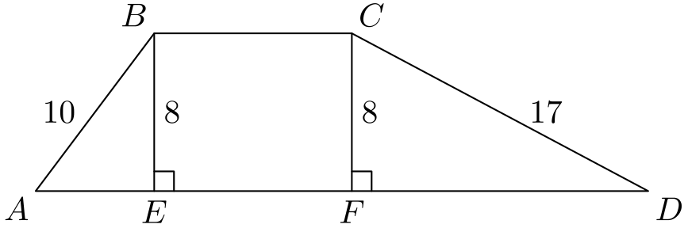
在左右两个直角三角形中，AE=√(10²-8²)=6，FD=√(17²-8²)=15。
两侧三角形面积分别为 1/2·6·8=24 和 1/2·15·8=60。中间长方形面积为 8· BC。
因此 164=24+60+8BC，所以 8BC=80，BC=10。
所以正确答案是B。
English
Drop perpendiculars from B and C to AD, meeting it at E and F.
In the left and right right triangles, AE=√(10²-8²)=6 and FD=√(17²-8²)=15.
The two side triangles have areas 1/2·6·8=24 and 1/2·15·8=60. The middle rectangle has area 8· BC.
Thus 164=24+60+8BC, so 8BC=80 and BC=10.
Thus,Bis the correct answer.
第 22 题 答案 C
在图形 A 中，阴影面积是一个 2 乘 2 正方形面积减去半径为 1 的圆面积，即 4-π。
图形 B 由四个边长为图形 A 一半的副本组成，所以每个副本的面积是原图的四分之一，总阴影面积也为 4-π。
在图形 C 中，圆的半径为 1，内接正方形的对角线为 2，所以其面积为 2。阴影面积为 π-2。
因为 π>3，所以 π-2>4-π，因此图形 C 的阴影面积最大。
所以正确答案是C。
English
In figure A, the shaded area is the area of a 2 by 2 square minus a circle of radius 1, so it is 4-π.
Figure B is made of four copies of figure A with half the side length, so each copy has one-fourth the area and the total shaded area is also 4-π.
In figure C, the circle has radius 1, and the inscribed square has diagonal 2, so its area is 2. The shaded area is π-2.
Since π>3, we have π-2>4-π, so figure C has the largest shaded area.
Thus,Cis the correct answer.
第 23 题 答案 A
猫的位置每 4 次移动重复一次，老鼠的位置每 8 次移动重复一次。
因为 247≡3pmod4，猫的位置与第 3 次移动后相同：在右下方正方形。
因为 247≡7pmod8，老鼠的位置与第 7 次移动后相同：在左下方正方形的左边。
所以正确答案是A。
English
The cat’s position repeats every 4 moves, and the mouse’s position repeats every 8 moves.
Since 247≡3pmod4, the cat is in the same position as after the 3rd move: the lower right square.
Since 247≡7pmod8, the mouse is in the same position as after the 7th move: the left side of the lower left square.
Thus,Ais the correct answer.
第 24 题 答案 B
从 A 到 B 的半圆路径上每一点到圆心 X 的距离都相同，所以图像一开始是水平的。
在从 B 到 C 的直线路径上，船先靠近 X，然后远离 X。
只有图 B 先保持水平，然后下降再上升。
所以正确答案是B。
English
Every point on the semicircular path from A to B is the same distance from the center X, so the graph starts horizontally.
On the straight path from B to C, the ship first gets closer to X and then farther away from X.
Only graph B starts flat and then decreases before increasing.
Thus,Bis the correct answer.
第 25 题 答案 C
正方形 WXYZ 的边长为 5 cm，因为 √(25) = 5。
WZ 到 BC 的距离是 2，因为它等于 2 个单位正方形的边长之和。
最后，A 到 BC 的距离等于 BC 到 O 的距离，即
2 + 5/2 = 9/2 cm。
现在可求 BC：
WZ - 2 = 5 - 2 = 3 cm。
因此 △ ABC 的面积为
1/2 · 3 · 9/2 = 27/4 cm²。
所以正确答案是C。
English
The side length of WXYZ is 5 cm, since √(25) = 5.
We also know that the distance from WZ to BC is 2 since it is the sum of the side lengths of 2 unit squares.
Finally, the distance from A to BC is the same as the distance from BC to O, which is
2 + 5/2 = 9/2 cm.
Now, we can find BC, which is
WZ - 2 = 5 - 2 = 3 cm.
Therefore, the area of △ ABC is
1/2 · 3 · 9/2 = 27/4 cm².
Thus,Cis the correct answer.

