2001 年 AMC 8 真题与解答
American Mathematics Competitions 8 · 中英双语
共 25 题，限时 40 分钟；单项选择题，每题 1 分，答错不扣分，满分 25 分。
编排说明：第一部分为题目（先中文、后英文原题），第二部分为解答与答案，便于先做题后对答案。
第一部分 题目
第 1 题
凯西的手工课正在制作一个高尔夫奖杯。他需要给一个高尔夫球上的 300 个凹点上色。如果给一个凹点上色需要 2 秒，他需要多少分钟完成这项工作？
（A）4 （B）6 （C）8 （D）10 （E）12
English
Casey’s shop class is making a golf trophy. He has to paint 300 dimples on a golf ball. If it takes him 2 seconds to paint one dimple, how many minutes will he need to do his job?
(A) 4 (B) 6 (C) 8 (D) 10 (E) 12
第 2 题
我想到了两个整数。它们的乘积是 24，和是 11。较大的数是多少？
（A）3 （B）4 （C）6 （D）8 （E）12
English
I’m thinking of two whole numbers. Their product is 24 and their sum is 11. What is the larger number?
(A) 3 (B) 4 (C) 6 (D) 8 (E) 12
第 3 题
史密斯奶奶有 $63。埃尔伯塔比安茹多 $2，而安茹的钱数是史密斯奶奶的三分之一。埃尔伯塔有多少美元？
（A）17 （B）18 （C）19 （D）21 （E）23
English
Granny Smith has $63. Elberta has $2 more than Anjou and Anjou has one-third as much as Granny Smith. How many dollars does Elberta have?
(A) 17 (B) 18 (C) 19 (D) 21 (E) 23
第 4 题
数字 1、2、3、4 和 9 各使用一次，组成尽可能小的偶数五位数。十位上的数字是
（A）1 （B）2 （C）3 （D）4 （E）9
English
The digits 1, 2, 3, 4, and 9 are each used once to form the smallest possibleevenfive-digit number. The digit in the tens place is
(A) 1 (B) 2 (C) 3 (D) 4 (E) 9
第 5 题
在一个漆黑的暴风雨夜，史努比突然看见一道闪电。十秒后他听到雷声。声速是每秒 1088 英尺，一英里是 5280 英尺。估计史努比距离闪电有多远，精确到最近的半英里。
（A）1 （B）11/2 （C）2 （D）21/2 （E）3
English
On a dark and stormy night Snoopy suddenly saw a flash of lightning. Ten seconds later he heard the sound of thunder. The speed of sound is 1088 feet per second and one mile is 5280 feet. Estimate, to the nearest half-mile, how far Snoopy was from the flash of lightning.
(A) 1 (B) 11/2 (C) 2 (D) 21/2 (E) 3
第 6 题
六棵树沿着一条直路的一侧等间距排列。第一棵树到第四棵树的距离是 60 英尺。第一棵树到最后一棵树之间的距离是多少英尺？
（A）90 （B）100 （C）105 （D）120 （E）140
English
Six trees are equally spaced along one side of a straight road. The distance from the first tree to the fourth is 60 feet. What is the distance in feet between the first and last trees?
(A) 90 (B) 100 (C) 105 (D) 120 (E) 140
第 7 题
第 7、8 和 9 题与这些风筝有关。
为了宣传学校一年一度的风筝奥林匹克活动，吉纳维芙为公告板展示制作了一个小风筝和一个大风筝。风筝形状如图。对于小风筝，吉纳维芙在一英寸方格纸上画风筝。对于大风筝，她将整个方格的高度和宽度都扩大为原来的三倍。
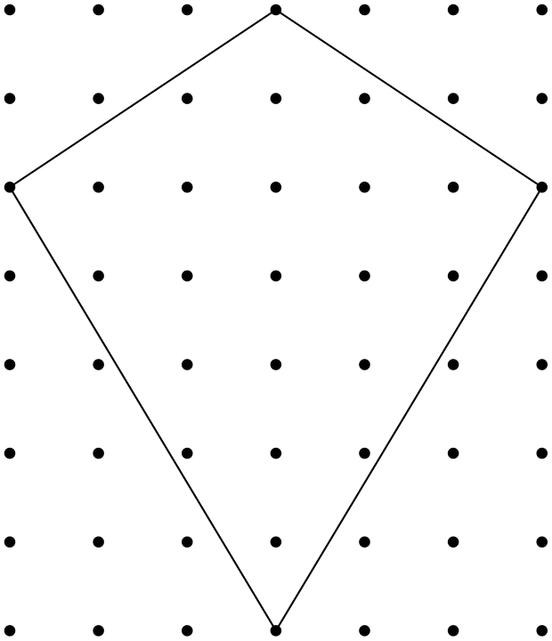
小风筝的面积是多少平方英寸？
（A）21 （B）22 （C）23 （D）24 （E）25
English
Problems 7, 8, and 9 are about these kites.
To promote her school’s annual Kite Olympics, Genevieve makes a small kite and a large kite for a bulletin board display. The kites look like the one in the diagram. For her small kite Genevieve draws the kite on a one-inch grid. For the large kite she triples both the height and width of the entire grid.
What is the number of square inches in the area of the small kite?
(A) 21 (B) 22 (C) 23 (D) 24 (E) 25
第 8 题
吉纳维芙在她的大风筝上加支撑条，形式是连接风筝相对顶点的十字。她需要多少英寸支撑材料？
（A）30 （B）32 （C）35 （D）38 （E）39
English
Genevieve puts bracing on her large kite in the form of a cross connecting opposite corners of the kite. How many inches of bracing material does she need?
(A) 30 (B) 32 (C) 35 (D) 38 (E) 39
第 9 题
大风筝要覆盖金箔。金箔从一张刚好覆盖整个方格的长方形纸上裁出。从四个角裁掉的废料有多少平方英寸？
（A）63 （B）72 （C）180 （D）189 （E）264
English
The large kite is covered with gold foil. The foil is cut from a rectangular piece that just covers the entire grid. How many square inches of waste material are cut off from the four corners?
(A) 63 (B) 72 (C) 180 (D) 189 (E) 264
第 10 题
一位收藏者提出按州纪念二十五分硬币面值的 2000% 购买。按这个价格，布赖登的四枚州纪念二十五分硬币能卖多少钱？
（A）$20 （B）$50 （C）$200 （D）$500 （E）$2000
English
A collector offers to buy state quarters for 2000% of their face value. At that rate how much will Bryden get for his four state quarters?
(A) $20 (B) $50 (C) $200 (D) $500 (E) $2000
第 11 题
点 A、B、C 和 D 的坐标分别为 A(3,2)、B(3,-2)、C(-3,-2) 和 D(-3,0)。四边形 ABCD 的面积是多少？
（A）12 （B）15 （C）18 （D）21 （E）24
English
Points A, B, C and D have these coordinates: A(3,2), B(3,-2), C(-3,-2) and D(-3,0). What is the area of quadrilateral ABCD?
(A) 12 (B) 15 (C) 18 (D) 21 (E) 24
第 12 题
如果
a otimes b = (a + b)/(a - b)，
那么
(6 otimes 4) otimes 3 =
（A）4 （B）13 （C）15 （D）30 （E）72
English
If
a otimes b = (a + b)/(a - b),
then
(6 otimes 4) otimes 3 =
(A) 4 (B) 13 (C) 15 (D) 30 (E) 72
第 13 题
瑞雪尔班上有 36 名学生，其中 12 人喜欢巧克力派，8 人喜欢苹果派，6 人喜欢蓝莓派。剩下的学生中一半喜欢樱桃派，一半喜欢柠檬派。瑞雪尔用这些数据画扇形统计图时，樱桃派应占多少度？
（A）10 （B）20 （C）30 （D）50 （E）72
English
Of the 36 students in Richelle’s class, 12 prefer chocolate pie, 8 prefer apple, and 6 prefer blueberry. Half of the remaining students prefer cherry pie and half prefer lemon. For Richelle’s pie graph showing this data, how many degrees should she use for cherry pie?
(A) 10 (B) 20 (C) 30 (D) 50 (E) 72
第 14 题
泰勒进入一条自助餐队伍，他要选择一种肉、两种不同的蔬菜和一种甜点。如果食物选择的顺序不重要，他可能选择多少种不同的餐食？
肉类：牛肉、鸡肉、猪肉
蔬菜：烤豆、玉米、土豆、番茄
甜点：布朗尼、巧克力蛋糕、巧克力布丁、冰淇淋
（A）4 （B）24 （C）72 （D）80 （E）144
English
Tyler has entered a buffet line in which he chooses one kind of meat, two different vegetables and one dessert. If the order of food items is not important, how many different meals might he choose?
Meat: beef, chicken, pork
Vegetables: baked beans, corn, potatoes, tomatoes
Dessert: brownies, chocolate cake, chocolate pudding, ice cream
(A) 4 (B) 24 (C) 72 (D) 80 (E) 144
第 15 题
荷马开始以每分钟削 3 个土豆的速度削一堆 44 个土豆。四分钟后克里斯滕加入，以每分钟削 5 个土豆的速度削。完成时，克里斯滕削了多少个土豆？
（A）20 （B）24 （C）32 （D）33 （E）40
English
Homer began peeling a pile of 44 potatoes at the rate of 3 potatoes per minute. Four minutes later Christen joined him and peeled at the rate of 5 potatoes per minute. When they finished, how many potatoes had Christen peeled?
(A) 20 (B) 24 (C) 32 (D) 33 (E) 40
第 16 题
一张边长 4 英寸的正方形纸沿竖直方向对折。然后将两层纸沿平行于折痕的方向切成两半。形成三个新的长方形：一个大的和两个小的。一个小长方形的周长与大长方形周长之比是多少？
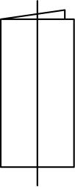
（A）1/3 （B）1/2 （C）3/4 （D）4/5 （E）5/6
English
A square piece of paper, 4 inches on a side, is folded in half vertically. Both layers are then cut in half parallel to the fold. Three new rectangles are formed, a large one and two small ones. What is the ratio of the perimeter of one of the small rectangles to the perimeter of the large rectangle?
(A) 1/3 (B) 1/2 (C) 3/4 (D) 4/5 (E) 5/6
第 17 题
游戏节目《谁想成为百万富翁？》中每道题的奖金如下表所示（其中 K=1000）。
boldsymbol# | 1 | 2 | 3
boldsymbol$ | 100 | 200 | 300

4 | 5 | 6 | 7 | 8
500 | 1K | 2K | 4K | 8K

9 | 10 | 11 | 12
16K | 32K | 64K | 125K

13 | 14 | 15
250K | 500K | 1000K

哪两道题之间奖金的百分比增加最小？
（A）从 1 到 2 （B）从 2 到 3 （C）从 3 到 4 （D）从 11 到 12 （E）从 14 到 15
English
For the game showWho Wants To Be a Millionaire?the dollar values of each question are shown in the following table (where K=1000).
boldsymbol# | 1 | 2 | 3
boldsymbol$ | 100 | 200 | 300

4 | 5 | 6 | 7 | 8
500 | 1K | 2K | 4K | 8K

9 | 10 | 11 | 12
16K | 32K | 64K | 125K

13 | 14 | 15
250K | 500K | 1000K

Between which two questions is the percent increase of the value the smallest?
(A) From 1 to 2 (B) From 2 to 3 (C) From 3 to 4 (D) From 11 to 12 (E) From 14 to 15
第 18 题
掷两个骰子。两个点数的乘积是 5 的倍数的概率是多少？
（A）1/36 （B）1/18 （C）1/6 （D）11/36 （E）1/3
English
Two dice are thrown. What is the probability that the product of the two numbers is a multiple of 5?
(A) 1/36 (B) 1/18 (C) 1/6 (D) 11/36 (E) 1/3
第 19 题
汽车 M 以恒定速度行驶了一段给定时间，如虚线所示。汽车 N 以两倍速度行驶相同距离。如果用实线表示汽车 N 的速度和时间，哪张图表示这种情况？
（A）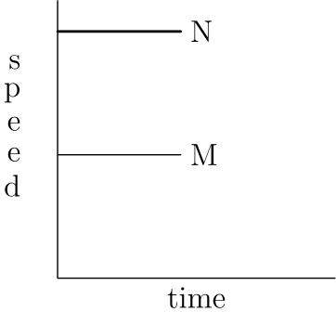
（B）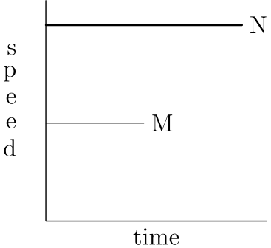
（C）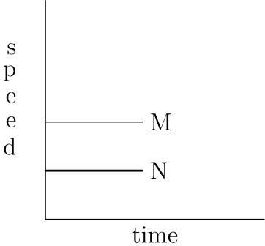
（D）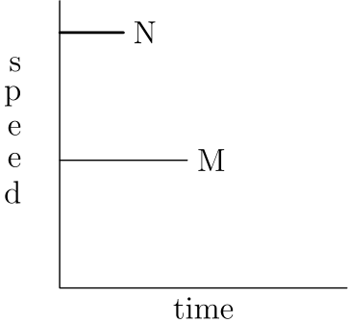
（E）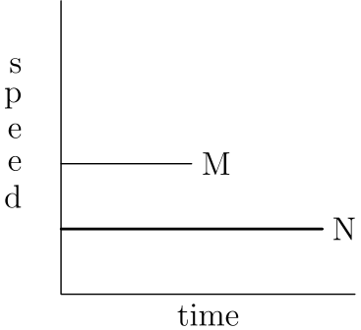
English
Car M traveled at a constant speed for a given time. This is shown by the dashed line. Car N traveled at twice the speed for the same distance. If Car N’s speed and time are shown as a solid line, which graph illustrates this?
(A)
(B)
(C)
(D)
(E)
第 20 题
卡莱安娜把自己的考试分数给奎伊、马蒂和莎娜看，但其他人都把自己的分数藏起来。奎伊想：“我们中至少有两个人分数相同。”马蒂想：“我不是最低分。”莎娜想：“我不是最高分。”按从低到高列出马蒂（M）、奎伊（Q）和莎娜（S）的分数。
（A）S,Q,M （B）Q,M,S （C）Q,S,M （D）M,S,Q （E）S,M,Q
English
Kaleana shows her test score to Quay, Marty and Shana, but the others keep theirs hidden. Quay thinks, “At least two of us have the same score.” Marty thinks, “I didn’t get the lowest score.” Shana thinks, “I didn’t get the highest score.” List the scores from lowest to highest for Marty (M), Quay (Q) and Shana (S).
(A) S,Q,M (B) Q,M,S (C) Q,S,M (D) M,S,Q (E) S,M,Q
第 21 题
一组五个互不相同的正整数的平均数是 15，中位数是 18。这五个整数中最大数的最大可能值是
（A）19 （B）24 （C）32 （D）35 （E）40
English
The mean of a set of five different positive integers is 15. The median is 18. The maximum possible value of the largest of these five integers is
(A) 19 (B) 24 (C) 32 (D) 35 (E) 40
第 22 题
在一场二十道题的测试中，每答对一题得 5 分，未作答一题得 1 分，答错一题得 0 分。下列哪个分数不可能出现？
（A）90 （B）91 （C）92 （D）95 （E）97
English
On a twenty-question test, each correct answer is worth 5 points, each unanswered question is worth 1 point and each incorrect answer is worth 0 points. Which of the following scores isNOTpossible?
(A) 90 (B) 91 (C) 92 (D) 95 (E) 97
第 23 题
点 R、S 和 T 是一个等边三角形的顶点，点 X、Y 和 Z 是它各边的中点。用这六个点中的任意三个作为顶点，可以画出多少个互不全等的三角形？
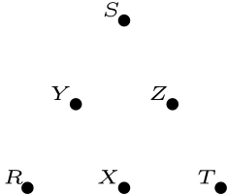
（A）1 （B）2 （C）3 （D）4 （E）20
English
Points R, S and T are vertices of an equilateral triangle, and points X, Y and Z are midpoints of its sides. How many noncongruent triangles can be drawn using any three of these six points as vertices?
(A) 1 (B) 2 (C) 3 (D) 4 (E) 20
第 24 题
这个图形的每一半都由 3 个红三角形、5 个蓝三角形和 8 个白三角形组成。当上半部分沿中心线向下折叠时，2 对红三角形重合，3 对蓝三角形也重合。有 2 对红白三角形重合。多少对白三角形重合？
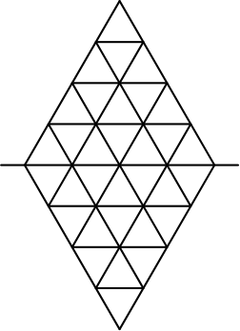
（A）4 （B）5 （C）6 （D）7 （E）9
English
Each half of this figure is composed of 3 red triangles, 5 blue triangles and 8 white triangles. When the upper half is folded down over the centerline, 2 pairs of red triangles coincide, as do 3 pairs of blue triangles. There are 2 red-white pairs. How many white pairs coincide?
(A) 4 (B) 5 (C) 6 (D) 7 (E) 9
第 25 题
有 24 个四位整数，每个都恰好使用数字 2，4，5 和 7 各一次。这些四位数中，只有一个是另一个的倍数。下列哪一个是这个倍数？
（A）5724 （B）7245 （C）7254 （D）7425 （E）7542
English
There are 24 four-digit whole numbers that use each of the four digits 2, 4, 5, and 7 exactly once. Only one of these four-digit numbers is a multiple of another one. Which of the following is it?
(A) 5724 (B) 7245 (C) 7254 (D) 7425 (E) 7542

第二部分 解答
答案速查：
题号 1 2 3 4 5 6 7 8 9
答案 D D E E C B A E D
题号 10 11 12 13 14 15 16 17 18
答案 A C A D C A E B D
题号 19 20 21 22 23 24 25
答案 D A D E D B D
答案串：DDEECBAEDACADCAEBDDADEDBD
第 1 题 答案 D
凯西完成工作需要 2·300=600 秒。因为 60 秒等于一分钟，所以这是 600÷60=10 分钟。
所以正确答案是D。
English
It will take Casey 2·300=600 seconds to do the job. Since 60 seconds make one minute, this is 600÷60=10 minutes.
Thus,Dis the correct answer.
第 2 题 答案 D
24 的因数对为 (1,24)、(2,12)、(3,8) 和 (4,6)。
唯一和为 11 的因数对是 (3,8)，所以较大的数是 8。
所以正确答案是D。
English
The factor pairs of 24 are (1,24), (2,12), (3,8), and (4,6).
The only pair with sum 11 is (3,8), so the larger number is 8.
Thus,Dis the correct answer.
第 3 题 答案 E
安茹有 $63÷3=$21。埃尔伯塔比安茹多 $2，所以埃尔伯塔有 $21+$2=$23。
所以正确答案是E。
English
Anjou has $63÷3=$21. Elberta has $2 more than Anjou, so Elberta has $21+$2=$23.
Thus,Eis the correct answer.
第 4 题 答案 E
个位数字必须是 2 或 4。若个位是 2，把其余数字按尽可能小的顺序排列，得到 13492。若个位是 4，最小的排列是 12394，它更小。因此最小的偶数是 12394，其十位数字是 9。
所以正确答案是E。
English
The units digit must be 2 or 4. If it is 2, arranging the remaining digits as small as possible gives 13492. If it is 4, the smallest arrangement is 12394, which is smaller. Therefore the smallest even number is 12394, whose tens digit is 9.
Thus,Eis the correct answer.
第 5 题 答案 C
在 10 秒内，雷声传播了 10 · 1088 = 10880 英尺。
2 英里约为 2 · 5280 = 10560 英尺，接近上面的距离。
所以正确答案是C。
English
In 10 seconds, the thunder was able to travel 10 · 1088 = 10880 feet.
Note that 2 miles is about 2 · 5280 = 10560 feet, which is close to what we found above.
Thus,Cis the correct answer.
第 6 题 答案 B
第一棵和第四棵之间有 3 个间隔，因此每个间隔长 60 ÷ 3 = 20 英尺。
第一棵和最后一棵之间有 5 个间隔，所以它们相距 5 · 20 = 100 英尺。
所以正确答案是B。
English
There are 3 gaps between the first and fourth trees, which means that one gap is 60 ÷ 3 = 20 feet long.
There are 5 gaps between the first and last trees. This means that they are 5 · 20 = 100 feet apart.
Thus,Bis the correct answer.
第 7 题 答案 A
风筝面积等于两条对角线的乘积除以 2。
因此小风筝面积为
(6 · 7)/2 = 42/2 = 21。
所以正确答案是A。
English
Recall that the area of a kite is the product of its diagonals divided by 2.
Therefore, the area of the small kite is
(6 · 7)/2 = 42/2 = 21.
Thus,Ais the correct answer.
第 8 题 答案 E
长对角线是 7 个单位，短对角线是 6 个单位。
在大风筝中，一个单位为 3 英寸，所以需要的支撑材料总长为
3(7 + 6) = 3 · 13 = 39。
所以正确答案是E。
English
The long diagonal is 7 units, and the short one is 6 units.
In the large kite, one unit is 3 inches, so the total amount of bracing material needed is
3(7 + 6) = 3 · 13 = 39.
Thus,Eis the correct answer.
第 9 题 答案 D
整个方格的面积是
3 · 7 · 3 · 6 = 378。
由风筝面积公式，风筝面积是这个面积的一半，所以废料面积为 378 ÷ 2 = 189。
所以正确答案是D。
English
The area of the entire grid would be
3 · 7 · 3 · 6 = 378.
The area of the kite is one-half this area from the formula for the area of the kite, so the wasted material is 378 ÷ 2 = 189.
Thus,Dis the correct answer.
第 10 题 答案 A
四枚州纪念二十五分硬币的面值为 $1。
因为 2000%=20，收藏者支付面值的 20 倍，也就是 $20。
所以正确答案是A。
English
Four state quarters have face value $1.
Since 2000%=20, the collector pays 20 times face value, or $20.
Thus,Ais the correct answer.
第 11 题 答案 C
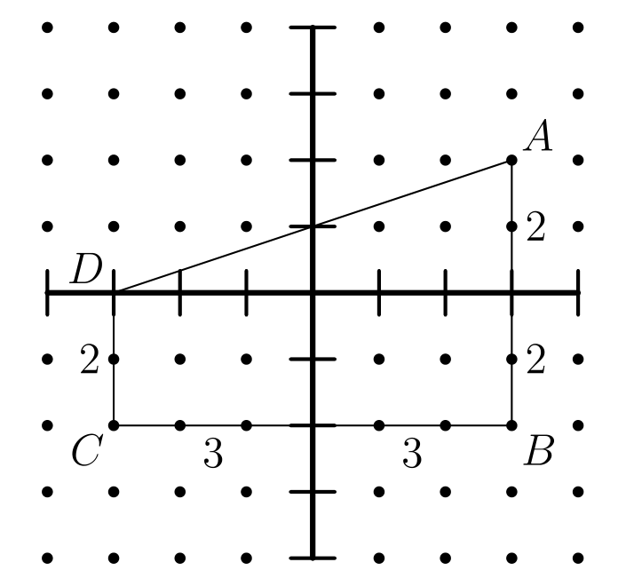
因为 DC ∥ AB，所以 ABCD 是梯形。
梯形面积公式为
A = 1/2 (b₁ + b₂) h。
代入
b₁ = DC = 2、
b₂ = AB = 4
和
h = CB = 6，
可得
A = 1/2 (2 + 4) · 6
= 1/2 · 6 · 6 = 18。
所以正确答案是C。
English
We can see that ABCD is a trapezoid since DC ∥ AB.
Recall that the formula for the area of a trapezoid is
A = 1/2 (b₁ + b₂) h.
Plugging in
b₁ = DC = 2,
b₂ = AB = 4,
and
h = CB = 6,
we get that
A = 1/2 (2 + 4) · 6
= 1/2 · 6 · 6 = 18.
Thus,Cis the correct answer.
第 12 题 答案 A
计算如下：
(6 otimes 4) otimes 3 = (6 + 4)/(6 - 4) otimes 3
= 5 otimes 3
= (5 + 3)/(5 - 3)
= 4
。
所以正确答案是A。
English
We can evaluate it as follows
(6 otimes 4) otimes 3 = (6 + 4)/(6 - 4) otimes 3
= 5 otimes 3
= (5 + 3)/(5 - 3)
= 4.
Thus,Ais the correct answer.
第 13 题 答案 D
喜欢樱桃派或柠檬派的学生数为
36 - 12 - 8 - 6 = 10。
其中一半喜欢樱桃派，即 10 ÷ 2 = 5 人。
樱桃派对应的角度为
360° · 5/36 = 5 · 10° = 50°。
所以正确答案是D。
English
The number of students that prefer cherry or lemon pie is
36 - 12 - 8 - 6 = 10.
Half of these like cherry pie, which is 10 ÷ 2 = 5.
The number of degrees for cherry pie would then be
360° · 5/36 = 5 · 10° = 50°.
Thus,Dis the correct answer.
第 14 题 答案 C
他有 3 种肉类选择和 4 种甜点选择。
他必须从 4 种蔬菜中选 2 种。因为顺序不重要，蔬菜选择有 (4·3)/2=6 种。
因此可能的餐食数为 3·6·4=72。
所以正确答案是C。
English
He has 3 choices for the meat and 4 choices for dessert.
He must choose 2 of the 4 vegetables. Since order does not matter, there are (4·3)/2=6 vegetable choices.
This gives 3·6·4=72 possible meals.
Thus,Cis the correct answer.
第 15 题 答案 A
克里斯滕加入时，荷马已经削了 3 · 4 = 12 个土豆，还剩 44 - 12 = 32 个。
荷马和克里斯滕合起来每分钟削 5 + 3 = 8 个土豆，因此还需要 32 ÷ 8 = 4 分钟削完剩下的。
4 分钟内，克里斯滕削了 4 · 5 = 20 个土豆。
所以正确答案是A。
English
Homer had peeled 3 · 4 = 12 potatoes by the time Christen joined him, leaving 44 - 12 = 32 potatoes.
Together, Homer and Christen peel 5 + 3 = 8 potatoes per minute, taking them 32 ÷ 8 = 4 minutes to peel the rest.
In 4 minutes, Christen peeled 4 · 5 = 20 potatoes.
Thus,Ais the correct answer.
第 16 题 答案 E
正方形对折后形成一个 4×2 的长方形。
将折叠后的纸沿平行于折痕的方向切成两半，得到两个 4×1 的小长方形和一个 4×2 的大长方形。
一个小长方形周长与大长方形周长之比为
(2(4+1))/(2(4+2))=10/12=5/6。
所以正确答案是E。
English
The square is folded in half to create a 4×2 rectangle.
Cutting the folded paper in half parallel to the fold gives two small 4×1 rectangles and one large 4×2 rectangle.
The ratio of the perimeter of a small rectangle to the perimeter of the large rectangle is
(2(4+1))/(2(4+2))=10/12=5/6.
Thus,Eis the correct answer.
第 17 题 答案 B
列出的多数增加都是翻倍，也就是增加 100%。
在选项中，例外是从 2 到 3、从 3 到 4、以及从 11 到 12。
这些百分比增加分别是 300-200/200=50%，500-300/300=662/3%，以及 125000-64000/64000，约为 95%。
最小的是从第 2 题到第 3 题。
所以正确答案是B。
English
Most of the listed increases are doublings, which are 100% increases.
The exceptions among the answer choices are from 2 to 3, from 3 to 4, and from 11 to 12.
These percent increases are 300-200/200=50%, 500-300/300=662/3%, and 125000-64000/64000, which is about 95%.
The smallest is from question 2 to question 3.
Thus,Bis the correct answer.
第 18 题 答案 D
乘积是 5 的倍数的唯一方法是至少一个骰子掷出 5。
用补集计数。两个骰子都不掷出 5 的概率是
5/6 · 5/6 = 25/36。
因此至少一个骰子掷出 5 的概率为
1 - 25/36 = 11/36。
所以正确答案是D。
English
The only way for the product to be a multiple of 5 is if at least one of the rolls is 5.
We can do complementary counting. The probability that neither rolls is a 5 is
5/6 · 5/6 = 25/36.
Therefore, the probability that at least one roll is a 5 is
1 - 25/36 = 11/36.
Thus,Dis the correct answer.
第 19 题 答案 D
汽车 N 的速度是汽车 M 的两倍，所以它在速度轴上的高度应是汽车 M 的两倍。
因为汽车 N 以更快速度行驶与汽车 M 相同的距离，所以它用一半时间完成行程。
因此表示汽车 N 速度的线段长度是表示汽车 M 速度的线段长度的一半。
两条线都水平，因为速度恒定。查看给出的图，唯一满足条件的是图D。
所以正确答案是D。
English
Car N travels at twice the speed of car M, so it is represented by a point that is twice as high on the speed axis as car M.
Since car N travels at the same distance as car M but at a faster speed, it takes half the time to complete the trip.
Therefore, the line representing car N’s speed is half the length of the line representing car M’s speed.
Both lines are horizontal because the speeds are constant. Examining the given graphs, the only one that meets these conditions is graphD.
Thus,Dis the correct answer.
第 20 题 答案 A
因为奎伊只知道卡莱安娜的分数，所以奎伊和卡莱安娜的分数相同，即 K = Q。
马蒂知道他的分数高于卡莱安娜，所以 M > K。莎娜知道她的分数低于卡莱安娜，所以 S < K。
用 Q 替换 K，得到 S < Q < M。
所以正确答案是A。
English
Since Quay only knows Kaleana’s score, we get that Quay and Kaleana have the same score, so K = Q.
Marty knows that his score is higher than Kaleana’s, so M > K. Shana knows that her score is lower than Kaleana’s, so S < K.
Substituting Q for K, we get the following inequality: S < Q < M.
Thus,Ais the correct answer.
第 21 题 答案 D
中位数是第三大的数，即 18。有两个数小于 18，两个数大于它。
平均数为 15，所以五个数的和为 5 · 15 = 75。要在这个总和下使最大数尽量大，其余数必须尽量小。
小于 18 的两个数必须是不同的正整数，所以最小为 1 和 2。
紧接在 18 后的数也应尽量小，所以是 19。
因此剩下的数，也就是最大可能值，为
75 - 1 - 2 - 18 - 19 = 35。
所以正确答案是D。
English
The median of the set of numbers is the third largest number, which is 18. There are two numbers less than 18 and two numbers greater than it.
The mean of the set is 15, so the sum of all the numbers is 5 · 15 = 75. In order to maximize the largest number with this sum, the other numbers must be as small as possible.
The two numbers less than 18 must be positive and distinct, so they must be 1 and 2.
The number immediately after 18 must also be as small as possible, so it must be 19.
Therefore, the remaining number, the maximum possible value in the set, is
75 - 1 - 2 - 18 - 19 = 35.
Thus,Dis the correct answer.
第 22 题 答案 E
答对 20 题时，分数是 100。
答对 19 题时，根据剩下一题是答错还是未作答，分数是 95 或 96。
答对 18 题时，剩下两题可以贡献 0、1 或 2 分，所以可得 90、91 或 92。
因此列出的分数 90,91,92,95 都可能，而 97 不可能。
所以正确答案是E。
English
With 20 correct answers, the score is 100.
With 19 correct answers, the score is either 95 or 96, depending on whether the remaining question is incorrect or unanswered.
With 18 correct answers, the remaining two questions can contribute 0, 1, or 2 points, giving 90, 91, or 92.
Thus the listed scores 90,91,92,95 are possible, while 97 is not.
Thus,Eis the correct answer.
第 23 题 答案 D
以小等边三角形的边长为一个单位，可能的三角形边长模式有：
边长为 2,2,2 的等边三角形；边长为 1,1,1 的等边三角形；边长为 1,1,√(3) 的小等腰三角形；以及边长为 1,√(3),2 的较大等腰三角形。
这四种模式都在图中出现，而且由对称性可知，用六个点中任意三个形成的三角形都属于其中一种。
因此有 4 个互不全等的三角形。
所以正确答案是D。
English
Using the side length of the small equilateral triangles as one unit, the possible triangle side-length patterns are:
equilateral with sides 2,2,2; equilateral with sides 1,1,1; small isosceles with sides 1,1,√(3); and larger isosceles with sides 1,√(3),2.
These four patterns all occur in the figure, and symmetry shows every triangle formed by three of the six points matches one of them.
Thus there are 4 noncongruent triangles.
Thus,Dis the correct answer.
第 24 题 答案 B
每一半都有 3 个红、5 个蓝和 8 个白三角形。
2 对红红配对各使用每一半中的 2 个红三角形，所以每一半剩下的一个红三角形用于 2 对红白配对。于是所有红三角形都已计算。
3 对蓝蓝配对各使用每一半中的 3 个蓝三角形，每一半还剩 2 个蓝三角形。由于没有更多蓝蓝配对，这 4 个蓝三角形必须与白三角形配对。
所以每一半中，1 个白三角形与红色配对，2 个白三角形与蓝色配对，剩下 8-3=5 个白三角形与白三角形配对。
所以正确答案是B。
English
Each half has 3 red, 5 blue, and 8 white triangles.
The 2 red-red pairs use 2 red triangles from each half, so the remaining red triangle from each half is used in the 2 red-white pairs. Thus all red triangles are accounted for.
The 3 blue-blue pairs use 3 blue triangles from each half, leaving 2 blue triangles from each half. Since no more blue-blue pairs occur, those 4 blue triangles must pair with white triangles.
So on each half, 1 white is used with red and 2 whites are used with blue, leaving 8-3=5 white triangles to pair with white triangles.
Thus,Bis the correct answer.
第 25 题 答案 D
一个在 4000、5000 或 7000 范围内的数乘以 2 或更大的数后，不可能仍是这些四位排列之一。因此较小的数必须以 2 开头，较大的数必须是它的两倍或三倍。
对于两倍，只有以 4 结尾的选项可能。但 5724/2=2862，7254/2=3627，都没有恰好使用数字 2,4,5,7。
对于三倍，可能的选项是能被 3 整除的 7245,7425,7542。分别除以三得到 2415,2475,2514，只有 2475 恰好使用所需数字。
因此 7425=3·2475 是唯一列出的倍数。
所以正确答案是D。
English
A number in the 4000, 5000, or 7000 range cannot be multiplied by 2 or more and remain one of the given four-digit permutations. So the smaller number must start with 2, and the larger number must be either double or triple it.
For doubles, only answer choices ending in 4 can work. But 5724/2=2862 and 7254/2=3627, neither of which uses exactly the digits 2,4,5,7.
For triples, the possible answer choices are those divisible by 3: 7245,7425,7542. Dividing gives 2415,2475,2514, and only 2475 uses exactly the required digits.
Therefore 7425=3·2475 is the unique listed multiple.
Thus,Dis the correct answer.

