2000 年 AMC 8 真题与解答
American Mathematics Competitions 8 · 中英双语
共 25 题，限时 40 分钟；单项选择题，每题 1 分，答错不扣分，满分 25 分。
编排说明：第一部分为题目（先中文、后英文原题），第二部分为解答与答案，便于先做题后对答案。
第一部分 题目
第 1 题
Anna 阿姨 42 岁。Caitlin 比 Brianna 小 5 岁，而 Brianna 的年龄是 Anna 阿姨的一半。Caitlin 几岁？
（A）15 （B）16 （C）17 （D）21 （E）37
English
Aunt Anna is 42 years old. Caitlin is 5 years younger than Brianna, and Brianna is half as old as Aunt Anna. How old is Caitlin?
(A) 15 (B) 16 (C) 17 (D) 21 (E) 37
第 2 题
下列哪个数小于它的倒数？
（A）-2 （B）-1 （C）0 （D）1 （E）2
English
Which of these numbers is less than its reciprocal?
(A) -2 (B) -1 (C) 0 (D) 1 (E) 2
第 3 题
在 5/3 和 2π 之间有多少个整数？
（A）2 （B）3 （C）4 （D）5 （E）无限多个
English
How many whole numbers lie in the interval between 5/3 and 2π?
(A) 2 (B) 3 (C) 4 (D) 5 (E) infinitely many
第 4 题
1960 年，卡林市只有 5% 的在职成年人在家工作。到 1970 年，在家工作的劳动力增加到 8%。1980 年约有 15% 在家工作，1990 年有 30%。最能表示这些数据的图是
（A）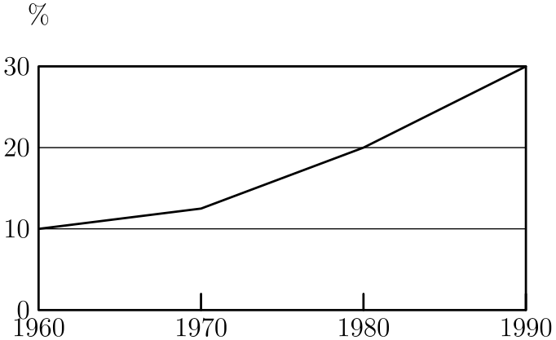
（B）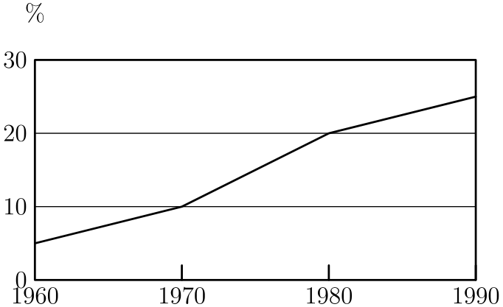
（C）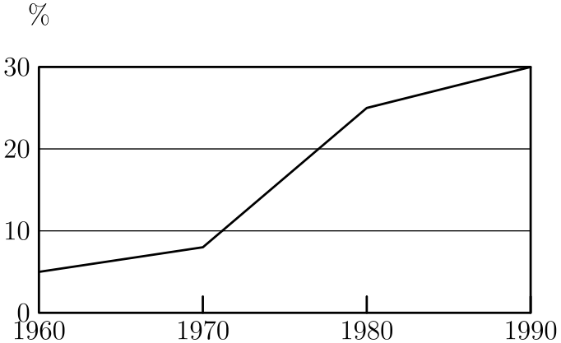
（D）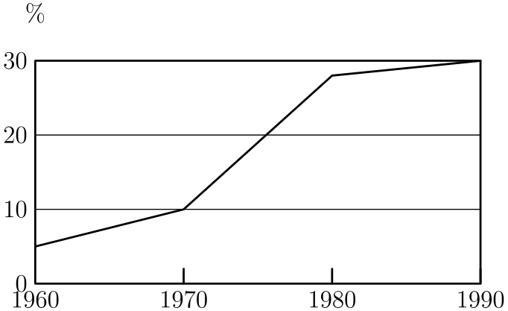
（E）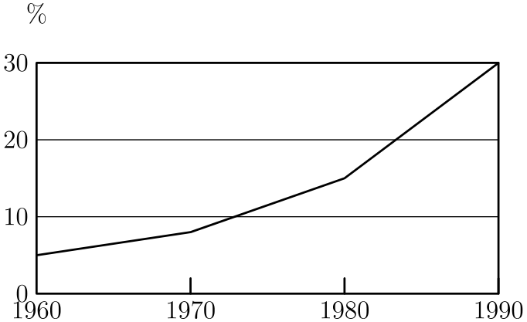
English
In 1960 only 5% of the working adults in Carlin City worked at home. By 1970 the “at-home” work force had increased to 8%. In 1980 there were approximately 15% working at home, and in 1990 there were 30%. The graph that best illustrates this is
(A)
(B)
(C)
(D)
(E)
第 5 题
Lincoln High School 的每位校长任期恰好为 3 年。在一段 8 年期间，这所学校最多可能有多少位校长？
（A）2 （B）3 （C）4 （D）5 （E）8
English
Each principal of Lincoln High School serves exactly one 3-year term. What is the maximum number of principals this school could have during an 8-year period?
(A) 2 (B) 3 (C) 4 (D) 5 (E) 8
第 6 题
图形 ABCD 是一个正方形。在这个正方形内画了三个较小的正方形，其边长如图所示。阴影的 L 形区域面积是
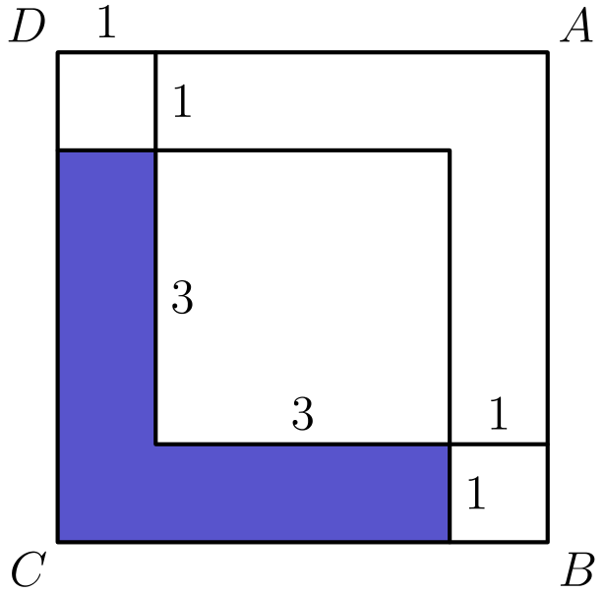
（A）7 （B）10 （C）12.5 （D）14 （E）15
English
Figure ABCD is a square. Inside this square three smaller squares are drawn with side lengths as labeled. The area of the shaded L-shaped region is
(A) 7 (B) 10 (C) 12.5 (D) 14 (E) 15
第 7 题
从下面的集合中取三个不同的数，它们的乘积最小可能是多少？这个集合是
{-8,-6,-4,0,3,5,7}。
（A）-336 （B）-280 （C）-210 （D）-192 （E）0
English
What is the minimum possible product of three different numbers of the set
{-8,-6,-4,0,3,5,7}?
(A) -336 (B) -280 (C) -210 (D) -192 (E) 0
第 8 题
三个面上编号为 1 到 6 的骰子如图堆叠。十八个面中有七个面可见，剩下十一个面被隐藏（背面、底面、相接面）。从这个视角看不到的点数总和是
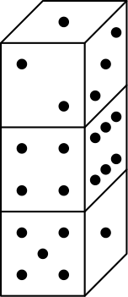
（A）21 （B）22 （C）31 （D）41 （E）53
English
Three dice with faces numbered 1 through 6 are stacked as shown. Seven of the eighteen faces are visible, leaving eleven faces hidden (back, bottom, between). The total number of dots NOT visible in this view is
(A) 21 (B) 22 (C) 31 (D) 41 (E) 53
第 9 题
这个“数字填字”题中使用了三位数的 2 的幂和 5 的幂。带框方格中唯一可能的数字是什么？
横向 |  | 纵向
2. 2ᵐ |  | 1. 5ⁿ

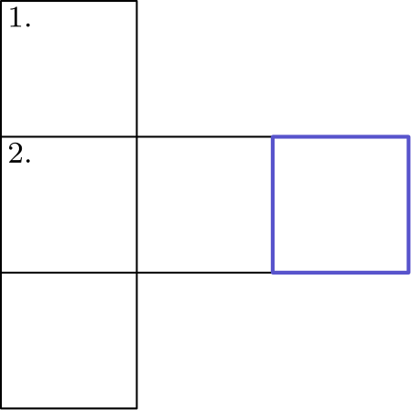
（A）0 （B）2 （C）4 （D）6 （E）8
English
Three-digit powers of 2 and 5 are used in this “cross-number” puzzle. What is the only possible digit for the outlined square?
ACROSS |  | DOWN
2. 2ᵐ |  | 1. 5ⁿ

(A) 0 (B) 2 (C) 4 (D) 6 (E) 8
第 10 题
Ara 和 Shea 曾经一样高。此后 Shea 长高了 20%，而 Ara 长高的英寸数是 Shea 的一半。Shea 现在高 60 英寸。Ara 现在高多少英寸？
（A）48 （B）51 （C）52 （D）54 （E）55
English
Ara and Shea were once the same height. Since then Shea has grown 20% while Ara has grown half as many inches as Shea. Shea is now 60 inches tall. How tall, in inches, is Ara now?
(A) 48 (B) 51 (C) 52 (D) 54 (E) 55
第 11 题
数 64 有一个性质：它能被自己的个位数字整除。10 到 50 之间有多少个整数具有这个性质？
（A）15 （B）16 （C）17 （D）18 （E）20
English
The number 64 has the property that it is divisible by its unit digit. How many whole numbers between 10 and 50 have this property?
(A) 15 (B) 16 (C) 17 (D) 18 (E) 20
第 12 题
要建造一面长 100 英尺、高 7 英尺的砌块墙，使用的砌块高 1 英尺，长度可以是 2 英尺或 1 英尺（不得切割砌块）。砌块的竖缝必须如图所示错开，且墙两端必须齐平。建造这面墙最少需要多少块砌块？
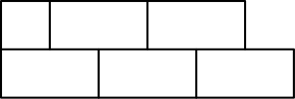
（A）344 （B）347 （C）350 （D）353 （E）356
English
A block wall 100 feet long and 7 feet high will be constructed using blocks that are 1 foot high and either 2 feet long or 1 foot long (no blocks may be cut). The vertical joins in the blocks must be staggered as shown, and the wall must be even on the ends. What is the smallest number of blocks needed to build this wall?
(A) 344 (B) 347 (C) 350 (D) 353 (E) 356
第 13 题
在三角形 CAT 中，∠ ACT =∠ ATC，且 ∠ CAT = 36°。如果 TR 平分 ∠ ATC，那么 ∠ CRT =
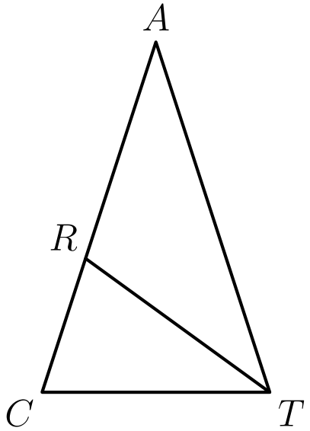
（A）16° （B）51° （C）72° （D）90° （E）108°
English
In triangle CAT, we have ∠ ACT =∠ ATC and ∠ CAT = 36°. If TR bisects ∠ ATC, then ∠ CRT =
(A) 16° (B) 51° (C) 72° (D) 90° (E) 108°
第 14 题
19¹⁹ + 99⁹⁹ 的个位数字是多少？
（A）0 （B）1 （C）2 （D）8 （E）9
English
What is the units digit of 19¹⁹ + 99⁹⁹?
(A) 0 (B) 1 (C) 2 (D) 8 (E) 9
第 15 题
三角形 ABC、ADE 和 EFG 都是等边三角形。点 D 和 G 分别是 AC 和 AE 的中点。如果 AB = 4，图形 ABCDEFG 的周长是多少？
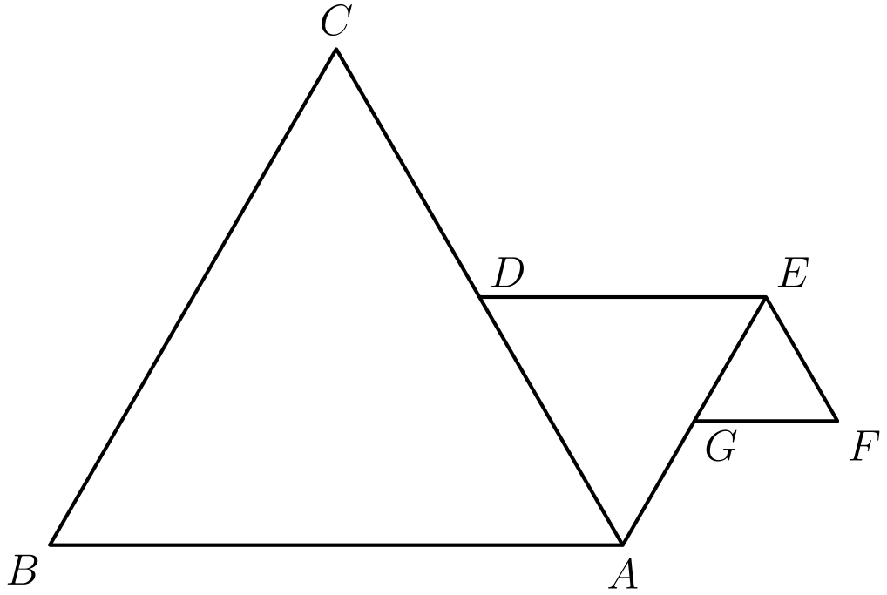
（A）12 （B）13 （C）15 （D）18 （E）21
English
Triangles ABC, ADE, and EFG are all equilateral. Points D and G are midpoints of AC and AE, respectively. If AB = 4, what is the perimeter of figure ABCDEFG?
(A) 12 (B) 13 (C) 15 (D) 18 (E) 21
第 16 题
为了在他的长方形后院里走一千米（1000 米），Mateen 必须沿着长走 25 次，或者沿着周长走 10 次。Mateen 后院的面积是多少平方米？
（A）40 （B）200 （C）400 （D）500 （E）1000
English
In order for Mateen to walk a kilometer (1000 meters) in his rectangular backyard, he must walk the length 25 times or walk its perimeter 10 times. What is the area of Mateen’s backyard in square meters?
(A) 40 (B) 200 (C) 400 (D) 500 (E) 1000
第 17 题
对所有非零数，运算 otimes 定义为
aotimes b =a²/b。
求
[(1otimes 2)otimes 3]-[1otimes (2otimes 3)]。
（A）-2/3 （B）-1/4 （C）0 （D）1/4 （E）2/3
English
The operation otimes is defined for all nonzero numbers by
aotimes b =a²/b.
Determine
[(1otimes 2)otimes 3]-[1otimes (2otimes 3)].
(A) -2/3 (B) -1/4 (C) 0 (D) 1/4 (E) 2/3
第 18 题
考虑这两个钉板四边形。下列哪一项正确？
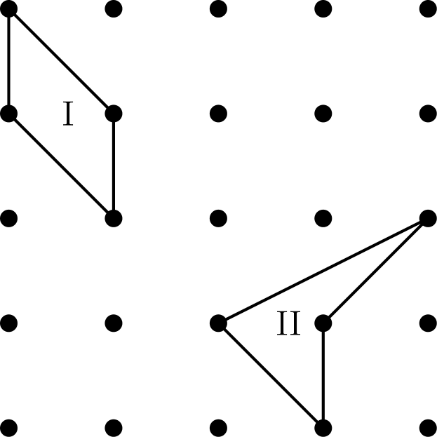
（A）四边形 I 的面积大于四边形 II 的面积。 （B）四边形 I 的面积小于四边形 II 的面积。 （C）两个四边形面积相同，周长也相同。 （D）两个四边形面积相同，但 I 的周长大于 II 的周长。 （E）两个四边形面积相同，但 I 的周长小于 II 的周长。
English
Consider these two geoboard quadrilaterals. Which of the following statements is true?
(A) The area of quadrilateral I is more than the area of
quadrilateral II. (B) The area of quadrilateral I is less than the area of
quadrilateral II. (C) The quadrilaterals have the same area and the same
perimeter. (D) The quadrilaterals have the same area, but the perimeter of
I is more than the perimeter of II. (E) The quadrilaterals have the same area, but the
perimeter of I is less than the perimeter of II.
第 19 题
半径为 5 个单位的三段圆弧围成了图示区域。弧 AB 和 AD 是四分之一圆，弧 BCD 是半圆。这个区域的面积是多少平方单位？
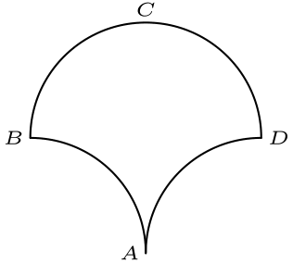
（A）25 （B）10+5π （C）50 （D）50+5π （E）25π
English
Three circular arcs of radius 5 units bound the region shown. Arcs AB and AD are quarter-circles, and arc BCD is a semicircle. What is the area, in square units, of the region?
(A) 25 (B) 10+5π (C) 50 (D) 50+5π (E) 25π
第 20 题
你有九枚硬币：包括一美分硬币、五美分硬币、十美分硬币和二十五美分硬币，总价值为 $1.02，且每种硬币至少有一枚。你必须有多少枚十美分硬币？
（A）1 （B）2 （C）3 （D）4 （E）5
English
You have nine coins: a collection of pennies, nickels, dimes, and quarters having a total value of $1.02, with at least one coin of each type. How many dimes must you have?
(A) 1 (B) 2 (C) 3 (D) 4 (E) 5
第 21 题
Keiko 抛一枚一美分硬币，Ephraim 抛两枚一美分硬币。Ephraim 得到的正面数与 Keiko 得到的正面数相同的概率是
（A）1/4 （B）3/8 （C）1/2 （D）2/3 （E）3/4
English
Keiko tosses one penny and Ephraim tosses two pennies. The probability that Ephraim gets the same number of heads that Keiko gets is
(A) 1/4 (B) 3/8 (C) 1/2 (D) 2/3 (E) 3/4
第 22 题
一个立方体的棱长为 2。现在把一个棱长为 1 的立方体粘在大立方体的上方，使它的一个面完全贴在大立方体的上表面上。从原立方体到新形成的立体，其表面积（侧面、顶面和底面）的百分比增加最接近
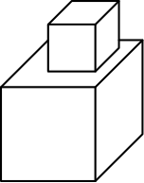
（A）10 （B）15 （C）17 （D）21 （E）25
English
A cube has edge length 2. Suppose that we glue a cube of edge length 1 on top of the big cube so that one of its faces rests entirely on the top face of the larger cube. The percent increase in the surface area (sides, top, and bottom) from the original cube to the new solid formed is closest to
(A) 10 (B) 15 (C) 17 (D) 21 (E) 25
第 23 题
有一个包含七个数的列表。前四个数的平均数是 5，后四个数的平均数是 8。如果全部七个数的平均数是 64/7，那么两组四个数中共同的那个数是
（A）53/7 （B）6 （C）64/7 （D）7 （E）73/7
English
There is a list of seven numbers. The average of the first four numbers is 5, and the average of the last four numbers is 8. If the average of all seven numbers is 64/7, then the number common to both sets of four numbers is
(A) 53/7 (B) 6 (C) 64/7 (D) 7 (E) 73/7
第 24 题
如果 ∠ A = 20°，且 ∠ AFG =∠ AGF，那么 ∠ B+∠ D =
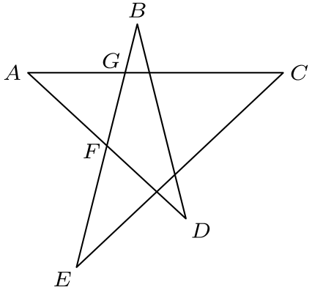
（A）48° （B）60° （C）72° （D）80° （E）90°
English
If ∠ A = 20° and ∠ AFG =∠ AGF, then ∠ B+∠ D =
(A) 48° (B) 60° (C) 72° (D) 80° (E) 90°
第 25 题
长方形 ABCD 的面积是 72 平方单位。若连接点 A、BC 的中点和 CD 的中点形成一个三角形，那么该三角形的面积是
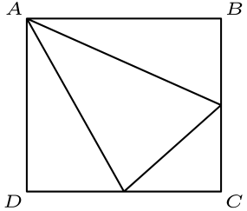
（A）21 （B）27 （C）30 （D）36 （E）40
English
The area of rectangle ABCD is 72 square units. If point A and the midpoints of BC and CD are joined to form a triangle, the area of that triangle is
(A) 21 (B) 27 (C) 30 (D) 36 (E) 40

第二部分 解答
答案速查：
题号 1 2 3 4 5 6 7 8 9
答案 B A D E C A B D D
题号 10 11 12 13 14 15 16 17 18
答案 E C D C D C C A E
题号 19 20 21 22 23 24 25
答案 C A B C B D B
答案串：BADECABDDECDCDCCAECABCBDB
第 1 题 答案 B
Brianna 的年龄是 42 ÷ 2 = 21 岁。因此 Caitlin 是 21 - 5 = 16 岁。
所以正确答案是B。
English
Brianna is 42 ÷ 2 = 21 years old. Caitlin is therefore 21 - 5 = 16 years old.
Thus,Bis the correct answer.
第 2 题 答案 A
0 没有倒数，1 和 -1 的倒数都是它们本身。
2 的倒数是 1/2，但 2 不小于 1/2。
因为 -2 < -1/2，所以 -2 是唯一小于其倒数的选项。
所以正确答案是A。
English
0 has no reciprocal, and 1 and -1 are their own reciprocals.
The reciprocal of 2 is 1/2, but 2 is not less than 1/2.
Therefore, as -2 < -1/2, we know that -2 is the only one of the answer choices that is less than its reciprocal.
Thus,Ais the correct answer.
第 3 题 答案 D
大于 5/3 的最小整数是 2。小于 2π 的最大整数是 6。
在这个范围内的整数是
2, 3, 4, 5, 6。
所以正确答案是D。
English
The smallest whole number greater than 5/3 is 2. The greatest whole number less than 2π is 6.
The whole numbers within this range are
2, 3, 4, 5, 6.
Thus,Dis the correct answer.
第 4 题 答案 E
唯一显示所有数据点的图是图E。
所以正确答案是E。
English
The only graph that shows all the data points is graphE.
Thus,Eis the correct answer.
第 5 题 答案 C
为了让校长人数最多，假设这段时间的第一年是某位校长任期的最后一年。
接着可以有 2 位校长完成接下来的 6 年，然后再有一位校长任最后一年。
总共是 4 位校长。
所以正确答案是C。
English
To maximize the number of principals, assume that the first year of this period is the final year of some principal’s term.
Then, there can be 2 more principals for 6 years, followed by another principal who works the final year.
This is 4 principals.
Thus,Cis the correct answer.
第 6 题 答案 A
可以从大正方形中减去上方的单位正方形、右下角的单位正方形，以及右上方的 4 × 4 正方形。
ABCD 的阴影面积为
5² - 2 · 1² - 4² = 7。
所以正确答案是A。
English
We can subtract out the areas of the top unit square, the bottom right unit square, and the top right 4 × 4 square.
The shaded area in ABCD is therefore
5² - 2 · 1² - 4² = 7.
Thus,Ais the correct answer.
第 7 题 答案 B
负乘积可能来自三个负因数，也可能来自一个负因数和两个正因数。
选三个负因数时，最小乘积为
-8 · -6 · -4 = -192。
选一个负因数时，应选最小的负数和最大的两个正数，得到
-8 · 5 · 7 = -280。
因为 -280<-192，所以最小可能乘积是 -280。
所以正确答案是B。
English
A negative product comes either from three negative factors or from one negative factor and two positive factors.
With three negative factors, the minimum is
-8 · -6 · -4 = -192.
With one negative factor, use the most negative number and the two largest positive numbers to get
-8 · 5 · 7 = -280.
Since -280<-192, the minimum possible product is -280.
Thus,Bis the correct answer.
第 8 题 答案 D
一个骰子各面的点数和为
1 + 2 + 3 + 4 + 5 + 6 = 21。
因此 3 个骰子的总点数是 3 · 21 = 63。
可见点数之和为
1 + 1 + 2 + 3 + 4 + 5 + 6 = 22。
所以不可见点数之和是 63 - 22 = 41。
所以正确答案是D。
English
The sum of the numbers on one die is
1 + 2 + 3 + 4 + 5 + 6 = 21.
Therefore, the sum of the numbers on all 3 dice is 3 · 21 = 63.
The visible numbers add up to
1 + 1 + 2 + 3 + 4 + 5 + 6 = 22.
This makes the sum of the unseen numbers 63 - 22 = 41.
Thus,Dis the correct answer.
第 9 题 答案 D
3 位数的 5 的幂只有 125 和 625。这说明标为 2 的位置填的是 2。
唯一的 3 位数且以 2 开头的 2 的幂是 256，所以带框方格填 6。
所以正确答案是D。
English
The only 3-digit powers of 5 are 125 and 625. This means that the 2 spot is filled with a 2.
The only 3-digit power of 2 beginning with a 2 is 256, so the outlined square is filled with a 6.
Thus,Dis the correct answer.
第 10 题 答案 E
设 Ara 和 Shea 原来的身高为 x。则
1.2x = 60
x = 50
。
Shea 长高了 10 英寸，所以 Ara 长高了 10 ÷ 2 = 5 英寸，她现在高 50 + 5 = 55 英寸。
所以正确答案是E。
English
Let x be Ara and Shea’s initial height. Then we get that
1.2x = 60
x = 50.
This means that Shea grew 10 inches, which means that Ara grew 10 ÷ 2 = 5 inches, making her 50 + 5 = 55 inches tall.
Thus,Eis the correct answer.
第 11 题 答案 C
以 1、2 或 5 结尾的数都满足条件，分别为 11、21、31、41；12、22、32、42；以及 15、25、35、45。这共有 12 个数。
其余满足条件的数是 24、33、36、44、48。以 0 结尾的数不行，因为除以 0 没有定义。
因此共有 12+5=17 个这样的数。
所以正确答案是C。
English
Numbers ending in 1, 2, or 5 all work in the lists 11, 21, 31, and 41; 12, 22, 32, and 42; and 15, 25, 35, and 45. This gives 12 numbers.
The remaining working numbers are 24, 33, 36, 44, and 48. Numbers ending in 0 do not work because division by 0 is undefined.
Thus there are 12+5=17 such numbers.
Thus,Cis the correct answer.
第 12 题 答案 D
墙共有 7 行，每行高 1 英尺。
为了使用最少砌块，第 1、3、5 和 7 行可采用图中底行的模式，每行需要 50 块砌块。
第 2、4 和 6 行采用图中上行的模式，中间有 49 块 2 英尺砌块，两端各有一块 1 英尺砌块，共 51 块砌块。
将 4 行 50 块和 3 行 51 块相加，得到
4 · 50 + 3 · 51 = 200 + 153 = 353
块砌块。
所以正确答案是D。
English
The total number of rows in the wall is 7, with each row being 1 foot high.
To use the minimum number of bricks, rows 1, 3, 5, and 7 will have the same pattern as the bottom row in the picture, which requires 50 bricks to construct.
Rows 2, 4, and 6 will have the same pattern as the upper row in the picture, which has 49 2-foot bricks in the middle and one 1-foot brick on each end, for a total of 51 bricks.
When you add up 4 rows of 50 bricks and 3 rows of 51 bricks, you get a total of
4 · 50 + 3 · 51 = 200 + 153 = 353
bricks.
Thus,Dis the correct answer.
第 13 题 答案 C
我们有
∠ CAT + ∠ ATC
+ ∠ ACT = 180
36 + 2 · ∠ ATC = 180
∠ ATC = 72°
。
因为该角被平分，所以
∠ RTC = 72 ÷ 2 = 36°。
最后，
∠ RTC + ∠ TCR
+ ∠ CRT = 180
36 + 72 + ∠ CRT = 180
∠ CRT = 72°
。
所以正确答案是C。
English
We get
∠ CAT + ∠ ATC
+ ∠ ACT = 180
36 + 2 · ∠ ATC = 180
∠ ATC = 72°.
Due to bisection, we also know that
∠ RTC = 72 ÷ 2 = 36°.
Finally, we see that
∠ RTC + ∠ TCR
+ ∠ CRT = 180
36 + 72 + ∠ CRT = 180
∠ CRT = 72°.
Thus,Cis the correct answer.
第 14 题 答案 D
幂的个位数字只取决于底数的个位数字。
观察可知，9 的偶次幂个位是 1，奇次幂个位是 9。
因此 19¹⁹ 个位是 9，99⁹⁹ 个位也是 9。相加后的个位为 8。
所以正确答案是D。
English
Note that the units digit of a power depends only upon the units digit of the base.
Experimenting, we get that 9 to an even power ends with a 1 and to an odd power ends with a 9.
Therefore, 19¹⁹ ends with a 9 and 99⁹⁹ also ends with a 9. Adding them together yields a number that ends in 8.
Thus,Dis the correct answer.
第 15 题 答案 C
大等边三角形边长为 4，中等边三角形边长为 2，小等边三角形边长为 1。
周长为
CB + CD + DE + EF
+ FG + GA + AB
= 4 + 4 + 2 + 2 + 1
+ 1 + 1 = 15
。
所以正确答案是C。
English
The large equilateral triangle has side length 4, the middle one has side length 2, and the smaller one has side length 1.
The perimeter is therefore
CB + CD + DE + EF
+ FG + GA + AB
= 4 + 4 + 2 + 2 + 1
+ 1 + 1 = 15.
Thus,Cis the correct answer.
第 16 题 答案 C
长为 1000 ÷ 25 = 40 米，周长为 1000 ÷ 10 = 100 米。
周长是长与宽之和的 2 倍。
因此宽为
100 ÷ 2 - 40 = 10
米，面积为
40 · 10 = 400
平方米。
所以正确答案是C。
English
We can see that the length is 1000 ÷ 25 = 40 meters, and the perimeter is 1000 ÷ 10 = 100 meters.
Note that the perimeter is 2 times the sum of the length and width.
This means that the width is
100 ÷ 2 - 40 = 10
meters, and the area is
40 · 10 = 400
square meters.
Thus,Cis the correct answer.
第 17 题 答案 A
计算如下：
[(1otimes 2)otimes 3]-[1otimes (2otimes 3)]
= [1²/2 otimes 3] - [1 otimes 2²/3]
= [1/2 otimes 3] - [1 otimes 4/3]
= ((1/2)²)/3 - 1²/((4/3))
= 1/4 · 1/3 - 3/4
= 1/12 - 3/4
= -2/3
。
所以正确答案是A。
English
We can calculate it as follows.
[(1otimes 2)otimes 3]-[1otimes (2otimes 3)]
= [1²/2 otimes 3] - [1 otimes 2²/3]
= [1/2 otimes 3] - [1 otimes 4/3]
= ((1/2)²)/3 - 1²/((4/3))
= 1/4 · 1/3 - 3/4
= 1/12 - 3/4
= -2/3.
Thus,Ais the correct answer.
第 18 题 答案 E
假设这个网格上相邻钉点相距 1 个单位。
区域 I 是底为 1、高为 1 的平行四边形，所以面积为 1 · 1 = 1。
区域 II 可以分成 2 个三角形，每个底为 1、高为 1。面积总和为
2 · 1/2 · 1 · 1 = 1。
因此两个区域面积相同。
每个区域都有 2 条长度为 √(2) 的边。区域 I 有 2 条单位边，而区域 II 只有 1 条单位边。
区域 II 的另一条边显然大于 1，所以区域 II 的周长更大。
所以正确答案是E。
English
Assume that the pegs on this grid are separated by 1 unit.
Note that region I is a parallelogram with base 1 and height 1, making its area 1 · 1 = 1.
We can split region II into 2 triangles, both with base 1 and height 1. This makes the sum of the areas
2 · 1/2 · 1 · 1 = 1.
This shows that both regions have the same area.
Note that each region has 2 sides that are of length √(2). Region I has 2 unit sides, whereas region II only has 1.
The other side of region II is clearly greater than 1, which shows that region II has the greater perimeter.
Thus,Eis the correct answer.
第 19 题 答案 C
如下图，作一个覆盖图形下半部分的矩形。
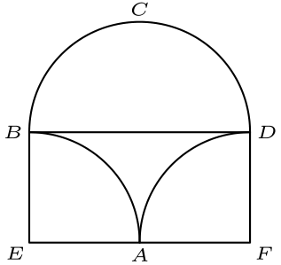
于是
[ABCD] = [ABD] + [BCD]。
还知道
[ABD] = [BDEF] - [ABE]
- [ADF]。
ABE 和 ADF 都是四分之一圆，它们合起来形成一个半圆，面积与 BCD 相同。
因此
[ABD] = [BDEF] - [BCD]
并且
[ABCD] = [BCD] + [BDEF]
- [BCD]
= [BDEF] = 10 · 5 = 50。
所以正确答案是C。
English
Create a rectangle that covers the bottom half of the figure as shown below.
Then, we get that
[ABCD] = [ABD] + [BCD].
We also know that
[ABD] = [BDEF] - [ABE]
- [ADF].
ABE and ADF are both quarter-circles that form a semicircle with the same area as BCD.
This means that
[ABD] = [BDEF] - [BCD]
and
[ABCD] = [BCD] + [BDEF]
- [BCD]
= [BDEF] = 10 · 5 = 50.
Thus,Cis the correct answer.
第 20 题 答案 A
一美分硬币的数量必须与 102 模 5 的余数相同，所以可能有 2 枚或 7 枚一美分硬币。如果有七枚，只剩两枚硬币给五美分硬币、十美分硬币和二十五美分硬币，不可能每种至少一枚。
所以有 2 枚一美分硬币。剩下 7 枚硬币价值 100 分。设五美分硬币、十美分硬币和二十五美分硬币的数量分别为 n、d、q，则 n+d+q=7，且 5n+10d+25q=100。
将价值方程除以 5，再减去硬币数量方程，得到 d+4q=13。唯一正整数解是 q=3、d=1、n=3。
因此必须有 1 枚十美分硬币。
所以正确答案是A。
English
The number of pennies must have the same remainder as 102 modulo 5, so there are either 2 or 7 pennies. Seven pennies would leave only two coins for nickels, dimes, and quarters, impossible because at least one of each type is needed.
So there are 2 pennies. The remaining 7 coins are worth 100 cents. If n, d, and q are the numbers of nickels, dimes, and quarters, then n+d+q=7 and 5n+10d+25q=100.
Dividing the value equation by 5 and subtracting the coin-count equation gives d+4q=13. The only positive solution is q=3, d=1, and n=3.
Thus there must be 1 dime.
Thus,Ais the correct answer.
第 21 题 答案 B
若记录 Keiko 的硬币和 Ephraim 的两枚硬币，共有 8 个等可能结果。
如果 Keiko 得到正面，Ephraim 必须恰好得到一个正面，这有 2 种结果。如果 Keiko 得到反面，Ephraim 必须没有正面，这有 1 种结果。
所以有 3 个满足条件的结果，共有 8 个等可能结果，所求概率为 3/8。
所以正确答案是B。
English
There are 8 equally likely outcomes if we record Keiko’s coin and Ephraim’s two coins.
If Keiko gets heads, Ephraim must get exactly one head; this happens in 2 outcomes. If Keiko gets tails, Ephraim must get no heads; this happens in 1 outcome.
So 3 of the 8 equally likely outcomes work, and the probability is 3/8.
Thus,Bis the correct answer.
第 22 题 答案 C
原来的表面积为
6 · 2² = 6 · 4 = 24。
注意单位立方体的顶面加上大立方体顶面仍可见的部分，面积与大立方体一个面相同。
因此放在上方的单位立方体只让总表面积增加 4 个单位正方形，增加量为 4。
百分比增加为
100 · 4/24 = 100 · 1/6 ≈ 16.7%。
所以正确答案是C。
English
The original surface area is just
6 · 2² = 6 · 4 = 24.
Note that the top face of the unit cube plus the visible area of the top face of the larger cube is the same as the area of one face of the larger cube.
This means that the unit square on top only adds 4 unit squares to the total surface area, making the increase 4.
The percent increase is therefore
100 · 4/24 = 100 · 1/6 ≈ 16.7%.
Thus,Cis the correct answer.
第 23 题 答案 B
前四个数的和是 4 · 5 = 20。后四个数的和是 4 · 8 = 32。
全部七个数的和是 7 · 64/7 = 46。共同的数包含在前两个和中。
也就是说，前两个和相加会把每个数计算一次，但共同的数计算两次。
而全部七个数的和只把每个数计算一次。因此用前两个和的总和减去七个数的总和，就得到共同的数。
所以共同的数为
20 + 32 - 46 = 52 - 46 = 6。
所以正确答案是B。
English
The sum of the first four numbers is 4 · 5 = 20. The sum of the last four numbers is 4 · 8 = 32.
The sum of all seven numbers is 7 · 64/7 = 46. We know that the number common to both sets is included in both of the first two sums.
This means that the sum of the first two sums includes every number once, except for the common number which is included twice.
The third sum, however, only includes every number once. This means that the sum of the first two sums minus the third sum yields our desired number.
Therefore, the common number is
20 + 32 - 46 = 52 - 46 = 6.
Thus,Bis the correct answer.
第 24 题 答案 D
在 △ AFG 中，两个底角相等，且 ∠ A=20°，所以
∠ AFG = ∠ AGF
= (180°-20°)/2
= 80°
。
因为 ∠ AFG 和 ∠ BFD 构成平角，所以 ∠ BFD=100°。
在 △ BFD 中，∠ B+∠ D=180°-100°=80°。
所以正确答案是D。
English
In △ AFG, the two base angles are equal and ∠ A=20°, so
∠ AFG = ∠ AGF
= (180°-20°)/2
= 80°.
Since ∠ AFG and ∠ BFD form a straight angle, ∠ BFD=100°.
In △ BFD, ∠ B+∠ D=180°-100°=80°.
Thus,Dis the correct answer.
第 25 题 答案 B
设长方形边长为 2a 和 2b，所以面积为 4ab=72，即 ab=18。
目标三角形外侧的三个直角三角形面积分别为 1/2(2a)(b)=ab、1/2(2b)(a)=ab 和 1/2(a)(b)=1/2ab。
它们的总面积为 5/2ab=45。因此目标三角形面积为 72-45=27。
所以正确答案是B。
English
Let the rectangle have side lengths 2a and 2b, so its area is 4ab=72 and ab=18.
The three right triangles outside the desired triangle have areas 1/2(2a)(b)=ab, 1/2(2b)(a)=ab, and 1/2(a)(b)=1/2ab.
Their total area is 5/2ab=45. Therefore the desired triangle has area 72-45=27.
Thus,Bis the correct answer.

