1999 年 AMC 8 真题与解答
American Mathematics Competitions 8 · 中英双语
共 25 题，限时 40 分钟；单项选择题，每题 1 分，答错不扣分，满分 25 分。
编排说明：第一部分为题目（先中文、后英文原题），第二部分为解答与答案，便于先做题后对答案。
第一部分 题目
第 1 题
(6 ? 3) + 4 - (2 - 1) = 5。要使这个等式成立，6 和 3 之间的问号应替换为
（A）÷ （B）× （C）+ （D）- （E）以上都不是
English
(6 ? 3) + 4 - (2 - 1) = 5. To make this statement true, the question mark between the 6 and the 3 should be replaced by
(A) ÷ (B) × (C) + (D) - (E) None of these
第 2 题
10 点整时，钟表两根指针形成的较小角的度数是多少？
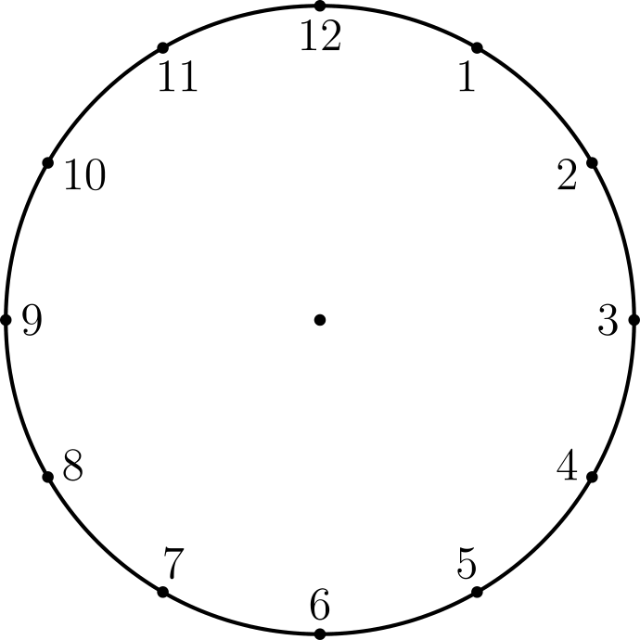
（A）30 （B）45 （C）60 （D）75 （E）90
English
What is the degree measure of the smaller angle formed by the hands of a clock at 10 o’clock?
(A) 30 (B) 45 (C) 60 (D) 75 (E) 90
第 3 题
下列哪一组三个数的和不等于 1？
（A）(1/2,1/3,1/6) （B）(2,-2,1) （C）(0.1,0.3,0.6) （D）(1.1,-2.1,1.0) （E）(-3/2,-5/2,5)
English
Which triplet of numbers has a sum NOT equal to 1?
(A) (1/2,1/3,1/6) (B) (2,-2,1) (C) (0.1,0.3,0.6) (D) (1.1,-2.1,1.0) (E) (-3/2,-5/2,5)
第 4 题
图中显示了骑车人阿尔韦托（Alberto）和比约恩（Bjorn）骑行的英里数。四小时后，阿尔韦托大约比比约恩多骑了多少英里？
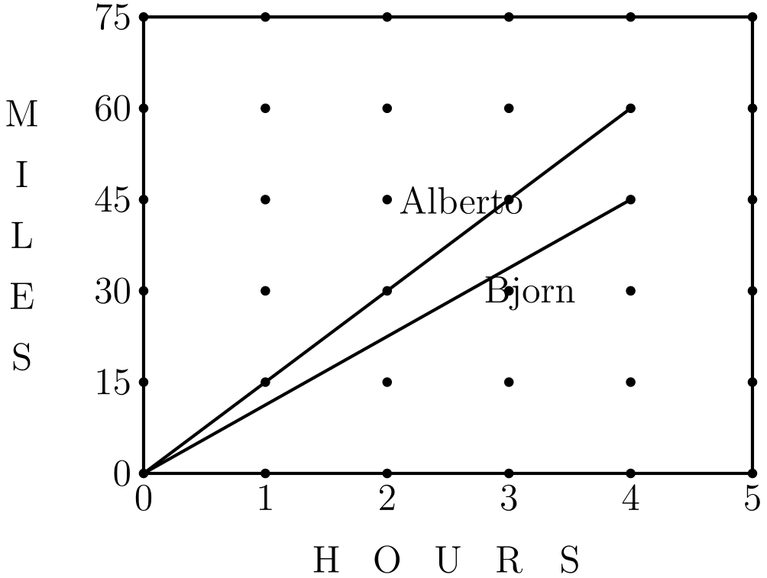
（A）15 （B）20 （C）25 （D）30 （E）35
English
The diagram shows the miles traveled by bikers Alberto and Bjorn. After four hours, about how many more miles has Alberto biked than Bjorn?
(A) 15 (B) 20 (C) 25 (D) 30 (E) 35
第 5 题
一个长 50 英尺、宽 10 英尺的长方形花园被栅栏围住。为了在使用同样栅栏的情况下扩大花园，花园改成正方形。面积增加了多少平方英尺？
（A）100 （B）200 （C）300 （D）400 （E）500
English
A rectangular garden 50 feet long and 10 feet wide is enclosed by a fence. To make the garden larger, while using the same fence, its shape is changed to a square. By how many square feet does this enlarge the garden?
(A) 100 (B) 200 (C) 300 (D) 400 (E) 500
第 6 题
博、科、弗洛、乔和莫的钱数各不相同。乔和博都没有弗洛的钱多。博和科都比莫钱多。乔比莫钱多，但比博钱少。谁的钱最少？
（A）博 （B）科 （C）弗洛 （D）乔 （E）莫
English
Bo, Coe, Flo, Jo, and Moe have different amounts of money. Neither Jo nor Bo has as much money as Flo. Both Bo and Coe have more than Moe. Jo has more than Moe, but less than Bo. Who has the least amount of money?
(A) Bo (B) Coe (C) Flo (D) Jo (E) Moe
第 7 题
一条高速公路的第三个出口在 40 英里标处，第十个出口在 160 英里标处。一个服务中心位于从第三个出口到第十个出口路程的四分之三处。这个服务中心应在多少英里标处？
（A）90 （B）100 （C）110 （D）120 （E）130
English
The third exit on a highway is located at milepost 40 and the tenth exit is at milepost 160. There is a service center on the highway located three-fourths of the way from the third exit to the tenth exit. At what milepost would you expect to find this service center?
(A) 90 (B) 100 (C) 110 (D) 120 (E) 130
第 8 题
六个正方形的正反两面都涂了颜色（R 表示红色，B 表示蓝色，O 表示橙色，Y 表示黄色，G 表示绿色，W 表示白色）。它们按图所示铰接在一起，然后折成一个立方体。与白色面相对的面是
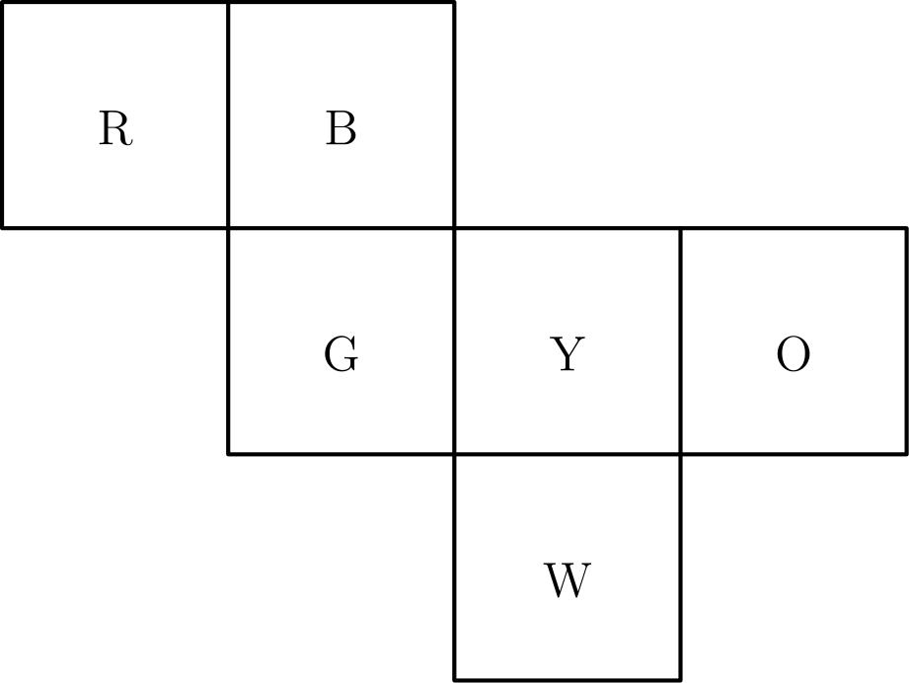
（A）B （B）G （C）O （D）R （E）Y
English
Six squares are colored, front and back (R = red, B = blue, O = orange, Y = yellow, G = green, and W = white). They are hinged together as shown, then folded to form a cube. The face opposite the white face is
(A) B (B) G (C) O (D) R (E) Y
第 9 题
如图，三个花坛互相重叠。花坛 A 有 500 株植物，花坛 B 有 450 株植物，花坛 C 有 350 株植物。花坛 A 和 B 共有 50 株植物，花坛 A 和 C 共有 100 株植物。植物总数是
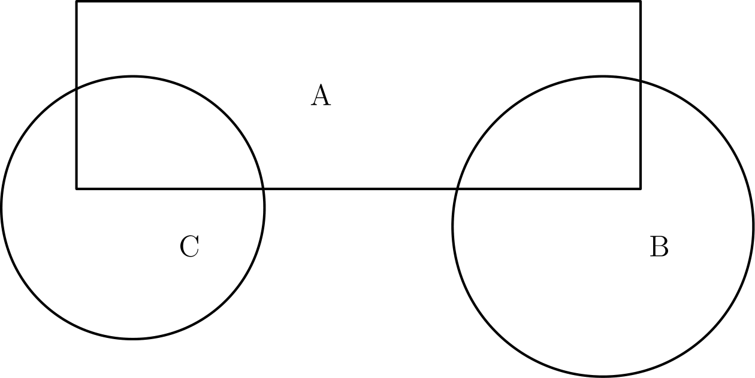
（A）850 （B）1000 （C）1150 （D）1300 （E）1450
English
Three flower beds overlap as shown. Bed A has 500 plants, bed B has 450 plants, and bed C has 350 plants. Beds A and B share 50 plants, while beds A and C share 100. The total number of plants is
(A) 850 (B) 1000 (C) 1150 (D) 1300 (E) 1450
第 10 题
一个交通灯的完整周期为 60 秒。每个周期中绿灯 25 秒，黄灯 5 秒，红灯 30 秒。在随机选取的一个时刻，交通灯不是绿灯的概率是多少？
（A）1/4 （B）1/3 （C）5/12 （D）1/2 （E）7/12
English
A complete cycle of a traffic light takes 60 seconds. During each cycle the light is green for 25 seconds, yellow for 5 seconds, and red for 30 seconds. At a randomly chosen time, what is the probability that the light will NOT be green?
(A) 1/4 (B) 1/3 (C) 5/12 (D) 1/2 (E) 7/12
第 11 题
将 1、4、7、10 和 13 这五个数分别填入五个方格中，使横排三个数之和等于竖列三个数之和。横排或竖列的和最大可能是多少？
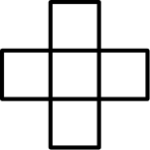
（A）20 （B）21 （C）22 （D）24 （E）30
English
Each of the five numbers 1, 4, 7, 10, and 13 is placed in one of the five squares so that the sum of the three numbers in the horizontal row equals the sum of the three numbers in the vertical column. The largest possible value for the horizontal or vertical sum is
(A) 20 (B) 21 (C) 22 (D) 24 (E) 30
第 12 题
中学小将队赢的场数与输的场数之比为 11/4，没有平局。四舍五入到最接近的整数百分比，这支队输了百分之多少的比赛？
（A）24% （B）27% （C）36% （D）45% （E）73%
English
The ratio of the number of games won to the number of games lost (no ties) by the Middle School Middies is 11/4. To the nearest whole percent, what percent of its games did the team lose?
(A) 24% (B) 27% (C) 36% (D) 45% (E) 73%
第 13 题
一个计算机科学营有 40 名成员，平均年龄为 17 岁。其中有 20 个女孩、15 个男孩和 5 个成年人。如果女孩的平均年龄为 15 岁，男孩的平均年龄为 16 岁，那么成年人的平均年龄是多少？
（A）26 （B）27 （C）28 （D）29 （E）30
English
The average age of the 40 members of a computer science camp is 17 years. There are 20 girls, 15 boys, and 5 adults. If the average age of the girls is 15 and the average age of the boys is 16, what is the average age of the adults?
(A) 26 (B) 27 (C) 28 (D) 29 (E) 30
第 14 题
在梯形 ABCD 中，边 AB 和 CD 相等。ABCD 的周长是
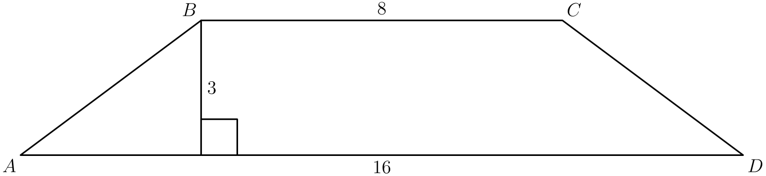
（A）27 （B）30 （C）32 （D）34 （E）48
English
In trapezoid ABCD, the sides AB and CD are equal. The perimeter of ABCD is
(A) 27 (B) 30 (C) 32 (D) 34 (E) 48
第 15 题
平原镇的自行车牌照每个含有三个字母。第一个字母从集合 {C,H,L,P,R} 中选，第二个从 {A,I,O} 中选，第三个从 {D,M,N,T} 中选。
当平原镇需要更多牌照时，他们增加了两个新字母。这两个新字母可以都加入同一个集合，也可以分别加入两个不同集合。加入两个字母后，最多能多制作多少个额外牌照？
（A）24 （B）30 （C）36 （D）40 （E）60
English
Bicycle license plates in Flatville each contain three letters. The first is chosen from the set {C,H,L,P,R}, the second from {A,I,O}, and the third from {D,M,N,T}.
When Flatville needed more license plates, they added two new letters. The new letters may both be added to one set or one letter may be added to one set and one to another set. What is the largest possible number ofadditionallicense plates that can be made by adding two letters?
(A) 24 (B) 30 (C) 36 (D) 40 (E) 60
第 16 题
托里的数学测试有 75 道题：10 道算术题、30 道代数题和 35 道几何题。她答对了 70% 的算术题、40% 的代数题和 60% 的几何题，但因为答对题数少于 60%，所以没有通过测试。
她还需要多答对多少道题，才能达到 60% 的及格分数？
（A）1 （B）5 （C）7 （D）9 （E）11
English
Tori’s mathematics test had 75 problems: 10 arithmetic, 30 algebra, and 35 geometry problems. Although she answered 70% of the arithmetic, 40% of the algebra, and 60% of the geometry problems correctly, she did not pass the test because she got less than 60% of the problems right.
How many more problems would she have needed to answer correctly to earn a 60% passing grade?
(A) 1 (B) 5 (C) 7 (D) 9 (E) 11
第 17 题
第 17、18 和 19 题参考以下内容：
给一群人做饼干
中央中学有 108 名参加 AMC 8 的学生，他们晚上聚在一起讨论题目，并且平均每人吃两个饼干。今年沃尔特和格蕾特要烤邦妮牌美味条形饼干。这个食谱每盘做 15 个饼干，配料包括：11/2 杯面粉、2 个鸡蛋、3 汤匙黄油、3/4 杯糖和 1 包巧克力粒。他们只做完整份食谱，不做部分份。
沃尔特可以按半打购买鸡蛋。为了做足够的饼干，他应该买多少半打鸡蛋？（可能会剩下一些鸡蛋和一些饼干。）
（A）1 （B）2 （C）5 （D）7 （E）15
English
Problems 17, 18, and 19 refer to the following:
Cookies For a Crowd
At Central Middle School the 108 students who take the AMC 8 meet in the evening to talk about problems and eat an average of two cookies apiece. Walter and Gretel are baking Bonnie’s Best Bar Cookies this year. Their recipe, which makes a pan of 15 cookies, lists these items: 11/2 cups of flour, 2 eggs, 3 tablespoons butter, 3/4 cups sugar, and 1 package of chocolate drops. They will make only full recipes, not partial recipes.
Walter can buy eggs by the half-dozen. How many half-dozens should he buy to make enough cookies? (Some eggs and some cookies may be left over.)
(A) 1 (B) 2 (C) 5 (D) 7 (E) 15
第 18 题
他们得知同一晚有一场大型音乐会，出席人数会减少 25%。他们应该为这个较小的聚会做多少份饼干食谱？
（A）6 （B）8 （C）9 （D）10 （E）11
English
They learn that a big concert is scheduled for the same night and attendance will be down 25%. How many recipes of cookies should they make for their smaller party?
(A) 6 (B) 8 (C) 9 (D) 10 (E) 11
第 19 题
鼓手生病了，音乐会取消了。沃尔特和格蕾特必须烤出足够的饼干，共计 216 块。每条黄油相当于 8 汤匙。需要多少条黄油？（当然，可能会剩下一些黄油。）
（A）5 （B）6 （C）7 （D）8 （E）9
English
The drummer gets sick. The concert is cancelled. Walter and Gretel must make enough pans of cookies to supply 216 cookies. There are 8 tablespoons in a stick of butter. How many sticks of butter will be needed? (Some butter may be left over, of course.)
(A) 5 (B) 6 (C) 7 (D) 8 (E) 9
第 20 题
图 1 称为“堆叠图”。数字表示每个位置上堆了多少个立方体。图 2 显示这些立方体，图 3 显示从正面看到的堆叠立方体视图。
下列哪一个是图 4 中堆叠图的正面视图？
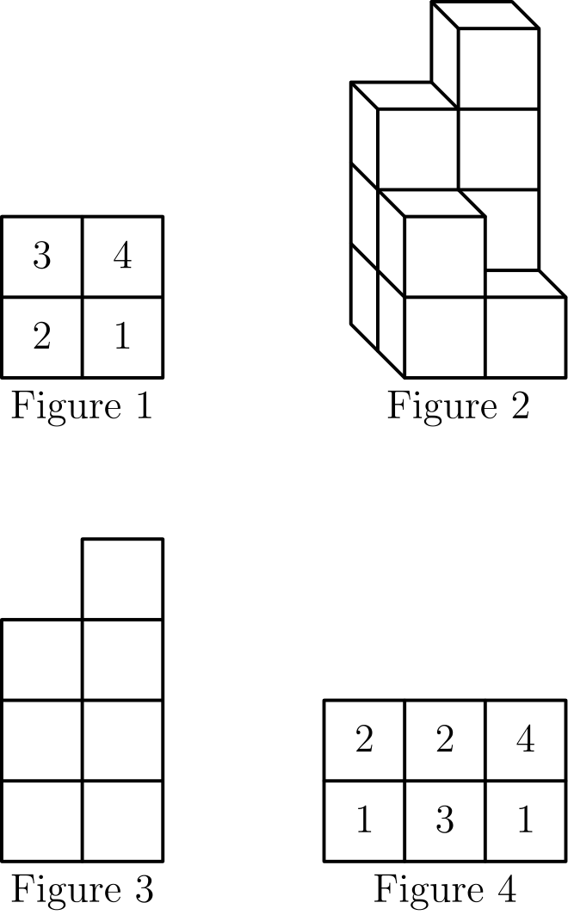
（A）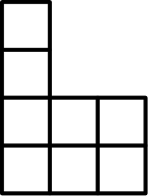
（B）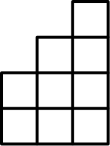
（C）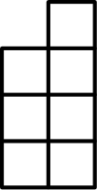
（D）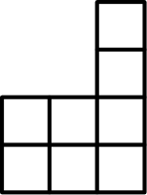
（E）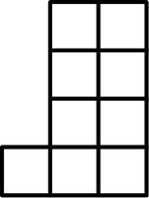
English
Figure 1 is called a “stack map.” The numbers tell how many cubes are stacked in each position. Fig. 2 shows these cubes, and Fig. 3 shows the view of the stacked cubes as seen from the front.
Which of the following is the front view for the stack map in Fig. 4?
(A)
(B)
(C)
(D)
(E)
第 21 题
角 A 的度数是
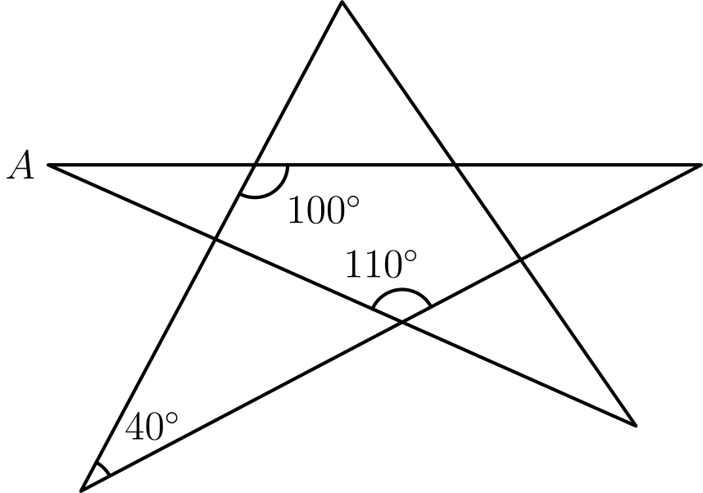
（A）20 （B）30 （C）35 （D）40 （E）45
English
The degree measure of angle A is
(A) 20 (B) 30 (C) 35 (D) 40 (E) 45
第 22 题
在一个遥远的地方，三条鱼可以换两个面包，一个面包可以换四袋米。一条鱼值多少袋米？
（A）3/8 （B）1/2 （C）3/4 （D）22/3 （E）31/3
English
In a far-off land three fish can be traded for two loaves of bread and a loaf of bread can be traded for four bags of rice. How many bags of rice is one fish worth?
(A) 3/8 (B) 1/2 (C) 3/4 (D) 22/3 (E) 31/3
第 23 题
正方形 ABCD 的边长为 3。线段 CM 和 CN 将正方形面积分成三个相等部分。线段 CM 有多长？
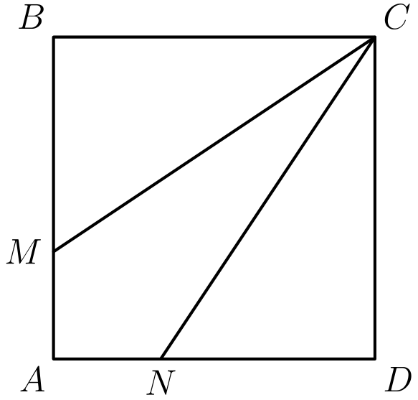
（A）√(10) （B）√(12) （C）√(13) （D）√(14) （E）√(15)
English
Square ABCD has sides of length 3. Segments CM and CN divide the square’s area into three equal parts. How long is segment CM?
(A) √(10) (B) √(12) (C) √(13) (D) √(14) (E) √(15)
第 24 题
1999²⁰⁰⁰ 除以 5 的余数是
（A）4 （B）3 （C）2 （D）1 （E）0
English
When 1999²⁰⁰⁰ is divided by 5, the remainder is
(A) 4 (B) 3 (C) 2 (D) 1 (E) 0
第 25 题
点 B、D 和 J 是直角三角形 ACG 各边的中点。点 K、E 和 I 是三角形 JDG 各边的中点，依此类推。如果这种分割并涂阴影的过程进行 100 次（图中显示了前三次），且 AC = CG = 6，那么阴影三角形的总面积最接近
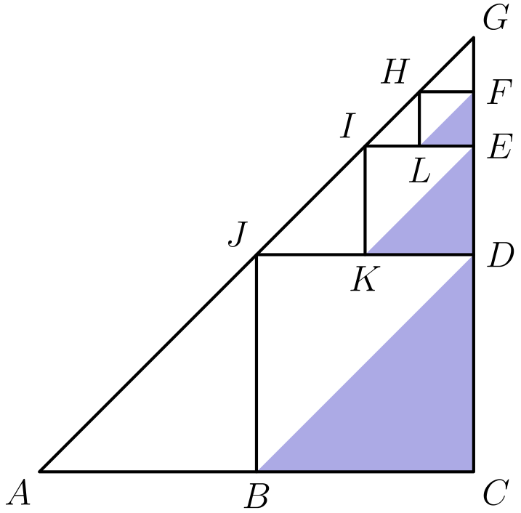
（A）6 （B）7 （C）8 （D）9 （E）10
English
Points B, D, and J are midpoints of the sides of right triangle ACG. Points K, E, I are midpoints of the sides of triangle JDG, etc. If the dividing and shading process is done 100 times (the first three are shown) and AC = CG = 6, then the total area of the shaded triangles is nearest
(A) 6 (B) 7 (C) 8 (D) 9 (E) 10

第二部分 解答
答案速查：
题号 1 2 3 4 5 6 7 8 9
答案 A C D A D E E A C
题号 10 11 12 13 14 15 16 17 18
答案 E D B C D D B C E
题号 19 20 21 22 23 24 25
答案 B B B D C D A
答案串：ACDADEEACEDBCDDBCEBBBDCDA
第 1 题 答案 A
我们有
4 - (2 - 1) = 4 - 1 = 3。
因此
(6 ? 3) + 3 = 5
6 ? 3 = 2。
唯一可行的选择是 ÷。
所以正确答案是A。
English
We have that
4 - (2 - 1) = 4 - 1 = 3.
Then
(6 ? 3) + 3 = 5
6 ? 3 = 2.
The only choice that works is ÷.
Thus,Ais the correct answer.
第 2 题 答案 C
10 点整时，时针指向 10，分针指向 12。
两根指针相隔整个圆的 1/6。所以角度为
360° · 1/6 = 60°。
所以正确答案是C。
English
At 10 o’clock, we have that the hour hand is at 10 and the minute hand is at 12.
This means that the hands are a 1/6 of the entire circle apart. This is equal to
360° · 1/6 = 60°.
Thus,Cis the correct answer.
第 3 题 答案 D
A等于
3/6 + 2/6 + 1/6 = 1。
B化简为
2 - 2 + 1 = 1。
C的和是
0.1 + 0.3 + 0.6 = 1。
但D的和为
1.1 - 2.1 + 1.0 = 0。
为确认起见，E的和为
-8/2 + 5 = 5 - 4 = 1。
所以正确答案是D。
English
We have thatAis the same as
3/6 + 2/6 + 1/6 = 1.
Breduces to
2 - 2 + 1 = 1.
Cadds up to
0.1 + 0.3 + 0.6 = 1.
Dhowever adds to
1.1 - 2.1 + 1.0 = 0.
To make sure, we check thatEhas a sum of
-8/2 + 5 = 5 - 4 = 1.
Thus,Dis the correct answer.
第 4 题 答案 A
从图中可见，4 小时后阿尔韦托骑了 60 英里，比约恩骑了 45 英里。
两者的距离差是 60 - 45 = 15 英里。
所以正确答案是A。
English
Looking at the graph, we have that Alberto has biked 60 miles and Bjorn 45 miles after 4 hours.
The difference between the two distances is 60 - 45 = 15 miles.
Thus,Ais the correct answer.
第 5 题 答案 D
当前栅栏的周长为
2(50 + 10) = 2 · 60 = 120
英尺。如果四条边都相等，那么每条边长为 120 ÷ 4 = 30 英尺。因此正方形面积为 30² = 900 平方英尺。原花园面积为 50 · 10 = 500 平方英尺。
因此面积差是 900 - 500 = 400 平方英尺。
所以正确答案是D。
English
The current length of the fence is
2(50 + 10) = 2 · 60 = 120
feet. If all the sides become the same, then each side length is 120 ÷ 4 = 30 feet. As such, the area of the square is then 30² = 900 square feet. Note that the original area of the garden is 50 · 10 = 500 square feet.
Therefore, the difference is 900 - 500 = 400 square feet.
Thus,Dis the correct answer.
第 6 题 答案 E
设 B, C, F, J 和 M 分别表示博、科、弗洛、乔和莫的钱数。
那么
J < F, B < F。
还知道
B > M, C > M。
最后，题目给出
M < J < B。
由第一组和第二组不等式可知 F > M。
因此每个人的钱都比莫多。
所以正确答案是E。
English
Let B, C, F, J, and M represent the amount of money that Bo, Coe, Flo, Jo, and Moe have respectively.
Then
J < F, B < F.
We also have
B > M, C > M.
Finally, we are given
M < J < B.
From the first and second inequalities, we can get that F > M.
This shows that everyone has more money than Moe.
Thus,Eis the correct answer.
第 7 题 答案 E
第三个和第十个出口之间相差 160 - 40 = 120 英里。
这意味着全程的 3/4 处位于
40 + 3/4 · 120 = 130
英里标处。
所以正确答案是E。
English
There are 160 - 40 = 120 miles between the third and tenth exits.
This means 3/4 of the way is at the
40 + 3/4 · 120 = 130
milepost.
Thus,Eis the correct answer.
第 8 题 答案 A
设立方体的黄色面朝上。
这时白色、绿色和橙色面可以向下折。
因为蓝色面连在绿色面上，所以它会向后折。
因此蓝色面最终会与白色面相对。
所以正确答案是A。
English
Consider the cube with the yellow face facing upwards.
Then we can fold the white, green, and orange faces down.
Since the blue face is attached to the green face, it will end up folding backwards.
This means that the blue face will end up facing opposite the white face.
Thus,Ais the correct answer.
第 9 题 答案 C
有 50 + 100 = 150 株植物在两个花坛中，且没有植物同时在三个花坛中。
所以植物总数为
500 + 450 + 350 - 150 = 1150。
减去重叠部分是为了去掉被计算两次的植物。
所以正确答案是C。
English
Note there are 50 + 100 = 150 plants that are in two beds and there are no plants in all three beds.
The total number of plants is then
500 + 450 + 350 - 150 = 1150.
We subtract to get rid of the plants that we counted twice.
Thus,Cis the correct answer.
第 10 题 答案 E
在一个周期中，交通灯不是绿灯的时间为 30 + 5 = 35 秒。
所以不是绿灯的概率为
35/60 = 7/12。
所以正确答案是E。
English
During a given cycle, the light is not green for 30 + 5 = 35 seconds.
Then the probability that it is not green is
35/60 = 7/12.
Thus,Eis the correct answer.
第 11 题 答案 D
设中心方格中的数为 x。横排之和加上竖列之和时，其他数各计算一次，而中心数计算两次。
所以公共和的两倍是 1+4+7+10+13+x =35+x。当 x=13 时，这个值最大。
因此公共和至多为 35+13/2=24，而且可以达到：把 13 放在中心，把 1 和 10 放在一排的两端，把 4 和 7 放在另一排的两端。两个和都是 24。
所以正确答案是D。
English
Let x be the number in the center. The horizontal sum plus the vertical sum counts every number once, except the center number is counted twice.
So twice the common sum is 1+4+7+10+13+x =35+x. This is largest when x=13.
The largest common sum is therefore at most 35+13/2=24, and it is attainable: put 13 in the center, 1 and 10 at the ends of one row, and 4 and 7 at the ends of the other. Both sums are 24.
Thus,Dis the correct answer.
第 12 题 答案 B
可以把这支队看成每 15 场比赛中赢 11 场、输 4 场。
输掉的百分比为 4/15·100%≈ 27%。
所以正确答案是B。
English
The team can be viewed as winning 11 games and losing 4 games in each batch of 15 games.
The percent lost is 4/15·100%≈ 27%.
Thus,Bis the correct answer.
第 13 题 答案 C
全营所有人的年龄总和为 40 · 17 = 680。
女孩年龄总和为 20 · 15 = 300，男孩年龄总和为 15 · 16 = 240。
因此成年人的年龄总和为 680 - 300 - 240 = 140。
所以成年人的平均年龄为
140 ÷ 5 = 28。
所以正确答案是C。
English
The sum of the ages of everybody at the camp is 40 · 17 = 680.
The sum of the ages of the girls is 20 · 15 = 300 and of the boys is 15 · 16 = 240.
As such, we know that the ages of the adults must be 680 - 300 - 240 = 140.
And therefore, the average age of the adults is then
140 ÷ 5 = 28.
Thus,Cis the correct answer.
第 14 题 答案 D
设从 B 到 AD 的高交 AD 于 H。
于是我们有
AH = (16 - 8)/2 = 4，
因为 AB = CD。
于是
AB = √(4² + 3²) = √(25) = 5。
周长为
8 + 16 + 2 · 5 = 34。
所以正确答案是D。
English
Let H be where the altitude from B to AD intersects AD.
Then we have that
AH = (16 - 8)/2 = 4,
since AB = CD.
We then have that
AB = √(4² + 3²) = √(25) = 5.
Then the perimeter is
8 + 16 + 2 · 5 = 34.
Thus,Dis the correct answer.
第 15 题 答案 D
目前一共可以制作
5 · 3 · 4 = 60
个牌照。
如果两个字母都加入第一个集合，那么可以制作
7 · 3 · 4 = 84
个牌照。
如果两个字母都加入第二个集合，那么有
5 · 5 · 4 = 100
个牌照。
如果两个字母都加入第三个集合，那么有
5 · 3 · 6 = 90
种选择。
如果一个字母加入第一个集合，另一个加入第二个集合，那么有
6 · 4 · 4 = 96
个牌照。
如果另一个字母改为加入第三个集合，那么可以得到
6 · 3 · 5 = 90
个牌照。
最后，如果两个字母分别加入第二个和第三个集合，那么有
5 · 4 · 5 = 100
个牌照。
最大可以达到 100 个牌照，因此额外增加 100 - 60 = 40 个。
所以正确答案是D。
English
There are currently
5 · 3 · 4 = 60
license plates that can be made.
If both letters are added to the first set, then there are
7 · 3 · 4 = 84
possible plates.
If they are both added to the second, there are
5 · 5 · 4 = 100
plates.
If they are added to the third, there are
5 · 3 · 6 = 90
choices.
If one is added to the first set and the other to the second set, there are
6 · 4 · 4 = 96
plates.
If the other is added to the third set, we get
6 · 3 · 5 = 90
possible plates.
Finally, if the letters are added to the second and third sets, there are
5 · 4 · 5 = 100
plates.
We see that 100 is the greatest number of plates that we can achieve. This is an additional 100 - 60 = 40 plates.
Thus,Dis the correct answer.
第 16 题 答案 B
她答对了 10 · 0.7 = 7 道算术题，答对了 30 · 0.4 = 12 道代数题，还答对了 35 · 0.6 = 21 道几何题。
因此她总共答对 7 + 12 + 21 = 40 道题。
要达到 60%，托里必须答对
75 · 0.6 = 45
道题。所以她还需要多答对 45 - 40 = 5 道题。
所以正确答案是B。
English
She answered 10 · 0.7 = 7 arithmetic questions correctly. She answered 30 · 0.4 = 12 algebra ones correctly. She also got 35 · 0.6 = 21 geometry questions correctly.
This means she got a total of 7 + 12 + 21 = 40 questions correct.
As such, in order to get a 60%, Tori must have answered
75 · 0.6 = 45
questions correctly. This means that she would have needed to answer an additional 45 - 40 = 5 questions correctly.
Thus,Bis the correct answer.
第 17 题 答案 C
因为学生平均每人吃 2 个饼干，他们总共会吃 108 · 2 = 216 个饼干。
每份食谱做 15 个饼干，所以需要
⌈216/15⌉ = 15
份完整食谱，才能做够。
每盘需要 2 个鸡蛋，所以需要 15 · 2 = 30 个鸡蛋。半打是 6 个鸡蛋，因此需要 30 ÷ 6 = 5 个半打。
所以正确答案是C。
English
Since the students eat an average of 2 cookies each, they will eat a total of 108 · 2 = 216 cookies.
Each recipe makes 15 cookies, which means we need
⌈216/15⌉ = 15
full recipes to make enough cookies.
Each pan requires 2 eggs, which means we need 15 · 2 = 30 eggs. There are 6 eggs in a half-dozen, so we need 30 ÷ 6 = 5 half-dozens.
Thus,Cis the correct answer.
第 18 题 答案 E
现在聚会上只有
108 · (1 - 1/4) = 108 · 3/4 = 81
人。这意味着需要
⌈ (81 · 2)/15 ⌉ = ⌈ 162/15 ⌉ = 11
份食谱。
所以正确答案是E。
English
There will now only be
108 · (1 - 1/4) = 108 · 3/4 = 81
people at the party. This means we need
⌈ (81 · 2)/15 ⌉ = ⌈ 162/15 ⌉ = 11
recipes.
Thus,Eis the correct answer.
第 19 题 答案 B
要做 216 个饼干，他们必须做
⌈ 216/15 ⌉ = 15
盘。每盘需要 3 汤匙黄油，所以所有饼干共需要 15 · 3 = 45 汤匙。
因此他们需要
⌈ 45/8 ⌉ = 6
条黄油。
所以正确答案是B。
English
To make 216 cookies, they have to make
⌈ 216/15 ⌉ = 15
pans. Since each pan requires 3 tablespoons of butter, all the pans will need 15 · 3 = 45 tablespoons.
They will then need
⌈ 45/8 ⌉ = 6
sticks of butter.
Thus,Bis the correct answer.
第 20 题 答案 B
注意某一列在正面视图中的高度，是前后两个位置高度的最大值。
左列中，后面的立方体堆较高，高度为 2。
中列中，前面的立方体堆较高，高度为 3。
右列的高度为 4。
所以正确答案是B。
English
Note that the height of the column is the maximum height of the front and back columns.
In the left column, we have that the back column is taller with height 2.
In the middle column, we have that the front column is taller with height 3.
Finally, the right column has height 4.
Thus,Bis the correct answer.
第 21 题 答案 B
如下标记顶点。
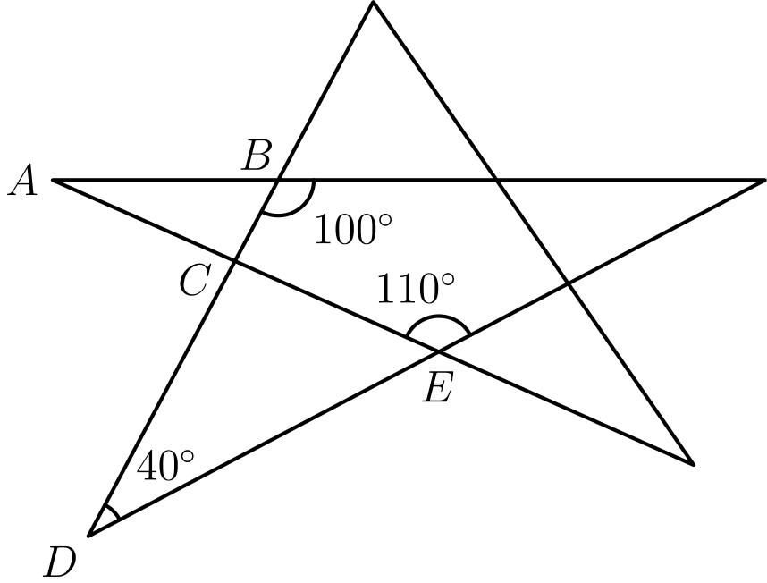
由补角关系，
∠ ABC = 180° - 100° = 80°。
同样由补角关系，
∠ CED = 180° - 110° = 70°。
利用三角形内角和为 180°，得到
∠ ECD = 180° - 70° - 40°
= 70°
。
再由对顶角相等，
∠ ACB = ∠ ECD = 70°。
最后在三角形中使用内角和，得到
∠ A = 180° - 80° - 70° = 30°。
所以正确答案是B。
English
Label the vertices as below.
We then have that
∠ ABC = 180° - 100° = 80°
by supplementary angles. Then we have
∠ CED = 180° - 110° = 70°
again by supplementary angles. Using the sum of the interior angles of a triangle is 180°, we get
∠ ECD = 180° - 70° - 40°
= 70°.
Then, using vertical angles, we have
∠ ACB = ∠ ECD = 70°.
Finally, using the sum of the interior angles of a triangle, we get
∠ A = 180° - 80° - 70° = 30°.
Thus,Bis the correct answer.
第 22 题 答案 D
三条鱼值两个面包，所以一条鱼值 2/3 个面包。
一条面包值 4 袋米，所以一条鱼值 2/3·4=8/3=22/3 袋米。
所以正确答案是D。
English
Three fish are worth two loaves of bread, so one fish is worth 2/3 of a loaf.
One loaf is worth 4 bags of rice, so one fish is worth 2/3·4=8/3=22/3 bags of rice.
Thus,Dis the correct answer.
第 23 题 答案 C
正方形面积为 3² = 9，所以每个区域的面积是 9 ÷ 3 = 3。
因此 △ BMC 的面积为 3，所以
1/2 · 3 · BM = 3
BM = 2。
因为 △ BMC 是直角三角形，
CM = √(2² + 3²) = √(13)。
所以正确答案是C。
English
The area of the square is 3² = 9, which means that the area of one region is 9 ÷ 3 = 3.
This means the area of △ BMC is 3, which means that
1/2 · 3 · BM = 3
BM = 2.
Since △ BMC is right, we have
CM = √(2² + 3²) = √(13).
Thus,Cis the correct answer.
第 24 题 答案 D
要求除以 5 的余数，只需要关注个位数。
因此只需观察个位数 9 的幂的规律。
9 的幂的个位数在 9 和 1 之间交替：
9, 81, 729, ⋯。
因为指数是偶数，所以 1999²⁰⁰⁰ 的个位数为 1。
除以 5 的余数就是 1，因为它比 10 的倍数多 1。
所以正确答案是D。
English
Note that to find the remainder when divided by 5, we only care about the units digit.
This means we only have to observe how the powers of the units digit work, namely the powers of 9.
Then, looking at powers of 9, we see that the units digit alternates between 9 and 1:
9, 81, 729, ⋯.
This means that 1999²⁰⁰⁰ ends in a 1 since the power is even.
The remainder when divided by 5 is then 1, since it is 1 more than a multiple of 10.
Thus,Dis the correct answer.
第 25 题 答案 A
第一个阴影三角形的两条直角边为 3 和 3，所以面积为 1/2·3·3=9/2。
之后每一步，相关三角形的边长变为原来的一半，因此阴影面积乘以 (1/2)²=1/4。
许多步后的阴影总面积非常接近等比和
9/2(1+1/4+1/16+⋯)
= 9/2·1/(1-1/4)
= 6
。
100 步后被省略的尾项极小，所以总面积最接近 6。
所以正确答案是A。
English
The first shaded triangle has legs 3 and 3, so its area is 1/2·3·3=9/2.
At each later step, the relevant triangle has half the leg length, so the shaded area is multiplied by (1/2)²=1/4.
The total shaded area after many steps is therefore very close to the geometric sum
9/2(1+1/4+1/16+⋯)
= 9/2·1/(1-1/4)
= 6.
After 100 steps the omitted tail is tiny, so the total area is nearest 6.
Thus,Ais the correct answer.

