1994 年 AMC 8 真题与解答
American Mathematics Competitions 8 · 中英双语
共 25 题，限时 40 分钟；单项选择题，每题 1 分，答错不扣分，满分 25 分。
编排说明：第一部分为题目（先中文、后英文原题），第二部分为解答与答案，便于先做题后对答案。
第一部分 题目
第 1 题
下列哪一个最大？
（A）1/3 （B）1/4 （C）3/8 （D）5/12 （E）7/24
English
Which of the following is the largest?
(A) 1/3 (B) 1/4 (C) 3/8 (D) 5/12 (E) 7/24
第 2 题
下列表达式的值是多少？
1/10 + 2/10 + 3/10 + 4/10
+ 5/10 + 6/10 + 7/10 + 8/10
+ 9/10 + 55/10
（A）41/2 （B）6.4 （C）9 （D）10 （E）11
English
What is the value of the following expression?
1/10 + 2/10 + 3/10 + 4/10
+ 5/10 + 6/10 + 7/10 + 8/10
+ 9/10 + 55/10
(A) 41/2 (B) 6.4 (C) 9 (D) 10 (E) 11
第 3 题
Maria 每天必须工作 8 小时，这不包括她 45 分钟的午餐时间。如果她上午 7:25 开始工作，并在中午吃午餐，那么她的工作日将在什么时候结束？
（A）下午 3:40 （B）下午 3:55 （C）下午 4:10 （D）下午 4:25 （E）下午 4:40
English
Each day Maria must work 8 hours. This does not include the 45 minutes she takes for lunch. If she begins working at 7:25 A.M. and takes her lunch break at noon, then her working day will end at
(A) 3:40 P.M. (B) 3:55 P.M. (C) 4:10 P.M. (D) 4:25 P.M. (E) 4:40 P.M.
第 4 题
右图绕中心顺时针旋转 120° 后，结果是哪一个？
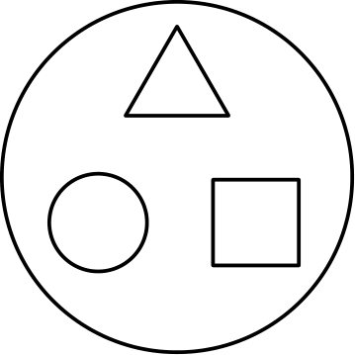
（A）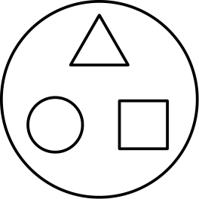
（B）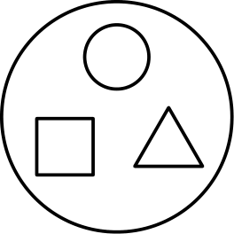
（C）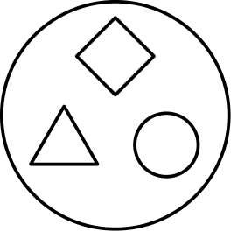
（D）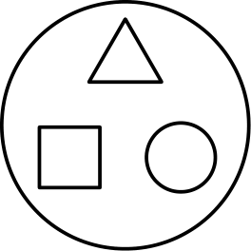
（E）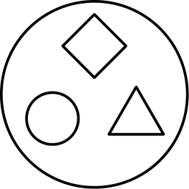
English
Which of the following represents the result when the figure shown at the right is rotated clockwise 120° about its center?
(A)
(B)
(C)
(D)
(E)
第 5 题
已知 1 英里 = 8 弗隆，且 1 弗隆 = 40 杆，那么一英里有多少杆？
（A）5 （B）320 （C）660 （D）1760 （E）5280
English
Given that 1 mile = 8 furlongs and 1 furlong = 40 rods, the number of rods in one mile is
(A) 5 (B) 320 (C) 660 (D) 1760 (E) 5280
第 6 题
任意六个连续正整数的乘积的个位数字是
（A）0 （B）2 （C）4 （D）6 （E）8
English
The unit’s digit (one’s digit) of the product of any six consecutive positive whole numbers is
(A) 0 (B) 2 (C) 4 (D) 6 (E) 8
第 7 题
如果 ∠ A = 60°，∠ E = 40°，且 ∠ C = 30°，那么 ∠ BDC =
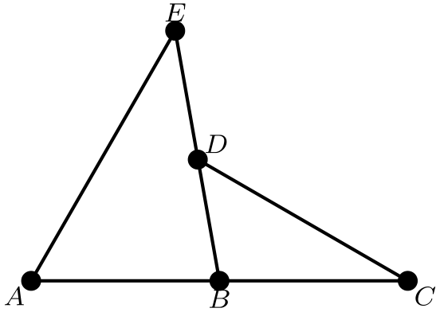
（A）40° （B）50° （C）60° （D）70° （E）80°
English
If ∠ A = 60°, ∠ E = 40°, and ∠ C = 30°, then ∠ BDC =
(A) 40° (B) 50° (C) 60° (D) 70° (E) 80°
第 8 题
有多少个三位正整数的数位和等于 25？
（A）2 （B）4 （C）6 （D）8 （E）10
English
For how many three-digit whole numbers does the sum of the digits equal 25?
(A) 2 (B) 4 (C) 6 (D) 8 (E) 10
第 9 题
一位购物者购买一件 $100 的外套，该外套正在减价 20% 出售。使用优惠券后，又从折后价中减去 $5。最终售价再加 8% 的销售税。购物者为这件外套总共支付
（A）$81.00 （B）$81.40 （C）$82.00 （D）$82.08 （E）$82.40
English
A shopper buys a $100 coat on sale for 20% off. An additional $5 is taken off the sale price by using a discount coupon. A sales tax of 8% is paid on the final selling price. The total amount the shopper pays for the coat is
(A) $81.00 (B) $81.40 (C) $82.00 (D) $82.08 (E) $82.40
第 10 题
有多少个正整数 N 满足 (N > 0)，使表达式
36/N+2
是整数？
（A）7 （B）8 （C）9 （D）10 （E）12
English
For how many positive integer values of N (N > 0) is the expression
36/N+2
an integer?
(A) 7 (B) 8 (C) 9 (D) 10 (E) 12
第 11 题
去年夏天有 100 名学生参加篮球营。其中有 52 名男生和 48 名女生。另外，40 名学生来自 Jones Middle School，60 名来自 Clay Middle School。有二十名女生来自 Jones Middle School。来自 Clay Middle School 的男生有多少名？
（A）20 （B）32 （C）40 （D）48 （E）52
English
Last summer 100 students attended basketball camp. Of those attending, 52 were boys and 48 were girls. Also, 40 students were from Jones Middle School and 60 were from Clay Middle School. Twenty of the girls were from Jones Middle School. How many of the boys were from Clay Middle School?
(A) 20 (B) 32 (C) 40 (D) 48 (E) 52
第 12 题
图中的三个大正方形大小相同。各线段与正方形边的交点都是边的中点。三个正方形中的阴影面积如何比较？
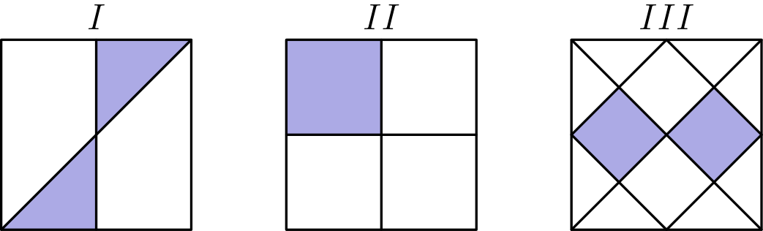
（A）三个阴影面积都相等。 （B）只有 I 和 II 的阴影面积相等。 （C）只有 I 和 III 的阴影面积相等。 （D）只有 II 和 III 的阴影面积相等。 （E）I、II 和 III 的阴影面积都不同。
English
Each of the three large squares shown is the same size. Segments that intersect the sides of the squares intersect at the midpoints of the sides. How do the shaded areas of these squares compare?
(A) The shaded areas in all three are equal. (B) Only the shaded areas of I and II are equal. (C) Only the shaded areas of I and III are equal. (D) Only the shaded areas of II and III are equal. (E) The shaded areas of I, II, and III are all
different.
第 13 题
位于 1/6 和 1/4 正中间的数是
（A）1/10 （B）1/5 （C）5/24 （D）7/24 （E）5/12
English
The number halfway between 1/6 and 1/4 is
(A) 1/10 (B) 1/5 (C) 5/24 (D) 7/24 (E) 5/12
第 14 题
pairball 每次可以由两个孩子玩。90 分钟内始终只有两个孩子同时在玩，五个孩子轮流上场，使每个人玩的时间相同。每个孩子玩了多少分钟？
（A）9 （B）10 （C）18 （D）20 （E）36
English
Two children at a time can play pairball. For 90 minutes, with only two children playing at one time, five children take turns so that each one plays the same amount of time. The number of minutes each child plays is
(A) 9 (B) 10 (C) 18 (D) 20 (E) 36
第 15 题
如果这条路径按相同规律继续，那么从点 425 到点 427 的箭头序列是哪一个？
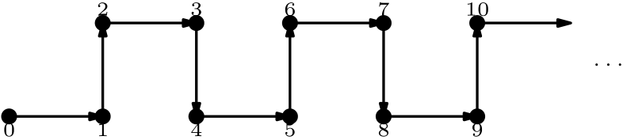
（A）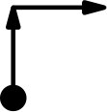
（B）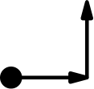
（C）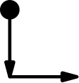
（D）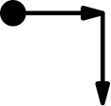
（E）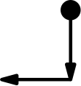
English
If this path is to continue in the same pattern, then which sequence of arrows goes from point 425 to point 427?
(A)
(B)
(C)
(D)
(E)
第 16 题
一个正方形的周长是另一个正方形周长的 3 倍。较大正方形的面积是较小正方形面积的多少倍？
（A）2 （B）3 （C）4 （D）6 （E）9
English
The perimeter of one square is 3 times the perimeter of another square. The area of the larger square is how many times the area of the smaller square?
(A) 2 (B) 3 (C) 4 (D) 6 (E) 9
第 17 题
Pauline Bunyan 第一小时可以铲 20 立方码雪，第二小时铲 19 立方码，第三小时铲 18 立方码，依此类推，每小时都比上一小时少铲一立方码。如果她的车道宽 4 码、长 10 码，并被 3 码深的雪覆盖，那么她铲干净大约需要多少小时？
（A）4 （B）5 （C）6 （D）7 （E）12
English
Pauline Bunyan can shovel snow at the rate of 20 cubic yards for the first hour, 19 cubic yards for the second, 18 for the third, etc., always shoveling one cubic yard less per hour than the previous hour. If her driveway is 4 yards wide, 10 yards long, and covered with snow 3 yards deep, then the number of hours it will take her to shovel it clean is closest to
(A) 4 (B) 5 (C) 6 (D) 7 (E) 12
第 18 题
Mike 离家后，先在城市交通中缓慢向东行驶。到达高速公路后，他更快地继续向东行驶，直到到达购物中心并停车。他在购物中心购物一小时。Mike 沿原路回家，先在高速公路上快速向西行驶，然后在城市交通中缓慢行驶。每个图的纵轴表示离家的距离，横轴表示离家后经过的时间。哪个图最能表示 Mike 的行程？
（A）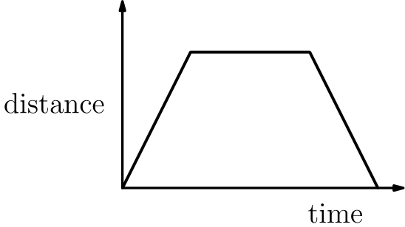
（B）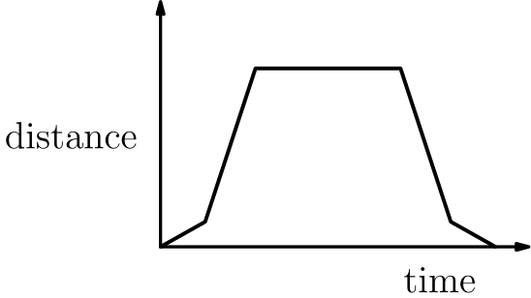
（C）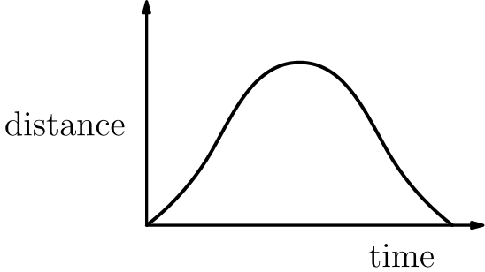
（D）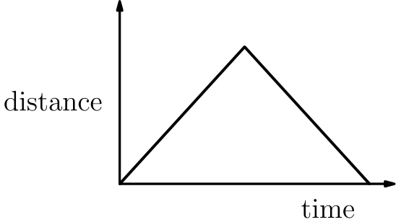
（E）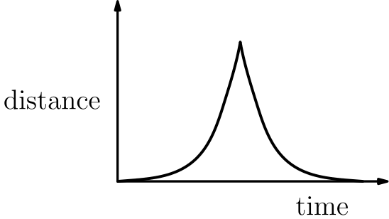
English
Mike leaves home and drives slowly east through city traffic. When he reaches the highway he drives east more rapidly until he reaches the shopping mall where he stops. He shops at the mall for an hour. Mike returns home by the same route as he came, driving west rapidly along the highway and then slowly through city traffic. Each graph shows the distance from home on the vertical axis versus the time elapsed since leaving home on the horizontal axis. Which graph is the best representation of Mike’s trip?
(A)
(B)
(C)
(D)
(E)
第 19 题
在一个 4 乘 4 的正方形外侧，以正方形的四条边为直径作四个半圆。另一个正方形 ABCD 的边分别与原正方形对应边平行，并且 ABCD 的每一边都与一个半圆相切。正方形 ABCD 的面积是
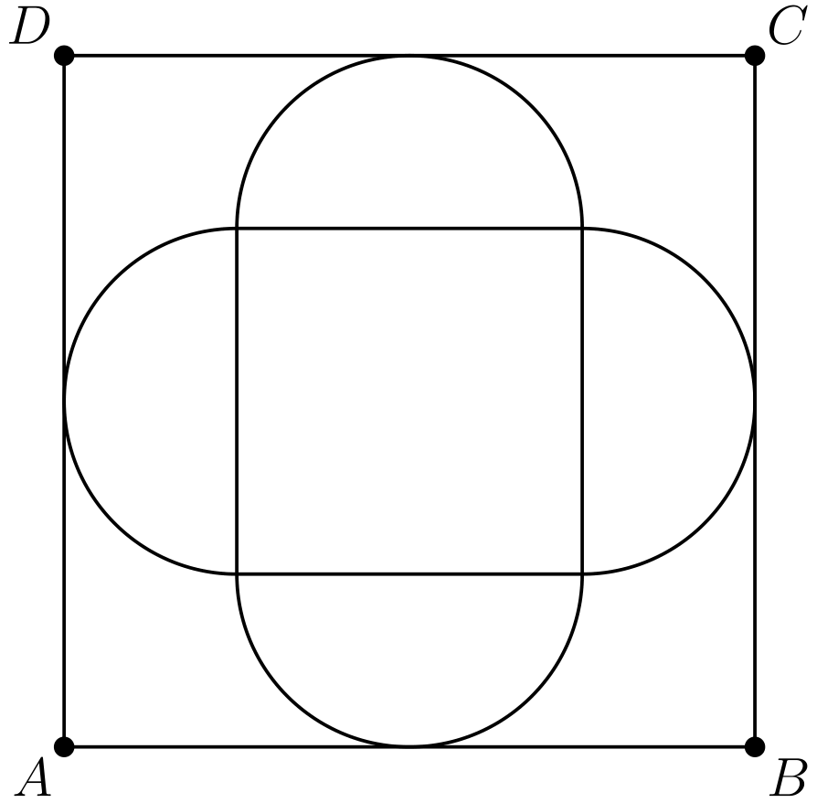
（A）16 （B）32 （C）36 （D）48 （E）64
English
Around the outside of a 4 by 4 square, construct four semicircles with the four sides of the square as their diameters. Another square, ABCD, has its sides parallel to the corresponding sides of the original square, and each side of ABCD is tangent to one of the semicircles. The area of the square ABCD is
(A) 16 (B) 32 (C) 36 (D) 48 (E) 64
第 20 题
从下列集合中选出四个不同数字 W，X，Y 和 Z：
{1, 2, 3, 4, 5, 6, 7, 8, 9}。
如果要使 W/X + Y/Z 尽可能小，那么 W/X + Y/Z 必须等于
（A）2/17 （B）3/17 （C）17/72 （D）25/72 （E）13/36
English
Let W, X, Y, and Z be four different digits selected from the set
{1, 2, 3, 4, 5, 6, 7, 8, 9}.
If the sum W/X + Y/Z is to be as small as possible, then W/X + Y/Z must equal
(A) 2/17 (B) 3/17 (C) 17/72 (D) 25/72 (E) 13/36
第 21 题
一台口香糖球机中有 9 个红色、7 个白色和 8 个蓝色口香糖球。为了保证得到四个同色口香糖球，一个人至少必须购买多少个口香糖球？
（A）8 （B）9 （C）10 （D）12 （E）18
English
A gumball machine contains 9 red, 7 white, and 8 blue gumballs. The least number of gumballs a person must buy to be sure of getting four gumballs of the same color is
(A) 8 (B) 9 (C) 10 (D) 12 (E) 18
第 22 题
右图中的两个转盘各转一次，并把得到的两个数相加。两个数之和为偶数的概率是
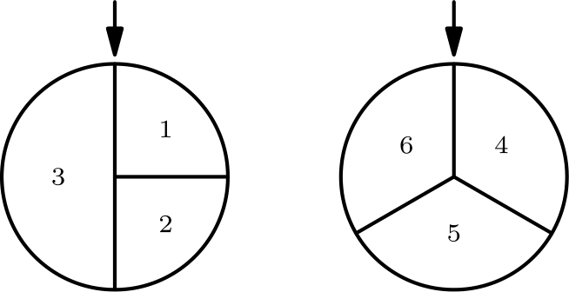
（A）1/6 （B）1/4 （C）1/3 （D）5/12 （E）4/9
English
The two wheels shown at the right are spun and the two resulting numbers are added. The probability that the sum of the two numbers is even is
(A) 1/6 (B) 1/4 (C) 1/3 (D) 5/12 (E) 4/9
第 23 题
如果 X，Y 和 Z 是不同数字，那么下列加法中可能得到的最大 3 位和
 | XXX
 | YX
+ | X

具有哪种形式？
（A）XXY （B）XYZ （C）YYX （D）YYZ （E）ZZY
English
If X, Y, and Z are different digits, then the largest possible 3-digit sum for
 | XXX
 | YX
+ | X

has the form
(A) XXY (B) XYZ (C) YYX (D) YYZ (E) ZZY
第 24 题
一个 2 乘 2 的正方形被分成四个 1 乘 1 的小正方形。每个小正方形要涂成绿色或红色。共有多少种不同涂法，使得没有任何绿色小正方形的上边或右边与红色小正方形相邻？绿色小正方形可以少到零个，也可以多到四个。
（A）4 （B）6 （C）7 （D）8 （E）16
English
A 2 by 2 square is divided into four 1 by 1 squares. Each of the small squares is to be painted either green or red. In how many different ways can the painting be accomplished so that no green square shares its top or right side with any red square? There may be as few as zero or as many as four small green squares.
(A) 4 (B) 6 (C) 7 (D) 8 (E) 16
第 25 题
求下列乘积结果的各位数字之和：
underbrace9999⋯99₉₄ × underbrace4444⋯44₉₄
也就是由 94 个九组成的数乘以由 94 个四组成的数。
（A）846 （B）855 （C）945 （D）954 （E）1072
English
Find the sum of the digits in the answer to
underbrace9999⋯99₉₄ × underbrace4444⋯44₉₄
where a string of 94 nines is multiplied by a string of 94 fours.
(A) 846 (B) 855 (C) 945 (D) 954 (E) 1072

第二部分 解答
答案速查：
题号 1 2 3 4 5 6 7 8 9
答案 D D C B B A B C A
题号 10 11 12 13 14 15 16 17 18
答案 A B A C E A E D B
题号 19 20 21 22 23 24 25
答案 E D C D D B A
答案串：DDCBBABCAABACEAEDBEDCDDBA
第 1 题 答案 D
通分到分母 24，这些分数分别是 8/24、6/24、9/24、10/24 和 7/24。
最大的分子是 10，所以 5/12 = 10/24 最大。
所以正确答案是D。
English
Over the common denominator 24, the fractions are 8/24, 6/24, 9/24, 10/24, and 7/24.
The largest numerator is 10, so 5/12 = 10/24 is the largest.
Thus, the correct answer isD.
第 2 题 答案 D
分子之和为 1 + 2 + ⋯ + 9 + 55 = 45 + 55 = 100。
所以总和是 100/10 = 10。
所以正确答案是D。
English
The numerators sum to 1 + 2 + ⋯ + 9 + 55 = 45 + 55 = 100.
So the total is 100/10 = 10.
Thus, the correct answer isD.
第 3 题 答案 C
上午 7:25 之后八小时是下午 3:25。
再加上 45 分钟午餐时间，结束时间为下午 4:10。
所以正确答案是C。
English
Eight hours after 7:25 A.M. is 3:25 P.M.
Adding the 45-minute lunch break gives an ending time of 4:10 P.M.
Thus, the correct answer isC.
第 4 题 答案 B
顺时针旋转 120° 后，每个图形移动到顺时针方向的下一个位置：上方的三角形移到右下，右下的正方形移到左下，左下的圆移到上方。
因此结果应为圆在上方，正方形在左下，三角形在右下，且每个图形形状保持不变。
所以正确答案是B。
English
A clockwise turn of 120° sends each shape to the next position clockwise: the triangle at the top moves to the lower right, the square at the lower right moves to the lower left, and the circle at the lower left moves to the top.
The result therefore has a circle on top, a square at the lower left, and a triangle at the lower right, with each shape keeping its original form.
Thus, the correct answer isB.
第 5 题 答案 B
一英里是 8 弗隆，每弗隆是 40 杆，所以一英里是 8 × 40 = 320 杆。
所以正确答案是B。
English
One mile is 8 furlongs, and each furlong is 40 rods, so one mile is 8 × 40 = 320 rods.
Thus, the correct answer isB.
第 6 题 答案 A
任意六个连续正整数中至少包含一个 5 的倍数和一个偶数，所以它们的乘积是 5 × 2 = 10 的倍数。
10 的倍数个位数字总是 0。
所以正确答案是A。
English
Any six consecutive whole numbers include at least one multiple of 5 and at least one even number, so their product is a multiple of 5 × 2 = 10.
A multiple of 10 always ends in 0.
Thus, the correct answer isA.
第 7 题 答案 B
在三角形 ABE 中，∠ ABE = 180° - (60° + 40°) = 80°。
因为 A, B, C 共线且 D 在 EB 上，所以 ∠ DBC = 180° - 80° = 100°。
在三角形 BDC 中，∠ BDC = 180° - (100° + 30°) = 50°。
所以正确答案是B。
English
In triangle ABE, ∠ ABE = 180° - (60° + 40°) = 80°.
Since A, B, C are collinear and D lies on segment EB, the angle ∠ DBC = 180° - 80° = 100°.
In triangle BDC, ∠ BDC = 180° - (100° + 30°) = 50°.
Thus, the correct answer isB.
第 8 题 答案 C
数位和为 25，而最大可能和是 27，所以至少有一个数字是 9。可能的数字组是 {9, 9, 7} 和 {9, 8, 8}。
每组都有 3 种不同排列：997、979、799 以及 988、898、889，共 6 个数。
所以正确答案是C。
English
Since the digits sum to 25 and the maximum is 27, at least one digit is 9. The possible digit sets are {9, 9, 7} and {9, 8, 8}.
Each set has 3 distinct arrangements (997, 979, 799 and 988, 898, 889), giving 6 numbers in all.
Thus, the correct answer isC.
第 9 题 答案 A
20% 折扣使价格降到 $80，$5 优惠券又使它降到 $75。
加上 8% 的税后，总价为 1.08 × $75 = $81.00。
所以正确答案是A。
English
The 20% discount lowers the price to $80, and the $5 coupon reduces it to $75.
Adding 8% tax gives 1.08 × $75 = $81.00.
Thus, the correct answer isA.
第 10 题 答案 A
表达式为整数时，N+2 必须整除 36。36 的正因数是 1、2、3、4、6、9、12、18、36。
因为 N > 0，所以 N + 2 > 2，可用的因数是 3、4、6、9、12、18、36，共有 7 个值。
所以正确答案是A。
English
The expression is an integer when N+2 divides 36. The divisors of 36 are 1, 2, 3, 4, 6, 9, 12, 18, 36.
Because N > 0, we need N + 2 > 2, leaving the divisors 3, 4, 6, 9, 12, 18, 36: that is 7 values.
Thus, the correct answer isA.
第 11 题 答案 B
共有 48 名女生，其中 20 名来自 Jones，所以来自 Clay 的女生有 48 - 20 = 28 名。
Clay 总共有 60 名学生，所以来自 Clay 的男生人数是 60 - 28 = 32。
所以正确答案是B。
English
Since 48 girls attended and 20 were from Jones, 48 - 20 = 28 girls were from Clay.
Clay had 60 students total, so the number of Clay boys is 60 - 28 = 32.
Thus, the correct answer isB.
第 12 题 答案 A
在正方形 II 中，阴影占 1 个小格，总共有 4 个相等小格，所以阴影面积是 1/4。
正方形 I 可分成 8 个相等三角形，其中 2 个涂色；正方形 III 可分成 16 个相等三角形，其中 4 个涂色。这些比例都是 2/8 = 4/16 = 1/4。
因为三个图形的阴影面积都占 1/4，所以阴影面积全都相等。
所以正确答案是A。
English
In square II, 1 of the 4 equal cells is shaded, so 1/4 of it is shaded.
Square I breaks into 8 equal triangles with 2 shaded, and square III breaks into 16 equal triangles with 4 shaded; each of these equals 2/8 = 4/16 = 1/4.
Since every figure has exactly 1/4 shaded, the shaded areas are all equal.
Thus, the correct answer isA.
第 13 题 答案 C
两个数正中间的数是它们的平均数：(1/6 + 1/4)/2。
因为 1/6 + 1/4 = 2/12 + 3/12 = 5/12，所以平均数是 5/12 ÷ 2 = 5/24。
所以正确答案是C。
English
The number halfway between two values is their average: (1/6 + 1/4)/2.
Since 1/6 + 1/4 = 2/12 + 3/12 = 5/12, the average is 5/12 ÷ 2 = 5/24.
Thus, the correct answer isC.
第 14 题 答案 E
任意时刻都有两个孩子在玩，共 90 分钟，所以总游戏时间是 2 × 90 = 180 个孩子分钟。
平均分给 5 个孩子，每个孩子玩 180/5 = 36 分钟。
所以正确答案是E。
English
Two children play at every moment for 90 minutes, so the total playing time is 2 × 90 = 180 child-minutes.
Split equally among 5 children, each plays 180/5 = 36 minutes.
Thus, the correct answer isE.
第 15 题 答案 A
这个模式每 4 个点重复一次，所以从某点出发的箭头只取决于它除以 4 的余数。
因为 425 = 4(106) + 1，且 427 = 4(106) + 3，所以从 425 到 427 的路径与从点 1 到点 3 相同：从 1 向上到 2，再向右到 3。
所以正确答案是A。
English
The pattern repeats every 4 points, so the arrows leaving a point depend only on its remainder upon division by 4.
Because 425 = 4(106) + 1 and 427 = 4(106) + 3, the path from 425 to 427 looks just like the path from point 1 to point 3: from 1 it goes up to 2, then right to 3.
Thus, the correct answer isA.
第 16 题 答案 E
正方形的周长与边长成正比，所以较大正方形的边长是较小正方形的 3 倍。
面积等于边长的平方，所以较大面积是较小面积的 3² = 9 倍。
所以正确答案是E。
English
A square’s perimeter is proportional to its side, so the larger square has side length 3 times the smaller one.
Area is the side squared, so the larger area is 3² = 9 times the smaller.
Thus, the correct answer isE.
第 17 题 答案 D
雪的体积是 4 × 10 × 3 = 120 立方码。
累计铲雪量是 20 + 19 + 18 + 17 + 16 + 15 + 14 = 119 立方码，也就是 7 小时的工作量。第八小时的铲雪速度是每小时 13 立方码，因此剩下的一立方码需要 1/13 小时。准确时间是 71/13 小时，最接近 7 小时。
所以正确答案是D。
English
The volume of snow is 4 × 10 × 3 = 120 cubic yards.
The amounts shoveled add up to 20 + 19 + 18 + 17 + 16 + 15 + 14 = 119 after 7 hours. In the eighth hour her rate is 13 cubic yards per hour, so the last cubic yard takes 1/13 hour. The exact time is therefore 71/13 hours, which is closest to 7.
Thus, the correct answer isD.
第 18 题 答案 B
去程中 Mike 先慢速行驶，对应平缓上升；再快速行驶，对应较陡上升。购物一小时期间离家距离不变，对应水平线段。
回程中他先快速行驶，对应较陡下降；再慢速行驶，对应较平缓下降。只有先慢后快上升、顶部水平、再先快后慢下降的图符合。
所以正确答案是B。
English
On the way out Mike drives slowly (a shallow slope) then rapidly (a steep slope), so the distance rises slowly and then more steeply. During the hour at the mall the distance stays the same, a flat segment.
On the return he drives rapidly (steep) then slowly (shallow), so the distance falls steeply and then more gently. Only the graph with a slow-then-fast rise, a flat top, and a fast-then-slow fall fits.
Thus, the correct answer isB.
第 19 题 答案 E
每个半圆建在长度为 4 的边上，所以半径为 2。每个半圆从原正方形的一边向外突出一个半径。
ABCD 的每条边等于原边长加两个半径：4 + 2(2) = 8。所以 ABCD 的面积是 8² = 64。
所以正确答案是E。
English
Each semicircle is built on a side of length 4, so its radius is 2. A semicircle bulges out from the middle of each side by that radius.
Each side of ABCD is the original side plus two radii: 4 + 2(2) = 8. So the area of ABCD is 8² = 64.
Thus, the correct answer isE.
第 20 题 答案 D
小分子和大分母会产生较小分数，所以用 1 和 2 作分子，用 8 和 9 作分母。
把较大的分子配给较大的分母，得到 1/8 + 2/9 = (9 + 16)/72 = 25/72，它小于 1/9 + 2/8 = 26/72。所以最小和是 25/72。
所以正确答案是D。
English
Small numerators and large denominators make small fractions, so use 1 and 2 as numerators and 8 and 9 as denominators.
Pairing the larger numerator with the larger denominator gives 1/8 + 2/9 = (9 + 16)/72 = 25/72, which is smaller than 1/9 + 2/8 = 26/72. So the minimum sum is 25/72.
Thus, the correct answer isD.
第 21 题 答案 C
最坏情况下，一个人可以先抽到 3 个红球、3 个白球和 3 个蓝球，共 9 个球，还没有四个同色。
第十个球必须与其中某一种颜色相同，从而得到四个同色。因此需要 10 个球。
所以正确答案是C。
English
In the worst case, a person could draw 3 red, 3 white, and 3 blue, which is 9 gumballs, without yet having four of any color.
The next (tenth) gumball must match one of these colors, giving four of that color. So 10 gumballs are needed.
Thus, the correct answer isC.
第 22 题 答案 D
第一个转盘中，P(1) = 1/4，P(2) = 1/4，P(3) = 1/2。第二个转盘中，4、5、6 各自的概率为 1/3。
和为偶数需要两个数同奇偶。两数都为奇数时，第一个数是 1 或 3，概率为 (3/4)；第二个数是 5，概率为 (1/3)，所以概率为 3/4 · 1/3 = 1/4。两数都为偶数时，第一个数是 2，概率为 (1/4)；第二个数是 4 或 6，概率为 (2/3)，所以概率为 1/4 · 2/3 = 1/6。
总概率是 1/4 + 1/6 = 5/12。
所以正确答案是D。
English
On the first wheel, P(1) = 1/4, P(2) = 1/4, and P(3) = 1/2. On the second wheel, each of 4, 5, 6 has probability 1/3.
The sum is even when both numbers are odd or both are even. Both odd: the first is 1 or 3 (3/4) and the second is 5 (1/3), giving 3/4 · 1/3 = 1/4. Both even: the first is 2 (1/4) and the second is 4 or 6 (2/3), giving 1/4 · 2/3 = 1/6.
The total probability is 1/4 + 1/6 = 5/12.
Thus, the correct answer isD.
第 23 题 答案 D
和的百位来自 X 加上可能的进位，所以若 X = 9，和会变成四位数。允许的最大值是 X = 8。
为了使和最大，取 Y = 9：此时 888 + 98 + 8 = 994。它的数字是 9、9、4；因为 9 = Y，而 4 是新数字 Z，所以和的形式是 YYZ。
所以正确答案是D。
English
The hundreds digit of the sum comes from X plus any carry, so if X = 9 the sum would spill over into four digits. The largest allowed value is X = 8.
To make the sum as large as possible, take Y = 9: then 888 + 98 + 8 = 994. Its digits are 9, 9, 4; since 9 = Y and 4 is a new digit Z, the sum has the form YYZ.
Thus, the correct answer isD.
第 24 题 答案 B
条件表示绿色方格不能在上方或右方紧邻红色方格，因此任何绿色方格都会迫使它上方和右方的方格也为绿色。绿色方格必须向右上角聚集。
合法涂法为：全红；只有右上角为绿；整行上排为绿；整列右排为绿；除左下角外全绿；全绿。共 6 种。
所以正确答案是B。
English
The rule says a green square cannot have a red square on its top or right side, so any green square forces the squares above and to its right to be green as well. The green squares must therefore cluster toward the top-right corner.
The valid colorings are: all four red; only the top-right green; the whole top row green; the whole right column green; all green except the bottom-left; and all four green. That is 6 colorings.
Thus, the correct answer isB.
第 25 题 答案 A
小例子显示规律：99 × 44 = 4356 和 999 × 444 = 443556。一般地，由 n 个九组成的数乘以由 n 个四组成的数，结果为 (n-1) 个四，然后一个 3，再 (n-1) 个五，最后一个 6。
当 n = 94 时，乘积含有 93 个四、一个 3、93 个五和一个 6。数字和为 93(4) + 3 + 93(5) + 6 = 93(9) + 9 = 94(9) = 846。
所以正确答案是A。
English
Small cases show the pattern: 99 × 44 = 4356 and 999 × 444 = 443556. In general, a string of n nines times a string of n fours gives (n-1) fours, then a 3, then (n-1) fives, then a 6.
For n = 94, the product has 93 fours, one 3, 93 fives, and one 6. The digit sum is 93(4) + 3 + 93(5) + 6 = 93(9) + 9 = 94(9) = 846.
Thus, the correct answer isA.

