1991 年 AMC 8 真题与解答
American Mathematics Competitions 8 · 中英双语
共 25 题，限时 40 分钟；单项选择题，每题 1 分，答错不扣分，满分 25 分。
编排说明：第一部分为题目（先中文、后英文原题），第二部分为解答与答案，便于先做题后对答案。
第一部分 题目
第 1 题
下列表达式的值是多少？
1,000,000,000,000
- 777,777,777,777
？
（A）222,222,222,222 （B）222,222,222,223 （C）233,333,333,333 （D）322,222,222,223 （E）333,333,333,333
English
What is the value of
1,000,000,000,000
- 777,777,777,777?
(A) 222,222,222,222 (B) 222,222,222,223 (C) 233,333,333,333 (D) 322,222,222,223 (E) 333,333,333,333
第 2 题
下面算式的值是多少？
16+8/4-2？
（A）4 （B）8 （C）12 （D）16 （E）20
English
What is the value of
16+8/4-2?
(A) 4 (B) 8 (C) 12 (D) 16 (E) 20
第 3 题
二十万乘以二十万等于
（A）四十万 （B）四百万 （C）四万 （D）四亿 （E）四百亿
English
Two hundred thousand times two hundred thousand equals
(A) four hundred thousand (B) four million (C) forty thousand (D) four hundred million (E) forty billion
第 4 题
如果 991 + 993 + 995 + 997 + 999 = 5000 - N，那么 N =
（A）5 （B）10 （C）15 （D）20 （E）25
English
If 991 + 993 + 995 + 997 + 999 = 5000 - N, then N =
(A) 5 (B) 10 (C) 15 (D) 20 (E) 25
第 5 题
一个“多米诺骨牌”由两个小正方形组成：

。下面哪一个“棋盘”不能被若干个不重叠的完整多米诺骨牌恰好完全覆盖？
（A）3 × 4
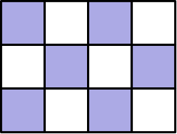
（B）3 × 5
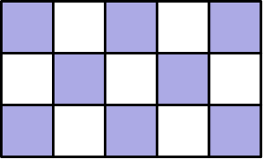
（C）4 × 4
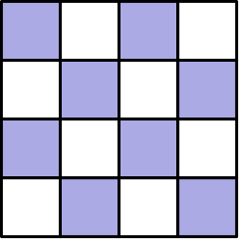
（D）4 × 5
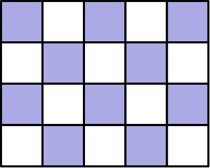
（E）6 × 3
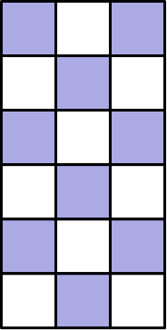
English
A “domino” is made up of two small squares:
. Which of the “checkerboards” illustrated below CANNOT be covered exactly and completely by a whole number of non-overlapping dominoes?
(A) 3 × 4
(B) 3 × 5
(C) 4 × 4
(D) 4 × 5
(E) 6 × 3
第 6 题
下面数组中的哪个数既是它所在列中最大的数，又是它所在行中最小的数？（列是上下方向，行是左右方向。）
10 | 6 | 4 | 3 | 2
11 | 7 | 14 | 10 | 8
8 | 3 | 4 | 5 | 9
13 | 4 | 15 | 12 | 1
8 | 2 | 5 | 9 | 3

（A）1 （B）6 （C）7 （D）12 （E）15
English
Which number in the array below is both the largest in its column and the smallest in its row? (Columns go up and down, rows go right and left.)
10 | 6 | 4 | 3 | 2
11 | 7 | 14 | 10 | 8
8 | 3 | 4 | 5 | 9
13 | 4 | 15 | 12 | 1
8 | 2 | 5 | 9 | 3

(A) 1 (B) 6 (C) 7 (D) 12 (E) 15
第 7 题
下列表达式
tiny((487,000)(12,027,300) + (9,621,001)(487,000))/((19,367)(0.05))
的值最接近
（A）10,000,000 （B）100,000,000 （C）1,000,000,000 （D）10,000,000,000 （E）100,000,000,000
English
The value of
tiny((487,000)(12,027,300) + (9,621,001)(487,000))/((19,367)(0.05))
is closest to
(A) 10,000,000 (B) 100,000,000 (C) 1,000,000,000 (D) 10,000,000,000 (E) 100,000,000,000
第 8 题
从集合 {-24, -3, -2, 1, 2, 8} 中选两个数相除，能形成的最大商是多少？
（A）-24 （B）-3 （C）8 （D）12 （E）24
English
What is the largest quotient that can be formed using two numbers chosen from the set {-24, -3, -2, 1, 2, 8}?
(A) -24 (B) -3 (C) 8 (D) 12 (E) 24
第 9 题
从 1 到 46 的整数中，有多少个能被 3 或 5 或两者都整除？
（A）18 （B）21 （C）24 （D）25 （E）27
English
How many whole numbers from 1 through 46 are divisible by either 3 or 5 or both?
(A) 18 (B) 21 (C) 24 (D) 25 (E) 27
第 10 题
平行四边形 ABCD 围成区域的面积是多少平方单位？
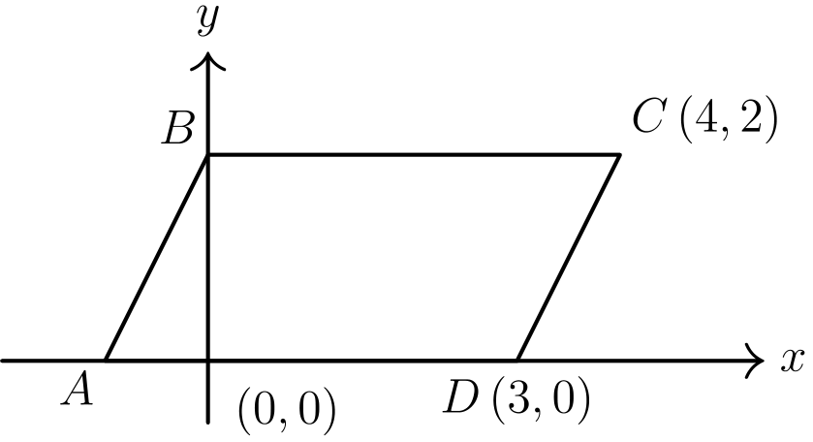
（A）6 （B）8 （C）12 （D）15 （E）18
English
The area in square units of the region enclosed by parallelogram ABCD is
(A) 6 (B) 8 (C) 12 (D) 15 (E) 18
第 11 题
从 {1, 2, 3, 4, 5, 6, 7, 8, 9} 中可以选出若干组三个不同的数，它们的和为 15。其中有多少组包含 5？
（A）3 （B）4 （C）5 （D）6 （E）7
English
There are several sets of three different numbers whose sum is 15 which can be chosen from {1, 2, 3, 4, 5, 6, 7, 8, 9}. How many of these sets contain a 5?
(A) 3 (B) 4 (C) 5 (D) 6 (E) 7
第 12 题
如果
2+3+4/3
= 1990+1991+1992/N
，
那么 N =
（A）3 （B）6 （C）1990 （D）1991 （E）1992
English
If
2+3+4/3
= 1990+1991+1992/N,
then N =
(A) 3 (B) 6 (C) 1990 (D) 1991 (E) 1992
第 13 题
下列乘积末尾有多少个零？
25 × 25 × 25 × 25
× 25 × 25 × 25
× 8 × 8 × 8？
（A）3 （B）6 （C）9 （D）10 （E）12
English
How many zeros are at the end of the product
25 × 25 × 25 × 25
× 25 × 25 × 25
× 8 × 8 × 8?
(A) 3 (B) 6 (C) 9 (D) 10 (E) 12
第 14 题
几名学生参加三场赛跑。每场比赛第一名得 5 分，第二名得 3 分，第三名得 1 分。没有并列名次。一个学生在三场比赛中至少要得到多少分，才能保证他的总分高于任何其他学生？
（A）9 （B）10 （C）11 （D）13 （E）15
English
Several students are competing in a series of three races. A student earns 5 points for winning a race, 3 points for finishing second, and 1 point for finishing third. There are no ties. What is the smallest number of points that a student must earn in the three races to be guaranteed of earning more points than any other student?
(A) 9 (B) 10 (C) 11 (D) 13 (E) 15
第 15 题
一个长方体的六个面都是长方形。如图，从这个长方体中切去一个边长为一英尺的立方体。新立体的表面积比原立体的表面积多或少多少平方英尺？
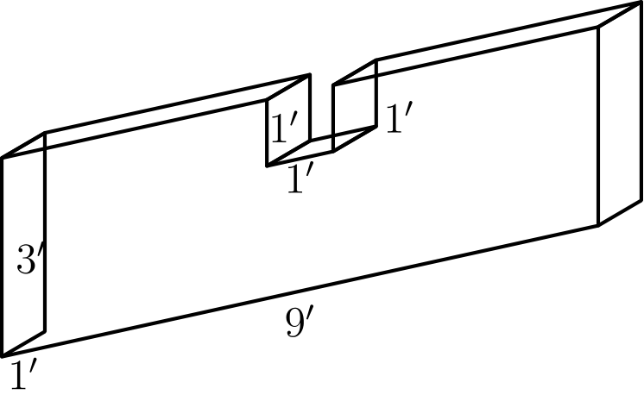
（A）少 2 （B）少 1 （C）相同 （D）多 1 （E）多 2
English
All six sides of a rectangular solid were rectangles. A one-foot cube was cut out of the rectangular solid as shown. The total number of square feet in the surface of the new solid is how many more or less than that of the original solid?
(A) 2 less (B) 1 less (C) the same (D) 1 more (E) 2 more
第 16 题
一张纸上的 16 个小正方形按图编号。纸平放在桌上，按下面顺序对折四次：
(1) 将上半部分折到下半部分上；
(2) 将下半部分折到上半部分上；
(3) 将右半部分折到左半部分上；
(4) 将左半部分折到右半部分上。
第 4 步之后，哪个编号的小正方形在最上面？
1 | 2 | 3 | 4
5 | 6 | 7 | 8
9 | 10 | 11 | 12
13 | 14 | 15 | 16

（A）1 （B）9 （C）10 （D）14 （E）16
English
The 16 squares on a piece of paper are numbered as shown in the diagram. While lying on a table, the paper is folded in half four times in the following sequence:
(1) fold the top half over the bottom half;
(2) fold the bottom half over the top half;
(3) fold the right half over the left half;
(4) fold the left half over the right half.
Which numbered square is on top after step 4?
1 | 2 | 3 | 4
5 | 6 | 7 | 8
9 | 10 | 11 | 12
13 | 14 | 15 | 16

(A) 1 (B) 9 (C) 10 (D) 14 (E) 16
第 17 题
一个礼堂有 20 排座位，第一排有 10 个座位。之后每一排都比前一排多一个座位。如果参加考试的学生可以坐在任何一排，但同一排中不能与另一个学生相邻，那么最多能安排多少名学生考试？
（A）150 （B）180 （C）200 （D）400 （E）460
English
An auditorium with 20 rows of seats has 10 seats in the first row. Each successive row has one more seat than the previous row. If students taking an exam are permitted to sit in any row, but not next to another student in that row, then the maximum number of students that can be seated for an exam is
(A) 150 (B) 180 (C) 200 (D) 400 (E) 460
第 18 题
纵轴表示员工人数，但这张图的刻度被意外漏掉了。高斯公司有百分之几的员工已经在那里工作了 5 年或更久？
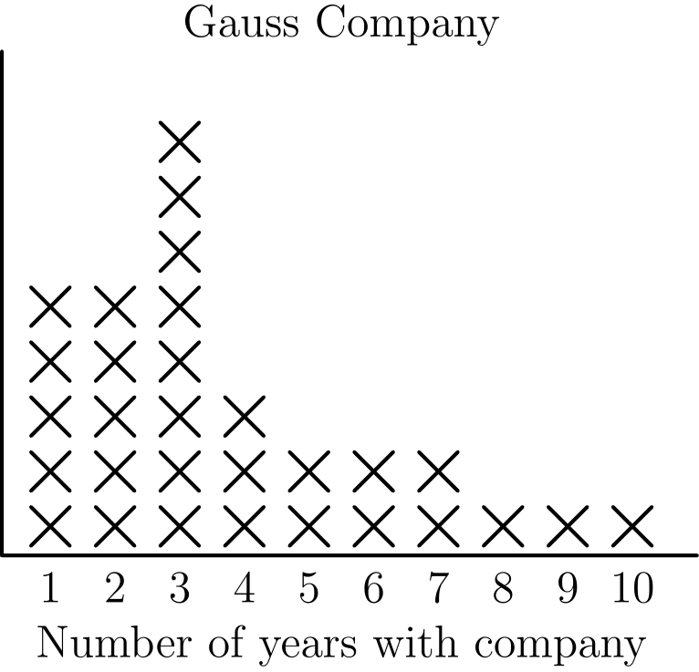
（A）9% （B）231/3% （C）30% （D）426/7% （E）50%
English
The vertical axis indicates the number of employees, but the scale was accidentally omitted from this graph. What percent of the employees at the Gauss Company have worked there for 5 years or more?
(A) 9% (B) 231/3% (C) 30% (D) 426/7% (E) 50%
第 19 题
10 个不同正整数的平均数是 10。这些数中任意一个可能取得的最大值是
（A）10 （B）50 （C）55 （D）90 （E）91
English
The average (arithmetic mean) of 10 different positive whole numbers is 10. The largest possible value of any of these numbers is
(A) 10 (B) 50 (C) 55 (D) 90 (E) 91
第 20 题
在所示加法算式中，每个数字都被一个字母代替。若不同字母表示不同数字，那么 C =
 | A | B | C
 |  | A | B
+ |  |  | A
 | 3 | 0 | 0

（A）1 （B）3 （C）5 （D）7 （E）9
English
In the addition problem shown, each digit has been replaced by a letter. If different letters represent different digits, then C =
 | A | B | C
 |  | A | B
+ |  |  | A
 | 3 | 0 | 0

(A) 1 (B) 3 (C) 5 (D) 7 (E) 9
第 21 题
温度每升高 3°，某种气体的体积就膨胀 4 立方厘米。如果温度为 32° 时气体体积是 24 立方厘米，那么温度为 20° 时气体体积是多少立方厘米？
（A）8 （B）12 （C）15 （D）16 （E）40
English
For every 3° rise in temperature, the volume of a certain gas expands by 4 cubic centimeters. If the volume of the gas is 24 cubic centimeters when the temperature is 32°, what was the volume of the gas in cubic centimeters when the temperature was 20°?
(A) 8 (B) 12 (C) 15 (D) 16 (E) 40
第 22 题
每个转盘都被平均分成 3 部分。转动两个转盘，把得到的两个数相乘。乘积为偶数的概率是多少？
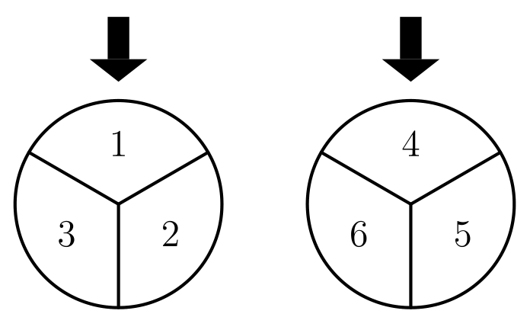
（A）1/3 （B）1/2 （C）2/3 （D）7/9 （E）1
English
Each spinner is divided into 3 equal parts. The results obtained from spinning the two spinners are multiplied. What is the probability that this product is an even number?
(A) 1/3 (B) 1/2 (C) 2/3 (D) 7/9 (E) 1
第 23 题
毕达哥拉斯高中的乐队有 100 名女生和 80 名男生。毕达哥拉斯高中的管弦乐队有 80 名女生和 100 名男生。有 60 名女生同时属于乐队和管弦乐队。总共有 230 名学生属于乐队或管弦乐队或两者都属于。属于乐队但不属于管弦乐队的男生人数是
（A）10 （B）20 （C）30 （D）50 （E）70
English
The Pythagoras High School band has 100 female and 80 male members. The Pythagoras High School orchestra has 80 female and 100 male members. There are 60 females who are members in both band and orchestra. Altogether, there are 230 students who are in either band or orchestra or both. The number of males in the band who are NOT in the orchestra is
(A) 10 (B) 20 (C) 30 (D) 50 (E) 70
第 24 题
一个边长为 3 厘米的正方体被切成 N 个较小的正方体，且这些小正方体不全同样大小。如果每个小正方体的边长都是整厘米数，那么 N =
（A）4 （B）8 （C）12 （D）16 （E）20
English
A cube of edge 3 cm is cut into N smaller cubes, not all the same size. If the edge of each of the smaller cubes is a whole number of centimeters, then N =
(A) 4 (B) 8 (C) 12 (D) 16 (E) 20
第 25 题
一个等边三角形最初被涂成黑色。每次改变时，每个黑色三角形的中间四分之一变成白色。经过五次改变后，仍为黑色的部分占原三角形面积的几分之几？
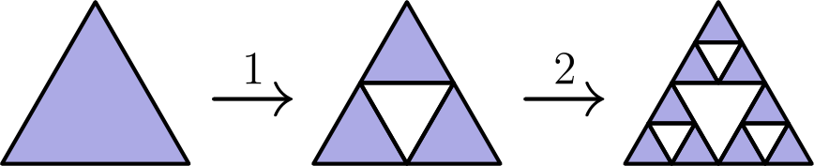
（A）1/1024 （B）15/64 （C）243/1024 （D）1/4 （E）81/256
English
An equilateral triangle is originally painted black. Each time the triangle is changed, the middle fourth of each black triangle turns white. After five changes, what fractional part of the original area of the black triangle remains black?
(A) 1/1024 (B) 15/64 (C) 243/1024 (D) 1/4 (E) 81/256

第二部分 解答
答案速查：
题号 1 2 3 4 5 6 7 8 9
答案 B C E E B C D D B
题号 10 11 12 13 14 15 16 17 18
答案 B B D C D C B C C
题号 19 20 21 22 23 24 25
答案 C A A D A E C
答案串：BCEEBCDDBBBDCDCBCCCAADAEC
第 1 题 答案 B
竖式相减得
1,000,000,000,000
- 777,777,777,777
= 222,222,222,223
。
也可以想成：从 777,777,777,777 增加到 1,000,000,000,000，个位要加 3，其余十一位各加 2。
所以正确答案是B。
English
Lining up the subtraction gives
1,000,000,000,000
- 777,777,777,777
= 222,222,222,223.
Equivalently, to climb from 777,777,777,777 up to 1,000,000,000,000 you add 3 in the units place and 2 in each of the other eleven places.
Thus, the correct answer isB.
第 2 题 答案 C
16+8/4-2 = 24/2 = 12。
所以正确答案是C。
English
16+8/4-2 = 24/2 = 12.
Thus, the correct answer isC.
第 3 题 答案 E
200,000 × 200,000 = 4 × 10¹⁰ = 40,000,000,000，也就是四百亿。
所以正确答案是E。
English
200,000 × 200,000 = 4 × 10¹⁰ = 40,000,000,000, which is forty billion.
Thus, the correct answer isE.
第 4 题 答案 E
因为
991+993+995
+997+999
= (1000-9)+(1000-7)
+(1000-5)
+(1000-3)+(1000-1)
= 5000 - (9+7+5+3+1)
= 5000 - 25
，
所以 N = 25。
所以正确答案是E。
English
Since
991+993+995
+997+999
= (1000-9)+(1000-7)
+(1000-5)
+(1000-3)+(1000-1)
= 5000 - (9+7+5+3+1)
= 5000 - 25,
we get N = 25.
Thus, the correct answer isE.
第 5 题 答案 B
每个多米诺骨牌覆盖 2 个小正方形，所以能被不重叠多米诺完全覆盖的棋盘必须有偶数个小正方形。
各棋盘的格数为：3 × 4 = 12，3 × 5 = 15，4 × 4 = 16，4 × 5 = 20，6 × 3 = 18。只有 3 × 5 = 15 是奇数，所以不能被完全覆盖。（每个格数为偶数的棋盘都有一条边长是偶数，很容易用多米诺骨牌铺满。）
所以正确答案是B。
English
Every domino covers exactly 2 squares, so any board that is completely covered by non-overlapping dominoes must contain an even number of small squares.
Counting squares: 3 × 4 = 12, 3 × 5 = 15, 4 × 4 = 16, 4 × 5 = 20, and 6 × 3 = 18. Only 3 × 5 = 15 is odd, so that board cannot be covered. (Each of the even boards has a side of even length and is easily tiled with dominoes.)
Thus, the correct answer isB.
第 6 题 答案 C
五列的最大数依次为 13（第 1 列）、7（第 2 列）、15（第 3 列）、12（第 4 列）和 9（第 5 列）。
这些数中，只有 7 是它所在行中的最小数，因为第 2 行是 11、7、14、10、8。
所以正确答案是C。
English
The largest entry in each column is 13 (column 1), 7 (column 2), 15 (column 3), 12 (column 4), and 9 (column 5).
Of these, only 7 is the smallest number in its own row (row 2 is 11, 7, 14, 10, 8).
Thus, the correct answer isC.
第 7 题 答案 D
分子可提取公因数：487,000 · (12,027,300 + 9,621,001)。
粗略估计为 500,000 × (10,000,000 + 10,000,000) = 500,000 × 2 × 10⁷。分母约为 20,000 × 0.05 = 1000。
所以整个值约为 (500,000 × 2 × 10⁷)/1000 = 10¹⁰ = 10,000,000,000。
所以正确答案是D。
English
Factor the numerator: 487,000 · (12,027,300 + 9,621,001).
Rounding to leading digits, this is about 500,000 × (10,000,000 + 10,000,000) = 500,000 × 2 × 10⁷. The denominator is about 20,000 × 0.05 = 1000.
So the value is roughly (500,000 × 2 × 10⁷)/1000 = 10¹⁰ = 10,000,000,000.
Thus, the correct answer isD.
第 8 题 答案 D
要得到较大的商，应让商为正，所以可以用两个正数或两个负数。
最好的正数组合是 8/1 = 8。最好的负数组合是 -24/-2 = 12。较大的是 12。
所以正确答案是D。
English
For a large quotient it should be positive, so use two positive numbers or two negative numbers.
Best positive pair: 8/1 = 8. Best negative pair: -24/-2 = 12. The larger is 12.
Thus, the correct answer isD.
第 9 题 答案 B
不超过 46 的 3 的倍数有 15 个，5 的倍数有 9 个。15 的倍数有 3 个，即 15、30、45，它们被重复计算了。
用容斥原理，所求个数是 15 + 9 - 3 = 21。
所以正确答案是B。
English
There are 15 multiples of 3 and 9 multiples of 5 up to 46. The 3 multiples of 15 (namely 15, 30, 45) were counted twice.
By inclusion-exclusion, the count is 15 + 9 - 3 = 21.
Thus, the correct answer isB.
第 10 题 答案 B
边 BC 从 (0,2) 到 (4,2)，所以底长为 4。相对边 AD 在 x 轴上，所以高为 2。
面积是 4 × 2 = 8。
所以正确答案是B。
English
Side BC runs from (0,2) to (4,2), so the base is 4. The opposite side AD lies on the x-axis, so the height is 2.
The area is 4 × 2 = 8.
Thus, the correct answer isB.
第 11 题 答案 B
选定 5 后，另外两个不同的数必须和为 10。这样的数对是 1+9、2+8、3+7、4+6，共 4 组。
所以正确答案是B。
English
With 5 chosen, the other two different numbers must sum to 10. The pairs are 1+9, 2+8, 3+7, 4+6, giving 4 sets.
Thus, the correct answer isB.
第 12 题 答案 D
左边是 9/3 = 3。右边是 5973/N，令它等于 3，得到 N = 1991。
也可以用规律：(k-1) + k + (k+1) = 3k，所以除以 3 后得到中间项。这里中间项是 1991。
所以正确答案是D。
English
The left side is 9/3 = 3. The right side is 5973/N, and setting it equal to 3 gives N = 1991.
Equivalently, (k-1) + k + (k+1) = 3k, so dividing by 3 leaves the middle term. Here the middle term is 1991.
Thus, the correct answer isD.
第 13 题 答案 C
因为 25 = 5²，七个 25 提供 5¹⁴。因为 8 = 2³，三个 8 提供 2⁹。
末尾零的个数是 min(14, 9) = 9。
所以正确答案是C。
English
Since 25 = 5², the seven 25’s give 5¹⁴. Since 8 = 2³, the three 8’s give 2⁹.
The number of trailing zeros is min(14, 9) = 9.
Thus, the correct answer isC.
第 14 题 答案 D
总分 11 并不能保证第一，例如 5+5+1 可能被另一个学生也得到 11 分。
但如果一个学生得到 5+5+3 = 13 分，那么剩下的名次使任何其他学生最多得到 3+3+5 = 11 分。因此 13 分能保证领先。
所以正确答案是D。
English
A total of 11 (for example 5+5+1) does not guarantee first place, since another student could also reach 11.
But if one student scores 5+5+3 = 13, the remaining places give every other student at most 3+3+5 = 11. So 13 points guarantees the lead.
Thus, the correct answer isD.
第 15 题 答案 C
被切掉的小立方体有三个面原来在立体表面上：上面、前面、后面，所以移除了 3 平方英尺表面积。
切出凹口后，又露出三个新面：凹口底面和两个侧壁，共增加 3 平方英尺。因此表面积不变。
所以正确答案是C。
English
The removed cube had three faces on the surface of the solid (top, front, and back), so 3 square feet of surface are removed.
Cutting it out exposes three new faces (the floor of the notch and its two side walls), adding 3 square feet. The surface area is unchanged.
Thus, the correct answer isC.
第 16 题 答案 B
第 1 次上半折到下半后，9–16 在底部。第 2 次下半折到上半后，9–12 在底部。第 3 次右半折到左半后，9 和 10 在底部。
第 4 次左半折到右半，会让 10 在底部，并把 9 带到最上面。
所以正确答案是B。
English
Fold 1 (top over bottom) leaves squares 9–16 on the bottom. Fold 2 (bottom over top) leaves 9–12 on the bottom. Fold 3 (right over left) leaves 9 and 10 on the bottom.
Fold 4 (left over right) puts 10 on the bottom and brings 9 to the top.
Thus, the correct answer isB.
第 17 题 答案 C
第 k 排有 9+k 个座位，所以最多坐 ⌈ 9+k/2 ⌉ 人。第 1 到第 20 排的座位数从 10 到 29，对应最大人数为 5、6、6、7、7、8、8、…、14、14、15。
这些数相加为 200。
所以正确答案是C。
English
Row k has 9+k seats, so it holds ⌈ 9+k/2 ⌉ students. For rows 1 through 20 (seats 10 through 29) the maxima are 5, 6, 6, 7, 7, 8, 8, …, 14, 14, 15.
These sum to 200.
Thus, the correct answer isC.
第 18 题 答案 C
不论缺失的刻度是多少，每个 X 都代表相同数量的员工。共有 9 个 X 分布在工作年数 5 到 10 的各栏上，全图共有 30 个 X。
所以比例是 9/30 = 30%。
所以正确答案是C。
English
No matter the missing scale, each X represents the same number of employees. There are 9 X’s over years 5 through 10, and 30 X’s in all.
So the fraction is 9/30 = 30%.
Thus, the correct answer isC.
第 19 题 答案 C
这十个数的总和是 100。要使其中一个数最大，另外九个不同正整数应尽可能小，即 1 + 2 + ⋯ + 9 = 45。
最大的那个数就是 100 - 45 = 55。
所以正确答案是C。
English
The ten numbers sum to 100. To maximize one of them, the other nine (all different positive whole numbers) should be as small as possible: 1 + 2 + ⋯ + 9 = 45.
The largest number is then 100 - 45 = 55.
Thus, the correct answer isC.
第 20 题 答案 A
三个数相加为 111A + 11B + C = 300。若 A = 1，数值太小；若 A ≥ 3，数值太大，所以 A = 2。
此时 11B + C = 78，只能有 B = 7 且 C = 1。所以 C = 1。
所以正确答案是A。
English
The three numbers add to 111A + 11B + C = 300. Since A = 1 is too small and A ≥ 3 is too large, A = 2.
Then 11B + C = 78, which forces B = 7 and C = 1. So C = 1.
Thus, the correct answer isA.
第 21 题 答案 A
从 32° 到 20° 是下降 12°，也就是 4 个 3°。
体积减少 4 × 4 = 16 立方厘米，所以从 24 降到 24 - 16 = 8。
所以正确答案是A。
English
From 32° to 20° is a 12° decrease, which is 4 steps of 3°.
The volume decreases by 4 × 4 = 16 cubic centimeters, from 24 down to 24 - 16 = 8.
Thus, the correct answer isA.
第 22 题 答案 D
乘积为奇数当且仅当两个数都是奇数。第一个转盘转到奇数 1 或 3 的概率是 2/3，第二个转盘转到奇数 5 的概率是 1/3。
所以乘积为奇数的概率是 2/3 × 1/3 = 2/9，乘积为偶数的概率是 1 - 2/9 = 7/9。
所以正确答案是D。
English
The product is odd only when both numbers are odd. The first spinner is odd (1 or 3) with probability 2/3, and the second is odd (5) with probability 1/3.
So the product is odd with probability 2/3 × 1/3 = 2/9, and even with probability 1 - 2/9 = 7/9.
Thus, the correct answer isD.
第 23 题 答案 A
属于乐队或管弦乐队的女生人数为 100 + 80 - 60 = 120。所以属于至少一个团体的男生人数为 230 - 120 = 110。
乐队有 80 名男生，管弦乐队有 100 名男生，因此两个团体都有的男生人数是 80 + 100 - 110 = 70。属于乐队但不属于管弦乐队的男生有 80 - 70 = 10 人。
所以正确答案是A。
English
Females in band or orchestra: 100 + 80 - 60 = 120. So males in at least one group: 230 - 120 = 110.
With 80 males in band and 100 in orchestra, the males in both are 80 + 100 - 110 = 70. Hence males in band but not orchestra: 80 - 70 = 10.
Thus, the correct answer isA.
第 24 题 答案 E
这个 3 × 3 × 3 正方体的体积是 27。由于小正方体更小且边长为整数，它们的边长只能是 1 或 2。原正方体内不能放下两个互不相交的边长为 2 的正方体，因为要将它们分开，某个方向上的总跨度至少为 4。因此最多只能放下一个边长为 2 的正方体。
剩余体积 27 - 8 = 19，由 19 个单位正方体填满。总数是 1 + 19 = 20 个正方体。
所以正确答案是E。
English
The 3 × 3 × 3 cube has volume 27. Since the cubes are smaller and have whole-number edge lengths, their edges are 1 or 2. Two edge-2 cubes cannot be disjoint inside the original cube: separating them would require a total span of at least 4 in some direction. Thus at most one edge-2 cube fits.
The remaining 27 - 8 = 19 of volume is filled by 19 unit cubes. That is 1 + 19 = 20 cubes.
Thus, the correct answer isE.
第 25 题 答案 C
每一次改变都会让当前黑色面积的 3/4 保持黑色。五次改变后，黑色面积比例为
(3/4)⁵ = 243/1024。
所以正确答案是C。
English
Each change leaves 3/4 of the current black area black. After five changes the black fraction is
(3/4)⁵ = 243/1024.
Thus, the correct answer isC.

