1990 年 AMC 8 真题与解答
American Mathematics Competitions 8 · 中英双语
共 25 题，限时 40 分钟；单项选择题，每题 1 分，答错不扣分，满分 25 分。
编排说明：第一部分为题目（先中文、后英文原题），第二部分为解答与答案，便于先做题后对答案。
第一部分 题目
第 1 题
把两个 3 位数加法算式中的六个方框分别填入数字 4、5、6、7、8、9，每个数字用一次。能够得到的最小的两个 3 位数之和是多少？
（A）947 （B）1037 （C）1047 （D）1056 （E）1245
English
What is the smallest sum of two 3-digit numbers that can be obtained by placing each of the six digits 4, 5, 6, 7, 8, 9 into one of the six boxes of a sum of two 3-digit numbers?
(A) 947 (B) 1037 (C) 1047 (D) 1056 (E) 1245
第 2 题
把 0.12345 中的哪一个数字改成 9，会得到最大的数？
（A）1 （B）2 （C）3 （D）4 （E）5
English
Which digit of 0.12345, when changed to 9, gives the largest number?
(A) 1 (B) 2 (C) 3 (D) 4 (E) 5
第 3 题
正方形中有多少比例的面积被涂色？
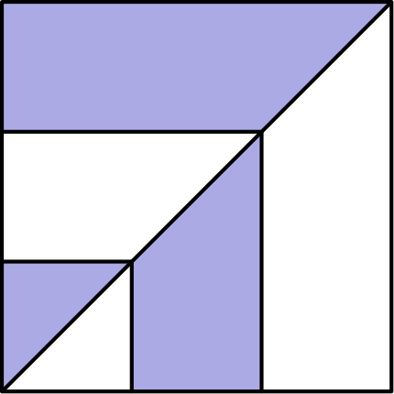
（A）1/3 （B）2/5 （C）5/12 （D）3/7 （E）1/2
English
What fraction of the square is shaded?
(A) 1/3 (B) 2/5 (C) 5/12 (D) 3/7 (E) 1/2
第 4 题
下列哪一个数不可能是某个整数平方的个位数字？
（A）1 （B）4 （C）5 （D）6 （E）8
English
Which of the following couldnotbe the units digit [one’s digit] of the square of a whole number?
(A) 1 (B) 4 (C) 5 (D) 6 (E) 8
第 5 题
下列哪一个数最接近乘积 (0.48017)(0.48017)(0.48017)？
（A）0.011 （B）0.110 （C）1.10 （D）11.0 （E）110
English
Which of the following is closest to the product (0.48017)(0.48017)(0.48017)?
(A) 0.011 (B) 0.110 (C) 1.10 (D) 11.0 (E) 110
第 6 题
这五个数中哪一个最大？
（A）13579 + 1/2468 （B）13579 - 1/2468 （C）13579 × 1/2468 （D）13579 ÷ 1/2468 （E）13579.2468
English
Which of these five numbers is the largest?
(A) 13579 + 1/2468 (B) 13579 - 1/2468 (C) 13579 × 1/2468 (D) 13579 ÷ 1/2468 (E) 13579.2468
第 7 题
从集合 { -3, -2, -1, 4, 5 } 中选出三个不同的数相乘，可能得到的最大乘积是
（A）10 （B）20 （C）30 （D）40 （E）60
English
When three different numbers from the set { -3, -2, -1, 4, 5 } are multiplied, the largest possible product is
(A) 10 (B) 20 (C) 30 (D) 40 (E) 60
第 8 题
一条裙子的原价是 $80，打 25% 折扣出售。如果在打折价上再加 10% 的税，那么这条裙子的总售价是
（A）$45 （B）$52 （C）$54 （D）$66 （E）$68
English
A dress originally priced at $80 was put on sale at 25% off. If 10% tax was added to the sale price, then the total selling price of the dress was
(A) $45 (B) $52 (C) $54 (D) $66 (E) $68
第 9 题
Jones 初中使用如下评分标准。Freeman 老师班上的十五个分数是：89、72、54、97、77、92、85、74、75、63、84、78、71、80、90。
A | 93--100
B | 85--92
C | 75--84
D | 70--74
F | 0--69

Freeman 老师班上有百分之几的学生得了 C？
（A）20% （B）25% （C）30% （D）331/3% （E）40%
English
The grading scale shown is used at Jones Junior High. The fifteen scores in Mr. Freeman’s class were: 89, 72, 54, 97, 77, 92, 85, 74, 75, 63, 84, 78, 71, 80, 90.
A | 93--100
B | 85--92
C | 75--84
D | 70--74
F | 0--69

In Mr. Freeman’s class, what percent of the students received a grade of C?
(A) 20% (B) 25% (C) 30% (D) 331/3% (E) 40%
第 10 题
在这张月历中，把某个字母盖住的日期与 C 盖住的日期相加。如果这个和等于 A 与 B 盖住的日期之和，那么这个字母是
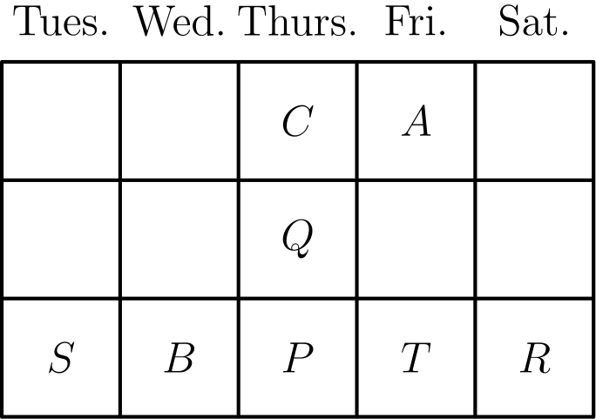
（A）P （B）Q （C）R （D）S （E）T
English
On this monthly calendar, the date behind one of the letters is added to the date behind C. If this sum equals the sum of the dates behind A and B, then the letter is
(A) P (B) Q (C) R (D) S (E) T
第 11 题
这个立方体各面上的数字是连续的整数。三对相对面上的两个数字之和都相等。这个立方体六个面上数字的总和是
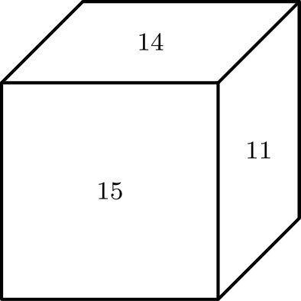
（A）75 （B）76 （C）78 （D）80 （E）81
English
The numbers on the faces of this cube are consecutive whole numbers. The sums of the two numbers on each of the three pairs of opposite faces are equal. The sum of the six numbers on this cube is
(A) 75 (B) 76 (C) 78 (D) 80 (E) 81
第 12 题
二十四个 4 位整数可以由数字 2、4、5 和 7 各使用一次组成。把它们从小到大排列，第 17 个数是
（A）4527 （B）5724 （C）5742 （D）7245 （E）7524
English
There are twenty-four 4-digit whole numbers that use each of the four digits 2, 4, 5, and 7 exactly once. Listed in numerical order from smallest to largest, the number in the 17th position in the list is
(A) 4527 (B) 5724 (C) 5742 (D) 7245 (E) 7524
第 13 题
有人建议新的信件邮资为：第一盎司 30 美分，每增加一盎司或不足一盎司的部分加收 22 美分。一封重 4.5 盎司的信件邮资是
（A）96 美分 （B）$1.07 （C）$1.18 （D）$1.20 （E）$1.40
English
One proposal for new postage rates for a letter was 30¢ for the first ounce and 22¢ for each additional ounce (or fraction of an ounce). The postage for a letter weighing 4.5 ounces was
(A) 96¢ (B) $1.07 (C) $1.18 (D) $1.20 (E) $1.40
第 14 题
一个袋子里只有蓝球和绿球。袋中有 6 个蓝球。如果从袋中随机取出一个球，取到蓝球的概率是 1/4，那么袋中有多少个绿球？
（A）12 （B）18 （C）24 （D）30 （E）36
English
A bag contains only blue balls and green balls. There are 6 blue balls. If the probability of drawing a blue ball at random from this bag is 1/4, then the number of green balls in the bag is
(A) 12 (B) 18 (C) 24 (D) 30 (E) 36
第 15 题
这个图形的面积是 100 cm²。它的周长是
（该图形由四个全等正方形组成。）
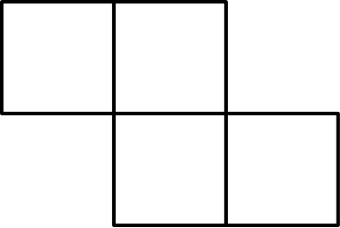
（A）20 cm （B）25 cm （C）30 cm （D）40 cm （E）50 cm
English
The area of this figure is 100 cm². Its perimeter is
(The figure consists of four identical squares.)
(A) 20 cm (B) 25 cm (C) 30 cm (D) 40 cm (E) 50 cm
第 16 题
下列表达式的值是多少？
1990 - 1980 + 1970 - 1960
+ ⋯ - 20 + 10
（A）-990 （B）-10 （C）990 （D）1000 （E）1990
English
What is the value of the following expression?
1990 - 1980 + 1970 - 1960
+ ⋯ - 20 + 10
(A) -990 (B) -10 (C) 990 (D) 1000 (E) 1990
第 17 题
一条笔直的混凝土人行道宽 3 英尺，长 60 英尺，厚 3 英寸。如果混凝土必须按整立方码订购，承包商至少需要订购多少立方码混凝土？
（A）2 （B）5 （C）12 （D）20 （E）多于 20
English
A straight concrete sidewalk is to be 3 feet wide, 60 feet long, and 3inchesthick. How many cubic yards of concrete must a contractor order for the sidewalk if concrete must be ordered in a whole number of cubic yards?
(A) 2 (B) 5 (C) 12 (D) 20 (E) more than 20
第 18 题
一个长方体的每个顶点都被一刀切掉，切面穿过该顶点相邻的三条棱，在八个顶点各切去一个小三角形部分。新立体有多少条棱？
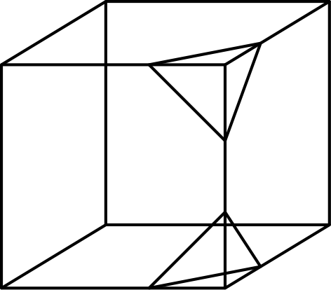
（A）24 （B）30 （C）36 （D）42 （E）48
English
Every corner of a rectangular prism is cut off by a straight slice through the three edges meeting at that corner, removing a small triangular piece at each of the eight corners. How many edges does the new figure have?
(A) 24 (B) 30 (C) 36 (D) 42 (E) 48
第 19 题
一排有 120 个座位。至少要占用多少个座位，才能保证下一个入座的人必须坐在某个人旁边？
（A）30 （B）40 （C）41 （D）60 （E）119
English
There are 120 seats in a row. What is the fewest number of seats that must be occupied so the next person to be seated must sit next to someone?
(A) 30 (B) 40 (C) 41 (D) 60 (E) 119
第 20 题
1,000 个家庭的年收入从 $8200 到 $98,000 不等。由于错误，最高收入在电脑中被输入为 $980,000。错误数据的平均数与实际数据的平均数相差多少？
（A）$882 （B）$980 （C）$1078 （D）$482,000 （E）$882,000
English
The annual incomes of 1,000 families range from $8200 to $98,000. In error, the largest income was entered on the computer as $980,000. The difference between the mean of the incorrect data and the mean of the actual data is
(A) $882 (B) $980 (C) $1078 (D) $482,000 (E) $882,000
第 21 题
一个含 8 个数的数列以前两个给定的数开始。之后每一个新数都是前两个数的乘积。如果最后三个数是 16、64、1024，求第一个数。
?, phantomx, phantomx, phantomx, phantomx, 16, 64, 1024
（A）1/64 （B）1/4 （C）1 （D）2 （E）4
English
A list of 8 numbers is formed by beginning with two given numbers. Each new number in the list is the product of the two previous numbers. Find the first number if the last three are 16, 64, 1024:
?, phantomx, phantomx, phantomx, phantomx, 16, 64, 1024
(A) 1/64 (B) 1/4 (C) 1 (D) 2 (E) 4
第 22 题
几名学生围坐在一张大圆桌旁。他们传递一个装有 100 颗糖的袋子。每个人拿到袋子后取一颗糖，然后把袋子传给下一个人。如果 Chris 拿了第一颗和最后一颗糖，那么桌旁学生人数可能是
（A）10 （B）11 （C）19 （D）20 （E）25
English
Several students are seated at a large circular table. They pass around a bag containing 100 pieces of candy. Each person receives the bag, takes one piece of candy, and then passes the bag to the next person. If Chris takes the first and the last piece of candy, then the number of students at the table could be
(A) 10 (B) 11 (C) 19 (D) 20 (E) 25
第 23 题
图中表示一架实验飞机在一次飞行中，已飞行距离（英里）与经过时间（小时）的关系。在哪一个小时内，这架飞机的平均速度最大？
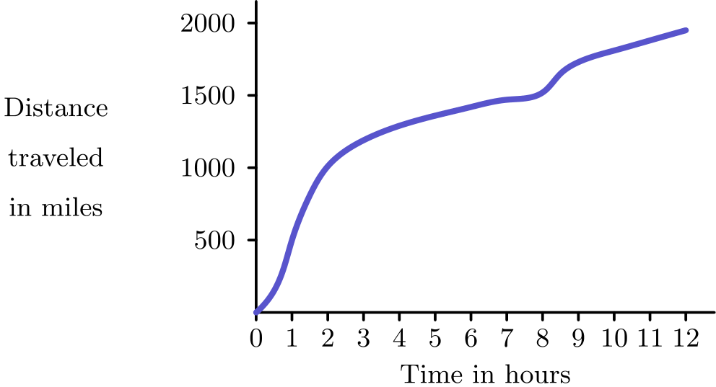
（A）第一个小时 (0-1) （B）第二个小时 (1-2) （C）第三个小时 (2-3) （D）第九个小时 (8-9) （E）最后一个小时 (11-12)
English
The graph relates the distance traveled (in miles) to the time elapsed (in hours) on a trip taken by an experimental airplane. During which hour was the average speed of this airplane the largest?
(A) first (0-1) (B) second (1-2) (C) third (2-3) (D) ninth (8-9) (E) last (11-12)
第 24 题
三个三角形和一个菱形与九个圆点平衡。另外，一个三角形与一个菱形和一个圆点平衡。两个菱形需要多少个圆点来平衡？
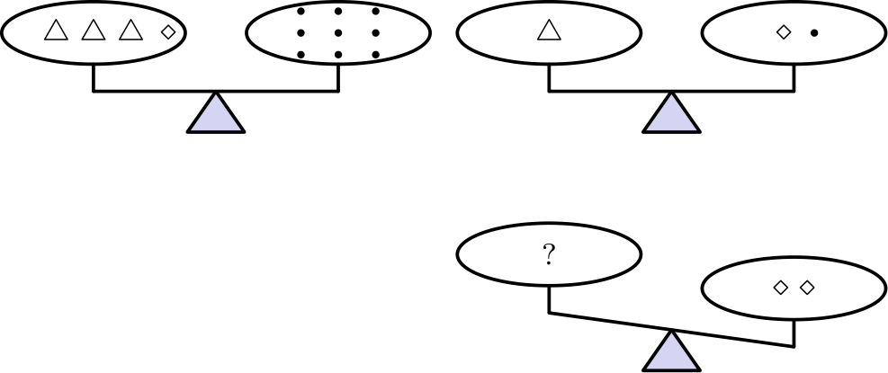
（A）1 （B）2 （C）3 （D）4 （E）5
English
Three triangles and a diamond balance nine dots. Also, one triangle balances a diamond and a dot. How many dots will balance two diamonds?
(A) 1 (B) 2 (C) 3 (D) 4 (E) 5
第 25 题
在一个 3 × 3 方格中，恰好给九个单位正方形中的两个涂色，可以形成多少种不同图案？通过翻转或旋转可以重合的图案不算不同。
（A）3 （B）6 （C）8 （D）12 （E）18
English
How many different patterns can be made by shading exactly two of the nine unit squares in a 3 × 3 grid? Patterns that can be matched by flips and/or turns are not considered different.
(A) 3 (B) 6 (C) 8 (D) 12 (E) 18

第二部分 解答
答案速查：
题号 1 2 3 4 5 6 7 8 9
答案 C A E E B D C D D
题号 10 11 12 13 14 15 16 17 18
答案 A E B C B E D A C
题号 19 20 21 22 23 24 25
答案 B A B B B C C
答案串：CAEEBDCDDAEBCBEDACBABBBCC
第 1 题 答案 C
要让和最小，两个最小的数字应放在百位，接下来的两个数字放在十位，最大的两个数字放在个位。
例如 468 + 579 = 1047，这种分配方式都会得到同样的和。
所以正确答案是C。
English
To make the sum small, the two smallest digits go in the hundreds places, the next two in the tens places, and the two largest in the units places.
One such arrangement is 468 + 579 = 1047, and every arrangement of this type gives the same sum.
Thus, the correct answer isC.
第 2 题 答案 A
改变十分位上的数字，比改变右边任何一位的影响都大。十分位上的数字是 1。
把它改成九后得到 0.92345，这是可能得到的最大数。
所以正确答案是A。
English
Changing a digit in the tenths place changes the number more than changing any digit farther to the right. The digit in the tenths place is 1.
Changing it gives 0.92345, which is the largest possible result.
Thus, the correct answer isA.
第 3 题 答案 E
从一个顶点到对角顶点的对角线把正方形分成两个面积相等的部分。对角线一侧的每个涂色部分，都是另一侧某个等面积未涂色部分的镜像。
因此涂色面积和未涂色面积相等，正好有 1/2 的正方形被涂色。
所以正确答案是E。
English
The diagonal from one corner to the opposite corner splits the square into two equal halves. Every shaded piece on one side of the diagonal is the mirror image of an equal unshaded piece on the other side.
So the shaded and unshaded areas are equal, and exactly 1/2 of the square is shaded.
Thus, the correct answer isE.
第 4 题 答案 E
平方数的个位数字由原数的个位数字决定。0 到 9 平方后的个位数字依次是 0、1、4、9、6、5、6、9、4、1。
所以平方数只能以 0、1、4、5、6 或 9 结尾；不可能以 2、3、7 或 8 结尾。选项中只有 8 不可能。
所以正确答案是E。
English
The units digit of a square is determined by the units digit of the number squared. Squaring 0 through 9 gives units digits 0, 1, 4, 9, 6, 5, 6, 9, 4, 1.
So a square can only end in 0, 1, 4, 5, 6, or 9; it can never end in 2, 3, 7, or 8. Among the choices, only 8 is impossible.
Thus, the correct answer isE.
第 5 题 答案 B
因为 0.48017 接近 1/2，所以这个乘积接近
(1/2)³ = 1/8 = 0.125。
选项中最接近 0.125 的是 0.110。
所以正确答案是B。
English
Since 0.48017 is close to 1/2, the product is close to
(1/2)³ = 1/8 = 0.125.
The choice closest to 0.125 is 0.110.
Thus, the correct answer isB.
第 6 题 答案 D
选项 A、B 和 E 都非常接近 13579。选项 C 把 13579 乘以一个很小的数，会变得更小。
选项 D 是除以 1/2468，也就是乘以 2468。它比 13579 大几千倍，所以最大。
所以正确答案是D。
English
Choices A, B, and E are all very close to 13579, and choice C multiplies 13579 by a tiny number, making it much smaller.
Choice D divides by 1/2468, which is the same as multiplying by 2468. This makes it thousands of times larger than 13579, so it is the largest.
Thus, the correct answer isD.
第 7 题 答案 C
三个数的乘积要为正，要么三个全是正数，要么恰好两个是负数。这里只有两个正数，所以必须用两个负数和一个正数。
为了使乘积最大，取两个最小的负数和最大的正数：(-3)(-2)(5) = 30。
所以正确答案是C。
English
For the product of three numbers to be positive, either all three are positive or exactly two are negative. There are only two positive numbers, so we must use two negatives and one positive.
To maximize, take the two most negative numbers and the largest positive: (-3)(-2)(5) = 30.
Thus, the correct answer isC.
第 8 题 答案 D
打折后的价格是 3/4 · $80 = $60。
税率是 10%，所以对 $60 征收的税是 $6，总价为 $60 + $6 = $66。
所以正确答案是D。
English
The sale price is 3/4 · $80 = $60.
The tax is 10% of $60, which is $6, so the total is $60 + $6 = $66.
Thus, the correct answer isD.
第 9 题 答案 D
C 对应的分数范围是 75 到 84。符合的分数是 77、75、84、78、80，共有 5 名学生。
所以百分比是 5/15 = 1/3 = 331/3%。
所以正确答案是D。
English
A grade of C corresponds to scores from 75 to 84. The qualifying scores are 77, 75, 84, 78, 80, which is 5 students.
So the percent is 5/15 = 1/3 = 331/3%.
Thus, the correct answer isD.
第 10 题 答案 A
向右移动一列日期增加 1，向下移动一行日期增加 7。设 C 盖住的日期为 n，则右边一列的 A 盖住 n+1。P 在 C 正下方两行，所以 P = n+14；B 在底行且位于 P 左边一列，所以它盖住 n+13。
设所求日期为 d，则 d + n = (n+1) + (n+13)，所以 d = n + 14。这个日期被 P 盖住。
所以正确答案是A。
English
Moving one column right adds 1 to the date, and moving one row down adds 7. Let C have date n. Then A, one column to the right, is n+1. The letter P sits two rows directly below C, so P = n+14, and B, one column left of P in the bottom row, is n+13.
We need a letter whose date d satisfies d + n = (n+1) + (n+13), so d = n + 14. That date is behind P.
Thus, the correct answer isA.
第 11 题 答案 E
六个连续整数包含 11、14、15，所以其中五个数是 11、12、13、14、15，第六个数是 10 或 16。
如果第六个数是 10，为了让相对面和相等，配对应为 (10,15)、(11,14)、(12,13)，这会使 11 和 14 相对。但图中标有 11、14、15 的三个面在同一个顶点相遇，所以它们任意两个都不相对。因此第六个数是 16，相对面可配成 (11,16)、(12,15)、(13,14)，每对和为 27。
六个面的总和是 3 · 27 = 81。
所以正确答案是E。
English
The six consecutive numbers include 11, 14, 15, so five of the faces are 11, 12, 13, 14, 15 and the sixth is 10 or 16.
If the sixth were 10, equal opposite sums would force the pairs (10,15), (11,14), (12,13), making 11 and 14 opposite. But the figure shows 11, 14, 15 meeting at one corner, so no two of them are opposite. Hence the sixth number is 16, with pairs (11,16), (12,15), (13,14), each summing to 27.
The total is 3 · 27 = 81.
Thus, the correct answer isE.
第 12 题 答案 B
每个首位数字对应 6 个四位数。全部 24 个数中，第 1 到 6 个以 2 开头，第 7 到 12 个以 4 开头，第 13 到 18 个以 5 开头。
所以第 17 个数是以 5 开头的第 5 个，依次为 5247、5274、5427、5472、5724。第五个是 5724。
所以正确答案是B。
English
Each leading digit accounts for 6 of the 24 numbers. Positions 1–6 begin with 2, positions 7–12 begin with 4, and positions 13–18 begin with 5.
So the 17th number is the 5th one beginning with 5: 5247, 5274, 5427, 5472, 5724. The fifth is 5724.
Thus, the correct answer isB.
第 13 题 答案 C
第一盎司花 30 美分。剩下的 3.5 盎司要按 4 个额外盎司收费，因为不足一盎司也按一整盎司算。
额外邮资是 4 · 22 美分 = 88 美分，总邮资是 30 美分 + 88 美分 = 118 美分 = $1.18。
所以正确答案是C。
English
The first ounce costs 30¢. The remaining 3.5 ounces are charged as 4 additional ounces, since any fraction rounds up to a full ounce.
That is 4 · 22¢ = 88¢, so the total is 30¢ + 88¢ = 118¢ = $1.18.
Thus, the correct answer isC.
第 14 题 答案 B
蓝球占袋中球总数的 1/4，而蓝球有 6 个，所以总数是 6 · 4 = 24 个。
绿球数为 24 - 6 = 18。
所以正确答案是B。
English
Since blue balls make up 1/4 of the bag and there are 6 of them, the total is 6 · 4 = 24 balls.
So the number of green balls is 24 - 6 = 18.
Thus, the correct answer isB.
第 15 题 答案 E
每个小正方形的面积是 100/4 = 25 cm²，所以边长是 5 cm。
这个阶梯形的外边界由 10 条这样的边组成，所以周长是 10 · 5 = 50 cm。
所以正确答案是E。
English
Each of the four squares has area 100/4 = 25 cm², so each side is 5 cm.
The outline of this staircase shape is made up of 10 such sides, so the perimeter is 10 · 5 = 50 cm.
Thus, the correct answer isE.
第 16 题 答案 D
把式子分组为 (1990 - 1980) + (1970 - 1960) + ⋯ + (30 - 20) + 10。每个括号里的差都是 10。
各组的第一项为 1990, 1970, …, 30，共 99 项，所以共有 99 组，贡献 990；再加最后的 +10，总数为 1000。
所以正确答案是D。
English
Group the terms as (1990 - 1980) + (1970 - 1960) + ⋯ + (30 - 20) + 10. Each parenthesized pair equals 10.
The first elements 1990, 1970, …, 30 number 99, so there are 99 pairs, giving 990, plus the leftover +10 at the end for a total of 1000.
Thus, the correct answer isD.
第 17 题 答案 A
厚度 3 英寸 = 1/4 英尺，所以体积是 3 · 60 · 1/4 = 45 立方英尺。
因为 1 立方码 = 27 立方英尺，所以体积是 45/27 = 12/3 立方码。按整立方码订购时必须向上取整，需订购 2 立方码。
所以正确答案是A。
English
The thickness is 3 inches = 1/4 foot, so the volume is 3 · 60 · 1/4 = 45 cubic feet.
Since 1 cubic yard = 27 cubic feet, this is 45/27 = 12/3 cubic yards. Rounding up to a whole number, the contractor must order 2 cubic yards.
Thus, the correct answer isA.
第 18 题 答案 C
长方体原来有 12 条棱。切掉顶点只会把这些棱截短，不会把它们完全去掉。
共有 8 个顶点，每个顶点切口会产生一个小三角形面，带来 3 条新棱。所以新增 8 · 3 = 24 条棱，总数是 12 + 24 = 36。
所以正确答案是C。
English
A rectangular prism starts with 12 edges, and cutting corners only shortens them without removing any.
Each of the 8 corner cuts creates a small triangular face with 3 new edges, adding 8 · 3 = 24 edges. The total is 12 + 24 = 36.
Thus, the correct answer isC.
第 19 题 答案 B
要迫使下一个人坐在别人旁边，每个空座位都必须与至少一个已坐座位相邻。每个已坐座位最多覆盖它自己及左右两个相邻座位，所以至少要坐满 120/3 = 40 个座位。
这个下界可以达到：重复采用“空、已坐、空”的排列，每三个座位只坐中间一个。这样恰好有 40 个已坐座位。
所以正确答案是B。
English
To force the next person next to someone, every empty seat must be adjacent to an occupied one. Each occupied seat can account for at most itself and its two neighboring seats, so at least 120/3 = 40 seats must be occupied.
This bound is attainable: use a repeating pattern of empty-occupied-empty, filling the middle seat of every group of three. This uses exactly 40 occupied seats.
Thus, the correct answer isB.
第 20 题 答案 A
只有一个数据被改错。错误总和比实际总和多 $980,000 - $98,000 = $882,000。
这多出的金额分摊到 1000 个家庭上，平均数相差 ($882,000)/1000 = $882。
所以正确答案是A。
English
Only one entry changed. The incorrect total exceeds the actual total by $980,000 - $98,000 = $882,000.
Since this extra amount is spread over 1000 families, the means differ by ($882,000)/1000 = $882.
Thus, the correct answer isA.
第 21 题 答案 B
因为每一项都是前两项的乘积，所以用某一项除以紧前一项，可以得到它前面第二项。从最后三个数 16、64、1024 倒推：
64 ÷ 16 = 4, 16 ÷ 4 = 4,
4 ÷ 4 = 1, 4 ÷ 1 = 4,
1 ÷ 4 = 1/4
。
因此完整数列为 1/4、4、1、4、4、16、64、1024，第一个数是 1/4。
所以正确答案是B。
English
Since each term is the product of the two before it, dividing any term by the term just before it recovers the term two positions earlier. Working backwards from the last three terms 16, 64, 1024:
64 ÷ 16 = 4, 16 ÷ 4 = 4,
4 ÷ 4 = 1, 4 ÷ 1 = 4,
1 ÷ 4 = 1/4.
These fill in the earlier terms, giving the full list 1/4, 4, 1, 4, 4, 16, 64, 1024. The first number is 1/4.
Thus, the correct answer isB.
第 22 题 答案 B
Chris 拿第一颗糖，然后袋子一圈圈传递，直到 Chris 拿到最后一颗，也就是第 100 颗。第一次和最后一次之间相隔 99 次取糖。
因此 Chris 第一次之后的取糖过程必须正好经过若干整圈后回到 Chris。这说明学生人数必须整除 99；选项中只有 11 能整除 99。
所以正确答案是B。
English
Chris takes the first piece, and then the bag goes around until Chris takes the last (100th) piece. So the 99 pieces after Chris’s first must be exactly a whole number of trips around the table back to Chris.
This means the number of students divides 99. Among the choices, only 11 divides 99.
Thus, the correct answer isB.
第 23 题 答案 B
任意一个小时内的平均速度等于这一个小时内飞行的距离，也就是图上对应一小时区间的竖直上升量。因此最大平均速度出现在曲线最陡的一小时。
从 t=1 到 t=2，曲线从约 500 英里升到约 1000 英里，上升约 500 英里，平均速度约 500 英里每小时。其他小时的上升量都小于约 350 英里。所以最大平均速度出现在第二个小时。
正确答案是B。
English
The average speed during any single hour equals the distance the airplane covers in that hour, which on the graph is the vertical rise of the curve over that one-hour interval. So the largest average speed happens during the hour where the curve is steepest.
From t=1 to t=2 the curve climbs from about 500 miles to about 1000 miles, a rise of roughly 500 miles, giving an average speed near 500 mph. During every other hour the curve rises by less than 350 miles, so those average speeds are all smaller. The steepest climb, and hence the largest average speed, is during the second hour.
Thus, the correct answer isB.
第 24 题 答案 C
设三角形、菱形和圆点的重量分别为 t、d 和 1。题意给出 3t + d = 9 和 t = d + 1。
代入得 3(d+1) + d = 9，所以 4d + 3 = 9，d = 3/2。两个菱形重 2d = 3 个圆点。
所以正确答案是C。
English
Let a triangle, diamond, and dot weigh t, d, and 1. The conditions give 3t + d = 9 and t = d + 1.
Substituting, 3(d+1) + d = 9, so 4d + 3 = 9 and d = 3/2. Then two diamonds weigh 2d = 3 dots.
Thus, the correct answer isC.
第 25 题 答案 C
先分类含有角格的图案：两个相邻角格、两个对角角格、角格与中心格、角格与相邻边中格、角格与较远边中格，共 5 种。
不含角格的图案有：两个相邻边中格、两个相对边中格、一个边中格与中心格，共 3 种。
总共有 5 + 3 = 8 种不同图案。
所以正确答案是C。
English
Classify the two shaded squares up to rotations and reflections. Patterns that include a corner: two adjacent corners (same edge), two diagonally opposite corners, corner with the center, corner with an adjacent edge-middle, and corner with a far edge-middle. That is 5 patterns.
Patterns with no corner: two adjacent edge-middles, two opposite edge-middles, and an edge-middle with the center. That is 3 more.
In total there are 5 + 3 = 8 distinct patterns.
Thus, the correct answer isC.

