1987 年 AMC 8 真题与解答
American Mathematics Competitions 8 · 中英双语
共 25 题，限时 40 分钟；单项选择题，每题 1 分，答错不扣分，满分 25 分。
编排说明：第一部分为题目（先中文、后英文原题），第二部分为解答与答案，便于先做题后对答案。
第一部分 题目
第 1 题
0.4 + 0.02 + 0.006 等于多少？
（A）0.012 （B）0.066 （C）0.12 （D）0.24 （E）0.426
English
What is 0.4 + 0.02 + 0.006?
(A) 0.012 (B) 0.066 (C) 0.12 (D) 0.24 (E) 0.426
第 2 题
2/25 写成小数是多少？
（A）0.008 （B）0.08 （C）0.8 （D）1.25 （E）12.5
English
What is 2/25 written as a decimal?
(A) 0.008 (B) 0.08 (C) 0.8 (D) 1.25 (E) 12.5
第 3 题
下式的值是多少？
2(81 + 83 + 85 + 87 + 89
+ 91 + 93 + 95 + 97 + 99)
？
（A）1600 （B）1650 （C）1700 （D）1750 （E）1800
English
What is the value of
2(81 + 83 + 85 + 87 + 89
+ 91 + 93 + 95 + 97 + 99)?
(A) 1600 (B) 1650 (C) 1700 (D) 1750 (E) 1800
第 4 题
火星人用“克勒特”（clert）衡量角度。一个整圆有 500 克勒特。一个直角有多少克勒特？
（A）90 （B）100 （C）125 （D）180 （E）250
English
Martians measure angles in clerts. There are 500 clerts in a full circle. How many clerts are there in a right angle?
(A) 90 (B) 100 (C) 125 (D) 180 (E) 250
第 5 题
图中矩形区域的面积是多少平方米？
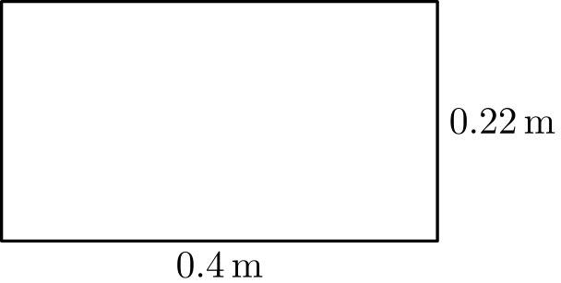
（A）0.088 m² （B）0.62 m² （C）0.88 m² （D）1.24 m² （E）4.22 m²
English
What is the area, in square meters, of the rectangular region shown?
(A) 0.088 m² (B) 0.62 m² (C) 0.88 m² (D) 1.24 m² (E) 4.22 m²
第 6 题
从集合 { -7, -5, -1, 1, 3 } 中选两个数相乘，可能得到的最小乘积是
（A）-35 （B）-21 （C）-15 （D）-1 （E）3
English
The smallest product one could obtain by multiplying two numbers in the set { -7, -5, -1, 1, 3 } is
(A) -35 (B) -21 (C) -15 (D) -1 (E) 3
第 7 题
图中的大立方体由 27 个大小相同的小立方体组成。大立方体每个面的相对面都用同样方式涂色。至少有一个面被涂色的小立方体共有多少个？
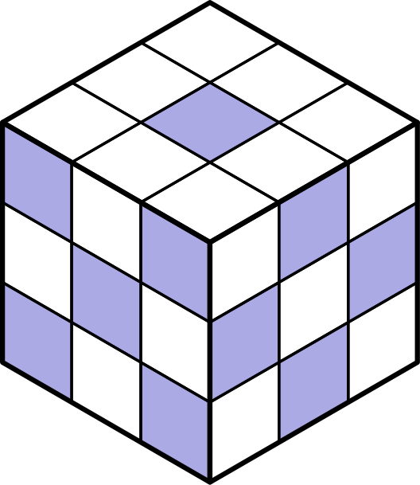
（A）10 （B）16 （C）20 （D）22 （E）24
English
The large cube shown is made up of 27 identical sized smaller cubes. For each face of the large cube, the opposite face is shaded the same way. The total number of smaller cubes that must have at least one face shaded is
(A) 10 (B) 16 (C) 20 (D) 22 (E) 24
第 8 题
在下面的加法中，A 和 B 是非零数字：
9876
A32
+B1

这三个整数的和有多少位数字（数字不一定互不相同）？
（A）4 （B）5 （C）6 （D）9 （E）取决于 A 和 B 的值
English
In the addition problem below, A and B are nonzero digits:
9876
A32
+B1

How many digits (not necessarily different) are in the sum of the three whole numbers?
(A) 4 (B) 5 (C) 6 (D) 9 (E) depends on the values of A and B
第 9 题
求和
1/2 + 1/3 + 1/4 + 1/5 + 1/6 + 1/7
时，使用的最小公分母是多少？
（A）120 （B）210 （C）420 （D）840 （E）5040
English
When finding the sum
1/2 + 1/3 + 1/4 + 1/5 + 1/6 + 1/7,
what is the least common denominator used?
(A) 120 (B) 210 (C) 420 (D) 840 (E) 5040
第 10 题
下式的值是多少？
4(299) + 3(299) + 2(299) + 298？
（A）2889 （B）2989 （C）2991 （D）2999 （E）3009
English
What is the value of
4(299) + 3(299) + 2(299) + 298?
(A) 2889 (B) 2989 (C) 2991 (D) 2999 (E) 3009
第 11 题
和 21/7 + 31/2 + 51/19 位于哪两个值之间？
（A）10 和 101/2 （B）101/2 和 11 （C）11 和 111/2 （D）111/2 和 12 （E）12 和 121/2
English
The sum 21/7 + 31/2 + 51/19 is between which two values?
(A) 10 and 101/2 (B) 101/2 and 11 (C) 11 and 111/2 (D) 111/2 and 12 (E) 12 and 121/2
第 12 题
这个 12 乘 18 的大矩形区域中，有几分之几被涂色？
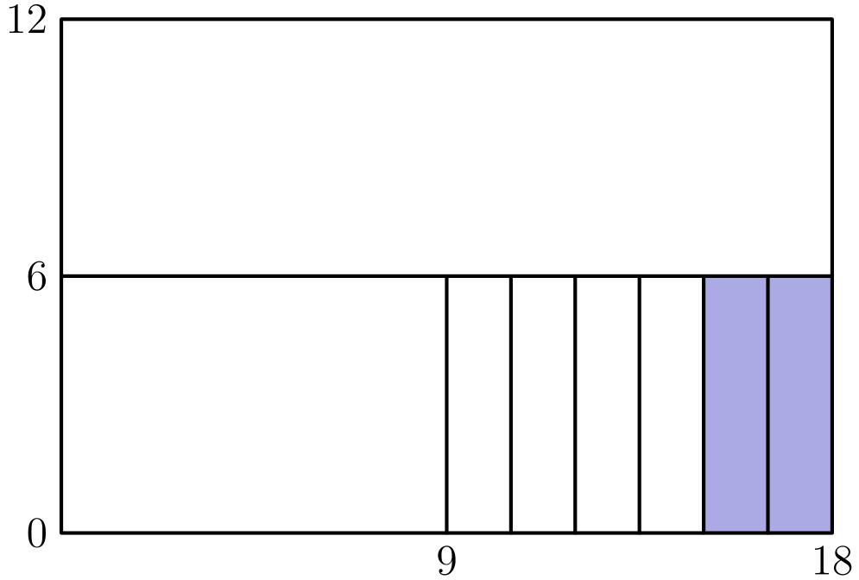
（A）1/108 （B）1/18 （C）1/12 （D）2/9 （E）1/3
English
What fraction of the large 12 by 18 rectangular region is shaded?
(A) 1/108 (B) 1/18 (C) 1/12 (D) 2/9 (E) 1/3
第 13 题
下列哪个分数的值最大？
（A）3/7 （B）4/9 （C）17/35 （D）100/201 （E）151/301
English
Which of the following fractions has the largest value?
(A) 3/7 (B) 4/9 (C) 17/35 (D) 100/201 (E) 151/301
第 14 题
一台计算机每秒可以做 10,000 次加法。它一小时可以做多少次加法？
（A）6 百万 （B）36 百万 （C）60 百万 （D）216 百万 （E）360 百万
English
A computer can do 10,000 additions per second. How many additions can it do in one hour?
(A) 6 million (B) 36 million (C) 60 million (D) 216 million (E) 360 million
第 15 题
一个促销广告写着：“按原价买三条轮胎，第四条轮胎只要 $3。”山姆在促销中花 $240 买了一套四条轮胎。一条轮胎的原价是多少？
（A）$59.25 （B）$60 （C）$70 （D）$79 （E）$80
English
A sale ad read: “Buy three tires at the regular price and get the fourth tire for $3.” Sam paid $240 for a set of four tires at the sale. What was the regular price of one tire?
(A) $59.25 (B) $60 (C) $70 (D) $79 (E) $80
第 16 题
篮球赛季前三场比赛中，乔伊丝前 30 次投篮命中 12 次，所以她的赛季投篮命中率是 40%。在下一场比赛中，她投篮 10 次，并把赛季命中率提高到 50%。这 10 次投篮中她命中了多少次？
（A）2 （B）3 （C）5 （D）6 （E）8
English
Joyce made 12 of her first 30 shots in the first three games of the basketball season, so her seasonal shooting average was 40%. In her next game, she took 10 shots and raised her seasonal shooting average to 50%. How many of these 10 shots did she make?
(A) 2 (B) 3 (C) 5 (D) 6 (E) 8
第 17 题
艾比、布雷特、卡尔和达娜坐在一排编号为 1 到 4 的四个座位上。乔看着他们说：“布雷特挨着卡尔。”“艾比坐在布雷特和卡尔之间。”然而乔的每一句话都是假的。布雷特实际坐在 3 号座位。谁坐在 2 号座位？
（A）艾比 （B）布雷特 （C）卡尔 （D）达娜 （E）信息不足，无法确定
English
Abby, Bret, Carl, and Dana are seated in a row of four seats numbered 1 to 4. Joe looks at them and says: “Bret is next to Carl.” “Abby is between Bret and Carl.” However, each one of Joe’s statements is false. Bret is actually sitting in seat 3. Who is sitting in seat 2?
(A) Abby (B) Bret (C) Carl (D) Dana (E) There is not enough information to be sure
第 18 题
房间里一半的人离开了。剩下的人中有三分之一开始跳舞。此时有 12 人没有跳舞。房间里原来有多少人？
（A）24 （B）30 （C）36 （D）42 （E）72
English
Half the people in a room left. One third of those remaining started to dance. There were then 12 people who were not dancing. What was the original number of people in the room?
(A) 24 (B) 30 (C) 36 (D) 42 (E) 72
第 19 题
一个计算器有一个平方键 boxedx²，会把当前显示的数替换成它的平方。例如，如果显示 boxedphantom003，按下 boxedx² 键后显示 boxedphantom009。如果显示的是 boxedphantom002，要按多少次 boxedx² 键才能得到大于 500 的显示数？
（A）4 （B）5 （C）8 （D）9 （E）250
English
A calculator has a squaring key boxedx² that replaces the number currently displayed with its square. For example, if the display reads boxedphantom003 and boxedx² is pressed, the display becomes boxedphantom009. If the display reads boxedphantom002, how many times must boxedx² be pressed to produce a displayed number greater than 500?
(A) 4 (B) 5 (C) 8 (D) 9 (E) 250
第 20 题
考虑命题：“如果整数 n 不是质数，那么整数 n - 2 不是质数。”下列哪个 n 的值说明这个命题是假的？
（A）9 （B）12 （C）13 （D）16 （E）23
English
Consider the statement: “If a whole number n is not prime, then the whole number n - 2 is not prime.” Which of the following values of n shows this statement to be false?
(A) 9 (B) 12 (C) 13 (D) 16 (E) 23
第 21 题
假设 n^(∗) 表示 1/n，即 n 的倒数。例如，5^(∗) = 1/5。下面四个命题中有多少个是真的？
(i) 3^(∗) + 6^(∗) = 9^(∗)
(ii) 6^(∗) - 4^(∗) = 2^(∗)
(iii) 2^(∗) · 6^(∗) = 12^(∗)
(iv) 10^(∗) ÷ 2^(∗) = 5^(∗)
（A）0 （B）1 （C）2 （D）3 （E）4
English
Suppose n^(∗) means 1/n, the reciprocal of n. For example, 5^(∗) = 1/5. How many of the following four statements are true?
(i) 3^(∗) + 6^(∗) = 9^(∗)
(ii) 6^(∗) - 4^(∗) = 2^(∗)
(iii) 2^(∗) · 6^(∗) = 12^(∗)
(iv) 10^(∗) ÷ 2^(∗) = 5^(∗)
(A) 0 (B) 1 (C) 2 (D) 3 (E) 4
第 22 题
ABCD 是一个矩形，D 是圆心，B 在圆上。如果 AD = 4 且 CD = 3，那么阴影区域面积位于哪两个值之间？
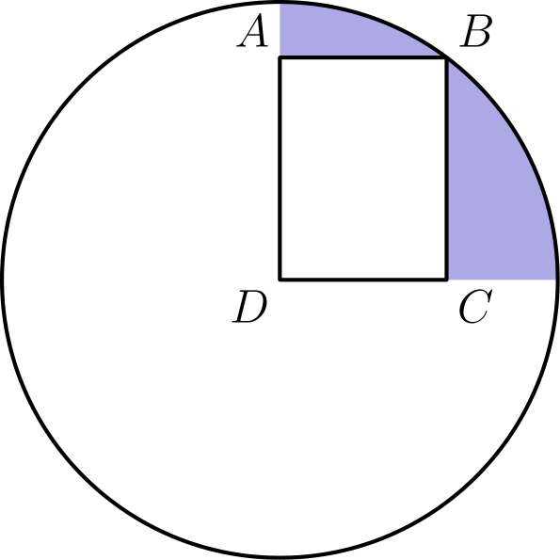
（A）4 和 5 （B）5 和 6 （C）6 和 7 （D）7 和 8 （E）8 和 9
English
ABCD is a rectangle, D is the center of the circle, and B is on the circle. If AD = 4 and CD = 3, then the area of the shaded region is between which two values?
(A) 4 and 5 (B) 5 and 6 (C) 6 and 7 (D) 7 and 8 (E) 8 and 9
第 23 题
假设下表列出了美国 1980 年各地区、各族裔的人口数，单位为百万。按最接近的百分数计算，美国黑人总人口中有百分之多少住在南部？
 | 东北 | 中西 | 南部 | 西部
白人 | 42 | 52 | 57 | 35
黑人 | 5 | 5 | 15 | 2
亚裔 | 1 | 1 | 1 | 3
其他 | 1 | 1 | 2 | 4

（A）20% （B）25% （C）40% （D）56% （E）80%
English
Assume the adjoining chart shows the 1980 U.S. population, in millions, for each region by ethnic group. To the nearest percent, what percent of the U.S. Black population lived in the South?
 | NE | MW | South | West
White | 42 | 52 | 57 | 35
Black | 5 | 5 | 15 | 2
Asian | 1 | 1 | 1 | 3
Other | 1 | 1 | 2 | 4

(A) 20% (B) 25% (C) 40% (D) 56% (E) 80%
第 24 题
一场选择题考试共有 20 题。计分规则是：每答对一题得 +5 分，每答错一题得 -2 分，未答题得 0 分。约翰的考试成绩是 48 分。他最多可能答对了多少题？
（A）9 （B）10 （C）11 （D）12 （E）16
English
A multiple choice examination consists of 20 questions. The scoring is +5 for each correct answer, -2 for each incorrect answer, and 0 for each unanswered question. John’s score on the examination is 48. What is the maximum number of questions he could have answered correctly?
(A) 9 (B) 10 (C) 11 (D) 12 (E) 16
第 25 题
罐子里有编号 1 到 10 的十个球。杰克伸手随机取出一个球。然后吉尔伸手随机取出另一个不同的球。取出的两个球上的数字之和为偶数的概率是多少？
（A）4/9 （B）9/19 （C）1/2 （D）10/19 （E）5/9
English
Ten balls numbered 1 to 10 are in a jar. Jack reaches into the jar and randomly removes one of the balls. Then Jill reaches into the jar and randomly removes a different ball. What is the probability that the sum of the two numbers on the balls removed is even?
(A) 4/9 (B) 9/19 (C) 1/2 (D) 10/19 (E) 5/9

第二部分 解答
答案速查：
题号 1 2 3 4 5 6 7 8 9
答案 E B E C A B C B C
题号 10 11 12 13 14 15 16 17 18
答案 B B C E B D E D C
题号 19 20 21 22 23 24 25
答案 A A C D D D A
答案串：EBECABCBCBBCEBDEDCAACDDDA
第 1 题 答案 E
按位相加，0.4 + 0.02 + 0.006 = 0.426。
所以正确答案是E。
English
Adding place by place, 0.4 + 0.02 + 0.006 = 0.426.
Thus, the correct answer isE.
第 2 题 答案 B
分子和分母同时乘以 4，得 2/25 = 8/100 = 0.08。
所以正确答案是B。
English
Multiplying top and bottom by 4 gives 2/25 = 8/100 = 0.08.
Thus, the correct answer isB.
第 3 题 答案 E
这十个等间隔数的平均数是 90，所以它们的和是 10 × 90 = 900。
加倍后得到 2 × 900 = 1800。
所以正确答案是E。
English
The ten evenly spaced numbers have average 90, so their sum is 10 × 90 = 900.
Doubling gives 2 × 900 = 1800.
Thus, the correct answer isE.
第 4 题 答案 C
直角是整圆的四分之一，所以它包含 1/4 × 500 = 125 克勒特。
所以正确答案是C。
English
A right angle is a quarter of a full circle, so it contains 1/4 × 500 = 125 clerts.
Thus, the correct answer isC.
第 5 题 答案 A
面积是 0.4 × 0.22 = 0.088 平方米。
所以正确答案是A。
English
The area is 0.4 × 0.22 = 0.088 square meters.
Thus, the correct answer isA.
第 6 题 答案 B
负乘积来自负数乘正数；要最负，就让两个因数的绝对值尽可能大。
最负的乘积是 (-7)(3) = -21。
所以正确答案是B。
English
A negative product comes from multiplying a negative number by a positive number, and it is most negative when both factors are largest in size.
The most negative product is (-7)(3) = -21.
Thus, the correct answer isB.
第 7 题 答案 C
先数没有任何涂色面的立方体，再从 27 中减去。一个小立方体未涂色，当且仅当它所有外露的小方格都是空白。
三种面图案如下：顶面和底面只有中心小方格涂色；一对相对侧面是四个角和中心涂色；另一对相对侧面是四条边的中点涂色。
恰有 7 个小立方体避开所有涂色小方格：大立方体最中心隐藏的一个；那对边中点涂色面中心处的两个小立方体，它们唯一外露的小方格是空白中心；以及四个在“角和中心涂色”的面与顶面或底面相交边中点处的小立方体，因为那里每个外露小方格都是空白边格。
因此有 27 - 7 = 20 个小立方体至少有一个涂色面。
所以正确答案是C。
English
Count the cubes with no shaded face and subtract from 27. A small cube is unshaded exactly when every one of its exposed squares is blank.
The three patterns are: the top and bottom faces show only their center square shaded; one pair of opposite side faces shows the four corners and the center shaded; the remaining pair shows the four edge-midpoints shaded.
Exactly 7 small cubes avoid every shaded square: the one hidden cube at the very center of the block; the two cubes at the centers of the edge-midpoints faces, whose only exposed square is that blank center; and the four cubes at the midpoints of the edges where a corners-and-center face meets the top or bottom face, since there each exposed square is a blank edge cell.
Hence 27 - 7 = 20 cubes have at least one shaded face.
Thus, the correct answer isC.
第 8 题 答案 B
因为 A 和 B 至少为 1，所以和至少是 9876 + 132 + 11 = 10,019，有 5 位。
另一端，当 A = B = 9 时，和为 9876 + 932 + 91 = 10,899，仍然是 5 位。因此和总是恰好有 5 位。
所以正确答案是B。
English
Since A and B are at least 1, the sum is at least 9876 + 132 + 11 = 10,019, which has 5 digits.
At the other extreme, with A = B = 9 the sum is 9876 + 932 + 91 = 10,899, still 5 digits. So the sum always has exactly 5 digits.
Thus, the correct answer isB.
第 9 题 答案 C
最小公倍数必须包含 4 = 2²、3、5 和 7（因数 6 = 2 × 3 已经被覆盖）。
所以它是 4 × 3 × 5 × 7 = 420。
所以正确答案是C。
English
The least common multiple must include 4 = 2², 3, 5, and 7 (the factor 6 = 2 × 3 is already covered).
So it is 4 × 3 × 5 × 7 = 420.
Thus, the correct answer isC.
第 10 题 答案 B
前三项合并为 (4 + 3 + 2)(299) = 9 × 299 = 2691。
再加最后一项，得 2691 + 298 = 2989。
所以正确答案是B。
English
The first three terms combine to (4 + 3 + 2)(299) = 9 × 299 = 2691.
Adding the last term gives 2691 + 298 = 2989.
Thus, the correct answer isB.
第 11 题 答案 B
整数部分的和是 10，分数部分是 1/2 + 1/7 + 1/19。
因为 1/7 + 1/19 是一个较小的正数，所以分数部分总和大于 1/2，但远小于 1。因此原和位于 101/2 和 11 之间。
所以正确答案是B。
English
The whole-number parts sum to 10. The fractional parts are 1/2 + 1/7 + 1/19.
Since 1/7 + 1/19 is a small positive amount, the fractional total is more than 1/2 but well under 1. So the sum lies between 101/2 and 11.
Thus, the correct answer isB.
第 12 题 答案 C
整个区域面积是 12 × 18 = 216。涂色区域宽 3、高 6，面积为 3 × 6 = 18。
所以涂色比例是 18/216 = 1/12。等价地，它是整个区域的 1/4 的 1/3。
所以正确答案是C。
English
The whole region has area 12 × 18 = 216. The shaded region is 3 wide and 6 tall, with area 3 × 6 = 18.
So the shaded fraction is 18/216 = 1/12. Equivalently, it is 1/3 of 1/4 of the whole.
Thus, the correct answer isC.
第 13 题 答案 E
对 3/7、4/9、17/35 和 100/201，每个分子都小于分母的一半，所以它们都小于 1/2。
对 151/301，分子 151 大于 301 的一半，所以这个分数大于 1/2，也是最大的。
所以正确答案是E。
English
For 3/7, 4/9, 17/35, and 100/201, each numerator is less than half its denominator, so each is less than 1/2.
For 151/301, the numerator 151 is more than half of 301, so this fraction exceeds 1/2 and is the largest.
Thus, the correct answer isE.
第 14 题 答案 B
一小时有 3600 秒，所以计算机可以做 10,000 × 3600 = 36,000,000 次加法。
也就是 36 百万。
所以正确答案是B。
English
One hour has 3600 seconds, so the computer does 10,000 × 3600 = 36,000,000 additions.
That is 36 million.
Thus, the correct answer isB.
第 15 题 答案 D
三条原价轮胎共花 $240 - $3 = $237。
所以一条轮胎的原价是 ($237)/3 = $79。
所以正确答案是D。
English
The three regular-price tires cost $240 - $3 = $237.
So one tire costs ($237)/3 = $79.
Thus, the correct answer isD.
第 16 题 答案 E
第四场后她共投篮 40 次。50% 命中率表示她总共命中 1/2 × 40 = 20 次。
她之前已经命中 12 次，所以最后 10 次中命中 20 - 12 = 8 次。
所以正确答案是E。
English
After the fourth game she has taken 40 shots. A 50% average means she made 1/2 × 40 = 20 shots in total.
She had already made 12, so she made 20 - 12 = 8 of the last 10.
Thus, the correct answer isE.
第 17 题 答案 D
布雷特在 3 号座位。因为“布雷特挨着卡尔”是假的，卡尔不在 2 号或 4 号座位，所以卡尔必须在 1 号座位。
布雷特（3 号）和卡尔（1 号）之间的座位是 2 号。因为“艾比在布雷特和卡尔之间”是假的，艾比不在 2 号，所以艾比必须在 4 号。
因此达娜坐在 2 号座位。
所以正确答案是D。
English
Bret is in seat 3. Since “Bret is next to Carl” is false, Carl is not in seat 2 or seat 4, so Carl must be in seat 1.
The seat between Bret (seat 3) and Carl (seat 1) is seat 2. Since “Abby is between Bret and Carl” is false, Abby is not in seat 2, so Abby must be in seat 4.
That leaves Dana in seat 2.
Thus, the correct answer isD.
第 18 题 答案 C
在留下的人中，1/3 跳舞，所以 2/3 没跳舞。因此剩余人数的 2/3 等于 12，得剩余 18 人。
这 18 人是原来人数的一半，所以房间一开始有 2 × 18 = 36 人。
所以正确答案是C。
English
Of those remaining, 1/3 danced, so 2/3 did not. Thus 2/3 of the remaining people equals 12, giving 18 remaining.
Those 18 are half the original group, so the room started with 2 × 18 = 36 people.
Thus, the correct answer isC.
第 19 题 答案 A
重复按键得到 2 → 4 → 16 → 256 → 65536。
因为 256 < 500 < 65536，显示数第一次超过 500 是第四次按键。
所以正确答案是A。
English
Pressing the key repeatedly gives 2 → 4 → 16 → 256 → 65536.
Since 256 < 500 < 65536, the display first exceeds 500 on the fourth press.
Thus, the correct answer isA.
第 20 题 答案 A
反例需要 n 不是质数，但 n - 2 是质数。当 n = 9 时，9 不是质数，而 9 - 2 = 7 是质数，所以它推翻了这个命题。
其他选项不能作为反例：12 - 2 = 10 和 16 - 2 = 14 不是质数，而 13 和 23 本身就是质数。
所以正确答案是A。
English
A counterexample needs n not prime but n - 2 prime. For n = 9, the number 9 is not prime while 9 - 2 = 7 is prime, so it breaks the statement.
The others fail to be counterexamples: 12 - 2 = 10 and 16 - 2 = 14 are not prime, while 13 and 23 are themselves prime.
Thus, the correct answer isA.
第 21 题 答案 C
(i) 1/3 + 1/6 = 1/2，但 9^(∗) = 1/9，所以为假。(ii) 1/6 - 1/4 = -1/12，但 2^(∗) = 1/2，所以为假。
(iii) 1/2 · 1/6 = 1/12 = 12^(∗)，为真。(iv) 1/10 ÷ 1/2 = 1/5 = 5^(∗)，为真。
因此正好有 2 个命题为真。
所以正确答案是C。
English
(i) 1/3 + 1/6 = 1/2, but 9^(∗) = 1/9, so false. (ii) 1/6 - 1/4 = -1/12, but 2^(∗) = 1/2, so false.
(iii) 1/2 · 1/6 = 1/12 = 12^(∗), true. (iv) 1/10 ÷ 1/2 = 1/5 = 5^(∗), true.
So exactly 2 of the statements are true.
Thus, the correct answer isC.
第 22 题 答案 D
因为 AD = 4 且 CD = 3，所以对角线 DB = √(3² + 4²) = 5，这就是半径。
阴影区域是以 D 为圆心的四分之一圆减去矩形：
1/4 π (5)² - (3)(4) = 25π/4 - 12
≈ 19.6 - 12 = 7.6
。
这个值位于 7 和 8 之间。
所以正确答案是D。
English
Since AD = 4 and CD = 3, the diagonal DB = √(3² + 4²) = 5, which is the radius.
The shaded region is the quarter circle at D minus the rectangle:
1/4 π (5)² - (3)(4) = 25π/4 - 12
≈ 19.6 - 12 = 7.6.
This lies between 7 and 8.
Thus, the correct answer isD.
第 23 题 答案 D
按百万人计，黑人总人口为 5 + 5 + 15 + 2 = 27。
南部所占比例是 15/27 = 5/9 ≈ 55.6%，四舍五入为 56%。
所以正确答案是D。
English
The total Black population is 5 + 5 + 15 + 2 = 27 million.
The South’s share is 15/27 = 5/9 ≈ 55.6%, which rounds to 56%.
Thus, the correct answer isD.
第 24 题 答案 D
设 c 为答对题数，w 为答错题数，则 5c - 2w = 48。于是 2w = 5c - 48，所以 c 必须为偶数。
试取 c = 14，得到 w = 11，但 c + w = 25 > 20，超过了题目总数；任何更大的偶数 c 都会需要回答更多题。试取 c = 12，得到 w = 6，且 c + w = 18 ≤ 20，符合条件。因此最大值是 12。
所以正确答案是D。
English
Let c be the number correct and w the number wrong, so 5c - 2w = 48. Then 2w = 5c - 48, which requires c to be even.
Trying c = 14 gives w = 11, but c + w = 25 > 20, too many; every larger even c would require still more answered questions. Trying c = 12 gives w = 6 and c + w = 18 ≤ 20, which works. So the maximum is 12.
Thus, the correct answer isD.
第 25 题 答案 A
和为偶数时，两个球同为奇数或同为偶数。全奇的配对有 C(5, 2) = 10 对，全偶的配对也有 C(5, 2) = 10 对，共 20 对有利情况。
总配对数是 C(10, 2) = 45，所以概率是 20/45 = 4/9。
所以正确答案是A。
English
The sum is even when both balls are odd or both are even. There are C(5, 2) = 10 all-odd pairs and C(5, 2) = 10 all-even pairs, for 20 favorable pairs.
The total number of pairs is C(10, 2) = 45, so the probability is 20/45 = 4/9.
Thus, the correct answer isA.

