1986 年 AMC 8 真题与解答
American Mathematics Competitions 8 · 中英双语
共 25 题，限时 40 分钟；单项选择题，每题 1 分，答错不扣分，满分 25 分。
编排说明：第一部分为题目（先中文、后英文原题），第二部分为解答与答案，便于先做题后对答案。
第一部分 题目
第 1 题
1861 年七月，印度乞拉朋齐降雨 366 英寸。那个月平均每小时降雨多少英寸？
（A）366/(31 × 24) （B）(366 × 31)/24 （C）(366 × 24)/31 （D）(31 × 24)/366 （E）366 × 31 × 24
English
In July 1861, 366 inches of rain fell in Cherrapunji, India. What was the average rainfall in inches per hour during that month?
(A) 366/(31 × 24) (B) (366 × 31)/24 (C) (366 × 24)/31 (D) (31 × 24)/366 (E) 366 × 31 × 24
第 2 题
下列哪个数的倒数最大？
（A）1/3 （B）2/5 （C）1 （D）5 （E）1986
English
Which of the following numbers has the largest reciprocal?
(A) 1/3 (B) 2/5 (C) 1 (D) 5 (E) 1986
第 3 题
从集合 {7, 25, -1, 12, -3} 中选三个不同的数相加，可能得到的最小和是
（A）-3 （B）-1 （C）3 （D）5 （E）21
English
The smallest sum one could get by adding three different numbers from the set {7, 25, -1, 12, -3} is
(A) -3 (B) -1 (C) 3 (D) 5 (E) 21
第 4 题
乘积 (1.8)(40.3 + 0.07) 最接近
（A）7 （B）42 （C）74 （D）84 （E）737
English
The product (1.8)(40.3 + 0.07) is closest to
(A) 7 (B) 42 (C) 74 (D) 84 (E) 737
第 5 题
一场比赛从某天中午开始，1000 分钟后结束。比赛在什么时间结束？
（A）晚上 10:00 （B）午夜 （C）凌晨 2:30 （D）凌晨 4:40 （E）早上 6:40
English
A contest began at noon one day and ended 1000 minutes later. At what time did the contest end?
(A) 10:00 p.m. (B) midnight (C) 2:30 a.m. (D) 4:40 a.m. (E) 6:40 a.m.
第 6 题
下列表达式的值是多少？
2/(1 - 2/3)
（A）-3 （B）-4/3 （C）2/3 （D）2 （E）6
English
What is the value of the following expression?
2/(1 - 2/3)
(A) -3 (B) -4/3 (C) 2/3 (D) 2 (E) 6
第 7 题
√(8) 和 √(80) 之间有多少个整数？
（A）5 （B）6 （C）7 （D）8 （E）9
English
How many whole numbers are between √(8) and √(80)?
(A) 5 (B) 6 (C) 7 (D) 8 (E) 9
第 8 题
在所示乘法中，B 表示一个数字。B 的值是多少？
B2
× 7B
6396

（A）3 （B）5 （C）6 （D）7 （E）8
English
In the multiplication shown, B represents a digit. What is the value of B?
B2
× 7B
6396

(A) 3 (B) 5 (C) 6 (D) 7 (E) 8
第 9 题
只沿图示路径和方向，从 M 到 N 有多少条不同路线？
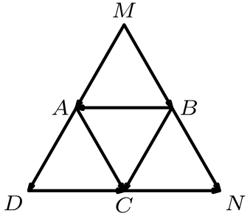
（A）2 （B）3 （C）4 （D）5 （E）6
English
Using only the paths and the directions shown, how many different routes are there from M to N?
(A) 2 (B) 3 (C) 4 (D) 5 (E) 6
第 10 题
一幅宽 3 英尺的画挂在一面宽 19 英尺的墙正中央。画最近的一边距离墙端多少英尺？
（A）11/2 （B）8 （C）91/2 （D）16 （E）22
English
A picture 3 feet across is hung in the center of a wall that is 19 feet wide. How many feet from the end of the wall is the nearest edge of the picture?
(A) 11/2 (B) 8 (C) 91/2 (D) 16 (E) 22
第 11 题
如果 A * B 表示 (A + B)/2，那么 (3 * 5) * 8 等于
（A）6 （B）8 （C）12 （D）16 （E）30
English
If A * B means (A + B)/2, then (3 * 5) * 8 is
(A) 6 (B) 8 (C) 12 (D) 16 (E) 30
第 12 题
图表显示了一个数学班 30 名学生在最近两次测验中的成绩分布。例如，正好有一名学生在测验 1 中得“D”，在测验 2 中得“C”（圈出的格子）。有百分之多少的学生两次测验得到了相同成绩？
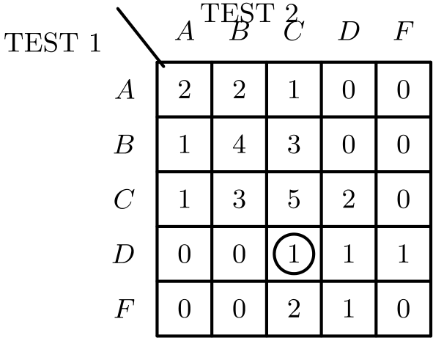
（A）12% （B）25% （C）331/3% （D）40% （E）50%
English
The table shown displays the grade distribution of the 30 students in a mathematics class on the last two tests. For example, exactly one student received a ‘D’ on Test 1 and a ‘C’ on Test 2 (the circled entry). What percent of the students received the same grade on both tests?
(A) 12% (B) 25% (C) 331/3% (D) 40% (E) 50%
第 13 题
图中多边形的周长是
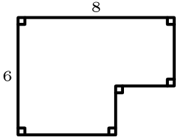
（A）14 （B）20 （C）28 （D）48 （E）无法由给定信息确定
English
The perimeter of the polygon shown is
(A) 14 (B) 20 (C) 28 (D) 48 (E) cannot be determined from the information given
第 14 题
如果 200 ≤ a ≤ 400 且 600 ≤ b ≤ 1200，那么商 b/a 的最大值是
（A）3/2 （B）3 （C）6 （D）300 （E）600
English
If 200 ≤ a ≤ 400 and 600 ≤ b ≤ 1200, then the largest value of the quotient b/a is
(A) 3/2 (B) 3 (C) 6 (D) 300 (E) 600
第 15 题
阿贾克斯折扣店的促销价比原价低 50%。周六在促销价基础上再打 20% 折扣。一件原价 $180 的外套周六价格是多少？
（A）$54 （B）$72 （C）$90 （D）$108 （E）$110
English
Sale prices at the Ajax Outlet Store are 50% below original prices. On Saturdays an additional discount of 20% off the sale price is given. What is the Saturday price of a coat whose original price is $180?
(A) $54 (B) $72 (C) $90 (D) $108 (E) $110
第 16 题
一幅条形图显示了一家快餐连锁店在每个季节卖出的汉堡数量。但是，表示冬季销量的条形被一块污迹遮住了。如果这家连锁店全年汉堡销量中正好有 25% 是秋季卖出的，那么冬季卖出多少百万个汉堡？
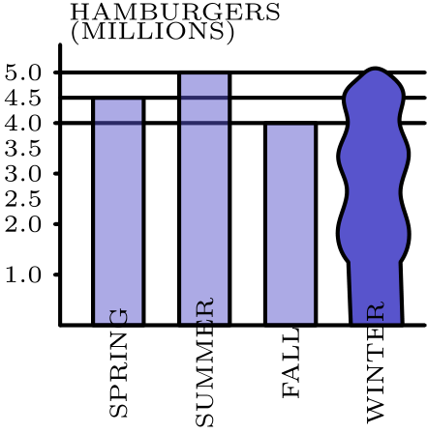
（A）2.5 （B）3 （C）3.5 （D）4 （E）4.5
English
A bar graph shows the number of hamburgers sold by a fast food chain each season. However, the bar indicating the number sold during the winter is covered by a smudge. If exactly 25% of the chain’s hamburgers are sold in the fall, how many million hamburgers are sold in the winter?
(A) 2.5 (B) 3 (C) 3.5 (D) 4 (E) 4.5
第 17 题
设 o 是一个奇整数，n 是任意整数。关于整数 o² + no，下列哪项总为真？
（A）它总是奇数 （B）它总是偶数 （C）只有当 n 为偶数时它才是偶数 （D）只有当 n 为奇数时它才是奇数 （E）只有当 n 为偶数时它才是奇数
English
Let o be an odd whole number and let n be any whole number. Which of the following statements about the whole number o² + no is always true?
(A) it is always odd (B) it is always even (C) it is even only if n is even (D) it is odd only if n is odd (E) it is odd only if n is even
第 18 题
一个矩形牧场要用一段 100 米石墙作为第四边，只在另外三边围栅栏。栅栏上每隔 12 米立一个柱子，包括栅栏与石墙相接处的两个柱子。围出一个 36 米乘 60 米的区域，最少需要多少根柱子？
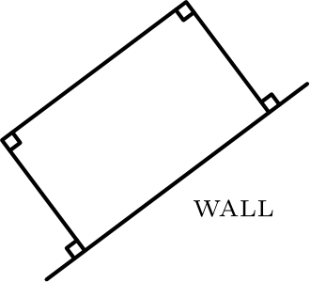
（A）11 （B）12 （C）13 （D）14 （E）16
English
A rectangular grazing area is to be fenced off on three sides using part of a 100 meter rock wall as the fourth side. Fence posts are to be placed every 12 meters along the fence, including the two posts where the fence meets the rock wall. What is the fewest number of posts required to fence an area 36 m by 60 m?
(A) 11 (B) 12 (C) 13 (D) 14 (E) 16
第 19 题
旅行开始时，里程表读数为 56,200 英里。司机给油箱加满了 6 加仑汽油。旅途中，当里程表读数为 56,560 时，司机又给油箱加了 12 加仑汽油。旅行结束时，司机又加了 20 加仑汽油；此时里程表读数为 57,060。按最接近的十分之一计算，整段旅行中汽车平均每加仑行驶多少英里？
（A）22.5 （B）22.6 （C）24.0 （D）26.9 （E）27.5
English
At the beginning of a trip, the mileage odometer read 56,200 miles. The driver filled the gas tank with 6 gallons of gasoline. During the trip, the driver filled the tank again with 12 gallons of gasoline when the odometer read 56,560. At the end of the trip, the driver filled the tank again with 20 gallons of gasoline; the odometer read 57,060. To the nearest tenth, what was the car’s average miles-per-gallon for the entire trip?
(A) 22.5 (B) 22.6 (C) 24.0 (D) 26.9 (E) 27.5
第 20 题
表达式
((304)⁵)/((29.7)(399)⁴)
的值最接近
（A）0.003 （B）0.03 （C）0.3 （D）3 （E）30
English
The value of the expression
((304)⁵)/((29.7)(399)⁴)
is closest to
(A) 0.003 (B) 0.03 (C) 0.3 (D) 3 (E) 30
第 21 题
在所示 T 形图中，分别把八个带字母的相同正方形中的一个与四个阴影正方形放在一起。所得图形中有多少个可以折成一个没有顶盖的立方体盒子？
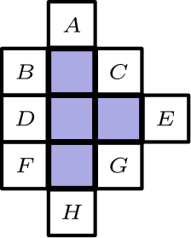
（A）2 （B）3 （C）4 （D）5 （E）6
English
Suppose one of the eight lettered identical squares is included with the four shaded squares in the T-shaped figure shown. How many of the resulting figures can be folded into a topless cubical box?
(A) 2 (B) 3 (C) 4 (D) 5 (E) 6
第 22 题
艾伦、贝丝、卡洛斯和戴安娜正在讨论本评分期数学课可能得到的成绩。艾伦说：“如果我得 A，那么贝丝会得 A。”贝丝说：“如果我得 A，那么卡洛斯会得 A。”卡洛斯说：“如果我得 A，那么戴安娜会得 A。”这些话都是真的，但只有两名学生得了 A。哪两名学生得了 A？
（A）艾伦、贝丝 （B）贝丝、卡洛斯 （C）卡洛斯、戴安娜 （D）艾伦、戴安娜 （E）贝丝、戴安娜
English
Alan, Beth, Carlos, and Diana were discussing their possible grades in mathematics class this grading period. Alan said, “If I get an A, then Beth will get an A.” Beth said, “If I get an A, then Carlos will get an A.” Carlos said, “If I get an A, then Diana will get an A.” All of these statements were true, but only two of the students received an A. Which two received A’s?
(A) Alan, Beth (B) Beth, Carlos (C) Carlos, Diana (D) Alan, Diana (E) Beth, Diana
第 23 题
大圆的直径是 AC。两个小圆的圆心在 AC 上，并且在大圆圆心 O 处相切。如果每个小圆半径为 1，阴影区域面积与一个小圆面积之比是多少？
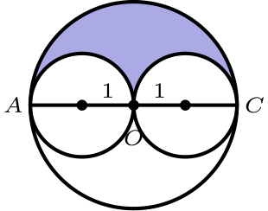
（A）在 1/2 和 1 之间 （B）1 （C）在 1 和 3/2 之间 （D）在 3/2 和 2 之间 （E）无法由给定信息确定
English
The large circle has diameter AC. The two small circles have their centers on AC and just touch at O, the center of the large circle. If each small circle has radius 1, what is the value of the ratio of the area of the shaded region to the area of one of the small circles?
(A) between 1/2 and 1 (B) 1 (C) between 1 and 3/2 (D) between 3/2 and 2 (E) cannot be determined from the information given
第 24 题
金氏初中的 600 名学生午餐时被平均分成三组。每组在不同时间吃午餐。电脑随机把每名学生分到三组之一。三个朋友艾尔、鲍勃和卡罗尔被分到同一午餐组的概率大约是
（A）1/27 （B）1/9 （C）1/8 （D）1/6 （E）1/3
English
The 600 students at King Middle School are divided into three groups of equal size for lunch. Each group has lunch at a different time. A computer randomly assigns each student to one of the three lunch groups. The probability that three friends, Al, Bob, and Carol, will be assigned to the same lunch group is approximately
(A) 1/27 (B) 1/9 (C) 1/8 (D) 1/6 (E) 1/3
第 25 题
下列哪一组整数的平均数最大？
（A）1 到 101 之间的 2 的倍数 （B）1 到 101 之间的 3 的倍数 （C）1 到 101 之间的 4 的倍数 （D）1 到 101 之间的 5 的倍数 （E）1 到 101 之间的 6 的倍数
English
Which of the following sets of whole numbers has the largest average?
(A) multiples of 2 between 1 and 101 (B) multiples of 3 between 1 and 101 (C) multiples of 4 between 1 and 101 (D) multiples of 5 between 1 and
101 (E) multiples of 6 between 1 and 101

第二部分 解答
答案速查：
题号 1 2 3 4 5 6 7 8 9
答案 A A C C D E B E E
题号 10 11 12 13 14 15 16 17 18
答案 B A D C C B A E B
题号 19 20 21 22 23 24 25
答案 D D E C B B D
答案串：AACCDEBEEBADCCBAEBDDECBBD
第 1 题 答案 A
平均每小时降雨量等于总降雨量除以总小时数。七月有 31 天，即 31 × 24 小时，所以平均值是 366/(31 × 24) = 61/124 英寸每小时。
所以正确答案是A。
English
The average rainfall per hour equals the total rainfall divided by the total number of hours. July has 31 days, or 31 × 24 hours, so the average is 366/(31 × 24) = 61/124 inches per hour.
Thus, the correct answer isA.
第 2 题 答案 A
较大的正数倒数较小，较小的正数倒数较大。列出的数中最小的是 1/3，它的倒数 3 最大。
所以正确答案是A。
English
A large positive number has a small reciprocal, and a small positive number has a large reciprocal. The smallest number listed is 1/3, whose reciprocal 3 is the largest.
Thus, the correct answer isA.
第 3 题 答案 C
集合中三个最小的数是 -3、-1 和 7。它们的和是 -3 + (-1) + 7 = 3。
所以正确答案是C。
English
The three smallest numbers in the set are -3, -1, and 7. Their sum is -3 + (-1) + 7 = 3.
Thus, the correct answer isC.
第 4 题 答案 C
第二个因数 40.3 + 0.07 = 40.37 约为 40，而 1.8 约为 2。快速估算为 2(40) - 0.2(40) = 80 - 8 = 72，所以乘积最接近 74。
所以正确答案是C。
English
The second factor 40.3 + 0.07 = 40.37 is about 40, and 1.8 is about 2. A quick estimate is 2(40) - 0.2(40) = 80 - 8 = 72, so the product is closest to 74.
Thus, the correct answer isC.
第 5 题 答案 D
因为 1000 分钟 = 1000/60 小时 = 162/3 小时 = 16 小时 40 分钟，所以比赛在中午后 16 小时 40 分钟结束，即凌晨 4:40。
所以正确答案是D。
English
Since 1000 minutes = 1000/60 hours = 162/3 hours = 16 hours 40 minutes, the contest ended 16 hours 40 minutes past noon, which is 4:40 a.m.
Thus, the correct answer isD.
第 6 题 答案 E
分母是 1 - 2/3 = 1/3，所以表达式是 2/(1/3) = 2 × 3 = 6。
所以正确答案是E。
English
The denominator is 1 - 2/3 = 1/3, so the expression is 2/(1/3) = 2 × 3 = 6.
Thus, the correct answer isE.
第 7 题 答案 B
因为 2 < √(8) < 3，且 8 < √(80) < 9，所以严格在 √(8) 和 √(80) 之间的整数是 3、4、5、6、7、8。共有六个。
所以正确答案是B。
English
Since 2 < √(8) < 3 and 8 < √(80) < 9, the whole numbers strictly between √(8) and √(80) are 3, 4, 5, 6, 7, 8. There are six of them.
Thus, the correct answer isB.
第 8 题 答案 E
乘积的个位来自 B × 2，只有当 B = 3 或 B = 8 时才以 6 结尾。由于乘积 6396 大于 6000，B 必须是 8：确实 82 × 78 = 6396。
所以正确答案是E。
English
The units digit of the product comes from B × 2, which ends in 6 only when B = 3 or B = 8. Since the product 6396 exceeds 6000, B must be 8: indeed 82 × 78 = 6396.
Thus, the correct answer isE.
第 9 题 答案 E
沿箭头可行的路线是 MADCN、MACN、MBADCN、MBACN、MBCN 和 MBN。共有六条。
所以正确答案是E。
English
Following the arrows, the possible routes are MADCN, MACN, MBADCN, MBACN, MBCN, and MBN. There are six of them.
Thus, the correct answer isE.
第 10 题 答案 B
画留下 19 - 3 = 16 英尺的墙面，平均分成两侧各 8 英尺的空隙。所以画最近的一边离墙端 8 英尺。
所以正确答案是B。
English
The picture leaves 19 - 3 = 16 feet of wall, split equally into two gaps of 8 feet each. So the nearest edge of the picture is 8 feet from the end of the wall.
Thus, the correct answer isB.
第 11 题 答案 A
首先，3 * 5 = (3 + 5)/2 = 4。然后 4 * 8 = (4 + 8)/2 = 6。
所以正确答案是A。
English
First, 3 * 5 = (3 + 5)/2 = 4. Then 4 * 8 = (4 + 8)/2 = 6.
Thus, the correct answer isA.
第 12 题 答案 D
学生两次测验成绩相同，正对应主对角线上的格子。这些数是 2 + 4 + 5 + 1 + 0 = 12。
所以比例是 12/30 = 4/10 = 40%。
所以正确答案是D。
English
A student received the same grade on both tests exactly when counted on the main diagonal. Those entries are 2 + 4 + 5 + 1 + 0 = 12.
So the fraction is 12/30 = 4/10 = 40%.
Thus, the correct answer isD.
第 13 题 答案 C
因为每个角都是直角，把边平移重组可见，水平边总共走过宽度两次，竖直边走过高度两次。因此周长等于完整 8 乘 6 矩形的周长，即 2(8 + 6) = 28。
答案不取决于缺口具体切在哪里。
所以正确答案是C。
English
Because every angle is a right angle, sliding the edges shows that the horizontal edges together traverse the width twice and the vertical edges traverse the height twice. So the perimeter equals that of the full 8 by 6 rectangle, 2(8 + 6) = 28.
The answer does not depend on exactly where the notch is cut.
Thus, the correct answer isC.
第 14 题 答案 C
当 b 取最大值、a 取最小值时，商 b/a 最大，得到 1200/200 = 6。
所以正确答案是C。
English
The quotient b/a is largest with the biggest b and smallest a, giving 1200/200 = 6.
Thus, the correct answer isC.
第 15 题 答案 B
促销价是 $180 的 50%，即 $90。周六价格再减 20%，留下 $90 的 80%，即 $72。
所以正确答案是B。
English
The sale price is 50% of $180, or $90. The Saturday price takes another 20% off, leaving 80% of $90, which is $72.
Thus, the correct answer isB.
第 16 题 答案 A
如果秋季 4 百万个是全年总量的 25%，那么全年总量是 16 百万个。
冬季销量是 16 - (4.5 + 5 + 4) = 2.5 百万个。
所以正确答案是A。
English
If the fall sales of 4 million are 25% of the yearly total, then the yearly total is 16 million.
The winter sales are 16 - (4.5 + 5 + 4) = 2.5 million.
Thus, the correct answer isA.
第 17 题 答案 E
因式分解得 o² + no = o(o + n)。因为 o 是奇数，这个乘积为奇数当且仅当 o + n 为奇数，而这只在 n 为偶数时发生。当 n 为奇数时，o + n 为偶数，乘积为偶数。
所以这个数只有当 n 为偶数时才是奇数。
所以正确答案是E。
English
Factor o² + no = o(o + n). Because o is odd, the product is odd exactly when o + n is odd, which happens only when n is even. When n is odd, o + n is even and the product is even.
So the number is odd only if n is even.
Thus, the correct answer isE.
第 18 题 答案 B
当石墙作为较长的 60 米边时，用的柱子最少；此时栅栏覆盖两条 36 米边和一条 60 米边，总路径长 36 + 60 + 36 = 132 米。
每隔 12 米放一根柱子并包括两端，共用 132/12 + 1 = 12 根柱子。
所以正确答案是B。
English
The fewest posts are used when the wall serves as the longer 60 meter side, so the fence covers two 36 meter sides and one 60 meter side, a path of 36 + 60 + 36 = 132 meters.
Placing a post every 12 meters, including both ends, uses 132/12 + 1 = 12 posts.
Thus, the correct answer isB.
第 19 题 答案 D
旅行距离是 57,060 - 56,200 = 860 英里。最初的 6 加仑只是出发前加满油箱；旅途中真正用掉的是后来为补回油量所加的 12 + 20 = 32 加仑。
所以平均值是 860/32 ≈ 26.9 英里每加仑。
所以正确答案是D。
English
The trip was 57,060 - 56,200 = 860 miles. The initial 6 gallons only topped off the tank before the trip; the gas actually used during the trip is the 12 + 20 = 32 gallons later added to replace it.
So the average is 860/32 ≈ 26.9 miles per gallon.
Thus, the correct answer isD.
第 20 题 答案 D
估算：
300⁵/(30 · 400⁴) = 10 (300/400)⁴
= 10 (3/4)⁴
= 10 · 81/256 ≈ 3
。
所以正确答案是D。
English
Estimating,
300⁵/(30 · 400⁴) = 10 (300/400)⁴
= 10 (3/4)⁴
= 10 · 81/256 ≈ 3.
Thus, the correct answer isD.
第 21 题 答案 E
四个阴影正方形折成开口盒子的四个面，新增正方形提供第五个面。想象折叠过程，正方形 A、E、H、B、D 和 F 都能补成一个有效的无顶盒。
正方形 C 和 G 不行，因为折叠后会迫使四个面在同一个角相遇。因此有 6 个有效图形。
所以正确答案是E。
English
The four shaded squares fold into four faces of an open box, and the added square supplies the fifth face. Picturing the folds, the squares A, E, H, B, D, and F each complete a valid topless box.
The squares C and G do not work, because folding would force four faces to meet at a single corner. That leaves 6 valid figures.
Thus, the correct answer isE.
第 22 题 答案 C
这些陈述形成一条链：艾伦得 A 会推出贝丝得 A，贝丝得 A 会推出卡洛斯得 A，卡洛斯得 A 会推出戴安娜得 A。如果艾伦得 A，则四人都得 A；如果贝丝得 A，则三人得 A。
正好有两个 A 的唯一方式是链条最后两人得 A，即卡洛斯和戴安娜。
所以正确答案是C。
English
The statements form a chain: Alan’s A forces Beth’s, Beth’s forces Carlos’s, and Carlos’s forces Diana’s. If Alan got an A, all four would; if Beth got an A, three would.
The only way to have exactly two A’s is for them to be the last two in the chain, Carlos and Diana.
Thus, the correct answer isC.
第 23 题 答案 B
大圆半径为 2，所以面积是 π(2)² = 4π，每个小圆面积是 π。
由对称性，阴影区域是面积差的一半：1/2(4π - 2π) = π。它与一个小圆面积 π 的比值是 1。
所以正确答案是B。
English
The large circle has radius 2, so its area is π(2)² = 4π, and each small circle has area π.
By symmetry the shaded region is half the difference of the areas: 1/2(4π - 2π) = π. The ratio of this to one small circle’s area π is 1.
Thus, the correct answer isB.
第 24 题 答案 B
不论艾尔在哪一组，鲍勃进入同一组的概率为 199/599。如果鲍勃进入该组，卡罗尔也进入该组的概率为 198/598。
所以三人在同一组的概率约为 199/599 · 198/598 ≈ 0.110，最接近 1/9。
所以正确答案是B。
English
Whatever group Al is in, Bob joins that same group with probability 199/599. If Bob does, Carol joins them with probability 198/598.
Thus all three share a group with probability 199/599 · 198/598 ≈ 0.110, closest to 1/9.
Thus, the correct answer isB.
第 25 题 答案 D
对一组等间隔整数，平均数等于最小数与最大数的平均数。各组平均数为：A：(2 + 100)/2 = 51，B：(3 + 99)/2 = 51，C：(4 + 100)/2 = 52，D：(5 + 100)/2 = 52.5，E：(6 + 96)/2 = 51。
最大平均数是 52.5，来自 5 的倍数。
所以正确答案是D。
English
For a set of evenly spaced whole numbers, the average is the average of the smallest and largest. The averages are: A: (2 + 100)/2 = 51, B: (3 + 99)/2 = 51, C: (4 + 100)/2 = 52, D: (5 + 100)/2 = 52.5, E: (6 + 96)/2 = 51.
The largest average is 52.5, from the multiples of 5.
Thus, the correct answer isD.

