2013A AMC 12 真题与解答
American Mathematics Competitions 12 · 中英双语
共 25 题，限时 75 分钟；答对得 6 分，未答得 1.5 分，答错 0 分，满分 150 分。
编排说明：第一部分为题目（先中文、后英文原题），第二部分为解答与答案，便于先做题后对答案。
第一部分 题目
第 1 题
正方形 ABCD 的边长为 10。点 E 在 BC 上，且 △ ABE 的面积为 40。BE 是多少？
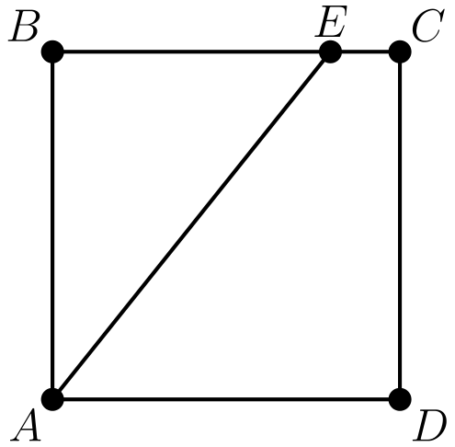
（A）4 （B）5 （C）6 （D）7 （E）8
English
Square ABCD has side length 10. Point E is on BC, and the area of △ ABE is 40. What is BE?
(A) 4 (B) 5 (C) 6 (D) 7 (E) 8
第 2 题
一支垒球队打了十场比赛，得分分别为 1，2，3，4，5，6，7，8，9 和 10 分。他们恰好在五场比赛中以一分之差输掉。在其他每场比赛中，他们的得分都是对手的两倍。对手总共得了多少分？
（A）35 （B）40 （C）45 （D）50 （E）55
English
A softball team played ten games, scoring 1, 2, 3, 4, 5, 6, 7, 8, 9, and 10 runs. They lost by one run in exactly five games. In each of their other games, they scored twice as many runs as their opponent. How many total runs did their opponents score?
(A) 35 (B) 40 (C) 45 (D) 50 (E) 55
第 3 题
一束花包含粉玫瑰、红玫瑰、粉康乃馨和红康乃馨。粉色花中有三分之一是玫瑰，红色花中有四分之三是康乃馨，且所有花中有十分之六是粉色。所有花中有百分之几是康乃馨？
（A）15 （B）30 （C）40 （D）60 （E）70
English
A flower bouquet contains pink roses, red roses, pink carnations, and red carnations. One third of the pink flowers are roses, three fourths of the red flowers are carnations, and six tenths of the flowers are pink. What percent of the flowers are carnations?
(A) 15 (B) 30 (C) 40 (D) 60 (E) 70
第 4 题
求下式的值：
(2²⁰¹⁴ + 2²⁰¹²)/(2²⁰¹⁴ - 2²⁰¹²)？
（A）-1 （B）1 （C）5/3 （D）2013 （E）2⁴⁰²⁴
English
What is the value of
(2²⁰¹⁴ + 2²⁰¹²)/(2²⁰¹⁴ - 2²⁰¹²)?
(A) -1 (B) 1 (C) 5/3 (D) 2013 (E) 2⁴⁰²⁴
第 5 题
Tom、Dorothy 和 Sammy 去度假，并约定平均分摊费用。旅途中 Tom 支付了 $105，Dorothy 支付了 $125，Sammy 支付了 $175。为了平摊费用，Tom 给 Sammy t 美元，Dorothy 给 Sammy d 美元。t - d 是多少？
（A）15 （B）20 （C）25 （D）30 （E）35
English
Tom, Dorothy, and Sammy went on a vacation and agreed to split the costs evenly. During their trip Tom paid $105, Dorothy paid $125, and Sammy paid $175. In order to share the costs equally, Tom gave Sammy t dollars, and Dorothy gave Sammy d dollars. What is t - d?
(A) 15 (B) 20 (C) 25 (D) 30 (E) 35
第 6 题
在最近的一场篮球比赛中，Shenille 只出手三分球和两分球。她的三分球命中率为 20%，两分球命中率为 30%。Shenille 一共出手 30 次。她得了多少分？
（A）12 （B）18 （C）24 （D）30 （E）36
English
In a recent basketball game, Shenille attempted only three-point shots and two-point shots. She was successful on 20% of her three-point shots and 30% of her two-point shots. Shenille attempted 30 shots. How many points did she score?
(A) 12 (B) 18 (C) 24 (D) 30 (E) 36
第 7 题
数列 S₁，S₂，S₃，…，S₁₀ 满足从第三项开始，每一项都是前两项之和。也就是说，
Sₙ = Sₙ₋₂ + Sₙ₋₁ 对所有 n ≥ 3。
已知 S₉ = 110 且 S₇ = 42。S₄ 是多少？
（A）4 （B）6 （C）10 （D）12 （E）16
English
The sequence S₁, S₂, S₃, …, S₁₀ has the property that every term beginning with the third is the sum of the previous two. That is,
Sₙ = Sₙ₋₂ + Sₙ₋₁ for n ≥ 3.
Suppose that S₉ = 110 and S₇ = 42. What is S₄?
(A) 4 (B) 6 (C) 10 (D) 12 (E) 16
第 8 题
已知 x 和 y 是不同的非零实数，且 x + 2/x = y + 2/y，xy 是多少？
（A）1/4 （B）1/2 （C）1 （D）2 （E）4
English
Given that x and y are distinct nonzero real numbers such that x + 2/x = y + 2/y, what is xy?
(A) 1/4 (B) 1/2 (C) 1 (D) 2 (E) 4
第 9 题
在 △ ABC 中，AB = AC = 28，且 BC = 20。点 D、E 和 F 分别在边 AB、BC 和 AC 上，使得 DE 和 EF 分别平行于 AC 和 AB。平行四边形 ADEF 的周长是多少？
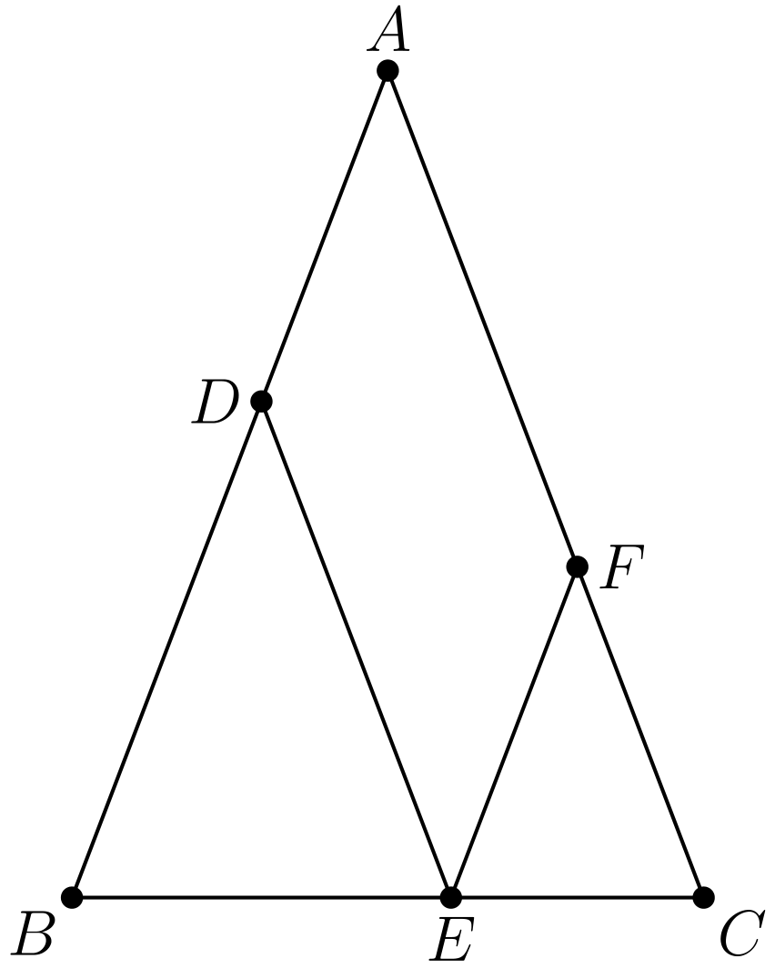
（A）48 （B）52 （C）56 （D）60 （E）72
English
In △ ABC, AB = AC = 28 and BC = 20. Points D, E, and F are on sides AB, BC, and AC, respectively, such that DE and EF are parallel to AC and AB, respectively. What is the perimeter of parallelogram ADEF?
(A) 48 (B) 52 (C) 56 (D) 60 (E) 72
第 10 题
设 S 为所有正整数 n 的集合，使得 1/n 的循环小数表示为 0.ab = 0.ababab…，其中 a 和 b 是不同的数字。集合 S 中元素的和是多少？
（A）11 （B）44 （C）110 （D）143 （E）155
English
Let S be the set of positive integers n for which 1/n has the repeating decimal representation 0.ab = 0.ababab…, with a and b different digits. What is the sum of the elements of S?
(A) 11 (B) 44 (C) 110 (D) 143 (E) 155
第 11 题
三角形 ABC 是等边三角形，且 AB = 1。点 E 和 G 在 AC 上，点 D 和 F 在 AB 上，使得 DE 和 FG 都平行于 BC。此外，三角形 ADE 以及梯形 DFGE 和 FBCG 的周长都相同。求 DE + FG。
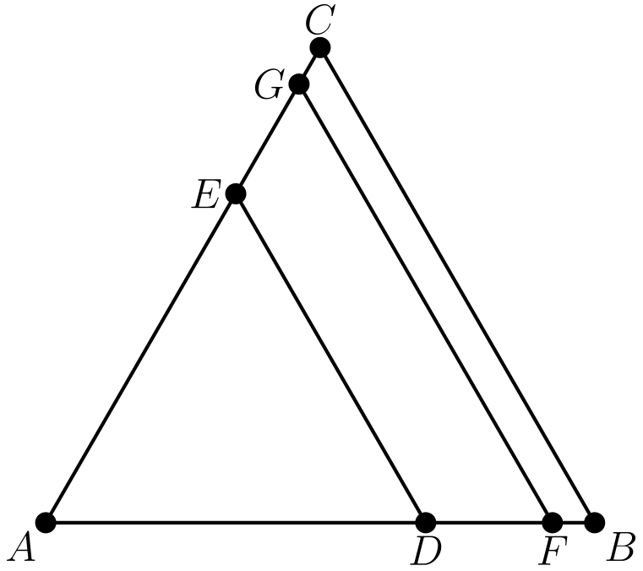
（A）1 （B）3/2 （C）21/13 （D）13/8 （E）5/3
English
Triangle ABC is equilateral with AB = 1. Points E and G are on AC and points D and F are on AB such that both DE and FG are parallel to BC. Furthermore, triangle ADE and trapezoids DFGE and FBCG all have the same perimeter. What is DE + FG?
(A) 1 (B) 3/2 (C) 21/13 (D) 13/8 (E) 5/3
第 12 题
某个三角形的三个角成等差数列，边长为 4，5，和 x。所有可能的 x 值之和等于 a + √(b) + √(c)，其中 a，b，和 c 为正整数。a + b + c 是多少？
（A）36 （B）38 （C）40 （D）42 （E）44
English
The angles in a particular triangle are in arithmetic progression, and the side lengths are 4, 5, and x. The sum of the possible values of x equals a + √(b) + √(c), where a, b, and c are positive integers. What is a + b + c?
(A) 36 (B) 38 (C) 40 (D) 42 (E) 44
第 13 题
设点 A = (0, 0)，B = (1, 2)，C = (3, 3)，和 D = (4, 0)。一条经过 A 的直线把四边形 ABCD 分成面积相等的两部分。该直线与 CD 交于点 (p/q, r/s)，其中这些分数均为最简形式。p + q + r + s 是多少？
（A）54 （B）58 （C）62 （D）70 （E）75
English
Let points A = (0, 0), B = (1, 2), C = (3, 3), and D = (4, 0). Quadrilateral ABCD is cut into equal area pieces by a line passing through A. This line intersects CD at point (p/q, r/s), where these fractions are in lowest terms. What is p + q + r + s?
(A) 54 (B) 58 (C) 62 (D) 70 (E) 75
第 14 题
数列
log₁₂ 162, log₁₂ x, log₁₂ y,
log₁₂ z, log₁₂ 1250
是一个等差数列。求 x。
（A）125√(3) （B）270 （C）162√(5) （D）434 （E）225√(6)
English
The sequence
log₁₂ 162, log₁₂ x, log₁₂ y,
log₁₂ z, log₁₂ 1250
is an arithmetic progression. What is x?
(A) 125√(3) (B) 270 (C) 162√(5) (D) 434 (E) 225√(6)
第 15 题
兔子 Peter 和 Pauline 有三个孩子 Flopsie、Mopsie 和 Cottontail。现在要把这五只兔子分配给四家不同的宠物店，使得没有一家店同时得到一只父母兔和一只孩子兔。不要求每家店都得到兔子。有多少种不同的分配方法？
（A）96 （B）108 （C）156 （D）204 （E）372
English
Rabbits Peter and Pauline have three offspring—Flopsie, Mopsie, and Cottontail. These five rabbits are to be distributed to four different pet stores so that no store gets both a parent and a child. It is not required that every store gets a rabbit. In how many different ways can this be done?
(A) 96 (B) 108 (C) 156 (D) 204 (E) 372
第 16 题
A、B 和 C 是三堆石头。A 中石头的平均重量为 40 磅，B 中石头的平均重量为 50 磅，合并 A 和 B 两堆后石头的平均重量为 43 磅，合并 A 和 C 两堆后石头的平均重量为 44 磅。合并 B 和 C 两堆后，石头平均重量的最大可能整数值是多少磅？
（A）55 （B）56 （C）57 （D）58 （E）59
English
A, B, and C are three piles of rocks. The mean weight of the rocks in A is 40 pounds, the mean weight of the rocks in B is 50 pounds, the mean weight of the rocks in the combined piles A and B is 43 pounds, and the mean weight of the rocks in the combined piles A and C is 44 pounds. What is the greatest possible integer value for the mean in pounds of the rocks in the combined piles B and C?
(A) 55 (B) 56 (C) 57 (D) 58 (E) 59
第 17 题
一组 12 名海盗同意按如下方式分一箱金币。第 k 个取份额的海盗拿走箱中剩余金币的 k/12。箱中最初的金币数是能使每名海盗都得到正整数枚金币的最小数。第 12 名海盗得到多少枚金币？
（A）720 （B）1296 （C）1728 （D）1925 （E）3850
English
A group of 12 pirates agree to divide a treasure chest of gold coins among themselves as follows. The kth pirate to take a share takes k/12 of the coins that remain in the chest. The number of coins initially in the chest is the smallest number for which this arrangement will allow each pirate to receive a positive whole number of coins. How many coins does the 12th pirate receive?
(A) 720 (B) 1296 (C) 1728 (D) 1925 (E) 3850
第 18 题
六个半径为 1 的球摆放成它们的球心位于边长为 2 的正六边形顶点上。这六个球都内切于一个大球，大球球心是该正六边形的中心。第八个球外切于这六个小球，并内切于大球。这个第八个球的半径是多少？
（A）√(2) （B）3/2 （C）5/3 （D）√(3) （E）2
English
Six spheres of radius 1 are positioned so that their centers are at the vertices of a regular hexagon of side length 2. The six spheres are internally tangent to a larger sphere whose center is the center of the hexagon. An eighth sphere is externally tangent to the six smaller spheres and internally tangent to the larger sphere. What is the radius of this eighth sphere?
(A) √(2) (B) 3/2 (C) 5/3 (D) √(3) (E) 2
第 19 题
在 △ ABC 中，AB = 86，且 AC = 97。以 A 为圆心、AB 为半径的圆与 BC 交于点 B 和 X。此外，BX 和 CX 的长度都是整数。BC 是多少？
（A）11 （B）28 （C）33 （D）61 （E）72
English
In △ ABC, AB = 86, and AC = 97. A circle with center A and radius AB intersects BC at points B and X. Moreover BX and CX have integer lengths. What is BC?
(A) 11 (B) 28 (C) 33 (D) 61 (E) 72
第 20 题
设 S 为集合 {1, 2, 3, …, 19}。对 a，b ∈ S，定义 a succ b 表示 0 < a - b ≤ 9 或 b - a > 9。有多少个由 S 中元素组成的有序三元组 (x, y, z) 满足 x succ y、y succ z 且 z succ x？
（A）810 （B）855 （C）900 （D）950 （E）988
English
Let S be the set {1, 2, 3, …, 19}. For a, b ∈ S, define a succ b to mean that either 0 < a - b ≤ 9 or b - a > 9. How many ordered triples (x, y, z) of elements of S have the property that x succ y, y succ z, and z succ x?
(A) 810 (B) 855 (C) 900 (D) 950 (E) 988
第 21 题
考虑
A =
tiny log(2013 + log(2012 + log(2011 + log(⋯ + log(3 + log 2)⋯))))
。
以下哪个区间包含 A？
（A）(log 2016, log 2017) （B）(log 2017, log 2018) （C）(log 2018, log 2019) （D）(log 2019, log 2020) （E）(log 2020, log 2021)
English
Consider
A =
tiny log(2013 + log(2012 + log(2011 + log(⋯ + log(3 + log 2)⋯)))).
Which of the following intervals contains A?
(A) (log 2016, log 2017) (B) (log 2017, log 2018) (C) (log 2018, log 2019) (D) (log 2019, log 2020) (E) (log 2020, log 2021)
第 22 题
回文数是一个非负整数，按 10 进制书写且没有前导零时，从前往后读和从后往前读相同。随机均匀选取一个 6 位回文数 n，n/11 也是回文数的概率是多少？
（A）8/25 （B）33/100 （C）7/20 （D）9/25 （E）11/30
English
A palindrome is a nonnegative integer number that reads the same forwards and backwards when written in base 10 with no leading zeros. A 6-digit palindrome n is chosen uniformly at random. What is the probability that n/11 is also a palindrome?
(A) 8/25 (B) 33/100 (C) 7/20 (D) 9/25 (E) 11/30
第 23 题
ABCD 是一个边长为 √(3) + 1 的正方形。点 P 在 AC 上，且 AP = √(2)。将正方形 ABCD 围成的区域绕中心 P 逆时针旋转 90°，扫过区域的面积为 1/c(aπ + b)，其中 a，b 和 c 为正整数且 gcd(a, b, c) = 1。求 a + b + c。
（A）15 （B）17 （C）19 （D）21 （E）23
English
ABCD is a square of side length √(3) + 1. Point P is on AC such that AP = √(2). The square region bounded by ABCD is rotated 90° counterclockwise with center P, sweeping out a region whose area is 1/c(aπ + b), where a, b, and c are positive integers and gcd(a, b, c) = 1. What is a + b + c?
(A) 15 (B) 17 (C) 19 (D) 21 (E) 23
第 24 题
从所有以正 12 边形顶点为端点的线段中随机选取三条不同的线段。这三条线段的长度能作为一个面积为正的三角形的三条边长的概率是多少？
（A）553/715 （B）443/572 （C）111/143 （D）81/104 （E）223/286
English
Three distinct segments are chosen at random among the segments whose endpoints are the vertices of a regular 12-gon. What is the probability that the lengths of these three segments are the three side lengths of a triangle with positive area?
(A) 553/715 (B) 443/572 (C) 111/143 (D) 81/104 (E) 223/286
第 25 题
定义函数 f: C → C 为 f(z) = z² + iz + 1。有多少个复数 z 满足 Im(z) > 0，并且 f(z) 的实部和虚部都是绝对值至多为 10 的整数？
（A）399 （B）401 （C）413 （D）431 （E）441
English
Let f: C → C be defined by f(z) = z² + iz + 1. How many complex numbers z are there such that Im(z) > 0 and both the real and the imaginary parts of f(z) are integers with absolute value at most 10?
(A) 399 (B) 401 (C) 413 (D) 431 (E) 441

第二部分 解答
答案速查：
题号 1 2 3 4 5 6 7 8 9
答案 E C E C B B C D C
题号 10 11 12 13 14 15 16 17 18
答案 D C A B B D E D B
题号 19 20 21 22 23 24 25
答案 D B A E C E A
答案串：ECECBBCDCDCABBDEDBDBAECEA
第 1 题 答案 E
直角三角形 ABE 的两条直角边为 AB = 10 和 BE。由 1/2· 10· BE = 40，得 BE = 8。
因此，正确答案是E。
English
The legs of right triangle ABE are AB = 10 and BE. From 1/2· 10· BE = 40, we get BE = 8.
Thus, the correct answer isE.
第 2 题 答案 C
只有当本队得分为偶数时，本队得分才可能是对手的两倍。这些比赛的得分为 2, 4, 6, 8, 10，因而对手得分为 1 + 2 + 3 + 4 + 5 = 15。
另外五场比赛的本队得分为 1, 3, 5, 7, 9，且都是一分惜败，所以对手得分为 2 + 4 + 6 + 8 + 10 = 30。总分为 15 + 30 = 45。
因此，正确答案是C。
English
The team can only score twice as many runs as its opponent when its own score is even. Those games have scores 2, 4, 6, 8, 10, so their opponents scored 1 + 2 + 3 + 4 + 5 = 15.
The other five games had scores 1, 3, 5, 7, 9 and were one-run losses, so their opponents scored 2 + 4 + 6 + 8 + 10 = 30. The total is 15 + 30 = 45.
Thus, the correct answer isC.
第 3 题 答案 E
所有花中十分之六是粉色，十分之四是红色。因为粉色花中三分之二是康乃馨，所以粉康乃馨占全部花的 2/3·6/10 = 4/10。
因为红色花中四分之三是康乃馨，所以红康乃馨占全部花的 3/4·4/10 = 3/10。康乃馨合计占 4/10 + 3/10 = 7/10 = 70%。
因此，正确答案是E。
English
Six tenths of the flowers are pink and four tenths are red. Since two thirds of the pink flowers are carnations, pink carnations make up 2/3·6/10 = 4/10 of the flowers.
Since three fourths of the red flowers are carnations, red carnations make up 3/4·4/10 = 3/10 of the flowers. Together the carnations are 4/10 + 3/10 = 7/10 = 70%.
Thus, the correct answer isE.
第 4 题 答案 C
从每一项中提出 2²⁰¹²，得
(2²⁰¹²(2² + 1))/(2²⁰¹²(2² - 1)) = (4 + 1)/(4 - 1) = 5/3。
因此，正确答案是C。
English
Factoring 2²⁰¹² from each term gives
(2²⁰¹²(2² + 1))/(2²⁰¹²(2² - 1)) = (4 + 1)/(4 - 1) = 5/3.
Thus, the correct answer isC.
第 5 题 答案 B
总花费为 105 + 125 + 175 = 405，所以每人的公平份额为 1/3· 405 = 135 美元。
于是 t = 135 - 105 = 30，d = 135 - 125 = 10，所以 t - d = 30 - 10 = 20。
因此，正确答案是B。
English
The total spent was 105 + 125 + 175 = 405, so each fair share is 1/3· 405 = 135 dollars.
Then t = 135 - 105 = 30 and d = 135 - 125 = 10, so t - d = 30 - 10 = 20.
Thus, the correct answer isB.
第 6 题 答案 B
如果 Shenille 出手 x 次三分球、30 - x 次两分球，那么她的得分为
0.2· 3· x + 0.3· 2·(30 - x)
= 0.6x + 0.6(30 - x)
= 0.6· 30 = 18
分。
因此，正确答案是B。
English
If Shenille attempted x three-point shots and 30 - x two-point shots, she scored
0.2· 3· x + 0.3· 2·(30 - x)
= 0.6x + 0.6(30 - x)
= 0.6· 30 = 18
points.
Thus, the correct answer isB.
第 7 题 答案 C
因为 S₉ = S₇ + S₈，所以 S₈ = 110 - 42 = 68。然后 S₆ = S₈ - S₇ = 68 - 42 = 26，S₅ = S₇ - S₆ = 42 - 26 = 16，且 S₄ = S₆ - S₅ = 26 - 16 = 10。
因此，正确答案是C。
English
Since S₉ = S₇ + S₈, we get S₈ = 110 - 42 = 68. Then S₆ = S₈ - S₇ = 68 - 42 = 26, S₅ = S₇ - S₆ = 42 - 26 = 16, and S₄ = S₆ - S₅ = 26 - 16 = 10.
Thus, the correct answer isC.
第 8 题 答案 D
同乘 xy 得 x² y + 2y = xy² + 2x，所以
x² y - xy² - 2x + 2y
= (x - y)(xy - 2)
= 0
。
因为 x ≠ y，所以 xy = 2。
因此，正确答案是D。
English
Multiplying by xy gives x² y + 2y = xy² + 2x, so
x² y - xy² - 2x + 2y
= (x - y)(xy - 2)
= 0.
Since x ≠ y, it follows that xy = 2.
Thus, the correct answer isD.
第 9 题 答案 C
因为 EF ∥ AB，三角形 FEC 与三角形 ABC 相似，而后者是等腰三角形，所以 FE = FC。
平行四边形 ADEF 周长的一半为 AF + FE = AF + FC = AC = 28。因此整个周长为 56。
因此，正确答案是C。
English
Because EF ∥ AB, triangle FEC is similar to triangle ABC, which is isosceles, so FE = FC.
Half the perimeter of parallelogram ADEF is AF + FE = AF + FC = AC = 28. The entire perimeter is 56.
Thus, the correct answer isC.
第 10 题 答案 D
若 1/n = 0.ab，则 99/n = ab 是一个两位数。99 的正因数为 1, 3, 9, 11, 33, 99。
只有 n = 11, 33, 99 时，99/n 分别等于 09, 03, 01，它们有两个不同的数字。所求和为 11 + 33 + 99 = 143。
因此，正确答案是D。
English
If 1/n = 0.ab, then 99/n = ab, a two-digit number. The positive divisors of 99 are 1, 3, 9, 11, 33, 99.
Only n = 11, 33, 99 make 99/n equal to 09, 03, 01, which have two different digits. The requested sum is 11 + 33 + 99 = 143.
Thus, the correct answer isD.
第 11 题 答案 C
设 x = DE、y = FG。平行线切出的较小区域是等边三角形或等腰梯形，所以周长为
△ ADE: 3x,
DFGE: 3y - x,
FBCG: 3 - y
。
令它们相等，3x = 3y - x 得 4x = 3y，且 3x = 3 - y。解得 x = 9/13、y = 12/13，所以 DE + FG = 21/13。
因此，正确答案是C。
English
Let x = DE and y = FG. The parallel cuts make the small regions equilateral or isosceles trapezoids, so the perimeters are
△ ADE: 3x,
DFGE: 3y - x,
FBCG: 3 - y.
Setting them equal, 3x = 3y - x gives 4x = 3y, and 3x = 3 - y. Solving yields x = 9/13 and y = 12/13, so DE + FG = 21/13.
Thus, the correct answer isC.
第 12 题 答案 A
若三个角为 α - δ, α, α + δ，它们的和 3α = 180° 给出 α = 60°，所以其中一个角是 60°。
若 x 对着 60° 角，由余弦定理得
x² = 4² + 5² - 2· 4· 5cos 60°
= 21，
所以 x = √(21)。
若 5 对着 60° 角，则 25 = x² - 4x + 16，正解为 x = 2 + √(13)。若 4 对着该角，则 16 = x² - 5x + 25，没有实数解。
所有可能值的和为 2 + √(13) + √(21)，所以 a + b + c = 2 + 13 + 21 = 36。
因此，正确答案是A。
English
If the angles are α - δ, α, α + δ, their sum 3α = 180° gives α = 60°, so one angle is 60°.
If x is opposite the 60° angle, the Law of Cosines gives
x² = 4² + 5² - 2· 4· 5cos 60°
= 21,
so x = √(21).
If 5 is opposite the 60° angle, then 25 = x² - 4x + 16, whose positive solution is x = 2 + √(13). If 4 is opposite, then 16 = x² - 5x + 25 has no real solution.
The sum of the possible values is 2 + √(13) + √(21), so a + b + c = 2 + 13 + 21 = 36.
Thus, the correct answer isA.
第 13 题 答案 B
由鞋带公式，ABCD 的面积为 15/2。设直线与 CD 交于 G。三角形 ADG 的面积必须为 15/4。
因为 AD = 4 在 x 轴上，1/2· 4· y_(G) = 15/4 给出 y_(G) = 15/8。直线 CD 为 y = -3(x - 4)，所以 x_(G) = 27/8。
于是 p + q + r + s = 27 + 8 + 15 + 8 = 58。
因此，正确答案是B。
English
By the shoelace formula, the area of ABCD is 15/2. Let the line meet CD at G. Triangle ADG must have area 15/4.
Since AD = 4 lies on the x-axis, 1/2· 4· y_(G) = 15/4 gives y_(G) = 15/8. Line CD is y = -3(x - 4), so x_(G) = 27/8.
Then p + q + r + s = 27 + 8 + 15 + 8 = 58.
Thus, the correct answer isB.
第 14 题 答案 B
因为这些对数成等差数列，162, x, y, z, 1250 成等比数列。它的公比 r 满足 162 r⁴ = 1250，所以 r⁴ = 625/81，且 r = 5/3。
因此 x = 162·5/3 = 270。
因此，正确答案是B。
English
Because the logarithms are in arithmetic progression, 162, x, y, z, 1250 is a geometric sequence. Its common ratio r satisfies 162 r⁴ = 1250, so r⁴ = 625/81 and r = 5/3.
Therefore x = 162·5/3 = 270.
Thus, the correct answer isB.
第 15 题 答案 D
如果两只父母兔在同一家店，有 4 种选择，而每只孩子兔必须去另外三家店之一：共有 4· 3³ = 108 种。
如果父母兔去不同的店，有 4· 3 = 12 种选择，而每只孩子兔必须去剩下两家店之一：共有 12· 2³ = 96 种。
总数为 108 + 96 = 204。
因此，正确答案是D。
English
If the two parents share a store, there are 4 choices for it, and each child must go to one of the other three stores: 4· 3³ = 108 ways.
If the parents go to different stores, there are 4· 3 = 12 choices, and each child must go to one of the two remaining stores: 12· 2³ = 96 ways.
The total is 108 + 96 = 204.
Thus, the correct answer isD.
第 16 题 答案 E
设 a, b, c 分别为三堆石头的数量。由 (40a + 50b)/(a + b) = 43，得 7b = 3a，所以 a = 7k 且 b = 3k。
设 μ_(BC) 为 B 和 C 的平均重量。利用 A, C 的平均数 44 表示出 μ_(C) = (28k + 44c)/c，可得 μ_(BC) = (178k + 44c)/(3k + c)，所以 (μ_(BC) - 44)c = (178 - 3μ_(BC))k。
因为 B 比 A 重，所以 B 和 C 的平均数大于 44，这迫使 178 - 3μ_(BC) > 0，即 μ_(BC) < 178/3 = 591/3。取 k=15c 时可以达到 59：此时堆 C 的平均重量为 464，代入上式得 μ_(BC)=59。因此最大的整数平均数是 59。
因此，正确答案是E。
English
Let a, b, c be the numbers of rocks in the piles. From (40a + 50b)/(a + b) = 43, we get 7b = 3a, so a = 7k and b = 3k.
Let μ_(BC) be the mean of B and C. Using the A, C mean 44 to express μ_(C) = (28k + 44c)/c, we find μ_(BC) = (178k + 44c)/(3k + c), so (μ_(BC) - 44)c = (178 - 3μ_(BC))k.
Since B is heavier than A, the mean of B and C exceeds 44, forcing 178 - 3μ_(BC) > 0, i.e. μ_(BC) < 178/3 = 591/3. The value 59 is attainable by taking k=15c; then pile C has mean 464 and the displayed formula gives μ_(BC)=59. Thus the greatest integer mean is 59.
Thus, the correct answer isE.
第 17 题 答案 D
对 1 ≤ k ≤ 11，第 k 名海盗取走份额之前的金币数，是取走之后金币数的 12/(12 - k) 倍。所以若留给第 12 名海盗的是 n 枚金币，初始金币数为
(12¹¹ n)/(11!) = (2¹⁴· 3⁷ n)/(5²· 7· 11)。
使其成为正整数的最小 n 为 5²·7·11=1925。在第 k 名海盗取金币之前，剩余的金币数等于初始数目乘以 (11!)/((12-k)! 12ᵏ⁻¹)；代入这个 n 便可看出它对每个 k 都是整数。因此每个人分到的都是整数枚金币，而第 12 名海盗得到 1925 枚金币。
因此，正确答案是D。
English
For 1 ≤ k ≤ 11, the number of coins before the kth pirate takes a share is 12/(12 - k) times the number afterward. So if n coins are left for the 12th pirate, the initial count is
(12¹¹ n)/(11!) = (2¹⁴· 3⁷ n)/(5²· 7· 11).
The smallest n making this a positive integer is 5²·7·11=1925. Before pirate k, the remaining count is the initial count multiplied by (11!)/((12-k)! 12ᵏ⁻¹); substituting this n shows it is an integer for every k. Hence all shares are integral, and the 12th pirate receives 1925 coins.
Thus, the correct answer isD.
第 18 题 答案 B
每个小球球心到中心 O 的距离为 2，而小球半径为 1，所以大球半径为 3。设第八个球半径为 r，球心 G 到 O 的距离为 x，则 x + r = 3。
因为 G 到两个相对的六边形顶点等距，GO 垂直于通向某个顶点的线，由勾股定理得
(r + 1)² = 2² + x²
= 4 + (3 - r)²
。
化简得 2r + 1 = 13 - 6r，所以 r = 3/2。
因此，正确答案是B。
English
Each small center is 2 from the center O, and the small spheres have radius 1, so the large sphere has radius 3. Let the eighth sphere have radius r and center G at distance x from O; then x + r = 3.
Since G is equidistant from two opposite hexagon vertices, GO is perpendicular to the line to a vertex, and the Pythagorean Theorem gives
(r + 1)² = 2² + x²
= 4 + (3 - r)².
This simplifies to 2r + 1 = 13 - 6r, so r = 3/2.
Thus, the correct answer isB.
第 19 题 答案 D
由点的幂定理，BC· CX = AC² - AB²，其中 AB 是圆的半径。因此 BC· CX = 97² - 86² = 2013。
因为 BC = BX + CX 且 CX 都是整数，它们是 2013 = 3· 11· 61 的一对互补因数。由于 CX < BC < AB + AC = 183，唯一可能是 CX = 33 且 BC = 61。
因此，正确答案是D。
English
By the Power of a Point Theorem, BC· CX = AC² - AB² where AB is the radius. Thus BC· CX = 97² - 86² = 2013.
Since BC = BX + CX and CX are integers, they are complementary factors of 2013 = 3· 11· 61. As CX < BC < AB + AC = 183, the only possibility is CX = 33 and BC = 61.
Thus, the correct answer isD.
第 20 题 答案 B
把元素按模 19 来看，关系 a succ b 恰好在 0 < (a - b) bmod 19 ≤ 9 时成立。
x 有 19 种选择。固定 x 后，令 y = x + i，其中 1 ≤ i ≤ 9。那么 z 必须满足 x + 10 ≤ z ≤ x + 9 + i，因而有 i 种选择。
总数为 19(1 + 2 + ⋯ + 9) = 19· 45 = 855。
因此，正确答案是B。
English
Reading the elements modulo 19, the relation a succ b holds exactly when 0 < (a - b) bmod 19 ≤ 9.
There are 19 choices for x. Once x is fixed, take y = x + i for some 1 ≤ i ≤ 9. Then z must satisfy x + 10 ≤ z ≤ x + 9 + i, giving i choices.
The total is 19(1 + 2 + ⋯ + 9) = 19· 45 = 855.
Thus, the correct answer isB.
第 21 题 答案 A
设 tiny Aₙ = log(n + log((n-1) + ⋯ + log(3 + log 2)⋯))。可以检查 2 ≤ n ≤ 9 时 0 < Aₙ < 1，10 ≤ n ≤ 98 时 1 < Aₙ < 2，99 ≤ n ≤ 997 时 2 < Aₙ < 3，且 998 ≤ n ≤ 9996 时 3 < Aₙ < 4。
因此 3 < A₂₀₁₂ < 4，所以 2016 < 2013 + A₂₀₁₂ < 2017，从而 log 2016 < A < log 2017。
因此，正确答案是A。
English
Let tiny Aₙ = log(n + log((n-1) + ⋯ + log(3 + log 2)⋯)). One checks 0 < Aₙ < 1 for 2 ≤ n ≤ 9, then 1 < Aₙ < 2 for 10 ≤ n ≤ 98, then 2 < Aₙ < 3 for 99 ≤ n ≤ 997, and 3 < Aₙ < 4 for 998 ≤ n ≤ 9996.
Hence 3 < A₂₀₁₂ < 4, so 2016 < 2013 + A₂₀₁₂ < 2017 and therefore log 2016 < A < log 2017.
Thus, the correct answer isA.
第 22 题 答案 E
令 m= n/11。如果 m 是四位数，那么 n<110000，所以六位回文数 n 的首位和末位都必须是 1。这迫使回文数 m 的首位和末位也都是 1，从而 m<2000 且 n<22000，矛盾。因此 m 是五位回文数 abcba。
写成 n=11m=abcba0+abcba，恰好在 a+b≤9 且 b+c≤9 时没有进位；所得数字依次为 a,a+b,b+c,b+c,a+b,a。若 a+b≥10，首位与末位不同；若只有 b+c≥10，第二位与倒数第二位不同。所以这些条件也是必要的。有效的 m 的个数是
Σ_(b=0)⁹(10 - b)(9 - b) = 330。
六位回文数共有 9· 10² = 900 个，所以概率为 330/900 = 11/30。
因此，正确答案是E。
English
Let m= n/11. If m had four digits, then n<110000, so the first and last digits of the six-digit palindrome n would both be 1. This forces the first and last digits of the palindromic m to be 1, hence m<2000 and n<22000, a contradiction. Therefore m is a five-digit palindrome abcba.
Writing n=11m=abcba0+abcba, no carries occur exactly when a+b≤9 and b+c≤9; the resulting digits are a,a+b,b+c,b+c,a+b,a. If a+b≥10, the leading and trailing digits differ; if only b+c≥10, the next pair differs. Thus the conditions are also necessary. The number of valid m is
Σ_(b=0)⁹(10 - b)(9 - b) = 330.
There are 9· 10² = 900 six-digit palindromes, so the probability is 330/900 = 11/30.
Thus, the correct answer isE.
第 23 题 答案 C
设 A', B', C', D' 为各顶点旋转后的像。扫过的区域可分解为四个圆扇形和四个三角形。
因为 AP = √(2) 且 PC = AC - AP = √(6)，所以 A 和 C 处的扇形面积分别为 π/2 和 3π/2。若 H 是 AA' 的中点，则 PH=AH=1 且 HB=√(3)，所以 △ BPH 是 30-60-90° 三角形，并且 PB=2。因此沿 BC 的两个 60° 扇形面积各为 2π/3。以 PH 为高的两个三角形贡献 √(3)-1，另一对全等三角形的高为 √(3)，贡献 3-√(3)。所以四个三角形共贡献 2。
总面积为
π/2 + 3π/2 + 2·2π/3 + 2
= (10π + 6)/3
，
因此 a + b + c = 10 + 6 + 3 = 19。
因此，正确答案是C。
English
Let A', B', C', D' be the images of the vertices under the rotation. The swept region decomposes into four circular sectors and four triangles.
Since AP = √(2) and PC = AC - AP = √(6), the sectors at A and C have areas π/2 and 3π/2. If H is the midpoint of AA', then PH=AH=1 and HB=√(3), so △ BPH is a 30-60-90° triangle and PB=2. Hence the two 60° sectors along BC each have area 2π/3. The two triangles with altitude PH contribute √(3)-1, and the other congruent pair has altitude √(3) and contributes 3-√(3). Thus the four triangles contribute 2.
The total area is
π/2 + 3π/2 + 2·2π/3 + 2
= (10π + 6)/3,
so a + b + c = 10 + 6 + 3 = 19.
Thus, the correct answer isC.
第 24 题 答案 E
将正 12 边形内接于单位圆。线段长度为 dₖ = 2sin(15k°)，其中 1 ≤ k ≤ 6，长度 d₁, …, d₅ 各有 12 条，长度 d₆ 有 6 条。
比较各和，满足 dₐ ≤ d_(b) ≤ d_(c) 且 d_(c) ≥ dₐ + d_(b) 的禁用指标三元组 (a, b, c) 为
(1,1,3),(1,1,4),(1,1,5),
(1,1,6),(1,2,4),(1,2,5),
(1,2,6),(1,3,5),(1,3,6),
(2,2,6)
。
前三个以 3,4,5 结尾的三元组贡献 3C(12, 2)12；两个以 6 结尾且有重复长度的三元组贡献 2C(12, 2)6；三个长度互异且不含直径的三元组贡献 3·12³；剩下两个含直径的三元组贡献 2·12²·6。将总和除以 C(66, 3)，得到失败概率 63/286，所以答案是 1-63/286=223/286。
因此，正确答案是E。
English
Inscribe the 12-gon in a unit circle. The segment lengths are dₖ = 2sin(15k°) for 1 ≤ k ≤ 6, with 12 segments of each length d₁, …, d₅ and 6 of length d₆.
Comparing sums, the forbidden index triples (a, b, c) with dₐ ≤ d_(b) ≤ d_(c) and d_(c) ≥ dₐ + d_(b) are
(1,1,3),(1,1,4),(1,1,5),
(1,1,6),(1,2,4),(1,2,5),
(1,2,6),(1,3,5),(1,3,6),
(2,2,6).
The first three triples ending in 3,4,5 contribute 3C(12, 2)12; the two repeated-length triples ending in 6 contribute 2C(12, 2)6; the three triples of distinct non-diameter lengths contribute 3·12³; and the two remaining diameter triples contribute 2·12²·6. Dividing their sum by C(66, 3) gives failure probability 63/286, so the answer is 1-63/286=223/286.
Thus, the correct answer isE.
第 25 题 答案 A
在上半平面 H 上，若 f(z₁) = f(z₂)，则 (z₁ - z₂)(z₁ + z₂ + i) = 0；因为 Im(z₁), Im(z₂) > 0，因子 z₁ + z₂ + i ≠ 0，所以 f 在 H 上是一一的。
当 r 取实数时，边界上的值 f(r)=r²+1+ir 描出抛物线 Re(w)=(Im(w))²+1。因为 f(i)=-1 位于它的左侧，而 f 在 H 上连续且一一对应，所以它的像恰好由满足 Re(w)<(Im(w))²+1 的所有 w 组成。因此我们计数满足 a, b ∈ Z、|a|, |b| ≤ 10 且 a < b² + 1 的 w = a + ib：
|S| = 21²
- Σ_(b=-3)³(10 - b²)
= 441 - 42 = 399
。
因此，正确答案是A。
English
On the upper half-plane H, if f(z₁) = f(z₂) then (z₁ - z₂)(z₁ + z₂ + i) = 0; since Im(z₁), Im(z₂) > 0, the factor z₁ + z₂ + i ≠ 0, so f is one-to-one on H.
For real r, the boundary values f(r)=r²+1+ir trace the parabola Re(w)=(Im(w))²+1. Since f(i)=-1 lies to its left and f is continuous and one-to-one on H, its image consists precisely of the values w satisfying Re(w)<(Im(w))²+1. Thus we count w = a + ib with a, b ∈ Z, |a|, |b| ≤ 10, and a < b² + 1:
|S| = 21²
- Σ_(b=-3)³(10 - b²)
= 441 - 42 = 399.
Thus, the correct answer isA.

