2003B AMC 12 真题与解答
American Mathematics Competitions 12 · 中英双语
共 25 题，限时 75 分钟；答对得 6 分，未答得 1.5 分，答错 0 分，满分 150 分。
编排说明：第一部分为题目（先中文、后英文原题），第二部分为解答与答案，便于先做题后对答案。
第一部分 题目
第 1 题
下列哪一项等于
(2 - 4 + 6 - 8 + 10 - 12 + 14)/(3 - 6 + 9 - 12 + 15 - 18 + 21)？
（A）-1 （B）-2/3 （C）2/3 （D）1 （E）14/3
English
Which of the following is the same as
(2 - 4 + 6 - 8 + 10 - 12 + 14)/(3 - 6 + 9 - 12 + 15 - 18 + 21)?
(A) -1 (B) -2/3 (C) 2/3 (D) 1 (E) 14/3
第 2 题
Al 得了 algebritis，必须连续两周每天服用一粒绿色药丸和一粒粉色药丸。绿色药丸比粉色药丸贵 $1，这两周的药丸总费用为 $546。一粒绿色药丸多少钱？
（A）$7 （B）$14 （C）$19 （D）$20 （E）$39
English
Al gets the disease algebritis and must take one green pill and one pink pill each day for two weeks. A green pill costs $1 more than a pink pill, and Al’s pills cost a total of $546 for the two weeks. How much does one green pill cost?
(A) $7 (B) $14 (C) $19 (D) $20 (E) $39
第 3 题
Rose 把她的长方形花坛中的每个长方形区域种上不同种类的花。图中给出了这些长方形区域的边长，单位为英尺。她在每平方英尺种一株花。紫菀每株 $1，秋海棠每株 $1.50，美人蕉每株 $2，大丽花每株 $2.50，复活节百合每株 $3。她的花园最少可能花费多少美元？
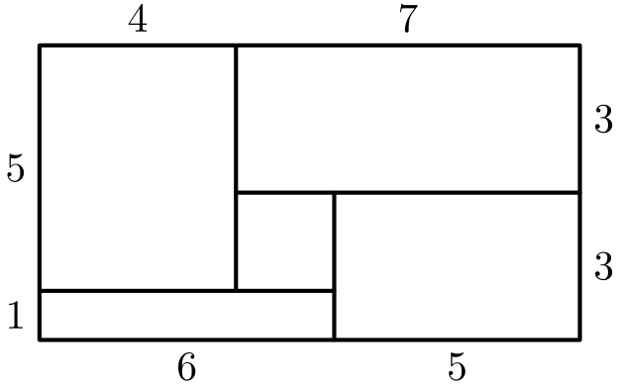
（A）108 （B）115 （C）132 （D）144 （E）156
English
Rose fills each of the rectangular regions of her rectangular flower bed with a different type of flower. The lengths, in feet, of the rectangular regions in her flower bed are as shown in the figure. She plants one flower per square foot in each region. Asters cost $1 each, begonias $1.50 each, cannas $2 each, dahlias $2.50 each, and Easter lilies $3 each. What is the least possible cost, in dollars, for her garden?
(A) 108 (B) 115 (C) 132 (D) 144 (E) 156
第 4 题
Moe 用割草机修剪一块 90 英尺乘 150 英尺的长方形草坪。割草机每次割出的草带宽 28 英寸，但他每次会重叠 4 英寸，以确保没有漏割。他推割草机时的速度是每小时 5000 英尺。下列哪一项最接近 Moe 修剪完草坪所需的小时数？
（A）0.75 （B）0.8 （C）1.35 （D）1.5 （E）3
English
Moe uses a mower to cut his rectangular 90-foot by 150-foot lawn. The swath he cuts is 28 inches wide, but he overlaps each cut by 4 inches to make sure that no grass is missed. He walks at the rate of 5000 feet per hour while pushing the mower. Which of the following is closest to the number of hours it will take Moe to mow his lawn?
(A) 0.75 (B) 0.8 (C) 1.35 (D) 1.5 (E) 3
第 5 题
许多电视屏幕是用对角线长度来度量的长方形。标准电视屏幕的水平长度与高度之比为 4: 3。一台 27 英寸电视屏幕的水平长度最接近下列哪一个数，单位为英寸？
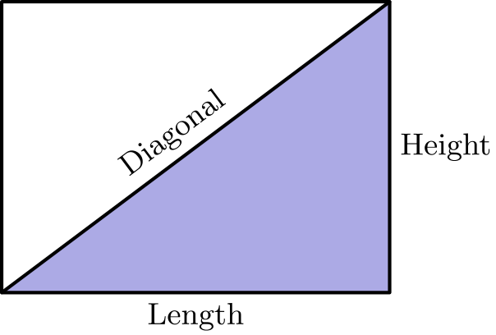
（A）20 （B）20.5 （C）21 （D）21.5 （E）22
English
Many television screens are rectangles that are measured by the length of their diagonals. The ratio of the horizontal length to the height in a standard television screen is 4: 3. The horizontal length of a 27-inch television screen is closest, in inches, to which of the following?
(A) 20 (B) 20.5 (C) 21 (D) 21.5 (E) 22
第 6 题
一个等比数列的第二项和第四项分别是 2 和 6。下列哪一项可能是第一项？
（A）-√(3) （B）-(2√(3))/3 （C）-(√(3))/3 （D）√(3) （E）3
English
The second and fourth terms of a geometric sequence are 2 and 6. Which of the following is a possible first term?
(A) -√(3) (B) -(2√(3))/3 (C) -(√(3))/3 (D) √(3) (E) 3
第 7 题
Penniless Pete 的存钱罐里没有便士，但有 100 枚硬币，全部是镍币、角币和二十五美分硬币，总价值为 $8.35。存钱罐不一定三种硬币都有。角币数量可能的最大值与最小值之差是多少？
（A）0 （B）13 （C）37 （D）64 （E）83
English
Penniless Pete’s piggy bank has no pennies in it, but it has 100 coins, all nickels, dimes, and quarters, whose total value is $8.35. It does not necessarily contain coins of all three types. What is the difference between the largest and smallest number of dimes that could be in the bank?
(A) 0 (B) 13 (C) 37 (D) 64 (E) 83
第 8 题
令 clubsuit(x) 表示正整数 x 的各位数字之和。例如，clubsuit(8) = 8，且 clubsuit(123) = 1 + 2 + 3 = 6。有多少个两位数 x 满足 clubsuit(clubsuit(x)) = 3？
（A）3 （B）4 （C）6 （D）9 （E）10
English
Let clubsuit(x) denote the sum of the digits of the positive integer x. For example, clubsuit(8) = 8 and clubsuit(123) = 1 + 2 + 3 = 6. For how many two-digit values of x is clubsuit(clubsuit(x)) = 3?
(A) 3 (B) 4 (C) 6 (D) 9 (E) 10
第 9 题
设 f 是线性函数，且 f(6) - f(2) = 12。f(12) - f(2) 是多少？
（A）12 （B）18 （C）24 （D）30 （E）36
English
Let f be a linear function for which f(6) - f(2) = 12. What is f(12) - f(2)?
(A) 12 (B) 18 (C) 24 (D) 30 (E) 36
第 10 题
把两个等边三角形接到正五边形 ABCDE 的五个图示位置中的两个位置上，可以得到若干图形。按这种方式能构造出多少个互不全等的图形？
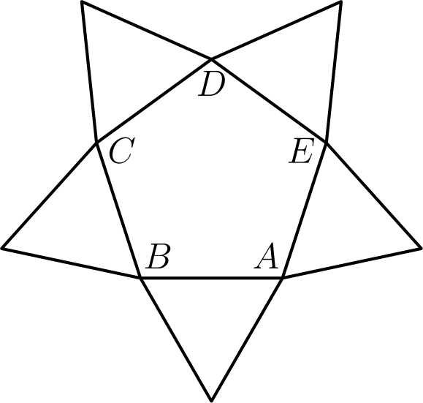
（A）1 （B）2 （C）3 （D）4 （E）5
English
Several figures can be made by attaching two equilateral triangles to the regular pentagon ABCDE in two of the five positions shown. How many non-congruent figures can be constructed in this way?
(A) 1 (B) 2 (C) 3 (D) 4 (E) 5
第 11 题
Cassandra 在中午把手表调到正确时间。实际时间为下午 1:00 整时，她发现手表显示 12:57 又 36 秒。假设她的手表以恒定速率走慢，当她的手表第一次显示晚上 10:00 整时，实际时间是多少？
（A）晚上 10:22 又 24 秒 （B）晚上 10:24 （C）晚上 10:25 （D）晚上 10:27 （E）晚上 10:30
English
Cassandra sets her watch to the correct time at noon. At the actual time of 1:00 PM, she notices that her watch reads 12:57 and 36 seconds. Assuming that her watch loses time at a constant rate, what will be the actual time when her watch first reads 10:00 PM?
(A) 10:22 PM and 24 seconds (B) 10:24 PM (C) 10:25 PM (D) 10:27 PM (E) 10:30 PM
第 12 题
对所有正偶数 n，能整除
(n + 1)(n + 3)(n + 5)
· (n + 7)(n + 9)
的最大整数是多少？
（A）3 （B）5 （C）11 （D）15 （E）165
English
What is the largest integer that is a divisor of
(n + 1)(n + 3)(n + 5)
· (n + 7)(n + 9)
for all positive even integers n?
(A) 3 (B) 5 (C) 11 (D) 15 (E) 165
第 13 题
一个冰淇淋甜筒由一个香草冰淇淋球和一个与球直径相同的直圆锥组成。若冰淇淋融化，它正好装满圆锥。假设融化后的冰淇淋体积是冷冻时体积的 75%。圆锥的高与半径之比是多少？
（A）2: 1 （B）3: 1 （C）4: 1 （D）16: 3 （E）6: 1
English
An ice cream cone consists of a sphere of vanilla ice cream and a right circular cone that has the same diameter as the sphere. If the ice cream melts, it will exactly fill the cone. Assume that the melted ice cream occupies 75% of the volume of the frozen ice cream. What is the ratio of the cone’s height to its radius?
(A) 2: 1 (B) 3: 1 (C) 4: 1 (D) 16: 3 (E) 6: 1
第 14 题
在长方形 ABCD 中，AB = 5，BC = 3。点 F 和 G 在 CD 上，且 DF = 1，GC = 2。直线 AF 与 BG 相交于 E。求 △ AEB 的面积。
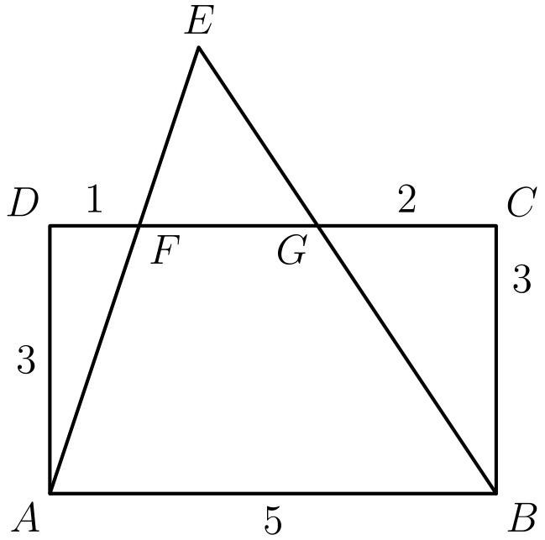
（A）10 （B）21/2 （C）12 （D）25/2 （E）15
English
In rectangle ABCD, AB = 5 and BC = 3. Points F and G are on CD so that DF = 1 and GC = 2. Lines AF and BG intersect at E. Find the area of △ AEB.
(A) 10 (B) 21/2 (C) 12 (D) 25/2 (E) 15
第 15 题
正八边形 ABCDEFGH 的面积为一平方单位。长方形 ABEF 的面积是多少？
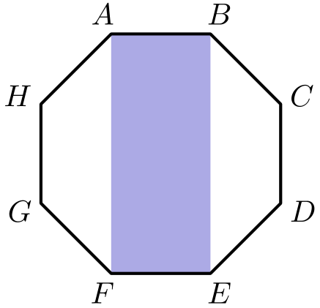
（A）1 - (√(2))/2 （B）(√(2))/4 （C）√(2) - 1 （D）1/2 （E）(1 + √(2))/4
English
A regular octagon ABCDEFGH has an area of one square unit. What is the area of the rectangle ABEF?
(A) 1 - (√(2))/2 (B) (√(2))/4 (C) √(2) - 1 (D) 1/2 (E) (1 + √(2))/4
第 16 题
在半径为 2 的半圆的直径 AB 上作三个半径为 1 的半圆。小半圆的圆心把 AB 分成四段相等的线段，如图所示。位于大半圆内且在小半圆外的阴影区域面积是多少？
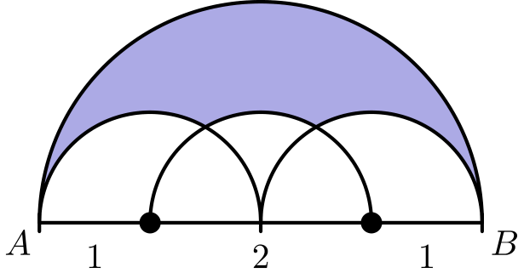
（A）π - √(3) （B）π - √(2) （C）(π + √(2))/2 （D）(π + √(3))/2 （E）7/6π - (√(3))/2
English
Three semicircles of radius 1 are constructed on diameter AB of a semicircle of radius 2. The centers of the small semicircles divide AB into four line segments of equal length, as shown. What is the area of the shaded region that lies within the large semicircle but outside the smaller semicircles?
(A) π - √(3) (B) π - √(2) (C) (π + √(2))/2 (D) (π + √(3))/2 (E) 7/6π - (√(3))/2
第 17 题
若 log(xy³) = 1 且 log(x²y) = 1，log(xy) 是多少？
（A）-1/2 （B）0 （C）1/2 （D）3/5 （E）1
English
If log(xy³) = 1 and log(x²y) = 1, what is log(xy)?
(A) -1/2 (B) 0 (C) 1/2 (D) 3/5 (E) 1
第 18 题
设 x 和 y 为正整数，且 7x⁵ = 11y¹³。x 的最小可能值的素因数分解为 aᶜ bᵈ。a + b + c + d 是多少？
（A）30 （B）31 （C）32 （D）33 （E）34
English
Let x and y be positive integers such that 7x⁵ = 11y¹³. The minimum possible value of x has a prime factorization aᶜ bᵈ. What is a + b + c + d?
(A) 30 (B) 31 (C) 32 (D) 33 (E) 34
第 19 题
设 S 为序列 1，2，3，4，5 的所有排列中第一项不是 1 的排列集合。从 S 中随机选一个排列。若第二项为 2 的概率化为最简分数为 a/b。a + b 是多少？
（A）5 （B）6 （C）11 （D）16 （E）19
English
Let S be the set of permutations of the sequence 1, 2, 3, 4, 5 for which the first term is not 1. A permutation is chosen randomly from S. The probability that the second term is 2, in lowest terms, is a/b. What is a + b?
(A) 5 (B) 6 (C) 11 (D) 16 (E) 19
第 20 题
图中给出了 f(x) = ax³ + bx² + cx + d 的部分图像。b 是多少？
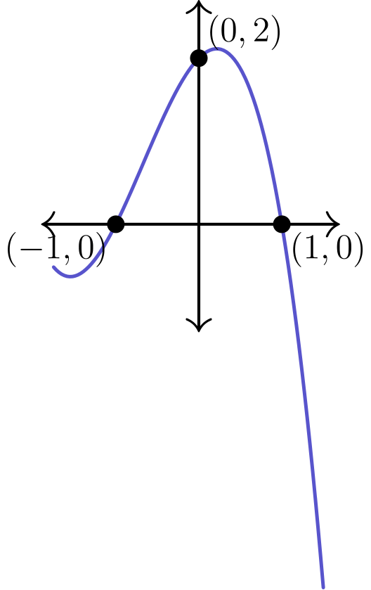
（A）-4 （B）-2 （C）0 （D）2 （E）4
English
Part of the graph of f(x) = ax³ + bx² + cx + d is shown. What is b?
(A) -4 (B) -2 (C) 0 (D) 2 (E) 4
第 21 题
一个物体从 A 沿直线移动 8 cm 到 B，再转过角 α。这个角以弧度计，从区间 (0, π) 中随机选取。随后物体沿直线移动 5 cm 到 C。AC < 7 的概率是多少？
（A）1/6 （B）1/5 （C）1/4 （D）1/3 （E）1/2
English
An object moves 8 cm in a straight line from A to B, turns at an angle α, measured in radians and chosen at random from the interval (0, π), and moves 5 cm in a straight line to C. What is the probability that AC < 7?
(A) 1/6 (B) 1/5 (C) 1/4 (D) 1/3 (E) 1/2
第 22 题
设 ABCD 是菱形，且 AC = 16，BD = 30。设 N 是 AB 上一点，P 和 Q 分别是从 N 到 AC 和 BD 的垂足。下列哪一项最接近 PQ 的最小可能值？
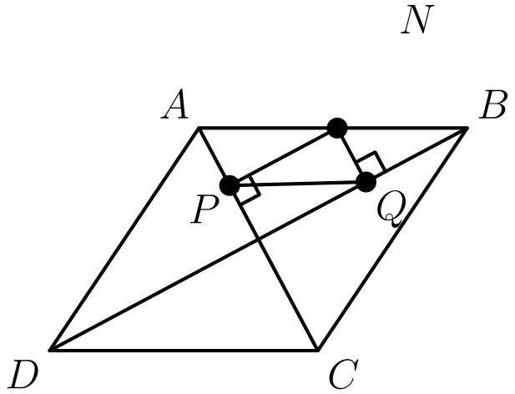
（A）6.5 （B）6.75 （C）7 （D）7.25 （E）7.5
English
Let ABCD be a rhombus with AC = 16 and BD = 30. Let N be a point on AB, and let P and Q be the feet of the perpendiculars from N to AC and BD, respectively. Which of the following is closest to the minimum possible value of PQ?
(A) 6.5 (B) 6.75 (C) 7 (D) 7.25 (E) 7.5
第 23 题
函数 y = sin(1/x) 的图像在区间 (0.0001, 0.001) 中的 x 轴截距个数最接近
（A）2900 （B）3000 （C）3100 （D）3200 （E）3300
English
The number of x-intercepts on the graph of y = sin(1/x) in the interval (0.0001, 0.001) is closest to
(A) 2900 (B) 3000 (C) 3100 (D) 3200 (E) 3300
第 24 题
选择正整数 a、b、c，使得 a < b < c，且方程组
2x + y = 2003
和
y = |x - a| + |x - b|
+ |x - c|
恰有一个解。c 的最小值是多少？
（A）668 （B）669 （C）1002 （D）2003 （E）2004
English
Positive integers a, b, and c are chosen so that a < b < c, and the system of equations
2x + y = 2003
and
y = |x - a| + |x - b|
+ |x - c|
has exactly one solution. What is the minimum value of c?
(A) 668 (B) 669 (C) 1002 (D) 2003 (E) 2004
第 25 题
在一个圆上随机且独立地选取三个点。三点两两之间的距离都小于该圆半径的概率是多少？
（A）1/36 （B）1/24 （C）1/18 （D）1/12 （E）1/9
English
Three points are chosen randomly and independently on a circle. What is the probability that all three pairwise distances between the points are less than the radius of the circle?
(A) 1/36 (B) 1/24 (C) 1/18 (D) 1/12 (E) 1/9

第二部分 解答
答案速查：
题号 1 2 3 4 5 6 7 8 9
答案 C D A C D B D E D
题号 10 11 12 13 14 15 16 17 18
答案 B C D B D D E D B
题号 19 20 21 22 23 24 25
答案 E B D C A C D
答案串：CDACDBDEDBCDBDDEDBEBDCACD
第 1 题 答案 C
从分子提出 2，从分母提出 3 得到
(2(1 - 2 + 3 - 4 + 5 - 6 + 7))/(3(1 - 2 + 3 - 4 + 5 - 6 + 7))。
相同的括号和可以约去，剩下 2/3。
因此，正确答案是C。
English
Factor 2 from the numerator and 3 from the denominator:
(2(1 - 2 + 3 - 4 + 5 - 6 + 7))/(3(1 - 2 + 3 - 4 + 5 - 6 + 7)).
The equal parenthesized sums cancel, leaving 2/3.
Thus, the correct answer isC.
第 2 题 答案 D
共 14 天，两粒药丸的每日费用为
546/14 = 39。
设一粒绿色药丸价格为 g。粉色药丸价格为 g - 1，所以
g + (g - 1) = 39，
解得 g = 20。
因此，正确答案是D。
English
Over 14 days the daily cost of the two pills is
546/14 = 39.
Let g be the cost of a green pill. The pink pill costs g - 1, so
g + (g - 1) = 39,
giving g = 20.
Thus, the correct answer isD.
第 3 题 答案 A
五个区域的面积分别为 4、6、15、20 和 21 平方英尺。
为了使费用最小，应把越贵的花种在越小的区域。最小可能费用为
3(4) + 2.5(6) + 2(15)
+ 1.5(20) + 1(21) = 108
。
因此，正确答案是A。
English
The five regions have areas 4, 6, 15, 20, and 21 square feet.
To minimize the cost, plant the most expensive flowers in the smallest regions. The least possible cost is
3(4) + 2.5(6) + 2(15)
+ 1.5(20) + 1(21) = 108.
Thus, the correct answer isA.
第 4 题 答案 C
因为重叠，每次新增的草带宽度为 28 - 4 = 24 英寸 = 2 英尺。所以 Moe 每走一英尺就割 2 平方英尺，也就是每小时割 2 · 5000 = 10000 平方英尺。
草坪面积为 90 · 150 = 13500 平方英尺，所以所需时间为
13500/10000 = 1.35
小时。
因此，正确答案是C。
English
Because of the overlap, each pass adds a strip 28 - 4 = 24 inches = 2 feet wide. So each foot Moe walks mows 2 square feet, that is, 2 · 5000 = 10000 square feet per hour.
The lawn has area 90 · 150 = 13500 square feet, so the time is
13500/10000 = 1.35
hours.
Thus, the correct answer isC.
第 5 题 答案 D
边长比为 4: 3 的长方形，其高度、水平长度和对角线之比为 3: 4: 5。对角线为 27，所以水平长度为
4/5(27) = 21.6，
最接近 21.5。
因此，正确答案是D。
English
A rectangle with side ratio 4: 3 has height, length, and diagonal in ratio 3: 4: 5. With diagonal 27, the horizontal length is
4/5(27) = 21.6,
which is closest to 21.5.
Thus, the correct answer isD.
第 6 题 答案 B
设第一项为 a，公比为 r，则 ar = 2，且 ar³ = 6，因此 r² = 3，r = ±√(3)。
第一项为
a = 2/r = ±2/(√(3)) = ±(2√(3))/3。
选项中出现的是 -(2√(3))/3。
因此，正确答案是B。
English
Let the first term be a and the common ratio r. Then ar = 2 and ar³ = 6, so r² = 3 and r = ±√(3).
The first term is
a = 2/r = ±2/(√(3)) = ±(2√(3))/3.
The choice -(2√(3))/3 appears among the options.
Thus, the correct answer isB.
第 7 题 答案 D
设镍币、角币、二十五美分硬币数分别为 n、d、q，则 n + d + q = 100，且把总价值方程除以 5 得 n + 2d + 5q = 167。
两式相减得 d + 4q = 67，所以 d = 67 - 4q。
当 q = 0 时 d 最大，得到 d = 67（此时 n = 33）。当 q = 16 时，角币数最小，得到 d = 3（此时 n = 81）。差为 67 - 3 = 64。
因此，正确答案是D。
English
Let n, d, q be the numbers of nickels, dimes, quarters. Then n + d + q = 100 and n + 2d + 5q = 167 (dividing the value equation by 5).
Subtracting gives d + 4q = 67, so d = 67 - 4q.
The largest d is at q = 0, giving d = 67 (with n = 33). The smallest occurs at q = 16, giving d = 3 (with n = 81). The difference is 67 - 3 = 64.
Thus, the correct answer isD.
第 8 题 答案 E
令 y = clubsuit(x)。因为 x ≤ 99，所以 y ≤ 18。因此 clubsuit(y) = 3 要求 y = 3 或 y = 12。
数字和为 3 的两位数是 12, 21, 30（3 个），数字和为 12 的两位数是 39, 48, 57, 66, 75, 84, 93（7 个），共 10 个。
因此，正确答案是E。
English
Let y = clubsuit(x). Since x ≤ 99, we have y ≤ 18. Then clubsuit(y) = 3 requires y = 3 or y = 12.
The two-digit numbers with digit sum 3 are 12, 21, 30 (3 values), and those with digit sum 12 are 39, 48, 57, 66, 75, 84, 93 (7 values), for 10 in all.
Thus, the correct answer isE.
第 9 题 答案 D
f 的斜率为
(f(6) - f(2))/(6 - 2) = 12/4 = 3。
因此
f(12) - f(2) = 3(12 - 2) = 30。
因此，正确答案是D。
English
The slope of f is
(f(6) - f(2))/(6 - 2) = 12/4 = 3.
Therefore
f(12) - f(2) = 3(12 - 2) = 30.
Thus, the correct answer isD.
第 10 题 答案 B
假设一个三角形接在边 AB 上。第二个三角形可以接在与 AB 相隔一步或两步的边上。
接在 BC 或 CD 上得到两种图形；接在 AE 或 DE 上得到的图形分别是前两种关于五边形对称轴的镜像。
因此只有 2 个互不全等的图形。
因此，正确答案是B。
English
Assume one triangle is attached to side AB. The second triangle can be attached to a side that is one step away or two steps away from AB.
Attaching it to BC or CD gives two figures; attaching it to AE or DE gives figures that are mirror images of these across the pentagon’s axis of symmetry.
So there are only 2 non-congruent figures.
Thus, the correct answer isB.
第 11 题 答案 C
实际经过 60 分钟时，手表只前进了 57 分 36 秒 = 57.6 分钟。因此当手表显示中午后 t 分钟时，实际经过时间为 60/57.6t = 25/24t 分钟。
手表显示晚上 10:00 整时，记录经过了 600 分钟，所以实际经过时间为
25/24(600) = 625
分钟 = 10 小时 25 分钟。因此实际时间是晚上 10:25。
因此，正确答案是C。
English
In 60 real minutes the watch advances only 57 minutes 36 seconds = 57.6 minutes. So when the watch shows t minutes past noon, the real elapsed time is 60/57.6t = 25/24t minutes.
The watch reads 10:00 PM after 600 recorded minutes, so the real elapsed time is
25/24(600) = 625
minutes = 10 hours 25 minutes past noon. The actual time is 10:25 PM.
Thus, the correct answer isC.
第 12 题 答案 D
当 n 为偶数时，这五个因数是连续奇数。任意五个连续奇数中至少有一个能被 3 整除，且有一个能被 5 整除，所以乘积总能被 15 整除。
没有更大的整数总是可行：当 n = 20 和 n = 10 时，乘积分别为 21 · 23 · 25 · 27 · 29 和 11 · 13 · 15 · 17 · 19，它们的最大公因数是 15。
因此，正确答案是D。
English
For even n, the five factors are consecutive odd numbers. Among any five consecutive odd numbers, at least one is divisible by 3 and exactly one by 5, so the product is always divisible by 15.
No larger divisor always works: the products for n = 10 and n = 20 are 11 · 13 · 15 · 17 · 19 and 21 · 23 · 25 · 27 · 29, whose greatest common divisor is 15.
Thus, the correct answer isD.
第 13 题 答案 B
设共同半径为 r，圆锥高为 h。融化后的冰淇淋装满圆锥，所以
3/4·4/3π r³ = 1/3π r² h。
化简得 π r³ = 1/3π r² h，所以 h = 3r，比为 3: 1。
因此，正确答案是B。
English
Let r be the common radius and h the cone’s height. The melted ice cream fills the cone, so
3/4·4/3π r³ = 1/3π r² h.
This simplifies to π r³ = 1/3π r² h, so h = 3r, a ratio of 3: 1.
Thus, the correct answer isB.
第 14 题 答案 D
因为 FG = 5 - 1 - 2 = 2，且 FG ∥ AB，所以三角形 FEG 与 AEB 相似，相似比为 FG/AB = 2/5。
设 E 到直线 CD 的距离为 k，则 E 到 AB 的距离为 k + 3，且
k/(k + 3) = 2/5，
解得 k = 2。
△ AEB 的高为 k + 3 = 5，所以面积为
1/2(5)(5) = 25/2。
因此，正确答案是D。
English
Since FG = 5 - 1 - 2 = 2 and FG ∥ AB, triangles FEG and AEB are similar with ratio FG/AB = 2/5.
Let the distance from E to line CD be k. Then the distance from E to AB is k + 3, and
k/(k + 3) = 2/5,
giving k = 2.
The height of △ AEB is k + 3 = 5, so its area is
1/2(5)(5) = 25/2.
Thus, the correct answer isD.
第 15 题 答案 D
设 O 为八边形中心。连接 O 与各顶点，把八边形分成 8 个全等三角形，所以 △ AOB 的面积为 1/8。
因为 O 是 AE 的中点，三角形 AOB 和 BOE 面积相等，所以 △ ABE 的面积为 1/4。
长方形 ABEF 被对角线 BE 分成两个全等三角形，所以 △ ABE 是它的一半。因此 ABEF 的面积为 1/2。
因此，正确答案是D。
English
Let O be the center of the octagon. Joining O to the vertices splits the octagon into 8 congruent triangles, so △ AOB has area 1/8.
Since O is the midpoint of AE, triangles AOB and BOE have equal areas, so △ ABE has area 1/4.
The rectangle ABEF is split by diagonal BE into two congruent triangles, so △ ABE is half of it. Hence ABEF has area 1/2.
Thus, the correct answer isD.
第 16 题 答案 E
大半圆面积为 1/2π(2)² = 2π。
在计入重叠之前，三个小半圆的总面积为 3π/2。每相邻两个小半圆的圆心相距 1，所以它们的公共部分由两个 60° 扇形和一个等边三角形围成。因此两块重叠部分的面积各为 π/3 - (√(3))/4。
阴影面积为
2π - [3π/2 - 2(π/3 - (√(3))/4)]
= 7/6π - (√(3))/2
。
因此，正确答案是E。
English
The large semicircle has area 1/2π(2)² = 2π.
The three small semicircles have total area 3π/2 before their overlaps are accounted for. The centers of each adjacent pair are 1 unit apart, so their intersection is bounded by two 60° sectors and an equilateral triangle. Each of the two overlaps therefore has area π/3 - (√(3))/4.
The shaded area is
2π - [3π/2 - 2(π/3 - (√(3))/4)]
= 7/6π - (√(3))/2.
Thus, the correct answer isE.
第 17 题 答案 D
令 X = log x，Y = log y，则
X + 3Y = 1
且
2X + Y = 1。
解得 X = 2/5，Y = 1/5，所以
log(xy) = X + Y = 3/5。
因此，正确答案是D。
English
Let X = log x and Y = log y. Then
X + 3Y = 1
and
2X + Y = 1.
Solving gives X = 2/5 and Y = 1/5, so
log(xy) = X + Y = 3/5.
Thus, the correct answer isD.
第 18 题 答案 B
要使 x 最小，x 和 y 都不应含有 7 与 11 以外的素因数。写成 x = 7ᶜ 11ᵈ，则 7x⁵ = 7⁵ᶜ⁺¹ 11⁵ᵈ。再写成 y = 7ᵐ 11ⁿ，需要 7⁵ᶜ⁺¹11⁵ᵈ = 7¹³ᵐ11¹³ⁿ⁺¹。
比较指数：5c + 1 ≡ 0 pmod13 给出最小的 c = 5，而 5d ≡ 1 pmod13 给出最小的 d = 8。所以 a = 7，b = 11，
a + b + c + d
= 7 + 11 + 5 + 8 = 31
。
因此，正确答案是B。
English
For the minimum x, neither x nor y has prime factors other than 7 and 11. Write x = 7ᶜ 11ᵈ, so 7x⁵ = 7⁵ᶜ⁺¹ 11⁵ᵈ. Writing y = 7ᵐ 11ⁿ, we need 7⁵ᶜ⁺¹11⁵ᵈ = 7¹³ᵐ11¹³ⁿ⁺¹.
Matching exponents: 5c + 1 ≡ 0 pmod13 gives the least c = 5, and 5d ≡ 1 pmod13 gives the least d = 8. So a = 7, b = 11, and
a + b + c + d
= 7 + 11 + 5 + 8 = 31.
Thus, the correct answer isB.
第 19 题 答案 E
集合 S 中有 4 · 4! = 96 个排列，因为第一项有 4 种选择，剩下四项可按 4! 种方式任意排列。
若第二项为 2，第一项必须是 3, 4 或 5（不能是 1 也不能是 2），有 3 种选择，剩下三项有 3! 种排列，共 3 · 3! = 18 个。
概率为 18/96 = 3/16，所以 a + b = 3 + 16 = 19。
因此，正确答案是E。
English
The set S contains 4 · 4! = 96 permutations, since the first term has 4 choices and the remaining four terms can be arranged in 4! ways.
For the second term to be 2, the first term must be 3, 4, or 5 (not 1, not 2), giving 3 choices, and the remaining three terms can be arranged in 3! ways: 3 · 3! = 18.
The probability is 18/96 = 3/16, so a + b = 3 + 16 = 19.
Thus, the correct answer isE.
第 20 题 答案 B
图像经过 (-1, 0)，(1, 0)，和 (0, 2)。所以 f(0) = d = 2。
将两式相加：
f(1) + f(-1)
= (a + b + c + d)
+ (-a + b - c + d)
= 2b + 2d = 0，
因此 b = -d = -2。
因此，正确答案是B。
English
The graph passes through (-1, 0), (1, 0), and (0, 2). So f(0) = d = 2.
Adding
f(1) + f(-1)
= (a + b + c + d)
+ (-a + b - c + d)
= 2b + 2d = 0,
so b = -d = -2.
Thus, the correct answer isB.
第 21 题 答案 D
令 β = π - α 为 △ ABC 在 B 处的内角。由余弦定理，
AC² = 8² + 5²
- 2(8)(5)cosβ
= 89 - 80cosβ
。
于是 AC < 7 表示 89 - 80cosβ < 49，即 cosβ > 1/2，也就是 β < π/3。
因为 α 在 (0, π) 上均匀分布，所以 β 也均匀分布。概率为
(π/3)/π = 1/3。
因此，正确答案是D。
English
Let β = π - α be the interior angle of △ ABC at B. By the Law of Cosines,
AC² = 8² + 5²
- 2(8)(5)cosβ
= 89 - 80cosβ.
Then AC < 7 means 89 - 80cosβ < 49, i.e. cosβ > 1/2, i.e. β < π/3.
As α is uniform on (0, π), so is β. The probability is
(π/3)/π = 1/3.
Thus, the correct answer isD.
第 22 题 答案 C
设 O 为两条对角线的交点。则 △ AOB 在 O 处为直角，且 OA = 8，OB = 15。四边形 OPNQ 在 O，P，Q 处均为直角，所以它是长方形，且 PQ = ON。
ON 的最小值是在 △ AOB 中从 O 到 AB 的高。因为 AB = √(8² + 15²) = 17，由两种面积表达式相等，得
ON = (OA · OB)/AB
= (8 · 15)/17
= 120/17 ≈ 7.06
。
这最接近 7。
因此，正确答案是C。
English
Let O be the intersection of the diagonals. Then △ AOB is right-angled at O with legs OA = 8 and OB = 15. Quadrilateral OPNQ has right angles at O, P, and Q, so it is a rectangle and PQ = ON.
The minimum of ON is the altitude from O to AB in △ AOB. Since AB = √(8² + 15²) = 17, equating the two area expressions gives
ON = (OA · OB)/AB
= (8 · 15)/17
= 120/17 ≈ 7.06.
This is closest to 7.
Thus, the correct answer isC.
第 23 题 答案 A
截距出现在 1/x = kπ 时，也就是 x = 1/kπ，其中 k 为非零整数。
条件 0.0001 < 1/kπ < 0.001 化为
1000/π < k < 10000/π。
这样的整数个数为
⌊ 10000/π ⌋ - ⌊ 1000/π ⌋
= 3183 - 318 = 2865，
最接近 2900。
因此，正确答案是A。
English
The intercepts occur where 1/x = kπ, that is x = 1/kπ for a nonzero integer k.
The condition 0.0001 < 1/kπ < 0.001 becomes
1000/π < k < 10000/π.
The number of such integers is
⌊ 10000/π ⌋ - ⌊ 1000/π ⌋
= 3183 - 318 = 2865,
closest to 2900.
Thus, the correct answer isA.
第 24 题 答案 C
函数 y = |x-a| + |x-b| + |x-c| 是分段线性的，斜率依次为 -3, -1, 1, 3，折点在 x = a, b, c。直线 2x + y = 2003 的斜率为 -2。
斜率为 -2 的直线与该图像恰好相交一次，当且仅当它经过最左边的折点 (a, b + c - 2a)，此处图像斜率从 -3 跳到 -1。代入得到
2a + (b + c - 2a) = 2003，
所以 b + c = 2003。
因为 b < c，必须有 c > 2003/2，所以 c ≥ 1002。这个下界可以达到：取 a = 1，b = 1001，和 c = 1002。因此最小值为 1002。
所以正确答案是C。
English
The function y = |x-a| + |x-b| + |x-c| is piecewise linear with slopes -3, -1, 1, 3 and corners at x = a, b, c. The line 2x + y = 2003 has slope -2.
A line of slope -2 meets this graph exactly once only if it passes through the leftmost corner (a, b + c - 2a), where the graph’s slope jumps from -3 to -1. Substituting,
2a + (b + c - 2a) = 2003,
so b + c = 2003.
Since b < c, we need c > 2003/2, so c ≥ 1002. This bound is attained: take a = 1, b = 1001, and c = 1002. Therefore the minimum is 1002.
Thus, the correct answer isC.
第 25 题 答案 D
一条弦的长度小于半径，当且仅当它所对的弧小于 60°，因为 60° 弧对应的弦长正好等于半径。
三条两两弦都短于半径，恰好等价于三个点都位于某个 60° 弧内。
在任何成功的情形中，恰好有一个点是这样一段包含弧的逆时针端点（概率为零的边界情形除外）。这个端点有 3 种选法；另外两个点各自独立地以概率 1/6 落在其后的 60° 弧内。因此所求概率为
3(1/6)² = 1/12。
因此，正确答案是D。
English
A chord has length less than the radius exactly when the arc it subtends is less than 60°, since a chord of a 60° arc equals the radius.
All three pairwise chords are shorter than the radius precisely when the three points all lie within some arc of 60°.
For any successful configuration, exactly one of the three points is the counterclockwise endpoint of such a containing arc (apart from probability-zero boundary cases). Choose that endpoint in 3 ways; each of the other two points independently has probability 1/6 of lying in the next 60°. Hence the probability is
3(1/6)² = 1/12.
Thus, the correct answer isD.

