2002A AMC 12 真题与解答
American Mathematics Competitions 12 · 中英双语
共 25 题，限时 75 分钟；答对得 6 分，未答得 1.5 分，答错 0 分，满分 150 分。
编排说明：第一部分为题目（先中文、后英文原题），第二部分为解答与答案，便于先做题后对答案。
第一部分 题目
第 1 题
求下列方程的所有根之和。
(2x+3)(x-4)
+(2x+3)(x-6)=0
。
（A）7/2 （B）4 （C）5 （D）7 （E）13
English
Compute the sum of all the roots of
(2x+3)(x-4)
+(2x+3)(x-6)=0.
(A) 7/2 (B) 4 (C) 5 (D) 7 (E) 13
第 2 题
老师要求 Cindy 从某个数中减去 3，再将结果除以 9。可她却先减去 9，再将结果除以 3 得到答案 43。如果她按正确步骤计算，答案应是多少？
（A）15 （B）34 （C）43 （D）51 （E）138
English
Cindy was asked by her teacher to subtract 3 from a certain number and then divide the result by 9. Instead, she subtracted 9 and then divided the result by 3, giving an answer of 43. What would her answer have been had she worked the problem correctly?
(A) 15 (B) 34 (C) 43 (D) 51 (E) 138
第 3 题
按照指数运算的标准约定，
2^(2^(2²)) = 2^((2^((2²)))) = 2¹⁶ = 65,536。
如果改变指数运算的执行顺序，还可能得到多少个其他值？
（A）0 （B）1 （C）2 （D）3 （E）4
English
According to the standard convention for exponentiation,
2^(2^(2²)) = 2^((2^((2²)))) = 2¹⁶ = 65,536.
If the order in which the exponentiations are performed is changed, how many other values are possible?
(A) 0 (B) 1 (C) 2 (D) 3 (E) 4
第 4 题
求一个角的度数，已知它的余角是它的补角的 25%。
（A）48 （B）60 （C）75 （D）120 （E）150
English
Find the degree measure of an angle whose complement is 25% of its supplement.
(A) 48 (B) 60 (C) 75 (D) 120 (E) 150
第 5 题
图中每个小圆的半径都是一。最里面的圆与围绕它的六个圆相切，这六个圆中的每个又与大圆以及相邻的小圆相切。求阴影区域的面积。
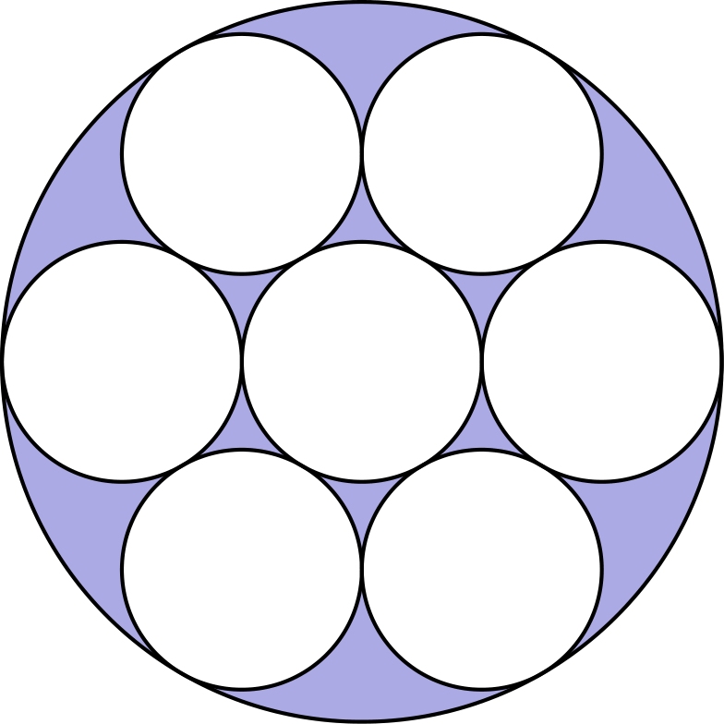
（A）π （B）1.5π （C）2π （D）3π （E）3.5π
English
Each of the small circles in the figure has radius one. The innermost circle is tangent to the six circles that surround it, and each of those circles is tangent to the large circle and to its small-circle neighbors. Find the area of the shaded region.
(A) π (B) 1.5π (C) 2π (D) 3π (E) 3.5π
第 6 题
有多少个正整数 m 满足：存在至少一个正整数 n，使得 m · n ≤ m + n？
（A）4 （B）6 （C）9 （D）12 （E）无穷多个
English
For how many positive integers m does there exist at least one positive integer n such that m · n ≤ m + n?
(A) 4 (B) 6 (C) 9 (D) 12 (E) infinitely many
第 7 题
若圆 A 上 45° 的弧长等于圆 B 上 30° 的弧长，则圆 A 的面积与圆 B 的面积之比为
（A）4/9 （B）2/3 （C）5/6 （D）3/2 （E）9/4
English
If an arc of 45° on circle A has the same length as an arc of 30° on circle B, then the ratio of the area of circle A to the area of circle B is
(A) 4/9 (B) 2/3 (C) 5/6 (D) 3/2 (E) 9/4
第 8 题
Betsy 用蓝色三角形、小白色正方形和红色中心正方形设计了一面旗帜，如图所示。设 B 为蓝色三角形总面积，W 为白色正方形总面积，R 为红色正方形面积。下列哪一项正确？
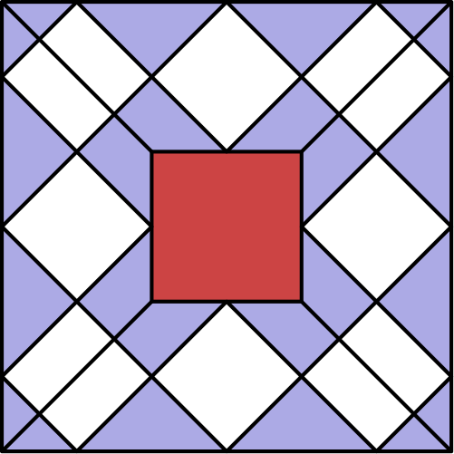
（A）B = W （B）W = R （C）B = R （D）3B = 2R （E）2R = W
English
Betsy designed a flag using blue triangles, small white squares, and a red center square, as shown. Let B be the total area of the blue triangles, W the total area of the white squares, and R the area of the red square. Which of the following is correct?
(A) B = W (B) W = R (C) B = R (D) 3B = 2R (E) 2R = W
第 9 题
Jamal 想把 30 个电脑文件存到软盘上，每张软盘容量为 1.44 兆字节（MB）。其中三个文件各需要 0.8 MB，另有 12 个各需要 0.7 MB，剩下 15 个各需要 0.4 MB。一个文件不能拆分到多张软盘上。装下所有文件最少需要多少张软盘？
（A）12 （B）13 （C）14 （D）15 （E）16
English
Jamal wants to store 30 computer files on floppy disks, each of which has a capacity of 1.44 megabytes (mb). Three of his files require 0.8 mb of memory each, 12 more require 0.7 mb each, and the remaining 15 require 0.4 mb each. No file can be split between floppy disks. What is the minimal number of floppy disks that will hold all the files?
(A) 12 (B) 13 (C) 14 (D) 15 (E) 16
第 10 题
Sarah 将四盎司咖啡倒入一个八盎司杯中，又将四盎司奶油倒入另一个同样大小的杯子。她把第一杯中一半的咖啡倒入第二杯，充分搅拌后，再把第二杯中一半的液体倒回第一杯。现在第一杯中的液体有几分之几是奶油？
（A）1/4 （B）1/3 （C）3/8 （D）2/5 （E）1/2
English
Sarah pours four ounces of coffee into an eight-ounce cup and four ounces of cream into a second cup of the same size. She then transfers half the coffee from the first cup to the second and, after stirring thoroughly, transfers half the liquid in the second cup back to the first. What fraction of the liquid in the first cup is now cream?
(A) 1/4 (B) 1/3 (C) 3/8 (D) 2/5 (E) 1/2
第 11 题
Earl E. Bird 先生每天上午 8:00 整离家上班。当他的平均速度为每小时 40 英里时，会晚到三分钟；当平均速度为每小时 60 英里时，会早到三分钟。Bird 先生应以多少英里每小时的平均速度行驶，才能准时到达工作地点？
（A）45 （B）48 （C）50 （D）55 （E）58
English
Mr. Earl E. Bird leaves his house for work at exactly 8:00 A.M. every morning. When he averages 40 miles per hour, he arrives at his workplace three minutes late. When he averages 60 miles per hour, he arrives three minutes early. At what average speed, in miles per hour, should Mr. Bird drive to arrive at his workplace precisely on time?
(A) 45 (B) 48 (C) 50 (D) 55 (E) 58
第 12 题
二次方程
x² - 63x + k = 0
的两个根都是质数。k 可能取值的个数是多少？
（A）0 （B）1 （C）2 （D）4 （E）多于四个
English
Both roots of the quadratic equation
x² - 63x + k = 0
are prime numbers. The number of possible values of k is
(A) 0 (B) 1 (C) 2 (D) 4 (E) more than four
第 13 题
两个不同的正数 a 和 b 各自与其倒数相差 1。a + b 是多少？
（A）1 （B）2 （C）√(5) （D）√(6) （E）3
English
Two different positive numbers a and b each differ from their reciprocals by 1. What is a + b?
(A) 1 (B) 2 (C) √(5) (D) √(6) (E) 3
第 14 题
对所有正整数 n，定义 f(n) = log₂₀₀₂ n²。令
N = f(11) + f(13) + f(14)。
下列哪个关系成立？
（A）N > 1 （B）N = 1 （C）1 < N < 2 （D）N = 2 （E）N > 2
English
For all positive integers n, let f(n) = log₂₀₀₂ n². Let
N = f(11) + f(13) + f(14).
Which of the following relations is true?
(A) N > 1 (B) N = 1 (C) 1 < N < 2 (D) N = 2 (E) N > 2
第 15 题
一组八个整数的平均数、中位数、唯一众数和极差都等于 8。这组数中可能出现的最大整数是多少？
（A）11 （B）12 （C）13 （D）14 （E）15
English
The mean, median, unique mode, and range of a collection of eight integers are all equal to 8. The largest integer that can be an element of this collection is
(A) 11 (B) 12 (C) 13 (D) 14 (E) 15
第 16 题
Tina 从集合 {1, 2, 3, 4, 5} 中随机选择两个不同的数，Sergio 从集合 {1, 2, …, 10} 中随机选择一个数。Sergio 选的数大于 Tina 所选两个数之和的概率是多少？
（A）2/5 （B）9/20 （C）1/2 （D）11/20 （E）24/25
English
Tina randomly selects two distinct numbers from the set {1, 2, 3, 4, 5}, and Sergio randomly selects a number from the set {1, 2, …, 10}. The probability that Sergio’s number is larger than the sum of the two numbers chosen by Tina is
(A) 2/5 (B) 9/20 (C) 1/2 (D) 11/20 (E) 24/25
第 17 题
有若干组质数，例如 {7, 83, 421, 659}，恰好各使用九个非零数字一次。这样的质数组的和最小可能是多少？
（A）193 （B）207 （C）225 （D）252 （E）477
English
Several sets of prime numbers, such as {7, 83, 421, 659}, use each of the nine nonzero digits exactly once. What is the smallest possible sum such a set of primes could have?
(A) 193 (B) 207 (C) 225 (D) 252 (E) 477
第 18 题
设圆 C₁ 和 C₂ 的方程分别为
(x - 10)² + y² = 36
和
(x + 15)² + y² = 81。
线段 PQ 在 P 点与 C₁ 相切，并在 Q 点与 C₂ 相切。这样的最短线段长多少？
（A）15 （B）18 （C）20 （D）21 （E）24
English
Let C₁ and C₂ be circles defined by
(x - 10)² + y² = 36
and
(x + 15)² + y² = 81,
respectively. What is the length of the shortest line segment PQ that is tangent to C₁ at P and to C₂ at Q?
(A) 15 (B) 18 (C) 20 (D) 21 (E) 24
第 19 题
函数 f 的图像如下。方程 f(f(x)) = 6 有多少个解？
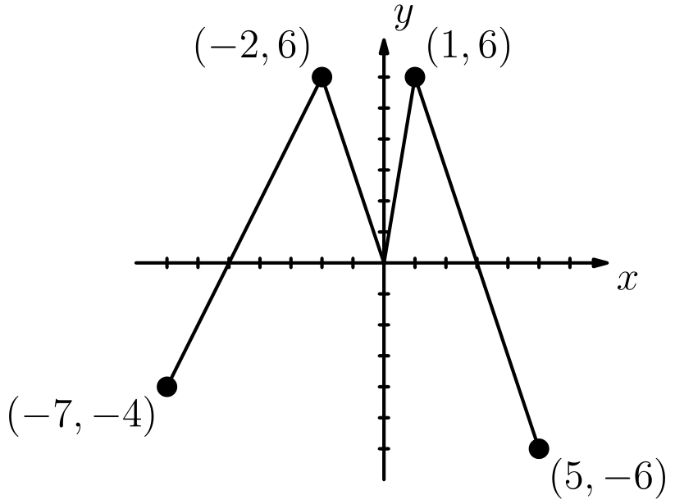
（A）2 （B）4 （C）5 （D）6 （E）7
English
The graph of the function f is shown below. How many solutions does the equation f(f(x)) = 6 have?
(A) 2 (B) 4 (C) 5 (D) 6 (E) 7
第 20 题
设 a 和 b 是数字，不同时为九也不同时为零，循环小数 0.ab 被化为最简分数。可能出现多少个不同的分母？
（A）3 （B）4 （C）5 （D）8 （E）9
English
Suppose that a and b are digits, not both nine and not both zero, and the repeating decimal 0.ab is expressed as a fraction in lowest terms. How many different denominators are possible?
(A) 3 (B) 4 (C) 5 (D) 8 (E) 9
第 21 题
考虑数列 4，7，1，8，9，7，6，…。对 n > 2，第 n 项是前两项之和的个位数字。令 Sₙ 表示该数列前 n 项的和。使 Sₙ > 10,000 的最小 n 是
（A）1992 （B）1999 （C）2001 （D）2002 （E）2004
English
Consider the sequence of numbers 4, 7, 1, 8, 9, 7, 6, … For n > 2, the nth term of the sequence is the units digit of the sum of the two previous terms. Let Sₙ denote the sum of the first n terms of this sequence. The smallest value of n for which Sₙ > 10,000 is
(A) 1992 (B) 1999 (C) 2001 (D) 2002 (E) 2004
第 22 题
三角形 ABC 是直角三角形，∠ ACB 为直角，m∠ ABC = 60°，且 AB = 10。在 △ ABC 内随机选一点 P，再将 BP 延长交 AC 于 D。求 BD > 5√(2) 的概率。
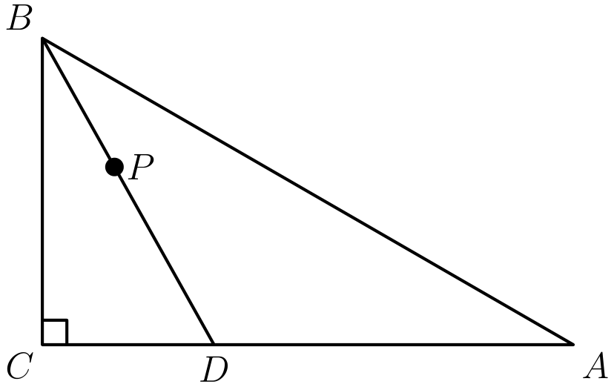
（A）(2 - √(2))/2 （B）1/3 （C）(3 - √(3))/3 （D）1/2 （E）(5 - √(5))/5
English
Triangle ABC is a right triangle with ∠ ACB as its right angle, m∠ ABC = 60°, and AB = 10. Let P be randomly chosen inside △ ABC, and extend BP to meet AC at D. What is the probability that BD > 5√(2)?
(A) (2 - √(2))/2 (B) 1/3 (C) (3 - √(3))/3 (D) 1/2 (E) (5 - √(5))/5
第 23 题
在三角形 ABC 中，边 AC 与 BC 的垂直平分线交于点 D，且 BD 平分 ∠ ABC。若 AD = 9，DC = 7，求三角形 ABD 的面积。
（A）14 （B）21 （C）28 （D）14√(5) （E）28√(5)
English
In triangle ABC, side AC and the perpendicular bisector of BC meet in point D, and BD bisects ∠ ABC. If AD = 9 and DC = 7, what is the area of triangle ABD?
(A) 14 (B) 21 (C) 28 (D) 14√(5) (E) 28√(5)
第 24 题
求有多少个有序实数对 (a, b) 满足 (a + bi)²⁰⁰² = a - bi。
（A）1001 （B）1002 （C）2001 （D）2002 （E）2004
English
Find the number of ordered pairs of real numbers (a, b) such that (a + bi)²⁰⁰² = a - bi.
(A) 1001 (B) 1002 (C) 2001 (D) 2002 (E) 2004
第 25 题
将实系数多项式 P 的所有非零系数都替换成这些系数的平均数，得到多项式 Q。下列哪一幅可能是在区间 -4 ≤ x ≤ 4 上 y = P(x) 和 y = Q(x) 的图像？
（A）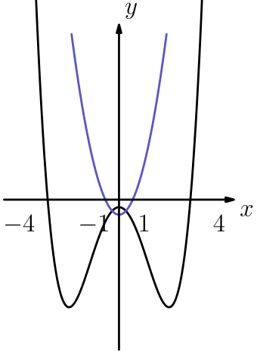
（B）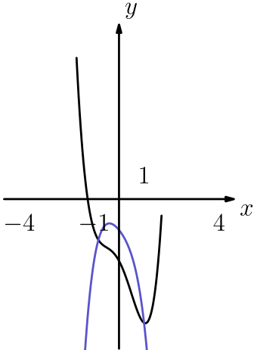
（C）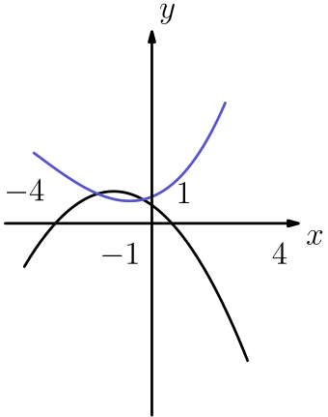
（D）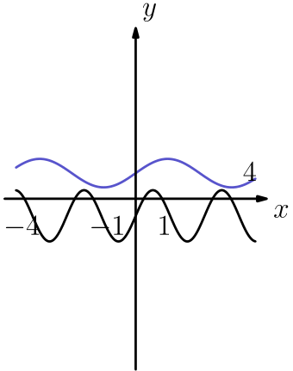
（E）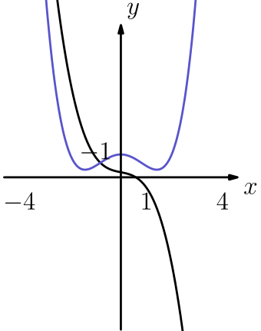
English
The nonzero coefficients of a polynomial P with real coefficients are all replaced by their mean to form a polynomial Q. Which of the following could be a graph of y = P(x) and y = Q(x) over the interval -4 ≤ x ≤ 4?
(A)
(B)
(C)
(D)
(E)

第二部分 解答
答案速查：
题号 1 2 3 4 5 6 7 8 9
答案 A A B B C E A A B
题号 10 11 12 13 14 15 16 17 18
答案 D B B C D D A B C
题号 19 20 21 22 23 24 25
答案 D C B C D E B
答案串：AABBCEAABDBBCDDABCDCBCDEB
第 1 题 答案 A
提出 2x+3 得到 (2x+3)[(x-4)+(x-6)] = (2x+3)(2x-10) = 0。
两个根为 -3/2 和 5，它们的和是 -3/2 + 5 = 7/2。
因此，正确答案是A。
English
Factoring out 2x+3 gives (2x+3)[(x-4)+(x-6)] = (2x+3)(2x-10) = 0.
The roots are -3/2 and 5, whose sum is -3/2 + 5 = 7/2.
Thus, the correct answer isA.
第 2 题 答案 A
设原数为 x。Cindy 计算了 x-9/3 = 43，所以 x - 9 = 129，x = 138。
正确计算为 138-3/9 = 135/9 = 15。
因此，正确答案是A。
English
Let x be the number. Cindy computed x-9/3 = 43, so x - 9 = 129 and x = 138.
The correct computation gives 138-3/9 = 135/9 = 15.
Thus, the correct answer isA.
第 3 题 答案 B
2^(2^(2²)) 的五种加括号方式给出
((2²)²)² = 2⁸,
(2^(2²))² = 2⁸,
(2²)^(2²) = 2⁸
，
2^((2²)²) = 2¹⁶, 2^(2^(2²)) = 2¹⁶。
因此只可能得到 2¹⁶ = 65,536 和 2⁸ = 256。除标准值外，恰好还有 1 个其他值。
因此，正确答案是B。
English
The five parenthesizations of 2^(2^(2²)) give
((2²)²)² = 2⁸,
(2^(2²))² = 2⁸,
(2²)^(2²) = 2⁸,
2^((2²)²) = 2¹⁶, 2^(2^(2²)) = 2¹⁶.
So the only values are 2¹⁶ = 65,536 and 2⁸ = 256. Besides the standard value there is exactly 1 other.
Thus, the correct answer isB.
第 4 题 答案 B
设这个角为 x，则 90 - x = 1/4(180 - x)，所以 360 - 4x = 180 - x。
由此 3x = 180，所以 x = 60。
因此，正确答案是B。
English
Let the angle be x. Then 90 - x = 1/4(180 - x), so 360 - 4x = 180 - x.
This gives 3x = 180, so x = 60.
Thus, the correct answer isB.
第 5 题 答案 C
六个外圈单位圆都与中心单位圆相切，所以它们的圆心到中心距离为 2。再加上一个半径，大圆半径为 3，面积为 9π。
七个单位圆的总面积为 7π，所以阴影区域面积为 9π - 7π = 2π。
因此，正确答案是C。
English
Each of the six outer unit circles is tangent to the central unit circle, so its center is 2 units from the center. Adding one more radius, the large circle has radius 3 and area 9π.
The seven unit circles have total area 7π, so the shaded region has area 9π - 7π = 2π.
Thus, the correct answer isC.
第 6 题 答案 E
取 n = 1，不等式变为 m ≤ m + 1，这对每个正整数 m 都成立。
所以每个正整数 m 都满足条件，共有无穷多个。
因此，正确答案是E。
English
Taking n = 1, the inequality becomes m ≤ m + 1, which holds for every positive integer m.
So every positive integer m works, and there are infinitely many.
Thus, the correct answer isE.
第 7 题 答案 A
弧长相等给出 45/360· 2π R_(A) = 30/360· 2π R_(B)，所以 (R_(A))/(R_(B)) = 30/45 = 2/3。
面积比为 ((R_(A))/(R_(B)))² = 4/9。
因此，正确答案是A。
English
Equal arc lengths give 45/360· 2π R_(A) = 30/360· 2π R_(B), so (R_(A))/(R_(B)) = 30/45 = 2/3.
The ratio of areas is ((R_(A))/(R_(B)))² = 4/9.
Thus, the correct answer isA.
第 8 题 答案 A
画出所示的对角线后，整面旗帜被分成全等三角形。数一数可得，蓝色区域有 24 个三角形，白色区域有 24 个，红色正方形有 16 个。
由于蓝色和白色区域含有相同数量的三角形，所以 B = W。
因此，正确答案是A。
English
Drawing the diagonals shown, the entire flag is tiled by congruent triangles. Counting, there are 24 triangles in the blue region, 24 in the white region, and 16 in the red square.
Since the blue and white regions contain the same number of triangles, B = W.
Thus, the correct answer isA.
第 9 题 答案 B
文件总大小为 3(0.8)+12(0.7) +15(0.4) = 16.8 mb，所以仅按容量至少需要 16.8/1.44 = 112/3 张软盘。
含有 0.8-mb 文件的软盘只能再放一个 0.4-mb 文件，至少留下 0.24 mb 空间。三个 0.8-mb 文件总共至少浪费 3(0.24) = 0.72 mb，超过半张软盘容量，因此至少需要 13 张。
十三张也足够：六张各放两个 0.7-mb 文件，三张各放一个 0.8-mb 文件和一个 0.4-mb 文件，四张各放三个 0.4-mb 文件。
因此，正确答案是B。
English
The files need 3(0.8)+12(0.7) +15(0.4) = 16.8 mb, so at least 16.8/1.44 = 112/3 disks by volume alone.
A disk containing a 0.8-mb file has room for only one more 0.4-mb file, leaving at least 0.24 mb unused. Across the three 0.8-mb files this wastes at least 3(0.24) = 0.72 mb, over half a disk, forcing at least 13 disks.
Thirteen suffice: six disks each hold two 0.7-mb files, three disks each hold one 0.8-mb file plus one 0.4-mb file, and four disks each hold three 0.4-mb files.
Thus, the correct answer isB.
第 10 题 答案 D
倒出一半咖啡后，杯 1 有 2 oz 咖啡；杯 2 有 2 oz 咖啡和 4 oz 奶油，共 6 oz。
杯 2 倒回一半，会转移 1 oz 咖啡和 2 oz 奶油。于是杯 1 有 2 + 1 = 3 oz 咖啡和 2 oz 奶油。
奶油所占比例为 2/2+3 = 2/5。
因此，正确答案是D。
English
After transferring half the coffee, cup 1 has 2 oz coffee and cup 2 has 2 oz coffee and 4 oz cream, a total of 6 oz.
Transferring half of cup 2 back moves 1 oz coffee and 2 oz cream. Cup 1 then holds 2 + 1 = 3 oz coffee and 2 oz cream.
The fraction that is cream is 2/2+3 = 2/5.
Thus, the correct answer isD.
第 11 题 答案 B
设准时所需时间为 t 小时。三分钟是 0.05 小时，所以 40(t+0.05) = 60(t-0.05)。
得 40t + 2 = 60t - 3，所以 t = 0.25。路程为 40(0.25+0.05) = 12 英里，所需速度为 12/0.25 = 48 英里每小时。
因此，正确答案是B。
English
Let t be the time in hours to arrive on time. Since three minutes is 0.05 hours, 40(t+0.05) = 60(t-0.05).
This gives 40t + 2 = 60t - 3, so t = 0.25. The distance is 40(0.25+0.05) = 12 miles, and the required speed is 12/0.25 = 48 miles per hour.
Thus, the correct answer isB.
第 12 题 答案 B
如果两个根是质数 p 和 q，则由韦达定理 p + q = 63，且 pq = k。
因为 63 是奇数，所以一个质数必须是偶数，即 2，另一个是 61。两者都是质数，所以 k = 2· 61 = 122 是唯一可能值。
因此，正确答案是B。
English
If the roots are primes p and q, then by Vieta’s formulas p + q = 63 and pq = k.
Since 63 is odd, one prime must be even, namely 2, and the other is 61. Both are prime, so k = 2· 61 = 122 is the only possible value.
Thus, the correct answer isB.
第 13 题 答案 C
正数 x 与其倒数相差 1 时，x - 1/x = 1 或 x - 1/x = -1，即 x² - x - 1 = 0 或 x² + x - 1 = 0。
正根为 (1+√(5))/2 和 (-1+√(5))/2，它们互为倒数。它们的和是 a + b = √(5)。
因此，正确答案是C。
English
A positive number x differs from its reciprocal by 1 when x - 1/x = 1 or x - 1/x = -1, i.e. x² - x - 1 = 0 or x² + x - 1 = 0.
The positive roots are (1+√(5))/2 and (-1+√(5))/2, which are reciprocals of each other. Their sum is a + b = √(5).
Thus, the correct answer isC.
第 14 题 答案 D
利用 log a² = 2log a 并合并对数，
N = log₂₀₀₂ 11² + log₂₀₀₂ 13²
+ log₂₀₀₂ 14²
= log₂₀₀₂(11· 13· 14)²
。
因为 11· 13· 14 = 2002，所以这是 log₂₀₀₂ 2002² = 2。
因此，正确答案是D。
English
Using log a² = 2log a and adding logs,
N = log₂₀₀₂ 11² + log₂₀₀₂ 13²
+ log₂₀₀₂ 14²
= log₂₀₀₂(11· 13· 14)².
Since 11· 13· 14 = 2002, this is log₂₀₀₂ 2002² = 2.
Thus, the correct answer isD.
第 15 题 答案 D
集合 6, 6, 6, 8, 8, 8, 8, 14 的平均数、中位数、唯一众数和极差都等于 8，所以 14 可以达到。
假设最大值为 15。极差 8 迫使最小值为 7。因为 8 是众数，它在排好序的八个数中重复出现；再结合中位数 8，中间两个数只能是 8, 8。于是 7 + 8 + 8 + 15 = 38，剩下四个数的和为 64 - 38 = 26，平均为 6.5。这样至少有一个数会小于 7，与最小值矛盾。因此 15 不可能。
因此，正确答案是D。
English
The collection 6, 6, 6, 8, 8, 8, 8, 14 has mean, median, unique mode, and range all equal to 8, so 14 is attainable.
Suppose the largest were 15. The range 8 forces the smallest to be 7. Because 8 is the mode, it occurs in the sorted list; together with median 8, this forces the two middle values to be 8, 8. Then 7 + 8 + 8 + 15 = 38, so the remaining four values sum to 64 - 38 = 26, averaging 6.5. At least one would be below 7, contradicting the minimum. So 15 is impossible.
Thus, the correct answer isD.
第 16 题 答案 A
Tina 的十个数对的和为 3, 4, 5, 5, 6, 6, 7, 7, 8, 9。对于和 s，Sergio 的数大于它的概率为 (10 - s)/10。
相应的 10 - s 值为 7, 6, 5, 5, 4, 4, 3, 3, 2, 1，总和为 40。总概率为 40/(10· 10) = 2/5。
因此，正确答案是A。
English
Tina’s ten pairs have sums 3, 4, 5, 5, 6, 6, 7, 7, 8, 9. For a sum s, Sergio’s number exceeds it with probability (10 - s)/10.
The corresponding values of 10 - s are 7, 6, 5, 5, 4, 4, 3, 3, 2, 1, totaling 40. The overall probability is 40/(10· 10) = 2/5.
Thus, the correct answer isA.
第 17 题 答案 B
偶数字 4, 6, 8 不能作为多位质数的个位，所以每个都必须出现在十位或更高位，至少贡献 40 + 60 + 80 = 180。另外六个数字至少贡献 1 + 2 + 3 + 5 + 7 + 9 = 27，因此总和至少为 207。
这个下界可以达到，例如 {2, 3, 5, 41, 67, 89}，它们的和为 207。
因此，正确答案是B。
English
The even digits 4, 6, 8 cannot be the units digit of a multi-digit prime, so each must appear in a tens place or higher, contributing at least 40 + 60 + 80 = 180. The other six digits contribute at least 1 + 2 + 3 + 5 + 7 + 9 = 27, so the sum is at least 207.
This bound is achieved, for example by {2, 3, 5, 41, 67, 89}, whose sum is 207.
Thus, the correct answer isB.
第 18 题 答案 C
圆心为 A = (10, 0) 和 B = (-15, 0)，半径分别为 6 和 9，所以 AB = 25。最短切线是内公切线，它在点 D 与 AB 相交，并按 6: 9 分割该线段，因此 D = (0, 0)。
直角三角形 APD 和 BQD 相似，比例为 2: 3。因而 PD = √(10² - 6²) = 8，QD = √(15² - 9²) = 12，所以 PQ = 8 + 12 = 20。
因此，正确答案是C。
English
The centers are A = (10, 0) and B = (-15, 0), with radii 6 and 9, so AB = 25. The shortest tangent is the internal one, meeting AB at a point D that splits it in the ratio 6: 9, giving D = (0, 0).
The right triangles APD and BQD are similar with ratio 2: 3. Then PD = √(10² - 6²) = 8 and QD = √(15² - 9²) = 12, so PQ = 8 + 12 = 20.
Thus, the correct answer isC.
第 19 题 答案 D
图像在 x = -2 和 x = 1 处达到 6，所以 f(f(x)) = 6 要求 f(x) = -2 或 f(x) = 1。
水平线 y = -2 与图像相交两次，y = 1 与图像相交四次，共有 2 + 4 = 6 个解。
因此，正确答案是D。
English
The graph reaches 6 at x = -2 and x = 1, so f(f(x)) = 6 requires f(x) = -2 or f(x) = 1.
The horizontal line y = -2 meets the graph twice, and y = 1 meets it four times, giving 2 + 4 = 6 solutions.
Thus, the correct answer isD.
第 20 题 答案 C
因为 0.ab = ab/99，最简分母必须整除 99 = 3²· 11。它的因数为 1, 3, 9, 11, 33, 99。
分母为 1 会要求 ab = 99，即 a = b = 9，但这种情况被排除。其余各个分母都能达到：分子 33, 11, 9, 3 和 1 分别约分后得到分母 3, 9, 11, 33 和 99，所以共有 5 种可能的分母。
所以正确答案是C。
English
Since 0.ab = ab/99, the reduced denominator divides 99 = 3²· 11. The divisors are 1, 3, 9, 11, 33, 99.
The denominator 1 would require ab = 99, i.e. a = b = 9, which is excluded. Each is achievable: numerators 33, 11, 9, 3, and 1 reduce to denominators 3, 9, 11, 33, and 99, respectively. Thus there are 5 possible denominators.
Thus, the correct answer isC.
第 21 题 答案 B
继续写数列得到 4, 7, 1, 8, 9, 7, 6，3, 9, 2, 1, 3, 4, 7, 1, …，它以 12 为周期重复。每个 12 项循环的和为 60。
满足 60k ≤ 10,000 的最大 k 是 k = 166，因此 S_(12· 166) = 9960。再加上下一轮的 4, 7, 1, 8, 9, 7, 6，增加 42，总和超过 10,000。所以 n = 12· 166 + 7 = 1999。
因此，正确答案是B。
English
Continuing the sequence gives 4, 7, 1, 8, 9, 7, 6, 3, 9, 2, 1, 3, 4, 7, 1, …, which repeats with period 12. Each block of 12 terms sums to 60.
The largest k with 60k ≤ 10,000 is k = 166, giving S_(12· 166) = 9960. Adding the next terms 4, 7, 1, 8, 9, 7, 6 contributes 42, pushing the total past 10,000. So n = 12· 166 + 7 = 1999.
Thus, the correct answer isB.
第 22 题 答案 C
因为 AB = 10 且 ∠ ABC = 60°，这个 30-60-90 三角形满足 BC = 5，AC = 5√(3)。
在 AC 上取点 E，使 CE = 5，则 BE = √(5² + 5²) = 5√(2)。当 D 沿 AC 移动时，BD = √(25 + CD²)。它超过 5√(2) 正好等价于 CD > 5，也就是 D 位于 E 的外侧；这又当且仅当 P 在 △ ABE 内。
所求概率为
([ABE])/([ABC]) = EA/CA
= (5√(3) - 5)/(5√(3))
= (3 - √(3))/3
。
因此，正确答案是C。
English
Since AB = 10 and ∠ ABC = 60°, the 30-60-90 triangle has BC = 5 and AC = 5√(3).
Place E on AC with CE = 5; then BE = √(5² + 5²) = 5√(2). As D moves along AC, BD = √(25 + CD²) exceeds 5√(2) exactly when CD > 5, i.e. when D lies beyond E, which happens iff P is inside △ ABE.
The probability is
([ABE])/([ABC]) = EA/CA
= (5√(3) - 5)/(5√(3))
= (3 - √(3))/3.
Thus, the correct answer isC.
第 23 题 答案 D
因为 D 在 BC 的垂直平分线上，所以 DB = DC = 7。角平分线 BD 给出 AB/BC = AD/DC = 9/7，设 AB = 9x，BC = 7x。
令 θ = ∠ ABD = ∠ DBC。在等腰三角形 △ BDC 中，垂足是 BC 的中点 M，所以 cosθ = BM/BD = (7x/2)/7 = x/2。
在 △ ABD 中应用余弦定理：
9² = (9x)² + 7² - 2(9x)(7)·x/2，
化简得 81 = 18x² + 49，所以 x = 4/3，AB = 12。
现在 △ ABD 的三边为 9, 7, 12。由海伦公式，半周长 s = 14，面积为 √(14· 5· 7· 2) = √(980) = 14√(5)。
因此，正确答案是D。
English
Since D lies on the perpendicular bisector of BC, DB = DC = 7. The angle bisector BD gives AB/BC = AD/DC = 9/7, so write AB = 9x and BC = 7x.
Let θ = ∠ ABD = ∠ DBC. In isosceles △ BDC, the foot of the perpendicular is the midpoint M of BC, so cosθ = BM/BD = (7x/2)/7 = x/2.
Applying the Law of Cosines in △ ABD:
9² = (9x)² + 7² - 2(9x)(7)·x/2,
which simplifies to 81 = 18x² + 49, so x = 4/3 and AB = 12.
Now △ ABD has sides 9, 7, 12. By Heron’s formula with s = 14, the area is √(14· 5· 7· 2) = √(980) = 14√(5).
Thus, the correct answer isD.
第 24 题 答案 E
设 z = a + bi。方程为 z²⁰⁰² = z。取模长，得 |z|²⁰⁰² = |z|，所以 |z|(|z|²⁰⁰¹ - 1) = 0，因此 |z| = 0 或 |z| = 1。
若 |z| = 0，则 (a, b) = (0, 0)，得到一个解。若 |z| = 1，则 z = 1/z，所以 z²⁰⁰² = 1/z，即 z²⁰⁰³ = 1，它有 2003 个不同的根。
总共有 1 + 2003 = 2004 个有序对。
因此，正确答案是E。
English
Let z = a + bi. The equation is z²⁰⁰² = z. Taking magnitudes, |z|²⁰⁰² = |z|, so |z|(|z|²⁰⁰¹ - 1) = 0, giving |z| = 0 or |z| = 1.
If |z| = 0, then (a, b) = (0, 0), one solution. If |z| = 1, then z = 1/z, so z²⁰⁰² = 1/z, i.e. z²⁰⁰³ = 1, which has 2003 distinct roots.
Altogether there are 1 + 2003 = 2004 ordered pairs.
Thus, the correct answer isE.
第 25 题 答案 B
将非零系数替换为它们的平均数，会保持系数总和不变，所以 P 和 Q 的系数和相同。由于 P(1) 和 Q(1) 都等于各自的系数和，P(1) = Q(1)。
因此 y = P(x) 和 y = Q(x) 的图像必须在 x = 1 处相交。唯一显示在 x = 1 处相交的是图 B。（其中 P(x) = 2x⁴ - 3x² - 3x - 4，Q(x) = -2x⁴ - 2x² - 2x - 2。）
因此，正确答案是B。
English
Replacing the nonzero coefficients by their mean keeps the total of the coefficients unchanged, so P and Q have the same coefficient sum. Since P(1) and Q(1) each equal that sum, P(1) = Q(1).
Therefore the graphs of y = P(x) and y = Q(x) must cross at x = 1. The only choice showing an intersection at x = 1 is graph B. (There, P(x) = 2x⁴ - 3x² - 3x - 4 and Q(x) = -2x⁴ - 2x² - 2x - 2.)
Thus, the correct answer isB.

