2000 年 AMC 12 真题与解答
American Mathematics Competitions 12 · 中英双语
共 25 题，限时 75 分钟；答对得 6 分，未答得 1.5 分，答错 0 分，满分 150 分。
编排说明：第一部分为题目（先中文、后英文原题），第二部分为解答与答案，便于先做题后对答案。
第一部分 题目
第 1 题
2001 年，美国将主办国际数学奥林匹克。设 I、M 和 O 是互不相同的正整数，且 I · M · O = 2001。I + M + O 的最大可能值是多少？
（A）23 （B）55 （C）99 （D）111 （E）671
English
In the year 2001, the United States will host the International Mathematical Olympiad. Let I, M, and O be distinct positive integers such that the product I · M · O = 2001. What is the largest possible value of the sum I + M + O?
(A) 23 (B) 55 (C) 99 (D) 111 (E) 671
第 2 题
2000(2000²⁰⁰⁰) 等于多少？
（A）2000²⁰⁰¹ （B）4000²⁰⁰⁰ （C）2000⁴⁰⁰⁰ （D）4,000,000²⁰⁰⁰ （E）2000^(4,000,000)
English
What is 2000(2000²⁰⁰⁰)?
(A) 2000²⁰⁰¹ (B) 4000²⁰⁰⁰ (C) 2000⁴⁰⁰⁰ (D) 4,000,000²⁰⁰⁰ (E) 2000^(4,000,000)
第 3 题
Jenny 每天吃掉当天开始时罐子里软糖的 20%。第二天结束时还剩 32 颗。罐子里原来有多少颗软糖？
（A）40 （B）50 （C）55 （D）60 （E）75
English
Each day, Jenny ate 20% of the jellybeans that were in her jar at the beginning of that day. At the end of the second day, 32 remained. How many jellybeans were in the jar originally?
(A) 40 (B) 50 (C) 55 (D) 60 (E) 75
第 4 题
Fibonacci 数列 1，1，2，3，5，8，13，21，… 以两个 1 开始，之后每一项都是前两项之和。十个数字中，哪一个最晚出现在 Fibonacci 数列某一项的个位上？
（A）0 （B）4 （C）6 （D）7 （E）9
English
The Fibonacci sequence 1, 1, 2, 3, 5, 8, 13, 21, … starts with two 1s, and each term afterwards is the sum of its two predecessors. Which one of the ten digits is the last to appear in the units position of a number in the Fibonacci sequence?
(A) 0 (B) 4 (C) 6 (D) 7 (E) 9
第 5 题
若 |x - 2| = p，且 x < 2，则 x - p 是多少？
（A）-2 （B）2 （C）2 - 2p （D）2p - 2 （E）|2p - 2|
English
If |x - 2| = p, where x < 2, then what is x - p?
(A) -2 (B) 2 (C) 2 - 2p (D) 2p - 2 (E) |2p - 2|
第 6 题
从 4 和 18 之间选出两个不同的质数。用它们的乘积减去它们的和，可能得到下列哪个数？
（A）21 （B）60 （C）119 （D）180 （E）231
English
Two different prime numbers between 4 and 18 are chosen. When their sum is subtracted from their product, which of the following numbers could be obtained?
(A) 21 (B) 60 (C) 119 (D) 180 (E) 231
第 7 题
有多少个正整数 b 满足 log_(b) 729 是正整数？
（A）0 （B）1 （C）2 （D）3 （E）4
English
How many positive integers b have the property that log_(b) 729 is a positive integer?
(A) 0 (B) 1 (C) 2 (D) 3 (E) 4
第 8 题
图形 0，1，2 和 3 分别由 1，5，13 和 25 个互不重叠的单位正方形组成。如果继续这个规律，图形 100 中会有多少个互不重叠的单位正方形？
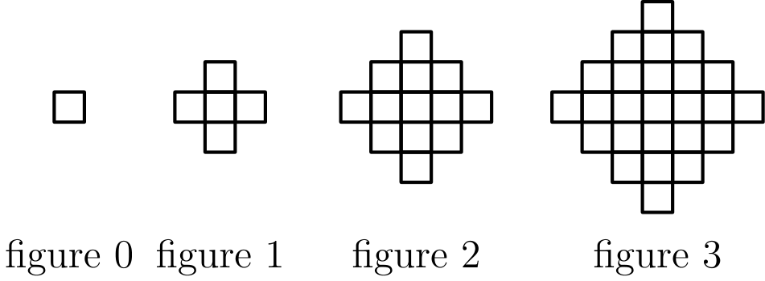
（A）10401 （B）19801 （C）20201 （D）39801 （E）40801
English
Figures 0, 1, 2, and 3 consist of 1, 5, 13, and 25 nonoverlapping unit squares, respectively. If the pattern were continued, how many nonoverlapping unit squares would there be in figure 100?
(A) 10401 (B) 19801 (C) 20201 (D) 39801 (E) 40801
第 9 题
Walter 老师给一个五人数学班考试。她把成绩按随机顺序输入电子表格，表格在每输入一个成绩后重新计算班级平均分。Walter 老师注意到每次输入后，平均分总是整数。五个成绩按升序为 71，76，80，82 和 91。Walter 老师最后输入的成绩是多少？
（A）71 （B）76 （C）80 （D）82 （E）91
English
Mrs. Walter gave an exam in a mathematics class of five students. She entered the scores in random order into a spreadsheet, which recalculated the class average after each score was entered. Mrs. Walter noticed that after each score was entered, the average was always an integer. The scores (listed in ascending order) were 71, 76, 80, 82, and 91. What was the last score Mrs. Walter entered?
(A) 71 (B) 76 (C) 80 (D) 82 (E) 91
第 10 题
点 P = (1, 2, 3) 关于 xy-平面反射，得到的像 Q 再绕 x-轴旋转 180° 得到 R，最后 R 沿正 y 方向平移 5 个单位得到 S。S 的坐标是什么？
（A）(1, 7, -3) （B）(-1, 7, -3) （C）(-1, -2, 8) （D）(-1, 3, 3) （E）(1, 3, 3)
English
The point P = (1, 2, 3) is reflected in the xy-plane, then its image Q is rotated by 180° about the x-axis to produce R, and finally, R is translated by 5 units in the positive y direction to produce S. What are the coordinates of S?
(A) (1, 7, -3) (B) (-1, 7, -3) (C) (-1, -2, 8) (D) (-1, 3, 3) (E) (1, 3, 3)
第 11 题
两个非零实数 a 和 b 满足 ab = a - b。求下式的一个可能值：
a/b + b/a - ab。
（A）-2 （B）-1/2 （C）1/3 （D）1/2 （E）2
English
Two non-zero real numbers, a and b, satisfy ab = a - b. Find a possible value of
a/b + b/a - ab.
(A) -2 (B) -1/2 (C) 1/3 (D) 1/2 (E) 2
第 12 题
设 A、M 和 C 是非负整数，且 A + M + C = 12。求下式的最大值：
A · M · C + A · M
+ M · C + C · A
？
（A）62 （B）72 （C）92 （D）102 （E）112
English
Let A, M, and C be nonnegative integers such that A + M + C = 12. What is the maximum value of
A · M · C + A · M
+ M · C + C · A?
(A) 62 (B) 72 (C) 92 (D) 102 (E) 112
第 13 题
某天早上，Angela 家的每个人都喝了一杯 8-盎司的咖啡牛奶混合饮品。每杯中咖啡和牛奶的量可能不同，但都不为零。Angela 喝掉了全家牛奶总量的四分之一和咖啡总量的六分之一。这个家庭有多少人？
（A）3 （B）4 （C）5 （D）6 （E）7
English
One morning each member of Angela’s family drank an 8-ounce mixture of coffee with milk. The amounts of coffee and milk varied from cup to cup, but were never zero. Angela drank a quarter of the total amount of milk and a sixth of the total amount of coffee. How many people are in the family?
(A) 3 (B) 4 (C) 5 (D) 6 (E) 7
第 14 题
当列表
10, 2, 5, 2, 4, 2, x
的平均数、中位数和众数按递增顺序排列后，它们形成一个非常数等差数列。所有可能的实数 x 的和是多少？
（A）3 （B）6 （C）9 （D）17 （E）20
English
When the mean, median, and mode of the list
10, 2, 5, 2, 4, 2, x
are arranged in increasing order, they form a non-constant arithmetic progression. What is the sum of all possible real values of x?
(A) 3 (B) 6 (C) 9 (D) 17 (E) 20
第 15 题
设函数 f 满足 f(x/3) = x² + x + 1。求所有满足 f(3z) = 7 的 z 的和。
（A）-1/3 （B）-1/9 （C）0 （D）5/9 （E）5/3
English
Let f be a function for which f(x/3) = x² + x + 1. Find the sum of all values of z for which f(3z) = 7.
(A) -1/3 (B) -1/9 (C) 0 (D) 5/9 (E) 5/3
第 16 题
一个 13 行 17 列的棋盘，每个方格中都写有一个数，从左上角开始编号，第一行编号为 1，2，…，17，第二行编号为 18，19，…，34，依此向下。如果重新编号，使左列从上到下为 1，2，…，13，第二列为 14，15，…，26，依此向右，有些方格在两种编号方式下得到相同的数。求这些方格中数字的和（任一种编号方式下都一样）。
（A）222 （B）333 （C）444 （D）555 （E）666
English
A checkerboard of 13 rows and 17 columns has a number written in each square, beginning in the upper left corner, so that the first row is numbered 1, 2, …, 17, the second row 18, 19, …, 34, and so on down the board. If the board is renumbered so that the left column, top to bottom, is 1, 2, …, 13, the second column 14, 15, …, 26 and so on across the board, some squares have the same numbers in both numbering systems. Find the sum of the numbers in these squares (under either system).
(A) 222 (B) 333 (C) 444 (D) 555 (E) 666
第 17 题
一个以 O 为圆心、半径为 1 的圆经过点 A。线段 AB 在点 A 处与圆相切，且 ∠ AOB = θ。若点 C 位于 OA 上，且 BC 平分 ∠ ABO，则 OC 等于多少？
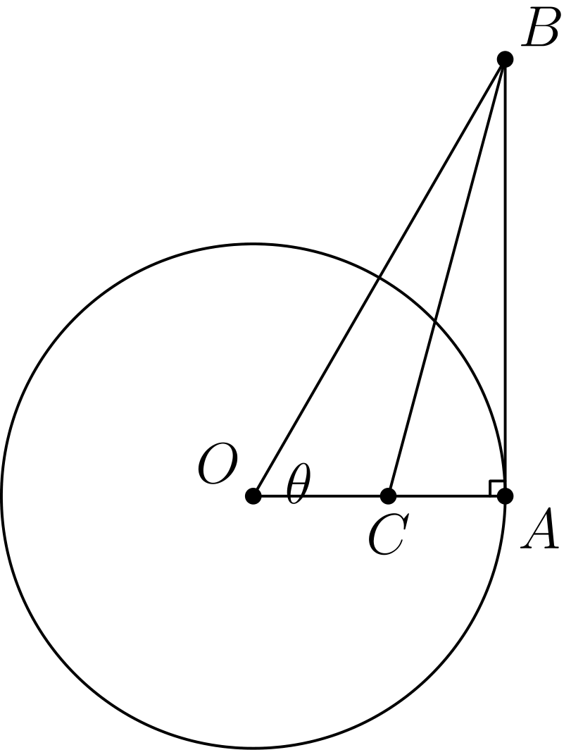
（A）sec²θ - tanθ （B）1/2 （C）cos²θ/(1 + sinθ) （D）1/(1 + sinθ) （E）sinθ/cos²θ
English
A circle centered at O has radius 1 and contains the point A. Segment AB is tangent to the circle at A and ∠ AOB = θ. If point C lies on OA and BC bisects ∠ ABO, then what is OC?
(A) sec²θ - tanθ (B) 1/2 (C) cos²θ/(1 + sinθ) (D) 1/(1 + sinθ) (E) sinθ/cos²θ
第 18 题
N 年的第 300 天是星期二，N + 1 年的第 200 天也是星期二。那么 N - 1 年的第 100 天是星期几？
（A）星期四 （B）星期五 （C）星期六 （D）星期日 （E）星期一
English
In year N, the 300th day of the year is a Tuesday. In year N + 1, the 200th day is also a Tuesday. On what day of the week did the 100th day of year N - 1 occur?
(A) Thursday (B) Friday (C) Saturday (D) Sunday (E) Monday
第 19 题
在三角形 ABC 中，AB = 13、BC = 14、AC = 15。设 D 为 BC 的中点，E 为角 BAC 的角平分线与 BC 的交点。下列哪一个数最接近三角形 ADE 的面积？
（A）2 （B）2.5 （C）3 （D）3.5 （E）4
English
In triangle ABC, AB = 13, BC = 14, and AC = 15. Let D denote the midpoint of BC and let E denote the intersection of BC with the bisector of angle BAC. Which of the following is closest to the area of triangle ADE?
(A) 2 (B) 2.5 (C) 3 (D) 3.5 (E) 4
第 20 题
若正数 x、y 和 z 满足
x + 1/y = 4，
y + 1/z = 1，
以及
z + 1/x = 7/3，
则 xyz 等于多少？
（A）2/3 （B）1 （C）4/3 （D）2 （E）7/3
English
If x, y, and z are positive numbers satisfying
x + 1/y = 4,
y + 1/z = 1,
and
z + 1/x = 7/3,
then what is xyz?
(A) 2/3 (B) 1 (C) 4/3 (D) 2 (E) 7/3
第 21 题
过直角三角形斜边上的一点，作两条分别平行于两条直角边的直线，把三角形分成一个正方形和两个较小的直角三角形。若其中一个小直角三角形的面积是正方形面积的 m 倍，则另一个小直角三角形面积与正方形面积的比是多少？
（A）1/(2m + 1) （B）m （C）1 - m （D）1/4m （E）1/8m²
English
Through a point on the hypotenuse of a right triangle, lines are drawn parallel to the legs of the triangle so that the triangle is divided into a square and two smaller right triangles. The area of one of the two small right triangles is m times the area of the square. What is the ratio of the area of the other small right triangle to the area of the square?
(A) 1/(2m + 1) (B) m (C) 1 - m (D) 1/4m (E) 1/8m²
第 22 题
下图显示了由四次多项式
P(x) = x⁴ + ax³ + bx² + cx + d
定义的曲线的一部分。下列哪一项最小？
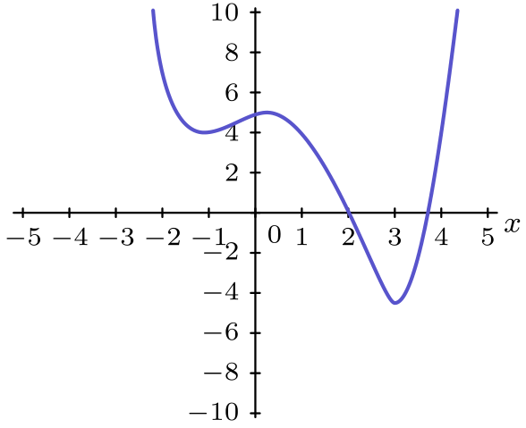
（A）P(-1) （B）P 的零点的乘积 （C）P 的非实零点的乘积 （D）P 的系数之和 （E）P 的实零点之和
English
The graph below shows a portion of the curve defined by the quartic polynomial
P(x) = x⁴ + ax³ + bx² + cx + d.
Which of the following is the smallest?
(A) P(-1) (B) The product of the zeros of P (C) The product of the non-real zeros of P (D) The sum of the coefficients of P (E) The sum of the real zeros of P
第 23 题
Gamble 教授买了一张彩票，需要从 1 到 46（含）中选出六个不同的整数。他选择的数字满足这六个数字的常用对数之和为整数。碰巧中奖彩票上的整数也有相同性质，即常用对数之和为整数。Gamble 教授持有中奖彩票的概率是多少？
（A）1/5 （B）1/4 （C）1/3 （D）1/2 （E）1
English
Professor Gamble buys a lottery ticket, which requires that he pick six different integers from 1 through 46, inclusive. He chooses his numbers so that the sum of the base-ten logarithms of his six numbers is an integer. It so happens that the integers on the winning ticket have the same property -- the sum of the base-ten logarithms is an integer. What is the probability that Professor Gamble holds the winning ticket?
(A) 1/5 (B) 1/4 (C) 1/3 (D) 1/2 (E) 1
第 24 题
若圆弧 AC 和 BC 的圆心分别为 B 和 A，则存在一个圆同时与圆弧 AC、圆弧 BC 以及线段 AB 相切。若圆弧 BC 的长度为 12，则这个圆的周长是多少？
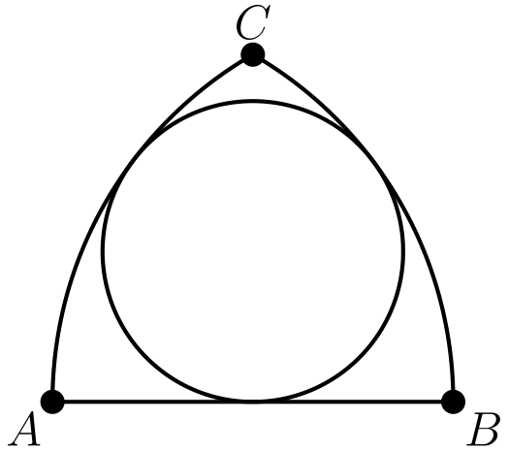
（A）24 （B）25 （C）26 （D）27 （E）28
English
If circular arcs AC and BC have centers at B and A, respectively, then there exists a circle tangent to both arc AC and arc BC, and to AB. If the length of arc BC is 12, then what is the circumference of the circle?
(A) 24 (B) 25 (C) 26 (D) 27 (E) 28
第 25 题
八个全等的等边三角形，每个颜色都不同，被用来构造一个正八面体。构造这个八面体有多少种可区分的方法？（如果两个着色八面体不能通过旋转变得完全一样，则称它们可区分。）
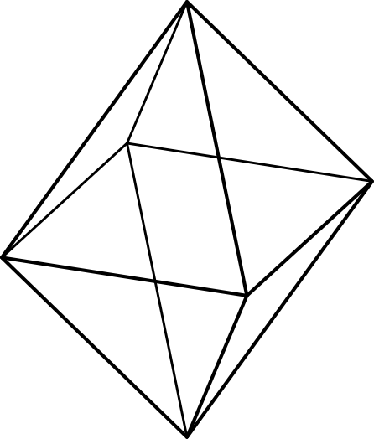
（A）210 （B）560 （C）840 （D）1260 （E）1680
English
Eight congruent equilateral triangles, each of a different color, are used to construct a regular octahedron. How many distinguishable ways are there to construct the octahedron? (Two colored octahedrons are distinguishable if neither can be rotated to look just like the other.)
(A) 210 (B) 560 (C) 840 (D) 1260 (E) 1680

第二部分 解答
答案速查：
题号 1 2 3 4 5 6 7 8 9
答案 E A B C C C E C C
题号 10 11 12 13 14 15 16 17 18
答案 E E E C E B D D A
题号 19 20 21 22 23 24 25
答案 C B D C B D E
答案串：EABCCCECCEEECEBDDACBDCBDE
第 1 题 答案 E
分解质因数得 2001 = 3 · 23 · 29。
在乘积固定且三个正整数互不相同的条件下，要使和最大，取 I = 1，M = 3，且 O = 23 · 29 = 667。
最大和为 1 + 3 + 667 = 671。
因此，正确答案是E。
English
Factoring gives 2001 = 3 · 23 · 29.
To maximize the sum of three distinct positive integers with this product, take I = 1, M = 3, and O = 23 · 29 = 667.
The largest sum is 1 + 3 + 667 = 671.
Thus, the correct answer isE.
第 2 题 答案 A
将 2000 = 2000¹ 得到
2000¹ · 2000²⁰⁰⁰
= 2000^(1 + 2000)
= 2000²⁰⁰¹
。
其他选项都比这个值大。
因此，正确答案是A。
English
Writing 2000 = 2000¹, we get
2000¹ · 2000²⁰⁰⁰
= 2000^(1 + 2000)
= 2000²⁰⁰¹.
All of the other options are larger than this.
Thus, the correct answer isA.
第 3 题 答案 B
每天吃掉 20%，所以每天结束时剩下 80%。若原来有 x 颗，则
(0.8)² x = 32。
解得 0.64x = 32，所以 x = 50。
因此，正确答案是B。
English
Since 20% is eaten each day, 80% remains at the end of each day. If x is the original number, then
(0.8)² x = 32.
Solving gives 0.64x = 32, so x = 50.
Thus, the correct answer isB.
第 4 题 答案 C
个位数字序列开始为
1, 1, 2, 3, 5, 8, 3, 1, 4, 5, 9,
4, 3, 7, 0, 7, 7, 4, 1, 5, 6, …
查看这个列表，数字 6 是十个数字中最后出现的。
因此，正确答案是C。
English
The sequence of units digits begins
1, 1, 2, 3, 5, 8, 3, 1, 4, 5, 9,
4, 3, 7, 0, 7, 7, 4, 1, 5, 6, …
Scanning this list, the digit 6 is the last of the ten digits to appear.
Thus, the correct answer isC.
第 5 题 答案 C
因为 x < 2，所以 |x - 2| = 2 - x = p，因此 x = 2 - p。
于是
x - p = (2 - p) - p = 2 - 2p。
因此，正确答案是C。
English
Since x < 2, we have |x - 2| = 2 - x = p, so x = 2 - p.
Then
x - p = (2 - p) - p = 2 - 2p.
Thus, the correct answer isC.
第 6 题 答案 C
4 和 18 之间的质数是 5, 7, 11, 13 和 17。
对这样的两个质数，xy - (x + y) = (x - 1)(y - 1) - 1 是两个偶数的乘积减去 1，因此它同余于 3 pmod 4。这样只剩下 119 和 231。后者要求 (x-1)(y-1)=232，但 {4,6,10,12,16} 中没有两个不同的数的乘积等于 232。
实际上，
11 · 13 - (11 + 13) = 143 - 24
= 119
。
因此，正确答案是C。
English
The primes between 4 and 18 are 5, 7, 11, 13, and 17.
For two such primes, xy - (x + y) = (x - 1)(y - 1) - 1 is a product of two even numbers minus 1, hence it is 3 pmod 4. This leaves 119 and 231. The latter would require (x-1)(y-1)=232, but no two distinct numbers in {4,6,10,12,16} have product 232.
Indeed,
11 · 13 - (11 + 13) = 143 - 24
= 119.
Thus, the correct answer isC.
第 7 题 答案 E
若 log_(b) 729 = n，则 bⁿ = 729 = 3⁶，所以 n 必须是 6 的正因数。
n = 1, 2, 3, 6 分别给出 b = 3⁶, 3³, 3², 3¹，也就是 729, 27, 9 和 3。
共有 4 个这样的 b。
因此，正确答案是E。
English
If log_(b) 729 = n, then bⁿ = 729 = 3⁶, so n must be a positive divisor of 6.
The possibilities n = 1, 2, 3, 6 give b = 3⁶, 3³, 3², 3¹, that is, 729, 27, 9, and 3.
There are 4 such values of b.
Thus, the correct answer isE.
第 8 题 答案 C
图形 n 是一个菱形，各行长度按奇数增大后再减小，所以共有 n² + (n + 1)² 个单位正方形。这与 n = 0, 1, 2, 3 时的 1, 5, 13, 25 相符。
因此图形 100 中单位正方形的个数为
100² + 101² = 10000 + 10201
= 20201
个。
因此，正确答案是C。
English
Figure n is a diamond whose row lengths increase through the odd numbers and back down, giving a total of n² + (n + 1)² unit squares. This matches 1, 5, 13, 25 for n = 0, 1, 2, 3.
Therefore figure 100 has
100² + 101² = 10000 + 10201
= 20201
unit squares.
Thus, the correct answer isC.
第 9 题 答案 C
总和为 71 + 76 + 80 + 82 + 91 = 400，可被 5 整除。前三个成绩的和必须能被 3 整除。
模 3，这些成绩的余数是 2, 1, 2, 1, 1。唯一和为 3 的倍数的三元组是 76 + 82 + 91 = 249，所以它们是前三个成绩（其中 91 第三个，因为前两个 76 和 82，必须奇偶性相同）。
因为 249 ≡ 1 pmod 4，第四个成绩必须 ≡ 3 pmod 4，即 71。于是最后输入的是 80。
因此，正确答案是C。
English
The total is 71 + 76 + 80 + 82 + 91 = 400, which is divisible by 5. The sum of the first three scores must be divisible by 3.
Modulo 3, the scores are 2, 1, 2, 1, 1. The only triple summing to a multiple of 3 is 76 + 82 + 91 = 249, so these are the first three (with 91 third, since the first two, 76 and 82, must have equal parity).
Since 249 ≡ 1 pmod 4, the fourth score must be ≡ 3 pmod 4, which is 71. That leaves 80 as the last score entered.
Thus, the correct answer isC.
第 10 题 答案 E
(1, 2, 3) 关于 xy-平面反射得到 Q = (1, 2, -3)。
绕 x-轴旋转 180° 会使 y 和 z 变号，得到 R = (1, -2, 3)。
沿正 y 方向平移 5 个单位得到 S = (1, 3, 3)。
因此，正确答案是E。
English
Reflecting (1, 2, 3) in the xy-plane gives Q = (1, 2, -3).
Rotating 180° about the x-axis negates y and z, giving R = (1, -2, 3).
Translating 5 units in the positive y direction gives S = (1, 3, 3).
Thus, the correct answer isE.
第 11 题 答案 E
通分得
a/b + b/a - ab = (a² + b² - (ab)²)/ab。
在分子中用 a - b 替换 ab，得
a² + b² - (a - b)²
= a² + b²
- (a² - 2ab + b²)
= 2ab
。
因此原式等于 2ab/ab = 2。
因此，正确答案是E。
English
Combining over a common denominator,
a/b + b/a - ab = (a² + b² - (ab)²)/ab.
Replacing ab with a - b in the numerator,
a² + b² - (a - b)²
= a² + b²
- (a² - 2ab + b²)
= 2ab.
Therefore the expression equals 2ab/ab = 2.
Thus, the correct answer isE.
第 12 题 答案 E
注意
AMC + AM + MC + CA
= (A + 1)(M + 1)(C + 1)
- (A + M + C) - 1
。
因为 A + M + C = 12，原式等于 (A + 1)(M + 1)(C + 1) - 13。这三个因数的和为 15，乘积在它们都等于 5 时最大，等于 5³ = 125。
最大值为 125 - 13 = 112。
因此，正确答案是E。
English
Observe that
AMC + AM + MC + CA
= (A + 1)(M + 1)(C + 1)
- (A + M + C) - 1.
Since A + M + C = 12, this equals (A + 1)(M + 1)(C + 1) - 13. The three factors sum to 15, so their product is maximized when each equals 5, giving 5³ = 125.
The maximum value is 125 - 13 = 112.
Thus, the correct answer isE.
第 13 题 答案 C
以 8-盎司的一杯为单位计量，所以 Angela 的杯中有 c 杯咖啡和 m 杯牛奶，且 c + m = 1。
因为 Angela 喝掉了咖啡总量的六分之一，所以咖啡总量为 6c；因为她喝掉了牛奶总量的四分之一，所以牛奶总量为 4m。人数等于总杯数：
6c + 4m = 6c + 4(1 - c)
= 4 + 2c
。
这必须是整数，所以 2c 是整数。又因 0 < c < 1，只能有 c = 1/2，从而人数为 4 + 1 = 5。
因此，正确答案是C。
English
Measure amounts in 8-ounce cups, so Angela’s cup holds c coffee and m milk with c + m = 1.
Since Angela drank a sixth of the coffee, the total coffee is 6c; since she drank a quarter of the milk, the total milk is 4m. The number of people equals the total number of cups,
6c + 4m = 6c + 4(1 - c)
= 4 + 2c.
This is an integer only when 2c is an integer, and since 0 < c < 1 this forces c = 1/2, giving 4 + 1 = 5 people.
Thus, the correct answer isC.
第 14 题 答案 E
六个固定数的和为 25，所以平均数是 (25 + x)/7，众数是 2。若 x ≤ 2，则 2 同时是中位数和众数，会迫使等差数列为常数，所以 x > 2。
情形 2 < x < 4：中位数为 x。要求 2, x, (25 + x)/7 构成等差数列，得到此范围内唯一的值 x = 3。
情形 x ≥ 4：中位数为 4，等差数列 2, 4, 6 迫使平均数为 6，所以 (25 + x)/7 = 6，得 x = 17。
所有可能值的和为 3 + 17 = 20。
因此，正确答案是E。
English
The six fixed numbers sum to 25, so the mean is (25 + x)/7, and the mode is 2. If x ≤ 2, then 2 is both median and mode, forcing a constant progression, so x > 2.
Case 2 < x < 4:the median is x. Requiring 2, x, (25 + x)/7 to form an arithmetic progression yields x = 3 as the only value in this range.
Case x ≥ 4:the median is 4, and the progression 2, 4, 6 forces the mean to be 6, so (25 + x)/7 = 6, giving x = 17.
The sum of all possible values is 3 + 17 = 20.
Thus, the correct answer isE.
第 15 题 答案 B
令 x/3 = 3z 得到 x = 9z，所以
f(3z) = (9z)² + 9z + 1
= 81z² + 9z + 1
= 7
。
整理得 81z² + 9z - 6 = 0。
由根和公式，所有 z 的和为 -9/81 = -1/9。
因此，正确答案是B。
English
Setting x/3 = 3z gives x = 9z, so
f(3z) = (9z)² + 9z + 1
= 81z² + 9z + 1
= 7.
This rearranges to 81z² + 9z - 6 = 0.
By the sum-of-roots formula, the sum of the values of z is -9/81 = -1/9.
Thus, the correct answer isB.
第 16 题 答案 D
方格 (m, n) 原来的编号为 17(m - 1) + n，重新编号后为 13(n - 1) + m。令它们相等，得
4m - 3n = 1。
满足 1 ≤ m ≤ 13 且 1 ≤ n ≤ 17 的解为 (1, 1)，(4, 5)，(7, 9)，(10, 13)，和 (13, 17)。
这些方格中的数为 1, 56, 111, 166 和 221，总和为 555。
因此，正确答案是D。
English
The square (m, n) is numbered 17(m - 1) + n originally and 13(n - 1) + m after renumbering. Setting these equal gives
4m - 3n = 1.
The solutions with 1 ≤ m ≤ 13 and 1 ≤ n ≤ 17 are (1, 1), (4, 5), (7, 9), (10, 13), and (13, 17).
These squares hold the numbers 1, 56, 111, 166, and 221, whose sum is 555.
Thus, the correct answer isD.
第 17 题 答案 D
因为 OA = 1 且 AB 在 A 点与圆相切，角 OAB 为直角，所以
BA = tanθ, OB = secθ。
因为 BC 平分 ∠ ABO，由角平分线定理得 OC/CA = OB/BA。又 OC + CA = OA = 1，
OC = OB/(OB + BA)
= secθ/(secθ + tanθ)
。
分子分母同乘 cosθ 得到 OC = 1/(1 + sinθ)。
因此，正确答案是D。
English
Because OA = 1 and AB is tangent at A, angle OAB is right, so
BA = tanθ, OB = secθ.
Since BC bisects ∠ ABO, the angle bisector theorem gives OC/CA = OB/BA. Using OC + CA = OA = 1,
OC = OB/(OB + BA)
= secθ/(secθ + tanθ).
Multiplying numerator and denominator by cosθ gives OC = 1/(1 + sinθ).
Thus, the correct answer isD.
第 18 题 答案 A
从 N 年第 300 天到 N + 1 年第 200 天，若 N 不是闰年，相隔 365 - 300 + 200 = 265 天。但 265 = 7 · 37 + 6，会落在星期一，而不是星期二。
所以 N 是闰年，相隔 266 = 7 · 38 天，正好仍为星期二。因此 N - 1 年不是闰年。
N - 1 年第 100 天比 N 年第 300 天早 365 - 100 + 300 = 565 天。因为 565 = 7 · 80 + 5，所以那一天比星期二早 5 天，即星期四。
因此，正确答案是A。
English
From day 300 of year N to day 200 of year N + 1, the number of days is 365 - 300 + 200 = 265 if N is not a leap year. But 265 = 7 · 37 + 6, which would land on a Monday, not a Tuesday.
So year N is a leap year, and the gap is 266 = 7 · 38 days, giving a Tuesday as stated. It follows that year N - 1 is not a leap year.
The 100th day of year N - 1 precedes the Tuesday on day 300 of year N by 365 - 100 + 300 = 565 days. Since 565 = 7 · 80 + 5, that day is 5 weekdays before Tuesday, namely Thursday.
Thus, the correct answer isA.
第 19 题 答案 C
由海伦公式，△ ABC 的面积为 √(21 · 8 · 7 · 6) = 84，所以从 A 到 BC 的高为 (2 · 84)/14 = 12。
中点 D 到 B 的距离为 7。从 A 作出的角平分线与 BC 相交于 E，且 BE: EC = AB: AC = 13: 15，所以 BE = 14 · 13/28 = 6.5。
D 和 E 都在 BC 上，所以 △ ADE 的底为 DE = 7 - 6.5 = 0.5，高为 12，面积为
1/2 · 0.5 · 12 = 3。
因此，正确答案是C。
English
By Heron’s formula, the area of △ ABC is √(21 · 8 · 7 · 6) = 84, so the altitude from A to BC is (2 · 84)/14 = 12.
The midpoint D is 7 from B. The bisector from A meets BC at E with BE: EC = AB: AC = 13: 15, so BE = 14 · 13/28 = 6.5.
Both D and E lie on BC, so △ ADE has base DE = 7 - 6.5 = 0.5 and altitude 12, giving area
1/2 · 0.5 · 12 = 3.
Thus, the correct answer isC.
第 20 题 答案 B
三个方程相加得
(x + 1/y) + (y + 1/z)
+ (z + 1/x)
= 4 + 1 + 7/3
= 22/3。
三个方程相乘得
4 · 1 · 7/3 = 28/3。
展开乘积，得到
(x + 1/y)
· (y + 1/z)
· (z + 1/x)
= xyz
+ (x + y + z + 1/x + 1/y + 1/z)
+ 1/xyz。
中间括号中的一组之和就是 22/3，所以 xyz + 1/xyz = 28/3 - 22/3 = 2。
因此 (xyz - 1)² = 0，所以 xyz = 1。
因此，正确答案是B。
English
Adding the three equations gives
(x + 1/y) + (y + 1/z)
+ (z + 1/x)
= 4 + 1 + 7/3
= 22/3.
Multiplying them gives
4 · 1 · 7/3 = 28/3.
Expanding the product,
(x + 1/y)
· (y + 1/z)
· (z + 1/x)
= xyz
+ (x + y + z + 1/x + 1/y + 1/z)
+ 1/xyz.
The middle group is the sum 22/3, so xyz + 1/xyz = 28/3 - 22/3 = 2.
Hence (xyz - 1)² = 0, so xyz = 1.
Thus, the correct answer isB.
第 21 题 答案 D
设正方形边长为 1。与正方形一边相邻的小三角形有一条长为 r 的垂直边，所以它的面积为 1/2 · 1 · r = m，从而 r = 2m。
两个小三角形相似，所以另一个三角形沿正方形的直角边长为 1/r，面积为
1/2 · 1 · 1/r = 1/2r = 1/4m。
因此，正确答案是D。
English
Let the square have side 1. The small triangle sharing one side of the square has a perpendicular leg r, so its area is 1/2 · 1 · r = m, giving r = 2m.
The two small triangles are similar, so the other triangle’s leg along the square is 1/r, and its area is
1/2 · 1 · 1/r = 1/2r = 1/4m.
Thus, the correct answer isD.
第 22 题 答案 C
图像与 x-轴恰好相交两次，且两次都在正数处，所以 P 有两个实零点和两个非实（复共轭）零点。
从图像读出：系数之和为 P(1) > 3；P(-1) > 4；实零点之和大于 4.5；所有零点的乘积为 d，即 y-截距，小于 6。
设实零点的乘积为 R，则 R > 4.5。非实零点的乘积为 d/R，它小于 6/4.5 < 2。
这比列出的其他每一个量都小。
因此，正确答案是C。
English
The graph crosses the x-axis exactly twice, both times at positive values, so P has two real zeros and two non-real (complex conjugate) zeros.
Reading off the graph: the sum of the coefficients is P(1) > 3; P(-1) > 4; the sum of the real zeros is greater than 4.5; and the product of all zeros is d, the y-intercept, which is less than 6.
Let R be the product of the real zeros, so R > 4.5. The product of the non-real zeros is d/R, which is less than 6/4.5 < 2.
This is smaller than every other listed quantity.
Thus, the correct answer isC.
第 23 题 答案 B
对数之和为整数 k，当且仅当六个数的乘积为 10ᵏ。因为 10 = 2 · 5，每个选中的数都必须形如 2ᵃ 5ᵇ，所以只能来自
1, 2, 4, 5, 8, 10, 16, 20, 25, 32, 40。
对每个数记录因数 2 的个数比因数 5 的个数多多少：0, 1, 2, -1, 3, 0, 4, 1, -2, 5, 2。乘积为 10 的幂，要求六个所选数中 2 与 5 的总指数相等，也就是这些差值之和为 0。
负差值只有 5 的 -1 和 25 的 -2。总差值为 0 的六数彩票必须同时包含两者：缺少任意一个，都没有足够的零和小正差值凑满六个数。因此另外四个数的差值之和必须为 3。差值为 0 的数有两个（1,10），差值为 1 的数有两个（2,20），差值为 2 的数有两个（4,40）；若使用差值至少为 3 的数，就没有足够的零差值数凑满四个。因此必须取两个差值为 0 的数、一个差值为 1 的数和一个差值为 2 的数。恰有四张有效彩票：{1, 5, 10, 20, 25, 40}，{1, 2, 5, 10, 25, 40}，{1, 2, 4, 5, 10, 25}，和 {1, 4, 5, 10, 20, 25}。
Gamble 教授持有其中一张，而只有一张与中奖彩票相同，所以概率为 1/4。
所以正确答案是B。
English
The sum of the logarithms is an integer k exactly when the product of the six numbers is 10ᵏ. Since 10 = 2 · 5, each chosen number must be of the form 2ᵃ 5ᵇ, so it comes from
1, 2, 4, 5, 8, 10, 16, 20, 25, 32, 40.
For each, record the excess of factors of 2 over factors of 5: 0, 1, 2, -1, 3, 0, 4, 1, -2, 5, 2. The product is a power of 10 only if the six chosen values have equal totals of 2s and 5s, i.e. their excesses sum to 0.
The only negative excesses are -1 for 5 and -2 for 25. A six-number ticket with total excess 0 must contain both: omitting either leaves too few zero and small positive excesses to reach six numbers. The other four numbers must therefore have total excess 3. There are two numbers of excess 0 (1,10), two of excess 1 (2,20), and two of excess 2 (4,40); any number of excess at least 3 would leave too few zeros to complete a four-number selection. Thus we must take both excess-0 numbers, one excess-1 number, and one excess-2 number. This gives exactly four valid tickets: {1, 5, 10, 20, 25, 40}, {1, 2, 5, 10, 25, 40}, {1, 2, 4, 5, 10, 25}, and {1, 4, 5, 10, 20, 25}.
Professor Gamble holds one of these four, and only one matches the winning ticket, so the probability is 1/4.
Thus, the correct answer isB.
第 24 题 答案 D
每条圆弧的半径都是 AB，且 C 到 A 和 B 的距离都为 AB，所以 △ ABC 是等边三角形。因此圆弧 BC 对应半径为 AB 的圆上的 60° 圆心角，该大圆的整周长为 6 · 12 = 72。
设小圆半径为 r，并在线段 AB 的中点 D 处相切，其中 AD = 1/2 AB。由点幂定理，AD² = AB(AB - 2r)，所以
AB²/4 = AB² - 2r AB，
从而 2r = 3/4 AB，因而 r = 3/8 AB。
周长之比等于半径之比，所以小圆的周长为 3/8 · 72 = 27。
因此，正确答案是D。
English
Each arc has radius AB, and C is at distance AB from both A and B, so △ ABC is equilateral. Thus arc BC subtends 60° of a circle of radius AB, whose full circumference is 6 · 12 = 72.
Let the small circle have radius r and touch AB at its midpoint D, where AD = 1/2 AB. By Power of a Point, AD² = AB(AB - 2r), so
AB²/4 = AB² - 2r AB,
giving 2r = 3/4 AB, hence r = 3/8 AB.
The circumferences are in the ratio of the radii, so the small circle’s circumference is 3/8 · 72 = 27.
Thus, the correct answer isD.
第 25 题 答案 E
将八种不同颜色分配给八个面共有 8! 种方式。两个分配表示同一个八面体，当且仅当其中一个可以旋转成另一个。
正八面体的旋转群有 24 个元素。因为八种颜色全都不同，没有非平凡旋转会固定一种着色，所以每个可区分的八面体恰好对应 24 种分配。
因此可区分的八面体数量为
(8!)/24 = 40320/24 = 1680。
因此，正确答案是E。
English
There are 8! ways to assign the eight distinct colors to the eight faces. Two assignments give the same octahedron exactly when one is a rotation of the other.
The rotation group of a regular octahedron has 24 elements. Because all eight colors are different, no nontrivial rotation fixes a coloring, so each distinguishable octahedron corresponds to exactly 24 assignments.
Therefore the number of distinguishable octahedrons is
(8!)/24 = 40320/24 = 1680.
Thus, the correct answer isE.

