2021B AMC 10 真题与解答
American Mathematics Competitions 10 · 中英双语
共 25 题，限时 75 分钟；答对得 6 分，未答得 1.5 分，答错 0 分，满分 150 分。
编排说明：第一部分为题目（先中文、后英文原题），第二部分为解答与答案，便于先做题后对答案。
第一部分 题目
第 1 题
有多少个整数 x 满足 |x| < 3π？
（A）9 （B）10 （C）18 （D）19 （E）20
English
How many integer values of x satisfy |x| < 3π?
(A) 9 (B) 10 (C) 18 (D) 19 (E) 20
第 2 题
下式的值是多少？
√((3-2√(3))²)
+√((3+2√(3))²)
？
（A）0 （B）4√(3)-6 （C）6 （D）4√(3) （E）4√(3)+6
English
What is the value of
√((3-2√(3))²)
+√((3+2√(3))²)?
(A) 0 (B) 4√(3)-6 (C) 6 (D) 4√(3) (E) 4√(3)+6
第 3 题
在一个面向低年级和高年级学生的课后项目中，有一支辩论队，队中来自两个年级的学生人数相同。这个项目共有 28 名学生，其中 25% 的低年级学生和 10% 的高年级学生在辩论队中。这个项目中有多少名低年级学生？
（A）5 （B）6 （C）8 （D）11 （E）20
English
In an after-school program for juniors and seniors, there is a debate team with an equal number of students from each class on the team. Among the 28 students in the program, 25% of the juniors and 10% of the seniors are on the debate team. How many juniors are in the program?
(A) 5 (B) 6 (C) 8 (D) 11 (E) 20
第 4 题
在一场数学竞赛中，57 名学生穿蓝色衬衫，另外 75 名学生穿黄色衬衫。这 132 名学生被分成 66 对。其中恰有 23 对中两名学生都穿蓝色衬衫。有多少对中两名学生都穿黄色衬衫？
（A）23 （B）32 （C）37 （D）41 （E）64
English
At a math contest, 57 students are wearing blue shirts, and another 75 students are wearing yellow shirts. The 132 students are assigned into 66 pairs. In exactly 23 of these pairs, both students are wearing blue shirts. In how many pairs are both students wearing yellow shirts?
(A) 23 (B) 32 (C) 37 (D) 41 (E) 64
第 5 题
Jonie 的四个表亲年龄互不相同，且都是一位正整数。其中两个表亲的年龄相乘为 24，另外两个相乘为 30。Jonie 的四个表亲年龄之和是多少？
（A）21 （B）22 （C）23 （D）24 （E）25
English
The ages of Jonie’s four cousins are distinct single-digit positive integers. Two of the cousins’ ages multiplied together give 24, while the other two multiply to 30. What is the sum of the ages of Jonie’s four cousins?
(A) 21 (B) 22 (C) 23 (D) 24 (E) 25
第 6 题
Blackwell 老师给两个班考试。上午班学生的平均分是 84，下午班学生的平均分是 70。上午班人数与下午班人数之比为 3/4。所有学生的平均分是多少？
（A）74 （B）75 （C）76 （D）77 （E）78
English
Ms. Blackwell gives an exam to two classes. The mean of the scores of the students in the morning class is 84, and the afternoon class’s mean score is 70. The ratio of the number of students in the morning class to the number of students in the afternoon class is 3/4. What is the mean of the scores of all the students?
(A) 74 (B) 75 (C) 76 (D) 77 (E) 78
第 7 题
在平面中，半径分别为 1、3、5 和 7 的四个圆都与直线 ell 在同一点 A 相切，但它们可以位于 ell 的任一侧。区域 S 由恰好位于这四个圆中一个圆内部的所有点组成。区域 S 的最大可能面积是多少？
（A）24π （B）32π （C）64π （D）65π （E）84π
English
In a plane, four circles with radii 1, 3, 5, and 7 are tangent to line ell at the same point A, but they may be on either side of ell. Region S consists of all the points that lie inside exactly one of the four circles. What is the maximum possible area of region S?
(A) 24π (B) 32π (C) 64π (D) 65π (E) 84π
第 8 题
Zhou 先生把从 1 到 225 的所有整数放入一个 15 行 15 列的方格中。他把 1 放在正中间的方格（第八行第八列），然后如图所示按顺时针方向逐个放入其他数。在从上往下数第二行中出现的最大数与最小数之和是多少？
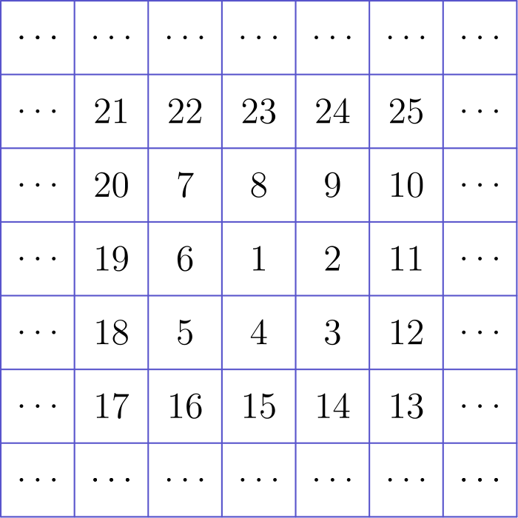
（A）367 （B）368 （C）369 （D）379 （E）380
English
Mr. Zhou places all the integers from 1 to 225 into a 15 by 15 grid. He places 1 in the middle square (eighth row and eighth column) and places other numbers one by one clockwise, as shown in part in the diagram below. What is the sum of the greatest number and the least number that appear in the second row from the top?
(A) 367 (B) 368 (C) 369 (D) 379 (E) 380
第 9 题
xy 平面中的点 P(a,b) 先绕点 (1,5) 逆时针旋转 90°，再关于直线 y = -x 反射。经过这两个变换后，P 的像为 (-6,3)。b - a 等于多少？
（A）1 （B）3 （C）5 （D）7 （E）9
English
The point P(a,b) in the xy-plane is first rotated counterclockwise by 90° around the point (1,5) and then reflected about the line y = -x. The image of P after these two transformations is at (-6,3). What is b - a ?
(A) 1 (B) 3 (C) 5 (D) 7 (E) 9
第 10 题
一个倒置的圆锥底面半径为 12 cm，高为 18 cm，里面装满了水。把水倒入一个高圆柱中，圆柱的水平底面半径为 24 cm。圆柱中水的高度是多少厘米？
（A）1.5 （B）3 （C）4 （D）4.5 （E）6
English
An inverted cone with base radius 12 cm and height 18 cm is full of water. The water is poured into a tall cylinder whose horizontal base has a radius of 24 cm. What is the height in centimeters of the water in the cylinder?
(A) 1.5 (B) 3 (C) 4 (D) 4.5 (E) 6
第 11 题
奶奶刚烤好一大盘长方形布朗尼。她打算沿着盘子的边平行地直线切开，做成大小和形状相同的长方形小块。每一刀都必须从盘子的一边完全切到另一边。奶奶希望内部小块的数量与位于周边的小块数量相同。她最多可以做出多少块布朗尼？
（A）24 （B）30 （C）48 （D）60 （E）64
English
Grandma has just finished baking a large rectangular pan of brownies. She is planning to make rectangular pieces of equal size and shape, with straight cuts parallel to the sides of the pan. Each cut must be made entirely across the pan. Grandma wants to make the same number of interior pieces as pieces along the perimeter of the pan. What is the greatest possible number of brownies she can produce?
(A) 24 (B) 30 (C) 48 (D) 60 (E) 64
第 12 题
设 N = 34 · 34 · 63 · 270。N 的奇因数之和与 N 的偶因数之和的比是多少？
（A）1: 16 （B）1: 15 （C）1: 14 （D）1: 8 （E）1: 3
English
Let N = 34 · 34 · 63 · 270. What is the ratio of the sum of the odd divisors of N to the sum of the even divisors of N?
(A) 1: 16 (B) 1: 15 (C) 1: 14 (D) 1: 8 (E) 1: 3
第 13 题
设 n 是正整数，d 是一个数字。以 n 为底的数 32d 的值等于 263，并且以 n 为底的数 324 的值等于以六为底的数 11d1 的值。n + d 等于多少？
（A）10 （B）11 （C）13 （D）15 （E）16
English
Let n be a positive integer and d be a digit such that the value of the numeral 32d in base n equals 263, and the value of the numeral 324 in base n equals the value of the numeral 11d1 in base six. What is n + d ?
(A) 10 (B) 11 (C) 13 (D) 15 (E) 16
第 14 题
三条等距平行线与一个圆相交，形成三条长度分别为 38、38 和 34 的弦。相邻两条平行线之间的距离是多少？
（A）51/2 （B）6 （C）61/2 （D）7 （E）71/2
English
Three equally spaced parallel lines intersect a circle, creating three chords of lengths 38, 38, and 34. What is the distance between two adjacent parallel lines?
(A) 51/2 (B) 6 (C) 61/2 (D) 7 (E) 71/2
第 15 题
实数 x 满足方程
x+1/x = √(5)。
求 x¹¹-7x⁷+x³ 的值。
（A）-1 （B）0 （C）1 （D）2 （E）√(5)
English
The real number x satisfies the equation
x+1/x = √(5).
What is the value of x¹¹-7x⁷+x³?
(A) -1 (B) 0 (C) 1 (D) 2 (E) √(5)
第 16 题
如果一个正整数的每一位数字都严格大于前一位数字，则称它为上坡整数。例如 1357，89 和 5 都是上坡整数，但 32，1240 和 466 不是。多少个上坡整数能被 15 整除？
（A）4 （B）5 （C）6 （D）7 （E）8
English
Call a positive integer an uphill integer if every digit is strictly greater than the previous digit. For example, 1357, 89, and 5 are all uphill integers, but 32, 1240, and 466 are not. How many uphill integers are divisible by 15?
(A) 4 (B) 5 (C) 6 (D) 7 (E) 8
第 17 题
Ravon、Oscar、Aditi、Tyrone 和 Kim 玩一个纸牌游戏。每人从编号 1，2，3，…，10 的 10 张牌中拿到 2 张。玩家的得分是自己两张牌上数字之和。五人的得分如下：Ravon 为 11，Oscar 为 4，Aditi 为 7，Tyrone 为 16，Kim 为 17。下列哪项陈述正确？
（A）Ravon 拿到了 3 号牌。 （B）Aditi 拿到了 3 号牌。 （C）Ravon 拿到了 4 号牌。 （D）Aditi 拿到了 4 号牌。 （E）Tyrone 拿到了 7 号牌。
English
Ravon, Oscar, Aditi, Tyrone, and Kim play a card game. Each person is given 2 cards out of a set of 10 cards numbered 1, 2, 3, …, 10. The score of a player is the sum of the numbers of their cards. The scores of the players are as follows: Ravon--11, Oscar--4, Aditi--7, Tyrone--16, Kim--17. Which of the following statements is true?
(A) Ravon was given card 3. (B) Aditi was given card 3. (C) Ravon was given card 4. (D) Aditi was given card 4. (E) Tyrone was given card 7.
第 18 题
反复掷一枚公平的 6 面骰，直到第一次出现奇数为止。在第一次出现奇数之前，每个偶数都至少出现一次的概率是多少？
（A）1/120 （B）1/32 （C）1/20 （D）3/20 （E）1/6
English
A fair 6-sided die is repeatedly rolled until an odd number appears. What is the probability that every even number appears at least once before the first occurrence of an odd number?
(A) 1/120 (B) 1/32 (C) 1/20 (D) 3/20 (E) 1/6
第 19 题
设 S 是一个有限的正整数集合。
如果从 S 中移除 S 中最大的整数，剩余整数的平均值为 32。如果再从 S 中移除最小的整数，剩余整数的平均值为 35。如果随后把最大的整数放回 S，平均值升高到 40。原集合 S 中最大的整数比最小的整数大 72。
集合 S 中所有整数的平均值是多少？
（A）36.2 （B）36.4 （C）36.6 （D）36.8 （E）37
English
Suppose that S is a finite set of positive integers.
If the greatest integer in S is removed from S, then the average value (arithmetic mean) of the integers remaining is 32. If the least integer in S is also removed, then the average value of the integers remaining is 35. If the greatest integer is then returned to the set, the average value of the integers rises to 40. The greatest integer in the original set S is 72 greater than the least integer in S.
What is the average value of all the integers in the set S?
(A) 36.2 (B) 36.4 (C) 36.6 (D) 36.8 (E) 37
第 20 题
下图由 11 条线段构成，每条线段长度都为 2。五边形 ABCDE 的面积可写成 √(m) + √(n)，其中 m 和 n 为正整数。m + n 等于多少？
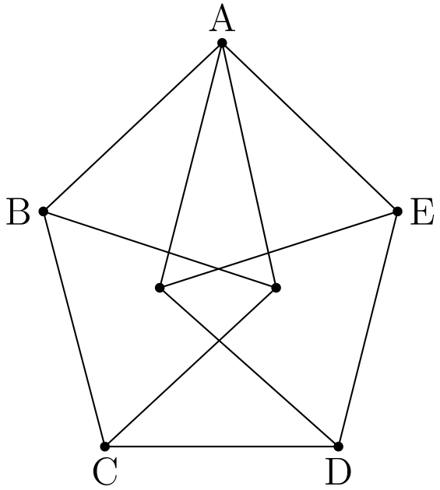
（A）20 （B）21 （C）22 （D）23 （E）24
English
The figure below is constructed from 11 line segments, each of which has length 2. The area of pentagon ABCDE can be written as √(m) + √(n), where m and n are positive integers. What is m + n ?
(A) 20 (B) 21 (C) 22 (D) 23 (E) 24
第 21 题
一张正方形纸片边长为 1，顶点按顺序为 A，B，C 和 D。如图所示，将纸片折叠，使顶点 C 落在边 AD 上的点 C'，且边 BC 与边 AB 相交于点 E。若 C'D = 1/3，三角形 △ AEC' 的周长是多少？
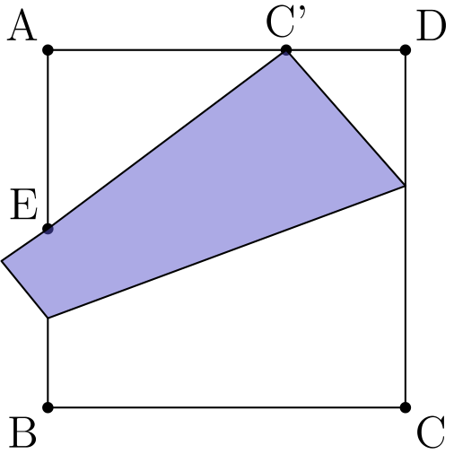
（A）2 （B）1+2/3√(3) （C）13/6 （D）1 + 3/4√(3) （E）7/3
English
A square piece of paper has side length 1 and vertices A, B, C, and D in that order. As shown in the figure, the paper is folded so that vertex C meets edge AD at point C', and edge BC intersects edge AB at point E. Suppose that C'D = 1/3. What is the perimeter of △ AEC'?
(A) 2 (B) 1+2/3√(3) (C) 13/6 (D) 1 + 3/4√(3) (E) 7/3
第 22 题
Ang、Ben 和 Jasmin 每人都有 5 块积木，颜色分别为红、蓝、黄、白、绿；另有 5 个空盒子。三个人各自随机且彼此独立地把自己的每种颜色积木各放入一个盒子中。至少有一个盒子收到 3 块同色积木的概率为 m/n，其中 m 与 n 是互质正整数。m + n 等于多少？
（A）47 （B）94 （C）227 （D）471 （E）542
English
Ang, Ben, and Jasmin each have 5 blocks, colored red, blue, yellow, white, and green; and there are 5 empty boxes. Each of the people randomly and independently of the other two people places one of their blocks into each box. The probability that at least one box receives 3 blocks all of the same color is m/n, where m and n are relatively prime positive integers. What is m + n ?
(A) 47 (B) 94 (C) 227 (D) 471 (E) 542
第 23 题
一个边长为 8 的正方形中，除了 4 个角上腿长为 2 的阴影等腰直角三角形，以及正方形中心一个边长为 2√(2) 的阴影菱形外，其余部分都不涂阴影，如图所示。
一枚直径为 1 的圆形硬币落到正方形上，并随机落在一个使硬币完全包含在正方形内的位置。硬币覆盖到正方形阴影区域一部分的概率可写成 1/196(a+b√(2)+π)，其中 a 与 b 是正整数。a+b 等于多少？

（A）64 （B）66 （C）68 （D）70 （E）72
English
A square with side length 8 is colored white except for 4 black isosceles right triangular regions with legs of length 2 in each corner of the square and a black diamond with side length 2√(2) in the center of the square, as shown in the diagram.
A circular coin with diameter 1 is dropped onto the square and lands in a random location where the coin is completely contained within the square. The probability that the coin will cover part of the black region of the square can be written as 1/196(a+b√(2)+π), where a and b are positive integers. What is a+b?
(A) 64 (B) 66 (C) 68 (D) 70 (E) 72
第 24 题
Arjun 和 Beth 玩一个游戏：他们轮流从若干堵砖墙中的一堵移除一块砖，或移除相邻的两块砖；移除后产生的空隙可能把一堵墙分成新的墙。每堵墙都只有一块砖高。例如，大小为 4 和 2 的一组墙，经过一步可以变成以下任意一种：(3,2)，(2,1,2)，(4)，(4,1)，(2,2)，或 (1,1,2)。
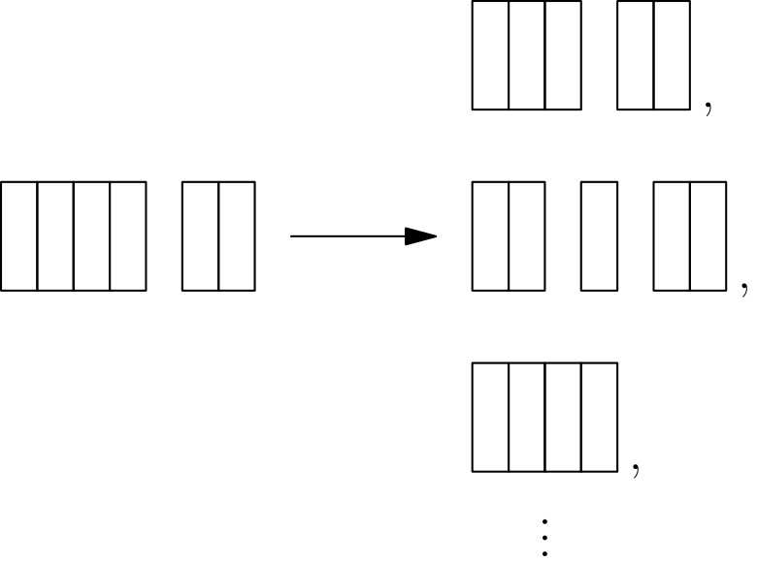
Arjun 先手，移除最后一块砖的玩家获胜。对于哪一种初始配置，Beth 有必胜策略？
（A）(6,1,1) （B）(6,2,1) （C）(6,2,2) （D）(6,3,1) （E）(6,3,2)
English
Arjun and Beth play a game in which they take turns removing one brick or two adjacent bricks from one “wall” among a set of several walls of bricks, with gaps possibly creating new walls. The walls are one brick tall. For example, a set of walls of sizes 4 and 2 can be changed into any of the following by one move: (3,2), (2,1,2), (4), (4,1), (2,2), or (1,1,2).
Arjun plays first, and the player who removes the last brick wins. For which starting configuration is there a strategy that guarantees a win for Beth?
(A) (6,1,1) (B) (6,2,1) (C) (6,2,2) (D) (6,3,1) (E) (6,3,2)
第 25 题
设 S 是坐标平面中的格点集合，其中两个坐标都是从 1 到 30 的整数。恰有 300 个 S 中的点位于直线 y=mx 上或其下方。所有可能的 m 值构成一个长度为 a/b 的区间，其中 a 与 b 是互质正整数。a+b 等于多少？
（A）31 （B）47 （C）62 （D）72 （E）85
English
Let S be the set of lattice points in the coordinate plane, both of whose coordinates are integers between 1 and 30, inclusive. Exactly 300 points in S lie on or below a line with equation y=mx. The possible values of m lie in an interval of length a/b, where a and b are relatively prime positive integers. What is a+b?
(A) 31 (B) 47 (C) 62 (D) 72 (E) 85

第二部分 解答
答案速查：
题号 1 2 3 4 5 6 7 8 9
答案 D D C B B C D A D
题号 10 11 12 13 14 15 16 17 18
答案 A D C B B B C C C
题号 19 20 21 22 23 24 25
答案 D D A D C B E
答案串：DDCBBCDADADCBBBCCCDDADCBE
第 1 题 答案 D
从 -9 到 9 的每个整数都满足条件，共有 9-(-9)+1 = 19 个。
所以正确答案是D。
English
Every integer from -9 to 9, inclusive, works. This yields 9-(-9)+1 = 19 solutions.
Thus, the correct answer isD.
第 2 题 答案 D
因为 √(u²)=|u|，所以原式等于
|3-2√(3)|+|3+2√(3)|。
又因为 2√(3)>3，所以它化为
(2√(3)-3)+(3+2√(3))=4√(3)。
所以正确答案是D。
English
Because √(u²)=|u|, the expression equals
|3-2√(3)|+|3+2√(3)|.
Since 2√(3)>3, this becomes
(2√(3)-3)+(3+2√(3))=4√(3).
Thus, the correct answer isD.
第 3 题 答案 C
设低年级学生有 j 人，高年级学生有 s 人。那么 j+s = 28，且 0.25j = 0.1s。这说明 2.5j = s，所以 3.5j = 28。因此 j=8。
所以正确答案是C。
English
Let the number of juniors be j and the number of seniors be s. Then, j+s = 28 and 0.25j = 0.1s. This means 2.5j = s, so 3.5j = 28. This makes j=8.
Thus, the correct answer isC.
第 4 题 答案 B
蓝蓝配对用掉 2· 23 = 46 名穿蓝色衬衫的学生。因此还有 57-46=11 名穿蓝色衬衫的学生在混合配对中，也就恰有 11 名穿黄色衬衫的学生在混合配对中。
剩下只有 64 名穿黄色衬衫的学生与另一名穿黄色衬衫的学生配对，所以黄黄配对数为 64/2 = 32。
所以答案是B。
English
There are 2· 23 = 46 students with blue shirts that are in a pair with just blue shirts. This means there are 57-46=11 students in blue shirts who are paired with someone wearing a yellow shirt, meaning exactly 11 people wearing yellow shirts are paired with someone wearing a blue shirt.
This leaves just 64 students wearing a yellow shirt who are paired with someone else wearing a yellow shirt. This yields 64/2 = 32 pairs.
Thus, the answer isB.
第 5 题 答案 B
乘积为 30 的一位正整数对只有 5,6。乘积为 24 的一位数因数对是 3,8 和 4,6。因为四个年龄互不相同，若取 4,6 就会重复年龄 6，所以另一对必须是 3,8。因此四个年龄是 3,5,6,8，它们的和为 22。
所以答案是B。
English
The only pair of single-digit positive integers with product 30 is 5,6. The single-digit factor pairs of 24 are 3,8 and 4,6. Because all four ages are distinct, the pair 4,6 would repeat the age 6, so the other pair must be 3,8. Thus the ages are 3,5,6,8, whose sum is 22.
Thus, the answer isB.
第 6 题 答案 C
设上午班有 3x 人，那么下午班有 4x 人。
上午班总分为 84· 3x = 252x，下午班总分为 70· 4x = 280x。因此总分为 532x，总人数为 7x。
所以所有学生的平均分为 532x/7x = 76。
所以正确答案是C。
English
Let the number of people in the first class be 3x. This means the number of people in the second class is 4x.
Thus, the sum of the scores of the first class is 84· 3x = 252x and the sum of the scores for the people in the second class is 70· 4x = 280x. This means the total sum is 532x, with 7x people.
Therefore, the average of all the students is 532x/7x = 76.
Thus, the correct answer isC.
第 7 题 答案 D
在 ell 的同一侧，所有在 A 处相切的圆互相包含。若套在一起的圆半径为 r₁>r₂>⋯，则恰好在一个圆内的面积为 π(r₁²-r₂²)；更小圆内的点同时位于至少三个圆内，不符合“恰好一个”的条件。
要使面积最大，把半径 7 的圆单独放在一侧，把半径 5,3,1 的圆放在另一侧。这给出
7²π+(5²-3²)π
=49π+16π=65π
。
所以答案是D。
English
On one side of ell, circles tangent at A are nested. For nested circles with radii r₁>r₂>⋯, the points inside exactly one of those circles have area π(r₁²-r₂²) if there are at least two circles; a third smaller nested circle does not count because its points are inside three circles, not exactly one.
To maximize the area, put the circle of radius 7 alone on one side, and put the circles of radii 5,3,1 on the other side. This gives
7²π+(5²-3²)π
=49π+16π=65π.
Thus, the answer isD.
第 8 题 答案 A
在外层 15×15 的一圈中，最上面一行包含 211,212,…,225，因此第二行中正好在 211 下方的数是 210。
这是第二行的最大数。内层 13×13 螺旋的右上角是 13²=169。在整个方格第二行中，内层这一行的数从 157 到 169，因此最小数是 157。
所求和为 210+157=367。
所以答案是A。
English
In the outer 15×15 ring, the top row contains 211,212,…,225, so the number just below 211 in the second row is 210. This is the greatest number in the second row.
The inner 13×13 spiral has 13²=169 in its upper-right corner. In the second row of the full grid, the inner-ring entries run from 157 to 169. Thus the least entry in that row is 157.
The required sum is 210+157=367.
Thus, the answer isA.
第 9 题 答案 D
倒推变换。点 (-6,3) 关于 y=-x 反射后得到 (-3,6)。
接着把 (-3,6) 绕 (1,5) 顺时针旋转 90°，以撤销原来的逆时针旋转。相对于 (1,5)，该点为 (-4,1)。顺时针旋转四分之一圈得到 (1,4)，再平移回去得到 (2,9)。
因此 a=2、b=9，所以 b-a=7。
所以答案是D。
English
Work backward. Reflecting (-6,3) across y=-x gives (-3,6).
Now undo the 90° counterclockwise rotation by rotating (-3,6) clockwise about (1,5). Relative to (1,5), the point is (-4,1). A clockwise quarter-turn sends this to (1,4), and translating back gives (2,9).
Thus a=2, b=9, and b-a=7.
Thus, the answer isD.
第 10 题 答案 A
因为水是从一个容器倒入另一个容器，所以体积保持不变。圆锥中水的体积为 (r²h π)/3 = (12²· 18 π)/3 = 864 π。
圆柱中水的体积为 r²h π =24²h π = 576h π。于是 576 h π = 864 π，所以 h = 1.5。
所以答案是A。
English
The volumes must be the same since the water is poured from one to another. The volume of the cone is (r²h π)/3 = (12²· 18 π)/3 = 864 π.
The volume of the cylinder is r²h π =24²h π = 576h π. This makes 576 h π = 864 π, so h = 1.5.
Thus, the answer isA.
第 11 题 答案 D
假设切成 l× w 的网格。内部小块数为 (l-2)(w-2)，总块数为 lw。因为内部小块数等于周边小块数，所以内部小块占总块数的一半：
(l-2)(w-2)=lw/2。
展开得到 lw-4l-4w+8=0，整理为：
(l-4)(w-4)=8。
8 的正因数对给出 (l,w)=(5,12) 或 (6,8)，顺序可交换。它们分别产生 60 或 48 块，所以最大可能数量是 60。
所以答案是D。
English
Suppose the cuts make an l× w grid of pieces. The number of interior pieces is (l-2)(w-2), and the total number of pieces is lw. Since the number of interior pieces equals the number of perimeter pieces, the interior pieces make up half the total:
(l-2)(w-2)=lw/2.
Multiplying out gives lw-4l-4w+8=0, or
(l-4)(w-4)=8.
The positive factor pairs of 8 give (l,w)=(5,12) or (6,8), up to order. These produce 60 or 48 pieces, respectively, so the greatest possible number is 60.
Thus, the answer isD.
第 12 题 答案 C
分解质因数得
N =2³· 3⁵· 5· 7· 17²。
若 x 是 N 的一个奇因数，则 2x,4x,8x 都是 N 的偶因数，它们的和为 14x。把所有奇因数都这样配对，偶因数之和就是奇因数之和的 14 倍。因此所求比为 1:14。
所以答案是C。
English
Using prime factorization, we get
N =2³· 3⁵· 5· 7· 17².
If we have an odd divisor x of N, then 2x,4x,8x are divisors of N, which has a combined sum of 14x. If we take the sum of every odd divisor, then the even divisors must have a sum which is 14 times the sum of the odd divisors. Therefore, the requested ratio is 1:14.
Thus, the answer isC.
第 13 题 答案 B
第一个条件表示
3n² + 2n+d = 263。
类似地，第二个条件表示
3n² +2n +4
= 6³ +6² +6d+1
= 253 + 6d。
两式相减得
4-d = 6d-10
7d = 14
d=2。
因此 3n² + 2n + 2 = 263，所以 n(3n+2) = 261。
这给出 n=9。因此 n+d = 11。
所以答案是B。
English
The first statement means
3n² + 2n+d = 263.
Similarly, the second statement means
3n² +2n +4
= 6³ +6² +6d+1
= 253 + 6d.
Subtracting these shows us that
4-d = 6d-10
7d = 14
d=2.
Therefore, 3n² + 2n + 2 = 263, so n(3n+2) = 261.
This implies n=9. Therefore, n+d = 11.
Thus, the answer isB.
第 14 题 答案 B
两条长度为 38 的弦到圆心的距离相等。它们不能位于两条最外侧的直线上：否则圆心会在中间直线上，该线所截的弦会是直径，长度大于 38，而不是给定的 34。因此两条相等弦位于相邻直线上，圆心在两线中间。设这个半间距为 d。则每条长 38 的弦到圆心的距离是 d，长 34 的弦到圆心的距离是 3d。
若圆的半径为 r，则
r²=19²+d²=17²+(3d)²。
因此 19²-17²=8d²，所以 72=8d²，得到 d=3。相邻平行线的距离是 2d=6。
所以答案是B。
English
The two chords of length 38 are equally far from the center of the circle. They cannot lie on the two outer lines: then the center would lie on the middle line, whose chord would be a diameter longer than 38, not the given 34. Therefore, the equal chords lie on adjacent lines, with the center halfway between them. Let that half-distance be d. Then each 38-chord is distance d from the center, and the 34-chord is distance 3d from the center.
If the circle has radius r, then
r²=19²+d²=17²+(3d)².
Thus 19²-17²=8d², so 72=8d², and d=3. The distance between adjacent parallel lines is 2d=6.
Thus, the answer isB.
第 15 题 答案 B
由 x+1/x = √(5)，两边平方得
x² + 2 + 1/x² = 5
x² + 1/x² = 3。
再平方一次，得
x⁴ + 2 + 1/x⁴ = 9
x⁴ -7 + 1/x⁴ = 0。
两边乘以 x⁷，得到
x¹¹-7x⁷+x³=0。
所以答案是B。
English
Since x+1/x = √(5), squaring yields
x² + 2 + 1/x² = 5
x² + 1/x² = 3.
Squaring again yields
x⁴ + 2 + 1/x⁴ = 9
x⁴ -7 + 1/x⁴ = 0.
Multiplying by x⁷ yields
x¹¹-7x⁷+x³=0.
Thus, the answer isB.
第 16 题 答案 C
能被 15 整除的数，个位必须是 0 或 5。若上坡整数的个位是 0，则这个数只能是 0，不是正整数。因此只需考虑个位为 5 的数。
接着要求这个上坡整数是 3 的倍数。其余数字只能从 {1,2,3,4} 中选，所选集合的数字和除以 3 必须余 1。数字 3 取或不取不影响余数，所以先在不含 3 的情况下计数再乘以 2。满足条件的子集只有 3 个，即 {1}, {4} 和 {1,2,4}。因此总共有 6 个子集。
所以正确答案是C。
English
If a number is divisible by 15, it has a units digit of 0 or 5. If the units digit is 0 and the digits are strictly increasing, then the number is 0, which isn’t positive. Therefore, we can just look at numbers with a units digit of 5.
Next, we need to find uphill integers that are a multiple of 3. This means the other digits are a subset of {1,2,3,4}. Taking the sum of the set must have a remainder of 1 when divided by 3. Also, having or taking out 3 wouldn’t affect the remainder, so we can take the number of subsets without a 3 and multiply it by 2. There are only 3 such subsets, namely {1}, {4}, and {1,2,4}. Thus, there are 6 total subsets.
Thus, the correct answer isC.
第 17 题 答案 C
Oscar 的得分为 4，所以他的牌必须是 1 和 3。在剩余牌中，和为 7 的唯一一对是 2 和 5，所以它们是 Aditi 的牌。
未使用的牌是 4,6,7,8,9,10。Tyrone 的得分 16 只能来自 6+10 或 7+9。若 Tyrone 拿到 7 和 9，剩余的 4,6,8,10 无法配成 Ravon 的得分 11。因此 Tyrone 拿到 6 和 10。
剩余的牌是 4,7,8,9。Ravon 必须拿 4 和 7，得分才为 11，留下 8 和 9 给 Kim，得分为 17。所以 Ravon 拿到了 4 号牌。
所以答案是C。
English
Oscar’s score of 4 forces his cards to be 1 and 3. From the remaining cards, the only pair with sum 7 is 2 and 5, so those are Aditi’s cards.
The unused cards are now 4,6,7,8,9,10. Tyrone’s score of 16 can come only from 6+10 or 7+9. If Tyrone had 7 and 9, then the remaining cards 4,6,8,10 could not be paired to give Ravon’s score 11. Thus Tyrone has 6 and 10.
The remaining cards are 4,7,8,9. Ravon must have 4 and 7 to score 11, leaving 8 and 9 for Kim’s score of 17. Therefore, Ravon was given card 4.
Thus, the answer isC.
第 18 题 答案 C
第一个不同的点数是偶数的概率为 3/6。
在已经出现一个偶数后，第二个不同点数仍为偶数的概率为 2/5。
在已经出现两个不同偶数后，第三个不同点数仍为偶数的概率为 1/4。
因此所求概率为
(3· 2· 1)/(6· 5· 4) = 1/20。
所以答案是C。
English
The probability that the first number is even is 3/6.
The probability that the second distinct number is even is 2/5.
The probability that the third distinct number is even is 1/4.
The combined probability is
(3· 2· 1)/(6· 5· 4) = 1/20.
Thus, the answer isC.
第 19 题 答案 D
设所有整数之和为 s，最大数为 g，最小数为 l，集合 S 的大小为 n。
两个含 n-1 个元素的集合的平均数给出
s-l=40(n-1),
s-g=32(n-1)
。
两式相减并利用 g-l=72，得 72=8(n-1)，所以 n=10。
同时去掉最大数和最小数后，还剩 8 个数，其和为 8·35=280。另一方面，只去掉最小数时剩下的和为 9·40=360，所以 g=360-280=80。于是 l=80-72=8，原来的总和为 s=280+80+8=368。
平均值为 s/n=368/10=36.8。
所以答案是D。
English
Let the sum of all the integers be s, the greatest number be g, the least number be l, and the size of S be n.
The two averages of sets with n-1 elements give
s-l=40(n-1),
s-g=32(n-1).
Subtracting and using g-l=72 gives 72=8(n-1), so n=10.
Removing both extremes leaves 8 numbers with sum 8·35=280. On the other hand, removing only the least number leaves a sum of 9·40=360, so g=360-280=80. Hence l=80-72=8, and the original sum is s=280+80+8=368.
The required average is s/n=368/10=36.8.
Thus, the answer isD.
第 20 题 答案 D
设 F 为与 A,B 和 C 都相连但未标字母的点。因为所有画出的线段长度都是 2，三角形 ABF 和 CBF 是位于 BF 两侧的等边三角形。因此 ∠ ABC=120°，所以
[ABC]=1/2·2·2sin120°=√(3)。
另一侧同理可得 [ADE]=√(3)。此外，在 △ ABC 中应用余弦定理，得 AC²=12，同理 AD²=12。因此等腰三角形 ACD 到底边 CD=2 的高为
√((√(12))²-1²)=√(11)。
所以 [ACD]=1/2·2·√(11)=√(11)。五边形的总面积为
√(12)+√(11)，
所以 m+n=12+11=23。
所以答案是D。
English
Let F be the unlabeled point joined to A,B, and C. Because all the drawn segments have length 2, triangles ABF and CBF are equilateral and lie on opposite sides of BF. Hence ∠ ABC=120°, so
[ABC]=1/2·2·2sin120°=√(3).
The same reasoning on the other side gives [ADE]=√(3). Also, the Law of Cosines in △ ABC gives AC²=12, and similarly AD²=12. Thus the altitude of isosceles triangle ACD to its base CD=2 is
√((√(12))²-1²)=√(11).
Therefore [ACD]=1/2·2·√(11)=√(11). The pentagon’s total area is
√(12)+√(11),
so m+n=12+11=23.
Thus, the answer isD.
第 21 题 答案 A
取坐标 A=(0,1)、B=(0,0)、C=(1,0)、D=(1,1)。因为 C'D=1/3，所以 C'=(2/3,1)，从而 AC'=2/3。
折叠把 C 反射到 C'，所以边 BC 的像是过 C' 和 E 的直线。把 B=(0,0) 关于 CC' 的垂直平分线反射，得到 (-2/15,2/5)。过该点与 C' 的直线与 AB 相交于 E=(0,1/2)。
因此 AE=1/2，并且
EC'=√((2/3)²+(1/2)²)=5/6。
△ AEC' 的周长为
1/2+2/3+5/6=2。
所以答案是A。
English
Use coordinates with A=(0,1), B=(0,0), C=(1,0), and D=(1,1). Since C'D=1/3, we have C'=(2/3,1), so AC'=2/3.
The fold reflects C to C', so the image of side BC is the line through C' and E. Reflecting B=(0,0) across the perpendicular bisector of CC' gives (-2/15,2/5). The line through this point and C' meets AB at E=(0,1/2).
Thus AE=1/2, and
EC'=√((2/3)²+(1/2)²)=5/6.
The perimeter of △ AEC' is
1/2+2/3+5/6=2.
Thus, the answer isA.
第 22 题 答案 D
固定 Ang 的摆放方式，并用 Ang 放入的颜色标记每个盒子。Ben 和 Jasmin 各自选择五种颜色的一个排列，因此共有 (5!)² 个等可能的摆放对。
若指定 k 个盒子都收到三块同色积木，则 Ben 和 Jasmin 在这 k 个盒子中都必须与 Ang 的颜色相同。这可以用 ((5-k)!)² 种方式完成。由容斥原理，成功的摆放对数为
C(5, 1)(4!)²-C(5, 2)(3!)²
+C(5, 3)(2!)²-C(5, 4)(1!)²
+C(5, 5)(0!)²
。
上式等于
2880-360+40-5+1=2556。
这等于
2556/((5!)²)=2556/14400=71/400。
因此 m+n=71+400=471。
所以答案是D。
English
Fix Ang’s placement and label each box by the color Ang put in it. Ben and Jasmin each choose a permutation of the five colors, so there are (5!)² equally likely pairs of placements.
For a specified set of k boxes to receive three blocks of the same color, both Ben and Jasmin must match Ang in those k boxes. This can happen in ((5-k)!)² ways. By inclusion-exclusion, the number of successful placement pairs is
C(5, 1)(4!)²-C(5, 2)(3!)²
+C(5, 3)(2!)²-C(5, 4)(1!)²
+C(5, 5)(0!)².
This equals
2880-360+40-5+1=2556.
Therefore the probability is
2556/((5!)²)=2556/14400=71/400.
Thus m+n=71+400=471.
Thus, the answer isD.
第 23 题 答案 C
硬币半径为 1/2，所以它的圆心均匀分布在一个 7×7 的正方形内，该区域面积为 49。
对每个角上的阴影三角形，能覆盖到它的圆心位置是在允许区域内距离该三角形不超过 1/2 的点集。每个角对应一个高为 (1+√(2))/2 的等腰直角三角形，所以面积为
((1+√(2))/2)²=(3+2√(2))/4。
四个角合计贡献 3+2√(2)。
中心阴影菱形是一个边长为 2√(2) 的正方形。把它向外扩张距离 1/2，除了菱形本身面积 8，还增加总面积 4√(2) 的四个矩形，以及合起来面积为 π/4 的四个四分之一圆。因此中心部分贡献
8+4√(2)+π/4。
有利面积为
3+2√(2)+8+4√(2)+π/4
=11+6√(2)+π/4
。
概率为
(11+6√(2)+π/4)/49
=(44+24√(2)+π)/196
。
所以 a+b=44+24=68。
所以答案是C。
English
The coin has radius 1/2, so its center is uniformly distributed over a 7×7 square of area 49.
A shaded corner triangle contributes the set of center positions within distance 1/2 of that triangle, inside the allowed center square. For each corner this is a right isosceles triangle whose altitude is (1+√(2))/2, so its area is
((1+√(2))/2)²=(3+2√(2))/4.
All four corners contribute 3+2√(2).
The center shaded diamond is a square of side 2√(2). Expanding it by distance 1/2 adds four rectangles of total area 4√(2) and four quarter-circles of total area π/4, in addition to the diamond’s area 8. Thus the center contribution is
8+4√(2)+π/4.
The favorable area is
3+2√(2)+8+4√(2)+π/4
=11+6√(2)+π/4.
The probability is
(11+6√(2)+π/4)/49
=(44+24√(2)+π)/196.
So a+b=44+24=68.
Thus, the answer isC.
第 24 题 答案 B
对长度为 n 的单独一堵墙，根据所有可能操作计算它的 Sprague-Grundy 值。这里用到的各个墙长的值为
g(1)=1, g(2)=2,
g(3)=3, g(4)=1,
g(5)=4, g(6)=3
。
多堵墙的局面在这些值按位异或为 0 时，正好是轮到行动者的必败局面。逐一计算选项：
(6,1,1): 3oplus1oplus1=3，
(6,2,1): 3oplus2oplus1=0，
(6,2,2): 3oplus2oplus2=3，
(6,3,1): 3oplus3oplus1=1，
(6,3,2): 3oplus3oplus2=2。
只有 (6,2,1) 是轮到行动者的必败局面，所以 Beth 恰好在这个初始配置下有必胜策略。
所以答案是B。
English
For a single wall of length n, compute its Sprague-Grundy value from the possible moves. For the wall lengths needed here, the values are
g(1)=1, g(2)=2,
g(3)=3, g(4)=1,
g(5)=4, g(6)=3.
For several walls, the position is losing for the player to move exactly when the xor of the wall values is 0. Evaluating the choices gives
(6,1,1): 3oplus1oplus1=3,
(6,2,1): 3oplus2oplus1=0,
(6,2,2): 3oplus2oplus2=3,
(6,3,1): 3oplus3oplus1=1,
(6,3,2): 3oplus3oplus2=2.
Only (6,2,1) is losing for the player to move, so Beth has a guaranteed win exactly for that starting configuration.
Thus, the answer isB.
第 25 题 答案 E
对固定斜率 m，集合 S 中位于 y=mx 上或下方的点数为
Σₓ₌₁³⁰⌊ mx⌋，
这适用于答案附近的斜率。
当 m=2/3 时，把 x=3k+1,3k+2,3k+3 分组，其中 k=0,1,…,9。于是
⌊ 2x/3⌋=2k, 2k+1, 2k+2，
每个区块上的和为 6k+3。因此总数为
Σₖ₌₀⁹(6k+3)=270+30=300。
若 m<2/3，十个比值 y/x=2/3 的点不再被计入，所以点数小于 300。因此区间下端为 2/3。
下一个大于 2/3 的可能比值 y/x，在 1≤ x,y≤30 下可按 x 模 3 检查。最佳候选为
19/28, 20/29, 21/30=7/10，
其中最小的是 19/28。因此区间长度为
19/28-2/3=1/84。
所以 a+b=1+84=85。
所以答案是E。
English
For a fixed slope m, the number of points in S on or below y=mx is
Σₓ₌₁³⁰⌊ mx⌋,
for the slopes near the answer.
At m=2/3, grouping x=3k+1,3k+2,3k+3 for k=0,1,…,9 gives
⌊ 2x/3⌋=2k, 2k+1, 2k+2,
whose sum over each block is 6k+3. Thus the total is
Σₖ₌₀⁹(6k+3)=270+30=300.
If m<2/3, the ten points with ratios y/x=2/3 are no longer counted, so the count is less than 300. Therefore the lower end is 2/3.
The next possible ratio y/x greater than 2/3, with 1≤ x,y≤30, is minimized by checking x modulo 3. The best candidates are
19/28, 20/29, 21/30=7/10,
and the smallest is 19/28. Hence the interval length is
19/28-2/3=1/84.
Thus a+b=1+84=85.
Thus, the answer isE.

