2014A AMC 10 真题与解答
American Mathematics Competitions 10 · 中英双语
共 25 题，限时 75 分钟；答对得 6 分，未答得 1.5 分，答错 0 分，满分 150 分。
编排说明：第一部分为题目（先中文、后英文原题），第二部分为解答与答案，便于先做题后对答案。
第一部分 题目
第 1 题
下列表达式的值是多少？
10·(1/2+1/5+1/10)⁻¹
（A）3 （B）8 （C）25/2 （D）170/3 （E）170
English
What is the value of the following expression?
10·(1/2+1/5+1/10)⁻¹
(A) 3 (B) 8 (C) 25/2 (D) 170/3 (E) 170
第 2 题
Roy 的猫每天早上吃 1/3 罐猫粮，每天晚上吃 1/4 罐猫粮。星期一早上喂猫之前，Roy 打开一个装有 6 罐猫粮的盒子。这只猫在星期几吃完盒子里所有猫粮？
（A）星期二 （B）星期三 （C）星期四 （D）星期五 （E）星期六
English
Roy’s cat eats 1/3 of a can of cat food every morning and 1/4 of a can of cat food every evening. Before feeding his cat on Monday morning, Roy opened a box containing 6 cans of cat food. On what day of the week did the cat finish eating all the cat food in the box?
(A) Tuesday (B) Wednesday (C) Thursday (D) Friday (E) Saturday
第 3 题
Bridget 为她的面包店烤了 48 条面包。上午她以每条 $ 2.50 卖出一半。下午她卖出剩余面包的三分之二；因为不新鲜了，她只收半价。傍晚她以每条一美元卖出剩下的面包。每条面包的制作成本为 $ 0.75。她当天的利润是多少美元？
（A）24 （B）36 （C）44 （D）48 （E）52
English
Bridget bakes 48 loaves of bread for her bakery. She sells half of them in the morning for $ 2.50 each. In the afternoon she sells two thirds of what she has left, and because they are not fresh, she charges only half price. In the late afternoon she sells the remaining loaves at a dollar each. Each loaf costs $ 0.75 for her to make. In dollars, what is her profit for the day?
(A) 24 (B) 36 (C) 44 (D) 48 (E) 52
第 4 题
Ralph 沿 Jane 街走过连续四栋房子，每栋房子颜色不同。他先经过橙色房子，再经过红色房子；他先经过蓝色房子，再经过黄色房子。蓝色房子不与黄色房子相邻。这些彩色房子的排列有多少种可能？
（A）2 （B）3 （C）4 （D）5 （E）6
English
Walking down Jane Street, Ralph passed four houses in a row, each painted a different color. He passed the orange house before the red house, and he passed the blue house before the yellow house. The blue house was not next to the yellow house. How many orderings of the colored houses are possible?
(A) 2 (B) 3 (C) 4 (D) 5 (E) 6
第 5 题
一次代数测验中，10% 的学生得 70 分，35% 得 80 分，30% 得 90 分，其余学生得 100 分。学生分数的平均数与中位数之差是多少？
（A）1 （B）2 （C）3 （D）4 （E）5
English
On an algebra quiz, 10% of the students scored 70 points, 35% scored 80 points, 30% scored 90 points, and the rest scored 100 points. What is the difference between the mean and the median of the students’ scores on this quiz?
(A) 1 (B) 2 (C) 3 (D) 4 (E) 5
第 6 题
假设 a 头奶牛在 c 天里产 b 加仑牛奶。按这个速度，d 头奶牛在 e 天里会产多少加仑牛奶？
（A）bde/ac （B）ac/bde （C）abde/c （D）bcde/a （E）abc/de
English
Suppose that a cows give b gallons of milk in c days. At this rate, how many gallons of milk will d cows give in e days?
(A) bde/ac (B) ac/bde (C) abde/c (D) bcde/a (E) abc/de
第 7 题
非零实数 x、y、a 和 b 满足 x < a 且 y < b。下面四个不等式中有多少个必然成立？
(I)x + y < a + b
(II)x - y < a - b
(III)xy < ab
(IV)x/y < a/b
（A）0 （B）1 （C）2 （D）3 （E）4
English
Nonzero real numbers x, y, a, and b satisfy x < a and y < b. How many of the following inequalities must be true?
(I)x + y < a + b
(II)x - y < a - b
(III)xy < ab
(IV)x/y < a/b
(A) 0 (B) 1 (C) 2 (D) 3 (E) 4
第 8 题
下列哪个数是完全平方数？
（A）(14!15!)/2 （B）(15!16!)/2 （C）(16!17!)/2 （D）(17!18!)/2 （E）(18!19!)/2
English
Which of the following numbers is a perfect square?
(A) (14!15!)/2 (B) (15!16!)/2 (C) (16!17!)/2 (D) (17!18!)/2 (E) (18!19!)/2
第 9 题
一个直角三角形的两条直角边也是高，长度分别为 2√(3) 和 6。这个三角形的第三条高有多长？
（A）1 （B）2 （C）3 （D）4 （E）5
English
The two legs of a right triangle, which are altitudes, have lengths 2√(3) and 6. How long is the third altitude of the triangle?
(A) 1 (B) 2 (C) 3 (D) 4 (E) 5
第 10 题
从 a 开始的五个连续正整数的平均数为 b。从 b 开始的 5 个连续整数的平均数是多少？
（A）a+3 （B）a+4 （C）a+5 （D）a+6 （E）a+7
English
Five positive consecutive integers starting with a have average b. What is the average of 5 consecutive integers that start with b?
(A) a+3 (B) a+4 (C) a+5 (D) a+6 (E) a+7
第 11 题
一位打算购买电器的顾客有三张优惠券，但只能使用其中一张：
优惠券 1：标价至少为 $50 时，减价 10%
优惠券 2：标价至少为 $100 时，减 $ 20
优惠券 3：对标价超过 $100 的部分减价 18%
对下列哪个标价，优惠券 1 的减价幅度会同时大于优惠券 2 和优惠券 3？
（A）$ 179.95 （B）$ 199.95 （C）$ 219.95 （D）$ 239.95 （E）$ 259.95
English
A customer who intends to purchase an appliance has three coupons, only one of which may be used:
Coupon 1: 10% off the listed price if the listed price is at least $50
Coupon 2: $ 20 off the listed price if the listed price is at least $100
Coupon 3: 18% off the amount by which the listed price exceeds $100
For which of the following listed prices will coupon 1 offer a greater price reduction than either coupon 2 or coupon 3?
(A) $ 179.95 (B) $ 199.95 (C) $ 219.95 (D) $ 239.95 (E) $ 259.95
第 12 题
一个正六边形边长为 6。以每个顶点为圆心画半径为 3 的全等圆弧，形成如图所示的扇形。六边形内部但扇形外部的区域被涂阴影。阴影区域的面积是多少？
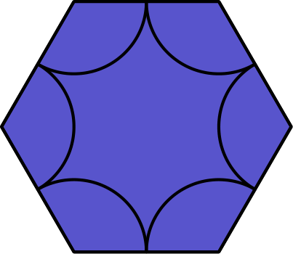
（A）27√(3)-9π （B）27√(3)-6π （C）54√(3)-18π （D）54√(3)-12π （E）108√(3)-9π
English
A regular hexagon has side length 6. Congruent arcs with radius 3 are drawn with the center at each of the vertices, creating circular sectors as shown. The region inside the hexagon but outside the sectors is shaded as shown. What is the area of the shaded region?
(A) 27√(3)-9π (B) 27√(3)-6π (C) 54√(3)-18π (D) 54√(3)-12π (E) 108√(3)-9π
第 13 题
等边 △ ABC 的边长为 1，正方形 ABDE、BCHI、CAFG 都在三角形外侧。六边形 DEFGHI 的面积是多少？
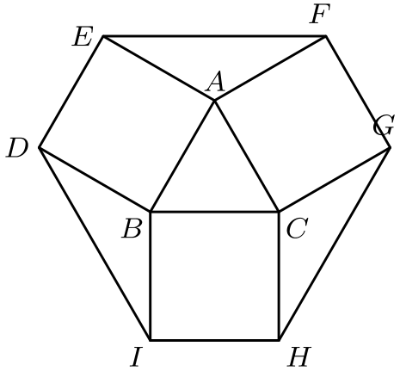
（A）(12+3√(3))/4 （B）9/2 （C）3+√(3) （D）(6+3√(3))/2 （E）6
English
Equilateral △ ABC has side length 1, and squares ABDE, BCHI, CAFG lie outside the triangle. What is the area of hexagon DEFGHI?
(A) (12+3√(3))/4 (B) 9/2 (C) 3+√(3) (D) (6+3√(3))/2 (E) 6
第 14 题
两条相互垂直的直线交于点 A(6,8)，它们的 y 轴截距为 P 和 Q，且两个截距之和为零。求 △ APQ 的面积。
（A）45 （B）48 （C）54 （D）60 （E）72
English
The y-intercepts, P and Q, of two perpendicular lines intersecting at the point A(6,8) have a sum of zero. What is the area of △ APQ?
(A) 45 (B) 48 (C) 54 (D) 60 (E) 72
第 15 题
David 从家开车去机场赶飞机。第一小时他开了 35 英里，但意识到如果继续按这个速度行驶会迟到 1 小时。之后他把速度提高 15 英里每小时，并提前 30 分钟到达。机场离他家多少英里？
（A）140 （B）175 （C）210 （D）245 （E）280
English
David drives from his home to the airport to catch a flight. He drives 35 miles in the first hour, but realizes that he will be 1 hour late if he continues at this speed. He increases his speed by 15 miles per hour for the rest of the way to the airport and arrives 30 minutes early. How many miles is the airport from his home?
(A) 140 (B) 175 (C) 210 (D) 245 (E) 280
第 16 题
在长方形 ABCD 中，AB=1，BC=2，点 E、F、G 分别是 BC、CD、AD 的中点。点 H 是 GE 的中点。阴影区域的面积是多少？
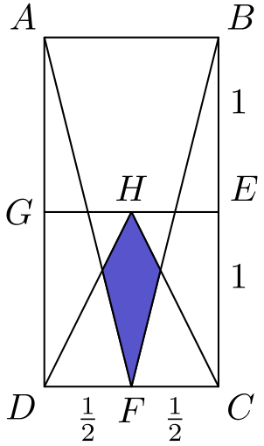
（A）1/12 （B）(√(3))/18 （C）(√(2))/12 （D）(√(3))/12 （E）1/6
English
In rectangle ABCD, AB=1, BC=2, and points E, F, and G are midpoints of BC, CD, and AD, respectively. Point H is the midpoint of GE. What is the area of the shaded region?
(A) 1/12 (B) (√(3))/18 (C) (√(2))/12 (D) (√(3))/12 (E) 1/6
第 17 题
掷三枚公平的六面骰子。恰有两枚骰子的点数之和等于剩下一枚骰子的点数的概率是多少？
（A）1/6 （B）13/72 （C）7/36 （D）5/24 （E）2/9
English
Three fair six-sided dice are rolled. What is the probability that the values shown on two of the dice sum to the value shown on the remaining die?
(A) 1/6 (B) 13/72 (C) 7/36 (D) 5/24 (E) 2/9
第 18 题
坐标平面中的一个正方形，其四个顶点的 y 坐标为 0、1、4、5。这个正方形的面积是多少？
（A）16 （B）17 （C）25 （D）26 （E）27
English
A square in the coordinate plane has vertices whose y-coordinates are 0, 1, 4, and 5. What is the area of the square?
(A) 16 (B) 17 (C) 25 (D) 26 (E) 27
第 19 题
边长分别为 1、2、3 和 4 的四个立方体如图堆叠。线段 XY 位于边长为 3 的立方体内部的部分有多长？
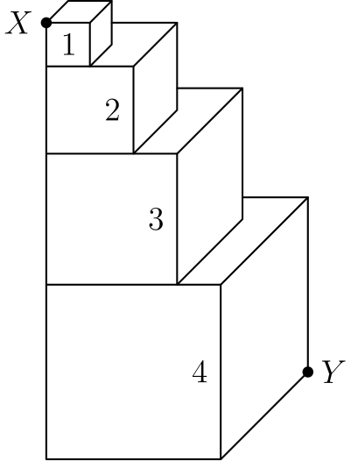
（A）(3√(33))/5 （B）2√(3) （C）(2√(33))/3 （D）4 （E）3√(2)
English
Four cubes with edge lengths 1, 2, 3, and 4 are stacked as shown. What is the length of the portion of XY contained in the cube with edge length 3?
(A) (3√(33))/5 (B) 2√(3) (C) (2√(33))/3 (D) 4 (E) 3√(2)
第 20 题
乘积 (8)(888…8) 中第二个因子有 k 位数字。该乘积是一个各位数字和为 1000 的整数。求 k。
（A）901 （B）911 （C）919 （D）991 （E）999
English
The product (8)(888…8), where the second factor has k digits, is an integer whose digits have a sum of 1000. What is k?
(A) 901 (B) 911 (C) 919 (D) 991 (E) 999
第 21 题
正整数 a 和 b 使得直线 y=ax+5 与 y=3x+b 在 x 轴上交于同一点。所有可能交点的 x 坐标之和是多少？
（A）-20 （B）-18 （C）-15 （D）-12 （E）-8
English
Positive integers a and b are such that the graphs of y=ax+5 and y=3x+b intersect the x-axis at the same point. What is the sum of all possible x-coordinates of these points of intersection?
(A) -20 (B) -18 (C) -15 (D) -12 (E) -8
第 22 题
在长方形 ABCD 中，AB=20，BC=10。点 E 在 CD 上，且 ∠ CBE=15°。求 AE 的长度。
（A）(20√(3))/3 （B）10√(3) （C）18 （D）11√(3) （E）20
English
In rectangle ABCD, AB=20 and BC=10. Let E be a point on CD such that ∠ CBE=15°. What is AE?
(A) (20√(3))/3 (B) 10√(3) (C) 18 (D) 11√(3) (E) 20
第 23 题
一张长方形纸的长是宽的 √(3) 倍，面积为 A。这张纸沿相对的长边分成三个相等部分，然后如图从一侧的第一个分点到另一侧的第二个分点画一条虚线。纸沿这条虚线折平，形成的新图形面积为 B。求 B:A。
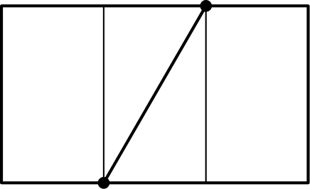
（A）1:2 （B）3:5 （C）2:3 （D）3:4 （E）4:5
English
A rectangular piece of paper whose length is √(3) times the width has area A. The paper is divided into three equal sections along the opposite lengths, and then a dotted line is drawn from the first divider to the second divider on the opposite side as shown. The paper is then folded flat along this dotted line to create a new shape with area B. What is the ratio B:A?
(A) 1:2 (B) 3:5 (C) 2:3 (D) 3:4 (E) 4:5
第 24 题
一个自然数序列按如下方式构造：先列出前 4 个数，然后跳过一个数；再列出接下来的 5 个数，跳过 2 个数；再列出 6 个数，跳过 3 个数；在第 n 次迭代中，列出 n+3 个数并跳过 n 个数。该序列开头为
1,2,3,4,6,7,8,9,10,13。
这个序列的第 500,000 个数是多少？
（A）996, 506 （B）996, 507 （C）996, 508 （D）996, 509 （E）996, 510
English
A sequence of natural numbers is constructed by listing the first 4, then skipping one, listing the next 5, skipping 2, listing 6, skipping 3, and on the nth iteration, listing n+3 and skipping n. The sequence begins
1,2,3,4,6,7,8,9,10,13.
What is the 500,000th number in the sequence?
(A) 996, 506 (B) 996, 507 (C) 996, 508 (D) 996, 509 (E) 996, 510
第 25 题
数 5⁸⁶⁷ 介于 2²⁰¹³ 和 2²⁰¹⁴ 之间。有多少对整数 (m,n) 满足 1≤ m≤ 2012 且
5ⁿ < 2ᵐ < 2ᵐ⁺² < 5ⁿ⁺¹？
（A）278 （B）279 （C）280 （D）281 （E）282
English
The number 5⁸⁶⁷ is between 2²⁰¹³ and 2²⁰¹⁴. How many pairs of integers (m,n) are there such that 1≤ m≤ 2012 and
5ⁿ < 2ᵐ < 2ᵐ⁺² < 5ⁿ⁺¹?
(A) 278 (B) 279 (C) 280 (D) 281 (E) 282

第二部分 解答
答案速查：
题号 1 2 3 4 5 6 7 8 9
答案 C C E B C A B D C
题号 10 11 12 13 14 15 16 17 18
答案 B C C C D C E D B
题号 19 20 21 22 23 24 25
答案 A D E E C A B
答案串：CCEBCABDCBCCCDCEDBADEECAB
第 1 题 答案 C
先计算括号内的和：
1/2 + 1/5 + 1/10
= 5/10 + 2/10 + 1/10
= 4/5
。
因此 (4/5)⁻¹ = 5/4，最后得到
10 · 5/4 = 25/2。
所以正确答案是C。
English
We get that
1/2 + 1/5 + 1/10
= 5/10 + 2/10 + 1/10
= 4/5.
Then (4/5)⁻¹ = 5/4 and then finally,
10 · 5/4 = 25/2.
Thus,Cis the correct answer.
第 2 题 答案 C
这只猫每个完整的一天共吃
1/3 + 1/4 = 7/12
罐猫粮。经过 10 个完整的一天，它吃了 10·7/12=35/6 罐，还剩 1/6 罐。
它会在下一次早晨喂食时吃完剩余部分。从星期一算作第一个早晨，第十一个早晨是星期四。
所以正确答案是C。
English
The cat eats
1/3 + 1/4 = 7/12
cans of food each full day. After 10 full days, it has eaten 10·7/12=35/6 cans, leaving 1/6 of a can.
The cat finishes that remainder during its next morning feeding. The eleventh morning, counting Monday as the first, is Thursday.
Thus,Cis the correct answer.
第 3 题 答案 E
上午 Bridget 卖出 24 条面包，收入 24·$2.50=$60。
她还剩 24 条面包。下午她以半价卖出 2/3·24=16 条，收入 16·$1.25=$20。
剩下的 8 条卖得 $8，所以总收入为 $60+$20+$8=$88。成本为 48·$0.75=$36。
她的利润为 $88-$36=$52。
所以正确答案是E。
English
In the morning Bridget sells 24 loaves for 24·$2.50=$60.
She has 24 loaves left. In the afternoon she sells 2/3·24=16 loaves at half price, earning 16·$1.25=$20.
The remaining 8 loaves sell for $8, so her revenue is $60+$20+$8=$88. Her cost is 48·$0.75=$36.
Her profit is $88-$36=$52.
Thus,Eis the correct answer.
第 4 题 答案 B
蓝色必须在黄色之前且不相邻，所以蓝黄位置只能是 (1,3)、(1,4)、(2,4)。
每种情况下，橙色和红色填入剩下两个位置，并且橙色必须在红色之前，因此被唯一确定。三种排列依次为：橙、蓝、红、黄；蓝、橙、红、黄；蓝、橙、黄、红。
共有 3 种排列。
所以正确答案是B。
English
Blue must come before yellow but not next to it, so they sit in positions (1,3) or (1,4) or (2,4).
In each case orange and red fill the two remaining spots with orange before red, which is forced. The three orderings are orange, blue, red, yellow; blue, orange, red, yellow; and blue, orange, yellow, red.
There are 3 possible orderings.
Thus,Bis the correct answer.
第 5 题 答案 C
45% 的学生低于 90 分，25% 的学生高于 90 分，所以中位数为 90。
平均数为 0.10·70 +0.35·80 +0.30·90 +0.25·100=87。
差为 90-87=3。
所以正确答案是C。
English
The median is 90, because 45% of the students scored below 90 and 25% scored above 90.
The mean is 0.10·70 +0.35·80 +0.30·90 +0.25·100=87.
The difference is 90-87=3.
Thus,Cis the correct answer.
第 6 题 答案 A
先用 b 乘以 d/a，来调整奶牛数量。
再乘以 e/c，来调整产奶天数。
因此产奶量为
b · d/a · e/c = bde/ac。
所以正确答案是A。
English
We have to multiply b by d/a to account for the new number of cows.
We then have to multiply by e/c to account for the new time that we have.
This gives us a final answer of
b · d/a · e/c = bde/ac.
Thus,Ais the correct answer.
第 7 题 答案 B
把两个不等式相加，得到
x + y < a + b，
所以(I)必然成立。
不等式不能直接相减，所以(II)不一定成立。
例如取 x = 1、y = 1、a = 2、b = 3，就会得到错误的不等式 0 < -1。
(III)也不一定成立，因为 x 和 y 可能都是负数。
取 x = -3、y = -2、a = 1、b = 1，则 xy = 6，而 ab = 1，所以(III)不成立。
(IV)也有同样的问题。使用同一组数，有 x/y = 1.5，而 a/b = 1。
因此只有(I)必然成立。
所以正确答案是B。
English
Adding the two inequalities together gets us
x + y < a + b,
which shows that(I)is correct.
One cannot subtract inequalities, which means that(II)is not necessarily true.
Consider x = 1, y = 1, a = 2, and b = 3 as a counter-example. This would give us 0 < -1.
(III)is also not always true, since x and y might be negative numbers.
Let x = -3, y = -2, a = 1, and b = 1. Then xy = 6 and ab = 1 which shows that(III)is wrong.
The same thing occurs with(IV). Using the same values as above, we have x/y = 1.5 and a/b = 1.
This shows that(I)is the only true statement.
Thus,Bis the correct answer.
第 8 题 答案 D
注意每个选项都形如
(n!(n + 1)!)/2 = ((n!)²(n + 1))/2。
其中 (n!)² 已经是完全平方数，所以还需要 (n + 1)/2 也是完全平方数。
这说明 n + 1 必须是完全平方数的两倍。选项中只有 n + 1 = 18，因此 n = 17。
所以正确答案是D。
English
Note that all of these answer choices are of the form
(n!(n + 1)!)/2 = ((n!)²(n + 1))/2.
We have that (n!)² is square, so we need (n + 1)/2 to be square as well.
This means that n + 1 must be twice a perfect square. The only choice we have is n + 1 = 18, which gives us n = 17.
Thus,Dis the correct answer.
第 9 题 答案 C
三角形面积为
1/2 · 2√(3) · 6 = 6√(3)。
斜边长为
√((2√(3))² + 6²) = √(48) = 4√(3)。
设斜边上的高为 h，
1/2 · h · 4√(3) = 6√(3)
h = 3。
所以正确答案是C。
English
We get that the area of the triangle is
1/2 · 2√(3) · 6 = 6√(3).
The length of the hypotenuse is
√((2√(3))² + 6²) = √(48) = 4√(3).
Dropping the altitude, h, from the vertex to the hypotenuse, we get that
1/2 · h · 4√(3) = 6√(3)
h = 3.
Thus,Cis the correct answer.
第 10 题 答案 B
从 x 开始的 5 个连续整数的平均数为
(5x + 1 + 2 + 3 + 4)/5 = x + 2。
因此，从 a 开始的 5 个连续整数的平均数为 a + 2，也就是 b。
从 b 开始的 5 个连续整数的平均数为
b + 2 = a + 4。
所以正确答案是B。
English
Note that the average of 5 consecutive numbers starting with x is
(5x + 1 + 2 + 3 + 4)/5 = x + 2.
This means that the average of 5 consecutive integers starting with a is a + 2, which we know is b.
Furthermore, the average of 5 consecutive numbers starting with b is
b + 2 = a + 4.
Thus,Bis the correct answer.
第 11 题 答案 C
设标价为 x。
优惠券 1 使价格变为 0.9x，优惠券 2 使价格变为 x - 20，优惠券 3 使价格变为
x - 0.18(x - 100) = 0.82x + 18。
需要同时满足
0.9x < x - 20
和
0.9x < 0.82x + 18。
解这两个不等式，得到
200 < x < 225。
选项中只有 $ 219.95 符合。
所以正确答案是C。
English
Let us analyze what these coupons do to an arbitrary price, x.
Coupon 1 changes this price to 0.9x. Coupon 2 changes the price to x - 20. Coupon 3 changes the price to
x - 0.18(x - 100) = 0.82x + 18.
We want
0.9x < x - 20
and
0.9x < 0.82x + 18.
Solving both gives us
200 < x < 225.
The only answer choice that works is $ 219.95.
Thus,Cis the correct answer.
第 12 题 答案 C
正六边形可以分成 6 个边长为 6 的等边三角形。
边长为 s 的等边三角形面积为
(s² √(3))/4。
因此正六边形的面积为
6 · (6² √(3))/4 = 54√(3)。
正六边形每个内角为 120°，所以六个扇形合起来相当于 2 个完整圆。
因此所有扇形的总面积为
2 · 3² π = 18π。
所以阴影区域的面积为
54√(3) - 18π。
所以正确答案是C。
English
Note that we can split the hexagon up into 6 equilateral triangles each with side length 6.
Recall that the area of an equilateral triangle with side length s is
(s² √(3))/4.
This means that the area of the hexagon is
6 · (6² √(3))/4 = 54√(3).
Since each interior angle of a regular hexagon is 120°, the six sectors form 2 full circles.
This means that the area of all the sectors is
2 · 3² π = 18π.
The area of the shaded region is then
54√(3) - 18π.
Thus,Cis the correct answer.
第 13 题 答案 C
求出各个小块的面积，再把它们相加。
中央等边三角形的面积为
(1² √(3))/4 = (√(3))/4。
所有正方形的总面积为
3 · 1² = 3。
另外，
∠ EAF = 360° - 60° - 2 · 90°
= 120°。
又有 AE=AF=1，且 ∠ EAF=120°。从 A 向底边作高可得 EF=√(3)，高为 1/2，所以 [EAF]=(√(3))/4。另外两个外侧三角形面积相同。因此它们的总面积为 (3√(3))/4。
总面积为
(√(3))/4 + (3√(3))/4 + 3 = 3 + √(3)。
所以正确答案是C。
English
We can find the areas of all the individual pieces and then add them up together.
The area of the center equilateral triangle is
(1² √(3))/4 = (√(3))/4.
We have that the areas of all the squares is
3 · 1² = 3.
We also have that
∠ EAF = 360° - 60° - 2 · 90°
= 120°.
Also, AE=AF=1 and ∠ EAF=120°. Dropping the altitude from A shows that EF=√(3) and the altitude is 1/2, so [EAF]=(√(3))/4. The other two outer triangles have the same area. Thus their combined area is (3√(3))/4.
The total area is then
(√(3))/4 + (3√(3))/4 + 3 = 3 + √(3).
Thus,Cis the correct answer.
第 14 题 答案 D
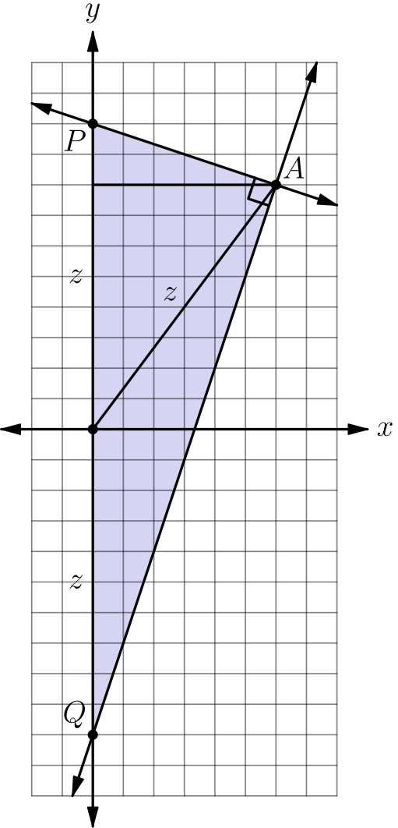
两个 y 轴截距到原点的距离相等，因为它们的数值之和为 0。
设这个距离为 z。因为两条给定直线互相垂直，△ APQ 在 A 处为直角。原点是斜边 PQ 的中点，所以它到 P、Q 和 A 的距离相等。因此 A 到原点的距离也是 z。
由距离公式，
z = √(6² + 8²) = 10。
从 A 到 PQ 的高为 6（也就是 A 的 x 坐标）。
又有 PQ = 2 · 10 = 20，所以面积为
[APQ] = 1/2 · 6 · 20 = 60。
所以正确答案是D。
English
We have that the y-intercepts are an equal distance from the origin since their values sum to 0.
Let this distance be z. Because the two given lines are perpendicular, △ APQ is right at A. The origin is the midpoint of its hypotenuse PQ, so it is equidistant from P, Q, and A. Hence the distance from A to the origin is also z.
We then know that
z = √(6² + 8²) = 10
by the distance formula. We know the altitude from A to PQ is 6 (it is just the x-value of A).
We also know that PQ = 2 · 10 = 20, which tells us that the area
[APQ] = 1/2 · 6 · 20 = 60.
Thus,Dis the correct answer.
第 15 题 答案 C
第一小时后，David 的速度为 50 英里每小时。
若机场离家 x 英里，则两种行程时间相差一个半小时，因此
x/35 - (1+x-35/50) = 3/2。
解这个方程：
x/35 - (1+x-35/50) = 3/2
x/35 - x-35+50/50 = 3/2
10x - 7(x+15)= 525
10x - 7x-105= 525
3x= 630
x=210
所以机场离家 x=210 英里。
所以正确答案是C。
English
Note that David drives at 50 miles per hour after one hour.
Then, if the airport is x miles from David’s house, we know that:
x/35 - (1+x-35/50) = 3/2
We solve this equation as follows:
x/35 - (1+x-35/50) = 3/2
x/35 - x-35+50/50 = 3/2
10x - 7(x+15)= 525
10x - 7x-105= 525
3x= 630
x=210
Therefore, the airport is x=210 miles from David’s house.
Thus,Cis the correct answer.
第 16 题 答案 E
用 △ DHC 的面积减去两个未涂阴影的小三角形。
把 DH 延长到 B。令 DB 与 AF 交于 X。
有 △ DXF∼△ BXA。由于 AB=2· DF，对应边成比例，所以 BX=2· DX。
这说明 DX = 1/3 · DB，所以 △ DXF 的高是长方形高度的 1/3。
△ DXF 的面积为
1/2 · 1/2 · 2/3 = 1/6。
两个未涂阴影小三角形面积合计为 2 · 1/6 = 1/3。△ DHC 的面积为
1/2 · 1 · 1 = 1/2。
因此阴影区域面积为 1/2 - 1/3 = 1/6。
所以正确答案是E。
English
We can find the area of the shaded region by finding the area of △ DHC and subtracting out the two unshaded triangles.
Extend DH so that it hits B. Let the intersection of DB and AF be X.
We have that △ DXF∼△ BXA. Since AB=2· DF, corresponding sides give BX=2· DX.
This means that DX = 1/3 · DB, which means that the altitude of △ DXF is 1/3 the height of the rectangle.
The area of △ DXF is then
1/2 · 1/2 · 2/3 = 1/6.
The area of both unshaded triangles is then 2 · 1/6 = 1/3. The area of △ DHC is
1/2 · 1 · 1 = 1/2.
The area of the shaded region is then 1/2 - 1/3 = 1/6.
Thus,Eis the correct answer.
第 17 题 答案 D
若一枚骰子的点数是另外两枚之和，它必然是三枚中最大的。
先选哪一枚是这个和，有 3 种方式。
最大骰子的点数不能为 1，因为两个正整数之和不可能是 1。
它取其余每个点数的概率都是 1/6。
和为 2 时有 1 种有序数对，和为 3 时有 2 种，和为 4 时有 3 种，和为 5 时有 4 种，和为 6 时有 5 种。
另外两枚骰子共有 6² = 36 种有序结果，所以所求概率为
3 · 1/6 · (1 + 2 + 3 + 4 + 5)/36 = 5/24。
所以正确答案是D。
English
Note that if one die is the sum of the other two dice, then it is strictly greater than the other two dice.
There are 3 ways to choose which of the dice is the sum of the other two, which makes it the greatest.
This die cannot be 1, since there is no way to sum two positive integers to get 1.
There is a 1/6 chance that this die is any of the other numbers.
There is 1 way to get a sum of 2, 2 ways for 3, 3 for 4, 4 for 5, and 5 for 6.
We take these numbers of ways out of a total of 6² = 36 possibilities. The desired probability is then
3 · 1/6 · (1 + 2 + 3 + 4 + 5)/36 = 5/24.
Thus,Dis the correct answer.
第 18 题 答案 B
正方形的一对对角顶点具有相同的 y 坐标平均值。因此两对对角顶点的 y 坐标必须分别是 (0,5) 和 (1,4)，因为只有这两对的和相等。特别地，y 坐标为 0 的顶点，与 y 坐标为 1 和 4 的顶点相邻。
设一个顶点为 A=(0,0)，与它相邻且 y 坐标为 1 的顶点为 B=(x,1)，其中 x>0。
把边向量 (x,1) 旋转 90°，得到下一条边的向量 (-1,x)，所以另一个顶点的纵坐标为 x。剩余纵坐标为 4 和 5，故 x=4。
边长的平方为 AB²=x²+1²=4²+1=17，也就是正方形的面积。
所以正确答案是B。
English
Opposite vertices of a square have the same average y-coordinate. Thus the opposite pairs must have y-coordinates (0,5) and (1,4), the two pairs with equal sum. In particular, a vertex with y-coordinate 0 is adjacent to vertices with y-coordinates 1 and 4.
Let one vertex be A=(0,0), and let its adjacent vertex with y-coordinate 1 be B=(x,1) with x>0.
Rotating the side vector (x,1) by 90° gives the next side vector (-1,x), so another vertex has y-coordinate x. The remaining y-coordinates are 4 and 5, hence x=4.
The side length squared is AB²=x²+1²=4²+1=17, which is the area of the square.
Thus,Bis the correct answer.
第 19 题 答案 A
从 X 到 Y 的 z 轴方向距离为
1 + 2 + 3 + 4 = 10。
沿 x 轴和 y 轴方向的距离都为 4。
因此线段全长为
XY = √(4² + 4² + 10²) = 2√(33)。
取坐标 X=(0,0,10)、Y=(4,4,0)。直线与边长为 3 的立方体的上、下表面分别交于 (6/5,6/5,7) 和 (12/5,12/5,4)。两点都在相应的正方形面内，所以线段位于这个立方体内部的部分确实有 3 的竖直变化量。
设所求长度为 x。由相似三角形可得
x/3 = (2√(33))/10
x = (3√(33))/5。
所以正确答案是A。
English
The distance between X and Y with respect to the z-axis is
1 + 2 + 3 + 4 = 10.
Both the distances along the x and y-axes are 4.
Then
XY = √(4² + 4² + 10²) = 2√(33).
Using coordinates X=(0,0,10) and Y=(4,4,0), the line meets the top and bottom of the side-3 cube at (6/5,6/5,7) and (12/5,12/5,4). Both points lie inside those square faces, so the portion inside this cube really does have vertical change 3.
Let the desired length be x. Then using similar triangles, we have that
x/3 = (2√(33))/10
x = (3√(33))/5.
Thus,Ais the correct answer.
第 20 题 答案 D
由 k 个数字 8 组成的数为 810ᵏ-1/9，所以乘积为
6410ᵏ-1/9 =7·10ᵏ
+100(10ᵏ⁻²-1)/9
+4
。
当 k≥2 时，这个数的各位依次是 7、k-2 个一，再接 0,4。
因此，对任意 k ≥ 3，乘积的各位数字和为
7 + 4 + 0 + k - 2 = k + 9。
最后解得
k + 9 = 1000
k = 991。
所以正确答案是D。
English
The k-digit number made entirely of 8s is 810ᵏ-1/9, so the product is
6410ᵏ-1/9 =7·10ᵏ
+100(10ᵏ⁻²-1)/9
+4.
For k≥2, this is the number whose digits are 7, followed by k-2 ones, then 0,4.
This means that for any k ≥ 3, the sum of the digits in the product is
7 + 4 + 0 + k - 2 = k + 9.
Finally, we get
k + 9 = 1000
k = 991.
Thus,Dis the correct answer.
第 21 题 答案 E
两条直线与 x 轴相交时 y = 0。因此
0 = ax + 5
且
0 = 3x + b，
解得
x = -5/a
和
x = -b/3。
令二者相等，得到
5/a = b/3
ab = 15。
因为 a 和 b 都是正整数，所以 (a, b) 只能是
(1, 15)，
(3, 5)，
(5, 3)，
(15, 1)。
对应的 x 坐标为
x = -5, -5/3, -1, -1/3。
它们的和为 -8。
所以正确答案是E。
English
Note that the lines intersect the x-axis when y = 0. This gives us
0 = ax + 5
and
0 = 3x + b,
which when solved gives us
x = -5/a
and
x = -b/3.
Setting these equal to each other, we have
5/a = b/3
ab = 15.
We know that a and b are positive, which means that the only pairs of values (a, b) that satisfy the above equation are
(1, 15),
(3, 5),
(5, 3),
(15, 1).
Plugging these values back into the equations gives us x-values of
x = -5, -5/3, -1, -1/3.
The sum of all these values is -8.
Thus,Eis the correct answer.
第 22 题 答案 E
在 CD 上取点 E'，使 AE'=AB=20。
因为 AD=10，三角形 ADE' 是 30-60-90 三角形，所以 ∠ DAE'=60°，从而 ∠ BAE'=30°。
又 AE'=AB，所以三角形 ABE' 是等腰三角形，顶点在 A，顶角为 30°，两个底角为 75°。
于是 ∠ CBE'=90°-75°=15°，因此 E'=E，所以 AE=20。
所以正确答案是E。
English
Let E' be the point on CD such that AE'=AB=20.
Since AD=10, triangle ADE' is a 30-60-90 triangle, so ∠ DAE'=60° and ∠ BAE'=30°.
Also AE'=AB, so triangle ABE' is isosceles. Its vertex angle at A is 30°, so each base angle is 75°.
Therefore ∠ CBE'=90°-75°=15°, so E'=E, and AE=20.
Thus,Eis the correct answer.
第 23 题 答案 C
不妨设长方形宽为 1，长为 √(3)。
画出过折线中点的垂线，如图。
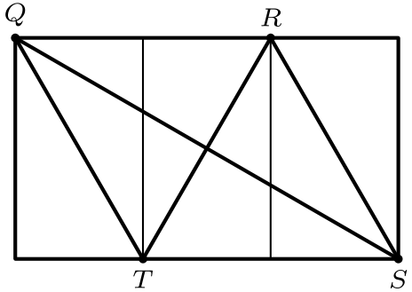
注意 QR = (2√(3))/3，并且
QT = √(1² + ((√(3))/3)²)
= √(1 + 1/3) = √(4/3)。
因此
QT = (2√(3))/3 = QR。
这说明 △ QRT 是等边三角形；同理，△ RTS 也是等边三角形，所以两个三角形全等。
折叠后，这个三角形区域会发生重叠。长方形面积为 1 · √(3) = √(3)，该三角形的边长为 QT = (2√(3))/3，所以它的面积为
((2√(3))/3)² · (√(3))/4 = (√(3))/3。
折后图形面积为
√(3) - (√(3))/3 = (2√(3))/3。
所求比值为
(2√(3))/3 ÷ √(3) = 2/3。
因此 B:A=2:3。所以正确答案是C。
English
WLOG, let the width of the rectangle be 1 and the length be √(3).
Draw the line perpendicular to the midpoint of the fold, as shown below.
Note that QR = (2√(3))/3 and
QT = √(1² + ((√(3))/3)²)
= √(1 + 1/3) = √(4/3).
This tells us
QT = (2√(3))/3 = QR.
This means that △ QRT is equilateral. Similarly, △ RTS is equilateral. This makes the two triangles congruent.
This means that after the rectangle gets folded, this area will be overlapped. The area of the rectangle is 1 · √(3) = √(3). The side length of this triangle is QT = (2√(3))/3. The area of it is then
((2√(3))/3)² · (√(3))/4 = (√(3))/3.
The area of the folded figure is then
√(3) - (√(3))/3 = (2√(3))/3.
The desired ratio is then
(2√(3))/3 ÷ √(3) = 2/3.
Therefore B:A=2:3. Thus,Cis the correct answer.
第 24 题 答案 A
完整 n 次迭代后，列出的项数为 4+5+⋯+(n+3)=(n(n+7))/2。
需要最大的 n 使 (n(n+7))/2<500000。因为 996·1003=998988，所以 996 次迭代后列出了 499494 项。
第 997 次迭代列出的第一个数，是此前所有列出和跳过的数的总数再加一，即 996²+4·996+1=996001。
第 500000 个列出的数，是下一段中的第 500000-499494=506 个数，所以它是 996001+505=996506。
所以正确答案是A。
English
After n full iterations, the number of listed terms is 4+5+⋯+(n+3)=(n(n+7))/2.
We need the largest n with (n(n+7))/2<500000. Since 996·1003=998988, after 996 iterations there are 499494 listed numbers.
The first number listed in iteration 997 is one more than the total of all listed and skipped numbers so far, namely 996²+4·996+1=996001.
The 500000th listed number is the 500000-499494=506th number of this next block, so it is 996001+505=996506.
Thus,Ais the correct answer.
第 25 题 答案 B
因为 2²<5<2³，每个区间 (5ⁿ,5ⁿ⁺¹) 中包含两个或三个 2 的幂。题目的不等式恰好对应含有三个这样的幂的区间。
对 0≤ n<867，设含两个 2 的幂的区间有 d 个，含三个 2 的幂的区间有 t 个，则 d+t=867。
由 2²⁰¹³<5⁸⁶⁷<2²⁰¹⁴ 可知，这些区间一共包含 2013 个 2 的幂，所以 2d+3t=2013。
解这个方程组得到 t=279。
所以正确答案是B。
English
Since 2²<5<2³, each interval (5ⁿ,5ⁿ⁺¹) contains either two or three powers of 2. The desired inequality holds exactly for intervals containing three such powers.
For 0≤ n<867, let d be the number of intervals with two powers of 2, and let t be the number with three powers of 2. Then d+t=867.
Because 2²⁰¹³<5⁸⁶⁷<2²⁰¹⁴, these intervals contain 2013 powers of 2 altogether, so 2d+3t=2013.
Solving the system gives t=279.
Thus,Bis the correct answer.

