2011B AMC 10 真题与解答
American Mathematics Competitions 10 · 中英双语
共 25 题，限时 75 分钟；答对得 6 分，未答得 1.5 分，答错 0 分，满分 150 分。
编排说明：第一部分为题目（先中文、后英文原题），第二部分为解答与答案，便于先做题后对答案。
第一部分 题目
第 1 题
求下式的值：
2+4+6/1+3+5 - 1+3+5/2+4+6
（A）-1 （B）5/36 （C）7/12 （D）147/60 （E）43/3
English
What is the value of the following expression?
2+4+6/1+3+5 - 1+3+5/2+4+6
(A) -1 (B) 5/36 (C) 7/12 (D) 147/60 (E) 43/3
第 2 题
Josanna 到目前为止的考试分数为 90、80、70、60 和 85。她的目标是在下一次考试后把考试平均分至少提高 3 分。她至少需要在下一次考试中得到多少分？
（A）80 （B）82 （C）85 （D）90 （E）95
English
Josanna’s test scores to date are 90, 80, 70, 60, and 85. Her goal is to raise her test average at least 3 points with her next test. What is the minimum test score she would need to accomplish this goal?
(A) 80 (B) 82 (C) 85 (D) 90 (E) 95
第 3 题
在一家商店中，若长度标为 x 英寸，则实际长度至少为 x - 0.5 英寸，至多为 x + 0.5 英寸。若一个长方形瓷砖的尺寸标为 2 英寸乘 3 英寸，则它的最小面积是多少平方英寸？
（A）3.75 （B）4.5 （C）5 （D）6 （E）8.75
English
At a store, when a length is reported as x inches that means it is at least x - 0.5 inches and at most x + 0.5 inches. Suppose the dimensions of a rectangular tile are reported as 2 inches by 3 inches. In square inches, what is the minimum area for the rectangle?
(A) 3.75 (B) 4.5 (C) 5 (D) 6 (E) 8.75
第 4 题
LeRoy 和 Bernardo 一起进行了一周旅行，并同意平分费用。一周中，两人分别支付了一些共同费用，例如汽油和租车。旅行结束时，LeRoy 支付了 A 美元，Bernardo 支付了 B 美元，其中 A < B。LeRoy 应给 Bernardo 多少美元，才能使两人平分费用？
（A）(A + B)/2 （B）(A - B)/2 （C）(B - A)/2 （D）B - A （E）A + B
English
LeRoy and Bernardo went on a week-long trip together and agreed to share the costs equally. Over the week, each of them paid for various joint expenses such as gasoline and car rental. At the end of the trip it turned out that LeRoy had paid A dollars and Bernardo had paid B dollars, where A < B. How many dollars must LeRoy give to Bernardo so that they share the costs equally?
(A) (A + B)/2 (B) (A - B)/2 (C) (B - A)/2 (D) B - A (E) A + B
第 5 题
在计算两个正整数 a 和 b 的乘积时，Ron 把两位数 a 的数字顺序颠倒了。他错误得到的乘积是 161。a 与 b 的正确乘积是多少？
（A）116 （B）161 （C）204 （D）214 （E）224
English
In multiplying two positive integers a and b, Ron reversed the digits of the two-digit number a. His erroneous product was 161. What is the correct value of the product of a and b?
(A) 116 (B) 161 (C) 204 (D) 214 (E) 224
第 6 题
万圣节时 Casper 吃掉了自己糖果的 1/3，然后给了弟弟 2 颗。第二天，他吃掉剩余糖果的 1/3，然后给了妹妹 4 颗。第三天，他吃掉最后的 8 颗糖果。Casper 一开始有多少颗糖果？
（A）30 （B）39 （C）48 （D）57 （E）66
English
On Halloween Casper ate 1/3 of his candies and then gave 2 candies to his brother. The next day he ate 1/3 of his remaining candies and then gave 4 candies to his sister. On the third day he ate his final 8 candies. How many candies did Casper have at the beginning?
(A) 30 (B) 39 (C) 48 (D) 57 (E) 66
第 7 题
一个三角形中两个角的和是直角的 6/5，且这两个角中的一个比另一个大 30°。这个三角形最大角的度数是多少？
（A）69 （B）72 （C）90 （D）102 （E）108
English
The sum of two angles of a triangle is 6/5 of a right angle, and one of these two angles is 30° larger than the other. What is the degree measure of the largest angle in the triangle?
(A) 69 (B) 72 (C) 90 (D) 102 (E) 108
第 8 题
某海滩在气温至少为 80° F 且晴朗时会很拥挤。六月 10 日该海滩不拥挤。关于六月 10 日的天气条件，可以推出什么？
（A）气温低于 80°F，且天气不晴朗。 （B）气温低于 80°F，或者天气不晴朗。 （C）如果气温至少为 80° F，那么那天晴朗。 （D）如果气温低于 80° F，那么那天晴朗。 （E）如果气温低于 80°F，那么那天不晴朗。
English
At a certain beach if it is at least 80° F and sunny, then the beach will be crowded. On June 10 the beach was not crowded. What can be concluded about the weather conditions on June 10?
(A) The temperature was cooler than 80° F and it was
not sunny. (B) The temperature was cooler than 80°
F or it was not sunny. (C) If the temperature was at least 80° F, then it was
sunny. (D) If the temperature was cooler than 80° F, then it
was sunny. (E) If the temperature was cooler than 80° F, then it
was not sunny.
第 9 题
△ EBD 的面积是 3-4-5 三角形 ABC 面积的三分之一。线段 DE 垂直于线段 AB。BD 是多少？
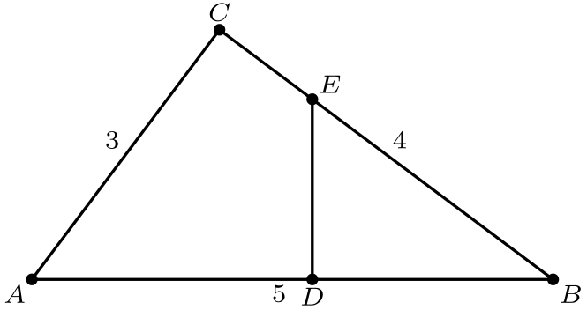
（A）4/3 （B）√(5) （C）9/4 （D）(4√(3))/3 （E）5/2
English
The area of △ EBD is one third of the area of the 3-4-5 triangle ABC. Segment DE is perpendicular to segment AB. What is BD?
(A) 4/3 (B) √(5) (C) 9/4 (D) (4√(3))/3 (E) 5/2
第 10 题
考虑集合 {1, 10, 10², 10³, …, 10¹⁰}。该集合最大元素与其他十个元素之和的比值最接近哪个整数？
（A）1 （B）9 （C）10 （D）11 （E）101
English
Consider the set of numbers {1, 10, 10², 10³, …, 10¹⁰}. The ratio of the largest element of the set to the sum of the other ten elements of the set is closest to which integer?
(A) 1 (B) 9 (C) 10 (D) 11 (E) 101
第 11 题
一个房间里有 52 人。使“这个房间中至少有 n 人的生日在同一个月份”这一陈述总为真的最大 n 是多少？
（A）2 （B）3 （C）4 （D）5 （E）12
English
There are 52 people in a room. What is the largest value of n such that the statement “At least n people in this room have birthdays falling in the same month” is always true?
(A) 2 (B) 3 (C) 4 (D) 5 (E) 12
第 12 题
Keiko 每天以完全相同的恒定速度绕跑道走一圈。跑道两侧为直线，两端为半圆。跑道宽 6 米，她沿外侧边缘走一圈比沿内侧边缘走一圈多用 36 秒。Keiko 的速度是多少米每秒？
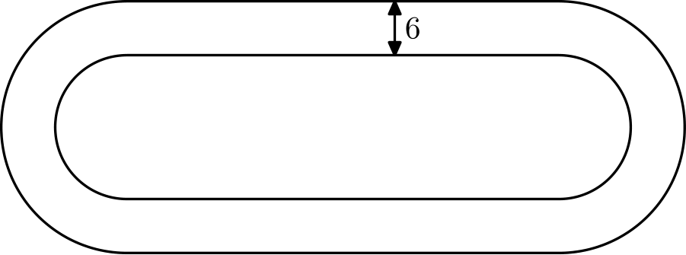
（A）π/3 （B）2π/3 （C）π （D）4π/3 （E）5π/3
English
Keiko walks once around a track at exactly the same constant speed every day. The sides of the track are straight, and the ends are semicircles. The track has a width of 6 meters, and it takes her 36 seconds longer to walk around the outside edge of the track than around the inside edge. What is Keiko’s speed in meters per second?
(A) π/3 (B) 2π/3 (C) π (D) 4π/3 (E) 5π/3
第 13 题
从区间 [-20, 10] 中独立随机选择两个实数。它们的乘积大于零的概率是多少？
（A）1/9 （B）1/3 （C）4/9 （D）5/9 （E）2/3
English
Two real numbers are selected independently at random from the interval [-20, 10]. What is the probability that the product of those numbers is greater than zero?
(A) 1/9 (B) 1/3 (C) 4/9 (D) 5/9 (E) 2/3
第 14 题
一个长方形停车场的对角线长 25 米，面积为 168 平方米。该停车场的周长是多少米？
（A）52 （B）58 （C）62 （D）68 （E）70
English
A rectangular parking lot has a diagonal of 25 meters and an area of 168 square meters. In meters, what is the perimeter of the parking lot?
(A) 52 (B) 58 (C) 62 (D) 68 (E) 70
第 15 题
令 @ 表示“与……取平均”的运算：a @ b = a+b/2。下列哪些分配律对所有数 x、y 和 z 都成立？
I. x @ (y + z) = (x @ y) + (x @ z)
II. x + (y @ z) = (x + y) @ (x + z)
III. x @ (y @ z) = (x @ y) @ (x @ z)
（A）仅 I （B）仅 II （C）仅 III （D）仅 I 和 III （E）仅 II 和 III
English
Let @ denote the “averaged with” operation: a @ b = a+b/2. Which of the following distributive laws hold for all numbers x, y, and z?
I. x @ (y + z) = (x @ y) + (x @ z)
II. x + (y @ z) = (x + y) @ (x + z)
III. x @ (y @ z) = (x @ y) @ (x @ z)
(A) I only (B) II only (C) III only (D) I and III only (E) II and III only
第 16 题
一个飞镖靶是如图所示分区的正八边形。假设飞镖落在靶上任意位置的概率相同。飞镖落在中心正方形内的概率是多少？
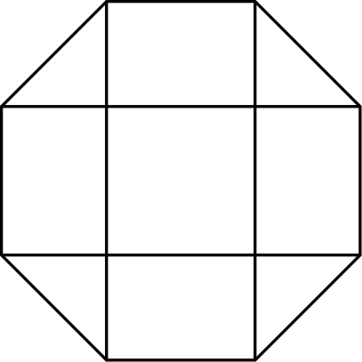
（A）(√(2) - 1)/2 （B）1/4 （C）(2 - √(2))/2 （D）(√(2))/4 （E）2 - √(2)
English
A dart board is a regular octagon divided into regions as shown. Suppose that a dart thrown at the board is equally likely to land anywhere on the board. What is the probability that the dart lands within the center square?
(A) (√(2) - 1)/2 (B) 1/4 (C) (2 - √(2))/2 (D) (√(2))/4 (E) 2 - √(2)
第 17 题
在给定圆中，直径 EB 平行于 DC，且 AB 平行于 ED。角 AEB 与 ABE 的比为 4: 5。角 BCD 的度数是多少？
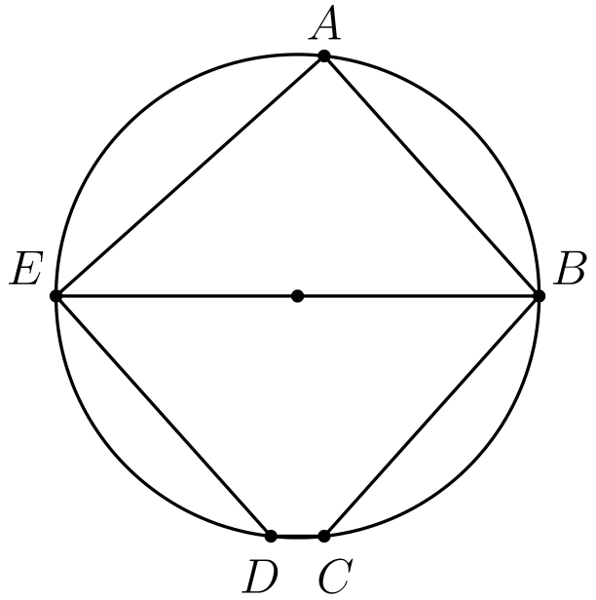
（A）120 （B）125 （C）130 （D）135 （E）140
English
In the given circle, the diameter EB is parallel to DC, and AB is parallel to ED. The angles AEB and ABE are in the ratio 4: 5. What is the degree measure of angle BCD?
(A) 120 (B) 125 (C) 130 (D) 135 (E) 140
第 18 题
长方形 ABCD 中，AB = 6，BC = 3。点 M 在边 AB 上，使得 ∠ AMD = ∠ CMD。∠ AMD 的度数是多少？
（A）15 （B）30 （C）45 （D）60 （E）75
English
Rectangle ABCD has AB = 6 and BC = 3. Point M is chosen on side AB so that ∠ AMD = ∠ CMD. What is the degree measure of ∠ AMD?
(A) 15 (B) 30 (C) 45 (D) 60 (E) 75
第 19 题
下列方程所有根的乘积是多少？
√(5 | x | + 8) = √(x² - 16)
（A）-64 （B）-24 （C）-9 （D）24 （E）576
English
What is the product of all the roots of the equation below?
√(5 | x | + 8) = √(x² - 16)
(A) -64 (B) -24 (C) -9 (D) 24 (E) 576
第 20 题
菱形 ABCD 的边长为 2，且 ∠ B = 120°。区域 R 由菱形内所有比到其他三个顶点更接近顶点 B 的点组成。R 的面积是多少？
（A）(√(3))/3 （B）(√(3))/2 （C）(2√(3))/3 （D）1 + (√(3))/3 （E）2
English
Rhombus ABCD has side length 2 and ∠ B = 120°. Region R consists of all points inside the rhombus that are closer to vertex B than any of the other three vertices. What is the area of R?
(A) (√(3))/3 (B) (√(3))/2 (C) (2√(3))/3 (D) 1 + (√(3))/3 (E) 2
第 21 题
Brian 写下四个整数 w > x > y > z，它们的和为 44。这些数两两之间的正差为 1、3、4、5、6 和 9。w 的所有可能值之和是多少？
（A）16 （B）31 （C）48 （D）62 （E）93
English
Brian writes down four integers w > x > y > z whose sum is 44. The pairwise positive differences of these numbers are 1, 3, 4, 5, 6, and 9. What is the sum of the possible values for w?
(A) 16 (B) 31 (C) 48 (D) 62 (E) 93
第 22 题
一个金字塔有边长为 1 的正方形底面，侧面都是等边三角形。一个立方体放在金字塔内，使其一个面在金字塔底面上，而相对的面所有边都位于金字塔侧面上。这个立方体的体积是多少？
（A）5√(2) - 7 （B）7 - 4√(3) （C）(2√(2))/27 （D）(√(2))/9 （E）(√(3))/9
English
A pyramid has a square base with sides of length 1 and has lateral faces that are equilateral triangles. A cube is placed within the pyramid so that one face is on the base of the pyramid and its opposite face has all its edges on the lateral faces of the pyramid. What is the volume of this cube?
(A) 5√(2) - 7 (B) 7 - 4√(3) (C) (2√(2))/27 (D) (√(2))/9 (E) (√(3))/9
第 23 题
2011²⁰¹¹ 的百位数字是多少？
（A）1 （B）4 （C）5 （D）6 （E）9
English
What is the hundreds digit of 2011²⁰¹¹?
(A) 1 (B) 4 (C) 5 (D) 6 (E) 9
第 24 题
在 xy 坐标系中，格点是指 (x, y) 中 x 和 y 都为整数的点。直线 y = mx +2 不经过任何满足 0 < x ≤ 100 的格点，且对所有 m，若 1/2 < m < a，这一结论都成立。a 的最大可能值是多少？
（A）51/101 （B）50/99 （C）51/100 （D）52/101 （E）13/25
English
A lattice point in an xy-coordinate system is any point (x, y) where both x and y are integers. The graph of y = mx +2 passes through no lattice point with 0 < x ≤ 100 for all m such that 1/2 < m < a. What is the maximum possible value of a?
(A) 51/101 (B) 50/99 (C) 51/100 (D) 52/101 (E) 13/25
第 25 题
设 T₁ 是边长为 2011、2012 和 2013 的三角形。对 n ≥ 1，若 Tₙ = △ ABC，且 D、E 和 F 分别是 △ ABC 的内切圆与边 AB、BC 和 AC 的切点，则若存在，Tₙ₊₁ 是边长为 AD、BE 和 CF 的三角形。数列 ( Tₙ) 中最后一个三角形的周长是多少？
（A）1509/8 （B）1509/32 （C）1509/64 （D）1509/128 （E）1509/256
English
Let T₁ be a triangle with side lengths 2011, 2012, and 2013. For n ≥ 1, if Tₙ = △ ABC and D, E, and F are the points of tangency of the incircle of △ ABC to the sides AB, BC, and AC, respectively, then Tₙ₊₁ is a triangle with side lengths AD, BE, and CF, if it exists. What is the perimeter of the last triangle in the sequence ( Tₙ)?
(A) 1509/8 (B) 1509/32 (C) 1509/64 (D) 1509/128 (E) 1509/256

第二部分 解答
答案速查：
题号 1 2 3 4 5 6 7 8 9
答案 C E A C E A B B D
题号 10 11 12 13 14 15 16 17 18
答案 B D A D C E A C E
题号 19 20 21 22 23 24 25
答案 A C B A D B D
答案串：CEACEABBDBDADCEACEACBADBD
第 1 题 答案 C
直接计算：
2+4+6/1+3+5 - 1+3+5/2+4+6
= 12/9 - 9/12
= 16/12 - 9/12
=7/12
。
所以正确答案是C。
English
Simply solving directly:
2+4+6/1+3+5 - 1+3+5/2+4+6
= 12/9 - 9/12
= 16/12 - 9/12
=7/12.
Thus, the correct answer isC.
第 2 题 答案 E
她当前的平均分为
90+80+70+60+85/5 = 77，
而总分为 385。目标平均分为 80，所以六次考试所需的总分为 80· 6。因此下一次考试至少需要得
80· 6-385 = 95。
所以正确答案是E。
English
Her current average is
90+80+70+60+85/5 = 77,
and the sum of her scores is 385. The desired average is then 80, so the sum of scores required is 80· 6. Therefore, the answer is
80· 6-385 = 95.
Thus, the correct answer isE.
第 3 题 答案 A
最小可能尺寸为 1.5× 2.5，所以面积为
1.5· 2.5=3.75。
所以正确答案是A。
English
The smallest possible dimensions are 1.5× 2.5, so the area is
1.5· 2.5=3.75.
Thus, the correct answer isA.
第 4 题 答案 C
两人每人应承担 A+B/2，而 LeRoy 已支付 A。因此他还需向 Bernardo 支付
A+B/2-A = B-A/2
美元。
所以正确答案是C。
English
The amount they each would have to pay is A+B/2, and LeRoy paid A. Thus, he has to pay
A+B/2-A = B-A/2
more.
Thus, the correct answer isC.
第 5 题 答案 E
数 161 等于 7· 23。161 除了 1· 161 外没有其他因数对，所以 23 是唯一的两位因数。因此 23 是颠倒后的数，原来的乘法应为 32· 7，结果是 224。
所以正确答案是E。
English
The number 161 is equal to 7· 23. There are no other pairs of numbers that multiply to 161 besides 1· 161, so 23 is the only two digit factor. Thus, 23 is the number reversed, so he meant to get 32· 7 which is 224.
Thus, the correct answer isE.
第 6 题 答案 A
倒推。给妹妹 4 颗之前，Casper 有 12 颗糖果，因为第二天结束时剩 8 颗。
这 12 颗是第一天结束后糖果数的 2/3，所以第一天结束后有 18 颗。
给弟弟 2 颗之前有 20 颗。这是原来糖果数的 2/3，所以一开始有 30 颗。
所以正确答案是A。
English
Work backward. Before giving 4 candies to his sister, Casper had 12 candies, because he ended the second day with 8.
Those 12 candies were 2/3 of what he had after the first day, so after the first day he had 18 candies.
Before giving 2 candies to his brother, he had 20 candies. This was 2/3 of his original amount, so he began with 30 candies.
Thus,Ais the correct answer.
第 7 题 答案 B
这两个角之和为 6/5 · 90 = 108。所以第三个角为 180-108=72。若这两个角中较大的为 x，较小的为 x-30，则 2x-30=108，所以 x=69。
没有角大于 72，因此最大角是 72。
所以正确答案是B。
English
The two angles add to 6/5 · 90 = 108. This makes the other angle 180-108=72. Then, if the larger of the two angles is x then the smaller of them is x-30 so their sum is 2x-30=108, making x=69.
This means no angle is larger than 72, making the largest equal to 72.
Thus, the correct answer isB.
第 8 题 答案 B
原命题是：若气温至少 80° F 且晴朗，则海滩拥挤。
因为海滩不拥挤，这两个条件不可能同时成立。因此气温低于 80° F，或者天气不晴朗，或者两者都成立。
所以正确答案是B。
English
The statement says that if the weather was at least 80° F and sunny, then the beach was crowded.
Because the beach was not crowded, the two conditions could not both have been true. Therefore the temperature was cooler than 80° F, or it was not sunny, or both.
Thus,Bis the correct answer.
第 9 题 答案 D
由角角相似，BDE ∼ BCA 。
面积比为 1/3，所以对应边长比为 1/(√(3))。
因此
BD/BC = BD/4 = 1/(√(3))，
从而
BD = 4/(√(3)) = (4√(3))/3。
所以正确答案是D。
English
By angle angle similarity, we have BDE ∼ BCA.
Then, since the ratio of the areas is 1/3, the ratio of the sidelengths is 1/(√(3)).
As such,
BD/BC = BD/4 = 1/(√(3)),
making
BD = 4/(√(3)) = (4√(3))/3.
Thus, the correct answer isD.
第 10 题 答案 B
最大元素为 10¹⁰。其余十个元素之和为
S=Σᵢ₌₀⁹ 10ⁱ=10¹⁰-1/9。
因此所求比值为
10¹⁰/S=9·10¹⁰/10¹⁰-1，
它略大于 9，所以最接近 9。
所以正确答案是B。
English
The largest number is 10¹⁰. The other ten numbers have sum
S=Σᵢ₌₀⁹ 10ⁱ=10¹⁰-1/9.
Therefore their ratio is
10¹⁰/S=9·10¹⁰/10¹⁰-1,
which is just slightly greater than 9 and hence closest to 9.
Thus, the correct answer isB.
第 11 题 答案 D
n≥ 6 不一定成立，因为可以让 5 人的生日落在前 4 个月中的每个月，而其余八个月各有 4 人生日。
但一定有某个月至少 5 人生日，因为平均每月人数为 52/12，大于 4。
所以正确答案是D。
English
It isn’t necessarily true for n≥ 6 as we could have 5 people born in the first 4 months and 4 people born in the subsequent months.
However, one month must be greater than or equal to 5 as the average of the number of people born in each month is 52/12 which is greater than 4, and some month must be above average.
Thus, the correct answer isD.
第 12 题 答案 A
设内侧半圆半径为 r。
内外路径的直线部分总长相同，所以距离差只来自两个半圆端。两个内侧半圆总长为 2π r，两个外侧半圆总长为 2π(r+6)，差为 12π。
Keiko 多用 36 秒走了 12π 米，所以速度为 12π/36=π/3 米每秒。
所以正确答案是A。
English
Let the inner semicircle radius be r. The straight parts of the inside and outside paths have the same total length, so only the semicircular ends change the distance.
The two inner semicircles have total length 2π r, while the two outer semicircles have total length 2π(r+6). The outside path is therefore 12π meters longer.
Keiko takes 36 more seconds to walk 12π more meters, so her speed is 12π/36=π/3 meters per second.
Thus,Ais the correct answer.
第 13 题 答案 D
选中的数为负数的概率是 20/30=2/3，为正数的概率是 10/30=1/3。（恰好选中 0 的概率为 0。）乘积为正当且仅当两个数同号，所以所求概率为
(2/3)²+(1/3)²=4/9+1/9=5/9。
所以正确答案是D。
English
A selected number is negative with probability 20/30=2/3 and positive with probability 10/30=1/3. (Selecting exactly 0 has probability 0.) The product is positive exactly when both numbers have the same sign, so the probability is
(2/3)²+(1/3)²=4/9+1/9=5/9.
Thus, the correct answer isD.
第 14 题 答案 C
设长方形边长为 l,w。要求的是 2(l+w)。由勾股定理，
25 = √(l²+w²)
l²+w² = 625
并且 lw = 168。
因此
l²+2lw+ w² = (l+w)²
= 961
= 31²
。
所以 l+w = 31，周长为 31· 2=62。
所以正确答案是C。
English
Let the side lengths be l,w. We wish to find 2(l+w). From the Pythagorean Theorem, we get
25 = √(l²+w²)
l²+w² = 625
We also know lw = 168.
As such
l²+2lw+ w² = (l+w)²
= 961
= 31².
This makes l+w = 31, and as such, our answer is 31· 2=62.
Thus, the correct answer isC.
第 15 题 答案 E
I 的左边为 x+y+z/2，右边为 x+y+z/2，不恒相等。
II 的左右两边都等于 x+y+z/2，所以恒成立。
III 的左右两边都等于 2x+y+z/4，所以也恒成立。
所以正确答案是E。
English
In statement I, the left-hand side equals x+y+z/2 and the right-hand side equals x+y+z/2, so they are not always equal.
In statement II, both sides equal x+y+z/2, so it holds.
In statement III, both sides equal 2x+y+z/4, so it also holds.
Thus, the correct answer isE.
第 16 题 答案 A
设中心正方形边长为 1。则中心面积为 1。
八边形可看作一个大正方形去掉 4 个等腰直角三角形。大正方形边长为
1 + 2· 1/(√(2)) = 1 + √(2)，
所以面积为
(1+√(2))² = 3 + 2 √(2)。
这些直角三角形的直角边长为 1/(√(2)) ，每个面积为
(1/(√(2))²)/2 = 1/4。
四个总面积为 1，所以八边形面积为 2+ 2 √(2)。
因此比值为
1/(2+ 2 √(2))
= (-2+ 2 √(2))/((2+ 2 √(2))(-2+ 2 √(2)))
=(2(√(2)-1))/4
=(√(2)-1)/2
。
所以正确答案是A。
English
Let the side length be 1. Then, the area of the center is 1.
Then, we must find the area of the octagon. It can be found as a square with 4 isosceles right triangles taken out. The side length of this square is
1 + 2· 1/(√(2)) = 1 + √(2).
It has an area of
(1+√(2))² = 3 + 2 √(2).
Then, the side length of the right triangles is 1/(√(2)), making the area of one equal to
(1/(√(2))²)/2 = 1/4.
This makes them have a total combined area of 1, so the area of the octagon is 2+ 2 √(2).
Thus, the ratio is
1/(2+ 2 √(2))
= (-2+ 2 √(2))/((2+ 2 √(2))(-2+ 2 √(2)))
=(2(√(2)-1))/4
=(√(2)-1)/2.
Thus, the correct answer isA.
第 17 题 答案 C
因为 EB 是直径，∠ EAB=90°。由 ∠ AEB:∠ ABE=4:5，得 ∠ AEB=40°，∠ ABE=50°。
因为 AB∥ ED，所以 ∠ DEB=50°。又 EB∥ DC，四边形 EBCD 是等腰梯形，所以 ∠ BCD=∠ CDE。
角 DEB 与 CDE 互补，所以 ∠ CDE=180°-50°=130°，因此 ∠ BCD=130°。
所以正确答案是C。
English
Since EB is a diameter, ∠ EAB=90°. The ratio ∠ AEB:∠ ABE=4:5 then gives ∠ AEB=40° and ∠ ABE=50°.
Because AB∥ ED, ∠ DEB=50°. Since EB∥ DC, quadrilateral EBCD is an isosceles trapezoid, so ∠ BCD=∠ CDE.
Angles DEB and CDE are supplementary, so ∠ CDE=180°-50°=130°. Hence ∠ BCD=130°.
Thus,Cis the correct answer.
第 18 题 答案 E
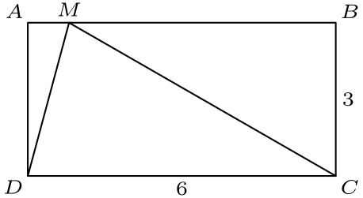
角 ∠ AMD 与 ∠ MDC 相等，因为 AB ∥ DC。
因此 ∠ MDC = ∠ DMC ，所以三角形 MDC 为等腰三角形，MC = DC = 6。
在直角三角形中，由边长比例可得 sin (∠ CMB) = 1/2，因此 ∠ CMB = 30° 。
因此 ∠ AMC = 150° 。由于 ∠ AMD 是它的一半，∠ AMD = 75° 。
所以正确答案是E。
English
The angles ∠ AMD and ∠ MDC are equal since AB ∥ DC.
As such, ∠ MDC = ∠ DMC, making MDC isosceles and MC = DC = 6.
As we can see, sin (∠ CMB) = 1/2, making ∠ CMB = 30°.
Therefore, ∠ AMC = 150°. Since ∠ AMD is half of that, ∠ AMD = 75°.
Thus, the correct answer isE.
第 19 题 答案 A
因为 x²=|x|²，将方程两边平方可得
5|x|+8 = |x|²-16,
|x|²-5|x|-24=0,
(|x|-8)(|x|+3)=0
。
|x| 在代数上可能为 8 或 -3，但绝对值不能为负。因此 |x|=8，两个根为 8 和 -8，乘积为 -64。
所以正确答案是A。
English
Because x²=|x|², squaring the equation gives
5|x|+8 = |x|²-16,
|x|²-5|x|-24=0,
(|x|-8)(|x|+3)=0.
The algebraic possibilities for |x| are 8 and -3, but an absolute value cannot be negative. Hence |x|=8, so the roots are 8 and -8, with product -64.
Thus, the correct answer isA.
第 20 题 答案 C
比到其他顶点更接近 B 的点由 BA、BC、BD 的垂直平分线围定。BD 的垂直平分线是对角线 AC，所以所求区域位于 △ ABC 中。
三角形 ABC 面积为 1/2·2·2sin120°=√(3)。BA 和 BC 的垂直平分线切去两个全等的 30-60-90 三角形，每个面积为 (√(3))/6。
所求面积为 √(3)-2·(√(3))/6=(2√(3))/3。
所以正确答案是C。
English
The points closer to B than to another vertex are bounded by the perpendicular bisectors of BA, BC, and BD. The bisector of BD is diagonal AC, so the desired region lies in △ ABC.
Triangle ABC has area 1/2·2·2sin120°=√(3). The perpendicular bisectors of BA and BC cut off two congruent 30-60-90 triangles, each with area (√(3))/6.
Therefore the desired area is √(3)-2·(√(3))/6=(2√(3))/3.
Thus,Cis the correct answer.
第 21 题 答案 B
最大差为 9，所以 w-z=9。对任一中间数 n，差 w-n 与 n-z 的和必须为 9。
可用的和为 9 的配对为 3+6 和 4+5，剩下两个中间数之间的差为 1。
一种集合为 {w,w-5,w-6,w-9}，给出 4w-20=44，所以 w=16。另一种为 {w,w-3,w-4,w-9}，给出 4w-16=44，所以 w=15。
可能的 w 之和为 16+15=31。
所以正确答案是B。
English
The largest difference is 9, so w-z=9. For either middle number n, the two differences w-n and n-z must add to 9.
The available pairs of differences that add to 9 are 3+6 and 4+5, and the remaining difference between the two middle numbers is 1.
One possible set is {w,w-5,w-6,w-9}, giving 4w-20=44 and w=16. The other is {w,w-3,w-4,w-9}, giving 4w-16=44 and w=15.
The sum of the possible values of w is 16+15=31.
Thus,Bis the correct answer.
第 22 题 答案 A
设立方体边长为 x。作金字塔的一个竖直对角截面，它经过正方形底面的两个相对顶点。
这个截面是斜边为 √(2) 的等腰直角三角形。立方体在其中表现为高 x、宽 √(2)x 的长方形，两侧留下两个全等的、直角边为 x 的等腰直角三角形。
因此 √(2)=√(2)x+2x，所以 x=√(2)-1，立方体体积为 x³=(√(2)-1)³=5√(2)-7。
所以正确答案是A。
English
Let the cube have side length x. Take a vertical diagonal cross-section of the pyramid through opposite vertices of the square base.
This cross-section is an isosceles right triangle with hypotenuse √(2). The cube appears as a rectangle of height x and width √(2)x, leaving two congruent right isosceles triangles of leg x.
Thus √(2)=√(2)x+2x, so x=√(2)-1. The cube volume is x³=(√(2)-1)³=5√(2)-7.
Thus,Ais the correct answer.
第 23 题 答案 D
因为 2011≡11pmod1000，只需计算 11²⁰¹¹=(10+1)²⁰¹¹ 在模 1000 下的值。
含 10³ 或更高幂的项都能被 1000 整除，所以只需前三项：
1+2011·10+C(2011, 2)10²。
模 1000 下，这等于
1+11·10+(2011·2010)/2·100
≡1+110+500=611
。
因此百位数字为 6。
所以正确答案是D。
English
Because 2011≡11pmod1000, it is enough to find 11²⁰¹¹=(10+1)²⁰¹¹ modulo 1000.
All terms with 10³ or higher are divisible by 1000, so only the first three terms matter:
1+2011·10+C(2011, 2)10².
Modulo 1000, this is
1+11·10+(2011·2010)/2·100
≡1+110+500=611
.
The hundreds digit is therefore 6.
Thus,Dis the correct answer.
第 24 题 答案 B
将图像下移 2。问题等价于找最小的 m>1/2，使直线 y=mx 经过某个满足 0< x≤100 的格点。
对固定整数 x，最小整数 y 必须满足 y/x>1/2。它为 x/2+1（若 x 为偶数），以及 x+1/2（若 x 为奇数）。
候选斜率为 1/2+1/x（当 x 为偶数），在 x=100 时最小为 51/100。候选斜率为 1/2+1/2x（若 x 为奇数），在 x=99 时最小为 50/99。
两类中较小的端点是 50/99。因此当 m 满足 1/2< m<50/99 时不会经过这些格点，而这个上端点已经是可能的最大值。
所以正确答案是B。
English
Shift the graph down by 2. The problem is equivalent to finding the smallest slope m>1/2 for which y=mx passes through a lattice point with 0< x≤100.
For a fixed integer x, the smallest integer y with y/x>1/2 is x/2+1 when x is even, and x+1/2 when x is odd.
Thus the candidate slopes are 1/2+1/x for even x, minimized at x=100 as 51/100, and 1/2+1/2x for odd x, minimized at x=99 as 50/99.
The smaller of these is 50/99, so every m with 1/2< m<50/99 avoids such lattice points, and this upper endpoint is best possible.
Thus,Bis the correct answer.
第 25 题 答案 D
对边长 a=BC、b=CA、c=AB 的三角形，同一顶点到内切圆的切线段相等，所以下一个三角形边长为
b+c-a/2,
a+c-b/2,
a+b-c/2
。
若当前边长为 s-1,s,s+1，则下一组边长为 s/2-1,s/2,s/2+1。因此这种形式会一直保持，而中间边每次减半。
对 Tₙ，中间边为 2012/(2ⁿ⁻¹)。形如 s-1,s,s+1 的三角形存在，当且仅当 s>2。
最后一个有效三角形满足 2012/(2ⁿ⁻¹)>2，但下一次不满足。此时 n=10，中间边为 2012/2⁹=503/128。
周长为 3·503/128=1509/128。
所以正确答案是D。
English
For a triangle with side lengths a=BC, b=CA, and c=AB, equal tangents from the same vertex give the next side lengths
b+c-a/2,
a+c-b/2,
a+b-c/2.
If the current side lengths are s-1,s,s+1, then the next side lengths are s/2-1,s/2,s/2+1. Thus the same form persists while the middle side halves each time.
For Tₙ, the middle side is 2012/(2ⁿ⁻¹). A triangle of the form s-1,s,s+1 exists exactly when s>2.
The last valid triangle has 2012/(2ⁿ⁻¹)>2, but the next one does not. This gives n=10, with middle side 2012/2⁹=503/128.
The perimeter is 3·503/128=1509/128.
Thus,Dis the correct answer.

