2010B AMC 10 真题与解答
American Mathematics Competitions 10 · 中英双语
共 25 题，限时 75 分钟；答对得 6 分，未答得 1.5 分，答错 0 分，满分 150 分。
编排说明：第一部分为题目（先中文、后英文原题），第二部分为解答与答案，便于先做题后对答案。
第一部分 题目
第 1 题
求下式的值：
100(100-3)-(100 · 100-3)
（A）-20,000 （B）-10,000 （C）-297 （D）-6 （E）0
English
What is the value of the following expression?
100(100-3)-(100 · 100-3)
(A) -20,000 (B) -10,000 (C) -297 (D) -6 (E) 0
第 2 题
Makayla 在 9 小时工作日中参加了两场会议。第一场会议用了 45 分钟，第二场会议用时是第一场的两倍。她工作日的百分之多少用于参加会议？
（A）15 （B）20 （C）25 （D）30 （E）35
English
Makayla attended two meetings during her 9-hour work day. The first meeting took 45 minutes and the second meeting took twice as long. What percent of her work day was spent attending meetings?
(A) 15 (B) 20 (C) 25 (D) 30 (E) 35
第 3 题
一个抽屉里有红、绿、蓝、白四种颜色的袜子，每种颜色至少 2 只。至少要从抽屉里取出多少只袜子，才能保证有一双同色袜子？
（A）3 （B）4 （C）5 （D）8 （E）9
English
A drawer contains red, green, blue, and white socks with at least 2 of each color. What is the minimum number of socks that must be pulled from the drawer to guarantee a matching pair?
(A) 3 (B) 4 (C) 5 (D) 8 (E) 9
第 4 题
对实数 x，定义 heartsuit(x) 为 x 和 x² 的平均数。求下式的值：
heartsuit(1)+heartsuit(2)+heartsuit(3)
（A）3 （B）6 （C）10 （D）12 （E）20
English
For a real number x, define heartsuit(x) to be the average of x and x². What is the value of the following expression?
heartsuit(1)+heartsuit(2)+heartsuit(3)
(A) 3 (B) 6 (C) 10 (D) 12 (E) 20
第 5 题
某个有 31 天的月份中，星期一和星期三的天数相同。这个月的第一天可能是七天中的多少种？
（A）2 （B）3 （C）4 （D）5 （E）6
English
A month with 31 days has the same number of Mondays and Wednesdays. How many of the seven days of the week could be the first day of this month?
(A) 2 (B) 3 (C) 4 (D) 5 (E) 6
第 6 题
圆心为 O，AB 是直径，点 C 在圆上，且 ∠ COB = 50°。∠ CAB 的度数是多少？
（A）20 （B）25 （C）45 （D）50 （E）65
English
A circle is centered at O, AB is a diameter and C is a point on the circle with ∠ COB = 50°. What is the degree measure of ∠ CAB?
(A) 20 (B) 25 (C) 45 (D) 50 (E) 65
第 7 题
一个三角形的边长为 10、10 和 12。一个长方形宽为 4，面积等于该三角形的面积。这个长方形的周长是多少？
（A）16 （B）24 （C）28 （D）32 （E）36
English
A triangle has side lengths 10, 10, and 12. A rectangle has width 4 and area equal to the area of the triangle. What is the perimeter of this rectangle?
(A) 16 (B) 24 (C) 28 (D) 32 (E) 36
第 8 题
一张学校戏剧票价为 x 美元，其中 x 是整数。一个 9 年级小组买票共花 $48，一个 10 年级小组买票共花 $64。x 可能有多少个值？
（A）1 （B）2 （C）3 （D）4 （E）5
English
A ticket to a school play costs x dollars, where x is a whole number. A group of 9th graders buys tickets costing a total of $48, and a group of 10th graders buys tickets costing a total of $64. How many values for x are possible?
(A) 1 (B) 2 (C) 3 (D) 4 (E) 5
第 9 题
Larry 的老师让他把数字代入 a、b、c、d 和 e，再计算下式：
a-(b-(c-(d+e)))
Larry 忽略了括号，但加减号本身算对了，并且碰巧得到了正确结果。他给 a、b、c、d 代入的数分别是 1、2、3、4。他给 e 代入了什么数？
（A）-5 （B）-3 （C）0 （D）3 （E）5
English
Lucky Larry’s teacher asked him to substitute numbers for a, b, c, d, and e in the expression
a-(b-(c-(d+e)))
and evaluate the result. Larry ignored the parentheses but added and subtracted correctly and obtained the correct result by coincidence. The numbers Larry substituted for a, b, c, and d were 1, 2, 3, and 4, respectively. What number did Larry substitute for e?
(A) -5 (B) -3 (C) 0 (D) 3 (E) 5
第 10 题
Shelby 在不下雨时以每小时 30 英里的速度骑踏板车，在下雨时以每小时 20 英里的速度骑行。今天上午她在晴天中骑行，傍晚在雨中骑行，共行驶 16 英里，用时 40 分钟。她在雨中骑了多少分钟？
（A）18 （B）21 （C）24 （D）27 （E）30
English
Shelby drives her scooter at a speed of 30 miles per hour if it is not raining, and 20 miles per hour if it is raining. Today she drove in the sun in the morning and in the rain in the evening, for a total of 16 miles in 40 minutes. How many minutes did she drive in the rain?
(A) 18 (B) 21 (C) 24 (D) 27 (E) 30
第 11 题
一位购物者计划购买一件标价大于 $100 的商品，并且可以使用三张优惠券中的任意一张。优惠券 A 可按标价打 15% 折扣，优惠券 B 可直接减 $30，优惠券 C 可打 25% 折扣，适用于标价超过 $100 的部分。
设 x 和 y 分别为使优惠券 A 节省的钱不少于优惠券 B 或 C 的最小和最大标价。求 y - x。
（A）50 （B）60 （C）75 （D）80 （E）100
English
A shopper plans to purchase an item that has a listed price greater than $100 and can use any one of the three coupons. Coupon A gives 15% off the listed price, Coupon B gives $30 off the listed price, and Coupon C gives 25% off the amount by which the listed price exceeds $100.
Let x and y be the smallest and largest prices, respectively, for which Coupon A saves at least as many dollars as Coupon B or C. What is y - x?
(A) 50 (B) 60 (C) 75 (D) 80 (E) 100
第 12 题
学年初，Wells 老师数学课上 50% 的学生对“你热爱数学吗？”回答“是”，50% 回答“否”。学年末，70% 回答“是”，30% 回答“否”。总共有 x% 的学生在学年初和学年末给出了不同回答。x 的最大可能值与最小可能值之差是多少？
（A）0 （B）20 （C）40 （D）60 （E）80
English
At the beginning of the school year, 50% of all students in Mr. Wells’ math class answered “Yes” to the question “Do you love math”, and 50% answered “No.” At the end of the school year, 70% answered “Yes” and 30% answered “No.” Altogether, x% of the students gave a different answer at the beginning and end of the school year. What is the difference between the maximum and the minimum possible values of x?
(A) 0 (B) 20 (C) 40 (D) 60 (E) 80
第 13 题
下列方程的所有解之和是多少？
x = |2x-|60-2x||
（A）32 （B）60 （C）92 （D）120 （E）124
English
What is the sum of all the solutions of the equation below?
x = |2x-|60-2x||
(A) 32 (B) 60 (C) 92 (D) 120 (E) 124
第 14 题
数 1、2、3、⋯、98、99 和 x 的平均数为 100x。求 x。
（A）49/101 （B）50/101 （C）1/2 （D）51/101 （E）50/99
English
The average of the numbers 1, 2, 3, ⋯, 98, 99, and x is 100x. What is x?
(A) 49/101 (B) 50/101 (C) 1/2 (D) 51/101 (E) 50/99
第 15 题
在一场 50 题的选择题数学竞赛中，学生每答对一题得 4 分，空题得 0 分，答错一题得 -1 分。Jesse 的总分为 99。Jesse 最多可能答对多少题？
（A）25 （B）27 （C）29 （D）31 （E）33
English
On a 50-question multiple choice math contest, students receive 4 points for a correct answer, 0 points for an answer left blank, and -1 point for an incorrect answer. Jesse’s total score on the contest was 99. What is the maximum number of questions that Jesse could have answered correctly?
(A) 25 (B) 27 (C) 29 (D) 31 (E) 33
第 16 题
一个边长为 1 的正方形和一个半径为 (√(3))/3 的圆有相同圆心。圆内但正方形外的面积是多少？
（A）π/3-1 （B）2π/9-(√(3))/3 （C）π/18 （D）1/4 （E）2π/9
English
A square of side length 1 and a circle of radius (√(3))/3 share the same center. What is the area inside the circle, but outside the square?
(A) π/3-1 (B) 2π/9-(√(3))/3 (C) π/18 (D) 1/4 (E) 2π/9
第 17 题
Euclid 市的每所高中都派出一支 3 人队伍参加数学竞赛。每位参赛者的分数都不同。Andrea 的分数是所有学生中的中位数，并且她是自己队伍中得分最高的。Andrea 的队友 Beth 和 Carla 分别排第 37 和第 64。这个城市有多少所学校？
（A）22 （B）23 （C）24 （D）25 （E）26
English
Every high school in the city of Euclid sent a team of 3 students to a math contest. Each participant in the contest received a different score. Andrea’s score was the median among all students, and hers was the highest score on her team. Andrea’s teammates Beth and Carla placed 37th and 64th, respectively. How many schools are in the city?
(A) 22 (B) 23 (C) 24 (D) 25 (E) 26
第 18 题
正整数 a、b、c 从集合 {1, 2, 3,…, 2010} 中随机且独立地有放回选取。
abc + ab + a 能被 3 整除的概率是多少？
（A）1/3 （B）29/81 （C）31/81 （D）11/27 （E）13/27
English
Positive integers a, b, and c are randomly and independently selected with replacement from the set {1, 2, 3,…, 2010}.
What is the probability that abc + ab + a is divisible by 3?
(A) 1/3 (B) 29/81 (C) 31/81 (D) 11/27 (E) 13/27
第 19 题
圆心为 O 的圆面积为 156π。三角形 ABC 是等边三角形，BC 是圆的一条弦，OA = 4√(3)，且点 O 在 △ ABC 外。求 △ ABC 的边长。
（A）2√(3) （B）6 （C）4√(3) （D）12 （E）18
English
A circle with center O has area 156π. Triangle ABC is equilateral, BC is a chord on the circle, OA = 4√(3), and point O is outside △ ABC. What is the side length of △ ABC?
(A) 2√(3) (B) 6 (C) 4√(3) (D) 12 (E) 18
第 20 题
两个圆位于正六边形 ABCDEF 外。第一个圆与 AB 相切，第二个圆与 DE 相切。两个圆都与直线 BC 和 FA 相切。第二个圆面积与第一个圆面积的比是多少？
（A）18 （B）27 （C）36 （D）81 （E）108
English
Two circles lie outside regular hexagon ABCDEF. The first is tangent to AB, and the second is tangent to DE. Both are tangent to lines BC and FA. What is the ratio of the area of the second circle to that of the first circle?
(A) 18 (B) 27 (C) 36 (D) 81 (E) 108
第 21 题
从 1000 到 10,000 之间随机选择一个回文数。它能被 7 整除的概率是多少？
（A）1/10 （B）1/9 （C）1/7 （D）1/6 （E）1/5
English
A palindrome between 1000 and 10,000 is chosen at random. What is the probability that it is divisible by 7?
(A) 1/10 (B) 1/9 (C) 1/7 (D) 1/6 (E) 1/5
第 22 题
七块不同的糖果要分到三个袋子中。红袋和蓝袋必须各至少得到一块糖，白袋可以为空。有多少种分法？
（A）1930 （B）1931 （C）1932 （D）1933 （E）1934
English
Seven distinct pieces of candy are to be distributed among three bags. The red bag and the blue bag must each receive at least one piece of candy; the white bag may remain empty. How many arrangements are possible?
(A) 1930 (B) 1931 (C) 1932 (D) 1933 (E) 1934
第 23 题
一个 3 × 3 数组中填入数字 1 到 9，每个数字恰好使用一次，并且每一行和每一列中的数字都按递增顺序排列。这样的数组有多少个？
（A）18 （B）24 （C）36 （D）42 （E）60
English
The entries in a 3 × 3 array include all the digits from 1 through 9, arranged so that the entries in every row and column are in increasing order. How many such arrays are there?
(A) 18 (B) 24 (C) 36 (D) 42 (E) 60
第 24 题
Raiders 和 Wildcats 的一场高中篮球赛在第一节结束时打平。Raiders 四节每节得分构成一个递增等比数列，Wildcats 四节每节得分构成一个递增等差数列。第四节结束时 Raiders 以一分获胜。两队得分都不超过 100。两队上半场总共得了多少分？
（A）30 （B）31 （C）32 （D）33 （E）34
English
A high school basketball game between the Raiders and Wildcats was tied at the end of the first quarter. The number of points scored by the Raiders in each of the four quarters formed an increasing geometric sequence, and the number of points scored by the Wildcats in each of the four quarters formed an increasing arithmetic sequence. At the end of the fourth quarter, the Raiders had won by one point. Neither team scored more than 100 points. What was the total number of points scored by the two teams in the first half?
(A) 30 (B) 31 (C) 32 (D) 33 (E) 34
第 25 题
设 a > 0，且 P(x) 是一个整系数多项式，满足
P(1) = P(3)
= P(5) = P(7) = a
，
并且
P(2)=P(4)=P(6)
=P(8)=-a
。
a 的最小可能值是多少？
（A）105 （B）315 （C）945 （D）7! （E）8!
English
Let a > 0, and let P(x) be a polynomial with integer coefficients such that
P(1) = P(3)
= P(5) = P(7) = a,
and
P(2)=P(4)=P(6)
=P(8)=-a.
What is the smallest possible value of a?
(A) 105 (B) 315 (C) 945 (D) 7! (E) 8!

第二部分 解答
答案速查：
题号 1 2 3 4 5 6 7 8 9
答案 C C C C B B D E D
题号 10 11 12 13 14 15 16 17 18
答案 C A D C B C B B E
题号 19 20 21 22 23 24 25
答案 B D E C D E B
答案串：CCCCBBDEDCADCBCBBEBDECDEB
第 1 题 答案 C
第一项为
100(100 - 3) = 100 · 97
= 9700
，
而第二项为
100 · 100 - 3 = 10000 - 3
= 9997
。
因此差为
9700 - 9997 = - 297。
所以正确答案是C。
English
We have that
100(100 - 3) = 100 · 97
= 9700
and
100 · 100 - 3 = 10000 - 3
= 9997.
As such, their difference is:
9700 - 9997 = - 297.
Thus,Cis the correct answer.
第 2 题 答案 C
45 分钟等于
45/60 = 3/4
小时。第二场会议用时为
2 · 3/4 = 3/2
小时，所以两场会议共用
3/4 + 3/2 = 9/4
小时。这占整个工作日的
100 % · (9/4)/9 = 100 % · 1/4 = 25 %。
所以正确答案是C。
English
Note that 45 minutes is
45/60 = 3/4
hours. The second meeting is then
2 · 3/4 = 3/2
hours. Both meetings take a total of
3/4 + 3/2 = 9/4
hours then. The percent of Makayla’s work day spent attending meetings is
100 % · (9/4)/9 = 100 % · 1/4 = 25 %.
Thus,Cis the correct answer.
第 3 题 答案 C
为了尽量延迟出现同色一双，最多可以先取出每种颜色各一只袜子。
一共有 4 种颜色，因此取出四只时仍可能没有同色一双。
再取一只就必然与其中一种颜色配成一双，所以需要 4 + 1 = 5 只。
所以正确答案是C。
English
To maximize the number of socks, we want to grab as many single socks as possible before getting a pair.
There are 4 colors, which means that we can draw one sock of each color before drawing a pair.
This means that it takes at least 4 + 1 = 5 socks to be drawn before a pair is guaranteed.
Thus,Cis the correct answer.
第 4 题 答案 C
依次计算得
heartsuit(1) = (1 + 1²)/2 = 1，
heartsuit(2) = (2 + 2²)/2 = 3，
以及
heartsuit(3) = (3 + 3²)/2 = 6。
因此总和为
1 + 3 + 6 = 10。
所以正确答案是C。
English
We have
heartsuit(1) = (1 + 1²)/2 = 1,
heartsuit(2) = (2 + 2²)/2 = 3,
and
heartsuit(3) = (3 + 3²)/2 = 6.
Then
1 + 3 + 6 = 10.
Thus,Cis the correct answer.
第 5 题 答案 B
注意 31 除以 7 时余数为 3。
因此，如果这个月从星期六、星期日、星期二或星期三开始，星期一和星期三的天数就不相等。
所以这个月只能从星期一、星期四或星期五开始。
所以正确答案是B。
English
Note that 31 days leaves a remainder of 3 when divided by 7.
This means that if the month starts on a Saturday, Sunday, Tuesday, or Wednesday, there will be an uneven number of Mondays and Wednesdays.
Then the month can only start on a Monday, Thursday, or Friday.
Thus,Bis the correct answer.
第 6 题 答案 B
参考下图：
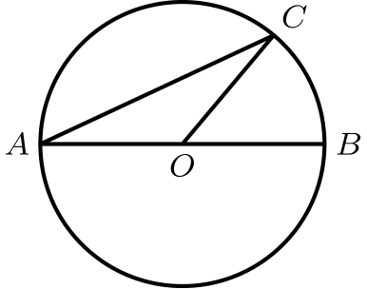
由于直径的两端与圆心在同一直线上，
∠ AOC = 180° - 50° = 130°。
△ AOC 是等腰三角形，所以
∠ CAO = (180° - 130°)/2 = 25°。
因为 ∠ CAB = ∠ CAO，所以 ∠ CAB = 25°。
所以正确答案是B。
English
Consider the following diagram:
We have that
∠ AOC = 180° - 50° = 130°.
Since △ AOC is isosceles, we have that
∠ CAO = (180° - 130°)/2 = 25°.
Since ∠ CAB = ∠ CAO, we have that ∠ CAB = 25°.
Thus,Bis the correct answer.
第 7 题 答案 D
为求三角形的面积，可以向长为 12 的边作高。
于是得到一个直角三角形，它的一条直角边为 12 ÷ 2 = 6，斜边为 10。
另一条直角边的长度为
√(10² - 6²) = √(64) = 8。
三角形面积为
(8 · 12)/2 = 48。
于是长方形的长为 48 ÷ 4 = 12。它的周长为
2(4 + 12) = 2 · 16 = 32。
所以正确答案是D。
English
To find the area of the triangle, we can drop the altitude to the side of length 12.
Then we have a right triangle with one leg 12 ÷ 2 = 6 and hypotenuse 10.
The other leg has length
√(10² - 6²) = √(64) = 8.
The area of the triangle is then
(8 · 12)/2 = 48.
The length of the rectangle is then 48 ÷ 4 = 12. Its perimeter is
2(4 + 12) = 2 · 16 = 32.
Thus,Dis the correct answer.
第 8 题 答案 E
x 必须同时整除 48 和 64，因此必须整除它们的最大公因数。
48 和 64 的最大公因数是 16，所以 x 必须整除 16。
16 有 5 个正因数，即 2 的不超过 16 的各个幂。
所以正确答案是E。
English
Note that x must divide both 48 and 64, which means that it must divide their greatest common divisor.
The greatest common divisor of 48 and 64 is 16, which means x divides 16.
16 has 5 factors, namely all the powers of 2 up to 16.
Thus,Eis the correct answer.
第 9 题 答案 D
忽略括号时，Larry 会得到
1 - 2 - 3 - 4 + e = e - 8。
按括号正确计算，
1 - (2 -(3 - (4 + e)))
= 1 - (2 - (-1 - e))
= 1 - (3 + e)
=-2 - e
。
两者相等，所以
e - 8 = -2 - e
e = 3。
所以正确答案是D。
English
Ignoring the parentheses, Larry would get
1 - 2 - 3 - 4 + e = e - 8.
Evaluating with the parentheses, one would get
1 - (2 -(3 - (4 + e)))
= 1 - (2 - (-1 - e))
= 1 - (3 + e)
=-2 - e.
Both of these values are the same, so
e - 8 = -2 - e
e = 3.
Thus,Dis the correct answer.
第 10 题 答案 C
40 分钟是 2/3 小时。设 Shelby 在晴天中骑了 h 小时。
则雨中骑了 2/3 - h 小时，所以总路程为
30h + 20(2/3 - h) = 10h + 40/3
英里。这个值等于 16，因此
10h + 40/3 = 16
h = 4/15。
因此雨中骑行时间为
60(2/3 - 4/15) = 60 · 2/5 = 24
分钟。
所以正确答案是C。
English
Note that 40 minutes is 2/3 hours. Let Shelby drive h hours in the sun.
Then she drives 2/3 - h hours in the rain, which means she travels a total of
30h + 20(2/3 - h) = 10h + 40/3
miles. We have this equals 16, so
10h + 40/3 = 16
h = 4/15.
Then Shelby drives
60(2/3 - 4/15) = 60 · 2/5 = 24
minutes in the rain.
Thus,Cis the correct answer.
第 11 题 答案 A
设商品标价为 p。优惠券 A 节省 0.15p，优惠券 B 节省 $ 30。
优惠券 C 节省
0.25(p - 100) = 0.25p - 25。
因此必须满足
0.15p ≥ 30
p ≥ 200
以及
0.15p ≥ 0.25p - 25
250 ≥ p。
这给出 x = 200、y = 250，所以 y - x = 50。
所以正确答案是A。
English
Let p be the price of the item. Then coupon A saves 0.15p. Coupon B saves $ 30.
Coupon C will save
0.25(p - 100) = 0.25p - 25.
We must have that
0.15p ≥ 30
p ≥ 200
and
0.15p ≥ 0.25p - 25
250 ≥ p.
This shows that x = 200 and y = 250. Therefore y - x = 50.
Thus,Ais the correct answer.
第 12 题 答案 D
为了最小化 x，尽量让学生保持原答案。
由于回答“是”的比例从百分之五十增到百分之七十，至少有 70 - 50 = 20 个百分点所对应的学生必须改变答案。
为了最大化 x，可以让所有原来回答“否”的学生都改成“是”，但最终仍需要百分之七十回答“是”。
这要求原来回答“是”的学生中有 70 - 50 = 20 个百分点仍回答“是”，所以原来回答“是”的百分之五十中，最多有 50 - 20 = 30 个百分点可以改变。
因此最多有 50 + 30 = 80 个百分点的学生改变答案。最大值与最小值之差为 80 - 20 = 60。
所以正确答案是D。
English
To minimize x, we want to have as many kids as possible maintain their answer.
We then need at least 70 - 50 = 20 percent of the students to change their answer.
To maximize x, we can have everybody that answered no change their answer, but some who answered yes must stay yes.
We need 70 - 50 = 20 percent of the people who said yes to stay yes, which means only 50 - 20 = 30 percent can switch.
This makes the maximum percent of students that can switch 50 + 30 = 80 percent. The difference is then 80 - 20 = 60.
Thus,Dis the correct answer.
第 13 题 答案 C
先处理外层绝对值。有两种可能：
x = 2x - |60 - 2x|
或
x = -2x + |60 - 2x|。
这两个方程分别化为
x = |60 - 2x|
和
3x = |60 - 2x|。
每个方程都有 2 种情况。第一个方程给出
x = 60 - 2x
和
x = 2x - 60。
分别求解得
3x = 60
x = 20
以及
-x = -60
x = 60。
第二个方程给出
3x = 60 - 2x
和
3x = 2x - 60。
再次分别求解，得
5x = 60
x = 12
和 x = -60。由于原方程右边非负，x 不能为负数。
所有解之和为
20 + 60 + 12 = 92。
所以正确答案是C。
English
We first take care of the outer absolute value. We have either
x = 2x - |60 - 2x|
or
x = -2x + |60 - 2x|.
These simplify to
x = |60 - 2x|
and
3x = |60 - 2x|.
We have 2 cases for each equation. For the first one, we have
x = 60 - 2x
and
x = 2x - 60.
Solving both gives us
3x = 60
x = 20
and
-x = -60
x = 60.
For the other equation, we have
3x = 60 - 2x
and
3x = 2x - 60.
Again solving both, we have
5x = 60
x = 12
and x = -60. Note that x cannot be negative since the right side of the original equation is nonnegative.
Adding up all the solutions gives us
20 + 60 + 12 = 92.
Thus,Cis the correct answer.
第 14 题 答案 B
前 n 个正整数的和为 (n(n + 1))/2。
因此有
((99 · 100)/2 + x)/100 = 100x，
化简得
99 · 50 = (100² - 1)x
= 101 · 99x，
所以 x = 50/101。
所以正确答案是B。
English
Recall that the sum of the first n integers is (n(n + 1))/2.
Then, we have that
((99 · 100)/2 + x)/100 = 100x,
which simplifies to
99 · 50 = (100² - 1)x
= 101 · 99x,
by difference of squares. Dividing gives us x = 50/101.
Thus,Bis the correct answer.
第 15 题 答案 C
设 Jesse 答对 x 题，答错 y 题。
因此必须同时满足
4x-y=99
和
x+y≤50。
我们有
y = 4x - 99
5x - 99 ≤ 50。
整理得 x ≤ 29.8。因为 x 是整数，所以最大值为 29。
所以正确答案是C。
English
Let x be the number of questions Jesse answered correctly and y be the number he answered incorrectly.
Then
4x-y=99
and
x+y≤50.
We have that
y = 4x - 99
5x - 99 ≤ 50.
Rearranging and simplifying tells us that x ≤ 29.8. Since x is an integer, its maximum value is 29.
Thus,Cis the correct answer.
第 16 题 答案 B
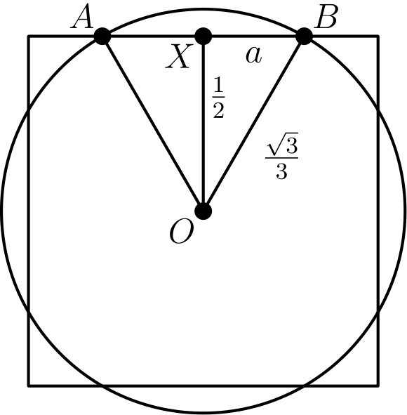
从 O 向 AB 作高，垂足为 X。
由边长关系，△ OBX 是 30-60-90 特殊直角三角形。
扇形 AOB 的面积为
1/6 · π · ((√(3))/3)² = π/18。
△ AOB 的面积为
1/2 · 2 · (√(3))/6 · 1/2 = (√(3))/12。
因此该边外、圆内的一个圆弓形面积为
π/18 - (√(3))/12。
这样的区域有 4 个，总面积为
4(π/18 - (√(3))/12) = 2π/9 - (√(3))/3。
所以正确答案是B。
English
Drop the altitude from O to AB at X.
Looking at the side lengths, we see that △ OBX is a 30-60-90 triangle.
This means that the area of sector AOB is
1/6 · π · ((√(3))/3)² = π/18.
We also have that the area of △ AOB is
1/2 · 2 · (√(3))/6 · 1/2 = (√(3))/12.
The area of the sector outside the square and inside the circle is then
π/18 - (√(3))/12.
There are 4 of these regions, which gives us a total area of
4(π/18 - (√(3))/12) = 2π/9 - (√(3))/3.
Thus,Bis the correct answer.
第 17 题 答案 B
设有 n 所学校，则比赛中共有 3n 名参赛者。
因为中位数是某一名学生的分数，3n 是奇数，所以 n 是奇数。Carla 排第 64 要求 3n≥64，因此奇数 n 至少为 23。
Andrea 的中位名次是 3n+1/2。因为她是队内最高分，所以名次在 Beth 之前，故 3n+1/2<37。这给出 3n<73，所以奇数 n 至多为 23。
因此共有 23 所学校。
所以正确答案是B。
English
Let there be n schools. Then there are 3n participants in the contest.
Because the median is one student’s score, 3n is odd, so n is odd. Carla’s 64th place requires 3n≥64, and hence the odd integer n is at least 23.
Andrea’s median place is 3n+1/2. Because she had the highest score on her team, she finished ahead of Beth, so 3n+1/2<37. This gives 3n<73, and therefore the odd integer n is at most 23.
Thus there are 23 schools.
Thus,Bis the correct answer.
第 18 题 答案 E
注意
abc + ab + a = a(bc + b + 1)。
因此若 a 能被 3 整除，整个表达式也能被它整除。
因为 2010 能被 3 整除，a 能被 3 整除的概率为 1/3。
现在考虑 a 不能被 3 整除的情况。要使表达式能被 3 整除，必须有 bc + b + 1 能被 3 整除。
这意味着
bc + b = b(c + 1) ≡ 2 pmod3。
唯一可能是一个因子为 2（模 3），另一个因子为 1（模 3）。
两种次序中的每一种，两个因子各有 1/3 的概率得到所需余数，因此概率为
1/3 · 1/3 = 1/9。
共有两种次序，所以这种情况的概率为 2/9。
总概率为
1/3 · 1 + 2/3 · 2/9 = 13/27。
所以正确答案是E。
English
Note that
abc + ab + a = a(bc + b + 1).
This means that if a is divisible by 3, the whole expression is as well.
Since 2010 is divisible by 3, we have that a is divisible by 3 with probability 1/3.
Now consider a not divisible by 3. For the expression to be divisible by 3, we must have that bc + b + 1 is divisible by 3.
This means that
bc + b = b(c + 1) ≡ 2 pmod3.
The only possibility for this is that one of the factors is 2 mod 3 and the other is 1 mod 3.
For each of the two cases, there is a 1/3 chance that each of the factors is the desired modulus, for a probability of
1/3 · 1/3 = 1/9.
There are two cases, which means that this happens with a 2/9 probability.
The total probability is then
1/3 · 1 + 2/3 · 2/9 = 13/27.
Thus,Eis the correct answer.
第 19 题 答案 B
参考下图：
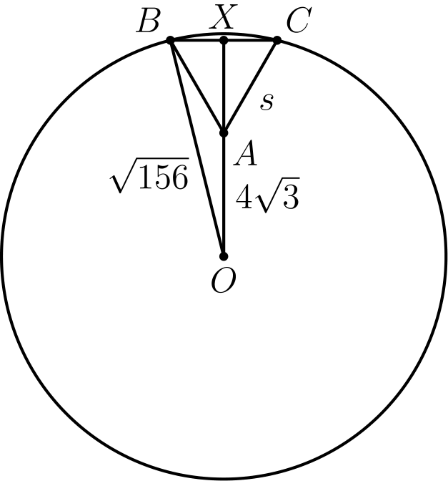
由圆面积公式可知 BO = √(156)，因为它是半径。
延长 AO 与 BC 交于 X。设 s 为 △ ABC 的边长。
于是
BX = s/2
且
AX = (s√(3))/2。
△ OXB 是直角三角形，所以
(√(156))² = (s/2)²
+ ((s√(3))/2 + 4√(3))²。
化简得
156 = s² + 12s + 48
s² + 12s - 108 = 0
(s - 6)(s + 18) = 0。
由于 s 为正，s = 6。
所以正确答案是B。
English
Consider the following diagram:
Using the formula for the area of a circle, we have that BO = √(156) since it is a radius.
Extend AO to intersect BC at X. Let s be the side length of △ ABC.
Then we have that
BX = s/2
and
AX = (s√(3))/2.
We have that △ OXB is right, which means that we can apply the Pythagorean Theorem. This gives us
(√(156))² = (s/2)²
+ ((s√(3))/2 + 4√(3))².
Simplifying, we get
156 = s² + 12s + 48
s² + 12s - 108 = 0
(s - 6)(s + 18) = 0.
Since s is positive, we must have that s = 6.
Thus,Bis the correct answer.
第 20 题 答案 D
参考下图：
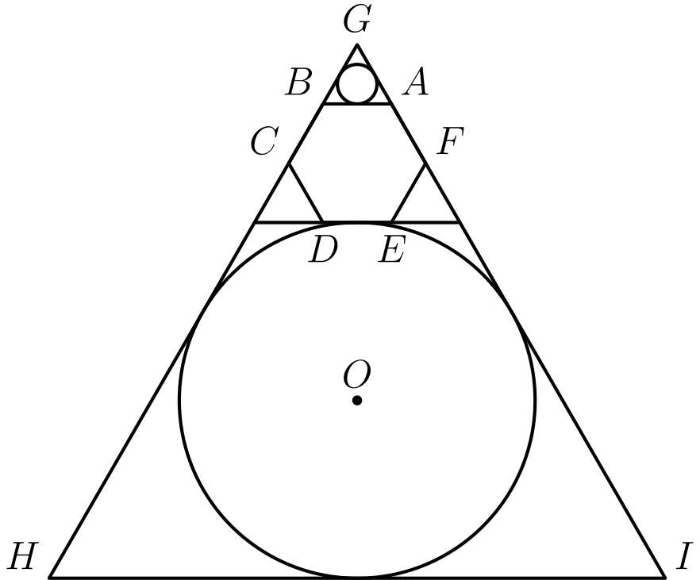
设正六边形边长为 1。较小圆内切于一个边长为 1 的等边三角形。
这个等边三角形的内切圆半径为 (√(3))/6。面积为
π · ((√(3))/6)² = π/12。
设较大圆圆心为 O，从 O 向 GH 作垂线，垂足为 J。并连接 OG。
△ OJG 是直角三角形，且由 ∠ HGI = 60° 可知，△ OJG 是 30-60-90 三角形。
设 OJ = r，则 OG = 2r。又 OG 等于正六边形的高、等边三角形的高与圆半径之和。
于是
OG = (√(3))/2 + √(3) + r。
代入 OG，得
2r = (√(3))/2 + √(3) + r。
化简得
r = (3√(3))/2。
较大圆面积为
π · ((3√(3))/2)² = 27/4π。
所求比值为
(27π/4)/(π/12) = 81。
所以正确答案是D。
English
Consider the following diagram:
Assume the regular hexagon has side length 1. The smaller circle is inscribed in an equilateral triangle of side length 1.
The inradius of this equilateral triangle is (√(3))/6. The area of the circle is then
π · ((√(3))/6)² = π/12.
Let O be the center of the larger circle. Drop the perpendicular from O to GH at J. Draw OG.
We have that △ OJG is right. Since ∠ HGI = 60°, we also have that △ OJG is a 30-60-90 triangle.
Let OJ = r. Then OG = 2r. We also have that OG is the sum of the height of the hexagon, equilateral triangle, and radius of the circle.
Then
OG = (√(3))/2 + √(3) + r.
Substituting in OG, we get
2r = (√(3))/2 + √(3) + r.
Simplifying gives us
r = (3√(3))/2.
The area of the larger circle is then
π · ((3√(3))/2)² = 27/4π.
The desired ratio is then
(27π/4)/(π/12) = 81.
Thus,Dis the correct answer.
第 21 题 答案 E
任意一个 4 位数都可写成 abcd，展开后为
10³a + 10²b + 10c + d。
对回文数，a = d 且 b = c，所以可化为
1001a + 110b。
因为 1001 能被 7 整除，所以还需要 110b 能被 7 整除。
只有 b 为 0 或 7 时才可能成立，因为 110 不能被 7 整除。
有 9 种 a 和 2 种 b，符合条件的回文数共有 9 · 2 = 18 个。
四位回文数总数为 9 · 10，因为千位有 9 种选择、百位有 10 种选择。
所求概率为
18/(9 · 10) = 1/5。
所以正确答案是E。
English
Note that we can express any 4 digit number as abcd. This can be expressed in long form as
10³a + 10²b + 10c + d.
Since in a palindrome, we have that a = d and b = c. We can simplify this to get
1001a + 110b.
Note that 1001 is divisible by 7. This means that 110b must also be divisible by 7.
The only way for this to happen is if b is 0 or 7 since 110 is not divisible by 7.
There are 9 options for a and 2 options for b, for a total of 9 · 2 = 18 palindromes.
The total number of palindromes is 9 · 10 since there are 9 options for the thousands digit and 10 options for the hundreds digit.
The desired probability is then
18/(9 · 10) = 1/5.
Thus,Eis the correct answer.
第 22 题 答案 C
可以用补集计数。无限制地分配糖果的方法总数为
3⁷ = 2187。
要数无效安排，需要考虑红袋或蓝袋为空的情况。
若红袋为空，则每块糖只有 2 个袋子可选，共
2⁷ = 128
种安排。蓝袋为空也同样有 128 种。
这两类有一个重叠情况：红袋和蓝袋都为空。因此有效分法的数量为
2187 - (128 + 128 - 1) = 1932。
所以正确答案是C。
English
We can count this with complementary counting. The total number of ways to distribute the candies with no restrictions is
3⁷ = 2187.
To find the number of invalid arrangements, we have to count the number of ways where either the red or blue bag is empty.
For the case where the red bag is empty, each candy has 2 options for the bag that goes into. There are then
2⁷ = 128
arrangements for this case. Similarly, there are 128 arrangements for the case where the blue bag is empty.
There is an overlap of one case where both bags are empty. The final answer is then
2187 - (128 + 128 - 1) = 1932.
Thus,Cis the correct answer.
第 23 题 答案 D
设 aᵢⱼ 表示第 i 行、第 j 列的数。递增条件迫使 a₁₁=1、a₃₃=9，而 a₂₂ 只能是 4、5 或 6。
若 a₂₂=4，则 {a₁₂,a₂₁}={2,3}。从 5、6、7 和 8 中选两个放入左下方的一对位置 {a₃₁,a₃₂}；另外两个放入右上方的一对位置 {a₁₃,a₂₃}。每一对都只有一种递增排列。因此共有 2C(4, 2)=12 个数阵：左上角周围的 2、3 有两种次序，左下方的一对有 C(4, 2) 种选择。把各数反向并旋转数阵，同样有 12 个中心为 6 的数阵。
若 a₂₂=5，选择位置 a₁₂、a₁₃ 和 a₂₃ 中的三个数。它们可以是 {2,3,4,6,7,8} 的任意三元子集，但不能是 {2,3,4} 或 {6,7,8}；因为这两种选择会把三个小数或三个大数全放在中心的一侧，从而违反与中心数的必要大小关系。其余每一种选择都唯一确定剩余各数及其递增次序。因此共有 C(6, 3)-2=18 个数阵。
总数为 12+18+12=42。
所以正确答案是D。
English
Let aᵢⱼ be the entry in row i and column j. The increasing conditions force a₁₁=1, a₃₃=9, and a₂₂ to be 4, 5, or 6.
If a₂₂=4, then {a₁₂,a₂₁}={2,3}. Choose which two of 5, 6, 7, and 8 go in the bottom-left pair {a₃₁,a₃₂}; the other two go in the top-right pair {a₁₃,a₂₃}. Each pair then has only one increasing order. There are 2C(4, 2)=12 arrays: two orders for 2, 3 around the upper-left corner and C(4, 2) choices for the bottom-left pair. By reversing the digits and rotating the array, there are also 12 arrays with center 6.
If a₂₂=5, choose the three entries in positions a₁₂, a₁₃, and a₂₃. They can be any three of {2,3,4,6,7,8} except {2,3,4} or {6,7,8}; those two choices would put all three small or all three large entries on one side and violate a required comparison with the center. Every other choice uniquely determines the remaining entries and their increasing orders. This gives C(6, 3)-2=18 arrays.
The total is 12+18+12=42.
Thus,Dis the correct answer.
第 24 题 答案 E
设两队第一节得分均为 a。设 Raiders 的公比为 r，Wildcats 的公差为 d。
将 r=m/n 写成最简分数。由于 Raiders 四节得分都是整数，a=n³A，其中 A 为正整数，且总分为 A(n³+n²m+nm²+m³)≤100，所以只需检查 3/2,2,3,4。
对 r=3/2 或 r=4，Raiders 的可行总分无法使 Wildcats 总分成为 4a+6d 的形式。对 r=3，方程 40a=4a+6d+1 模 6 不可能。
对 r=2，方程为 15a=4a+6d+1，所以 11a=6d+1。总分不超过 100 的唯一正整数解是 a=5,d=9。
上半场总分为 5+10+5+14=34。
所以正确答案是E。
English
Let the first-quarter score for each team be a. Let the Raiders have common ratio r and let the Wildcats have common difference d.
Write r=m/n in lowest terms. Since the Raiders’ four quarter scores are integers, a=n³A for some positive integer A, and their total is A(n³+n²m+nm²+m³)≤100. Thus the only possible ratios are 3/2,2,3,4.
For r=3/2 or r=4, the only possible Raiders totals give Wildcats totals that are not of the form 4a+6d. For r=3, the equation 40a=4a+6d+1 is impossible modulo 6.
For r=2, the equation is 15a=4a+6d+1, so 11a=6d+1. The only positive solution with total at most 100 is a=5,d=9.
The first-half total is 5+10+5+14=34.
Thus,Eis the correct answer.
第 25 题 答案 B
因为 1、3、5 和 7 是 P(x)-a 的根，可写成 P(x)-a=(x-1)(x-3) ·(x-5)(x-7)Q(x)，其中 Q(x) 也有整数系数。
将 2、4、6 和 8 代入 x，得到 -2a=-15Q(2) =9Q(4) =-15Q(6) =105Q(8)。因此 a 必须是 lcm(15,9,105)=315 的倍数。
这个下界可以达到：取 Q(x)=42 +(x-2)(x-6)(60-8x)，并定义 P(x)=315 +(x-1)(x-3) ·(x-5)(x-7)Q(x)。该多项式有整数系数并满足所有要求。
所以正确答案是B。
English
Because 1, 3, 5, and 7 are roots of P(x)-a, write P(x)-a=(x-1)(x-3) ·(x-5)(x-7)Q(x), where Q(x) has integer coefficients.
Substituting 2, 4, 6, and 8 for x gives -2a=-15Q(2) =9Q(4) =-15Q(6) =105Q(8). Hence a must be a multiple of lcm(15,9,105)=315.
This lower bound is attainable: take Q(x)=42 +(x-2)(x-6)(60-8x) and define P(x)=315 +(x-1)(x-3) ·(x-5)(x-7)Q(x). This polynomial has integer coefficients and satisfies the required values.
Thus,Bis the correct answer.

