2009A AMC 10 真题与解答
American Mathematics Competitions 10 · 中英双语
共 25 题，限时 75 分钟；答对得 6 分，未答得 1.5 分，答错 0 分，满分 150 分。
编排说明：第一部分为题目（先中文、后英文原题），第二部分为解答与答案，便于先做题后对答案。
第一部分 题目
第 1 题
一罐汽水有 12 盎司。要提供一加仑（128 盎司）汽水，至少需要多少罐？
（A）7 （B）8 （C）9 （D）10 （E）11
English
One can holds 12 ounces of soda. What is the minimum number of cans needed to provide a gallon (128 ounces) of soda?
(A) 7 (B) 8 (C) 9 (D) 10 (E) 11
第 2 题
从一个储钱罐中取出四枚硬币。储钱罐里有一分币、五分币、一角币和二十五分币。以下哪一个数值不可能是这四枚硬币的总价值，单位为美分？
（A）15 （B）25 （C）35 （D）45 （E）55
English
Four coins are picked out of a piggy bank that contains a collection of pennies, nickels, dimes, and quarters. Which of the following couldnotbe the total value of the four coins, in cents?
(A) 15 (B) 25 (C) 35 (D) 45 (E) 55
第 3 题
下列哪一项等于
1 + 1/(1 + 1/(1 + 1))？
（A）5/4 （B）3/2 （C）5/3 （D）2 （E）3
English
Which of the following is equal to
1 + 1/(1 + 1/(1 + 1))?
(A) 5/4 (B) 3/2 (C) 5/3 (D) 2 (E) 3
第 4 题
Eric 计划参加铁人三项。他在 1/4 英里的游泳中平均速度为每小时 2 英里，在 3 英里的跑步中平均速度为每小时 6 英里。他的目标是在 2 小时内完成比赛。为了达到目标，他在 15 英里自行车赛段的平均速度必须是多少英里每小时？
（A）120/11 （B）11 （C）56/5 （D）45/4 （E）12
English
Eric plans to compete in a triathlon. He can average 2 miles per hour in the 1/4-mile swim and 6 miles per hour in the 3-mile run. His goal is to finish the triathlon in 2 hours. To accomplish his goal what must his average speed, in miles per hour, be for the 15-mile bicycle ride?
(A) 120/11 (B) 11 (C) 56/5 (D) 45/4 (E) 12
第 5 题
111,111,111 的平方的各位数字之和是多少？
（A）18 （B）27 （C）45 （D）63 （E）81
English
What is the sum of the digits of the square of 111,111,111?
(A) 18 (B) 27 (C) 45 (D) 63 (E) 81
第 6 题
如图所示，一个半径为 2 的圆内切于一个半圆。半圆内但圆外的部分被涂阴影。阴影部分占半圆面积的几分之几？
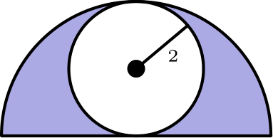
（A）1/2 （B）π/6 （C）2/π （D）2/3 （E）3/π
English
A circle of radius 2 is inscribed in a semicircle, as shown. The area inside the semicircle but outside the circle is shaded. What fraction of the semicircle’s area is shaded?
(A) 1/2 (B) π/6 (C) 2/π (D) 2/3 (E) 3/π
第 7 题
一盒牛奶含 2% 脂肪，这比一盒全脂牛奶所含脂肪少 40%。全脂牛奶的脂肪百分比是多少？
（A）12/5 （B）3 （C）10/3 （D）38 （E）42
English
A carton contains milk that is 2% fat, an amount that is 40% less fat than the amount contained in a carton of whole milk. What is the percentage of fat in whole milk?
(A) 12/5 (B) 3 (C) 10/3 (D) 38 (E) 42
第 8 题
Wen 家三代人去看电影，每一代有两人。最年轻一代的两人作为儿童享受 50% 折扣。最年长一代的两人作为老人享受 25% 折扣。中间一代的两人没有折扣。Wen 祖父的一张老人票价为 $6.00，他要为所有人付钱。他一共要付多少美元？
（A）34 （B）36 （C）42 （D）46 （E）48
English
Three generations of the Wen family are going to the movies, two from each generation. The two members of the youngest generation receive a 50% discount as children. The two members of the oldest generation receive a 25% discount as senior citizens. The two members of the middle generation receive no discount. Grandfather Wen, whose senior ticket costs $6.00, is paying for everyone. How many dollars must he pay?
(A) 34 (B) 36 (C) 42 (D) 46 (E) 48
第 9 题
正整数 a、b 和 2009 满足 a < b < 2009，并且按这个顺序组成一个公比为整数的等比数列。求 a 的值。
（A）7 （B）41 （C）49 （D）287 （E）2009
English
Positive integers a, b, and 2009, with a < b < 2009, form a geometric sequence with an integer ratio. What is a?
(A) 7 (B) 41 (C) 49 (D) 287 (E) 2009
第 10 题
三角形 ABC 在 B 处为直角。点 D 是从 B 向斜边作高的垂足，且 AD = 3、DC = 4。△ ABC 的面积是多少？
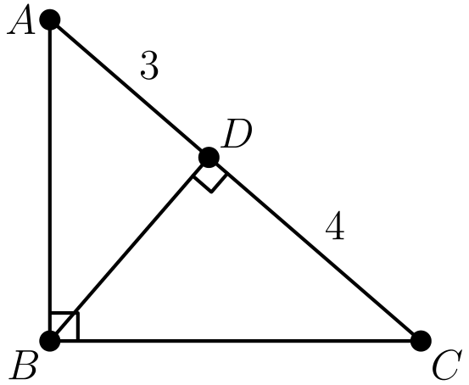
（A）4√(3) （B）7√(3) （C）21 （D）14√(3) （E）42
English
Triangle ABC has a right angle at B. Point D is the foot of the altitude from B, AD = 3, and DC = 4. What is the area of △ ABC?
(A) 4√(3) (B) 7√(3) (C) 21 (D) 14√(3) (E) 42
第 11 题
一个立方体的一条边增加 1，另一条边减少 1，第三条边不变。新的长方体体积比原立方体体积少 5。原立方体的体积是多少？
（A）8 （B）27 （C）64 （D）125 （E）216
English
One dimension of a cube is increased by 1, another is decreased by 1, and the third is left unchanged. The volume of the new rectangular solid is 5 less than that of the cube. What was the volume of the cube?
(A) 8 (B) 27 (C) 64 (D) 125 (E) 216
第 12 题
在四边形 ABCD 中，AB = 5、BC = 17、CD = 5、DA = 9，且 BD 是整数。BD 是多少？
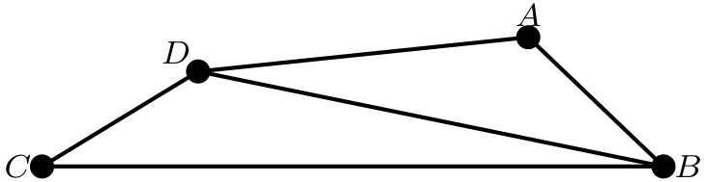
（A）11 （B）12 （C）13 （D）14 （E）15
English
In quadrilateral ABCD, AB = 5, BC = 17, CD = 5, DA = 9, and BD is an integer. What is BD?
(A) 11 (B) 12 (C) 13 (D) 14 (E) 15
第 13 题
设 P = 2ᵐ、Q = 3ⁿ。下列哪一项对任意整数对 (m, n) 都等于 12ᵐⁿ？
（A）P² Q （B）Pⁿ Qᵐ （C）Pⁿ Q²ᵐ （D）P²ᵐ Qⁿ （E）P²ⁿ Qᵐ
English
Suppose that P = 2ᵐ and Q = 3ⁿ. Which of the following is equal to 12ᵐⁿ for every pair of integers (m, n)?
(A) P² Q (B) Pⁿ Qᵐ (C) Pⁿ Q²ᵐ (D) P²ᵐ Qⁿ (E) P²ⁿ Qᵐ
第 14 题
四个全等的长方形如图摆放。外部正方形的面积是内部正方形面积的 4 倍。每个长方形长边与短边的比是多少？
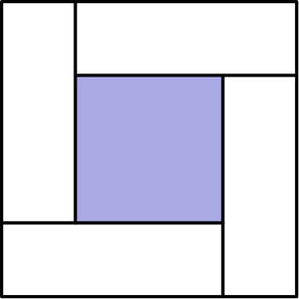
（A）3 （B）√(10) （C）2 + √(2) （D）2√(3) （E）4
English
Four congruent rectangles are placed as shown. The area of the outer square is 4 times that of the inner square. What is the ratio of the length of the longer side of each rectangle to the length of its shorter side?
(A) 3 (B) √(10) (C) 2 + √(2) (D) 2√(3) (E) 4
第 15 题
图中的 F₁、F₂、F₃ 和 F₄ 是一个图形序列的前几项。当 n ≥ 3 时，Fₙ 由 Fₙ₋₁ 构造而成：在它外面围上一个正方形，并且新正方形每条边上的菱形数量比 Fₙ₋₁ 外部正方形每条边上的菱形数量多一个。例如，图形 F₃ 有 13 个菱形。图形 F₂₀ 中有多少个菱形？
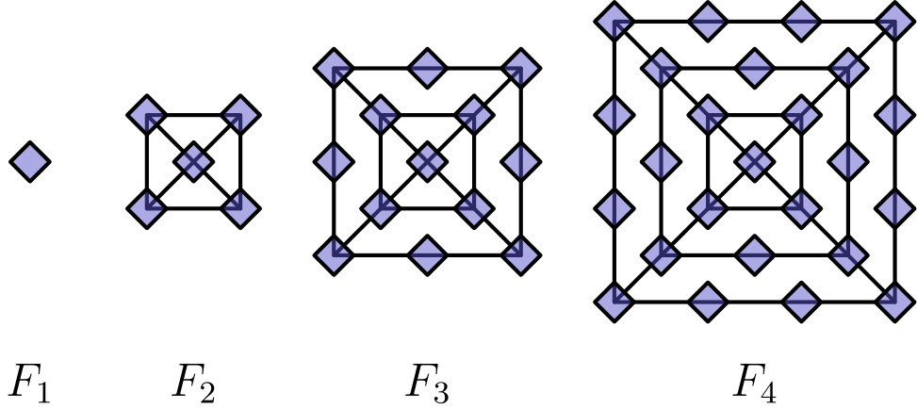
（A）401 （B）485 （C）585 （D）626 （E）761
English
The figures F₁, F₂, F₃, and F₄ shown are the first in a sequence of figures. For n ≥ 3, Fₙ is constructed from Fₙ₋₁ by surrounding it with a square and placing one more diamond on each side of the new square than Fₙ₋₁ had on each side of its outside square. For example, figure F₃ has 13 diamonds. How many diamonds are there in figure F₂₀?
(A) 401 (B) 485 (C) 585 (D) 626 (E) 761
第 16 题
设 a、b、c、d 为实数，且 |a - b| = 2、|b - c| = 3、|c - d| = 4。|a - d| 所有可能值的和是多少？
（A）9 （B）12 （C）15 （D）18 （E）24
English
Let a, b, c, and d be real numbers with |a - b| = 2, |b - c| = 3, and |c - d| = 4. What is the sum of all possible values of |a - d|?
(A) 9 (B) 12 (C) 15 (D) 18 (E) 24
第 17 题
长方形 ABCD 中，AB = 4，BC = 3。过 B 作线段 EF，使得 EF ⊥ DB，并且 A 和 C 分别在 DE 和 DF 上。EF 是多少？
（A）9 （B）10 （C）125/12 （D）103/9 （E）12
English
Rectangle ABCD has AB = 4 and BC = 3. Segment EF is constructed through B so that EF ⊥ DB, and A and C lie on DE and DF, respectively. What is EF?
(A) 9 (B) 10 (C) 125/12 (D) 103/9 (E) 12
第 18 题
在 Jefferson 夏令营，60% 的孩子踢足球，30% 的孩子游泳，并且 40% 的足球队员游泳。四舍五入到最接近的整数百分比，不游泳的孩子中有百分之多少踢足球？
（A）30% （B）40% （C）49% （D）51% （E）70%
English
At Jefferson Summer Camp, 60% of the children play soccer, 30% of the children swim, and 40% of the soccer players swim. To the nearest whole percent, what percent of the non-swimmers play soccer?
(A) 30% (B) 40% (C) 49% (D) 51% (E) 70%
第 19 题
圆 A 的半径为 100。圆 B 的半径 r < 100 是整数，并且在圆 A 内部相切地沿圆 A 的圆周滚动一圈。圆 B 旅程开始和结束时，两圆有相同的切点。r 可能有多少个值？
（A）4 （B）8 （C）9 （D）50 （E）90
English
Circle A has radius 100. Circle B has an integer radius r < 100 and remains internally tangent to circle A as it rolls once around the circumference of circle A. The two circles have the same points of tangency at the beginning and end of circle B’s trip. How many possible values can r have?
(A) 4 (B) 8 (C) 9 (D) 50 (E) 90
第 20 题
Andrea 和 Lauren 相距 20 千米。她们骑自行车相向而行，其中 Andrea 的速度是 Lauren 的三倍，两人之间的距离以每分钟 1 千米的速度缩短。5 分钟后，Andrea 因爆胎停止骑行并等待 Lauren。从她们开始骑车算起，Lauren 过多少分钟到达 Andrea 所在位置？
（A）20 （B）30 （C）55 （D）65 （E）80
English
Andrea and Lauren are 20 kilometers apart. They bike toward one another with Andrea traveling three times as fast as Lauren, and the distance between them decreasing at a rate of 1 kilometer per minute. After 5 minutes, Andrea stops biking because of a flat tire and waits for Lauren. After how many minutes from the time they started to bike does Lauren reach Andrea?
(A) 20 (B) 30 (C) 55 (D) 65 (E) 80
第 21 题
许多哥特式大教堂的窗户中，有一些部分含有一圈全等小圆，并由一个大圆外接。在图中，小圆的数量为四个。四个小圆的面积之和与大圆面积的比是多少？
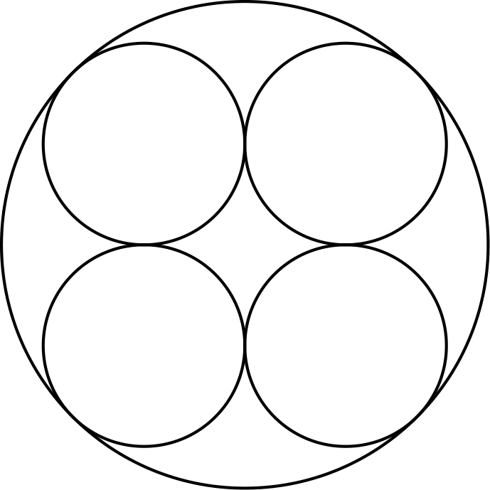
（A）3 - 2√(2) （B）2 - √(2) （C）4(3 - 2√(2)) （D）1/2(3 - √(2)) （E）2√(2) - 2
English
Many Gothic cathedrals have windows with portions containing a ring of congruent circles that are circumscribed by a larger circle. In the figure shown, the number of smaller circles is four. What is the ratio of the sum of the areas of the four smaller circles to the area of the larger circle?
(A) 3 - 2√(2) (B) 2 - √(2) (C) 4(3 - 2√(2)) (D) 1/2(3 - √(2)) (E) 2√(2) - 2
第 22 题
两个立方体骰子各有可拆卸的数字 1 到 6。把两个骰子上的十二个数字拆下放入袋中，然后一次抽出一个，随机重新贴到两个立方体的面上，每面贴一个数字。随后掷这两个骰子，并把两个顶面上的数字相加。和为 7 的概率是多少？
（A）1/9 （B）1/8 （C）1/6 （D）2/11 （E）1/5
English
Two cubical dice each have removable numbers 1 through 6. The twelve numbers on the two dice are removed, put into a bag, then drawn one at a time and randomly reattached to the faces of the cubes, one number to each face. The dice are then rolled and the numbers on the two top faces are added. What is the probability that the sum is 7?
(A) 1/9 (B) 1/8 (C) 1/6 (D) 2/11 (E) 1/5
第 23 题
凸四边形 ABCD 满足 AB = 9、CD = 12。对角线 AC 和 BD 交于 E，AC = 14，并且 △ AED 与 △ BEC 面积相等。AE 是多少？
（A）9/2 （B）50/11 （C）21/4 （D）17/3 （E）6
English
Convex quadrilateral ABCD has AB = 9 and CD = 12. Diagonals AC and BD intersect at E, AC = 14, and △ AED and △ BEC have equal areas. What is AE?
(A) 9/2 (B) 50/11 (C) 21/4 (D) 17/3 (E) 6
第 24 题
从一个立方体的顶点中随机选择三个不同顶点。由这三个顶点确定的平面包含立方体内部点的概率是多少？
（A）1/4 （B）3/8 （C）4/7 （D）5/7 （E）3/4
English
Three distinct vertices of a cube are chosen at random. What is the probability that the plane determined by these three vertices contains points inside the cube?
(A) 1/4 (B) 3/8 (C) 4/7 (D) 5/7 (E) 3/4
第 25 题
对 k > 0，令 Iₖ = 10…064，其中 1 和 6 之间有 k 个零。设 N(k) 为 Iₖ 的质因数分解中因数 2 的个数。N(k) 的最大值是多少？
（A）6 （B）7 （C）8 （D）9 （E）10
English
For k > 0, let Iₖ = 10…064, where there are k zeros between the 1 and the 6. Let N(k) be the number of factors of 2 in the prime factorization of Iₖ. What is the maximum value of N(k)?
(A) 6 (B) 7 (C) 8 (D) 9 (E) 10

第二部分 解答
答案速查：
题号 1 2 3 4 5 6 7 8 9
答案 E A C A E A C B B
题号 10 11 12 13 14 15 16 17 18
答案 B D C E A E D C D
题号 19 20 21 22 23 24 25
答案 B D C D E C B
答案串：EACAEACBBBDCEAEDCDBDCDECB
第 1 题 答案 E
因为 128/12 = 102/3，十罐只能装 120 盎司，不够。
因此需要 11 罐。
所以正确答案是E。
English
Since 128/12 = 102/3, ten cans hold only 120 ounces, which is not enough.
Therefore 11 cans are needed.
Thus, the correct answer isE.
第 2 题 答案 A
要得到 5 的倍数美分，一分币的数量必须是 5 的倍数。只有四枚硬币时，这意味着不能有一分币；但此时每枚硬币至少值 5 美分，总值至少为 20 美分。
所以 15 美分无法得到。其他金额都可以组成：25 = 10 + 3(5)，35 = 3(10) + 5，45 = 25 + 10 + 2(5)，以及 55 = 25 + 3(10)。
所以正确答案是A。
English
To get a multiple of 5 cents, the number of pennies must be a multiple of 5. With only four coins, that means using no pennies, but then the four coins are each worth at least 5 cents, for a total of at least 20 cents.
So 15 cents cannot be made. The others can: 25 = 10 + 3(5), 35 = 3(10) + 5, 45 = 25 + 10 + 2(5), and 55 = 25 + 3(10).
Thus, the correct answer isA.
第 3 题 答案 C
从内向外计算，
1 + 1/(1 + 1/(1 + 1))
= 1 + 1/(1 + 1/2)
= 1 + 1/(3/2)
= 1 + 2/3 = 5/3
。
所以正确答案是C。
English
Working outward,
1 + 1/(1 + 1/(1 + 1))
= 1 + 1/(1 + 1/2)
= 1 + 1/(3/2)
= 1 + 2/3 = 5/3.
Thus, the correct answer isC.
第 4 题 答案 A
游泳用时 (1/4)/2 = 1/8 小时，跑步用时 3/6 = 1/2 小时。这给自行车赛段留下
2 - 1/8 - 1/2 = 11/8
小时。
所需平均速度为
15/(11/8) = 120/11
英里/小时。
所以正确答案是A。
English
The swim takes (1/4)/2 = 1/8 hour and the run takes 3/6 = 1/2 hour. This leaves
2 - 1/8 - 1/2 = 11/8
hours for the bicycle ride.
His average speed must be
15/(11/8) = 120/11
miles per hour.
Thus, the correct answer isA.
第 5 题 答案 E
这个各位都是一的九位数的平方是回文数
111,111,111²
= 12,345,678,987,654,321
。
它的各位数字依次为 1, 2, …, 9, 8, …, 1，所以数字和为
2(1 + 2 + ⋯ + 8) + 9
= 2 · 36 + 9 = 81
。
所以正确答案是E。
English
The square of the nine-digit repunit is the palindrome
111,111,111²
= 12,345,678,987,654,321.
Its digits are 1, 2, …, 9, 8, …, 1, so the sum is
2(1 + 2 + ⋯ + 8) + 9
= 2 · 36 + 9 = 81.
Thus, the correct answer isE.
第 6 题 答案 A
内切圆落在直径上并与半圆弧相切，所以半圆的半径是 4。半圆面积为
1/2 π (4)² = 8π。
小圆面积为 π(2)² = 4π，所以阴影面积为 8π - 4π = 4π。
阴影部分占半圆的比例为 4π/8π = 1/2。
所以正确答案是A。
English
The inscribed circle rests on the diameter and is tangent to the arc, so the semicircle has radius 4. Its area is
1/2 π (4)² = 8π.
The circle’s area is π(2)² = 4π, so the shaded area is 8π - 4π = 4π.
The shaded fraction is 4π/8π = 1/2.
Thus, the correct answer isA.
第 7 题 答案 C
设全脂牛奶含脂肪 x%。因为 2 比 x 少 40%，所以
0.6x = 2，
从而
x = 2/0.6 = 10/3。
所以正确答案是C。
English
Let whole milk be x% fat. Since 2 is 40% less than x, we have
0.6x = 2,
so
x = 2/0.6 = 10/3.
Thus, the correct answer isC.
第 8 题 答案 B
老人票价为 $6，这是全价的 3/4，所以全价票为 4/3 · 6 = $8，儿童票为 1/2 · 8 = $4。
总价为
2(6 + 8 + 4) = $36。
所以正确答案是B。
English
The senior ticket costs $6, which is 3/4 of the full price, so a full ticket costs 4/3 · 6 = $8, and a child ticket costs 1/2 · 8 = $4.
The total is
2(6 + 8 + 4) = $36.
Thus, the correct answer isB.
第 9 题 答案 B
设公比为 r。则 a r² = 2009 = 7² · 41。
因为 r 必须是大于 1 的整数，唯一可能是 r = 7，从而 a = 41，数列为 41, 287, 2009。
所以正确答案是B。
English
Let the common ratio be r. Then a r² = 2009 = 7² · 41.
Since r must be an integer greater than 1, the only possibility is r = 7, giving a = 41 and the sequence 41, 287, 2009.
Thus, the correct answer isB.
第 10 题 答案 B
对直角三角形中从直角顶点到斜边的高，有
BD² = AD · DC = 3 · 4 = 12，
所以 BD = 2√(3)。
斜边满足 AC = 3 + 4 = 7，所以面积为
1/2 · 7 · 2√(3) = 7√(3)。
所以正确答案是B。
English
For the altitude from the right angle to the hypotenuse,
BD² = AD · DC = 3 · 4 = 12,
so BD = 2√(3).
The hypotenuse is AC = 3 + 4 = 7, so the area is
1/2 · 7 · 2√(3) = 7√(3).
Thus, the correct answer isB.
第 11 题 答案 D
设立方体边长为 x。新长方体的体积为
x(x+1)(x-1) = x³ - x。
新长方体的体积为 x³ - 5，所以 x³ - x = x³ - 5，得到 x = 5。
原立方体体积为 5³ = 125。
所以正确答案是D。
English
Let the cube have side length x. The new solid has volume
x(x+1)(x-1) = x³ - x.
Setting this equal to x³ - 5 gives x³ - x = x³ - 5, so x = 5.
The cube’s volume is 5³ = 125.
Thus, the correct answer isD.
第 12 题 答案 C
在 △ BCD 中，三角形不等式给出 5 + BD > 17，所以 BD > 12。
在 △ ABD 中，三角形不等式给出 5 + 9 > BD，所以 BD < 14。
唯一满足 12 < BD < 14 的整数是 BD = 13。
所以正确答案是C。
English
In △ BCD, the triangle inequality gives 5 + BD > 17, so BD > 12.
In △ ABD, it gives 5 + 9 > BD, so BD < 14.
The only integer with 12 < BD < 14 is BD = 13.
Thus, the correct answer isC.
第 13 题 答案 E
因为 12 = 2² · 3，
12ᵐⁿ = 2²ᵐⁿ · 3ᵐⁿ
= (2ᵐ)²ⁿ · (3ⁿ)ᵐ
= P²ⁿ Qᵐ
。
所以正确答案是E。
English
Since 12 = 2² · 3,
12ᵐⁿ = 2²ᵐⁿ · 3ᵐⁿ
= (2ᵐ)²ⁿ · (3ⁿ)ᵐ
= P²ⁿ Qᵐ.
Thus, the correct answer isE.
第 14 题 答案 A
设每个长方形短边为 x、长边为 y。外部正方形边长为 y + x，内部正方形边长为 y - x。
因为面积比为 4，所以边长比为 2，于是
y + x = 2(y - x)，
得到 y = 3x。
长边与短边的比为 y/x = 3。
所以正确答案是A。
English
Let each rectangle have shorter side x and longer side y. The outer square has side length y + x and the inner square has side length y - x.
Since the area ratio is 4, the side ratio is 2, so
y + x = 2(y - x),
which gives y = 3x.
The ratio of longer to shorter side is y/x = 3.
Thus, the correct answer isA.
第 15 题 答案 E
从 Fₙ₋₁ 到 Fₙ，新的外部正方形带来 4(n-1) 个菱形。从 F₁ 的单个菱形开始，
Fₙ = 1
+ 4(1 + 2 + ⋯ + (n-1))
= 1 + 4 · ((n-1)n)/2
= 1 + 2n(n-1)
。
因此
F₂₀ = 1 + 2 · 20 · 19 = 761。
所以正确答案是E。
English
Going from Fₙ₋₁ to Fₙ, the new outside square carries 4(n-1) diamonds. Starting from the single diamond of F₁,
Fₙ = 1
+ 4(1 + 2 + ⋯ + (n-1))
= 1 + 4 · ((n-1)n)/2
= 1 + 2n(n-1).
Therefore
F₂₀ = 1 + 2 · 20 · 19 = 761.
Thus, the correct answer isE.
第 16 题 答案 D
因为 a - d = (a-b) + (b-c) + (c-d) = ± 2 ± 3 ± 4，所以可能的绝对值为
2+3+4 = 9,
2+3-4 = 1,
2-3+4 = 3,
-2+3+4 = 5
。
它们的和为 9 + 1 + 3 + 5 = 18。
所以正确答案是D。
English
Since a - d = (a-b) + (b-c) + (c-d) = ± 2 ± 3 ± 4, the possible absolute values are
2+3+4 = 9,
2+3-4 = 1,
2-3+4 = 3,
-2+3+4 = 5.
Their sum is 9 + 1 + 3 + 5 = 18.
Thus, the correct answer isD.
第 17 题 答案 C
对角线 DB = √(4² + 3²) = 5。
直角三角形 EBA、DBC 和 BFC 都与 △ DBA 相似。由 △ EBA，
EB/AB = DB/BC
implies EB/4 = 5/3
implies EB = 20/3
。
由 △ BFC，
BF/BC = DB/AB
implies BF/3 = 5/4
implies BF = 15/4
。
因此
EF = EB + BF
= 20/3 + 15/4
= 125/12
。
所以正确答案是C。
English
The diagonal is DB = √(4² + 3²) = 5.
Right triangles EBA, DBC, and BFC are all similar to △ DBA. From △ EBA,
EB/AB = DB/BC
implies EB/4 = 5/3
implies EB = 20/3.
From △ BFC,
BF/BC = DB/AB
implies BF/3 = 5/4
implies BF = 15/4.
Therefore
EF = EB + BF
= 20/3 + 15/4
= 125/12.
Thus, the correct answer isC.
第 18 题 答案 D
假设有 100 个孩子：60 人踢足球，其中 40%，也就是 24 人，同时游泳。所以 60 - 24 = 36 名足球队员不游泳。
共有 30 名游泳者和 70 名不游泳者，因此不游泳者中踢足球的比例为
36/70 ≈ 0.514 ≈ 51%。
所以正确答案是D。
English
Take 100 children: 60 play soccer, and 40% of them, or 24, also swim. So 60 - 24 = 36 soccer players do not swim.
There are 30 swimmers and 70 non-swimmers, so the fraction of non-swimmers who play soccer is
36/70 ≈ 0.514 ≈ 51%.
Thus, the correct answer isD.
第 19 题 答案 B
两个圆的周长分别为 200π 和 2π r，所以初始切点在
200π/(2π r) = 100/r
圈后回到原处。
为使它是大于 1 的整数，r 必须是小于 100 的 100 的因数：1, 2, 4, 5, 10, 20, 25，和 50，共有 8 个值。
所以正确答案是B。
English
The circumferences are 200π and 2π r, so the initial point of tangency returns after
200π/(2π r) = 100/r
rolls.
For this to be an integer greater than 1, r must be a divisor of 100 less than 100: namely 1, 2, 4, 5, 10, 20, 25, and 50. That is 8 values.
Thus, the correct answer isB.
第 20 题 答案 D
设 Lauren 的速度为 r 千米/分钟。则 r + 3r = 1，所以 r = 1/4。
前 5 分钟间距缩短 5 千米，还剩 15 千米。Lauren 独自以 1/4 千米/分钟走完，需
15/(1/4) = 60
分钟。
总时间为 5 + 60 = 65 分钟。
所以正确答案是D。
English
Let Lauren’s rate be r km/min. Then r + 3r = 1, so r = 1/4.
In the first 5 minutes the gap shrinks by 5 km, leaving 15 km. Lauren covers this alone at 1/4 km/min, taking
15/(1/4) = 60
minutes.
The total time is 5 + 60 = 65 minutes.
Thus, the correct answer isD.
第 21 题 答案 C
设每个小圆半径为 1。它们的圆心构成边长为 2 的正方形，该正方形对角线为 2√(2)。
大圆的直径为 2 + 2√(2)，所以半径为 1 + √(2)。
所求比值为
(4 · π (1)²)/(π (1 + √(2))²) = 4/(3 + 2√(2))
= 4(3 - 2√(2))
。
所以正确答案是C。
English
Let each small circle have radius 1. Their centers form a square of side 2, whose diagonal is 2√(2).
The large circle’s diameter is 2 + 2√(2), so its radius is 1 + √(2).
The desired ratio is
(4 · π (1)²)/(π (1 + √(2))²) = 4/(3 + 2√(2))
= 4(3 - 2√(2)).
Thus, the correct answer isC.
第 22 题 答案 D
随机贴数字再掷骰子，等价于从这十二个数字中随机选两个并相加。
假设第一个顶面显示 N。若和为 7，第二个必须是 7 - N；符合要求的牌恰有 2 张，都等于 7 - N，而此时总共剩余 11 张牌。
所以概率为 2/11。
所以正确答案是D。
English
Randomly attaching the tiles and then rolling is equivalent to choosing two of the twelve numbers at random and adding them.
Suppose the first top face shows N. For a sum of 7, the second must be 7 - N, and there are exactly 2 tiles equal to 7 - N among the remaining 11.
So the probability is 2/11.
Thus, the correct answer isD.
第 23 题 答案 E
因为 [AED] = [BEC]，两边都加上 [CED]，得到 [ACD] = [BCD]。它们共用底边 CD，所以 A 和 B 到直线 CD 的距离相同，即 AB ∥ CD。
于是 △ ABE ∼ △ CDE，相似比为 AB/CD = 9/12 = 3/4，所以 AE/EC = 3/4。
又 AE + EC = AC = 14，得到 AE = 3/7 · 14 = 6。
所以正确答案是E。
English
Since [AED] = [BEC], adding [CED] to both gives [ACD] = [BCD]. These share base CD, so A and B are equidistant from line CD, meaning AB ∥ CD.
Then △ ABE ∼ △ CDE with ratio AB/CD = 9/12 = 3/4, so AE/EC = 3/4.
With AE + EC = AC = 14, we get AE = 3/7 · 14 = 6.
Thus, the correct answer isE.
第 24 题 答案 C
三个顶点确定的平面会穿过内部，除非这三个顶点都在同一个面上。
6 个面中每个面给出 C(4, 3) = 4 组三顶点，所以同一面上的共有 6 · 4 = 24 组；总数为 C(8, 3) = 56。
穿过内部的概率为
1 - 24/56 = 4/7。
所以正确答案是C。
English
Three vertices determine a plane that cuts through the interior unless all three lie on a single face.
Each of the 6 faces gives C(4, 3) = 4 triples, so 6 · 4 = 24 triples lie on a face out of C(8, 3) = 56 total.
The probability of hitting the interior is
1 - 24/56 = 4/7.
Thus, the correct answer isC.
第 25 题 答案 B
写成
Iₖ = 10ᵏ⁺² + 64
= 2ᵏ⁺² · 5ᵏ⁺² + 2⁶
。
如果 k < 4，第一项含有少于 6 个因数 2，所以 N(k) = k + 2 < 6。
如果 k > 4，第一项至少含有 7 个因数 2，而第二项恰好含有 6 个，所以它们的和恰好含有 6 个这样的因数，即 N(k) = 6。
如果 k = 4，则 I₄ = 2⁶(5⁶ + 1)。因为 5⁶ + 1 = (5² + 1)((5²)² - 5² + 1) = 26 · 601，它恰好多贡献一个因数 2，所以 N(4) = 7。
最大值为 N(4) = 7。
所以正确答案是B。
English
Write
Iₖ = 10ᵏ⁺² + 64
= 2ᵏ⁺² · 5ᵏ⁺² + 2⁶.
If k < 4, the first term has fewer than 6 factors of 2, so N(k) = k + 2 < 6.
If k > 4, the first term has at least 7 factors of 2 while the second has exactly 6, so their sum has exactly 6: N(k) = 6.
If k = 4, then I₄ = 2⁶(5⁶ + 1). Since 5⁶ + 1 = (5² + 1)((5²)² - 5² + 1) = 26 · 601, it contributes exactly one more factor of 2. Thus N(4) = 7.
The maximum value is N(4) = 7.
Thus, the correct answer isB.

