2008A AMC 10 真题与解答
American Mathematics Competitions 10 · 中英双语
共 25 题，限时 75 分钟；答对得 6 分，未答得 1.5 分，答错 0 分，满分 150 分。
编排说明：第一部分为题目（先中文、后英文原题），第二部分为解答与答案，便于先做题后对答案。
第一部分 题目
第 1 题
一位面包店老板在上午 8:30 打开甜甜圈机器。到上午 11:10，机器已完成当天工作的三分之一。甜甜圈机器将在什么时候完成这项工作？
（A）下午 1:50 （B）下午 3:00 （C）下午 3:30 （D）下午 4:30 （E）下午 5:50
English
A bakery owner turns on his doughnut machine at 8:30 am. At 11:10 am the machine has completed one third of the day’s job. At what time will the doughnut machine complete the job?
(A) 1:50 pm (B) 3:00 pm (C) 3:30 pm (D) 4:30 pm (E) 5:50 pm
第 2 题
一个正方形画在一个矩形内。矩形宽与正方形边长之比为 2:1。矩形长与宽之比为 2:1。正方形的面积占矩形面积的百分之多少？
（A）12.5 （B）25 （C）50 （D）75 （E）87.5
English
A square is drawn inside a rectangle. The ratio of the width of the rectangle to a side of the square is 2:1. The ratio of the rectangle’s length to its width is 2:1. What percent of the rectangle’s area is inside the square?
(A) 12.5 (B) 25 (C) 50 (D) 75 (E) 87.5
第 3 题
对正整数 n，令 〈 n 〉 表示 n 的所有正因数之和，但不包括 n 本身。例如，〈 4 〉 = 1 + 2 = 3，且 〈 12 〉 = 1 + 2 + 3 + 4 + 6 = 16。求 〈〈〈 6 〉〉〉 的值。
（A）6 （B）12 （C）24 （D）32 （E）36
English
For the positive integer n, let 〈 n 〉 denote the sum of all the positive divisors of n with the exception of n itself. For example, 〈 4 〉 = 1 + 2 = 3 and 〈 12 〉 = 1 + 2 + 3 + 4 + 6 = 16. What is 〈〈〈 6 〉〉〉?
(A) 6 (B) 12 (C) 24 (D) 32 (E) 36
第 4 题
假设 10 根香蕉中的 2/3 与 8 个橙子价值相同。那么 5 根香蕉中的 1/2 与多少个橙子价值相同？
（A）2 （B）5/2 （C）3 （D）7/2 （E）4
English
Suppose that 2/3 of 10 bananas are worth as much as 8 oranges. How many oranges are worth as much as 1/2 of 5 bananas?
(A) 2 (B) 5/2 (C) 3 (D) 7/2 (E) 4
第 5 题
下列哪一项等于乘积
8/4 · 12/8 · 16/12 ⋯ 4n+4/4n
⋯ 2008/2004
？
（A）251 （B）502 （C）1004 （D）2008 （E）4016
English
Which of the following is equal to the product
8/4 · 12/8 · 16/12 ⋯ 4n+4/4n
⋯ 2008/2004?
(A) 251 (B) 502 (C) 1004 (D) 2008 (E) 4016
第 6 题
一名铁人三项运动员参加一场比赛，其中游泳、骑车和跑步三段距离相同。他游泳速度为每小时 3 千米，骑车速度为每小时 20 千米，跑步速度为每小时 10 千米。以下哪一项最接近他整场比赛的平均速度（单位为千米每小时）？
（A）3 （B）4 （C）5 （D）6 （E）7
English
A triathlete competes in a triathlon in which the swimming, biking, and running segments are all of the same length. The triathlete swims at a rate of 3 kilometers per hour, bikes at a rate of 20 kilometers per hour, and runs at a rate of 10 kilometers per hour. Which of the following is closest to the triathlete’s average speed, in kilometers per hour, for the entire race?
(A) 3 (B) 4 (C) 5 (D) 6 (E) 7
第 7 题
分式
((3²⁰⁰⁸)² - (3²⁰⁰⁶)²)/((3²⁰⁰⁷)² - (3²⁰⁰⁵)²)
化简后等于下列哪一项？
（A）1 （B）9/4 （C）3 （D）9/2 （E）9
English
The fraction
((3²⁰⁰⁸)² - (3²⁰⁰⁶)²)/((3²⁰⁰⁷)² - (3²⁰⁰⁵)²)
simplifies to which of the following?
(A) 1 (B) 9/4 (C) 3 (D) 9/2 (E) 9
第 8 题
Heather 比较两家商店中一台新电脑的价格。A 店在标价基础上打 15% 折后再返还 $90，B 店在相同标价基础上打 25% 折但没有返还。Heather 在 A 店购买比在 B 店购买节省 $15。这台电脑的标价是多少美元？
（A）750 （B）900 （C）1000 （D）1050 （E）1500
English
Heather compares the price of a new computer at two different stores. Store A offers 15% off the sticker price followed by a $90 rebate, and store B offers 25% off the same sticker price with no rebate. Heather saves $15 by buying the computer at store A instead of store B. What is the sticker price of the computer, in dollars?
(A) 750 (B) 900 (C) 1000 (D) 1050 (E) 1500
第 9 题
假设
2x/3 - x/6
是整数。下列关于 x 的哪一项一定为真？
（A）它是负数。 （B）它是偶数，但不一定是 3 的倍数。 （C）它是 3 的倍数，但不一定是偶数。 （D）它是 6 的倍数，但不一定是 12 的倍数。 （E）它是 12 的倍数。
English
Suppose that
2x/3 - x/6
is an integer. Which of the following statements must be true about x?
(A) It is negative. (B) It is even, but not necessarily a multiple of
3. (C) It is a multiple of 3, but not necessarily even. (D) It is a multiple of 6, but not necessarily a multiple of
12. (E) It is a multiple of 12.
第 10 题
面积为 16 的正方形 S₁ 的每条边都被平分，并用这些中点作顶点构造一个较小正方形 S₂。对 S₂ 重复同样过程，构造更小的正方形 S₃。S₃ 的面积是多少？
（A）1/2 （B）1 （C）2 （D）3 （E）4
English
Each of the sides of a square S₁ with area 16 is bisected, and a smaller square S₂ is constructed using the bisection points as vertices. The same process is carried out on S₂ to construct an even smaller square S₃. What is the area of S₃?
(A) 1/2 (B) 1 (C) 2 (D) 3 (E) 4
第 11 题
Steve 和 LeRoy 在离岸 1 英里处钓鱼时，船开始漏水，水以每分钟 10 加仑的恒定速度进入。若进水超过 30 加仑，船就会沉。Steve 开始以每小时 4 英里的恒定速度向岸边划船，同时 LeRoy 往外舀水。若他们要在不沉船的情况下到达岸边，LeRoy 最慢要以每分钟多少加仑的速度舀水？
（A）2 （B）4 （C）6 （D）8 （E）10
English
While Steve and LeRoy are fishing 1 mile from shore, their boat springs a leak, and water comes in at a constant rate of 10 gallons per minute. The boat will sink if it takes in more than 30 gallons of water. Steve starts rowing toward the shore at a constant rate of 4 miles per hour while LeRoy bails water out of the boat. What is the slowest rate, in gallons per minute, at which LeRoy can bail if they are to reach the shore without sinking?
(A) 2 (B) 4 (C) 6 (D) 8 (E) 10
第 12 题
在一堆红、蓝、绿三色弹珠中，红弹珠比蓝弹珠多 25%，绿弹珠比红弹珠多 60%。设红弹珠有 r 个。这堆弹珠总数是多少？
（A）2.85r （B）3r （C）3.4r （D）3.85r （E）4.25r
English
In a collection of red, blue, and green marbles, there are 25% more red marbles than blue marbles, and there are 60% more green marbles than red marbles. Suppose that there are r red marbles. What is the total number of marbles in the collection?
(A) 2.85r (B) 3r (C) 3.4r (D) 3.85r (E) 4.25r
第 13 题
Doug 粉刷一个房间需要 5 小时。Dave 粉刷同一个房间需要 7 小时。Doug 和 Dave 一起粉刷这个房间，并午餐休息一小时。设 t 为他们一起完成工作所需的总时间（小时），包括午餐。t 满足下列哪个方程？
（A）(1/5 + 1/7)(t + 1) = 1 （B）(1/5 + 1/7)t + 1 = 1 （C）(1/5 + 1/7)t = 1 （D）(1/5 + 1/7)(t -
1) = 1 （E）(5 + 7)t = 1
English
Doug can paint a room in 5 hours. Dave can paint the same room in 7 hours. Doug and Dave paint the room together and take a one-hour break for lunch. Let t be the total time, in hours, required for them to complete the job working together, including lunch. Which of the following equations is satisfied by t?
(A) (1/5 + 1/7)(t + 1) = 1 (B) (1/5 + 1/7)t + 1 = 1 (C) (1/5 + 1/7)t = 1 (D) (1/5 + 1/7)(t -
1) = 1 (E) (5 + 7)t = 1
第 14 题
老式电视屏幕的宽高比为 4:3。也就是说，宽与高之比为 4:3。许多电影的宽高比不是 4:3，所以有时会以“宽银幕黑边”方式在电视屏幕上播放，也就是把屏幕顶部和底部等高的条带变暗，如图所示。假设一部电影的宽高比为 2:1，并在一台对角线为 27 英寸的老式电视上播放。每条变暗条带的高度是多少英寸？
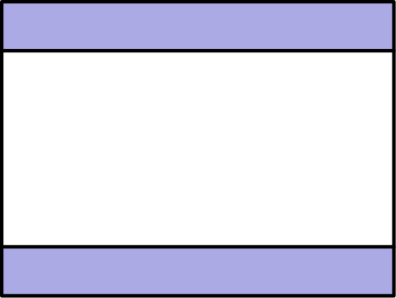
（A）2 （B）2.25 （C）2.5 （D）2.7 （E）3
English
Older television screens have an aspect ratio of 4:3. That is, the ratio of the width to the height is 4:3. The aspect ratio of many movies is not 4:3, so they are sometimes shown on a television screen by “letterboxing” — darkening strips of equal height at the top and bottom of the screen, as shown. Suppose a movie has an aspect ratio of 2:1 and is shown on an older television screen with a 27-inch diagonal. What is the height, in inches, of each darkened strip?
(A) 2 (B) 2.25 (C) 2.5 (D) 2.7 (E) 3
第 15 题
昨天 Han 比 Ian 多开 1 小时，平均速度比 Ian 快每小时 5 英里。Jan 比 Ian 多开 2 小时，平均速度比 Ian 快每小时 10 英里。Han 比 Ian 多开了 70 英里。Jan 比 Ian 多开了多少英里？
（A）120 （B）130 （C）140 （D）150 （E）160
English
Yesterday Han drove 1 hour longer than Ian at an average speed 5 miles per hour faster than Ian. Jan drove 2 hours longer than Ian at an average speed 10 miles per hour faster than Ian. Han drove 70 miles more than Ian. How many more miles did Jan drive than Ian?
(A) 120 (B) 130 (C) 140 (D) 150 (E) 160
第 16 题
点 A 和 B 在圆心为 O 的圆上，且 ∠ AOB = 60°。第二个圆内切于第一个圆，并且同时与 OA 和 OB 相切。小圆面积与大圆面积之比是多少？
（A）1/16 （B）1/9 （C）1/8 （D）1/6 （E）1/4
English
Points A and B lie on a circle centered at O, and ∠ AOB = 60°. A second circle is internally tangent to the first and tangent to both OA and OB. What is the ratio of the area of the smaller circle to that of the larger circle?
(A) 1/16 (B) 1/9 (C) 1/8 (D) 1/6 (E) 1/4
第 17 题
一个等边三角形边长为 6。所有在三角形外部且到三角形某一点的距离不超过 3 的点所组成的区域面积是多少？
（A）36 + 24√(3) （B）54 + 9π （C）54 + 18√(3) + 6π （D）(2√(3) + 3)² π （E）9(√(3) + 1)² π
English
An equilateral triangle has side length 6. What is the area of the region containing all points that are outside the triangle and not more than 3 units from a point of the triangle?
(A) 36 + 24√(3) (B) 54 + 9π (C) 54 + 18√(3) + 6π (D) (2√(3) + 3)² π (E) 9(√(3) + 1)² π
第 18 题
一个直角三角形周长为 32，面积为 20。它的斜边长是多少？
（A）57/4 （B）59/4 （C）61/4 （D）63/4 （E）65/4
English
A right triangle has perimeter 32 and area 20. What is the length of its hypotenuse?
(A) 57/4 (B) 59/4 (C) 61/4 (D) 63/4 (E) 65/4
第 19 题
矩形 PQRS 在平面内，且 PQ = RS = 2、QR = SP = 6。矩形先绕 R 顺时针旋转 90°，再绕第一次旋转后点 S 移到的位置顺时针旋转 90°。点 P 经过的路径长度是多少？
（A）(2√(3) + √(5))π （B）6π （C）(3 + √(10))π （D）(√(3) + 2√(5))π （E）2√(10)π
English
Rectangle PQRS lies in a plane with PQ = RS = 2 and QR = SP = 6. The rectangle is rotated 90° clockwise about R, then rotated 90° clockwise about the point that S moved to after the first rotation. What is the length of the path traveled by point P?
(A) (2√(3) + √(5))π (B) 6π (C) (3 + √(10))π (D) (√(3) + 2√(5))π (E) 2√(10)π
第 20 题
梯形 ABCD 的底边为 AB 和 CD，对角线交于 K。已知 AB = 9、DC = 12，且 △ AKD 的面积为 24。梯形 ABCD 的面积是多少？
（A）92 （B）94 （C）96 （D）98 （E）100
English
Trapezoid ABCD has bases AB and CD and diagonals intersecting at K. Suppose that AB = 9, DC = 12, and the area of △ AKD is 24. What is the area of trapezoid ABCD?
(A) 92 (B) 94 (C) 96 (D) 98 (E) 100
第 21 题
一个边长为 1 的立方体被一个平面切开，该平面经过一对相对顶点 A 和 C，以及不含 A 或 C 的两条相对棱的中点 B 和 D，如图所示。四边形 ABCD 的面积是多少？
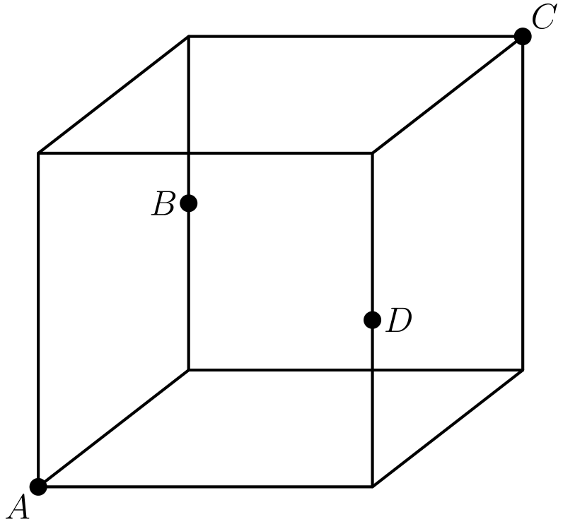
（A）(√(6))/2 （B）5/4 （C）√(2) （D）3/2 （E）√(3)
English
A cube with side length 1 is sliced by a plane that passes through two diagonally opposite vertices A and C and the midpoints B and D of two opposite edges not containing A or C, as shown. What is the area of quadrilateral ABCD?
(A) (√(6))/2 (B) 5/4 (C) √(2) (D) 3/2 (E) √(3)
第 22 题
Jacob 用如下过程写出一个数列。首先他选择第一项为 6。为了生成下一项，他抛一枚公平硬币。若正面朝上，他将前一项加倍再减 1。若反面朝上，他取前一项的一半再减 1。Jacob 数列的第四项为整数的概率是多少？
（A）1/6 （B）1/3 （C）1/2 （D）5/8 （E）3/4
English
Jacob uses the following procedure to write down a sequence of numbers. First he chooses the first term to be 6. To generate each succeeding term, he flips a fair coin. If it comes up heads, he doubles the previous term and subtracts 1. If it comes up tails, he takes half of the previous term and subtracts 1. What is the probability that the fourth term in Jacob’s sequence is an integer?
(A) 1/6 (B) 1/3 (C) 1/2 (D) 5/8 (E) 3/4
第 23 题
要从集合 S = {a, b, c, d, e} 中选择两个子集，使它们的并集为 S，且交集恰好包含两个元素。如果选择两个子集的顺序不重要，共有多少种方法？
（A）20 （B）40 （C）60 （D）160 （E）320
English
Two subsets of the set S = {a, b, c, d, e} are to be chosen so that their union is S and their intersection contains exactly two elements. In how many ways can this be done, assuming that the order in which the subsets are chosen does not matter?
(A) 20 (B) 40 (C) 60 (D) 160 (E) 320
第 24 题
令 k = 2008² + 2²⁰⁰⁸。k² + 2ᵏ 的个位数字是多少？
（A）0 （B）2 （C）4 （D）6 （E）8
English
Let k = 2008² + 2²⁰⁰⁸. What is the units digit of k² + 2ᵏ?
(A) 0 (B) 2 (C) 4 (D) 6 (E) 8
第 25 题
一张圆桌半径为 4。桌上放着六个矩形餐垫。每个餐垫宽为 1，长为 x，如图所示。每个餐垫都有两个角在桌边上，这两个角是一条长为 x 的边的两个端点。此外，每个内侧角都与相邻餐垫的一个内侧角相接。x 是多少？
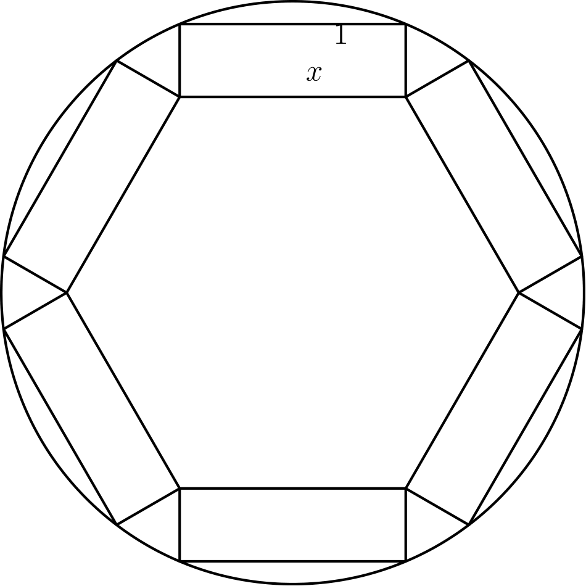
（A）2√(5) - √(3) （B）3 （C）(3√(7) - √(3))/2 （D）2√(3) （E）(5 + 2√(3))/2
English
A round table has radius 4. Six rectangular place mats are placed on the table. Each place mat has width 1 and length x as shown. They are positioned so that each mat has two corners on the edge of the table, these two corners being end points of the same side of length x. Further, the mats are positioned so that the inner corners each touch an inner corner of an adjacent mat. What is x?
(A) 2√(5) - √(3) (B) 3 (C) (3√(7) - √(3))/2 (D) 2√(3) (E) (5 + 2√(3))/2

第二部分 解答
答案速查：
题号 1 2 3 4 5 6 7 8 9
答案 D A A C B D E A B
题号 10 11 12 13 14 15 16 17 18
答案 E D C D D D B B B
题号 19 20 21 22 23 24 25
答案 C D A D B D C
答案串：DAACBDEABEDCDDDBBBCDADBDC
第 1 题 答案 D
从上午 8:30 到上午 11:10 是 2 小时 40 分钟，即 160 分钟，这完成了三分之一的工作。
因此整项工作需要 3 · 160 = 480 分钟，也就是 8 小时。
上午 8:30 之后八小时是下午 4:30。
所以正确答案是D。
English
From 8:30 am to 11:10 am is 2 hours and 40 minutes, or 160 minutes, to finish one third of the job.
The entire job therefore takes 3 · 160 = 480 minutes, or 8 hours.
Eight hours after 8:30 am is 4:30 pm.
Thus, the correct answer isD.
第 2 题 答案 A
设正方形边长为 s，则正方形面积为 s²。
矩形宽为 2s，长为 2 · 2s = 4s，面积为 8s²。
正方形占矩形面积的比例为 s²/8s² = 1/8 = 12.5%。
所以正确答案是A。
English
Let the side of the square be s, so its area is s².
The width of the rectangle is 2s, and its length is 2 · 2s = 4s, giving an area of 8s².
The fraction inside the square is s²/8s² = 1/8 = 12.5%.
Thus, the correct answer isA.
第 3 题 答案 A
6 的正因数中，不包括 6 本身的有 1, 2 和 3，所以 〈 6 〉 = 1 + 2 + 3 = 6。
再次对 6 应用这个运算仍得到 6，因此 〈〈〈 6 〉〉〉 = 6。
一个数若等于其真因数之和，称为完全数，而 6 是最小的完全数。
所以正确答案是A。
English
The positive divisors of 6 other than 6 are 1, 2, and 3, so 〈 6 〉 = 1 + 2 + 3 = 6.
Since applying the operation to 6 again returns 6, we get 〈〈〈 6 〉〉〉 = 6.
(A number equal to the sum of its proper divisors is called a perfect number, and 6 is the smallest.)
Thus, the correct answer isA.
第 4 题 答案 C
因为 10 根香蕉的 2/3 是 20/3 根香蕉，价值等于 8 个橙子，所以一根香蕉相当于 8 ÷ 20/3 = 6/5 个橙子。
5 根香蕉的 1/2 是 5/2 根香蕉，价值为 5/2 · 6/5 = 3 个橙子。
所以正确答案是C。
English
Since 2/3 of 10 bananas is 20/3 bananas worth 8 oranges, one banana is worth 8 ÷ 20/3 = 6/5 oranges.
Now 1/2 of 5 bananas is 5/2 bananas, worth 5/2 · 6/5 = 3 oranges.
Thus, the correct answer isC.
第 5 题 答案 B
除第一个分母外，每个分母都与前一个分数的分子约掉，因此整个乘积逐项约消为 2008/4 = 502。
所以正确答案是B。
English
Every denominator except the first cancels with the numerator of the previous fraction, so the whole product telescopes to 2008/4 = 502.
Thus, the correct answer isB.
第 6 题 答案 D
设每段长为 x。总距离为 3x，总时间为
x/3 + x/20 + x/10 = 29/60x
小时。
平均速度为 3x/(29/60x) = 180/29 ≈ 6.2，最接近 6。
所以正确答案是D。
English
Let each segment have length x. The total time is
x/3 + x/20 + x/10 = 29/60x
hours for the distance 3x.
The average speed is 3x/(29/60x) = 180/29 ≈ 6.2, which is closest to 6.
Thus, the correct answer isD.
第 7 题 答案 E
因为 (3ᵏ)² = 9ᵏ，分式为 (9²⁰⁰⁸ - 9²⁰⁰⁶)/(9²⁰⁰⁷ - 9²⁰⁰⁵)。
从上下都提出 9²⁰⁰⁵，得到
(9²⁰⁰⁵(9³ - 9))/(9²⁰⁰⁵(9² - 1)) = (9(9² - 1))/(9² - 1) = 9。
所以正确答案是E。
English
Since (3ᵏ)² = 9ᵏ, the fraction is (9²⁰⁰⁸ - 9²⁰⁰⁶)/(9²⁰⁰⁷ - 9²⁰⁰⁵).
Factoring 9²⁰⁰⁵ from each part gives
(9²⁰⁰⁵(9³ - 9))/(9²⁰⁰⁵(9² - 1)) = (9(9² - 1))/(9² - 1) = 9.
Thus, the correct answer isE.
第 8 题 答案 A
设标价为 x。Heather 在 A 店支付 0.85x - 90，在 B 店支付 0.75x。
因为 A 店便宜 $15，
0.85x - 90 = 0.75x - 15，
解得 0.1x = 75，所以 x = 750。
所以正确答案是A。
English
Let x be the sticker price. Heather pays 0.85x - 90 at store A and 0.75x at store B.
Since store A is $15 cheaper,
0.85x - 90 = 0.75x - 15,
which gives 0.1x = 75, so x = 750.
Thus, the correct answer isA.
第 9 题 答案 B
通分得 2x/3 - x/6 = (4x - x)/6 = x/2。
要使 x/2 为整数，x 必须是偶数。
例如 x = 4，这说明 x 不必是 3 的倍数，也排除了其他陈述。
所以正确答案是B。
English
Combining over a common denominator, 2x/3 - x/6 = (4x - x)/6 = x/2.
For x/2 to be an integer, x must be even.
The example x = 4 shows that x need not be a multiple of 3 and rules out the other statements.
Thus, the correct answer isB.
第 10 题 答案 E
S₁ 的边长为 4。由勾股定理，S₂ 的边长为 √(2² + 2²) = 2√(2)，所以面积为 8。
同理，S₃ 的面积是 S₂ 的一半，即 4。
所以正确答案是E。
English
The side of S₁ is 4. By the Pythagorean theorem, the side of S₂ is √(2² + 2²) = 2√(2), so its area is 8.
By the same reasoning, S₃ has half the area of S₂, namely 4.
Thus, the correct answer isE.
第 11 题 答案 D
以每小时 4 英里的速度，Steve 划 1 英里需要 15 分钟。这段时间会有 15 · 10 = 150 加仑水进入。
为了不超过 30 加仑，LeRoy 必须在 15 分钟内舀出 150 - 30 = 120 加仑，即每分钟 120/15 = 8 加仑。
所以正确答案是D。
English
At 4 miles per hour, Steve rows 1 mile in 15 minutes. During that time 15 · 10 = 150 gallons enter.
To stay under 30 gallons, LeRoy must bail 150 - 30 = 120 gallons in 15 minutes, or 120/15 = 8 gallons per minute.
Thus, the correct answer isD.
第 12 题 答案 C
因为 r = 1.25b，蓝弹珠数为 b = r/1.25 = 0.8r。
绿弹珠数为 g = 1.6r。
总数为 r + 0.8r + 1.6r = 3.4r。
所以正确答案是C。
English
Since r = 1.25b, the number of blue marbles is b = r/1.25 = 0.8r.
The number of green marbles is g = 1.6r.
The total is r + 0.8r + 1.6r = 3.4r.
Thus, the correct answer isC.
第 13 题 答案 D
Doug 和 Dave 一起每小时粉刷 1/5 + 1/7 个房间。
由于休息一小时，他们实际只工作 t - 1 小时，而这段时间必须完成整个房间：
(1/5 + 1/7)(t - 1) = 1。
所以正确答案是D。
English
Working together, Doug and Dave paint 1/5 + 1/7 of the room per hour.
Because they break for one hour, they work for only t - 1 hours, and this must complete the whole room:
(1/5 + 1/7)(t - 1) = 1.
Thus, the correct answer isD.
第 14 题 答案 D
因为屏幕为 4:3，对角线为 27 英寸，所以 h: w: 27 = 3: 4: 5，得到高 h = 3/5· 27 = 16.2，宽 w = 4/5· 27 = 21.6。
点亮的 2:1 区域使用完整宽度 21.6，高度为 21.6/2 = 10.8。
两条黑边平分剩余高度，所以每条高度为 (16.2 - 10.8)/2 = 2.7。
所以正确答案是D。
English
Since the screen is 4:3 with a 27-inch diagonal, h: w: 27 = 3: 4: 5, giving height h = 3/5· 27 = 16.2 and width w = 4/5· 27 = 21.6.
The lit 2:1 region has the full width 21.6 and height 21.6/2 = 10.8.
The two strips share the remaining height, so each has height (16.2 - 10.8)/2 = 2.7.
Thus, the correct answer isD.
第 15 题 答案 D
设 Ian 开了 t 小时，速度为每小时 r 英里，则路程为 rt。
Han 比 Ian 多开的距离为 (r + 5)(t + 1) - rt = 5t + r + 5 = 70，所以 5t + r = 65。
Jan 比 Ian 多开的距离为 (r + 10)(t + 2) - rt = 10t + 2r + 20 = 2(5t + r) + 20 = 2 · 65 + 20 = 150。
所以正确答案是D。
English
Let Ian drive t hours at rate r, covering rt miles.
Han drove (r + 5)(t + 1) - rt = 5t + r + 5 = 70, so 5t + r = 65.
Jan drove (r + 10)(t + 2) - rt = 10t + 2r + 20 = 2(5t + r) + 20 = 2 · 65 + 20 = 150 miles more than Ian.
Thus, the correct answer isD.
第 16 题 答案 B
设小圆和大圆半径分别为 r 和 R。小圆圆心 E 在 ∠ AOB 的角平分线上，所以 OE 与 OA 的夹角为 30°。
从 E 到 OA 的垂线长为 r，在所得 30-60-90 三角形中，OE = 2r。
又因为 OE = R - r，所以 2r = R - r，得到 R = 3r，面积比为 (1/3)² = 1/9。
所以正确答案是B。
English
Let the radii be r and R. The small circle’s center E lies on the bisector of ∠ AOB, so OE makes a 30° angle with OA.
The perpendicular from E to OA has length r, and in the resulting 30-60-90 triangle OE = 2r.
Since OE = R - r, we get 2r = R - r, so R = 3r and the area ratio is (1/3)² = 1/9.
Thus, the correct answer isB.
第 17 题 答案 B
沿三条边各有一个 6 × 3 的矩形，贡献面积 3 · 6 · 3 = 54。
每个顶点处有一个半径为 3、圆心角为 120° 的扇形；三个扇形合成一个整圆，面积为 π · 3² = 9π。
总面积为 54 + 9π。
所以正确答案是B。
English
Along each of the three sides is a 6 × 3 rectangle, contributing 3 · 6 · 3 = 54.
At each vertex is a 120° sector of radius 3; the three together form a full circle of area π · 3² = 9π.
The total area is 54 + 9π.
Thus, the correct answer isB.
第 18 题 答案 B
设两条直角边为 y, z，斜边为 x。则 y² + z² = x²，y + z = 32 - x，且 yz = 40。
将第二个等式平方，得到
(32 - x)²
= y² + z² + 2yz = x² + 80
。
这给出 1024 - 64x = 80，所以 x = 59/4。
所以正确答案是B。
English
Let the legs be y, z and the hypotenuse x. Then y² + z² = x², y + z = 32 - x, and yz = 40.
Squaring the second equation,
(32 - x)²
= y² + z² + 2yz = x² + 80.
This gives 1024 - 64x = 80, so x = 59/4.
Thus, the correct answer isB.
第 19 题 答案 C
第一次旋转中，P 绕 R 走四分之一圆，半径为 PR = √(2² + 6²) = 2√(10)。弧长为 1/4(2π · 2√(10)) = √(10) π。
第二次旋转中，P 绕 S 的新位置走四分之一圆，半径为 6。弧长为 1/4(2π · 6) = 3π。
总路径长度为 (3 + √(10))π。
所以正确答案是C。
English
In the first rotation, P moves on a quarter circle about R with radius PR = √(2² + 6²) = 2√(10). The arc length is 1/4(2π · 2√(10)) = √(10) π.
In the second rotation, P moves on a quarter circle about the new position of S with radius 6. The arc length is 1/4(2π · 6) = 3π.
The total path length is (3 + √(10))π.
Thus, the correct answer isC.
第 20 题 答案 D
三角形 AKB 和 CKD 相似，比例为 9/12 = 3/4。
因为 △ AKD 和 △ KCD 的底边 AK 与 KC 在同一直线上，且从 D 出发的高相同，所以 ([KCD])/([AKD]) = KC/AK = 4/3，于是 [KCD] = 32。同理 [AKB] = 18。
另外 [BKC] = [AKD] = 24。总面积为 24 + 32 + 18 + 24 = 98。
所以正确答案是D。
English
Triangles AKB and CKD are similar with ratio 9/12 = 3/4.
Since △ AKD and △ KCD have bases AK and KC on the same line and share the same altitude from D, ([KCD])/([AKD]) = KC/AK = 4/3, so [KCD] = 32. Similarly [AKB] = 18.
Also [BKC] = [AKD] = 24. The total is 24 + 32 + 18 + 24 = 98.
Thus, the correct answer isD.
第 21 题 答案 A
ABCD 的每条边都连接立方体一个顶点和一条棱的中点，所以四边相等，ABCD 是菱形。
它的对角线为立方体空间对角线 AC = √(3) 和面对角线 BD = √(2)。
菱形面积为对角线乘积的一半：1/2·√(3)·√(2) = (√(6))/2。
所以正确答案是A。
English
Each side of ABCD joins a vertex of the cube to the midpoint of an edge, so all four sides are equal and ABCD is a rhombus.
Its diagonals are the space diagonal AC = √(3) and the face diagonal BD = √(2).
The area of a rhombus is half the product of its diagonals: 1/2·√(3)·√(2) = (√(6))/2.
Thus, the correct answer isA.
第 22 题 答案 D
从 6 开始，第二项可能为 11（正面）或 2（反面）。
继续展开树形图，八个等可能的第四项为 41, 9.5, 8, 1.25, 5, 0.5, -1, -1。
其中 41, 8, 5, -1, -1 是整数，所以概率为 5/8。
所以正确答案是D。
English
Starting from 6, the second terms are 11 (heads) and 2 (tails).
Continuing the tree, the eight equally likely fourth terms are 41, 9.5, 8, 1.25, 5, 0.5, -1, -1.
Of these, 41, 8, 5, -1, -1 are integers, so the probability is 5/8.
Thus, the correct answer isD.
第 23 题 答案 B
共有元素可用 C(5, 2) = 10 种方式选择。
剩余 3 个元素必须恰好属于一个子集，有 2³ = 8 种分配方式，所以有 80 个有序子集对。
因为两个子集的顺序不重要，除以 2，得到 80/2 = 40。
所以正确答案是B。
English
Choose the two common elements in C(5, 2) = 10 ways.
Each of the remaining 3 elements must lie in exactly one subset, giving 2³ = 8 assignments, for 80 ordered pairs.
Since the order of the two subsets does not matter, divide by 2 to get 80/2 = 40.
Thus, the correct answer isB.
第 24 题 答案 D
2ⁿ 的个位数字按 2, 4, 8, 6 循环，所以 2²⁰⁰⁸ 个位为 6。另外 2008² 的个位为 4。
因此 k 的个位为 0，所以 k² 的个位为 0。
又因为 2008² 和 2²⁰⁰⁸ 都是 4 的倍数，所以 k ≡ 0 pmod 4，从而 2ᵏ 的个位为 6。
所以 k² + 2ᵏ 的个位数字为 0 + 6 = 6。
所以正确答案是D。
English
The units digit of 2ⁿ cycles 2, 4, 8, 6, so 2²⁰⁰⁸ ends in 6. Also 2008² ends in 4.
Thus k ends in 0, so k² ends in 0.
Both 2008² and 2²⁰⁰⁸ are multiples of 4, so k ≡ 0 pmod 4, which makes 2ᵏ end in 6.
The units digit of k² + 2ᵏ is 0 + 6 = 6.
Thus, the correct answer isD.
第 25 题 答案 C
取一个餐垫的外侧角为 P 和 Q，令 R 为圆上与 P 关于直径相对的点。于是 △ PQR 在 Q 处为直角，斜边 PR = 8。
相邻餐垫的内角相接，形成顶角为 120°、两腰为 x 的等腰三角形，其底边为 √(3) x。再加上两个餐垫宽度，QR = √(3) x + 2。
由勾股定理，
(√(3) x + 2)² + x² = 64，
化简为 x² + √(3) x - 15 = 0。
取正根，
x = (3√(7) - √(3))/2。
所以正确答案是C。
English
Pick a mat with outer corners P and Q, and let R be the point on the circle diametrically opposite P. Then △ PQR is right-angled at Q with hypotenuse PR = 8.
The inner corners of adjacent mats meet in isosceles triangles with vertex angle 120° and sides x, whose base is √(3) x. Together with the two mat widths, QR = √(3) x + 2.
By the Pythagorean theorem,
(√(3) x + 2)² + x² = 64,
which simplifies to x² + √(3) x - 15 = 0.
Taking the positive root,
x = (3√(7) - √(3))/2.
Thus, the correct answer isC.

