2007A AMC 10 真题与解答
American Mathematics Competitions 10 · 中英双语
共 25 题，限时 75 分钟；答对得 6 分，未答得 1.5 分，答错 0 分，满分 150 分。
编排说明：第一部分为题目（先中文、后英文原题），第二部分为解答与答案，便于先做题后对答案。
第一部分 题目
第 1 题
一张演出票全价为 $20。Susan 使用一张 25% 折扣券买了 4 张票。Pam 使用一张 30% 折扣券买了 5 张票。Pam 比 Susan 多付多少美元？
（A）2 （B）5 （C）10 （D）15 （E）20
English
One ticket to a show costs $20 at full price. Susan buys 4 tickets using a coupon that gives her a 25% discount. Pam buys 5 tickets using a coupon that gives her a 30% discount. How many more dollars does Pam pay than Susan?
(A) 2 (B) 5 (C) 10 (D) 15 (E) 20
第 2 题
定义 a@b = ab - b² 和 a#b = a + b - ab²。求下式的值：
(6@2)/(6#2)？
（A）-1/2 （B）-1/4 （C）1/8 （D）1/4 （E）1/2
English
Define a@b = ab - b² and a#b = a + b - ab². What is
(6@2)/(6#2)?
(A) -1/2 (B) -1/4 (C) 1/8 (D) 1/4 (E) 1/2
第 3 题
一个水族箱底面为 100 厘米乘 40 厘米的矩形，高为 50 厘米。水装到 40 厘米高。将一块底面为 40 厘米乘 20 厘米、高为 10 厘米的长方体砖放入水族箱。水面上升多少厘米？
（A）0.5 （B）1 （C）1.5 （D）2 （E）2.5
English
An aquarium has a rectangular base that measures 100 cm by 40 cm and has a height of 50 cm. It is filled with water to a height of 40 cm. A brick with a rectangular base that measures 40 cm by 20 cm and a height of 10 cm is placed in the aquarium. By how many centimeters does the water rise?
(A) 0.5 (B) 1 (C) 1.5 (D) 2 (E) 2.5
第 4 题
两个连续奇整数中较大的一个是较小的三倍。它们的和是多少？
（A）4 （B）8 （C）12 （D）16 （E）20
English
The larger of two consecutive odd integers is three times the smaller. What is their sum?
(A) 4 (B) 8 (C) 12 (D) 16 (E) 20
第 5 题
学校商店出售 7 支铅笔和 8 本笔记本，共 $4.15。它也出售 5 支铅笔和 3 本笔记本，共 $1.77。16 支铅笔和 10 本笔记本多少钱？
（A）$4.76 （B）$5.84 （C）$6.00 （D）$6.16 （E）$6.32
English
A school store sells 7 pencils and 8 notebooks for $4.15. It also sells 5 pencils and 3 notebooks for $1.77. How much do 16 pencils and 10 notebooks cost?
(A) $4.76 (B) $5.84 (C) $6.00 (D) $6.16 (E) $6.32
第 6 题
在 Euclid 高中，参加 AMC 10 的学生数在 2002 年为 60，2003 年为 66，2004 年为 70，2005 年为 76，2006 年为 78，2007 年为 85。哪两个连续年份之间的百分比增长最大？
（A）2002 和 2003 （B）2003 和 2004 （C）2004 和 2005 （D）2005 和 2006 （E）2006 和 2007
English
At Euclid High School, the number of students taking the AMC 10 was 60 in 2002, 66 in 2003, 70 in 2004, 76 in 2005, 78 in 2006, and is 85 in 2007. Between what two consecutive years was there the largest percentage increase?
(A) 2002 and 2003 (B) 2003 and 2004 (C) 2004 and 2005 (D) 2005 and 2006 (E) 2006 and 2007
第 7 题
去年 John Q. Public 先生收到一笔遗产。他对这笔遗产支付了 20% 的联邦税，又对剩下的钱支付了 10% 的州税。两种税合计为 $10,500。这笔遗产是多少美元？
（A）30,000 （B）32,500 （C）35,000 （D）37,500 （E）40,000
English
Last year Mr. John Q. Public received an inheritance. He paid 20% in federal taxes on the inheritance, and paid 10% of what he had left in state taxes. He paid a total of $10,500 for both taxes. How many dollars was the inheritance?
(A) 30,000 (B) 32,500 (C) 35,000 (D) 37,500 (E) 40,000
第 8 题
三角形 ABC 和 ADC 都是等腰三角形，其中 AB = BC，且 AD = DC。点 D 在 △ ABC 内部，∠ ABC = 40°，且 ∠ ADC = 140°。∠ BAD 的度数是多少？
（A）20 （B）30 （C）40 （D）50 （E）60
English
Triangles ABC and ADC are isosceles with AB = BC and AD = DC. Point D is inside △ ABC, ∠ ABC = 40°, and ∠ ADC = 140°. What is the degree measure of ∠ BAD?
(A) 20 (B) 30 (C) 40 (D) 50 (E) 60
第 9 题
实数 a 和 b 满足 3ᵃ = 81ᵇ⁺² 和 125ᵇ = 5ᵃ⁻³。求 ab？
（A）-60 （B）-17 （C）9 （D）12 （E）60
English
Real numbers a and b satisfy the equations 3ᵃ = 81ᵇ⁺² and 125ᵇ = 5ᵃ⁻³. What is ab?
(A) -60 (B) -17 (C) 9 (D) 12 (E) 60
第 10 题
Dunbar 家庭由母亲、父亲和若干孩子组成。全家成员的平均年龄为 20，父亲 48 岁，母亲和孩子们的平均年龄为 16。这个家庭有多少个孩子？
（A）2 （B）3 （C）4 （D）5 （E）6
English
The Dunbar family consists of a mother, a father, and some children. The average age of the members of the family is 20, the father is 48 years old, and the average age of the mother and children is 16. How many children are in the family?
(A) 2 (B) 3 (C) 4 (D) 5 (E) 6
第 11 题
将 1 到 8 的数字放在一个立方体的顶点上，使每个面上四个数字之和相同。这个共同和是多少？
（A）14 （B）16 （C）18 （D）20 （E）24
English
The numbers from 1 to 8 are placed at the vertices of a cube in such a manner that the sum of the four numbers on each face is the same. What is this common sum?
(A) 14 (B) 16 (C) 18 (D) 20 (E) 24
第 12 题
两名导游带领六名游客。导游决定分开行动。每名游客必须选择其中一名导游，但每名导游至少要带一名游客。导游和游客的不同分组共有多少种？
（A）56 （B）58 （C）60 （D）62 （E）64
English
Two tour guides are leading six tourists. The guides decide to split up. Each tourist must choose one of the guides, but with the stipulation that each guide must take at least one tourist. How many different groupings of guides and tourists are possible?
(A) 56 (B) 58 (C) 60 (D) 62 (E) 64
第 13 题
Yan 位于家和体育场之间。要到体育场，他可以直接走到体育场；也可以先走回家，再骑自行车到体育场。他骑车速度是步行速度的 7 倍，且两种选择所需时间相同。Yan 到家的距离与到体育场的距离之比是多少？
（A）2/3 （B）3/4 （C）4/5 （D）5/6 （E）6/7
English
Yan is somewhere between his home and the stadium. To get to the stadium he can walk directly to the stadium, or else he can walk home and then ride his bicycle to the stadium. He rides 7 times as fast as he walks, and both choices require the same amount of time. What is the ratio of Yan’s distance from his home to his distance from the stadium?
(A) 2/3 (B) 3/4 (C) 4/5 (D) 5/6 (E) 6/7
第 14 题
一个边长比为 3: 4: 5 的三角形内接于半径为 3 的圆。这个三角形的面积是多少？
（A）8.64 （B）12 （C）5π （D）17.28 （E）18
English
A triangle with side lengths in the ratio 3: 4: 5 is inscribed in a circle of radius 3. What is the area of the triangle?
(A) 8.64 (B) 12 (C) 5π (D) 17.28 (E) 18
第 15 题
如图，四个半径为 1 的圆各自与正方形的两条边相切，并且都与一个半径为 2 的圆外切。正方形的面积是多少？
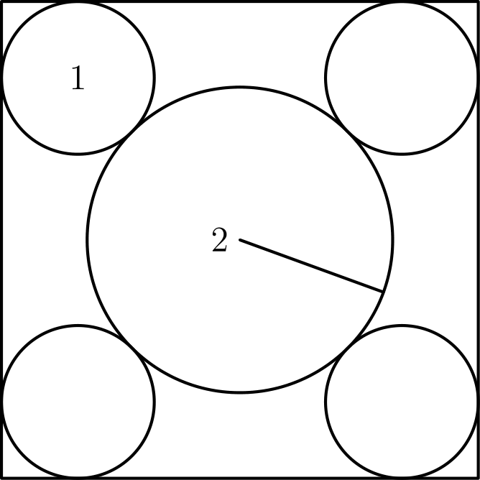
（A）32 （B）22 + 12√(2) （C）16 + 16√(3) （D）48 （E）36 + 16√(2)
English
Four circles of radius 1 are each tangent to two sides of a square and externally tangent to a circle of radius 2, as shown. What is the area of the square?
(A) 32 (B) 22 + 12√(2) (C) 16 + 16√(3) (D) 48 (E) 36 + 16√(2)
第 16 题
整数 a，b，c 和 d 不要求互不相同，分别独立地从 0 到 2007（含端点）中随机选择。ad - bc 为偶数的概率是多少？
（A）3/8 （B）7/16 （C）1/2 （D）9/16 （E）5/8
English
Integers a, b, c, and d, not necessarily distinct, are chosen independently and at random from 0 to 2007, inclusive. What is the probability that ad - bc is even?
(A) 3/8 (B) 7/16 (C) 1/2 (D) 9/16 (E) 5/8
第 17 题
设 m 和 n 是正整数，且 75m = n³。m + n 的最小可能值是多少？
（A）15 （B）30 （C）50 （D）60 （E）5700
English
Suppose that m and n are positive integers such that 75m = n³. What is the minimum possible value of m + n?
(A) 15 (B) 30 (C) 50 (D) 60 (E) 5700
第 18 题
如图，考虑 12 边形 ABCDEFGHIJKL，每条边长为 4，且每两条相邻边成直角。设 AG 与 CH 交于 M。四边形 ABCM 的面积是多少？
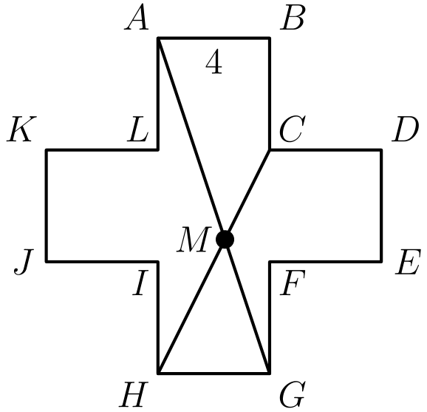
（A）44/3 （B）16 （C）88/5 （D）20 （E）62/3
English
Consider the 12-sided polygon ABCDEFGHIJKL, as shown. Each of its sides has length 4, and each two consecutive sides form a right angle. Suppose that AG and CH meet at M. What is the area of quadrilateral ABCM?
(A) 44/3 (B) 16 (C) 88/5 (D) 20 (E) 62/3
第 19 题
如图，一把画刷沿正方形的两条对角线扫过，形成对称的涂色区域。正方形面积的一半被涂色。正方形边长与画刷宽度之比是多少？

（A）2√(2) + 1 （B）3√(2) （C）2√(2) + 2 （D）3√(2) + 1 （E）3√(2) + 2
English
A paint brush is swept along both diagonals of a square to produce the symmetric painted area, as shown. Half the area of the square is painted. What is the ratio of the side length of the square to the brush width?
(A) 2√(2) + 1 (B) 3√(2) (C) 2√(2) + 2 (D) 3√(2) + 1 (E) 3√(2) + 2
第 20 题
设数 a 满足方程 4 = a + a⁻¹。求 a⁴ + a⁻⁴ 的值。
（A）164 （B）172 （C）192 （D）194 （E）212
English
Suppose that the number a satisfies the equation 4 = a + a⁻¹. What is the value of a⁴ + a⁻⁴?
(A) 164 (B) 172 (C) 192 (D) 194 (E) 212
第 21 题
一个球内切于表面积为 24 平方米的立方体。再将第二个立方体内接于这个球。内部立方体的表面积是多少平方米？
（A）3 （B）6 （C）8 （D）9 （E）12
English
A sphere is inscribed in a cube that has a surface area of 24 square meters. A second cube is then inscribed within the sphere. What is the surface area in square meters of the inner cube?
(A) 3 (B) 6 (C) 8 (D) 9 (E) 12
第 22 题
一个有限的三位整数数列具有如下性质：每一项的十位和个位数字分别是下一项的百位和十位数字；最后一项的十位和个位数字分别是第一项的百位和十位数字。例如，这样的数列可能以 247，475 和 756 开头，并以 824 结尾。设 S 为数列中所有项的和。总是整除 S 的最大质数是多少？
（A）3 （B）7 （C）13 （D）37 （E）43
English
A finite sequence of three-digit integers has the property that the tens and units digits of each term are, respectively, the hundreds and tens digits of the next term, and the tens and units digits of the last term are, respectively, the hundreds and tens digits of the first term. For example, such a sequence might begin with terms 247, 475, and 756 and end with the term 824. Let S be the sum of all the terms in the sequence. What is the largest prime number that always divides S?
(A) 3 (B) 7 (C) 13 (D) 37 (E) 43
第 23 题
有多少个正整数有序对 (m, n) 满足 m > n，且它们的平方差为 96？
（A）3 （B）4 （C）6 （D）9 （E）12
English
How many ordered pairs (m, n) of positive integers, with m > n, have the property that their squares differ by 96?
(A) 3 (B) 4 (C) 6 (D) 9 (E) 12
第 24 题
如图，以 A 和 B 为圆心的圆半径均为 2，点 O 是 AB 的中点，且 OA = 2√(2)。线段 OC 和 OD 分别与以 A 和 B 为圆心的圆相切，EF 是一条公切线。阴影区域 ECODF 的面积是多少？
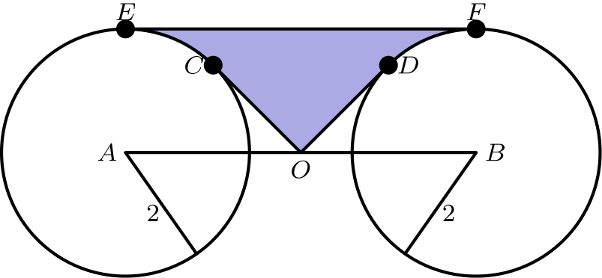
（A）(8√(2))/3 （B）8√(2) - 4 - π （C）4√(2) （D）4√(2) + π/8 （E）8√(2) - 2 - π/2
English
Circles centered at A and B each have radius 2, as shown. Point O is the midpoint of AB, and OA = 2√(2). Segments OC and OD are tangent to the circles centered at A and B, respectively, and EF is a common tangent. What is the area of the shaded region ECODF?
(A) (8√(2))/3 (B) 8√(2) - 4 - π (C) 4√(2) (D) 4√(2) + π/8 (E) 8√(2) - 2 - π/2
第 25 题
对每个正整数 n，令 S(n) 表示 n 的各位数字之和。有多少个 n 满足 n + S(n) + S(S(n)) = 2007？
（A）1 （B）2 （C）3 （D）4 （E）5
English
For each positive integer n, let S(n) denote the sum of the digits of n. For how many values of n is n + S(n) + S(S(n)) = 2007?
(A) 1 (B) 2 (C) 3 (D) 4 (E) 5

第二部分 解答
答案速查：
题号 1 2 3 4 5 6 7 8 9
答案 C A D A B A D D E
题号 10 11 12 13 14 15 16 17 18
答案 E C D B A B E D C
题号 19 20 21 22 23 24 25
答案 C D C D B B D
答案串：CADABADDEECDBABEDCCDCDBBD
第 1 题 答案 C
Susan 支付 4 · 0.75 · 20 = 60 美元。
Pam 支付 5 · 0.70 · 20 = 70 美元。
差为 70 - 60 = 10 美元。
所以正确答案是C。
English
Susan pays 4 · 0.75 · 20 = 60 dollars.
Pam pays 5 · 0.70 · 20 = 70 dollars.
The difference is 70 - 60 = 10 dollars.
Thus, the correct answer isC.
第 2 题 答案 A
分子为 6@2 = 6 · 2 - 2² = 12 - 4 = 8。
分母为 6#2 = 6 + 2 - 6 · 2² = 8 - 24 = -16。
商为
8/-16 = -1/2。
所以正确答案是A。
English
The numerator is 6@2 = 6 · 2 - 2² = 12 - 4 = 8.
The denominator is 6#2 = 6 + 2 - 6 · 2² = 8 - 24 = -16.
The quotient is
8/-16 = -1/2.
Thus, the correct answer isA.
第 3 题 答案 D
砖的体积为 40 · 20 · 10 = 8000 立方厘米。
若水面上升 h 厘米，增加的水体积为 100 · 40 · h = 4000h 立方厘米。
令二者相等，得 4000h = 8000，所以 h = 2。
所以正确答案是D。
English
The brick has volume 40 · 20 · 10 = 8000 cubic centimeters.
If the water rises by h centimeters, the added volume is 100 · 40 · h = 4000h cubic centimeters.
Setting these equal gives 4000h = 8000, so h = 2.
Thus, the correct answer isD.
第 4 题 答案 A
设较小整数为 x，则较大整数为 x + 2，并且
x + 2 = 3x
因此 x = 1。
两个整数为 1 和 3，和为 4。
所以正确答案是A。
English
Let the smaller integer be x. Then the larger is x + 2, and
x + 2 = 3x,
so x = 1.
The two integers are 1 and 3, and their sum is 4.
Thus, the correct answer isA.
第 5 题 答案 B
设 p 和 n 分别为一支铅笔和一本笔记本的价格，单位为美分。
7p + 8n = 415
5p + 3n = 177。
解这个方程组，得到 p = 9 和 n = 44。
所以 16 支铅笔和 10 本笔记本共需 16(9) + 10(44) = 584 美分，即 $5.84。
所以正确答案是B。
English
Let p and n be the prices in cents of a pencil and a notebook. Then
7p + 8n = 415
5p + 3n = 177.
Solving this system gives p = 9 and n = 44.
So 16 pencils and 10 notebooks cost 16(9) + 10(44) = 584 cents, or $5.84.
Thus, the correct answer isB.
第 6 题 答案 A
从 2002 到 2003，增长为
6/60 = 1/10 = 10%。
其他增长率为 4/66、6/70、2/76、7/78，都小于 1/10。
所以最大百分比增长发生在 2002 和 2003 之间。
所以正确答案是A。
English
From 2002 to 2003, the increase is
6/60 = 1/10 = 10%.
The other increases are 4/66, 6/70, 2/76, and 7/78, each less than 1/10.
So the largest percentage increase was between 2002 and 2003.
Thus, the correct answer isA.
第 7 题 答案 D
联邦税后，Public 先生保留遗产的 80%。
州税取这部分的 10%，即遗产的 8%。
总税额为遗产的 20% + 8% = 28%，所以遗产为
(10,500)/0.28 = 37,500。
所以正确答案是D。
English
After federal taxes, Mr. Public keeps 80% of his inheritance.
State taxes take 10% of that, which is 8% of the inheritance.
The total tax is 20% + 8% = 28% of the inheritance, so the inheritance is
(10,500)/0.28 = 37,500.
Thus, the correct answer isD.
第 8 题 答案 D
因为 △ ABC 是等腰三角形，∠ BAC = 1/2(180° - 40°) = 70°。
因为 △ ADC 是等腰三角形，∠ DAC = 1/2(180° - 140°) = 20°。
因此 ∠ BAD = ∠ BAC - ∠ DAC = 70° - 20° = 50°。
所以正确答案是D。
English
Since △ ABC is isosceles, ∠ BAC = 1/2(180° - 40°) = 70°.
Since △ ADC is isosceles, ∠ DAC = 1/2(180° - 140°) = 20°.
Therefore ∠ BAD = ∠ BAC - ∠ DAC = 70° - 20° = 50°.
Thus, the correct answer isD.
第 9 题 答案 E
两个方程变为 3ᵃ = 3⁴⁽ᵇ⁺²⁾ 和 5³ᵇ = 5ᵃ⁻³。
所以 a = 4(b + 2)，且 3b = a - 3。
解得 a = -12、b = -5，因此 ab = 60。
所以正确答案是E。
English
The equations become 3ᵃ = 3⁴⁽ᵇ⁺²⁾ and 5³ᵇ = 5ᵃ⁻³.
So a = 4(b + 2) and 3b = a - 3.
Solving gives a = -12 and b = -5, so ab = 60.
Thus, the correct answer isE.
第 10 题 答案 E
设孩子数为 N，全家总年龄为 T。
则 20 = T/(N + 2)，且 16 = (T - 48)/(N + 1)。
这给出 20N + 40 = T 和 16N + 64 = T，所以 20N + 40 = 16N + 64。
因此 4N = 24，所以 N = 6。
所以正确答案是E。
English
Let N be the number of children and T the total age of the family.
Then 20 = T/(N + 2) and 16 = (T - 48)/(N + 1).
These give 20N + 40 = T and 16N + 64 = T, so 20N + 40 = 16N + 64.
Hence 4N = 24 and N = 6.
Thus, the correct answer isE.
第 11 题 答案 C
每个顶点恰好属于三个面，所以把六个面的数字和加起来得到
3(1 + 2 + ⋯ + 8) = 3 · 36
= 108
。
共有六个面，所以共同和为 108 ÷ 6 = 18。
所以正确答案是C。
English
Each vertex belongs to exactly three faces, so summing the numbers over all six faces gives
3(1 + 2 + ⋯ + 8) = 3 · 36
= 108.
There are six faces, so the common sum is 108 ÷ 6 = 18.
Thus, the correct answer isC.
第 12 题 答案 D
每名游客独立选择两名导游之一，共有 2⁶ = 64 种安排。
其中恰好有两种安排会让某名导游没有游客，所以答案为 64 - 2 = 62。
所以正确答案是D。
English
Each tourist independently chooses one of the two guides, giving 2⁶ = 64 arrangements.
Exactly two of these leave a guide with no tourists, so the answer is 64 - 2 = 62.
Thus, the correct answer isD.
第 13 题 答案 B
设 Yan 到家的距离和到体育场的距离分别为 x 和 y，步行速度为 w。
直接步行到体育场需要 y/w。走回家再骑车需要 x/w + (x + y)/7w。
令二者相等，得 7y = 8x + y，所以 8x = 6y，从而 x/y = 3/4。
所以正确答案是B。
English
Let x and y be Yan’s distances from home and from the stadium, and let w be his walking speed.
Walking to the stadium takes y/w. Walking home and biking takes x/w + (x + y)/7w.
Setting these equal gives 7y = 8x + y, so 8x = 6y and x/y = 3/4.
Thus, the correct answer isB.
第 14 题 答案 A
设三边为 3x, 4x, 5x。
这个三角形是直角三角形，所以斜边为圆的直径。因此 5x = 2 · 3 = 6，得到 x = 6/5。
面积为
1/2 (3x)(4x) = 6x² = 6 · 36/25
= 8.64
。
所以正确答案是A。
English
Let the sides be 3x, 4x, 5x. The triangle is right-angled, so its hypotenuse is a diameter.
Thus 5x = 2 · 3 = 6, giving x = 6/5.
The area is
1/2 (3x)(4x) = 6x² = 6 · 36/25
= 8.64.
Thus, the correct answer isA.
第 15 题 答案 B
考虑连接半径 2 的圆心和两个相邻小圆圆心形成的等腰直角三角形。它的两条直角边长为 2 + 1 = 3，所以斜边为 3√(2)。
正方形边长比这条斜边多 2（两端各一个小圆半径），所以 s = 2 + 3√(2)。
面积为
(2 + 3√(2))² = 4 + 12√(2) + 18
= 22 + 12√(2)
。
所以正确答案是B。
English
Consider the isosceles right triangle joining the center of the radius-2 circle to the centers of two adjacent small circles. Its legs have length 2 + 1 = 3, so its hypotenuse is 3√(2).
The side of the square exceeds this hypotenuse by 2 (one radius on each end), so s = 2 + 3√(2).
The area is
(2 + 3√(2))² = 4 + 12√(2) + 18
= 22 + 12√(2).
Thus, the correct answer isB.
第 16 题 答案 E
从 0 到 2007 的整数中一半为奇数，所以 ad 为奇数的概率为 1/2 · 1/2 = 1/4，为偶数的概率为 3/4。bc 也是如此。
ad - bc 为偶数当两个乘积奇偶性相同：
1/4 · 1/4 + 3/4 · 3/4 = 1/16 + 9/16 = 5/8。
所以正确答案是E。
English
Half the integers from 0 to 2007 are odd, so each of ad and bc is odd with probability 1/2 · 1/2 = 1/4 and even with probability 3/4.
The difference ad - bc is even when both products have the same parity:
1/4 · 1/4 + 3/4 · 3/4 = 1/16 + 9/16 = 5/8.
Thus, the correct answer isE.
第 17 题 答案 D
因为 n³ = 75m = 3 · 5² · m，每个质因数的指数都必须是三的倍数。
最小这样的 m 是 3² · 5 = 45，此时 n³ = 3³ · 5³，所以 n = 15。
因此 m + n = 45 + 15 = 60。
所以正确答案是D。
English
Since n³ = 75m = 3 · 5² · m, every prime factor must occur a multiple of three times.
The smallest such m is 3² · 5 = 45, giving n³ = 3³ · 5³ and n = 15.
Then m + n = 45 + 15 = 60.
Thus, the correct answer isD.
第 18 题 答案 C
将图形放在坐标系中，取 A = (-2, 6)、B = (2, 6)、C = (2, 2)、G = (2, -6)、H = (-2, -6)。
直线 AG 为 y = -3x，直线 CH 为 y = 2x - 2。
它们的交点为 M = (2/5, -6/5)。
对 A, B, C, M 使用鞋带公式，面积为
[ABCM] =1/2|-8-136/5|
=88/5
。
所以正确答案是C。
English
Put the figure on coordinates with A = (-2, 6), B = (2, 6), C = (2, 2), G = (2, -6), and H = (-2, -6).
Line AG is y = -3x, and line CH is y = 2x - 2.
Their intersection is M = (2/5, -6/5).
Applying the shoelace formula to A, B, C, M gives
[ABCM] =1/2|-8-136/5|
=88/5.
Thus, the correct answer isC.
第 19 题 答案 C
设正方形边长为 s，画刷宽度为 w，一个未涂色等腰直角三角形的直角边为 x。每个三角形面积为 1/8 s²，所以 1/2 x² = 1/8 s²，得到 x = s/2。
直角边加上画刷宽度等于半条对角线：x + w = (√(2))/2 s。因此 w = (√(2))/2 s - s/2。
所以
s/w = 2/(√(2) - 1) = 2√(2) + 2。
所以正确答案是C。
English
Let s be the side, w the brush width, and x the leg of one unpainted isosceles right triangle. Each triangle has area 1/8 s², so 1/2 x² = 1/8 s² and x = s/2.
The leg plus the brush width is half the diagonal: x + w = (√(2))/2 s. Thus w = (√(2))/2 s - s/2.
Therefore
s/w = 2/(√(2) - 1) = 2√(2) + 2.
Thus, the correct answer isC.
第 20 题 答案 D
将 a + a⁻¹ = 4 平方，得到 a² + 2 + a⁻² = 16，所以 a² + a⁻² = 14。
再平方得到 a⁴ + 2 + a⁻⁴ = 196，所以 a⁴ + a⁻⁴ = 194。
所以正确答案是D。
English
Squaring a + a⁻¹ = 4 gives a² + 2 + a⁻² = 16, so a² + a⁻² = 14.
Squaring again gives a⁴ + 2 + a⁻⁴ = 196, so a⁴ + a⁻⁴ = 194.
Thus, the correct answer isD.
第 21 题 答案 C
外部立方体每个面的面积为 24 ÷ 6 = 4，所以边长为 2，球的直径为 2。
这个直径是内部立方体的空间对角线，所以 l√(3) = 2，得到 l² = 4/3。
内部立方体表面积为 6 l² = 6 · 4/3 = 8。
所以正确答案是C。
English
Each face of the outer cube has area 24 ÷ 6 = 4, so its side is 2, and the sphere has diameter 2.
This diameter is the space diagonal of the inner cube, so l√(3) = 2, giving l² = 4/3.
The inner cube’s surface area is 6 l² = 6 · 4/3 = 8.
Thus, the correct answer isC.
第 22 题 答案 D
在整个数列中，每个数字作为百位、十位、个位出现的次数相同。
若 k 是所有项个位数字之和，则 S = 111k = 3 · 37 · k，所以 S 总能被 37 整除。
数列 123、231、312 给出 S = 666 = 2 · 3² · 37，没有更大的质因数被强制整除，所以答案是 37。
所以正确答案是D。
English
Each digit appears as a hundreds digit, a tens digit, and a units digit the same number of times across the sequence.
If k is the sum of the units digits of all terms, then S = 111k = 3 · 37 · k, so S is always divisible by 37.
The sequence 123, 231, 312 gives S = 666 = 2 · 3² · 37, which has no larger prime factor forced, so 37 is the answer.
Thus, the correct answer isD.
第 23 题 答案 B
因数 m + n 和 m - n 的奇偶性相同。因为它们的乘积是 96，所以不可能都是奇数，只能都是偶数。
偶数因数对为 (48, 2)、(24, 4)、(16, 6) 和 (12, 8)，对应 (m, n) = (25, 23)、(14, 10)、(11, 5) 和 (10, 2)。
所以共有 4 个有序对。
所以正确答案是B。
English
The factors m + n and m - n have the same parity. Since their product is 96, they cannot both be odd, so both must be even.
The even factor pairs are (48, 2), (24, 4), (16, 6), and (12, 8), giving (m, n) = (25, 23), (14, 10), (11, 5), and (10, 2).
So there are 4 ordered pairs.
Thus, the correct answer isB.
第 24 题 答案 B
矩形 ABFE 面积为 AE · AB = 2 · 4√(2) = 8√(2)。
直角三角形 ACO 和 BDO 的斜边均为 2√(2)，且一条直角边为 2，所以每个都是面积为 2 的等腰直角三角形。
角 CAE 和 DBF 都是 45°，所以扇形 CAE 和 DBF 的面积各为 1/8 π · 2² = π/2。
阴影面积为
8√(2) - 2 · 2 - 2 · π/2
= 8√(2) - 4 - π
。
所以正确答案是B。
English
Rectangle ABFE has area AE · AB = 2 · 4√(2) = 8√(2).
Right triangles ACO and BDO each have hypotenuse 2√(2) and a leg of 2, so each is isosceles right with area 2.
Angles CAE and DBF are each 45°, so sectors CAE and DBF each have area 1/8 π · 2² = π/2.
The shaded area is
8√(2) - 2 · 2 - 2 · π/2
= 8√(2) - 4 - π.
Thus, the correct answer isB.
第 25 题 答案 D
若 n ≤ 2007，则 S(n) ≤ 28，且 S(S(n)) ≤ 10，所以 n ≥ 2007 - 28 - 10 = 1969。
因为 n、S(n)、S(S(n)) 模 9 都同余，且 2007 是 9 的倍数，所以它们都必须是 3 的倍数。
检查 1969 到 2007 之间的 3 的倍数，满足条件的是 1977、1980、1983、2001。
所以共有 4 个 n。
所以正确答案是D。
English
If n ≤ 2007, then S(n) ≤ 28 and S(S(n)) ≤ 10, so n ≥ 2007 - 28 - 10 = 1969.
Since n, S(n), and S(S(n)) all leave the same remainder modulo 9 and 2007 is a multiple of 9, each must be a multiple of 3.
Checking the multiples of 3 between 1969 and 2007, the condition holds for 1977, 1980, 1983, and 2001.
So there are 4 values of n.
Thus, the correct answer isD.

