2004B AMC 10 真题与解答
American Mathematics Competitions 10 · 中英双语
共 25 题，限时 75 分钟；答对得 6 分，未答得 1.5 分，答错 0 分，满分 150 分。
编排说明：第一部分为题目（先中文、后英文原题），第二部分为解答与答案，便于先做题后对答案。
第一部分 题目
第 1 题
Misty Moon Amphitheater 的每一排有 33 个座位。第 12 排到第 22 排预留给一个青年俱乐部。这个俱乐部一共预留了多少个座位？
（A）297 （B）330 （C）363 （D）396 （E）726
English
Each row of the Misty Moon Amphitheater has 33 seats. Rows 12 through 22 are reserved for a youth club. How many seats are reserved for this club?
(A) 297 (B) 330 (C) 363 (D) 396 (E) 726
第 2 题
有多少个两位正整数至少有一个数字是 7？
（A）10 （B）18 （C）19 （D）20 （E）30
English
How many two-digit positive integers have at least one 7 as a digit?
(A) 10 (B) 18 (C) 19 (D) 20 (E) 30
第 3 题
上周每次篮球训练中，Jenny 罚中球数都是前一次训练的两倍。她第五次训练罚中 48 个球。她第一次训练罚中了多少个球？
（A）3 （B）6 （C）9 （D）12 （E）15
English
At each basketball practice last week, Jenny made twice as many free throws as she made at the previous practice. At her fifth practice she made 48 free throws. How many free throws did she make at the first practice?
(A) 3 (B) 6 (C) 9 (D) 12 (E) 15
第 4 题
掷一个标准六面骰子，令 P 为可见的五个面上的数字之积。一定能整除 P 的最大数是多少？
（A）6 （B）12 （C）24 （D）144 （E）720
English
A standard six-sided die is rolled, and P is the product of the five numbers that are visible. What is the largest number that is certain to divide P?
(A) 6 (B) 12 (C) 24 (D) 144 (E) 720
第 5 题
在表达式 c · aᵇ - d 中，a、b、c 和 d 的值为 0、1、2 和 3，但顺序不一定如此。结果的最大可能值是多少？
（A）5 （B）6 （C）8 （D）9 （E）10
English
In the expression c · aᵇ - d, the values of a, b, c, and d are 0, 1, 2, and 3, although not necessarily in that order. What is the maximum possible value of the result?
(A) 5 (B) 6 (C) 8 (D) 9 (E) 10
第 6 题
下列哪个数是完全平方数？
（A）98! · 99! （B）98! · 100! （C）99! · 100! （D）99! · 101! （E）100! · 101!
English
Which of the following numbers is a perfect square?
(A) 98! · 99! (B) 98! · 100! (C) 99! · 100! (D) 99! · 101! (E) 100! · 101!
第 7 题
Isabella 从美国去加拿大旅行，带了 d 美元。在边境她把钱全部兑换，汇率为每 7 美元兑换 10 加元。花掉 60 加元后，她还剩 d 加元。d 的各位数字之和是多少？
（A）5 （B）6 （C）7 （D）8 （E）9
English
On a trip from the United States to Canada, Isabella took d U.S. dollars. At the border she exchanged them all, receiving 10 Canadian dollars for every 7 U.S. dollars. After spending 60 Canadian dollars, she had d Canadian dollars left. What is the sum of the digits of d?
(A) 5 (B) 6 (C) 7 (D) 8 (E) 9
第 8 题
Minneapolis-St. Paul International Airport 位于 St. Paul 市中心西南 8 英里处，也位于 Minneapolis 市中心东南 10 英里处。下列哪个数最接近 St. Paul 市中心与 Minneapolis 市中心之间的英里数？
（A）13 （B）14 （C）15 （D）16 （E）17
English
Minneapolis-St. Paul International Airport is 8 miles southwest of downtown St. Paul and 10 miles southeast of downtown Minneapolis. Which of the following is closest to the number of miles between downtown St. Paul and downtown Minneapolis?
(A) 13 (B) 14 (C) 15 (D) 16 (E) 17
第 9 题
一个正方形边长为 10，一个圆以该正方形的一个顶点为圆心、半径为 10。正方形和圆所围区域的并集面积是多少？
（A）200 + 25π （B）100 + 75π （C）75 + 100π （D）100 + 100π （E）100 + 125π
English
A square has sides of length 10, and a circle centered at one of its vertices has radius 10. What is the area of the union of the regions enclosed by the square and the circle?
(A) 200 + 25π (B) 100 + 75π (C) 75 + 100π (D) 100 + 100π (E) 100 + 125π
第 10 题
一位杂货商摆放罐头，最上面一排有一个罐头，每往下一排比上一排多两个罐头。如果这个展示架共有 100 个罐头，它有多少排？
（A）5 （B）8 （C）9 （D）10 （E）11
English
A grocer makes a display of cans in which the top row has one can and each lower row has two more cans than the row above it. If the display contains 100 cans, how many rows does it contain?
(A) 5 (B) 8 (C) 9 (D) 10 (E) 11
第 11 题
两个八面骰子的面都标有 1 到 8。掷骰子时，每个面朝上的概率相同。两个朝上数字的乘积大于它们的和的概率是多少？
（A）1/2 （B）47/64 （C）3/4 （D）55/64 （E）7/8
English
Two eight-sided dice each have faces numbered 1 through 8. When the dice are rolled, each face has an equal probability of appearing on the top. What is the probability that the product of the two top numbers is greater than their sum?
(A) 1/2 (B) 47/64 (C) 3/4 (D) 55/64 (E) 7/8
第 12 题
圆环是两个同心圆之间的区域。图中同心圆半径分别为 b 和 c，其中 b > c。令 OX 为大圆半径，XZ 在 Z 点与小圆相切，OY 是经过 Z 的大圆半径。设 a = XZ、d = YZ、e = XY。这个圆环的面积是多少？
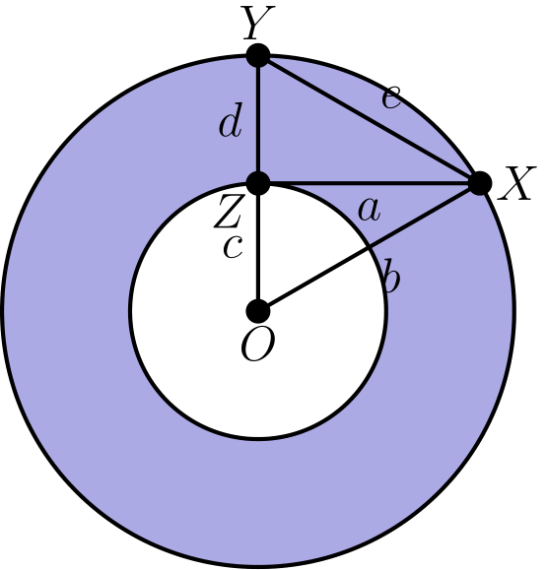
（A）π a² （B）π b² （C）π c² （D）π d² （E）π e²
English
Anannulusis the region between two concentric circles. The concentric circles in the figure have radii b and c, with b > c. Let OX be a radius of the larger circle, let XZ be tangent to the smaller circle at Z, and let OY be the radius of the larger circle that contains Z. Let a = XZ, d = YZ, and e = XY. What is the area of the annulus?
(A) π a² (B) π b² (C) π c² (D) π d² (E) π e²
第 13 题
美国硬币厚度如下：一分硬币为 1.55 毫米，五分硬币为 1.95 毫米，十分硬币为 1.35 毫米，二十五分硬币为 1.75 毫米。如果一叠这样的硬币高度正好为 14 毫米，那么这叠硬币有多少枚？
（A）7 （B）8 （C）9 （D）10 （E）11
English
In the United States, coins have the following thicknesses: penny, 1.55 mm; nickel, 1.95 mm; dime, 1.35 mm; quarter, 1.75 mm. If a stack of these coins is exactly 14 mm high, how many coins are in the stack?
(A) 7 (B) 8 (C) 9 (D) 10 (E) 11
第 14 题
一个袋子最初只含红色和蓝色弹珠，且蓝色比红色多。向袋中加入红色弹珠，直到蓝色弹珠只占袋中弹珠的 1/3。然后加入黄色弹珠，直到蓝色弹珠只占袋中弹珠的 1/5。最后，将袋中蓝色弹珠的数量加倍。现在袋中弹珠有几分之几是蓝色？
（A）1/5 （B）1/4 （C）1/3 （D）2/5 （E）1/2
English
A bag initially contains red marbles and blue marbles only, with more blue than red. Red marbles are added to the bag until only 1/3 of the marbles in the bag are blue. Then yellow marbles are added to the bag until only 1/5 of the marbles in the bag are blue. Finally, the number of blue marbles in the bag is doubled. What fraction of the marbles now in the bag are blue?
(A) 1/5 (B) 1/4 (C) 1/3 (D) 2/5 (E) 1/2
第 15 题
Patty 有 20 枚硬币，由五分硬币和十分硬币组成。如果她的五分硬币都变成十分硬币，而十分硬币都变成五分硬币，她会多 70 美分。她现在的硬币总值是多少？
（A）$1.15 （B）$1.20 （C）$1.25 （D）$1.30 （E）$1.35
English
Patty has 20 coins consisting of nickels and dimes. If her nickels were dimes and her dimes were nickels, she would have 70 cents more. How much are her coins worth?
(A) $1.15 (B) $1.20 (C) $1.25 (D) $1.30 (E) $1.35
第 16 题
三个半径为 1 的圆两两外切，并且都与一个较大的圆内切。大圆的半径是多少？
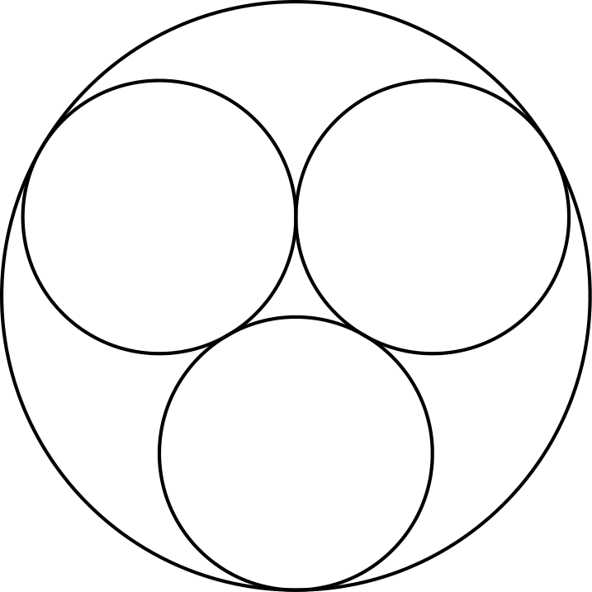
（A）(2 + √(6))/3 （B）2 （C）(2 + 3√(2))/3 （D）(3 + 2√(3))/3 （E）(3 + √(3))/2
English
Three circles of radius 1 are externally tangent to each other and internally tangent to a larger circle. What is the radius of the large circle?
(A) (2 + √(6))/3 (B) 2 (C) (2 + 3√(2))/3 (D) (3 + 2√(3))/3 (E) (3 + √(3))/2
第 17 题
Jack 年龄的两个数字与 Bill 年龄的两个数字相同，但顺序相反。五年后 Jack 的年龄将是 Bill 那时年龄的两倍。他们现在年龄相差多少？
（A）9 （B）18 （C）27 （D）36 （E）45
English
The two digits in Jack’s age are the same as the digits in Bill’s age, but in reverse order. In five years Jack will be twice as old as Bill will be then. What is the difference in their current ages?
(A) 9 (B) 18 (C) 27 (D) 36 (E) 45
第 18 题
在直角三角形 △ ACE 中，AC = 12、CE = 16、EA = 20。点 B、D 和 F 分别在 AC、CE 和 EA 上，且 AB = 3、CD = 4、EF = 5。△ BDF 的面积与 △ ACE 的面积之比是多少？
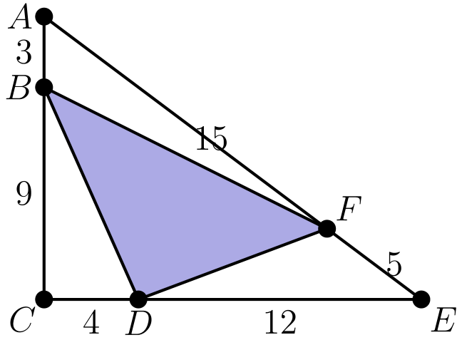
（A）1/4 （B）9/25 （C）3/8 （D）11/25 （E）7/16
English
In right triangle △ ACE, we have AC = 12, CE = 16, and EA = 20. Points B, D, and F are located on AC, CE, and EA, respectively, so that AB = 3, CD = 4, and EF = 5. What is the ratio of the area of △ BDF to that of △ ACE?
(A) 1/4 (B) 9/25 (C) 3/8 (D) 11/25 (E) 7/16
第 19 题
在数列 2001、2002、2003、… 中，第三项之后每一项等于前面两项的和减去紧前一项。例如第四项为 2001 + 2002 - 2003 = 2000。这个数列的第 2004 项是多少？
（A）-2004 （B）-2 （C）0 （D）4003 （E）6007
English
In the sequence 2001, 2002, 2003, …, each term after the third is found by subtracting the previous term from the sum of the two terms that precede that term. For example, the fourth term is 2001 + 2002 - 2003 = 2000. What is the 2004th term in this sequence?
(A) -2004 (B) -2 (C) 0 (D) 4003 (E) 6007
第 20 题
在 △ ABC 中，点 D 和 E 分别在 BC 和 AC 上。若 AD 与 BE 交于 T，且 AT/DT = 3、BT/ET = 4，求 CD/BD。
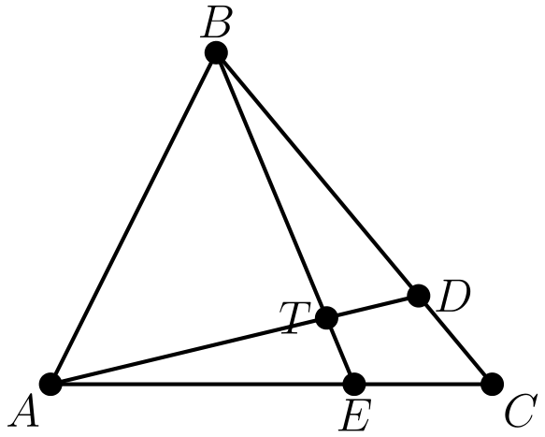
（A）1/8 （B）2/9 （C）3/10 （D）4/11 （E）5/12
English
In △ ABC points D and E lie on BC and AC, respectively. If AD and BE intersect at T so that AT/DT = 3 and BT/ET = 4, what is CD/BD?
(A) 1/8 (B) 2/9 (C) 3/10 (D) 4/11 (E) 5/12
第 21 题
设 1、4、… 和 9、16、… 是两个等差数列。集合 S 是这两个数列各自前 2004 项的并集。S 中有多少个不同的数？
（A）3722 （B）3732 （C）3914 （D）3924 （E）4007
English
Let 1, 4, … and 9, 16, … be two arithmetic progressions. The set S is the union of the first 2004 terms of each sequence. How many distinct numbers are in S?
(A) 3722 (B) 3732 (C) 3914 (D) 3924 (E) 4007
第 22 题
一个边长为 5、12 和 13 的三角形有内切圆和外接圆。这两个圆的圆心之间的距离是多少？
（A）(3√(5))/2 （B）7/2 （C）√(15) （D）(√(65))/2 （E）9/2
English
A triangle with sides of 5, 12, and 13 has both an inscribed and a circumscribed circle. What is the distance between the centers of those circles?
(A) (3√(5))/2 (B) 7/2 (C) √(15) (D) (√(65))/2 (E) 9/2
第 23 题
一个立方体的每个面独立地以概率 1/2 涂成红色或蓝色。这个涂色立方体可以放在水平面上，使四个竖直面颜色全相同的概率是多少？
（A）1/4 （B）5/16 （C）3/8 （D）7/16 （E）1/2
English
Each face of a cube is painted either red or blue, each with probability 1/2. The color of each face is determined independently. What is the probability that the painted cube can be placed on a horizontal surface so that the four vertical faces are all the same color?
(A) 1/4 (B) 5/16 (C) 3/8 (D) 7/16 (E) 1/2
第 24 题
在 △ ABC 中，AB = 7、AC = 8、BC = 9。点 D 在三角形的外接圆上，使得 AD 平分 ∠ BAC。求 AD/CD。
（A）9/8 （B）5/3 （C）2 （D）17/7 （E）5/2
English
In △ ABC we have AB = 7, AC = 8, and BC = 9. Point D is on the circumscribed circle of the triangle so that AD bisects ∠ BAC. What is the value of AD/CD?
(A) 9/8 (B) 5/3 (C) 2 (D) 17/7 (E) 5/2
第 25 题
一个半径为 1 的圆在点 A 和 B 处分别与两个半径为 2 的圆内切，其中 AB 是小圆的一条直径。求图中阴影区域面积，该区域位于小圆外部且在两个大圆内部。
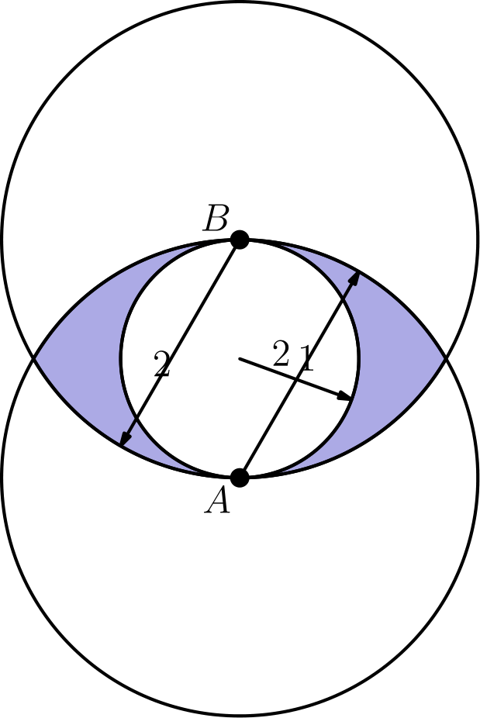
（A）5/3π - 3√(2) （B）5/3π - 2√(3) （C）8/3π - 3√(3) （D）8/3π - 3√(2) （E）8/3π - 2√(3)
English
A circle of radius 1 is internally tangent to two circles of radius 2 at points A and B, where AB is a diameter of the smaller circle. What is the area of the region, shaded in the figure, that is outside the smaller circle and inside each of the two larger circles?
(A) 5/3π - 3√(2) (B) 5/3π - 2√(3) (C) 8/3π - 3√(3) (D) 8/3π - 3√(2) (E) 8/3π - 2√(3)

第二部分 解答
答案速查：
题号 1 2 3 4 5 6 7 8 9
答案 C B A B D C A A B
题号 10 11 12 13 14 15 16 17 18
答案 D C A B C A D B E
题号 19 20 21 22 23 24 25
答案 C D A D B B B
答案串：CBABDCAABDCABCADBECDADBBB
第 1 题 答案 C
第 12 排到第 22 排共有 22 - 12 + 1 = 11 排。
每排有 33 个座位，所以总数为 33 × 11 = 363。
所以正确答案是C。
English
Rows 12 through 22 inclusive make up 22 - 12 + 1 = 11 rows.
Each row has 33 seats, so the total is 33 × 11 = 363.
Thus, the correct answer isC.
第 2 题 答案 B
70 到 79 给出 10 个十位为 7 的两位数。
数列 17, 27, …, 97 给出 9 个个位为 7 的两位数。
因为 77 被重复计算一次，所以总数为 10 + 9 - 1 = 18。
所以正确答案是B。
English
The numbers 70 through 79 give 10 with a 7 in the tens place.
The numbers 17, 27, …, 97 give 9 with a 7 in the units place.
Since 77 is counted twice, the total is 10 + 9 - 1 = 18.
Thus, the correct answer isB.
第 3 题 答案 A
从第五次训练倒推，罚中数依次为 48, 24, 12, 6 和 3，对应第五、第四、第三、第二、第一次训练。
所以正确答案是A。
English
Working backward from the fifth practice, the counts are 48, 24, 12, 6, and 3 at the fourth, third, second, and first practices.
Thus, the correct answer isA.
第 4 题 答案 B
因为 6! = 720 = 2⁴ · 3² · 5，所以可见乘积只会用到质数 2、3 和 5。
遮住 4 时剩下的因数 2 最少，为 2²。遮住 3 或 6 时剩下的因数 3 最少，为一个；遮住 5 时则没有因数 5。
因此 P 一定能被 2² · 3 = 12 整除，但不一定能被更大的数整除。
所以正确答案是B。
English
Since 6! = 720 = 2⁴ · 3² · 5, the visible product uses only the primes 2, 3, and 5.
Hiding 4 leaves the fewest 2’s, namely 2². Hiding 3 or 6 leaves the fewest 3’s, namely one. Hiding 5 leaves no factor of 5.
Therefore P is always divisible by 2² · 3 = 12, but not necessarily by any larger number.
Thus, the correct answer isB.
第 5 题 答案 D
取 d = 0 可以去掉减法，所以只需用 1、2、3 最大化 c · aᵇ。
取 c = 1、a = 3、b = 2，得到 3² = 9。另一种大幂 2³ = 8 更小，而让 c > 1 会迫使幂更小，所以最大值为 9。
所以正确答案是D。
English
Setting d = 0 removes the subtraction, so we maximize c · aᵇ using 1, 2, 3.
Taking c = 1, a = 3, b = 2 gives 3² = 9. The alternative 2³ = 8 is smaller, and any assignment with c > 1 forces a smaller power. The maximum is 9.
Thus, the correct answer isD.
第 6 题 答案 C
当 m < n 时，m! · n! 等于 (m!)² · (m+1)(m+2)⋯ n。前面的平方因子不影响判断，因此只需检查 (m+1)⋯ n 是否为完全平方数。
五个选项的剩余因子分别为 99、99 · 100、100、100 · 101 和 101。只有 100 = 10² 是完全平方数。
因此 99! · 100! = (99! · 10)² 是完全平方数。
所以正确答案是C。
English
For m < n, m! · n! equals (m!)² · (m+1)(m+2)⋯ n, which is a perfect square precisely when (m+1)⋯ n is a perfect square.
For the five choices this leftover factor is 99, 99 · 100, 100, 100 · 101, and 101. Only 100 = 10² is a perfect square.
Therefore 99! · 100! = (99! · 10)² is the perfect square.
Thus, the correct answer isC.
第 7 题 答案 A
Isabella 得到 10/7d 加元，花掉 60 加元后剩 d 加元，所以
10/7d - 60 = d。
即 3/7d = 60，所以 d = 140。数字和为 1 + 4 + 0 = 5。
所以正确答案是A。
English
Isabella received 10/7d Canadian dollars and spent 60, leaving d. So
10/7d - 60 = d.
Then 3/7d = 60, so d = 140. The sum of its digits is 1 + 4 + 0 = 5.
Thus, the correct answer isA.
第 8 题 答案 A
两个给定方向互相垂直，因此机场位于一个直角三角形的直角顶点，两条直角边为 8 和 10。
两个市中心之间的距离为 √(8² + 10²) = √(164) ≈ 12.8，最接近 13。
所以正确答案是A。
English
The two given directions are perpendicular, so the airport sits at the right angle of a right triangle with legs 8 and 10.
The distance between the downtowns is √(8² + 10²) = √(164) ≈ 12.8, which is closest to 13.
Thus, the correct answer isA.
第 9 题 答案 B
正方形面积为 10² = 100，圆面积为 π(10)² = 100π。
因为圆心在正方形顶点，正好有四分之一圆位于正方形内部，面积为 25π。
并集面积为 100 + 100π - 25π = 100 + 75π。
所以正确答案是B。
English
The square has area 10² = 100 and the circle has area π(10)² = 100π.
Since the circle is centered at a vertex of the square, exactly one quarter of the circle, area 25π, lies inside the square.
The union has area 100 + 100π - 25π = 100 + 75π.
Thus, the correct answer isB.
第 10 题 答案 D
各排罐头数为 1, 3, 5, …，前 n 个奇数的和为 n²。
令 n² = 100，得 n = 10。
所以正确答案是D。
English
The rows hold 1, 3, 5, … cans, and the sum of the first n odd numbers is n².
Setting n² = 100 gives n = 10.
Thus, the correct answer isD.
第 11 题 答案 C
共有 8 · 8 = 64 个有序结果。条件 mn > m + n 等价于 (m-1)(n-1) > 1。
不满足条件的情况只有 m = 1、n = 1，或 m = n = 2。这些情况共有 8 + 8 - 1 + 1 = 16 个。
因此概率为 (64 - 16)/64 = 48/64 = 3/4。
所以正确答案是C。
English
There are 8 · 8 = 64 ordered pairs. The inequality mn > m + n is equivalent to (m-1)(n-1) > 1.
This fails only when m = 1, n = 1, or m = n = 2, which account for 8 + 8 - 1 + 1 = 16 pairs.
The probability is (64 - 16)/64 = 48/64 = 3/4.
Thus, the correct answer isC.
第 12 题 答案 A
圆环面积是两个圆面积之差，即 π b² - π c²。
因为 XZ 在 Z 点与小圆相切，所以它垂直于半径 OZ。在直角三角形 OZX 中，OX = b、OZ = c、XZ = a，所以 b² - c² = a²。
因此圆环面积为 π a²。
所以正确答案是A。
English
The annulus is the difference of the two circular areas, π b² - π c².
Because XZ is tangent to the small circle at Z, it is perpendicular to the radius OZ. In right triangle OZX with OX = b, OZ = c, and XZ = a, we get b² - c² = a².
Therefore the area of the annulus is π a².
Thus, the correct answer isA.
第 13 题 答案 B
把每个厚度都用百分之一毫米表示。四种可能的厚度为 135、155、175、195，它们都同余于 15pmod20。若一摞有 k 枚硬币且高度为整数毫米，则以百分之一毫米表示的总厚度能被 20 整除，所以 15k 能被 20 整除。因此 k 必须是 4 的倍数。
4 枚硬币的高度至多为 4(1.95) = 7.8 毫米，12 枚硬币的高度至少为 12(1.35) = 16.2 毫米，所以只有 8 枚硬币可能恰好高 14 毫米。
事实上，8 枚二十五美分硬币的高度为 8(1.75) = 14 毫米。
所以正确答案是B。
English
Measure every thickness in hundredths of a millimeter. The four possible thicknesses are 135, 155, 175, 195, all congruent to 15pmod20. If the stack has k coins and an integer height, its total in hundredths is divisible by 20, so 15k is divisible by 20. Therefore k must be a multiple of 4.
A stack of 4 coins is at most 4(1.95) = 7.8 mm, and a stack of 12 coins is at least 12(1.35) = 16.2 mm, so only 8 coins can total 14 mm.
Indeed, 8 quarters give 8(1.75) = 14 mm.
Thus, the correct answer isB.
第 14 题 答案 C
设蓝色弹珠数为 B。加入红色弹珠后，总数为 3B；加入黄色弹珠后，总数为 5B，蓝色仍为 B。
将蓝色弹珠数量加倍后，有 2B 个蓝色弹珠，总数变为 6B，所以蓝色所占比例为 2B/6B = 1/3。
所以正确答案是C。
English
Let there be B blue marbles. After adding red marbles the total is 3B; after adding yellow marbles the total is 5B, still with B blue.
Doubling the blue marbles gives 2B blue out of 6B total, which is 2B/6B = 1/3.
Thus, the correct answer isC.
第 15 题 答案 A
交换后价值增加，所以 Patty 的五分硬币比十分硬币多。每枚硬币交换后价值变化 5 美分，所以五分硬币比十分硬币多 70/5 = 14 枚。
两种硬币的数量满足 n + d = 20 和 n - d = 14，解得她有 17 枚五分硬币和 3 枚十分硬币。
她的硬币总值为 17 · 5 + 3 · 10 = 115 美分，即 $1.15。
所以正确答案是A。
English
Swapping increases the value, so Patty has more nickels than dimes. Each swapped coin changes the total by 5 cents, so she has 70/5 = 14 more nickels than dimes.
With n + d = 20 and n - d = 14, she has 17 nickels and 3 dimes.
Her coins are worth 17 · 5 + 3 · 10 = 115 cents, or $1.15.
Thus, the correct answer isA.
第 16 题 答案 D
三个单位圆的圆心形成边长为 2 的等边三角形；它的中心就是大圆的圆心。
对于边长为 2 的等边三角形，中心到顶点的距离为 2/(√(3)) = (2√(3))/3。
再加上单位圆半径，大圆半径为 1 + (2√(3))/3 = (3 + 2√(3))/3。
所以正确答案是D。
English
The centers of the three unit circles form an equilateral triangle with side 2. Its center is the center of the large circle.
For an equilateral triangle of side length 2, the distance from its center to a vertex is 2/(√(3)) = (2√(3))/3.
Adding the unit radius, the large radius is 1 + (2√(3))/3 = (3 + 2√(3))/3.
Thus, the correct answer isD.
第 17 题 答案 B
设 Jack 的年龄为 10x + y，Bill 的年龄为 10y + x。条件给出 10x + y + 5 = 2(10y + x + 5)，即 8x = 19y + 5。
由于 x 和 y 是数字，唯一解为 y = 1、x = 3。
所以 Jack 为 31 岁，Bill 为 13 岁，差为 18。
所以正确答案是B。
English
Let Jack’s age be 10x + y and Bill’s be 10y + x. In five years 10x + y + 5 = 2(10y + x + 5), which simplifies to 8x = 19y + 5.
Since x and y are digits, the only solution is y = 1, x = 3.
So Jack is 31 and Bill is 13, a difference of 18.
Thus, the correct answer isB.
第 18 题 答案 E
△ ACE 的面积是 1/2(12)(16) = 96。
三个角上的三角形 △ ABF、△ BCD 和 △ DEF 的一组底和高，分别是 △ ACE 中对应底和高的 3/4 和 1/4。所以每个小三角形的面积都是 △ ACE 面积的 1/4 · 3/4 = 3/16。
因此
([BDF])/([ACE]) = 1 - 3 · 3/16
= 1 - 9/16 = 7/16
。
所以正确答案是E。
English
The area of △ ACE is 1/2(12)(16) = 96.
Each corner triangle △ ABF, △ BCD, and △ DEF has a base and an altitude that are 3/4 and 1/4 of a corresponding base and altitude of △ ACE. So each has area 1/4 · 3/4 = 3/16 of △ ACE.
Hence
([BDF])/([ACE]) = 1 - 3 · 3/16
= 1 - 9/16 = 7/16.
Thus, the correct answer isE.
第 19 题 答案 C
递推式 aₖ₊₁ = aₖ₋₂ + aₖ₋₁ - aₖ 给出 aₖ₊₁ - aₖ₋₁ = -(aₖ - aₖ₋₂)。数列开头为 2001、2002、2003、2000、2005、1998、…。
因此偶数位置项形成等差数列 2002, 2000, 1998, …，公差为 -2。第 2004 项是这个等差数列的第 1002 项，即 2002 + 1001(-2) = 0。
所以正确答案是C。
English
The recurrence aₖ₊₁ = aₖ₋₂ + aₖ₋₁ - aₖ gives aₖ₊₁ - aₖ₋₁ = -(aₖ - aₖ₋₂). The sequence begins 2001, 2002, 2003, 2000, 2005, 1998, …
So the even-position terms form the arithmetic sequence 2002, 2000, 1998, … with common difference -2. The 2004th term is its 1002nd term, 2002 + 1001(-2) = 0.
Thus, the correct answer isC.
第 20 题 答案 D
设 F 在 AC 上，且 DF ∥ BE。令 ET = x，则 BT = 4x。
由 △ ATE ∼ △ ADF，得 DF/x = AD/AT = 4/3，所以 DF = 4x/3。
由 △ BEC ∼ △ DFC，得 CD/BC = DF/BE = (4x/3)/5x = 4/15。
因此
CD/BD = (CD/BC)/(1 - CD/BC)
= (4/15)/(11/15) = 4/11
。
所以正确答案是D。
English
Let F be on AC with DF ∥ BE, and write ET = x, BT = 4x.
From △ ATE ∼ △ ADF, DF/x = AD/AT = 4/3, so DF = 4x/3.
From △ BEC ∼ △ DFC, CD/BC = DF/BE = (4x/3)/5x = 4/15.
Therefore
CD/BD = (CD/BC)/(1 - CD/BC)
= (4/15)/(11/15) = 4/11.
Thus, the correct answer isD.
第 21 题 答案 A
第一个数列为 1 + 3k，最大项为 6010。第二个数列为 9 + 7j，其最后一项更大，所以公共项上界由 6010 限制。
公共项形如 16 + 21m，因为第一个公共项为 16，且 lcm(3, 7) = 21。由 16 + 21m ≤ 6010 得 0 ≤ m ≤ 285，共有 286 个公共项。
因此不同数的个数为 2004 + 2004 - 286 = 3722。
所以正确答案是A。
English
The first sequence is 1 + 3k with largest term 6010, and the second is 9 + 7j with a much larger last term, so the binding limit is 6010.
A common value has the form 16 + 21m (the first shared term is 16, spaced by lcm(3, 7) = 21). Requiring 16 + 21m ≤ 6010 gives 0 ≤ m ≤ 285, that is 286 common numbers.
The number of distinct values is 2004 + 2004 - 286 = 3722.
Thus, the correct answer isA.
第 22 题 答案 D
因为 5² + 12² = 13²，这是直角三角形。将顶点放在 (0, 0)、(5, 0)、(0, 12)，则外心为斜边中点 (5/2, 6)。
内切圆半径满足 (12 - r) + (5 - r) = 13，所以 r = 2，内心为 (2, 2)。
两圆心之间的距离为
√((5/2 - 2)² + (6 - 2)²)
= √(1/4 + 16)
= (√(65))/2
。
所以正确答案是D。
English
Since 5² + 12² = 13², the triangle is right. Place it at (0, 0), (5, 0), (0, 12). The circumcenter is the midpoint of the hypotenuse, (5/2, 6).
The inradius satisfies (12 - r) + (5 - r) = 13, so r = 2 and the incenter is (2, 2).
The distance is
√((5/2 - 2)² + (6 - 2)²)
= √(1/4 + 16)
= (√(65))/2.
Thus, the correct answer isD.
第 23 题 答案 B
固定立方体方向，共有 2⁶ = 64 种涂色。
可行情况包括：六面同色，有 2 种；恰好五面同色，有 C(6, 5) · 2 = 12 种；以及四个面同色而剩下的一对相对面为另一种颜色，有 3 组相对面、2 种颜色，共 6 种。
总共有 2 + 12 + 6 = 20 种，所以概率为 20/64 = 5/16。
所以正确答案是B。
English
Fixing the orientation, there are 2⁶ = 64 colorings.
A coloring works if all six faces match (2 ways), exactly five match (C(6, 5) · 2 = 12 ways), or four faces share a color with the remaining pair being opposite faces of the other color (3 opposite pairs, 2 colors, giving 6 ways).
The total is 2 + 12 + 6 = 20, so the probability is 20/64 = 5/16.
Thus, the correct answer isB.
第 24 题 答案 B
设 AD 交 BC 于 E。因为 ∠ ABC 与 ∠ ADC 截同弧，所以它们相等；又有 ∠ EAB = ∠ CAD，因此 △ ABE ∼ △ ADC。
因此 AD/CD = AB/BE。
由角平分线定理，BE/EC = AB/AC，所以 BE = (AB · BC)/(AB + AC) = (7 · 9)/15。
因此
AD/CD = AB/BE = (AB + AC)/BC
= 15/9 = 5/3
。
所以正确答案是B。
English
Let AD meet BC at E. Since ∠ ABC and ∠ ADC subtend the same arc, they are equal, and ∠ EAB = ∠ CAD, so △ ABE ∼ △ ADC.
Hence AD/CD = AB/BE.
By the Angle Bisector Theorem, BE/EC = AB/AC, so BE = (AB · BC)/(AB + AC) = (7 · 9)/15.
Therefore
AD/CD = AB/BE = (AB + AC)/BC
= 15/9 = 5/3.
Thus, the correct answer isB.
第 25 题 答案 B
设两个大圆圆心为 A 和 B，小圆圆心为 C，两个大圆的一个交点为 D。
则 △ ACD 是直角三角形，且 AC = 1、AD = 2，所以 CD = √(3)、∠ CAD = 60°，其面积为 (√(3))/2。
阴影区域的四分之一等于半径为 2 的大圆中一个 60° 扇形面积 2π/3，减去 △ ACD 的面积 (√(3))/2，再减去小圆四分之一的面积 π/4，得到 2π/3 - (√(3))/2 - π/4 = 5π/12 - (√(3))/2。
乘以 4，阴影总面积为 5π/3 - 2√(3)。
所以正确答案是B。
English
Let the large circles have centers A and B, let C be the center of the small circle, and let D be a point where the two large circles meet.
Then △ ACD is right with AC = 1 and AD = 2, so CD = √(3), ∠ CAD = 60°, and its area is (√(3))/2.
One quarter of the shaded region equals the 60° sector of the radius-2 circle (area 2π/3) minus △ ACD (area (√(3))/2) minus a quarter of the small circle (area π/4), giving 2π/3 - (√(3))/2 - π/4 = 5π/12 - (√(3))/2.
Multiplying by 4, the shaded area is 5π/3 - 2√(3).
Thus, the correct answer isB.

