2000 年 AMC 10 真题与解答
American Mathematics Competitions 10 · 中英双语
共 25 题，限时 75 分钟；答对得 6 分，未答得 1.5 分，答错 0 分，满分 150 分。
编排说明：第一部分为题目（先中文、后英文原题），第二部分为解答与答案，便于先做题后对答案。
第一部分 题目
第 1 题
2001 年，美国将主办国际数学奥林匹克。设 I、M 和 O 是互不相同的正整数，且 I · M · O = 2001。那么 I + M + O 的最大可能值是多少？
（A）23 （B）55 （C）99 （D）111 （E）671
English
In the year 2001, the United States will host the International Mathematical Olympiad. Let I, M, and O be distinct positive integers such that the product I · M · O = 2001. What is the largest possible value of the sum I + M + O?
(A) 23 (B) 55 (C) 99 (D) 111 (E) 671
第 2 题
下列哪一项等于 2000 · 2000²⁰⁰⁰？
（A）2000²⁰⁰¹ （B）4000²⁰⁰⁰ （C）2000⁴⁰⁰⁰ （D）4,000,000²⁰⁰⁰ （E）2000^(4,000,000)
English
Which of the following is equal to 2000 · 2000²⁰⁰⁰?
(A) 2000²⁰⁰¹ (B) 4000²⁰⁰⁰ (C) 2000⁴⁰⁰⁰ (D) 4,000,000²⁰⁰⁰ (E) 2000^(4,000,000)
第 3 题
Jenny 每天吃掉当天开始时罐子里软糖的 20%。第二天结束时还剩 32 颗。罐子里原来有多少颗软糖？
（A）40 （B）50 （C）55 （D）60 （E）75
English
Each day, Jenny ate 20% of the jellybeans that were in her jar at the beginning of that day. At the end of the second day, 32 remained. How many jellybeans were in the jar originally?
(A) 40 (B) 50 (C) 55 (D) 60 (E) 75
第 4 题
Chandra 向一家网络服务提供商支付固定月费，另按连接时长支付费用。她十二月的账单是 $12.48；一月因为连接时间是十二月的两倍，账单为 $17.54。固定月费是多少？
（A）$2.53 （B）$5.06 （C）$6.24 （D）$7.42 （E）$8.77
English
Chandra pays an on-line service provider a fixed monthly fee plus an hourly charge for connect time. Her December bill was $12.48, but in January her bill was $17.54 because she used twice as much connect time as in December. What is the fixed monthly fee?
(A) $2.53 (B) $5.06 (C) $6.24 (D) $7.42 (E) $8.77
第 5 题
点 M 和 N 分别是边 PA 和 PB 的中点，这两条边属于 △ PAB。当 P 沿着一条与边 AB 平行的直线移动时，下面四个量中有多少个会改变？
（a）线段 MN 的长度；（b）△ PAB 的周长；（c）△ PAB 的面积；（d）梯形 ABNM 的面积。
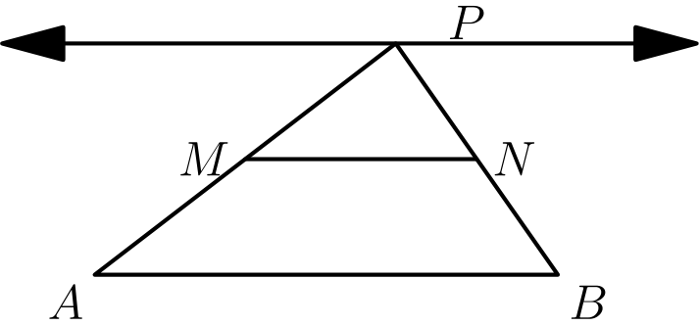
（A）0 （B）1 （C）2 （D）3 （E）4
English
Points M and N are the midpoints of sides PA and PB of △ PAB. As P moves along a line that is parallel to side AB, how many of the four quantities listed below change?
(a) the length of the segment MN; (b) the perimeter of △ PAB; (c) the area of △ PAB; (d) the area of trapezoid ABNM.
(A) 0 (B) 1 (C) 2 (D) 3 (E) 4
第 6 题
Fibonacci 数列 1，1，2，3，5，8，13，21，… 以两个 1 开始，之后每一项都是前两项之和。十个数字中，哪一个最晚出现在 Fibonacci 数列某一项的个位上？
（A）0 （B）4 （C）6 （D）7 （E）9
English
The Fibonacci sequence 1, 1, 2, 3, 5, 8, 13, 21, … starts with two 1s, and each term afterwards is the sum of its two predecessors. Which one of the ten digits is the last to appear in the units position of a number in the Fibonacci sequence?
(A) 0 (B) 4 (C) 6 (D) 7 (E) 9
第 7 题
在长方形 ABCD 中，AD = 1，点 P 在 AB 上，且 DB 和 DP 三等分 ∠ ADC。求 △ BDP 的周长。
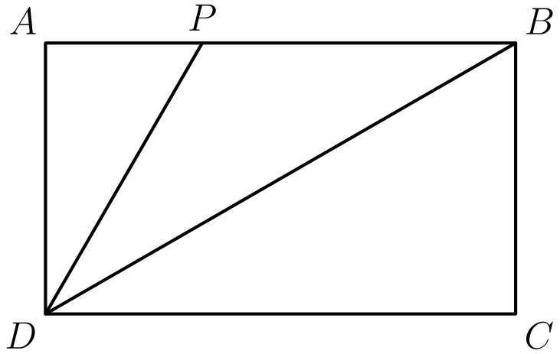
（A）3 + (√(3))/3 （B）2 + (4√(3))/3 （C）2 + 2√(2) （D）(3 + 3√(5))/2 （E）2 + (5√(3))/3
English
In rectangle ABCD, AD = 1, P is on AB, and DB and DP trisect ∠ ADC. What is the perimeter of △ BDP?
(A) 3 + (√(3))/3 (B) 2 + (4√(3))/3 (C) 2 + 2√(2) (D) (3 + 3√(5))/2 (E) 2 + (5√(3))/3
第 8 题
在奥林匹克高中，2/5 的高一学生和 4/5 的高二学生参加了 AMC 10。已知参加考试的高一学生人数和高二学生人数相同。下列哪一项一定成立？
（A）高二学生人数是高一学生人数的五倍。 （B）高二学生人数是高一学生人数的两倍。 （C）高一学生人数和高二学生人数相同。 （D）高一学生人数是高二学生人数的两倍。 （E）高一学生人数是高二学生人数的五倍。
English
At Olympic High School, 2/5 of the freshmen and 4/5 of the sophomores took the AMC 10. Given that the number of freshmen and sophomore contestants was the same, which of the following must be true?
(A) There are five times as many sophomores as freshmen. (B) There are twice as many sophomores as freshmen. (C) There are as many freshmen as sophomores. (D) There are twice as many freshmen as
sophomores. (E) There are five times as many freshmen as sophomores.
第 9 题
若 |x - 2| = p，其中 x < 2，则 x - p =
（A）-2 （B）2 （C）2 - 2p （D）2p - 2 （E）|2p - 2|
English
If |x - 2| = p, where x < 2, then x - p =
(A) -2 (B) 2 (C) 2 - 2p (D) 2p - 2 (E) |2p - 2|
第 10 题
一个面积为正的三角形边长为 4、6 和 x。另一个面积为正的三角形边长为 4、6 和 y。不能作为 |x - y| 取值的最小正数是多少？
（A）2 （B）4 （C）6 （D）8 （E）10
English
The sides of a triangle with positive area have lengths 4, 6, and x. The sides of a second triangle with positive area have lengths 4, 6, and y. What is the smallest positive number that is not a possible value of |x - y|?
(A) 2 (B) 4 (C) 6 (D) 8 (E) 10
第 11 题
从 4 和 18 之间选出两个不同的质数。用它们的乘积减去它们的和，可能得到下列哪个数？
（A）21 （B）60 （C）119 （D）180 （E）231
English
Two different prime numbers between 4 and 18 are chosen. When their sum is subtracted from their product, which of the following numbers could be obtained?
(A) 21 (B) 60 (C) 119 (D) 180 (E) 231
第 12 题
图形 0，1，2 和 3 分别由 1，5，13 和 25 个互不重叠的单位正方形组成。如果继续这个规律，图形 100 中会有多少个互不重叠的单位正方形？
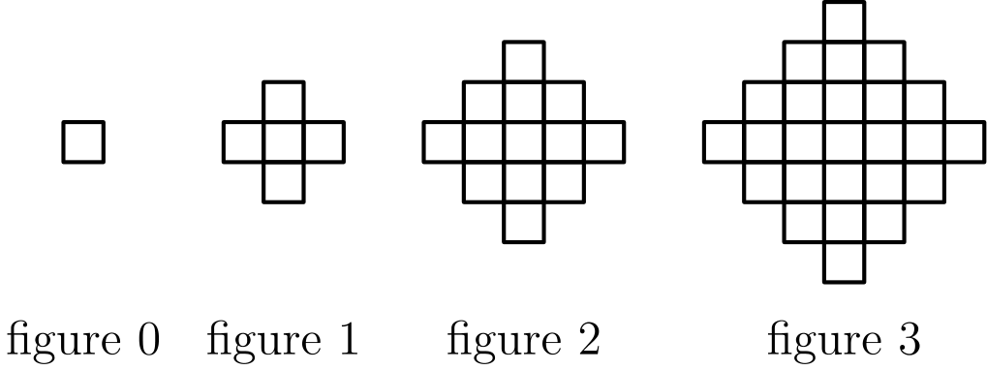
（A）10401 （B）19801 （C）20201 （D）39801 （E）40801
English
Figures 0, 1, 2, and 3 consist of 1, 5, 13, and 25 nonoverlapping unit squares, respectively. If the pattern were continued, how many nonoverlapping unit squares would there be in figure 100?
(A) 10401 (B) 19801 (C) 20201 (D) 39801 (E) 40801
第 13 题
有 5 个黄色钉、4 个红色钉、3 个绿色钉、2 个蓝色钉和 1 个橙色钉，要放在一个三角形钉板上。要求任意水平行或竖直列中不能有两个同色钉。共有多少种放法？
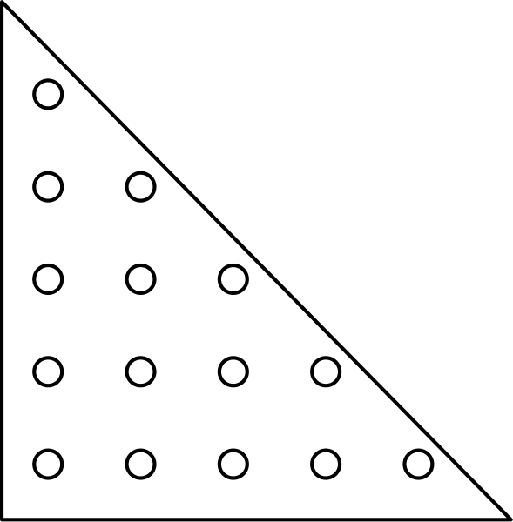
（A）0 （B）1 （C）5! · 4! · 3! · 2! · 1! （D）(15!)/(5! · 4! · 3! · 2! · 1!) （E）15!
English
There are 5 yellow pegs, 4 red pegs, 3 green pegs, 2 blue pegs, and 1 orange peg to be placed on a triangular peg board. In how many ways can the pegs be placed so that no (horizontal) row or (vertical) column contains two pegs of the same color?
(A) 0 (B) 1 (C) 5! · 4! · 3! · 2! · 1! (D) (15!)/(5! · 4! · 3! · 2! · 1!) (E) 15!
第 14 题
沃尔特老师给一个只有五名学生的数学班举行考试。她把成绩按随机顺序输入电子表格，表格在每输入一个成绩后重新计算班级平均分。她注意到每次输入后，平均分总是整数。五个成绩按升序为 71、76、80、82 和 91。沃尔特老师最后输入的成绩是多少？
（A）71 （B）76 （C）80 （D）82 （E）91
English
Mrs. Walter gave an exam in a mathematics class of five students. She entered the scores in random order into a spreadsheet, which recalculated the class average after each score was entered. Mrs. Walter noticed that after each score was entered, the average was always an integer. The scores (listed in ascending order) were 71, 76, 80, 82, and 91. What was the last score Mrs. Walter entered?
(A) 71 (B) 76 (C) 80 (D) 82 (E) 91
第 15 题
两个非零实数 a 和 b 满足 ab = a - b。求下面表达式的一个可能值：
a/b + b/a - ab。
（A）-2 （B）-1/2 （C）1/3 （D）1/2 （E）2
English
Two non-zero real numbers, a and b, satisfy ab = a - b. Find a possible value of
a/b + b/a - ab.
(A) -2 (B) -1/2 (C) 1/3 (D) 1/2 (E) 2
第 16 题
图中有 28 个格点，每个格点与最近的相邻格点相距一个单位。线段 AB 与线段 CD 交于 E。求线段 AE 的长度。
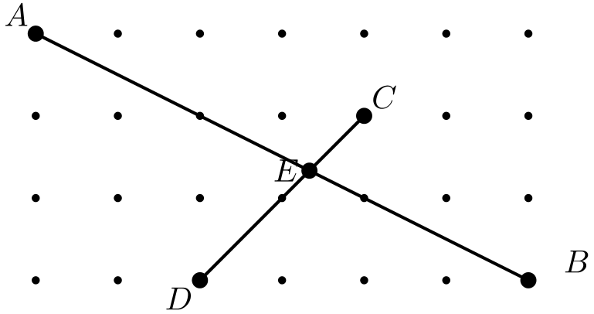
（A）(4√(5))/3 （B）(5√(5))/3 （C）(12√(5))/7 （D）2√(5) （E）(5√(65))/9
English
The diagram shows 28 lattice points, each one unit from its nearest neighbors. Segment AB meets segment CD at E. Find the length of segment AE.
(A) (4√(5))/3 (B) (5√(5))/3 (C) (12√(5))/7 (D) 2√(5) (E) (5√(65))/9
第 17 题
Boris 有一台神奇的换硬币机器。他放入一枚二十五分硬币，机器会吐出五枚五分硬币；放入一枚五分硬币，会吐出五枚一分硬币；放入一枚一分硬币，会吐出五枚二十五分硬币。Boris 一开始只有一枚一分硬币。反复使用这台机器后，他可能拥有下列哪一个金额？
（A）$3.63 （B）$5.13 （C）$6.30 （D）$7.45 （E）$9.07
English
Boris has an incredible coin changing machine. When he puts in a quarter, it returns five nickels; when he puts in a nickel, it returns five pennies; and when he puts in a penny, it returns five quarters. Boris starts with just one penny. Which of the following amounts could Boris have after using the machine repeatedly?
(A) $3.63 (B) $5.13 (C) $6.30 (D) $7.45 (E) $9.07
第 18 题
Charlyn 沿着边长均为 5 千米的正方形边界完整走一圈。在路径上的任意一点，她都能水平地看到所有方向 1 千米内的点。她行走过程中能看到的所有点组成的区域面积是多少平方千米？将答案四舍五入到最接近的整数。
（A）24 （B）27 （C）39 （D）40 （E）42
English
Charlyn walks completely around the boundary of a square whose sides are each 5 km long. From any point on her path she can see exactly 1 km horizontally in all directions. What is the area of the region consisting of all points Charlyn can see during her walk, expressed in square kilometers and rounded to the nearest whole number?
(A) 24 (B) 27 (C) 39 (D) 40 (E) 42
第 19 题
过直角三角形斜边上的一点，作两条分别平行于两条直角边的直线，把三角形分成一个正方形和两个较小的直角三角形。若其中一个小直角三角形的面积是正方形面积的 m 倍，则另一个小直角三角形面积与正方形面积的比是
（A）1/(2m + 1) （B）m （C）1 - m （D）1/4m （E）1/8m²
English
Through a point on the hypotenuse of a right triangle, lines are drawn parallel to the legs of the triangle so that the triangle is divided into a square and two smaller right triangles. The area of one of the two small right triangles is m times the area of the square. The ratio of the area of the other small right triangle to the area of the square is
(A) 1/(2m + 1) (B) m (C) 1 - m (D) 1/4m (E) 1/8m²
第 20 题
设 A、M 和 C 是非负整数，且 A + M + C = 10。求下面表达式的最大值：
A · M · C + A · M
+ M · C + C · A
？
（A）49 （B）59 （C）69 （D）79 （E）89
English
Let A, M, and C be nonnegative integers such that A + M + C = 10. What is the maximum value of
A · M · C + A · M
+ M · C + C · A?
(A) 49 (B) 59 (C) 69 (D) 79 (E) 89
第 21 题
若所有短吻鳄都是凶猛生物，且有些爬行生物是短吻鳄，下列哪些陈述一定为真？
I. 所有短吻鳄都是爬行生物。
II. 有些凶猛生物是爬行生物。
III. 有些短吻鳄不是爬行生物。
（A）只有 I （B）只有 II （C）只有 III （D）只有 II 和 III （E）没有一定为真的陈述
English
If all alligators are ferocious creatures and some creepy crawlers are alligators, which statement(s) must be true?
I. All alligators are creepy crawlers.
II. Some ferocious creatures are creepy crawlers.
III. Some alligators are not creepy crawlers.
(A) I only (B) II only (C) III only (D) II and III only (E) None must be true
第 22 题
某天早上，Angela 家的每个人都喝了一杯 8 盎司的咖啡牛奶混合饮品。每杯中咖啡和牛奶的量可能不同，但都不为零。Angela 喝掉了全家牛奶总量的四分之一和咖啡总量的六分之一。Angela 家有多少人？
（A）3 （B）4 （C）5 （D）6 （E）7
English
One morning each member of Angela’s family drank an 8-ounce mixture of coffee with milk. The amounts of coffee and milk varied from cup to cup, but were never zero. Angela drank a quarter of the total amount of milk and a sixth of the total amount of coffee. How many people are in the family?
(A) 3 (B) 4 (C) 5 (D) 6 (E) 7
第 23 题
将列表
10, 2, 5, 2, 4, 2, x
的平均数、中位数和众数按递增顺序排列后，它们形成一个非常数等差数列。所有可能的实数 x 的和是多少？
（A）3 （B）6 （C）9 （D）17 （E）20
English
When the mean, median, and mode of the list
10, 2, 5, 2, 4, 2, x
are arranged in increasing order, they form a non-constant arithmetic progression. What is the sum of all possible real values of x?
(A) 3 (B) 6 (C) 9 (D) 17 (E) 20
第 24 题
设 f 为满足 f(x/3) = x² + x + 1 的函数。求 z 的所有可能值之和，其中 f(3z) = 7。
（A）-1/3 （B）-1/9 （C）0 （D）5/9 （E）5/3
English
Let f be a function for which f(x/3) = x² + x + 1. Find the sum of all values of z for which f(3z) = 7.
(A) -1/3 (B) -1/9 (C) 0 (D) 5/9 (E) 5/3
第 25 题
在 N 年，第 300 天是星期二。在 N + 1 年，第 200 天也是星期二。那么 N - 1 年的第 100 天是星期几？
（A）星期四 （B）星期五 （C）星期六 （D）星期日 （E）星期一
English
In year N, the 300th day of the year is a Tuesday. In year N + 1, the 200th day is also a Tuesday. On what day of the week did the 100th day of year N - 1 occur?
(A) Thursday (B) Friday (C) Saturday (D) Sunday (E) Monday

第二部分 解答
答案速查：
题号 1 2 3 4 5 6 7 8 9
答案 E A B D B C B D C
题号 10 11 12 13 14 15 16 17 18
答案 D C C B C E B D C
题号 19 20 21 22 23 24 25
答案 D C B C E B A
答案串：EABDBCBDCDCCBCEBDCDCBCEBA
第 1 题 答案 E
分解质因数得 2001 = 3 · 23 · 29。
若一个因数是 1，另两个因数可能为 (3,667)，(23,87)，或 (29,69)。它们与 1 的和分别为 671，111，和 99。（数对 (1,2001) 会重复因数 1。）
若没有因数是 1，三个质因数必须分别分给三个整数，只能得到 3,23,29，其和小得多。因此最大可能的和是 1 + 3 + 667 = 671。
所以正确答案是E。
English
Factoring gives 2001 = 3 · 23 · 29.
If one factor is 1, the possible pairs for the other two factors are (3,667), (23,87), and (29,69). Their corresponding sums with 1 are 671, 111, and 99. (The pair (1,2001) would repeat the factor 1.)
If no factor is 1, all three prime factors must be split among the three integers, giving only 3,23,29 and a much smaller sum. Therefore, the largest possible sum is 1 + 3 + 667 = 671.
Thus, the correct answer isE.
第 2 题 答案 A
将因数 2000 写成 2000¹。则
2000¹ · 2000²⁰⁰⁰ = 2000^(1 + 2000)
= 2000²⁰⁰¹
。
其他每个选项都大于 2000²⁰⁰¹。
所以正确答案是A。
English
Write the factor 2000 as 2000¹. Then
2000¹ · 2000²⁰⁰⁰ = 2000^(1 + 2000)
= 2000²⁰⁰¹.
Each of the other options is larger than 2000²⁰⁰¹.
Thus, the correct answer isA.
第 3 题 答案 B
Jenny 每天吃掉 20%，所以每天结束时剩下 80%。
设原来有 x 颗，则
(0.8)² x = 0.64x = 32，
因此 x = 50。
所以正确答案是B。
English
Since Jenny eats 20% each day, 80% remain at the end of each day.
If x is the original number, then
(0.8)² x = 0.64x = 32,
so x = 50.
Thus, the correct answer isB.
第 4 题 答案 D
一月只有连接时间翻倍，所以账单增加的 $17.54 - $12.48 = $5.06 就是十二月的连接时长费用。
因此固定月费是 $12.48 - $5.06 = $7.42。
所以正确答案是D。
English
January doubled only the connect time, so the increase $17.54 - $12.48 = $5.06 equals December’s connect-time cost.
The fixed monthly fee is therefore $12.48 - $5.06 = $7.42.
Thus, the correct answer isD.
第 5 题 答案 B
由于 MN 是中位线，MN = 1/2 AB，所以它的长度不变。
底边 AB 固定，从 P 到 AB 的高也固定；当 P 沿平行线移动时，△ PAB 的面积不变。梯形 ABNM 是大三角形减去 △ PMN，面积也不变。
只有周长会改变，因为 PA 和 PB 会随着 P 的移动而变化。因此恰好有一个量会改变。
所以正确答案是B。
English
Since MN is a midsegment, MN = 1/2 AB, which is fixed.
The base AB and the height from P to AB are both constant as P slides along the parallel line, so the area of △ PAB does not change. The trapezoid ABNM is the triangle minus △ PMN, both of whose areas are constant, so its area does not change either.
Only the perimeter changes, since PA and PB vary as P moves. So exactly one quantity changes.
Thus, the correct answer isB.
第 6 题 答案 C
只记录个位数，得到
1, 1, 2, 3, 5, 8, 3, 1, 4, 5, 9,
4, 3, 7, 0, 7, 7, 4, 1, 5, 6, …
依次查看每个数字第一次出现的位置，数字 6 是十个数字中最后出现的。
所以正确答案是C。
English
Recording only the units digits gives the sequence
1, 1, 2, 3, 5, 8, 3, 1, 4, 5, 9,
4, 3, 7, 0, 7, 7, 4, 1, 5, 6, …
Scanning for the first appearance of each digit, the digit 6 is the last of the ten digits to show up.
Thus, the correct answer isC.
第 7 题 答案 B
直角 ∠ ADC = 90° 被三等分成三个 30° 角，所以 ∠ ADP = 30°，∠ ADB = 60°。
在直角三角形 ADP 中，由 AD = 1 得 DP = 1/(cos 30°) = (2√(3))/3，AP = tan 30° = (√(3))/3。
在直角三角形 ADB 中，由 AD = 1 得 DB = 1/(cos 60°) = 2，AB = tan 60° = √(3)。
于是
PB = AB - AP = √(3) - (√(3))/3
= (2√(3))/3
。
△ BDP 的周长为
DP + PB + DB
= (2√(3))/3 + (2√(3))/3 + 2
= 2 + (4√(3))/3
。
所以正确答案是B。
English
The right angle ∠ ADC = 90° is trisected into three 30° angles, so ∠ ADP = 30° and ∠ ADB = 60°.
In right triangle ADP, with AD = 1, we get DP = 1/(cos 30°) = (2√(3))/3 and AP = tan 30° = (√(3))/3.
In right triangle ADB, with AD = 1, we get DB = 1/(cos 60°) = 2 and AB = tan 60° = √(3).
Then
PB = AB - AP = √(3) - (√(3))/3
= (2√(3))/3.
The perimeter of △ BDP is
DP + PB + DB
= (2√(3))/3 + (2√(3))/3 + 2
= 2 + (4√(3))/3.
Thus, the correct answer isB.
第 8 题 答案 D
设高一和高二学生总人数分别为 f 和 s。参加考试的人数相同，所以
2/5 f = 4/5 s。
两边乘以 5，得 2f = 4s，所以 f = 2s。高一学生人数是高二学生人数的两倍。
所以正确答案是D。
English
Let f and s be the numbers of freshmen and sophomores. The contestant counts are equal, so
2/5 f = 4/5 s.
Multiplying by 5 gives 2f = 4s, so f = 2s. There are twice as many freshmen as sophomores.
Thus, the correct answer isD.
第 9 题 答案 C
因为 x < 2，所以 |x - 2| = 2 - x = p，于是 x = 2 - p。
因此
x - p = (2 - p) - p = 2 - 2p。
所以正确答案是C。
English
Because x < 2, we have |x - 2| = 2 - x = p, so x = 2 - p.
Then
x - p = (2 - p) - p = 2 - 2p.
Thus, the correct answer isC.
第 10 题 答案 D
由三角形不等式，x 和 y 都可以取严格介于 6 - 4 = 2 与 6 + 4 = 10 之间的任意数。
因此 |x - y| 可以取所有满足 0 ≤ |x - y| < 8 的值。
最小不能取到的正数是 10 - 2 = 8。
所以正确答案是D。
English
By the triangle inequality, each of x and y can be any number strictly between 6 - 4 = 2 and 6 + 4 = 10.
Then |x - y| can take any value with 0 ≤ |x - y| < 8.
The smallest positive number not attainable is 10 - 2 = 8.
Thus, the correct answer isD.
第 11 题 答案 C
在 4 和 18 之间的质数是 5、7、11、13 和 17。两个奇数的乘积是奇数、和是偶数，所以 xy - (x + y) 是奇数。
又因为 xy - (x + y) = (x - 1)(y - 1) - 1 会随着任一质数增大而增大，结果从 5 · 7 - 12 = 23 到 13 · 17 - 30 = 191。
选项中唯一在 [23, 191] 内的奇数是 119 = 11 · 13 - (11 + 13)。
所以正确答案是C。
English
The primes between 4 and 18 are 5, 7, 11, 13, and 17. The product of two of them is odd and the sum is even, so xy - (x + y) is odd.
Since xy - (x + y) = (x - 1)(y - 1) - 1 increases as either prime increases, the result ranges from 5 · 7 - 12 = 23 up to 13 · 17 - 30 = 191.
The only odd option in [23, 191] is 119 = 11 · 13 - (11 + 13).
Thus, the correct answer isC.
第 12 题 答案 C
图形 n 可以看作前 n 个奇数之和加上前 n+1 个奇数之和，所以单位正方形个数为 n² + (n+1)²。
对图形 100 有
100² + 101² = 10000 + 10201
= 20201
。
所以正确答案是C。
English
Figure n can be split into the sum of the first n odd numbers and the first n+1 odd numbers, giving n² + (n+1)² unit squares.
For figure 100, this is
100² + 101² = 10000 + 10201
= 20201.
Thus, the correct answer isC.
第 13 题 答案 B
钉板有五行和五列。为了避免同一行或同一列中出现两个黄色钉，每行和每列都必须恰有一个黄色钉，因此五个黄色钉的位置被确定在长对角线上。
接着，四个红色钉必须分别放在第 2 行至第 5 行中，剩余的位置也迫使它们排在一条对角线上。继续放置绿色、蓝色和橙色钉时，每种颜色的位置也都被唯一确定。
因此恰好有一种符合条件的放法。
所以正确答案是B。
English
The board has five rows and five columns. To avoid two yellow pegs in a row or column, there must be exactly one yellow peg in each row, forcing the yellow pegs onto the long diagonal.
The four red pegs must then each go in rows 2 through 5, and the only positions left force them into a single diagonal as well. Continuing with green, blue, and orange, every color is forced into a unique position.
Hence there is exactly one valid arrangement.
Thus, the correct answer isB.
第 14 题 答案 C
71, 76, 80, 82, 91 除以 3 的余数分别是 2, 1, 2, 1, 1。前三个成绩的和必须能被 3 整除，唯一可行的三元组是 76 + 82 + 91 = 249。因此第三个输入的成绩是 91，前两个是 76 和 82。
因为 249 比 4 的倍数多一，第四个成绩必须比 4 的倍数多三，只有 71 符合；剩下 80 作为第五个成绩。
确实，部分和 76, 158, 249, 320, 400 分别能被 1, 2, 3, 4, 5 整除。
所以正确答案是C。
English
The residues of 71, 76, 80, 82, 91 modulo 3 are 2, 1, 2, 1, 1. The sum of the first three scores must be divisible by 3, and the only such triple is 76 + 82 + 91 = 249, so the third score entered is 91 and the first two are 76 and 82.
Since 249 is one more than a multiple of 4, the fourth score must be three more than a multiple of 4, which only 71 satisfies. That leaves 80 as the fifth and last score.
Indeed 76, 158, 249, 320, 400 are divisible by 1, 2, 3, 4, 5.
Thus, the correct answer isC.
第 15 题 答案 E
通分到分母 ab 得
a/b + b/a - ab = (a² + b² - (ab)²)/ab。
代入 ab = a - b，得到
(a² + b² - (a - b)²)/ab = 2ab/ab = 2。
所以正确答案是E。
English
Over the common denominator ab,
a/b + b/a - ab = (a² + b² - (ab)²)/ab.
Substituting ab = a - b gives
(a² + b² - (a - b)²)/ab = 2ab/ab = 2.
Thus, the correct answer isE.
第 16 题 答案 B
取坐标 A = (0, 3)、B = (6, 0)、C = (4, 2)、D = (2, 0)。
直线 AB 是 x + 2y = 6，直线 CD 是 x - y = 2。联立解得 E = (10/3, 4/3)。
因此
AE = √((10/3)² + (4/3 - 3)²)
= √(100/9 + 25/9)
= (5√(5))/3
。
所以正确答案是B。
English
Place the points at A = (0, 3), B = (6, 0), C = (4, 2), D = (2, 0).
Line AB is x + 2y = 6 and line CD is x - y = 2. Solving simultaneously gives E = (10/3, 4/3).
Then
AE = √((10/3)² + (4/3 - 3)²)
= √(100/9 + 25/9)
= (5√(5))/3.
Thus, the correct answer isB.
第 17 题 答案 D
二十五分硬币换五分硬币，或五分硬币换一分硬币，都保持总金额不变。只有一分硬币换五枚二十五分硬币时，金额增加 5 · 25 - 1 = 124 美分。
从 1 美分开始，Boris 的总金额总是 1 + 124n 美分，其中 n 是非负整数。
只有 $7.45 符合，因为 745 = 1 + 124 · 6。
所以正确答案是D。
English
Trading a quarter for five nickels or a nickel for five pennies does not change the total value. Only trading a penny for five quarters changes it, adding 5 · 25 - 1 = 124 cents.
Starting from 1 cent, Boris always has 1 + 124n cents for some nonnegative integer n.
Only $7.45 has this form, since 745 = 1 + 124 · 6.
Thus, the correct answer isD.
第 18 题 答案 C
在正方形内部，她能看到除去中央边长为 5 - 2 = 3 的正方形以外的所有区域，面积为 25 - 9 = 16 平方千米。
在正方形外部，可见区域是四个 5 × 1 的长方形加四个半径为 1 的四分之一圆，面积为 4 · 5 + π = 20 + π 平方千米。
总面积为 36 + π ≈ 39 平方千米。
所以正确答案是C。
English
Inside the square, Charlyn sees everything except a central square of side 5 - 2 = 3, an area of 25 - 9 = 16 square kilometers.
Outside the square, the region is four rectangles each 5 × 1 plus four quarter circles of radius 1, an area of 4 · 5 + π = 20 + π square kilometers.
The total area is 36 + π ≈ 39 square kilometers.
Thus, the correct answer isC.
第 19 题 答案 D
设正方形边长为 1。一个小三角形的直角边为 1 和 r，面积为 1/2 r = m，所以 r = 2m。
两个小三角形相似，因此另一个小三角形的直角边为 1 和 1/r，面积为 1/2 · 1/r = 1/4m。
由于正方形面积为 1，所求比值是 1/4m。
所以正确答案是D。
English
Let the square have side 1. One small triangle has legs 1 and r, with area 1/2 r = m, so r = 2m.
The two small triangles are similar, so the other has legs 1 and 1/r, with area 1/2 · 1/r = 1/4m.
Since the square has area 1, the desired ratio is 1/4m.
Thus, the correct answer isD.
第 20 题 答案 C
注意
A · M · C + AM + MC + CA
= (A+1)(M+1)(C+1)
- (A + M + C) - 1
= (A+1)(M+1)(C+1) - 11
。
现在要最大化三个正整数的乘积，它们的和为 13。最平均的分配是 4, 4, 5，乘积为 4 · 4 · 5 = 80。
因此原式的最大值为 80 - 11 = 69。
所以正确答案是C。
English
Notice that
A · M · C + AM + MC + CA
= (A+1)(M+1)(C+1)
- (A + M + C) - 1
= (A+1)(M+1)(C+1) - 11.
We maximize a product of three positive integers summing to 13. The most balanced split is 4, 4, 5, giving 4 · 4 · 5 = 80.
The maximum is 80 - 11 = 69.
Thus, the correct answer isC.
第 21 题 答案 B
有些爬行生物是短吻鳄，而所有短吻鳄都是凶猛生物，所以这些对象既是爬行生物，也是凶猛生物。因此有些凶猛生物是爬行生物，即 II 一定为真。
陈述 I 不一定成立，因为并非每只短吻鳄都必须是爬行生物；陈述 III 也不一定成立，因为所有短吻鳄都有可能都是爬行生物。因此只有 II 一定成立。
所以正确答案是B。
English
Some creepy crawlers are alligators, and all alligators are ferocious, so those creatures are both creepy crawlers and ferocious. Hence some ferocious creatures are creepy crawlers, making II true.
Statement I fails because not every alligator need be a creepy crawler, and III fails because it is possible that all alligators are creepy crawlers. Only II must hold.
Thus, the correct answer isB.
第 22 题 答案 C
设共有 n 人，总共喝了 8n 盎司，其中牛奶总量为 M，咖啡总量为 C。Angela 只喝了其中一杯，所以
1/4 M + 1/6 C = 1/n (M + C)。
Angela 的一杯由总牛奶的 1/4 与总咖啡的 1/6 组成，所以 1/n 严格介于 1/6 和 1/4 之间。这迫使 4 < n < 6，即 n = 5。
所以正确答案是C。
English
Let there be n people, drinking 8n ounces total, split into milk M and coffee C. Angela drank one cup, so
1/4 M + 1/6 C = 1/n (M + C).
The left side is a weighted average of 1/4 and 1/6, so 1/n lies strictly between 1/6 and 1/4. That forces 4 < n < 6, so n = 5.
Thus, the correct answer isC.
第 23 题 答案 E
众数总是 2，平均数是 μ = 25+x/7。
若 x ≤ 2，中位数也是 2。两个相等的数不可能属于一个非常数三项等差数列，所以这种情况没有解。
若 2 < x < 4，三个数按 2 < x < μ 排列。它们恰好在 x-2 = μ-x 时构成等差数列。代入 μ 得
x-2 = 25+x/7-x，
解得 x=3。
若 x ≥ 4，中位数是 4，并且 μ>4。因此条件是
4-2 = μ-4，
所以 μ=6，且 x=17。
两个可能值是 3 和 17，其和为 20。
所以正确答案是E。
English
The mode is always 2, and the mean is μ = 25+x/7.
If x ≤ 2, the median is also 2. Two equal values cannot belong to a non-constant three-term arithmetic progression, so this case gives no solutions.
If 2 < x < 4, the values occur in the order 2 < x < μ. They form an arithmetic progression exactly when x-2 = μ-x. Substituting for μ gives
x-2 = 25+x/7-x,
whose solution is x=3.
If x ≥ 4, the median is 4 and μ>4. Thus the condition is
4-2 = μ-4,
so μ=6 and x=17.
The two possible values are therefore 3 and 17, whose sum is 20.
Thus, the correct answer isE.
第 24 题 答案 B
为了计算 f(3z)，令 x/3 = 3z，所以 x = 9z。于是
f(3z) = (9z)² + 9z + 1
= 81z² + 9z + 1
。
令它等于 7，得到 81z² + 9z - 6 = 0。
由根和公式，所有 z 的和为 -9/81 = -1/9。
所以正确答案是B。
English
To evaluate f(3z), set x/3 = 3z, so x = 9z. Then
f(3z) = (9z)² + 9z + 1
= 81z² + 9z + 1.
Setting this equal to 7 gives 81z² + 9z - 6 = 0.
By the sum-of-roots formula, the sum of the values of z is -9/81 = -1/9.
Thus, the correct answer isB.
第 25 题 答案 A
从第 300 天（N 年）到第 200 天（N + 1 年）相隔 (L - 300) + 200 天，其中 L 是 N 年的天数。若 N 不是闰年，相隔 265 ≡ 6 pmod 7 天，对应星期一而不是星期二。所以 N 是闰年，相隔 266 = 7 · 38 天，正好仍是星期二。
所以 N - 1 年和 N + 1 年都不是闰年。
第 100 天（N - 1 年）比星期二（第 300 天，N 年）早 (365 - 100) + 300 = 565 天。由于 565 = 7 · 80 + 5，它比星期二早 5 天，也就是星期四。
所以正确答案是A。
English
From day 300 of year N to day 200 of year N + 1 is (L - 300) + 200 days, where L is the length of year N. If N were not a leap year, this is 265 ≡ 6 pmod 7, giving a Monday, not a Tuesday. So year N is a leap year, and the count is 266 = 7 · 38, consistent with Tuesday.
Then years N - 1 and N + 1 are not leap years.
The 100th day of year N - 1 precedes the Tuesday (day 300 of year N) by (365 - 100) + 300 = 565 days. Since 565 = 7 · 80 + 5, that day is 5 days earlier in the week than Tuesday, which is a Thursday.
Thus, the correct answer isA.

